Optical Properties of hBN Quantum Dots for Ammonia Gas Detection
Shahla Shojaee¹, Javad Karamdel^{1∗}, Masoud Berahman^{2∗}, Mohammad T. Ahmadi³
¹Department of Electrical Engineering, South Tehran Branch, Islamic Azad University, Tehran, Iran
² Department of Electrical Engineering, Graduate University of Advanced Technology, Kerman, Iran
³Department of Physics, University of Urmia, Urmia, Iran

Supplementary:
- Optical spectrum of 32 BNQD without NH₃ molecules in terms of Energy
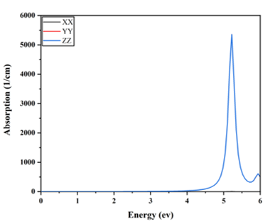

- Optical spectrum of 32 BNQD consists of: (a) with 1 NH3 and (b) with 2 NH₃ molecules in terms of Energy
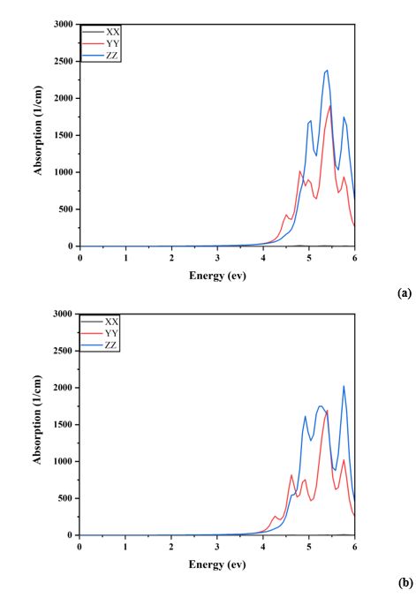

- Properties of 76 BNQD without NH₃ molecules consist of: Band Gap, Optical Spectrum and Blochstate

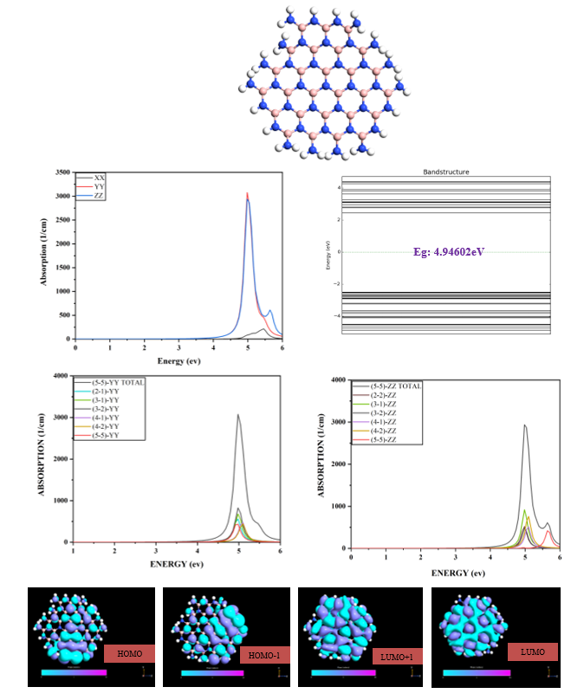
- Properties of 76 BNQD with 1 NH₃ molecules consist of: Band Gap and Optical Spectrum

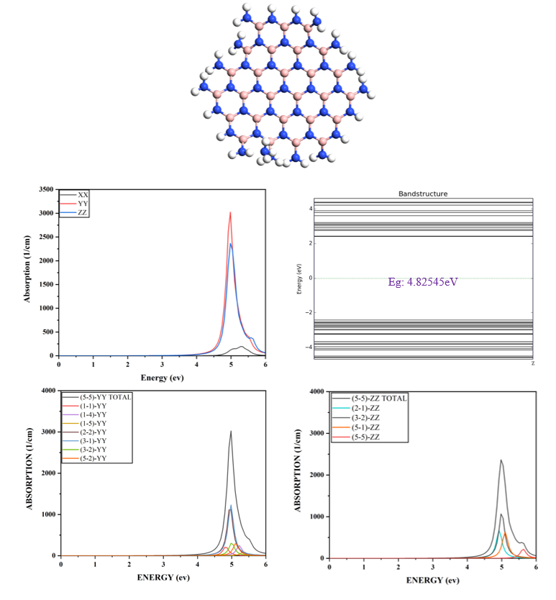

- Properties of 76 BNQD with 2 NH₃ molecules consist of: Band Gap and Optical Spectrum

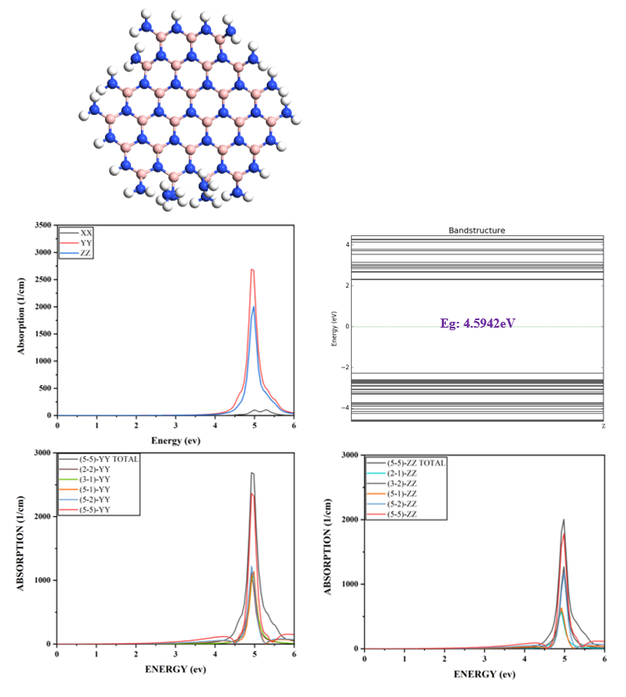

- Properties of 131 BNQD without NH₃ molecules consist of: Band Gap, Optical Spectrum and Blochstate

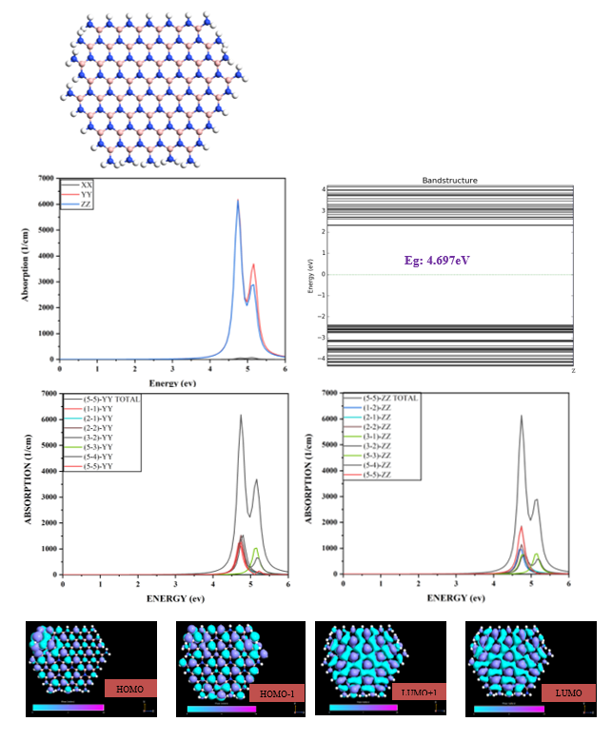

7-Properties of 131 BNQD with 1 NH₃ molecules consist of: Band Gap and Optical Spectrum
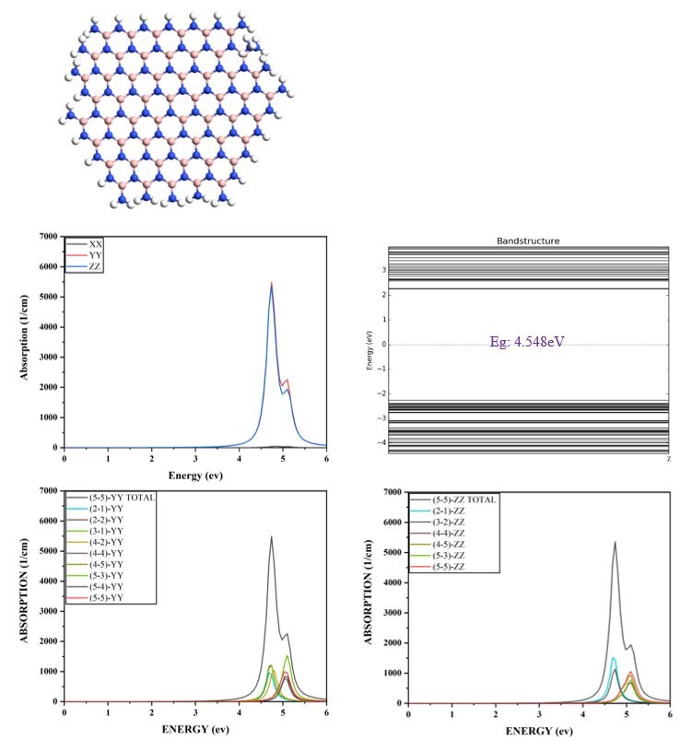

- Properties of 131 BNQD with 2 NH₃ molecules consist of: Band Gap and Optical Spectrum

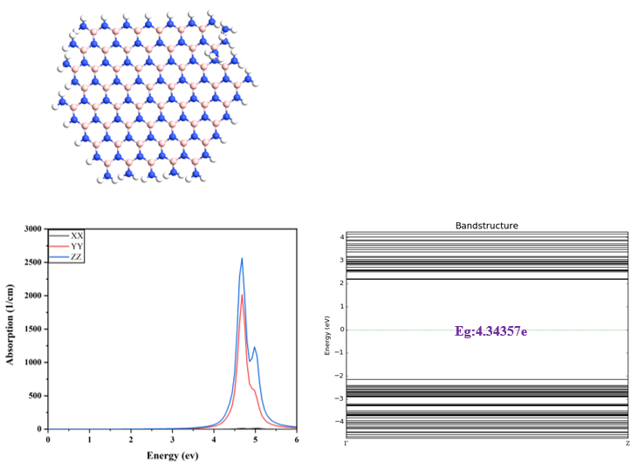

- Properties of 168 BNQD without NH₃ molecules consist of: Band Gap, Optical Spectrum and Blochstate
Journals
1-sensor and actuator B
2- Physica E: Low-Dimensional Systems and Nanostructures
3-Beilstein Journal of Nanotechnology
4-Physica B
5-OPTICAL AND QUANTUM ELECTRONICS
6-applied physics A
7-Journal of Computational Electronics

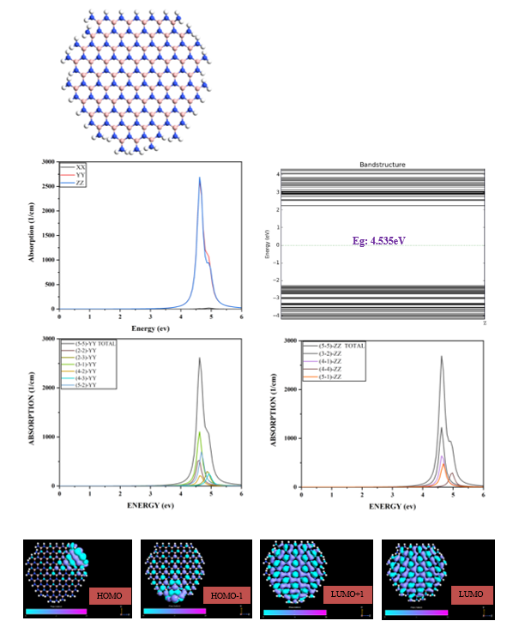

- Properties of 168 BNQD with 1 NH₃ molecules consist of: Band Gap and Optical Spectrum

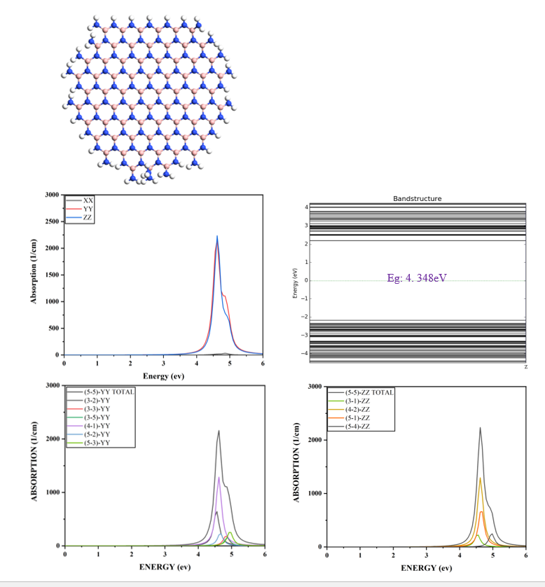

- Fatband structure
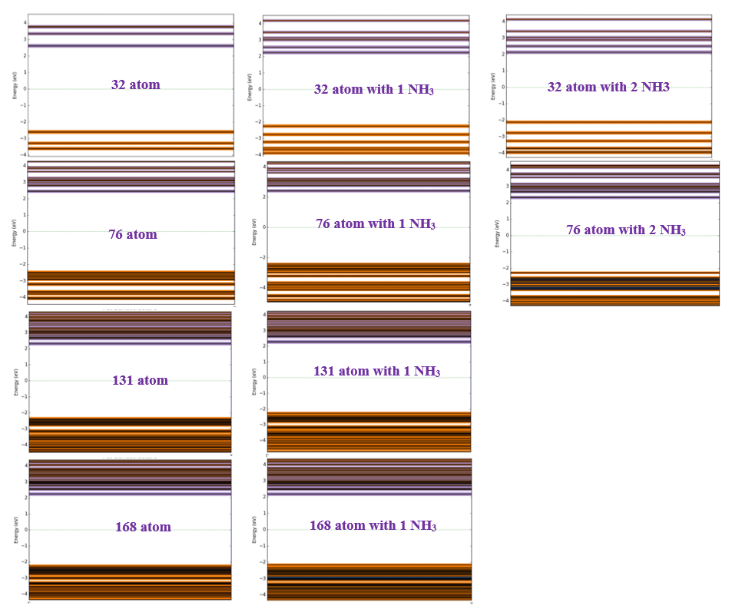

∗ Corresponding Authors: Javad Karamdel (j-karamdel@azad.ac.ir), and Masoud Berahman (m.berahman@kgut.ac.ir)

