Does long-term care insurance reduce the disability of middle-aged and older adults? Evidence from China
Supplementary data

Appendix table 1a
List of the first pilot cities of the LTCI
Name of city | Province | Insured personnel
Chende | Hebei | participants of The Urban Employee Basic Medical Insurance (UEBMI)
Changchun | Shenyang | participants of UEBMI;  participants Urban Resident Basic Medical Insurance (URBMI)
Qiqihaer | Heilongjiang | participants of UEBMI
Shanghai | Shanghai | participants of UEBMI; participants of urban and rural residents Basic Medical Insurance (URRMI) who above 60 years old
Nantong | Jiangsu | participants of UEBMI; participants of URRMI
Suzhou | Jiangsu | participants of UEBMI; participants of URRMI
Ningbo | Zhejiang | participants of UEBMI
Anqing | Anhui | participants of UEBMI
Shangrao | Jiangxi | participants of UEBMI
Qingdao | Shandong | participants of UEBMI; participants of URRMI
Jingmen | Hubei | participants of UEBMI; participants of URRMI
Guangzhou | Guangdong | participants of UEBMI
Chongqing | Chongqing | participants of UEBMI
Chengdu | Sichuan | participants of UEBMI
Shihezi | Guangdong | participants of UEBMI; participants of URRMI
Data source：According to the material of pilot cities

Appendix table 1b
List of the second pilot cities of the LTCI
Name of city | Province | Insured personnel
Shijingshan District | Beijing | participants of UEBMI; participants of URRMI
Tianjin | Tianjin | participants of UEBMI
Jinchen | Shanxi | participants of UEBMI
Hohhot | Inner Mongolia | participants of UEBMI; participants of URRMI
Panjin | Liaoning | participants of UEBMI
Fuzhou | Fujian | participants of UEBMI
Kaifang | Henan | participants of UEBMI
Xiangtan | Hunan | participants of UEBMI
Nanning | Guangxi | participants of UEBMI
Qianxi'Nan Buyei and Miao Autonomous Prefecture | Guizhou | participants of UEBMI
Kuiming | Yunnan | participants of UEBMI
Hanzhong | Shannxi | participants of UEBMI
Gannan Tibetan Autonomous Prefecture | Gansu | participants of UEBMI
Urumqi | Xinjiang | participants of UEBMI
Data source：According to the material of pilot cities

Appendix table 2a | Descriptive statistics of variables in treat group
Variables |  | Untreated |  |  | Treated
 |  | mean | sd |  | mean |  |  | sd
IADL |  | 0.183 | 0.612 |  | 0.232 |  |  | 0.701
ADL |  | 0.174 | 0.587 |  | 0.144 |  |  | 0.575
FL |  | 0.901 | 1.245 |  | 1.089 |  |  | 1.481
hukou |  | 1.518 | 0.544 |  | 1.336 |  |  | 0.474
living status |  | 0.891 | 0.312 |  | 0.795 |  |  | 0.405
basic medical insurance |  | 0.931 | 0.253 |  | 1 |  |  | 0
smoking |  | 3.586 | 8.675 |  | 5.514 |  |  | 10.355
drinking |  | 1.47 | 2.551 |  | 1.13 |  |  | 2.229
chronic disease |  | 1.434 | 1.424 |  | 2.021 |  |  | 1.511
depression |  | 6.17 | 5.616 |  | 8.493 |  |  | 4.396
observations |  | 394 |  |  |  |  | 146
(Observations of the untreated IADL、ADL、FL in treat group is 393,390,294 respectively. Observations of the treated IADL、ADL、FL in treat group is 142,146,146 respectively)

Appendix table 2b Descriptive statistics of variables in control group
Variables | 2011 |  |  |  | 2013 |  |  |  | 2015 |  |  |  | 2018
Variables | mean | sd | N |  | mean | sd | N |  | mean | sd | N |  | mean | sd | N
IADL | 0.378 | 0.942 | 10186 |  | 0.355 | 0.866 | 7735 |  | 0.412 | 0.963 | 9747 |  | 0.374 | 0.902 | 7134
ADL | 0.297 | 0.885 | 10128 |  | 0.311 | 0.846 | 7799 |  | .387 | 0.968 | 9841 |  | 0.37 | 0.954 | 7529
FL | 1.162 | 1.453 | 10224 |  | 1.402 | 1.583 | 7799 |  | 1.393 | 1.632 | 9841 |  | 1.591 | 1.72 | 7529
hukou | 1.205 | 0.421 | 10224 |  | 1.204 | 0.431 | 7833 |  | 1.214 | 0.465 | 9884 |  | 1.195 | 0.396 | 7529
living status | 0.893 | 0.309 | 10224 |  | 0.88 | 0.325 | 7833 |  | .871 | 0.336 | 9884 |  | 0.795 | 0.404 | 7529
basic medical insurance | 0.934 | 0.248 | 10224 |  | 0.966 | 0.181 | 7833 |  | .914 | 0.28 | 9884 |  | 0.975 | 0.157 | 7529
smoking | 4.397 | 9.584 | 10224 |  | 2.601 | 7.471 | 7833 |  | 4.79 | 9.675 | 9884 |  | 7.194 | 18.4 | 7529
drinking | 0.952 | 2.126 | 10224 |  | .933 | 2.101 | 7833 |  | 1.269 | 2.375 | 9884 |  | 0.994 | 2.128 | 7529
chronic disease | 1.298 | 1.269 | 10224 |  | 1.492 | 1.35 | 7833 |  | 1.919 | 1.524 | 9884 |  | 2.3 | 1.69 | 7529
depression | 8.33 | 6.29 | 10224 |  | 8.064 | 5.818 | 7833 |  | 7.997 | 6.349 | 9884 |  | 9.962 | 5.559 | 7529

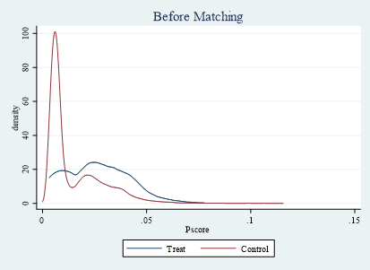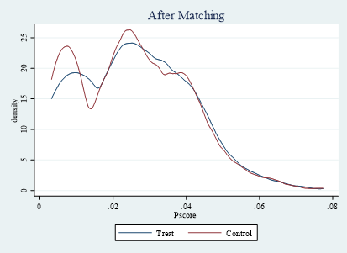
(a) (b)
Appendix figure 1a Probability score distribution. (a) Before matching; (b) after matching.

