Supplementary Materials for
Multifunctional solar water harvester with high transport selectivity and super fouling rejection capacity

Xuanzhang Hao^{1,2}, Houze Yao^{1,2}, Panpan Zhang^{1,2}, Qihua Liao^{1,2}, Kaixuan Zhu^{1,2}, Jian Chang,³ Huhu Cheng^{1,2*}, Jiaying Yuan^{3*}, Liangti Qu^{1,2*}

¹ Laboratory of Flexible Electronics Technology, Key Laboratory of Organic Optoelectronics & Molecular Engineering, Ministry of Education, Department of Chemistry, Tsinghua University, Beijing 100084, P. R. China.
² State Key Laboratory of Tribology in Advanced Equipment (SKLT), Department of Mechanical Engineering, Tsinghua University, Beijing 100084, P. R. China.
³ Department of Materials and Environmental Chemistry, Stockholm University, 10691 Stockholm, Sweden.

* Corresponding author. E-mail: Huhu Cheng, huhucheng@mail.tsinghua.edu.cn. Liangti Qu, lqu@mail.tsinghua.edu.cn. Jiayin Yuan, jiayin.yuan@mmk.su.se
Supplementary
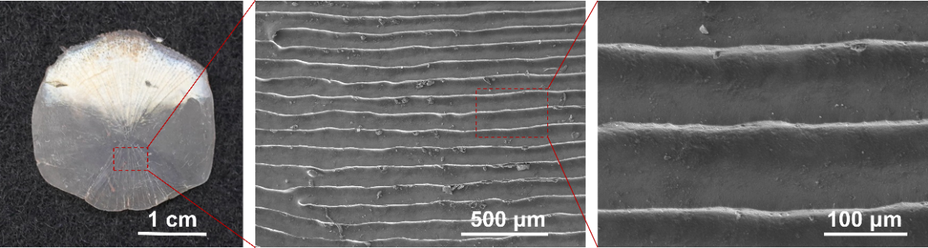
Fig. S1 | Scanning electron microscope (SEM) images of fish-scale.
The surface structure of fish scales. SEM images indicate that fish scales have structural sizes ranging from tens to more than a hundred microns and shapes ranging from parallel stripe to scattered geometric shapes, all of which can achieve antifouling effects. In this work, the striped fish scale structure is imitated.

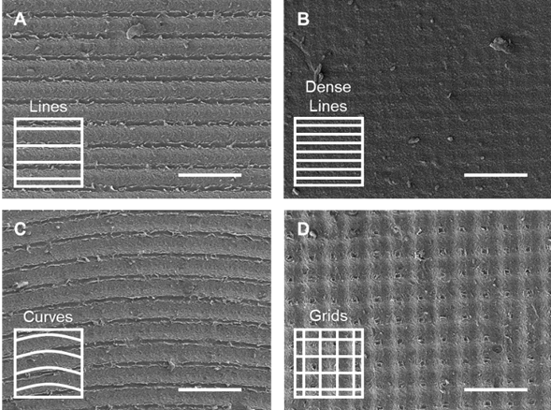
Fig. S2 | Different pre-defined patterns of microstructures machined on the GAH surface. A) Parallel straight lines spaced at 100 μm. B) Parallel straight lines spaced at 50 μm. C) Parallel curves spaced at 100 μm. D) Square grid with side length of 100 μm. The scale bar is 200 μm.
Microstructures with various shapes can be obtained on the material surface by adjusting the laser parameters and designing preset shapes.

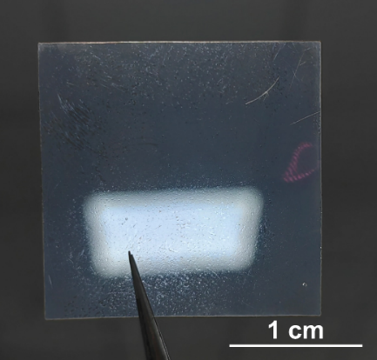
Fig. S3 | Photograph of a transparent SA membrane.

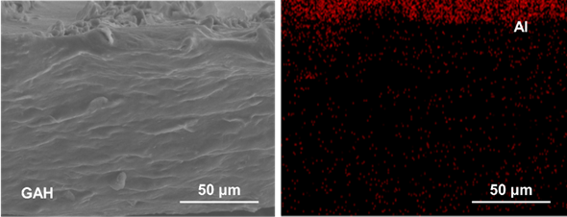
Fig. S4 | The cross-section SEM image of the GAH and the corresponding energy dispersive X-ray spectroscopy (EDS) image of aluminum element. Uniform distribution of aluminum element illustrates the uniform crosslinking of GAH.

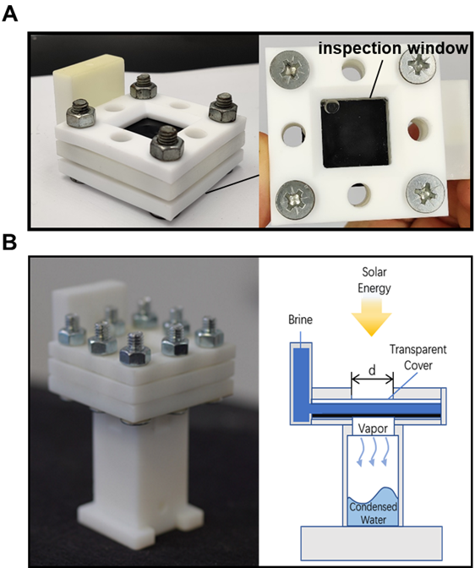
Fig. S5 | Lab-made equipment for A) vapor generation and B) extracted water collection, respectively.
Both devices adopt sandwich structure design and are divided into upper, middle and lower parts. Each part is sealed by silicone gasket and connected by screws.
For vapor generation device in Fig. S5A, the upper part is used to clamp the GAH film and leave a 2 cm side length square window to provide light, the middle part provides water storage space, and the lower part clamps the glass to form an inspection window to observe the water and GAH back state. And in the anti-salt-fouling test, the both sides of GAH can be observed with this device.
For extracted water collector in Fig. S5B, the upper part clamps the glass sheet to form an observation window, which also serves as the incident port of light. The middle part provides space for storing raw sewage, and the lower part clamps the GAH film and contains a condensation chamber. The light passes through the glass and raw water and is captured by GAH, turns into heat for GAH to extract pure steam. The obtained steam transmits would downward and condensed in the condensation chamber.

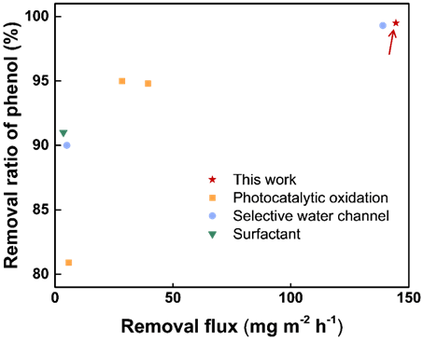
Fig. S6 | Performance comparison between published works and this work based on removal ration and removal flux of phenol.¹⁻¹⁴
For evaluation of purification membrane performance, removal rate and flux are two important indicators.^{15,16} However, due to the different types and concentrations of VOCs used in published work, we screened and normalized them before comparison. Firstly, we choose phenol as the target pollutant due to its high removal difficulty. And define the VOCs removal flux (F) according to the following formula.
$$\begin{aligned}\text{F} \text{=} {\text{W}}_{\text{raw}}\text{ R\%}{\text{ R}}_{\text{vapor}} \end{aligned}$$
Where W_{raw} is the phenol concentration of raw sewage in ppm, R% is the removal ratio of phenol, R_{vapor} is the water extraction rate in kg m⁻² h⁻¹.
With the evaluation system based on F and R%, we considered the three factors of evaporation rate, removal rate and flux, and demonstrated the excellent performance of this work.
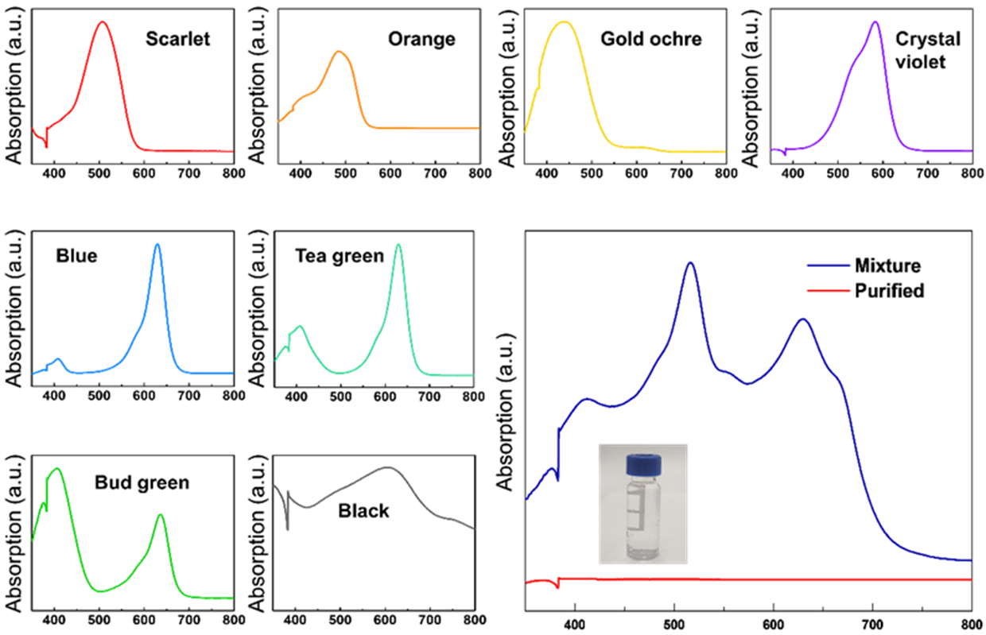
Fig. S7 | UV-VIS absorption spectra various pigments (scarlet, orange, gold ochre, crystal violet, blue, tea green, bud green and black) and GAH extracted water.
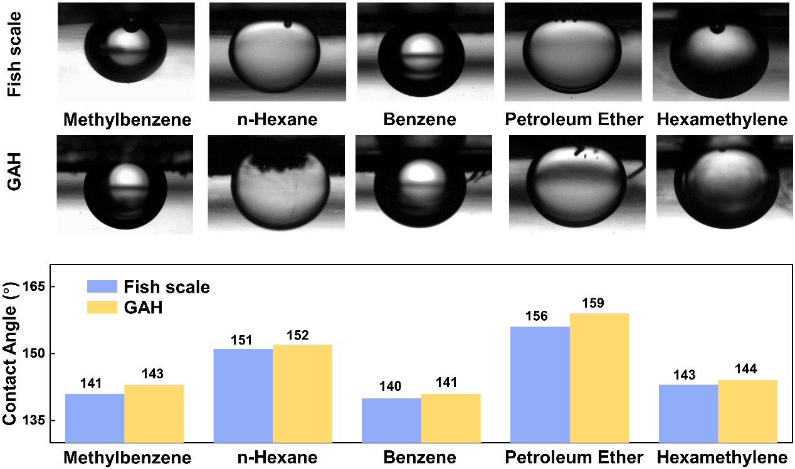
Fig. S8 | The images are the contact state of methylbenzene, n-Hexane, benzene, petroleum ether and hexamethylene droplets with fish scale and GAH under water. The chart shows the value of each contact angle.
Both fish scale and GAH show excellent resistance to contamination with various organic solvents, by forming contact angles greater than 140º. GAH inherits excellent antifouling properties from fish scales.

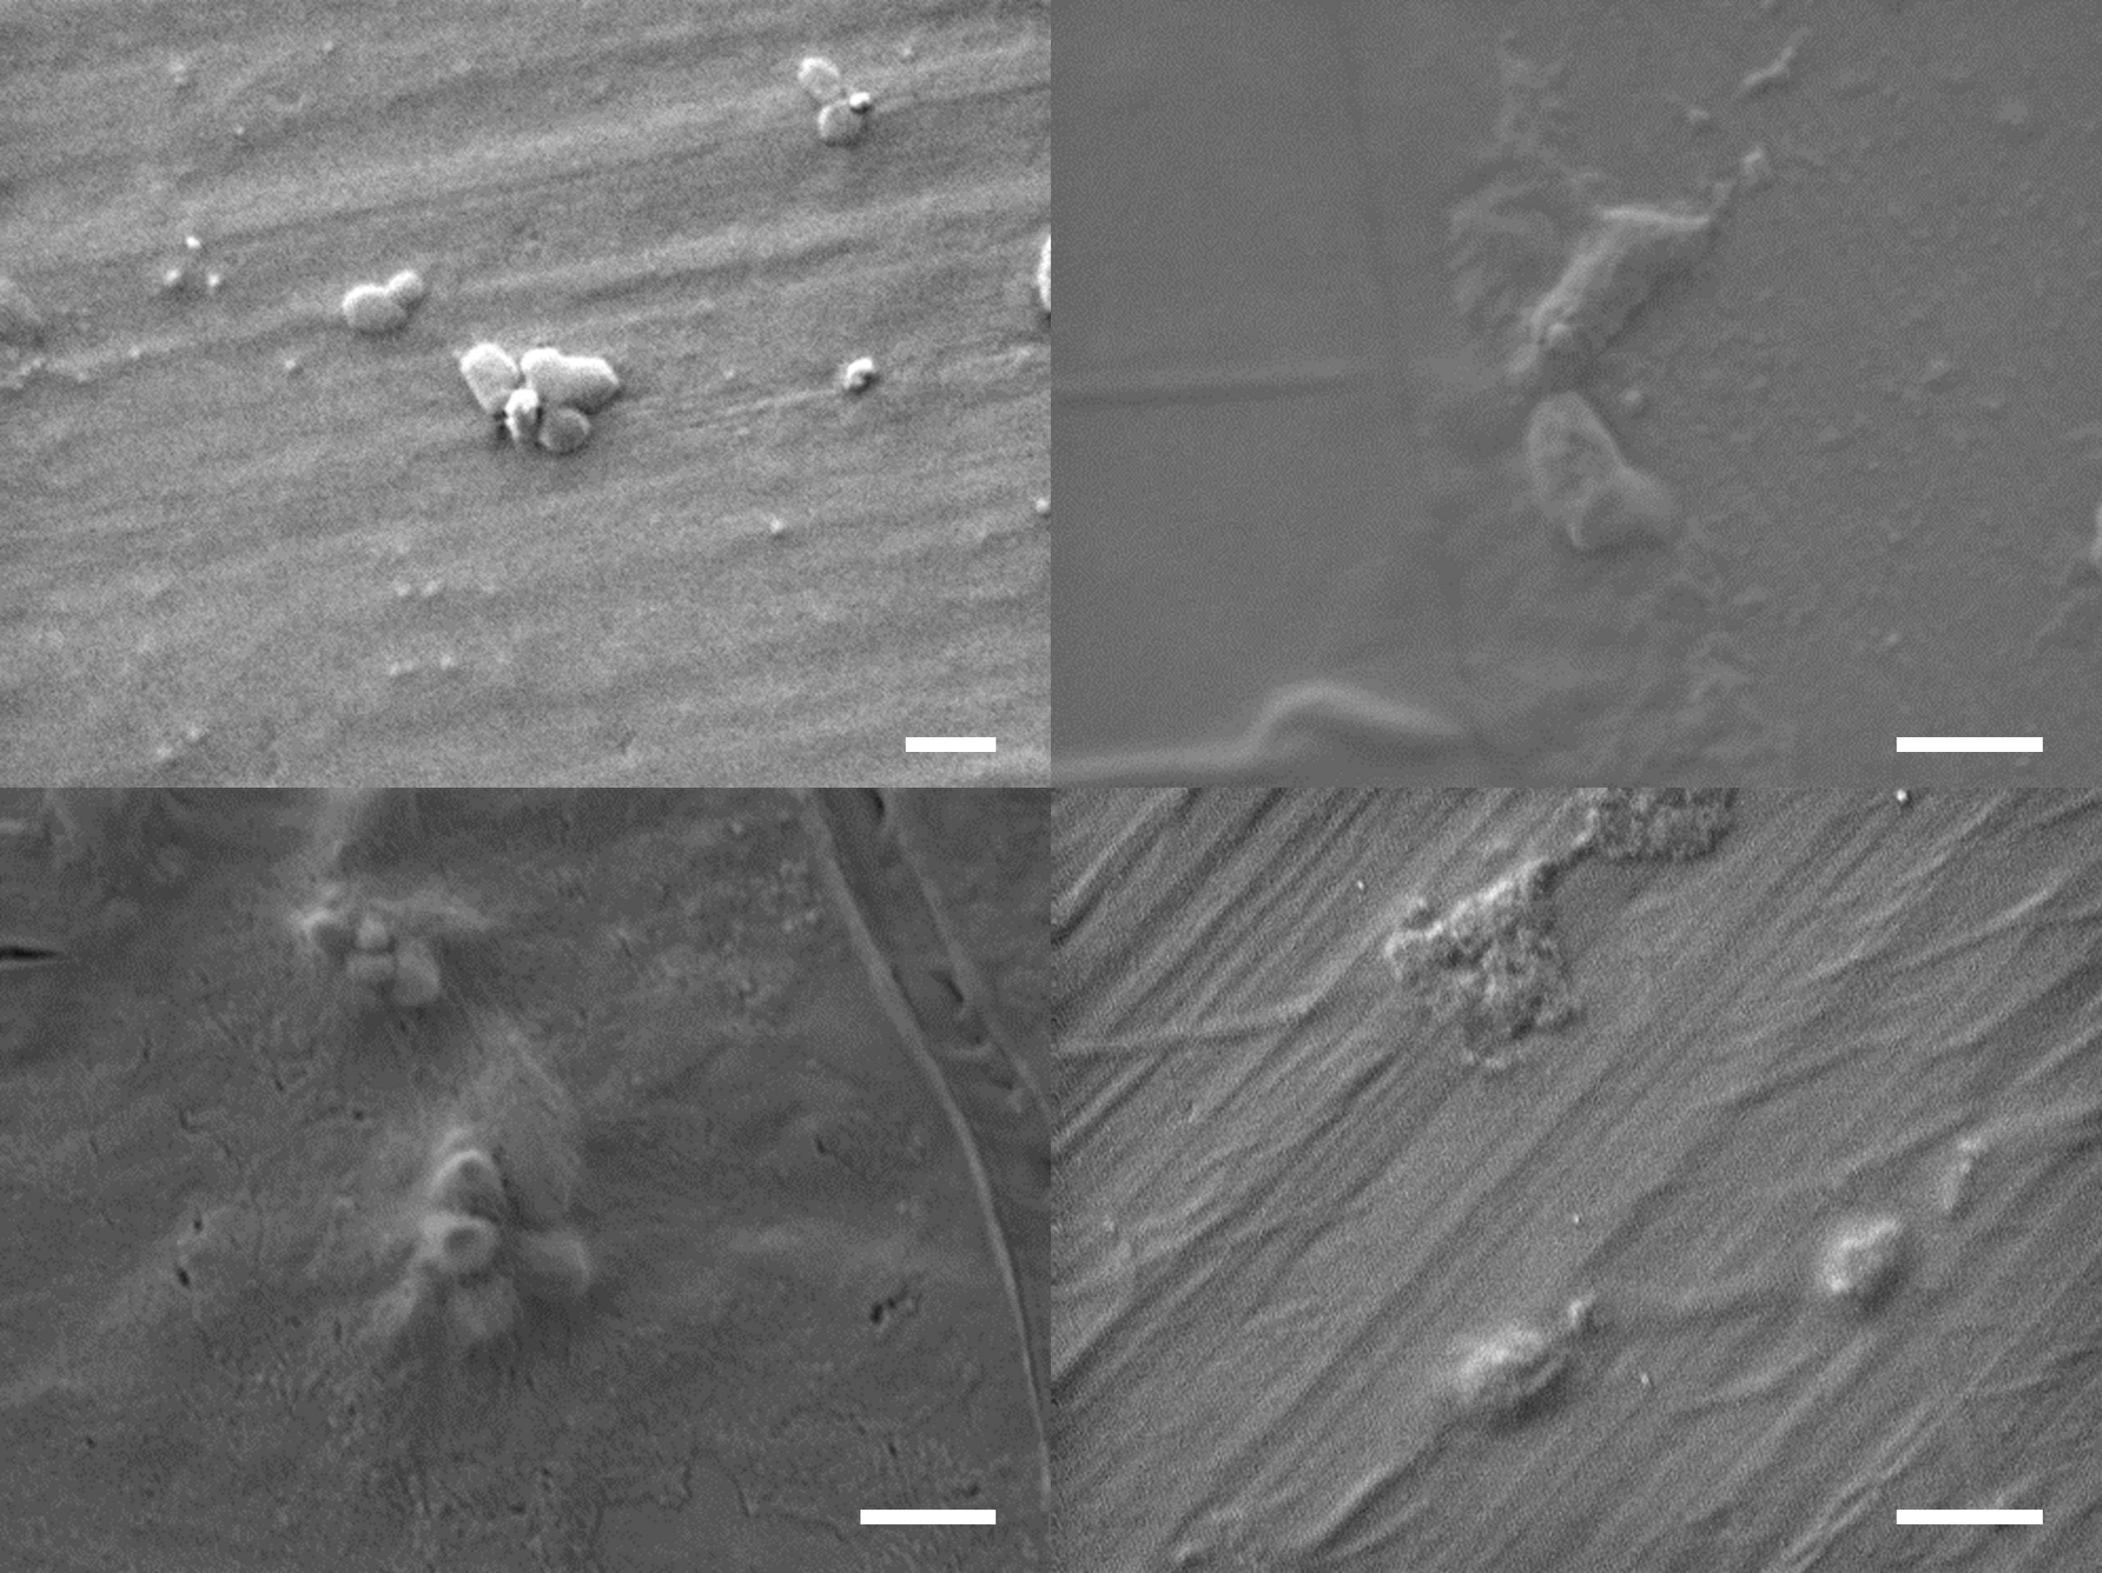
Fig. S9 | SEM images of broken dead bacteria pieces from GAH. The scale bars are 1 μm.

Reference
1. Shi, L., Shi, Y., Zhuo, S. F., Zhang, C. L., Aldrees, Y., Aleid, S., et al. Multi-functional 3D honeycomb ceramic plate for clean water production by heterogeneous photo-Fenton reaction and solar-driven water evaporation. Nano Energy 60, 222–230 (2019).
2. Deng, J. Y., Xiao, S. N., Wang, B., Li, Q., Li, G. S., Zhang, D. Q., et al. Self-suspended photothermal microreactor for water desalination and integrated volatile organic compound removal. ACS Applied Materials & Interfaces 12, 51537–51545 (2020).
3. Qi, D. P., Liu, Y., Liu, Y. B., Liu, Z. Y., Luo, Y. F., Xu, H. B., et al. Polymeric membranes with selective solution‐diffusion for intercepting volatile organic compounds during solar‐driven water remediation. Advanced Materials 32, 2004401 (2020).
4. Ma, X., Deng, Z., Li, Z., Chen, D., Wan, X., Wang, X., et al. A photothermal and Fenton active MOF-based membrane for high-efficient solar water evaporation and clean water production. Journal of Materials Chemistry A 8, 22728–22735 (2020).
5. Qi, D., Liu, Y., Liu, Y., Liu, Z., Luo, Y., Xu, H., et al. Polymeric membranes with selective solution‐diffusion for intercepting volatile organic compounds during solar‐driven water remediation. Advanced Materials 32, e2004401 (2020).
6. Song, C., Qi, D., Han, Y., Xu, Y., Xu, H., You, S., et al. Volatile-organic-compound-intercepting solar distillation enabled by a photothermal/photocatalytic nanofibrous membrane with dual-scale pores. Environmental Science & Technology 54, 9025–9033 (2020).
7. Yan, S. W., Song, H. J., Li, Y., Yang, J., Jia, X. H., Wang, S. Z., et al. Integrated reduced graphene oxide/polypyrrole hybrid aerogels for simultaneous photocatalytic decontamination and water evaporation. Applied Catalysis B: Environmental 301, 120820 (2021).
8. Xie, W. C., Tang, P., Wu, Q. D., Chen, C., Song, Z. Y., Li, T., et al. Solar-driven desalination and resource recovery of shale gas wastewater by on-site interfacial evaporation. Chemical Engineering Journal 428, 132624 (2021).
9. Wen, C. Y., Yang, J., Guo, H. S., Li, Q. S., Zhang, X. Y., Wang, X. D., et al. Zwitterionic functionalized catalytic evaporator enables simultaneous solar distillation and organic pollutant degradation. Applied Energy 321, 119372 (2022).
10. Elimian, E. A., Zhang, M., Chen, J., Jia, H. P., Sun, Y. & He, J., Construction of Pt-mTiO₂/USY multifunctional catalyst enriched with oxygen vacancies for the enhanced light-driven photothermocatalytic degradation of toluene. Applied Catalysis B: Environmental 307, 121203 (2022).
11. Li, C., Zhou, X., Xiao, Y., Zhang, T. & Ye, M., Inhibition of typical phenolic compounds entering into condensed freshwater by surfactants during solar-driven seawater distillation. Science of the Total Environment 815, 152694 (2022).
12. Ma, J., An, L., Liu, D., Yao, J., Qi, D., Xu, H., et al. A light-permeable solar evaporator with three-dimensional photocatalytic sites to boost volatile-organic-compound rejection for water Purification. Environmental Science & Technology 54, 9025–9033 (2022).
13. Zhang, P. P., Zhao, F., Shi, W., Lu, H. Y., Zhou, X. Y., Guo, Y. H., et al. Super water-extracting gels for solar-powered volatile organic compounds management in the Hydrological Cycle. Advanced Materials 34, e2110548 (2022).
14. Zhou, S., He, R., Pei, J., Liu, W., Huang, Z., Liu, X., et al. Self-regulating solar steam generators enable volatile organic compound removal through in situ H₂O₂ generation. Environmental Science & Technology 56, 10474–10482 (2022).
15. Shen, J., Cai, Y. C., Zhang, C. H., Wei, W., Chen, C. L., Liu, L. M., et al. Fast water transport and molecular sieving through ultrathin ordered conjugated-polymer-framework membranes. Nature Materials 21, 1083–1190 (2022).
16. Xu, L. H., Li, S. H., Mao, H., Li, Y., Zhang, A. S., Wang, S., et al. Highly flexible and superhydrophobic MOF nanosheet membrane for ultrafast alcohol-water separation. Science 378, 308–313 (2022).

