Table S1. Association of quintile of air pollutant levels with rapid renal progression.
CO, ppm | RP (n) | NRP (n) | OR (95% CI) | Adj. OR (95% CI)
Q1 (<0.435) | 24 | 65 | 1.00 [Reference] | 1.00 [Reference]
Q2 (0.435–0.452) | 23 | 67 | 0.93 (0.48–1.81) | 0.96 (0.44–2.11)
Q3 (0.453–0.472) | 27 | 62 | 1.18 (0.62–2.26) | 2.00 (0.93–4.31)
Q4 (0.473–0.483) | 20 | 60 | 0.77 (0.39–1.53) | 0.93 (0.42–2.09)
Q5 (>0.483) | 19 | 70 | 0.74 (0.37–1.47) | 0.86 (0.35–2.07)
NO, ppb
Q1 (<2.390) | 21 | 68 | 1.00 [Reference] | 1.00 [Reference]
Q2 (2.390–2.404) | 19 | 71 | 0.87 (0.43–1.75) | 1.02 (0.42–2.48)
Q3 (2.405–2.420) | 22 | 67 | 1.06 (0.54–2.11) | 1.12 (0.47–2.63)
Q4 (2.421–2.435) | 27 | 63 | 1.39 (0.71–2.70) | 1.92 (0.83–4.46)
Q5 (>2.435) | 24 | 65 | 1.20 (0.61–2.35) | 1.77 (0.77–4.11)
NO₂, ppb
Q1 (<12.702) | 26 | 63 | 1.00 [Reference] | 1.00 [Reference]
Q2 (12.702–13.407) | 20 | 70 | 0.69 (0.35–1.36) | 0.98 (0.43–2.24)
Q3 (13.408–13.767) | 25 | 64 | 0.95 (0.49–1.81) | 1.50 (0.71–3.18)
Q4 (13.768–13.963) | 21 | 69 | 0.74 (0.38–1.44) | 1.01 (0.45–2.28)
Q5 (>13.963) | 21 | 68 | 0.75 (0.38–1.46) | 0.95 (0.41–2.21)
NO_{x}, ppb
Q1 (<15.094) | 26 | 63 | 1.00 [Reference] | 1.00 [Reference]
Q2 (15.094–15.902) | 19 | 71 | 0.65 (0.33–1.28) | 0.91 (0.40–2.05)
Q3 (15.903–16.160) | 25 | 64 | 0.95 (0.49–1.81) | 1.57 (0.74–3.37)
Q4 (16.161–16.321) | 22 | 68 | 0.78 (0.40–1.52) | 1.14 (0.51–2.56)
Q5 (>16.321) | 21 | 68 | 0.75 (0.38–1.46) | 0.90 (0.38–2.09)
Abbreviations: ppb, parts per billion; ppm, parts per million; Q, quartile; CO, carbon monoxide; NO, nitrogen monoxide; NO₂, nitrogen dioxide; NO_{x}, nitrogen oxides; RP, rapid progression; NRP, non-rapid progression; Adj. OR, adjusted odds ratio; CI, confidence interval.
Using the logistic regression model, odds ratios were estimated and adjusted odds, then calculated after adjusting for age, sex, educational level, diabetes, hypertension, angiotensin-converting enzyme inhibitor/angiotensin receptor blocker, non-steroidal anti-inflammatory drugs, and urine protein creatinine ratio values at baseline.

Table S2. Association of quintile of air pollutant levels with rapid renal progression.
O₃, ppb | RP (n) | NRP (n) | OR (95% CI) | Adj. OR (95% CI)
Q1 (<31.281) | 24 | 65 | 1.00 [Reference] | 1.00 [Reference]
Q2 (31.281–31.373) | 27 | 63 | 1.16 (0.61–2.22) | 1.06 (0.50–2.28)
Q3 (31.374–31.609) | 24 | 65 | 1.00 (0.52–1.94) | 1.21 (0.55–2.66)
Q4 (31.610–31.744) | 19 | 71 | 0.73 (0.36–1.44) | 0.79 (0.36–1.76)
Q5 (>31.744) | 19 | 70 | 0.74 (0.37–1.47) | 0.77 (0.32–1.83)
PM₁₀, μg/m³
Q1 (<63.181) | 27 | 62 | 1.00 [Reference] | 1.00 [Reference]
Q2 (63.181–64.086) | 18 | 72 | 0.57 (0.29–1.14) | 0.72 (0.32–1.65)
Q3 (64.087–64.893) | 28 | 61 | 1.05 (0.56–1.99) | 1.76 (0.83–3.70)
Q4 (64.894–65.341) | 20 | 70 | 0.66 (0.34–1.28) | 0.86 (0.38–1.93)
Q5 (>65.341) | 20 | 69 | 0.67 (0.34–1.30) | 0.76 (0.32–1.83)
PM_{2.5}, μg/m³
Q1 (<34.899) | 28 | 61 | 1.00 [Reference] | 1.00 [Reference]
Q2 (34.899–35.496) | 18 | 72 | 0.55 (0.28–1.08) | 0.58 (0.26–1.32)
Q3 (35.497–36.211) | 27 | 62 | 0.95 (0.50–1.79) | 1.64 (0.78–3.45)
Q4 (36.212–36.586) | 20 | 70 | 0.62 (0.32–1.22) | 0.77 (0.34–1.71)
Q5 (>36.586) | 20 | 69 | 0.63 (0.32–1.23) | 0.69 (0.29–1.66)
SO₂, ppb
Q1 (<3.478) | 21 | 68 | 1.00 [Reference] | 1.00 [Reference]
Q2 (3.478–3.549) | 20 | 70 | 0.93 (0.46–1.86) | 1.26 (0.52–3.05)
Q3 (3.550–3.624) | 25 | 64 | 1.27 (0.65–2.48) | 1.50 (0.63–3.59)
Q4 (3.625–3.735) | 21 | 69 | 0.99 (0.49–1.97) | 1.19 (0.50–2.85)
Q5 (>3.735) | 26 | 63 | 1.34 (0.68–2.61) | 1.64 (0.70–3.86)
Abbreviations: ppb, parts per billion; ppm, parts per million; μg/m³, micrograms per cubic meter; Q, quartile; O₃, ozone; PM₁₀, particulate matter <10 μm in aerodynamic diameter; PM_{2.5}, particulate matter <2.5 μm in aerodynamic diameter; SO₂, sulfur dioxide; RP, rapid progression; NRP, non-rapid progression; Adj. OR, adjusted odds ratio; CI, confidence interval.
Using the logistic regression model, odds ratios were estimated and adjusted, then calculated after adjusting for age, sex, educational level, diabetes, hypertension, angiotensin-converting enzyme inhibitor/angiotensin receptor blocker, non-steroidal anti-inflammatory drugs, and urine protein creatinine ratio values at baseline.
Figure S1. The number of study patients with estimated glomerular filtration rate measurements in each follow-up year.

Footnote for Figure S1: There are 447 patients, with 5,811 estimated glomerular filtration rate measurements, in the study period. The patient numbers through 0-1, 1-2, 2-3, 3-4, 4-5, 5-6, 6-7, 7-8, 8-9, 9-10, and >10 years are 447, 335, 260, 188, 152, 127, 86, 52, 24, and 12, respectively.

Figure S2. Scatter plot matrix for selected ambient air pollutants and estimated glomerular filtration rate (eGFR) slope.

Footnote for Figure S2: Abbreviations: CO, carbon monoxide; NO, nitrogen monoxide; NO2, nitrogen dioxide.

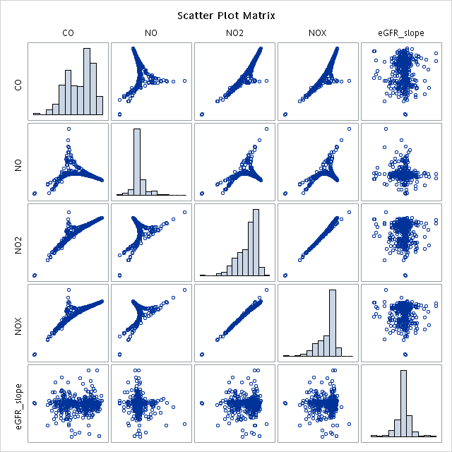
Figure S3. Scatter plot matrix for selected ambient air pollutants and estimated glomerular filtration rate (eGFR) slope.

Footnote for Figure S3: Abbreviations: O3, ozone; PM10, ambient coarse particulate matter ($≤$10μm); PM2.5, ambient coarse particulate matter ($≤$2.5μm); SO2, sulfur dioxide.

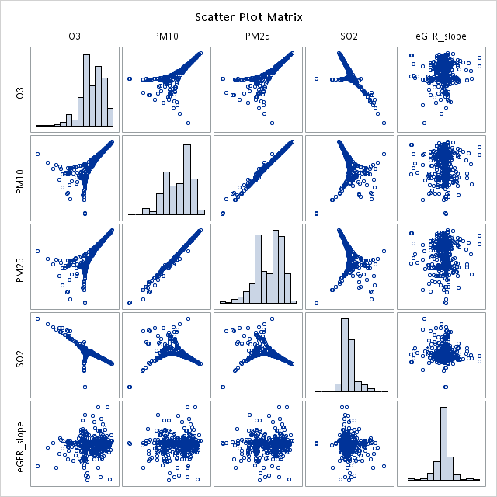
Figure S4. Renal function trajectory in the quartile of ambient air pollutant concentration. A) CO; B) NO; C) NO₂; D) NO_{x}; E) O₃; F) PM₁₀; G) PM_{2.5}; H) SO₂.

Footnote of Figure S4: The plots produced cubic splines by setting 50 smoothness in the spline curves. A value close to zero results in curves with many wiggles, which then nearly pass through every observed value. This value close to 100 results in flat curves that are nearly the least-square regression line.

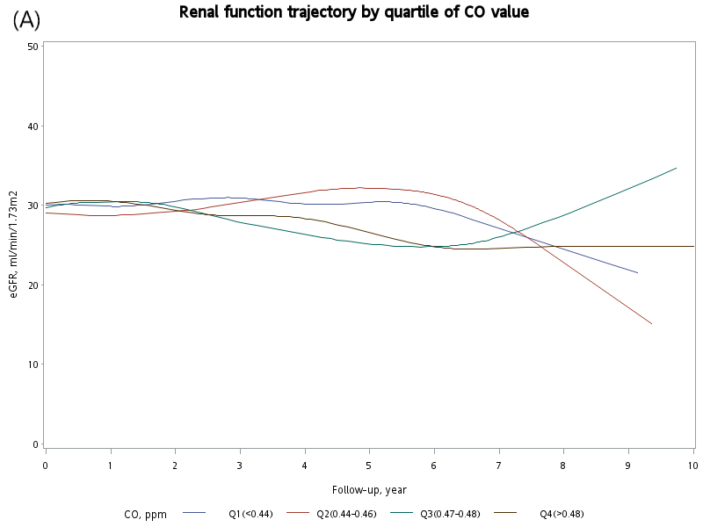

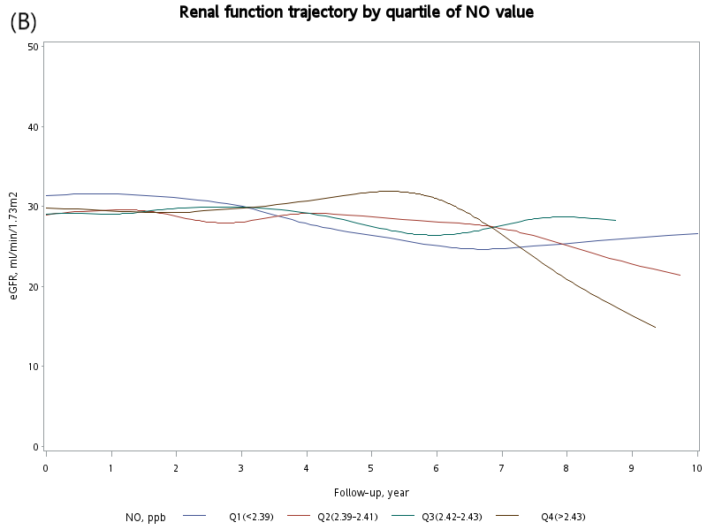

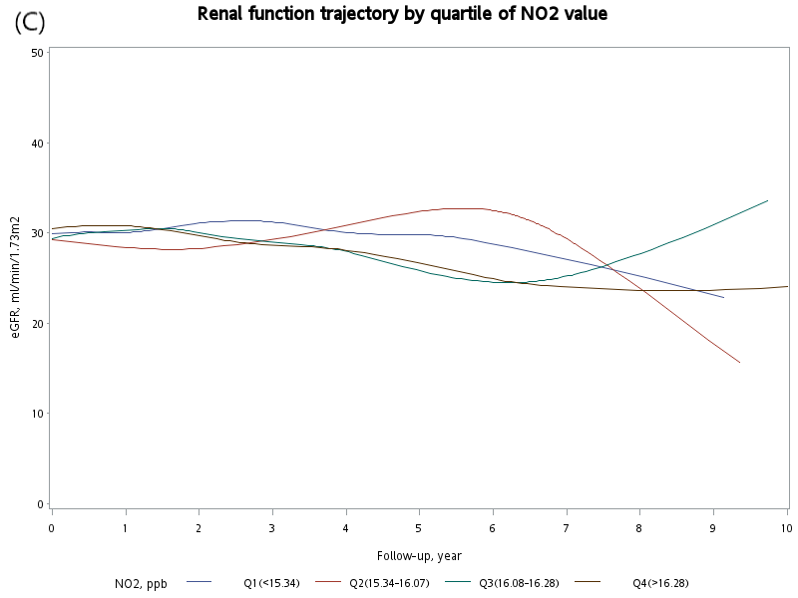

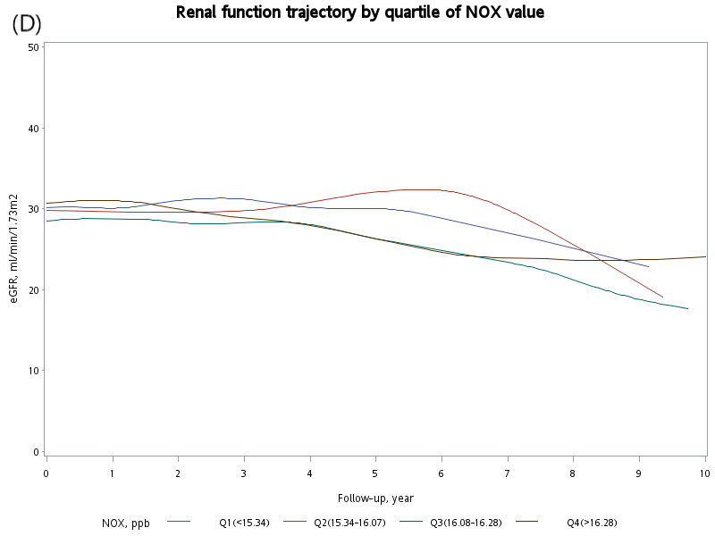

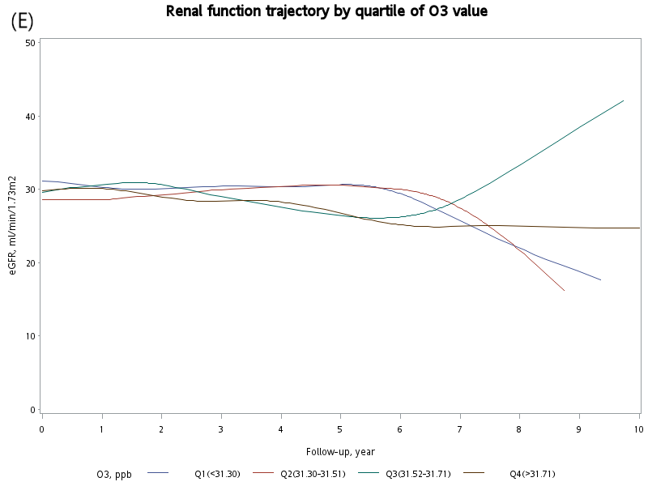
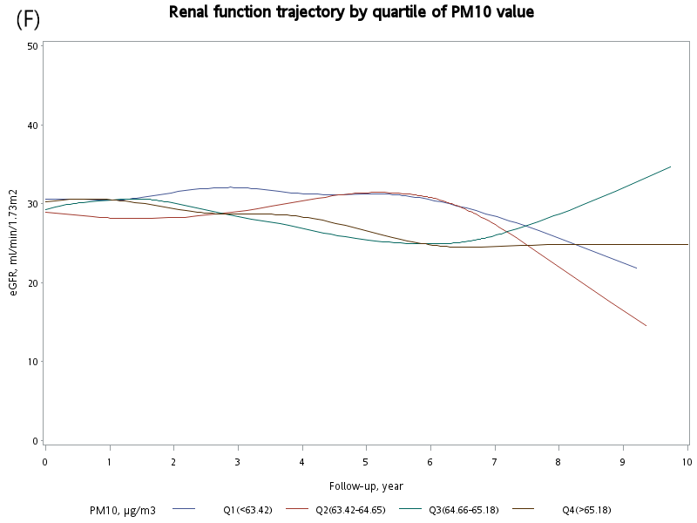

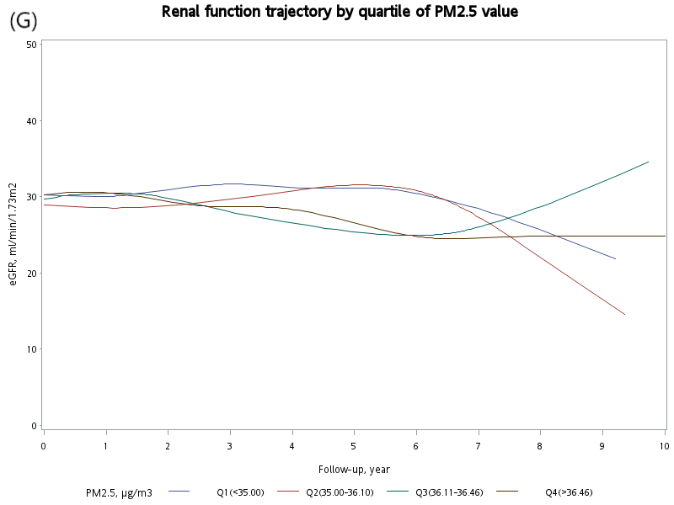

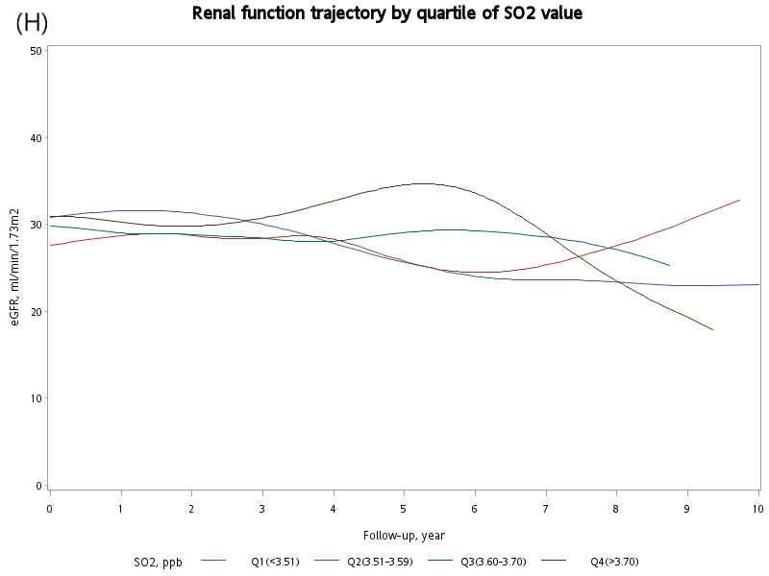
Table S1. Checklist of STROBE items of the cohort study
 | Item No | Recommendation | Page No
Title and abstract | 1 | (a) Indicate the study’s design with a commonly used term in the title or the abstract | 1,2
Title and abstract | 1 | (b) Provide in the abstract an informative and balanced summary of what was done and what was found | 2
Introduction
Background/rationale | 2 | Explain the scientific background and rationale for the investigation being reported | 3
Objectives | 3 | State specific objectives, including any prespecified hypotheses | 4
Methods
Study design | 4 | Present key elements of study design early in the paper | 10
Setting | 5 | Describe the setting, locations, and relevant dates, including periods of recruitment, exposure, follow-up, and data collection | 10
Participants | 6 | (a) Give the eligibility criteria, and the sources and methods of selection of participants. Describe methods of follow-up | 10
Participants | 6 | (b) For matched studies, give matching criteria and number of exposed and unexposed
Variables | 7 | Clearly define all outcomes, exposures, predictors, potential confounders, and effect modifiers. Give diagnostic criteria, if applicable | 11
Data sources/ measurement | 8* | For each variable of interest, give sources of data and details of methods of assessment (measurement). Describe comparability of assessment methods if there is more than one group | 5,6
Bias | 9 | Describe any efforts to address potential sources of bias | 9,12
Study size | 10 | Explain how the study size was arrived at | 10,18
Quantitative variables | 11 | Explain how quantitative variables were handled in the analyses. If applicable, describe which groupings were chosen and why | 11,12
Statistical methods | 12 | (a) Describe all statistical methods, including those used to control for confounding | 11,12
Statistical methods | 12 | (b) Describe any methods used to examine subgroups and interactions | 11,12
Statistical methods | 12 | (c) Explain how missing data were addressed | 18
Statistical methods | 12 | (d) If applicable, explain how loss to follow-up was addressed | 18
Statistical methods | 12 | (e) Describe any sensitivity analyses | 11,12
Results
Participants | 13* | (a) Report numbers of individuals at each stage of study—eg numbers potentially eligible, examined for eligibility, confirmed eligible, included in the study, completing follow-up, and analysed | 5,18
Participants | 13* | (b) Give reasons for non-participation at each stage | 5,18
Participants | 13* | (c) Consider use of a flow diagram | 18
Descriptive data | 14* | (a) Give characteristics of study participants (eg demographic, clinical, social) and information on exposures and potential confounders | 5,20
Descriptive data | 14* | (b) Indicate number of participants with missing data for each variable of interest | 18
Descriptive data | 14* | (c) Summarise follow-up time (eg, average and total amount) | 5
Outcome data | 15* | Report numbers of outcome events or summary measures over time | 5,6
Main results | 16 | (a) Give unadjusted estimates and, if applicable, confounder-adjusted estimates and their precision (eg, 95% confidence interval). Make clear which confounders were adjusted for and why they were included | 5,6
Main results | 16 | (b) Report category boundaries when continuous variables were categorized | 5
Main results | 16 | (c) If relevant, consider translating estimates of relative risk into absolute risk for a meaningful time period
Other analyses | 17 | Report other analyses done—eg analyses of subgroups and interactions, and sensitivity analyses | 5,6
Discussion
Key results | 18 | Summarise key results with reference to study objectives | 7
Limitations | 19 | Discuss limitations of the study, taking into account sources of potential bias or imprecision. Discuss both direction and magnitude of any potential bias | 9
Interpretation | 20 | Give a cautious overall interpretation of results considering objectives, limitations, multiplicity of analyses, results from similar studies, and other relevant evidence | 7,8,9
Generalisability | 21 | Discuss the generalisability (external validity) of the study results | 7,8,9
Other information
Funding | 22 | Give the source of funding and the role of the funders for the present study and, if applicable, for the original study on which the present article is based | 16
*Give information separately for exposed and unexposed groups.

