Supplementary Material

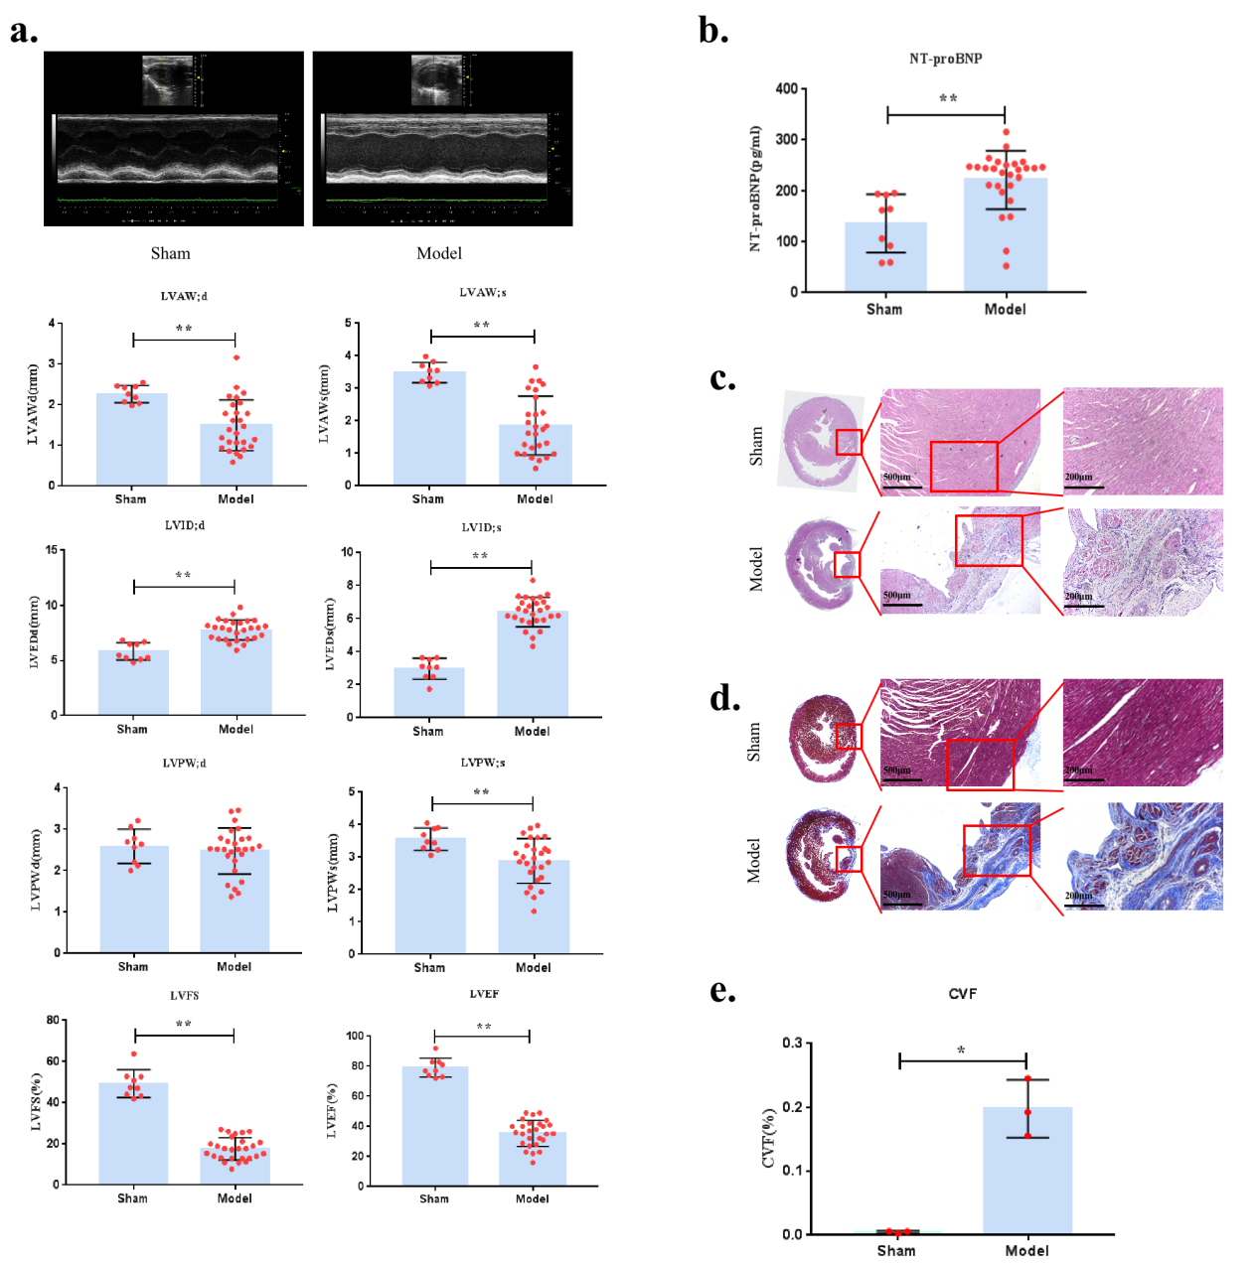
Figure S1 A rat model of post-myocardial infarction chronic heart failure via left anterior descending and exhaustive swimming
- M-mode echocardiographyand cardiac function parameters. LVAW;d, left ventricular anterior wall thickness of diastolic. LVAW;s, left ventricular anterior wall of systolic. LVID;s, left ventricular internal diameter of systole. LVID;d, left ventricular internal diameter of diastolic. LVPW;d, left ventricular posterior wall of diastolic. LVPW;s, left ventricular posterior wall of systolic. LVEF, left ventricular ejection fraction. LVFS, left ventricular percent fractional shortening. (b) NT-proBNP in serum. NT-proBNP, N terminal pro Brain natriuretic peptidepeptide. (c) HE stain image. (d) Masson stain image. (e) CVF. CVF, collagen volume fraction. Compaerd with Sham group, **P＜0.01,*P＜0.05.

 | Sham（n=9） | Model（n=27）
LVAW;d（mm） | 2.27±0.21 | 1.50±0.63**
LVAW;s（mm） | 3.49±0.31 | 1.85±0.90**
LVID;d（mm） | 5.83±0.78 | 7.76±0.92**
LVID;s（mm） | 2.97±0.63 | 6.40±0.89**
LVPW;d（mm） | 2.59±0.41 | 2.47±0.56
LVPW;s（mm） | 3.55±0.44 | 2.88±0.69**
LVEF（%） | 79.11±6.35 | 35.51±8.68**
LVFS（%） | 49.32±6.74 | 17.60±5.43**
NT-proBNP(pg/ml) | 136.69±57.50 | 221.64±57.10**
CVF(%) | 0.47±0.19 | 17.13*
Tabel S1 Cardiac Function Parameters、NT-proBNP、CVF
Compaerd with Sham group, **P＜0.01,*P＜0.05.

Echocardiography, NT-proBNP, and histological Analysis of Cardiac Tissue were performed After exhaustive swimming 28 days to identificate CHF model. Our experiment results indicate that, compared with Sham group, LVAW;d, LVAW;s, LVPW;S, LVEF, and LVFS of CHF model group were significantly decreased (P <0.01), and LVID;s and LVID;d increased significantly (P<0.01) (Fig.S.1a and Tab.S.2). NT-proBNP was remarkably higher with CHF model group versus Sham group(P<0.01) (Fig.S.1b and Tab.S.2). HE (Fig.S.1c) and Masson (Fig.S.1d) staining of the cardiac tissue section also indicated that the myocardial injury of CHF rats was serious, and the myocardial fibrosis was obvious. And masson staining showed that collagen volume fraction(CVF) of CHF model rtas was significantly higher (P<0.05) (Fig.S.1e and Tab.S.2). The above is consistent with chronic heart failure. Therefore，A stable and successful rat model of post-myocardial infarction chronic heart failure via left anterior descending and exhaustive swimming.

 | Sham | Model | S
LVAW;d（mm） | 2.40±0.23 | 1.87±0.61* | 2.24±0.67
LVAW;s（mm） | 3.66±0.35 | 2.34±0.85** | 3.00±1.10
LVID;d（mm） | 5.80±0.79 | 7.96±1.22** | 7.17±1.02
LVID;s（mm） | 3.21±0.54 | 6.53±1.24** | 5.12±1.22#
LVPW;d（mm） | 2.81±0.82 | 2.54±0.34 | 2.76±0.51
LVPW;s（mm） | 3.66±0.66 | 3.04±0.58* | 3.37±0.57
LVEF（%） | 75.09±6.12 | 36.76±6.11** | 54.36±14.77#
LVFS（%） | 44.50±7.08 | 18.31±4.99** | 29.18±10.38#
HW/BW | 0.37±0.04 | 0.44±0.06* | 0.42±0.12
NT-proBNP（pg/ml） | 310.20±78.34 | 468.79±85.88** | 293.99±63.56##
CVF（%） | 0.27±0.12 | 16.14±1.05** | 11.01±3.69#
Tabel S2 Cardiac Function Parameters、HW/BW、NT-proBNP、CVF
HW/BW, Heart weight/Body weight. Compared with Sham group, **P<0.01, **P<0.05, compared with Model group, ##P<0.01, #P<0.05.

Model | Type | A | N | R²X(cum) | R²Y(cum) | Q²(cum)
Positive Mode | PCA-X | 3 | 20 | 0.484 | - | 0.213
Negative Mode | PCA-X | 3 | 20 | 0.479 | - | 0.185
Positive Mode | PLS-DA | 3 | 20 | 0.467 | 0.859 | 0.433
Negative Mode | PLS-DA | 3 | 20 | 0.446 | 0.889 | 0.538
Tabel S3 Mathematical model parameters of sham group, model group, and S group
R²X is used to evaluate the validity of the model, R²Y represents the interpretation rate of the model, Q² represents the prediction ability of the model. The closer the parameter is to 1, the higher the interpretation rate is. R² and Q² are greater than 0.9, indicating that the model has excellent explanatory and predictive ability, and greater than 0.5 is considered to be reliable.

No. | Name | Total | Expected | Hits | Raw p | Holm p | FDR | -log10(p) | Impact
1 | Tryptophan metabolism | 41 | 0.21736 | 2 | 0.018187 | 1 | 1 | 1.7402 | 0.23722
2 | Glycine, serine and threonine metabolism | 34 | 0.18025 | 1 | 0.16702 | 1 | 1 | 0.77724 | 0.02408
3 | Glycerophospholipid metabolism | 36 | 0.19085 | 1 | 0.17603 | 1 | 1 | 0.75441 | 0.01736
4 | Valine, leucine and isoleucine biosynthesis | 8 | 0.042412 | 1 | 0.041729 | 1 | 1 | 1.3796 | 0
5 | Aminoacyl-tRNA biosynthesis | 48 | 0.25447 | 2 | 0.024554 | 1 | 1 | 1.6099 | 0

Tabel S4 Metabolic pathway analysis results
Total: the total number of compounds in the channel. Hits: the actual matching value of the data uploaded by the user. Rawp: calculate the original P value; Holm p: adjust the P value by Holm-Bonferoni method. FDR p: use the false discovery rate Adjusted P value. Impact: Path impact value calculated by path topology analysis.

