Fig. S1 Distinguishing NF and CAF from fibroblast population, related to the Figure 1. A. a, UMAP plot showing the classification of NF and CAF in Pancreatic cancer. b, Monocle2 was used to infer the developmental trajectories of NF and CAF in BRCA. Pseudotime plot was illustrated in the upper panel, while the classification of NF and CAF was illustrated in the lower panel. The pseudotime analysis revealed that NF developed into CAF. c, The expression levels of biomarkers of NF (DCN, IGFBP6 and MFAP5) and CAF (ACTA2, TAGLN and CTHRC1) showed specific distribution in NF and CAF clusters, respectively. B. The similar plots were shown for prostate cancer.

Fig. S2 Classification of four CAF subtypes and their specific biomarkers, related to the Figure 2. A. a, UMAP plot showing the classification and distribution of proCAF, iCAF, myCAF and matCAF in BRCA. b, Developmental trajectory of CAF subtypes in BRCA was identified, indicating that proCAF develops into other CAF subtypes. c, In the corresponding CAF subtype groups, specific biomarkers were expressed in a higher proportion of each subtype and showed higher average expression levels, respectively. d, UMAP plots of biomarker expression levels of different CAF subtypes in BRCA, including proCAF (IGF1, OGN and C7), matCAF (COL10A1, CTHRC1 and POSTN), myCAF (RGS5, MYH11 and ACTA2) and iCAF (CCL2, CXCL12 and CXCL14). Obviously, cells with higher expression levels matched with the corresponding CAF subtype population. B-C.The similar plots were shown for CHOL, COAD, and NEPC, respectively.
Fig. S3 Classification of four CAF subtypes and their specific biomarkers in PAAD, PRAD and LIHC (continued), related to the Figure 2.

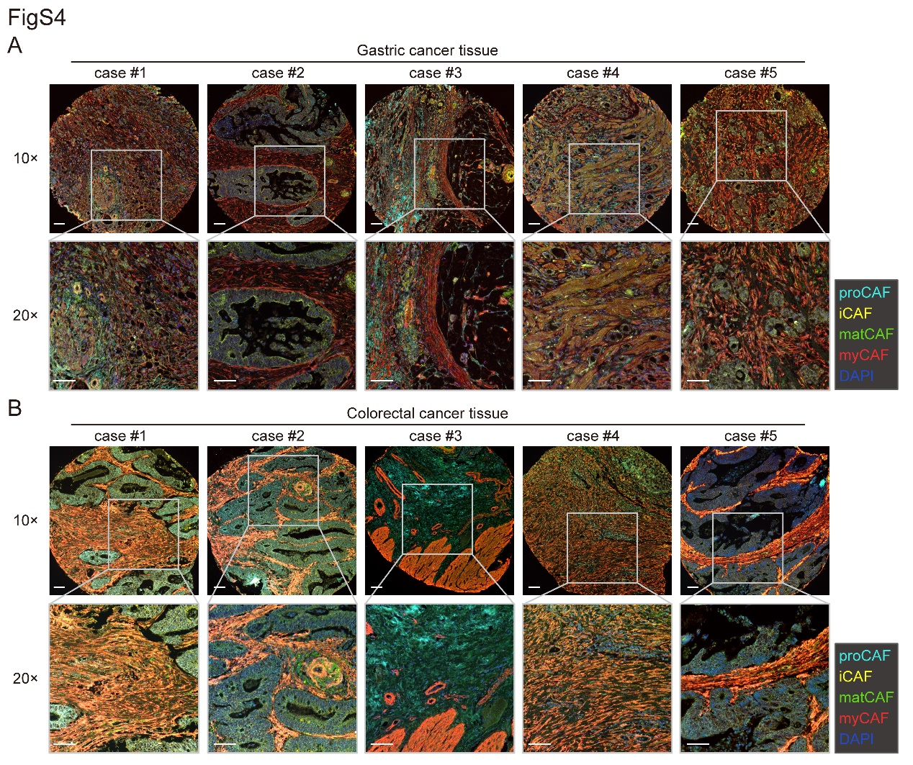
Fig. S4 Different CAF subtypes coexist independently in TME, related to the Figure 2. A. Multiplexed immunofluorescence (mIF) staining of COL10A1 (green), CCL2 (yellow), OGN (cyan) and α-SMA (red) and DAPI (blue) in lung cancer tissue (representative of n=5 patients). For each of the five cases, the upper panel was captured under 10× magnification, while the lower panel was captured under 20× magnification using the same tissue (the corresponding region in the 10× image is outlined by grey dotted lines). All scale bars are 200 μm. B. Representative images of the same mIF staining across the variety of colorectal cancer samples in the tissue microarrays. All scale bars are 200 μm.

Fig. S5 Multiple functional roles of CAF subtypes in single-cell distribution, related to the Figure 3. A. The left t-SNE plot shows the distribution of each CAF subtypes. Through the SCENIC analysis, the next four t-SNE plots based on the binary activity matrix of specific TFs were shown drak blue in different kinds of CAF subtypes, which reflects the varying CAF functions in BRCA. B. The SCENIC analysis was also performed using CAFs in LUAD, and consistent results were observed. C. The functional roles of CAF subtypes were confirmed using AUCell analysis in STAD. 4 gene sets, associated with stemness, immune responses, myofilament, and ECM formation, respectively, were selected to perform AUCell analysis on CAFs in STAD. Each cell was given an AUC score representing the relative expression of the signature genes and the strength of the related activities. Cells with high AUC scores matched with the corresponding CAF subtype population indicated in the leftmost UMAP plot. D. AUCell analysis with the same gene sets was also performed using CAFs in LUAD. The results are concordant with that of STAD.

Fig. S6 GO enrichment pathways in different CAF subtypes of BRCA and STAD, related to Figure 3. A. The DEG analysis was performed between proCAF and other CAF subtypes, and the genes with Fold Change (FC) > 1.5 and p-value < 0.05 were chosen for GO enrichment analysis. Results from BRCA and STAD were concordant with each other, showing that proCAF was involved in proliferation. B. The same GO enrichment analysis with the same criteria for FC and p-value, was also performed for other CAF subtypes in BRCA and STAD. Pathways related to immune responses were enriched in iCAF. C. Pathways related to contractile and muscle-related events were enriched in myCAF. D. Genes controlling ECM formation were enriched in matCAF.

Fig. S7 CAF subtypes participate in intercellular communication networks, related to Figure 5. A. Chord diagrams shows the intercellular communication networks from CAF scRNA-seq dataset of STAD. Heatmaps were also provided to reflect the communication probability, a measurement of relative signaling strength, of each cell-cell communication. The FGF pathway is primarily a communication channel among proCAF, NF and matCAF cells. B. The IGF signal is mainly derived from proCAF and is ultimately received by cancer cells. C. As immune signaling communication, the CCL pathway is chiefly derived from iCAF and proCAF. D. The ANGPT pathway is primarily derived from myCAF. E. Similarly, the PDGF pathway is the dominant communication network of myCAF and matCAF with other cells. F. The PERIOSTIN pathway is present in matCAF as an autocrine form of communication.

Fig. S8 CAF subtypes participate in intercellular communication networks (continued), related to Figure 5. A. Chord diagrams shows the intercellular communication networks from CAF scRNA-seq dataset of NEPC. Heatmaps were also provided to reflect the communication probability, a measurement of relative signaling strength, of each cell-cell communication. The FGF pathway is primarily a communication channel among proCAF, NF and matCAF cells. B. The IGF signal is mainly derived from proCAF and is ultimately received by cancer cells. C. As immune signaling communication, the CCL pathway is chiefly derived from iCAF and proCAF. D. The ANGPT pathway is primarily derived from myCAF. E. Similarly, the PDGF pathway is the dominant communication network of myCAF and matCAF with other cells. F. The PERIOSTIN pathway is present in matCAF as an autocrine form of communication.

Fig. S9 Diverse roles of CAF subtypes in clinical prognosis., related to Figure 6. Patients with different cancers in the TCGA cohort were divided into two groups according to the optimal cut-off, i.e., the group with higher expression levels of CAF biomarkers and the group with lower expression levels. Survival analysis between these two groups revealed that the clinical prognosis of biomarkers of CAF subtypes was heterogeneous across cancer types. Representative survival curves show the biomarker prognosis of proCAF (A), iCAF (B), myCAF (C) and matCAF (D), respectively.

Table S1. CAF biomarkers as druggable targets.
Biomarker | Drug | Disease | Reference
proCAF
IGF1 | Picropodophyllin | Osteosarcoma | [1]
OGN | Chrysophanol | Meningioma | [2]
C7 | Eculizumab* | Myasthenia gravis | [3]
matCAF
COL10A1 | Cyclopamine | Osteoarthritis | [4]
CTHRC1 | Cyclovirobuxine D | Colorectal cancer | [5]
POSTN | Anti-POSTN mAb | Breast cancer | [6]
myCAF
MYH11 | Blebbistatin | - | [7]
ACTA2 | Ferulic acid | Hepatocellular carcinoma | [8]
iCAF
CCL2 | 15a | Atherosclerosis | [9]
CXCL12 | Plerixafor | GI solid tumors | [10]
* via blocking its upstream C5
Table S2. Parameters of docking procedures.
Parameter | Value
Energy grid box | 40×40×40Å
Energy grid spacing | 0.375Å
number of individuals in population | 150
maximum number of energy evaluations | 2.5×10⁶
maximum number of generations | 2.7×10⁴
rate of gene mutation | 0.02

References:
1. Wu Q, Tian AL, Li B, Leduc M, Forveille S, Hamley P, Galloway W, Xie W, Liu P, Zhao L, et al: IGF1 receptor inhibition amplifies the effects of cancer drugs by autophagy and immune-dependent mechanisms. J Immunother Cancer 2021, 9.
2. Wang J, Lv P: Chrysophanol inhibits the osteoglycin/mTOR and activats NF2 signaling pathways to reduce viability and proliferation of malignant meningioma cells. Bioengineered 2021, 12:755-762.
3. Zelek WM, Morgan BP: Monoclonal Antibodies Capable of Inhibiting Complement Downstream of C5 in Multiple Species. Front Immunol 2020, 11:612402.
4. Salem O, Wang HT, Alaseem AM, Ciobanu O, Hadjab I, Gawri R, Antoniou J, Mwale F: Naproxen affects osteogenesis of human mesenchymal stem cells via regulation of Indian hedgehog signaling molecules. Arthritis Res Ther 2014, 16:R152.
5. Jiang F, Chen Y, Ren S, Li Z, Sun K, Xing Y, Zhu Y, Piao D: Cyclovirobuxine D inhibits colorectal cancer tumorigenesis via the CTHRC1AKT/ERKSnail signaling pathway. Int J Oncol 2020, 57:183-196.
6. Field S, Uyttenhove C, Stroobant V, Cheou P, Donckers D, Coutelier JP, Simpson PT, Cummings MC, Saunus JM, Reid LE, et al: Novel highly specific anti-periostin antibodies uncover the functional importance of the fascilin 1-1 domain and highlight preferential expression of periostin in aggressive breast cancer. Int J Cancer 2016, 138:1959-1970.
7. Sirigu S, Hartman JJ, Planelles-Herrero VJ, Ropars V, Clancy S, Wang X, Chuang G, Qian X, Lu PP, Barrett E, et al: Highly selective inhibition of myosin motors provides the basis of potential therapeutic application. Proc Natl Acad Sci U S A 2016, 113:E7448-E7455.
8. Mu M, Zuo S, Wu RM, Deng KS, Lu S, Zhu JJ, Zou GL, Yang J, Cheng ML, Zhao XK: Ferulic acid attenuates liver fibrosis and hepatic stellate cell activation via inhibition of TGF-beta/Smad signaling pathway [Corrigendum]. Drug Des Devel Ther 2019, 13:1819.
9. Bot I, Ortiz Zacarias NV, de Witte WE, de Vries H, van Santbrink PJ, van der Velden D, Kroner MJ, van der Berg DJ, Stamos D, de Lange EC, et al: A novel CCR2 antagonist inhibits atherogenesis in apoE deficient mice by achieving high receptor occupancy. Sci Rep 2017, 7:52.
10. Daniel SK, Seo YD, Pillarisetty VG: The CXCL12-CXCR4/CXCR7 axis as a mechanism of immune resistance in gastrointestinal malignancies. Semin Cancer Biol 2020, 65:176-188.

