Supporting Information
Biowaste derived sustainable carbon aerogels/polyvinylidene fluoride composites for effective removal of organic pollutants/oils
Lin Zhu* Wenjing Zheng Hongbo Xie Kan Zhang*
Research School of Polymer Materials, School of Materials Science & Engineering, Jiangsu University, 301 Xuefu Road, Zhenjiang 212013, P. R. China
Tel.: +86 511 88780191, fax: +86 511 88781947, E-mail: lzhu@ujs.edu.cn (Lin Zhu), zhangkan@ujs.edu.cn (Kan Zhang)
Materials and Methods
Adsorption experiment of PPCA/PVDF towards phenol
Batch mode adsorption experiments were conducted to investigate the adsorption of phenol on the PPCA/3%PVDF sample. The specific experimental process is as follows. A fixed amount of sample is added into a 100 ml conical flask containing 50ml phenol solution of certain concentration. The concentration of phenol after adsorption was determined by measuring the absorbance values using a Shimadzu UV-2550 spectrophotometer.
The influence of adsorption time (12~72 h) and initial phenol concentration (10~80 mg L-1) on the removal of phenol was investigated. The amount of phenol adsorbed at time t (Q_{t}) and the percentage of phenol removal (R) were calculated by the following formulas, respectively:
R(%) = (C₀-C_{t})/C₀×100 (S1)
Q_{t} = (C₀-C_{t})×V/m (S2)
where C₀ (mg L⁻¹) and C_{t} (mg L⁻¹) represent the phenol concentration initially and at time t, respectively. V (L) is the solution volume and m (g) is the adsorbent weight.
Adsorption kinetic models
Four kinetic models (Pseudo-first order model, Pseudo-second order model, Intraparticle diffusion model and Elovich kinetic model) were used to study the adsorption kinetics of phenol onto PPCA600/3%PVDF sample. These various models could be expressed as follows [1-3]:
Pseudo-first order model: log(q_{e}–q_{t}) = logq_{e}–(k₁/2.303)t (S3)
Pseudo-second order model: t/q_{t} = 1/(k₂q_{e}²) + t/q_{e} (S4)
Intraparticle diffusion model: q_{t} = k_{d}t^{1/2} + C (S5)
Elovich kinetic model: q_{t} = 1/β ln(αβ) + 1/βlnt (S6)
In these models, where q_{e} (mg g⁻¹) and q_{t} (mg g⁻¹) represented the mass of phenol adsorbed per unit mass of PPCA600/3%PVDF at adsorption equilibrium and time t, respectively. In Pseudo-first order model, k₁ (min⁻¹) represented the adsorption rate constant. In pseudo-second order model, k₂ (g mg⁻¹ min⁻¹) was the second-order reaction rate constant for adsorption kinetic. In the intraparticle diffusion model, C (mg g⁻¹) was the intercept for the q_{t} versus t^{1/2} plot and k_{d} was the intraparticle diffusion rate constant (mg g⁻¹ min^{-1/2}). In the Elovich kinetic model, α (mg g⁻¹ min⁻¹) was the initial sorption rate constant and the parameter β (g mg⁻¹) was related to rate of chemisorption. All of the kinetic constants and correlation coefficients could be calculated from the slope and intercept of the plots, respectively.
Adsorption equilibrium models
In this work, the Langmuir and Freundlich isotherms are used to investigate the adsorption process of phenol onto PPCA600/3%PVDF. First, the Langmuir isotherm can be expressed as follow [4],
C_{e}/q_{e} = C_{e}/q_{m} + 1/K_{L}q_{m} (S7)
where C_{e} (mg L⁻¹) represented the equilibrium concentration and q_{e} (mg g⁻¹) represented the amount of adsorbate adsorbed in the solution. q_{m} (mg g⁻¹) was the adsorption capacity of the monolayer on the surface of the unit adsorbent when the saturation of adsorption was reached. K_{L} (L mg⁻¹) was the adsorption equilibrium constant which was connected to the apparent energy of the adsorption process.
Second, the Freundlich isotherm can be expressed as follow [5],
lnq_{e} = lnK_{F} + 1/n lnC_{e} (S8)
where q_{e} (mg g⁻¹) is the amount of adsorption, K_{F} (mg g⁻¹) is the Freundlich constant related to adsorption capacity and 1/n is a constant related to energy or intensity of adsorption.

References
1. Doğan M, Özdemir Y, Alkan M (2007) Adsorption kinetics and mechanism of cationic methyl violet and methylene blue dyes onto sepiolite. Dyes Pigments, 75(3): 701-713.
2. Asfaram A, Fathi MR, Khodadoust S, Naraki M (2014) Removal of Direct Red 12B by garlic peel as a cheap adsorbent: kinetics, thermodynamic and equilibrium isotherms study of removal. Spectrochim Acta A 127: 415-421.
3. Ho YS (2006) Review of second-order models for adsorption systems. J Hazard Mater 136: 681-689.
4. Kumar KV, Sivanesan S (2006) Equilibrium data, isotherm parameters and process design for partial and complete isotherm of methylene blue onto activated carbon. J Hazard Mater 134(1): 237-244.
5. Febrianto J, Kosasih AN, Sunarso J, et al. (2009) Equilibrium and kinetic studies in adsorption of heavy metals using biosorbent: A summary of recent studies. J Hazard Mater 162: 616-645.
6. Malik PK (2004) Dye removal from wastewater using activated carbon developed from sawdust: adsorption equilibrium and kinetics. J Hazard Mater 113: 81-88.

Figures
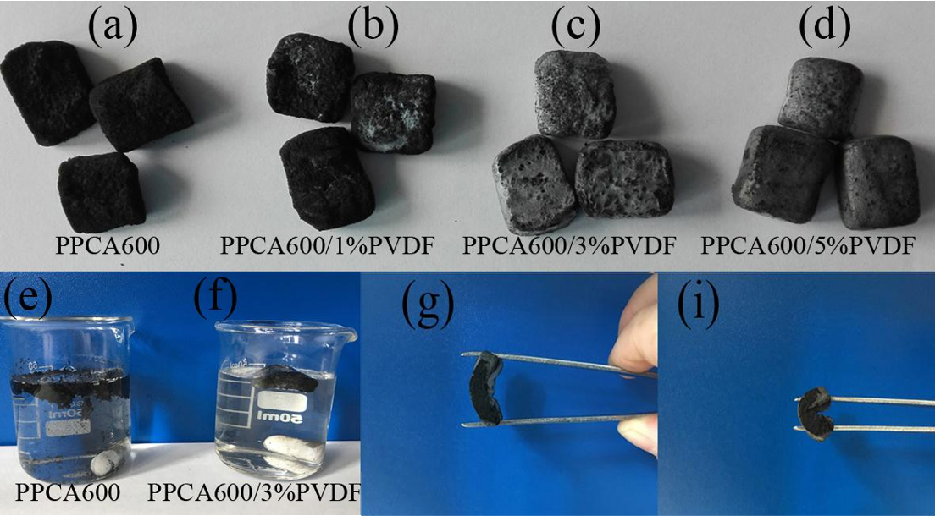
Fig. S1. Photographs of PPCA600 (a) and PPCA600/PVDF composites with different content of PVDF (b-d), and the images show the mechanical properties of them (e-i).

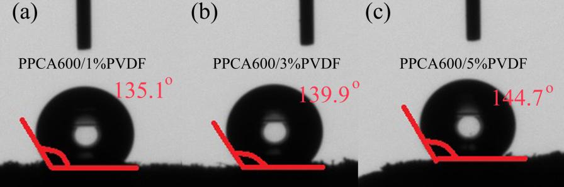
Fig. S2. The water contact angle images of different PPCA600/PVDF composites.

