Supplementary Fig. 1 Experimental protocol and interventions.
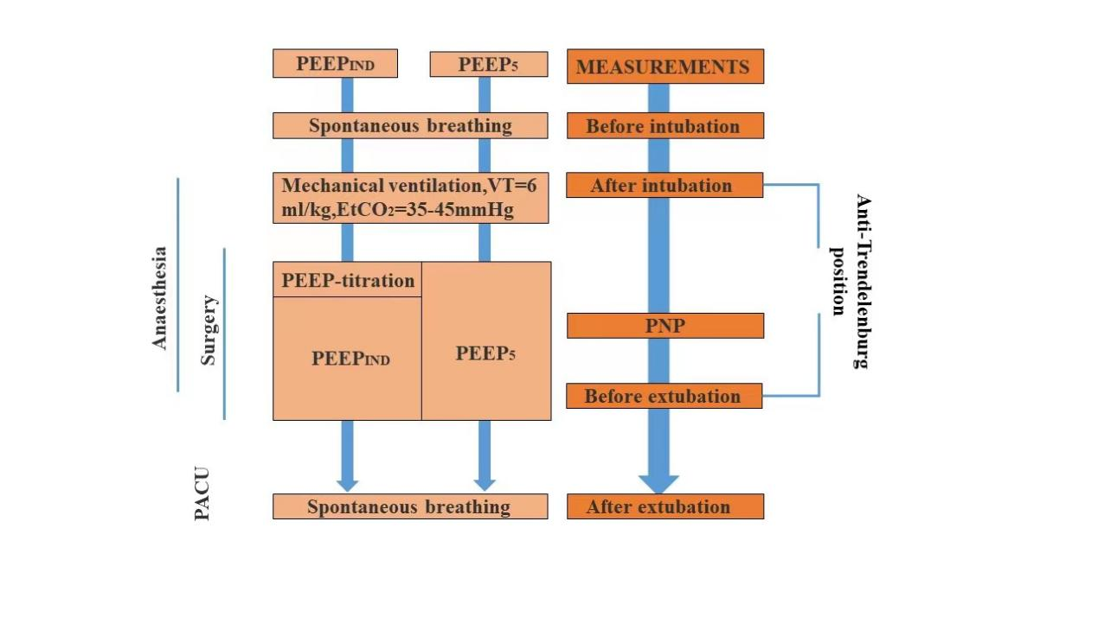
PACU, post-anaesthesia care unit; PEEP_{IND}, individualized PEEP setting guided by electrical impedance tomography; PEEP₅, standard PEEP setting of 5 cmH₂O; PNP, pneumoperitoneum.

