Supplementary Information

Spontaneous Formation of MXene-Oxidized Sono/Chemo-Dynamic Sonosensitizer/Nanocatalyst for Antibacteria and Bone-Tissue Regeneration

Yang Yu^{1,2,3†}, Houyi Sun^{1†}, Qunshan Lu¹, Junyuan Sun^{1,3}, Pengfei Zhang^{1,3}, Linran Zeng⁴, Krasimir Vasilev⁵, Yunpeng Zhao^{1*}, Yu Chen^{2*}, Peilai Liu^{1*}

¹Department of Orthopaedics, Qilu Hospital of Shandong University, Jinan 250012, P. R. China
²Materdicine Lab, School of Life Sciences, Shanghai University, Shanghai 200444, P. R. China
³Laboratory of Basic Medical Sciences, Qilu Hospital of Shandong University, Jinan 250012, P. R. China.
⁴The 1st Affiliated Hospital of Kunming Medical University, Kunming Yunnan 650032, P. R. China
⁵ College of Medicine and Public Health, Flinders University, Sturt Road, Bedford Park South Australia, 5042, Australia

† These authors contribute equally.
*Corresponding authors
Yunpeng Zhao, Yu Chen, Peilai Liu, Emails: lwwzyp@email.sdu.edu.cn (Prof. Y. Zhao); 199362000205@email.sdu.edu.cn (Prof. P. Liu); chenyuedu@shu.edu.cn (Prof. Y. Chen)

Authors’ emails
Yang Yu, gkyy1998@mail.sdu.edu.cn
Houyi Sun, 15051514605@163.com
Qunshan Lu, luqunshan1112@163.com
Junyuan Sun, 17621778576@163.com
Pengfei Zhang, pengfeizhang@mail.sdu.edu.cn
Linran Zeng, 147794316@qq.com
Krasimir Vasilev, krasimir.vasilev@flinders.edu.au
Yunpeng Zhao, lwwzyp@email.sdu.edu.cn
Yu Chen, chenyuedu@shu.edu.cn
Peilai Liu, 199362000205@email.sdu.edu.cn

Supplementary figures
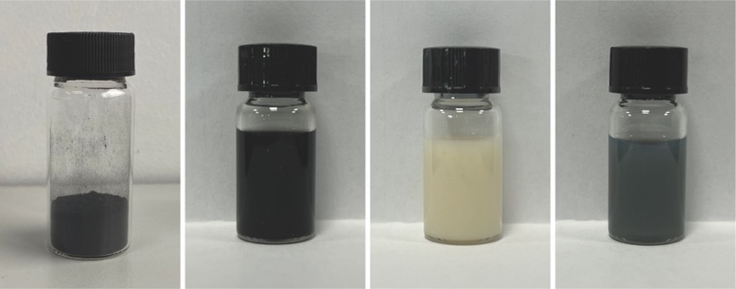
Supplementary Figure 1. Digital photographs of Ti₃AlC₂, Ti₃C₂ MXene, CaO₂-PVP and CaO₂-TiO_{x}@Ti₃C₂ (C-T@Ti₃C₂).

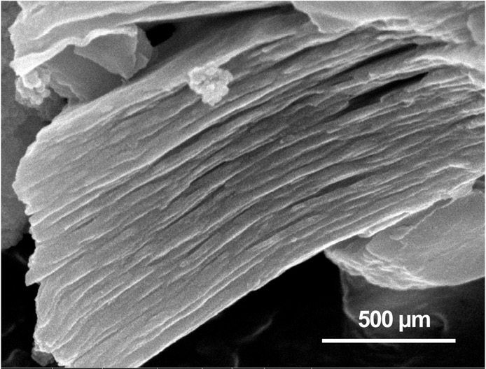
Supplementary Figure 2. SEM image of multilayered Ti₃C₂ MXene.

Supplementary Figure 3. TEM, dark-field STEM images and corresponding element mappings (for Ti, C, Ca and O) of C-T@Ti₃C₂ nanosheets.

Supplementary Figure 4. DLS analysis of CaO₂-PVP in water.

Supplementary Figure 5. DLS analysis for Ti₃C₂ MXene in water and saline.

Supplementary Figure 6. UV‒vis absorption spectra of time-dependent DPBF degradation under US treatment.

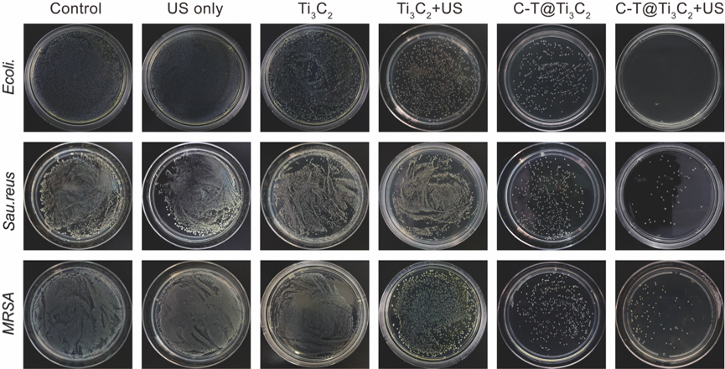
Supplementary Figure 7. Digital photos of spread plates containing E. coli, S. aureus, and MRSA with various treatments.

Supplementary Figure 8. Fluorescence microscopy images of MRSA stained with DCFH-DA after various treatments for ROS detection (I: Control group, II: US only group, III: Ti₃C₂ MXene group, IV: Ti₃C₂ MXene + US group, V: C-T@Ti₃C₂ group, VI: C-T@Ti₃C₂ + US group).
Supplementary Figure 9. Haematological index of C57BL/6JNifdc mice intravenously administered C-T@Ti₃C₂ nanonetwork dispersion for 14 d (n = 3). Data are presented as the mean $\text{±}$ SD. Routine blood parameters included red blood cells (RBCs), mean corpuscular haemoglobin (MCH), haemoglobin (HGB), mean corpuscular haemoglobin concentration (MCHC), mean corpuscular volume (MCV), mean platelet volume (MPV), number of neutrophils (GRAN), red cell distribution width (RDW), number of lymphocytes (LYMPH), haematocrit (HCT) and platelets (PLT). Biochemistry parameters included alanine transaminase (ALT), aspartate transaminase (AST), alkaline phosphatase (ALP), urea nitrogen (BUN), and creatinine (CREA).
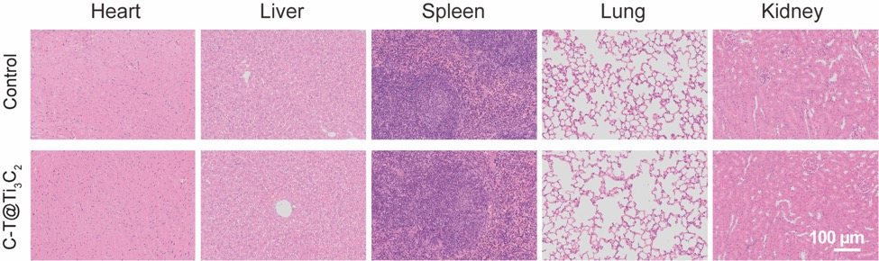
Supplementary Figure 10. Histological assessments of the major organs (heart, liver, spleen, lung and kidney) of C57BL/6JNifdc mice after intravenous injections with C-T@Ti₃C₂ nanonetworks for 14 d.

Supplementary Figure 11. Histological assessments of the major organs (heart, liver, spleen, lung and kidney) of C57BL/6JNifdc mice after different treatments in the MRSA-infected wound model.

Supplementary Figure 12. Micro-CT images of femurs in different groups after 2 weeks of treatment.

Supplementary Figure 13. Corresponding quantitative analysis showing BV/TV, Tb. Th and Tb.N. (n=3) in different groups after surgery for 2 weeks. Data are presented as the mean $\text{±}$ SD. Statistical significance was calculated with a two-tailed t test, *P≤ 0.05, **P ≤ 0.01, ***P ≤ 0.001.

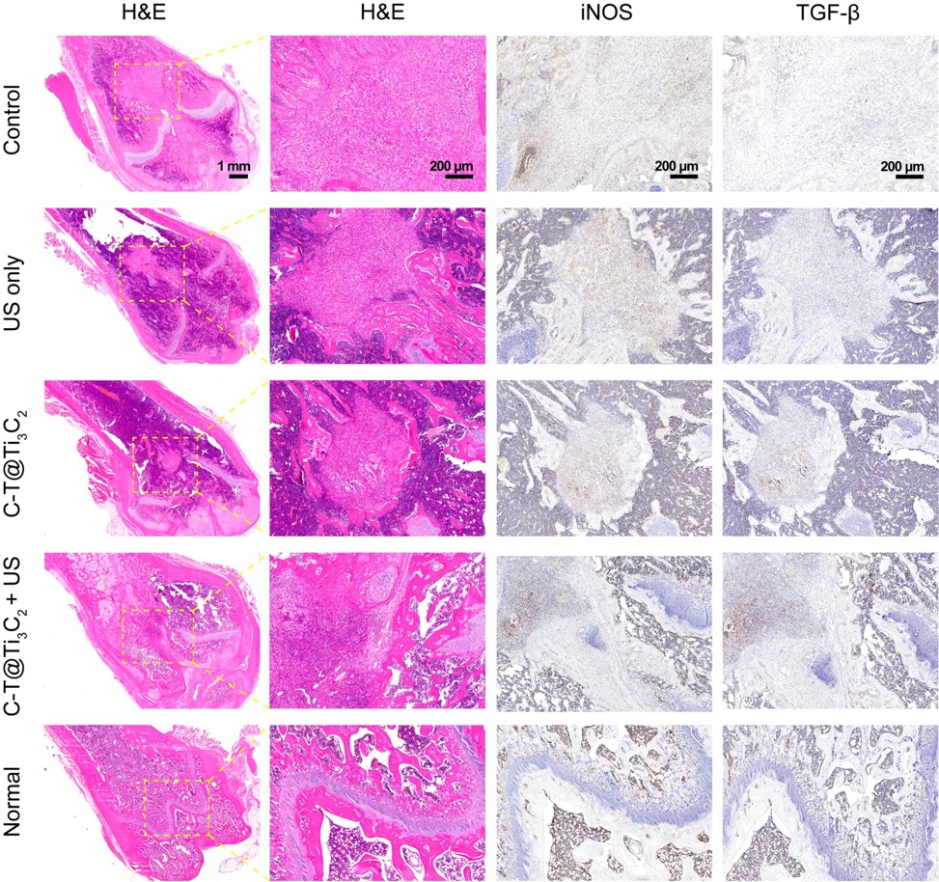
Supplementary Figure 14. Histological assessments (H&E staining, iNOS and TGF-β immunohistochemical staining) of bone tissue in different groups after 2 weeks of treatment.

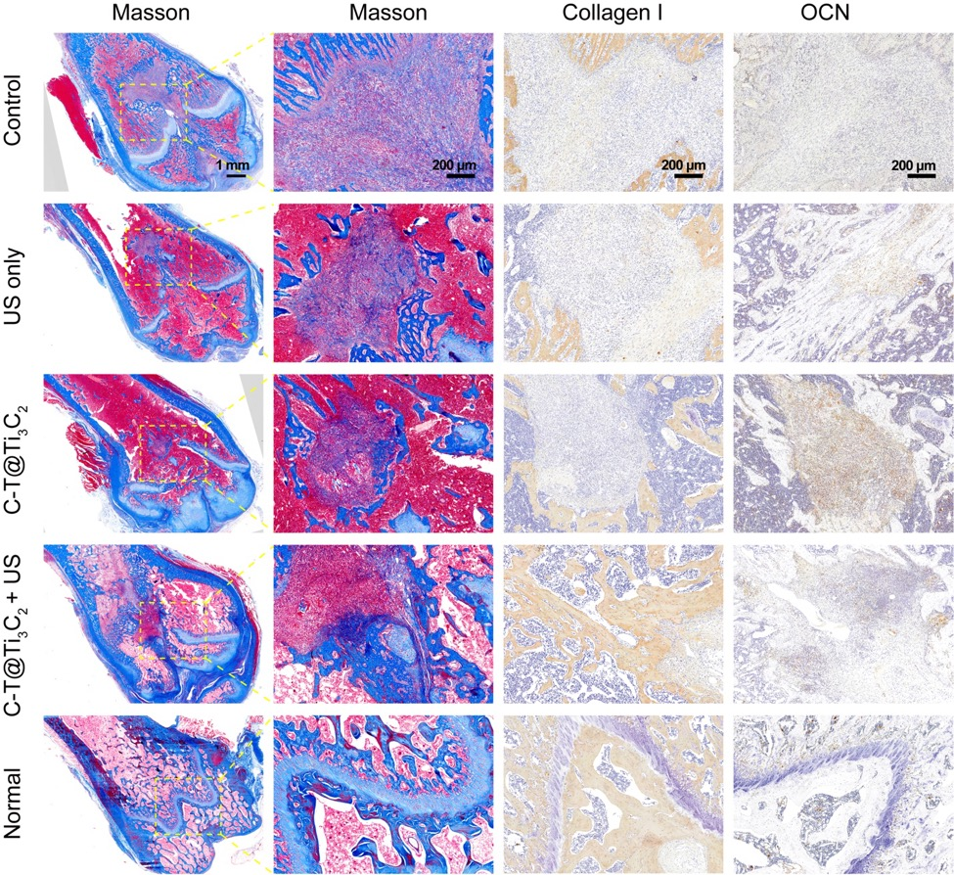
Supplementary Figure 15. Histological assessments (Masson staining, collagen I and OCN immunohistochemical staining) of the bone tissue in different groups after 2 weeks of treatment.

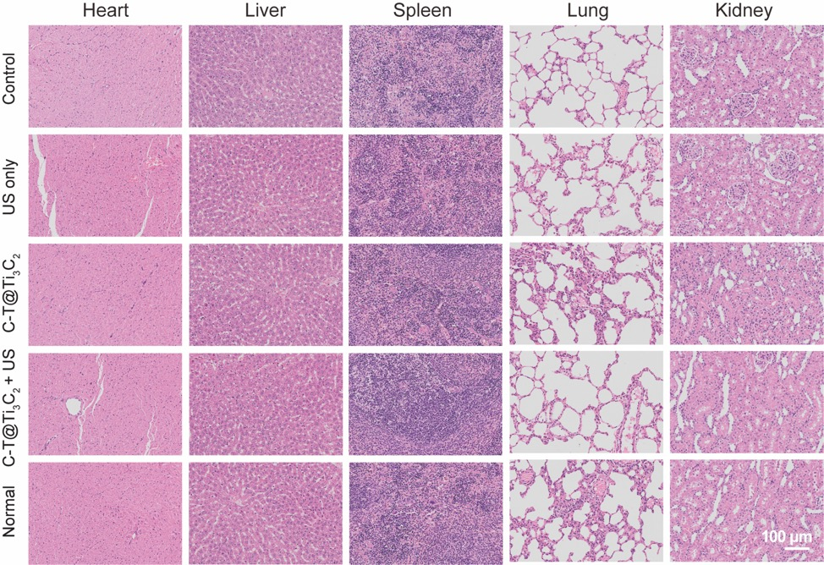
Supplementary Figure 16. Histological assessments of the major organs (heart, liver, spleen, lung and kidney) of SD rats from the bone defect model with MRSA infection at 2 weeks.

Supplementary Figure 17. Histological assessments of the major organs (heart, liver, spleen, lung and kidney) of SD rats from the bone defect model with MRSA infection at 4 weeks.

