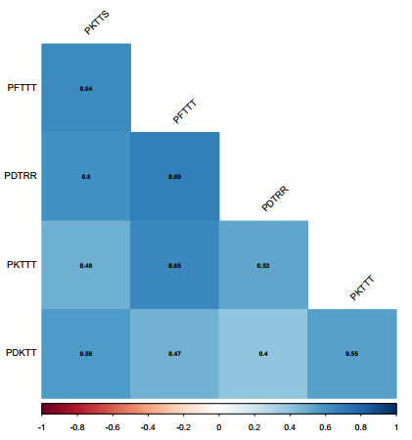
Value of correlation

Fig 1S. Correlation heatmap and Pearson’s correlation coefficients among leaf rust races (PKTTS, PFTTT, PDTRR, and PKTTT)

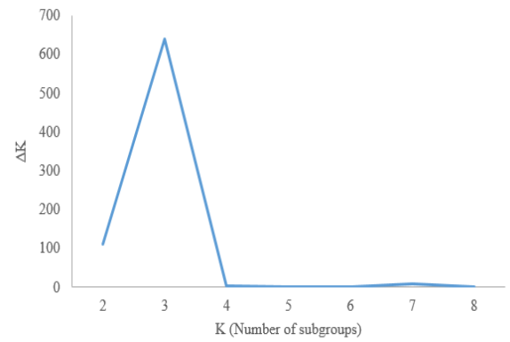
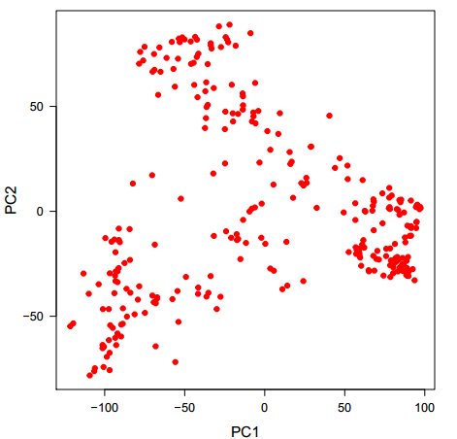
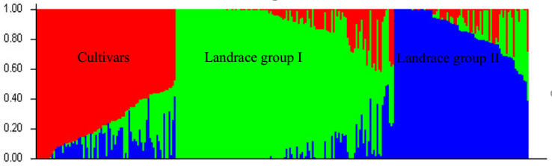
a
b
c

Proportion of inferred ancestry (Q)

Fig 2S. The number of wheat subpopulations based on ΔK values (a); Principal component analysis of 286 wheat genotypes and landraces (b); Structure plot of wheat accessions determined by K=3 (c).

