Supplementary Information
Starch Quality Matrix (SQM): An Analytical Model for Predicting Resistant Starch (RS) in Rice (Oryza sativa.L)
Sohel Rahaman^{Ψ1}. Deepanyeta Goswami¹. Sanjeev Kumar¹. Haritha Bollinedi². AnjaliAnand³. Sukanta Dash⁴. Mahesh Rao⁵. Archana Singh¹, A.K Singh² and Veda Krishnan ^{1Ψ*}
¹Division of Biochemistry, ICAR- Indian Agricultural Research Institute, New Delhi, India
²Division of Genetics, ICAR- Indian Agricultural Research Institute, New Delhi, India
³Division of Plant Physiology, ICAR- Indian Agricultural Research Institute, New Delhi, India
⁴Division of Design of experiments, ICAR- Indian Agricultural Statistics Research Institute, New Delhi, India
⁵National Institute of Plant Biotechnology (NIPB), New Delhi, India

*e-mail of corresponding authors: vedakrishnan@iari.res.in; vedabiochem@gmail.com
Ψ – Equal contributions

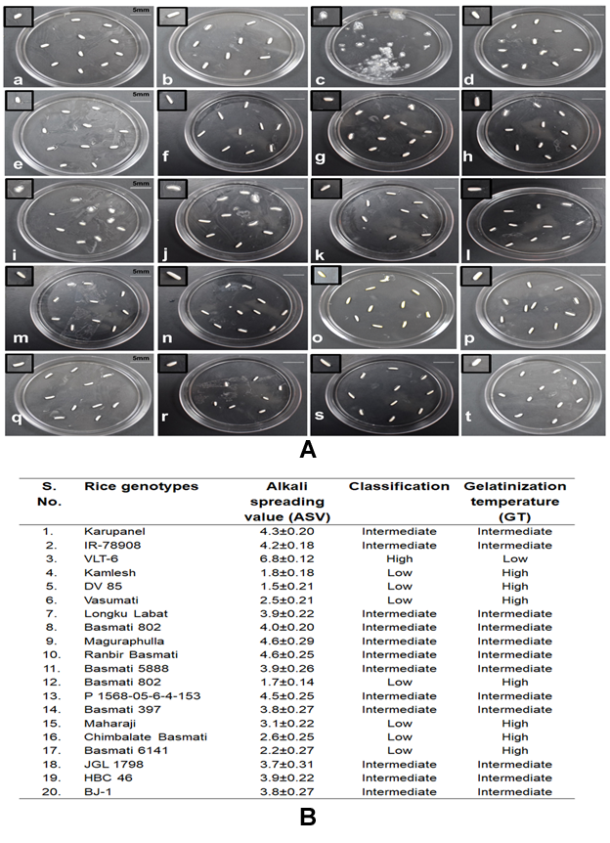
Supplementary Fig. 1. Alkali spreading value (ASV) analysis and indirect analysis of gelatinization temperature (GT) of the selected rice genotypes. (A) Different milled rice genotypes tested for ASV as whole rice grains after 23 h treatment with 1.8% KOH. a. Karupanel b. IR-78908 c.VLT-6 d. Kamlesh e. DV-85 f. Vasumati g. Longku labat h. Basmati 802(CANP377) i. Maguraphulla j. Ranbir basmati k. Basmati 5888 l. Basmati 802(ANP377) m. P1568-05-6-4-153 n. Basmati 397 o. Maharaji p. Chimbalate basmati q. Basmati 6141 r. JGL 1798 s. HBC 46 t. BJ-1.

Supplementary Fig. 2. Development and validation of the multiple regression model developed to predict the inherent glycaemic potential in terms of resistant starch (RS) content in rice (A) Analysis of variance (ANOVA) test for significant explanatory variables (TAC and TSC) (B) The distribution of residuals for the log-linear regression model. The normal (N) density estimate of residual in multiple linear regression analysis is depicted in solid line while kernel (K) density in dotted lines (C) Scatterplot of residuals associated with TAC variable tested (D) Scatterplot of residuals associated with TS variable tested (E) Predicted value of RS% using the linear regression model. (F) Observed values of RS% after analysis. [TAC-Total amylose content; TSC-Total starch content]
Supplementary Fig. 3. A regression model developed using the SAS System (‘Local’, X64_7PRO) based on SQM 1 to predict the % content of RS in the rice genotypes under study. Total RS% is the sum of predicted RS% plus residual RS%. Here only the values of apparent amylose content and total starch were considered to derive the equation.

