Supplementary material for

Unprecedented 2022 Yangtze River Valley heatwaves linked to the record-breaking Pakistan flood and triple-dip La Niña
Shankai Tang^{1,5}, Shaobo Qiao^{2,3*}, Bin Wang⁴, Fei Liu^{2,3}, Taichen Feng^{2,3}, Jie Yang ^{2,3}, Meng He^{2,3}, Dong Chen^{2,3}, Jianbo Cheng⁶, Guolin Feng^{1,3,5,7*} and Wenjie Dong^{2,3}

- College of Physical Science and Technology, Yangzhou University, Yangzhou, China
- School of Atmospheric Sciences, and Key Laboratory of Tropical Atmosphere-Ocean System, Ministry of Education, Sun Yat-sen University, Zhuhai, China
- Southern Marine Science and Engineering Guangdong Laboratory (Zhuhai), Zhuhai, China
- Department of Atmospheric Sciences and International Pacific Research Center, University of Hawaii at Manoa, Honolulu, USA
- College of Atmospheric Sciences, Lanzhou University, Lanzhou, China
- School of Environmental Science and Engineering, Yancheng Institute of Technology, Yancheng, China
- Laboratory for Climate Studies, National Climate Center, China Meteorological Administration, Beijing, China

*Corresponding author (qiaoshb3@mail.sysu.edu.cn & fenggl@cma.gov.cn)
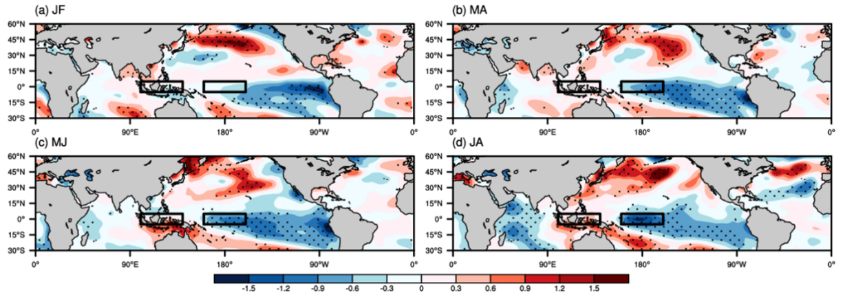
Supplementary Fig. 1: Seasonal evolution of SST anomalies in 2022
(a)–(d) Bi-monthly SST anomalies in January-February (JF), March-April (MA), May-June (MJ) and July-August (JA). Stippling represents the shading values exceeding one standard deviation. The black rectangles indicate the two regions that are used to define the SST zonal gradient in the equatorial western Pacific.
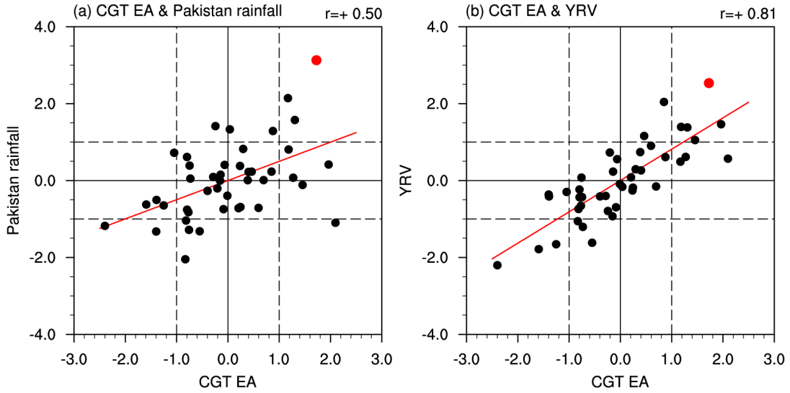
Supplementary Fig. 2: Linkages of the CGT action center in East Asia (CGT EA) to the Pakistan rainfall and Yangtze River valley (YRV) surface air temperature (SAT)
(a) Scatter plot between the normalized values of 200-hPa geopotential height anomalies averaged over the CGT EA and Pakistan rainfall during the 1979–2022 period. Red dot represents the year of 2022. (b) same as (a), but for the CGT EA and YRV SAT.
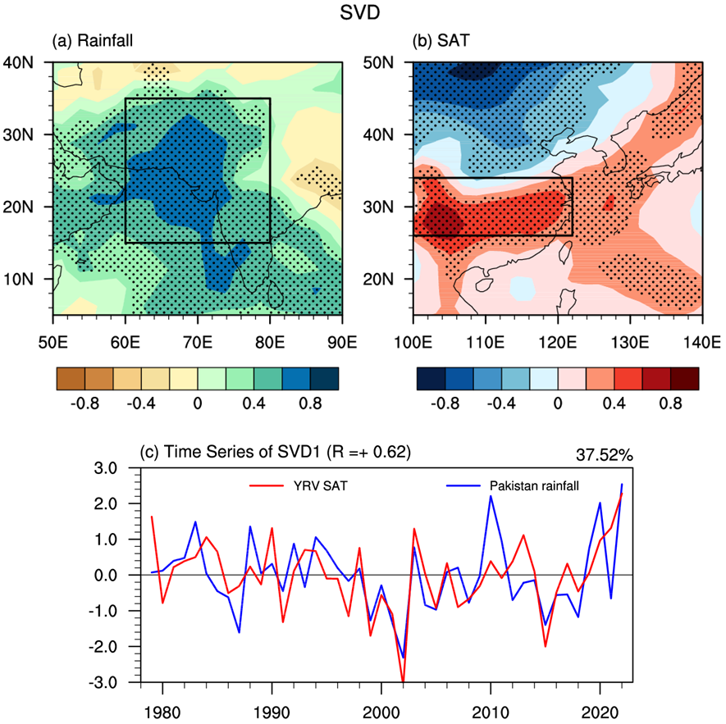
Supplementary Fig. 3: The leading heterogeneous singular value decomposition (SVD) mode between the India Peninsula rainfall anomalies and East Asia SAT anomalies
(a) The India Peninsula (5°N–40°N, 50°E–90°E) rainfall, (b) the East Asia (15°N–50°N, 100°E–140°E) SAT, and (c) their normalized time series during the 1979–2022 period.
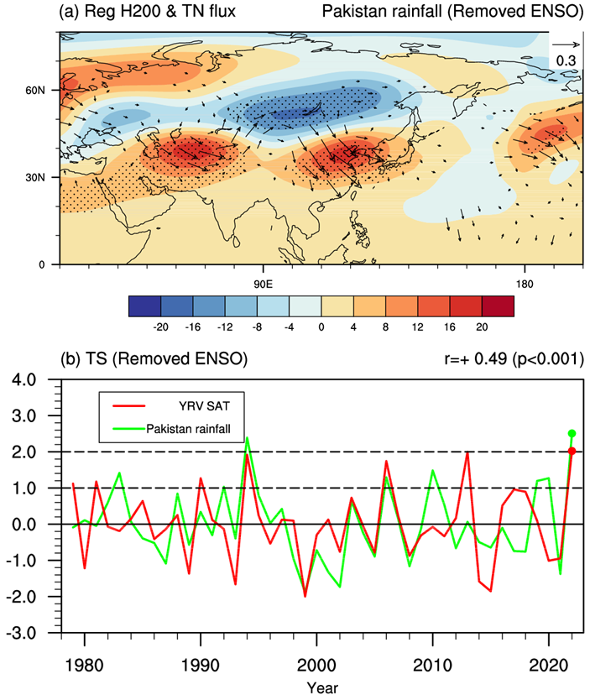
Supplementary Fig. 4: The linkage between the YRV SAT and Pakistan rainfall after removing ENSO effect
(a), (b) The same as (b), (c) in Fig. 3, but the ENSO effect on the YRV SAT and Pakistan rainfall are removed.
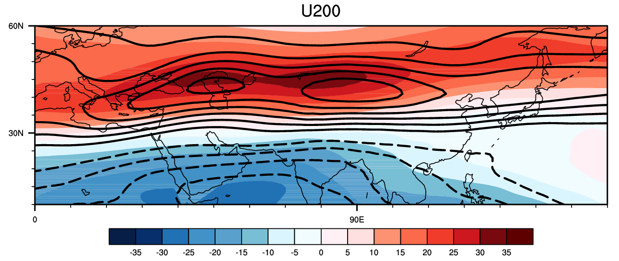
Supplementary Fig. 5: Comparison of the climatological-mean westerly jet in observations and model simulations
The midsummer climatological-mean 200-hPa zonal winds in the 1979–2021 observation (black contours; Solid line is positive and dashed line is negative with an interval of 5 m s⁻¹) and 20-year CTL run (shading; m s⁻¹).
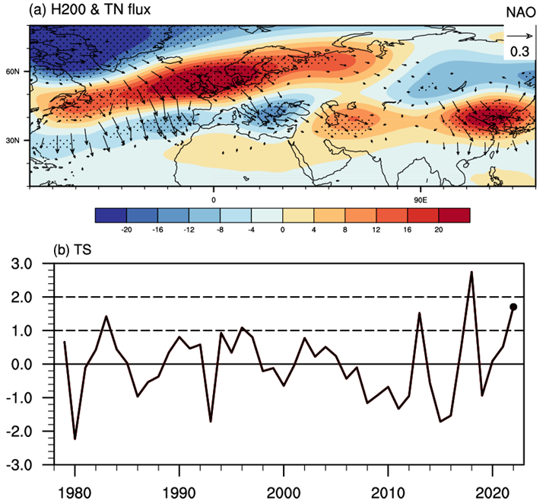
Supplementary Fig. 6: The effect of the midsummer North Atlantic Oscillation (NAO) on Rossby wave trains and associated energy propagation
(a) Regressed midsummer 200-hPa geopotential height anomalies (shading; gpm) and associated horizontal wave activity flux (vector; m² s⁻²) onto the NAO indices during the 1979–2022 period. Stippling represents the shading values exceeding the 95% confidence level. (b) Time series of the normalized values of the midsummer NAO indices.
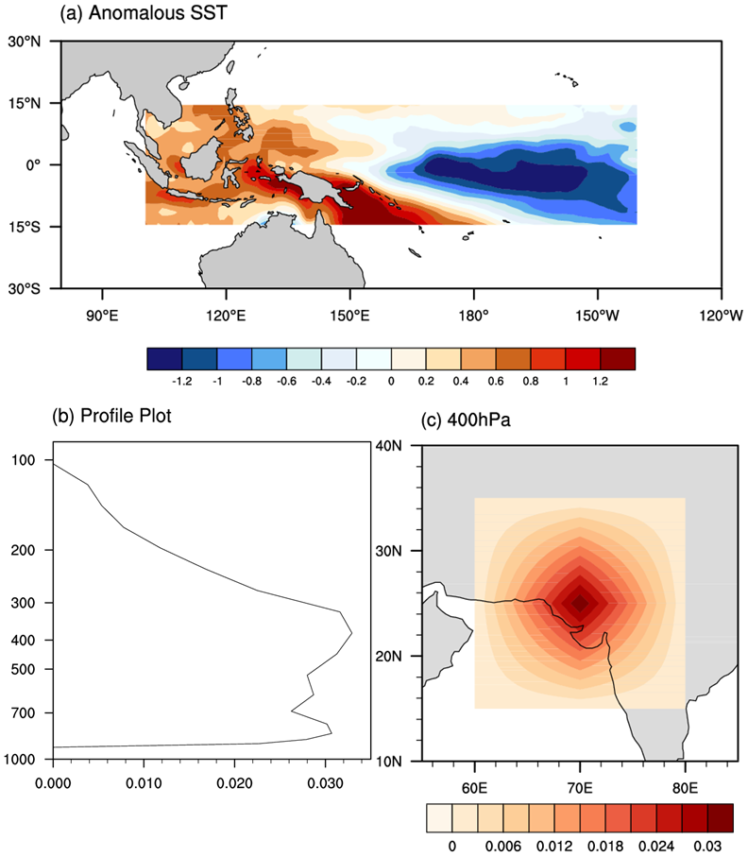
Supplementary Fig. 7: The added forcings in numerical experiments
(a) The added anomalous SST (shading; K) field in the tropical western Pacific (15°S–15°N, 100°E–140°W) for EXP_SST run. (b) The added anomalous diabatic heating rate (J kg⁻¹ s⁻¹) profile at the center for EXP_Q run. (c) The spatial pattern of the added anomalous diabatic heating rate (shading; J kg⁻¹ s⁻¹) at 400 hPa that shown for example.

