Supporting Material
Fe-modified fly ash/cotton stalk biochar composites for efficient removal of phosphate in water: mechanisms and green-reuse potential
Mengqi Hao ª, Wei Wu ^{a,} ^{b, *}, Nuzahat Habibul ^{a, b}, Guang Chai ª, Xiaoli Ma ^{a, b}, Xiaoqian Ma ª
ª College of Chemistry and chemical Engineering, Xinjiang Normal University, Urumqi, 830054, China
^{b} Xinjiang Key Laboratory of Energy Storage and Photoelectrocatalytic Materials, Xinjiang Normal University, Urumqi 830054, China
* Corresponding author E-mail: wuwei0523@sina.cn

This file contains 14 pages, including Text S1-S3, Figure S1-S6, and Table S1-S3.

Summary
Text S1 Optimization of pyrolysis temperature and FA content
Text S2 Characterization of materials
Text S3 Leaching of iron ions
Fig. S1 Effects of (a) biochar pyrolysis temperature and (b) fly ash content in FBC adsorbent on phosphate adsorption (Initial phosphate concentration: 25 mg/L, pH: 7, adsorbent dosage: 2 g/L, contact time: 720 min)
Fig. S2 SEM images of the samples. (a) BC, (b) FA, (c) FBC, (d) Fe-FBC
Fig. S3 Leaching of ferrous and ferric ions from Fe-FBC
Fig. S4 Phosphate adsorption capacity of BC, FBC, Fe-FBC, Fe-BC and Fe-FA (Initial phosphate concentration: 25 mg/L, pH: 7, adsorbent dosage: 2 g/L, contact time: 720 min)
Fig. S5 The effect of competing anions on (a) phosphate adsorption by BC, FBC and Fe-FBC and (b) pH of phosphate solution
Fig. S6 (a) XRD patterns and (b) FTIR spectra of BC-P, FBC-P and Fe-FBC-P
Table S1 BET analysis of BC, FBC and Fe-FBC
Table S2 Fitting data of adsorption kinetics
Table S3 Fitting data of adsorption isotherm

Note: cotton stalk biochar (BC), fly ash/cotton stalk biochar (FBC), Fe-modified fly ash/cotton stalk biochar (Fe-FBC), respectively.
Text S1 Optimization of pyrolysis temperature and FA content
To remove impurities, the cotton stalk was rinsed three times with water and soaked in distilled water for 1 h, then dried in an oven at 95ºC for 10 h. The clean cotton stalk was crushed by mill (800 A, Rongshida, China) and passed through a 20-mesh sieve. The powder was then pyrolyzed using a tube furnace under the N₂ atmosphere at 400ºC-800ºC for 2 h. The heating rate was 10ºC·min⁻¹ for a constant ramping rate. The samples were washed with distilled water more than three times and subsequently dried in an oven at 95ºC for 10 h before passing through an 80-mesh sieve. The samples are represented by BC400, BC500, BC600, BC700 and BC800 respectively.
The raw material and FA (different mass ratios: 9:1, 8:2, 7:3, and 6:4) were added into 60 mL distilled water and mixed for 8 h. The mixtures were then pyrolyzed using a tube furnace under the N₂ atmosphere at 800ºC for 2 h. The resulting FA/cotton stalk biochar composites were 10%FBC800, 20%FBC800, 30%FBC800 and 40%FBC800, respectively.
In order to optimize the pyrolysis temperature and the amount of FA, the adsorption performance of the adsorbent was tested, and the results are shown in Fig. S1. The phosphate adsorption capacity of biochar increased with the pyrolysis temperature increasing, and reached the highest value at 800℃ (Fig. S1(a)). Fig. S1(b) shows that the composite has the best adsorption effect when the FA content is 10%. Therefore, the preparation temperature of biochar was determined to be 800℃ and the amount of FA was 10%.

Text S2 Characterization of materials
The contents of C, H, N and S in the samples were determined using an elemental analyzer (Elementar Unicube, Germany). The content of O in the samples was calculated by the difference subtraction method. The leaching concentration of Fe from the Fe-FBC was determined by inductively coupled plasma optical emission spectrometer (ICP-OES) (Agilent 720ES, USA). The specific surface area (SSA) was calculated by Brunauer-Emmett-Teller (BET) method. The pore volume (PV) and pore diameter (PD) were calculated by Barret-Joyner-Halenda (BJH) method by N₂ vapor adsorption-desorption at 77 K on a surface area and porosity analyzer (Micromeritics ASAP 2460, USA). The morphology and microstructure of samples were observed by Scanning electron microscopy (SEM) (TESCAN MIRA LMS, Czech Republic). The crystal structure of samples was determined by X-ray diffractometer (XRD, Rigaku Smartlab SE, Japan) with a scan rate of 5◦/min in the scanning range of 10-90°. FTIR spectra (Bruker, Billerica, USA) was used to determine functional groups in the range of 400~4000cm-1. The zeta potentials of materials at different pH values were analyzed by using zeta potential analyzer (Malvern, Zetasizer Nano ZS90, UK). X-ray photoelectron spectroscopy (XPS) (Thermo Scientific K-Alpha, USA) was used to determine the surface elemental composition and electronic state of materials, equipped with Al Kαradiation as the X-ray source (1486.6 eV, 15 kV, 10 mA). All spectra were calibrated to the C 1s peak (binding energy at 284.8 eV) for the adventitious carbon. The absorbance of residual phosphate in water was measured by UV spectrophotometer (TU-1901 Purkinje General Instrument, China), and the specific detection method was shown below.

Text S3 Leaching of iron ions.
To check the stability of Fe-FBC, this sample was added to distilled water and shaken at 180 rpm. The iron ion content at different time intervals (0 to 720 min) in solution was analyzed. The concentrations of ferrous and total irons were measured by the 1, 10-phenanthroline method [1], and the concentration of ferric iron was calculated by the difference subtraction method.

Fig. S1 Effects of (a) biochar pyrolysis temperature and (b) fly ash content in FBC adsorbent on phosphate adsorption (Initial phosphate concentration: 25 mg/L, pH: 7, adsorbent dosage: 2 g/L, contact time: 720 min)
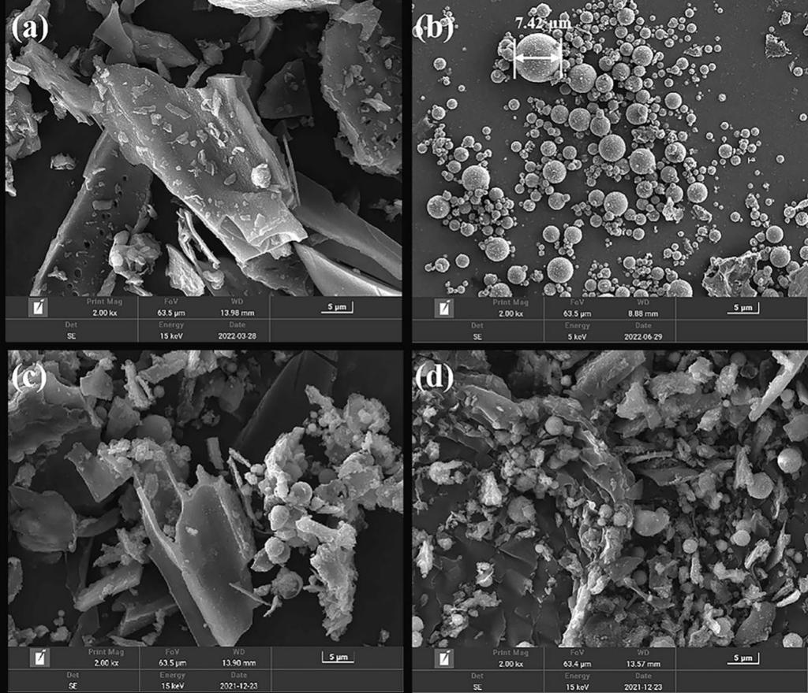
Fig. S2 SEM images of the samples. (a) BC, (b) FA, (c) FBC, (d) Fe-FBC

Fig. S3 Leaching of ferrous and ferric ions from Fe-FBC

Fig. S4 Phosphate adsorption capacity of BC, FBC, Fe-FBC, Fe-BC and Fe-FA (Initial phosphate concentration: 25 mg/L, pH: 7, adsorbent dosage: 2 g/L, contact time: 720 min)

Fig. S5 The effect of competing anions on (a) phosphate adsorption by BC, FBC and Fe-FBC and (b) pH of phosphate solution

Fig. S6 (a) XRD patterns and (b) FTIR spectra of BC-P, FBC-P and Fe-FBC-P

Table S1 BET analysis of BC, FBC and Fe-FBC
Material | BET Surface Area  (m²/g) | Pore Volume  (cm³/g) | Average Pore Diameter (nm)
BC | 88.27 | 0.059 | 10.31
FBC | 120.17 | 0.070 | 5.42
Fe-FBC | 212.98 | 0.151 | 7.84
BET: Brunauer-Emmett-Teller

Table S2 Fitting data of adsorption kinetics
Material | Pseudo-first-order model |  |  | Pseudo-second-order model |  |  | Intra-particle-diffusion model
Material | q_{e} | K₁ | R² | q_{e} | K₂ | R² | C₁ | C₂ | K_{p1} | K_{p2} | R₁² | R₂²
BC | 1.143 | 4.697 | 0.981 | 1.159 | 6.639 | 0.999 | 0.149 | 1.063 | 1.804 | 0.030 | 0.895 | 0.363
FBC | 1.710 | 1.190 | 0.846 | 1.455 | 12.45 | 0.999 | 0.420 | 1.248 | 1.582 | 0.083 | 0.986 | 0.638
Fe-FBC | 1.538 | 0.574 | 0.894 | 4.585 | 3.150 | 1 | 3.389 | 4.701 | 1.963 | 0.374 | 0.740 | 0.875
Note: cotton stalk biochar (BC), fly ash/cotton stalk biochar (FBC), Fe-modified fly ash/cotton stalk biochar (Fe-FBC), respectively.
.

Table S3 Fitting data of adsorption isotherm
Material | Langmuir |  |  | Freundlich |  |  | Sips
Material | q_{m}  (mg/g) | K_{L}  (L/mg) | R² | 1/n | K_{F}  (mg/g) | R² | q_{m}  (mg/g) | r | R²
BC | 3.80 | 0.016 | 0.959 | 0.493 | 0.199 | 0.991 | 6.60 | 0.569 | 0.992
FBC | 7.63 | 0.016 | 0.977 | 0.486 | 0.378 | 0.979 | 12.15 | 0.678 | 0.985
Fe-FBC | 26.32 | 0.014 | 0.986 | 0.365 | 2.672 | 0.995 | 47.91 | 0.514 | 0.999
Note: cotton stalk biochar (BC), fly ash/cotton stalk biochar (FBC), Fe-modified fly ash/cotton stalk biochar (Fe-FBC), respectively.
Reference
[1] Y. Liu, Z. Jiang, J. Fu, W. Ao, A. Siyal, C. Zhou, C. Liu, J. Dai, M. Yu, Y. Zhang, Iron-biochar production from oily sludge pyrolysis and its application for organic dyes removal, Chemosphere 301 (2022) 134803.https://doi.org/10.1016/j.chemosphere.2022.134803

