Table S1. Coordination Numbers of HBD around HBA in pure [Ch⁺/Cl⁻][FAs] DES and the binary mixtures in adjacent water.
 | HBA----HBD |  | HBA----HBD
 | TCA |  | TCA in adjacency water
n [Ch⁺ Cl] : n FAs | r(Å) | N_{coor} | r(Å) | N_{coor}
300 : 700 | 2.11 | 0.1871 | 2.18 | 0.0141
500 : 500 | 2.11 | 0.3958 | 2.18 | 0.011
700 : 300 | 2.11 | 0.6432 | 2.18 | 0.0604
 | TLA |  | TLA in adjacency water
300 : 700 | 2.15 | 0.1221 | 2.18 | 0.0141
500 : 500 | 2.15 | 0.2742 | 2.18 | 0.0363
700 : 300 | 2.15 | 0.6205 | 2.18 | 0.2182

Table S2. The average number of hydrogen bonds between the species (Navg) in pure [Ch⁺/Cl⁻][FAs] DES and the binary mixtures in adjacent water.

n [Ch+ Cl] : n FAs | TCA | TCA in adjacency water
n [Ch+ Cl] : n FAs | HBA – HBD | HBA – HBD
300 : 700 | 234 +/- 0.136 | 15 +/- 0.1431
500 : 500 | 376 +/- 0.3887 | 269 +/- 0.2489
700 : 300 | 427 +/- 0.2321 | 301 +/- 0.2487
 | TLA | TLA in adjacency water
300 : 700 | 197 +/- 0.223 | 21 +/- 0.0801
500 : 500 | 230 +/- 0.495 | 41 +/- 0.1208
700 : 300 | 292 +/- 0.0897 | 126 +/- 1.287

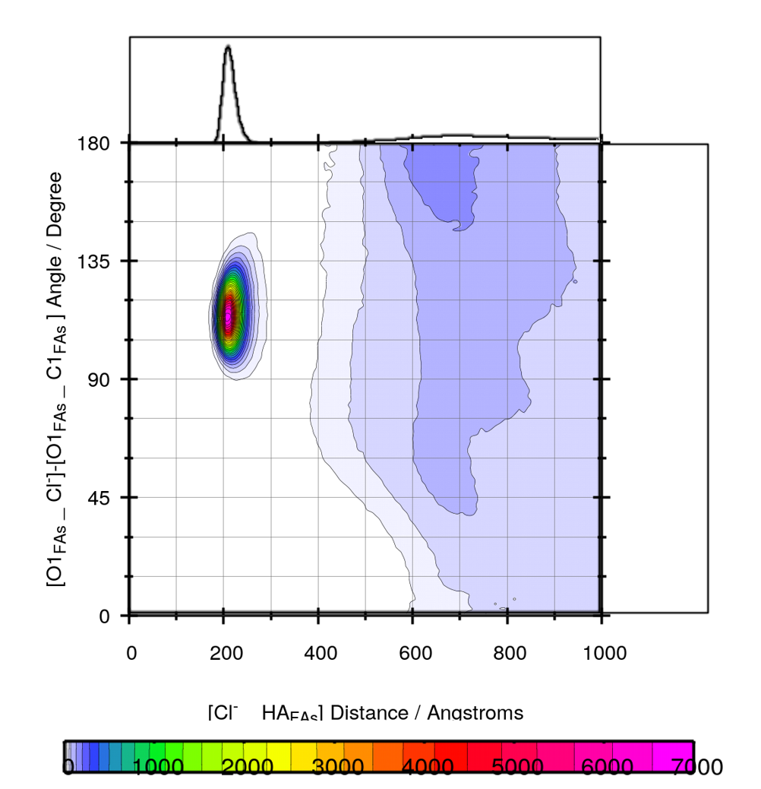
(a)

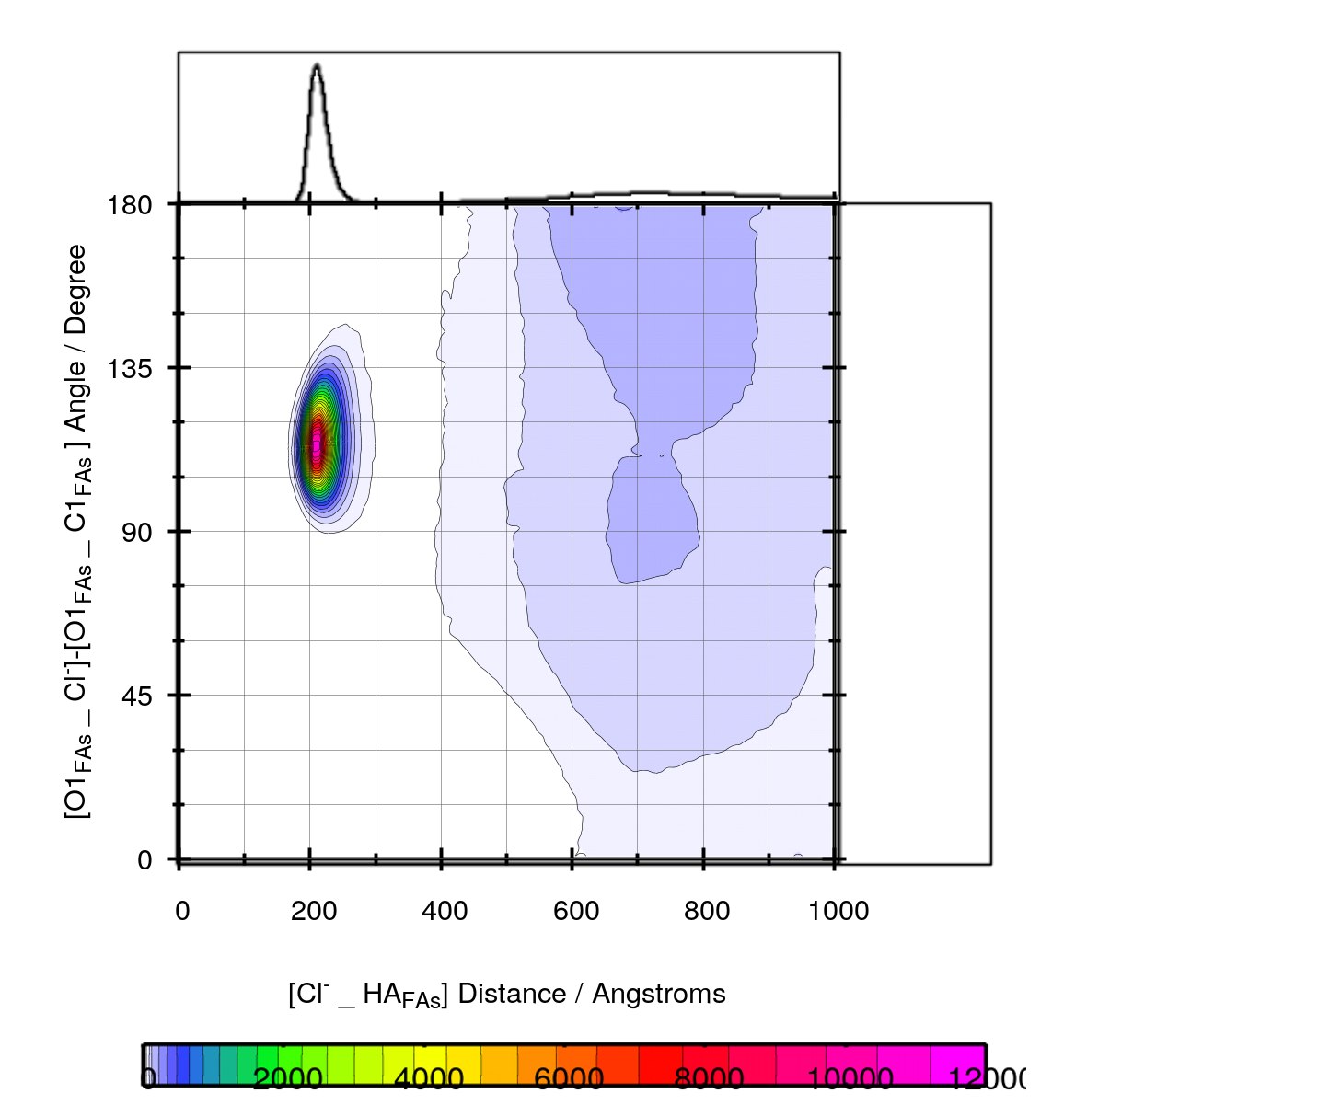

(b)

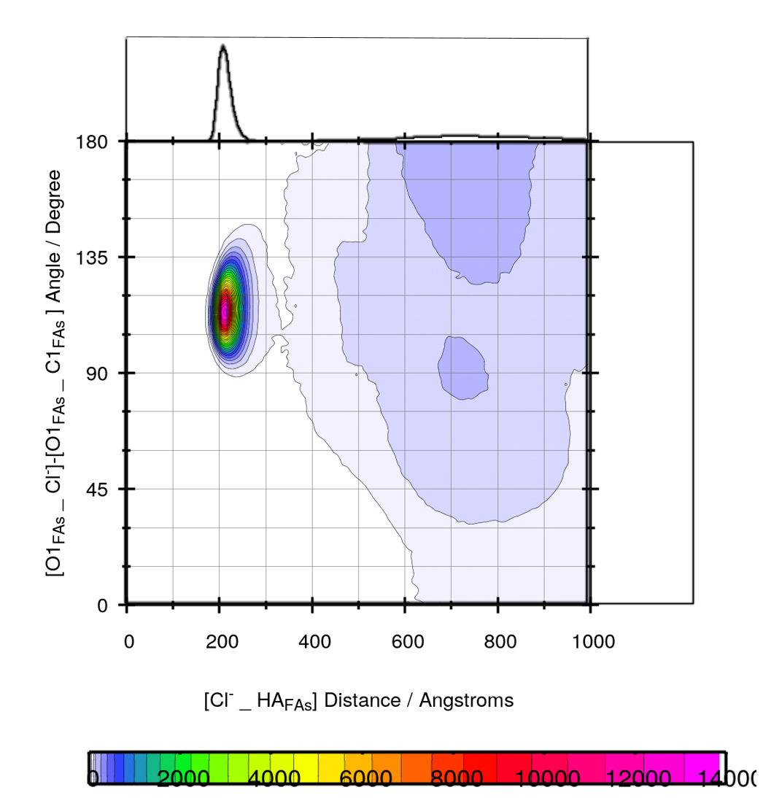
(c )
Fig. S1. (a) the HA _{FAs} _ Cl⁻ distance and C1_{FAs} – O1 _{FAs} – Cl⁻ angle for the binary mixtures with the mole percent at 30 % (b) the HA _{FAs} _ Cl⁻ distance and C1_{FAs} – O1 _{FAs} – Cl⁻ angle for the binary mixtures with the mole percent at 50 % (c) the HA _{FAs} _ Cl⁻ distance and C1_{FAs} – O1 _{FAs} – Cl⁻ angle for the binary mixtures with the mole percent at 70 %.

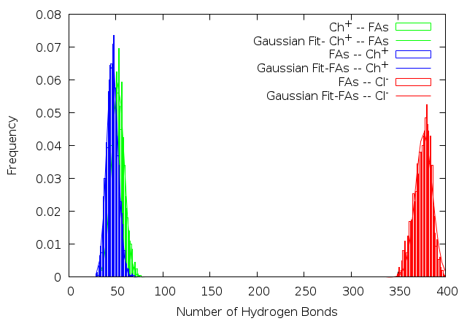
Fig. S2. The distribution of the hydrogen bond between the CAP molecules and [Ch⁺][Cl⁻] Salt in the mixtures containing 50% FAs at 353 K.

Fig.S3. The self-diffusion coefficient of chloride anions of DES2 as a function of percentage composition.

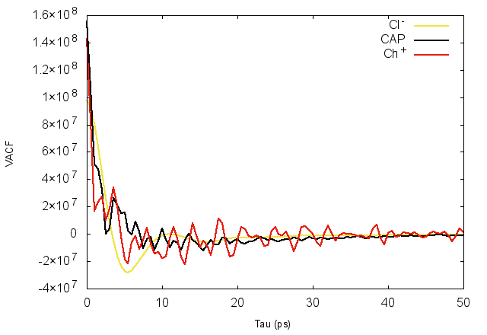
Fig. S4. The calculated VACF for the center of mass of [Ch⁺] and CAP molecule and [Cl⁻] anions in the mixture containing 50 % FAs at 353 K.

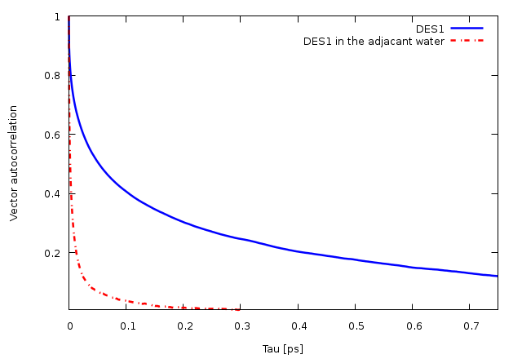
Fig. S5. Vector reorientation dynamics for bond (O1--HA) for the pure [Ch⁺/Cl⁻][FAs] DES and the binary mixtures containing 50 % in adjacent water.

