Atomically Dispersed d¹⁰ s-block Au Boosts Photocatalytic 1e⁻ Water Oxidation for Self-Cleaning, Sanitation and Safe Drinkable Water

Zhenyuan Teng,^{1,2,3,9} Hongbin Yang,^{1,2,9} Qitao Zhang,^{4,9} Wenan Cai,³ Ying-Rui Lu,⁵ Kosaku Kato,⁶ Zhenzong Zhang,¹ Jie Ding,¹ Han Sun,⁷ Sixiao Liu,⁸ Chengyin Wang,⁸ Peng Chen,¹ Akira, Yamakata,⁶ Chenliang Su,^{4,*} Bin Liu,^{1,2,*} and Teruhisa Ohno^{3,*}
¹School of Chemistry, Chemical Engineering and Biotechnology, Nanyang Technological University, Singapore 637459, Singapore
²Department of Materials Science and Engineering, City University of Hong Kong, Tat Chee Avenue, Kowloon, Hong Kong SAR 999007, China
³Department of Applied Chemistry, Faculty of Engineering, Kyushu Institute of Technology, Kitakyushu 804-8550, Japan
⁴International Collaborative Laboratory of 2D Materials for Optoelectronics Science and Technology of Ministry of Education, Institute of Microscale Optoelectronics, Shenzhen University, Shenzhen 518060, China
⁵National Synchrotron Radiation Research Center, Hsinchu 30076, Taiwan
⁶Department of Chemistry, Okayama University, 3-1-1 Tsushima-naka, Kita-ku, Okayama 700-8530, Japan
⁷The Third Affiliated Hospital of Soochow University, 185 Juqian Street, Changzhou 213003, China
⁸College of Chemistry and Chemical Engineering, Yangzhou University, 180 Si-Wang-Ting Road, Yangzhou 225002, China
⁹These authors contributed equally

Email: chmsuc@szu.edu.cn (C. Su), liubin@ntu.edu.sg/bliu48@cityu.edu.hk (B. Liu) and tohno@che.kyutech.ac.jp (T. Ohno)

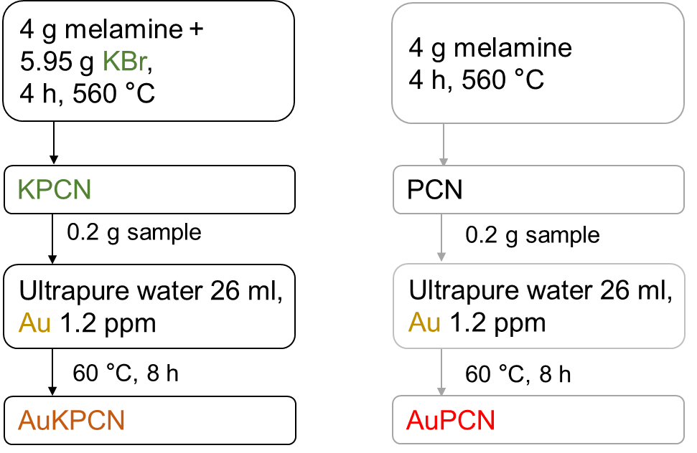

Supplementary Figure 1 | Synthesis process of PCN, KPCN, AuPCN and AuKPCN.

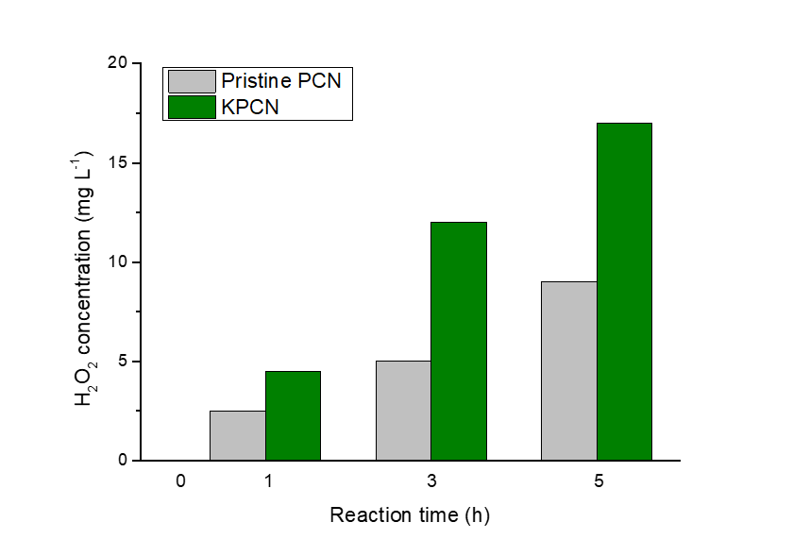

Supplementary Figure 2 | Comparison of activities of PCN and KPCN for photocatalytic H₂O₂ production. Light source: Xe lamp; light intensity at 420−500 nm: 30.3 W m⁻²; reaction medium: a 10% (v/v) ethanol aqueous solution at pH = 9.0 for PCN and 10.2 for KPCN.
Note: The pH of the aqueous suspension (solvent is pure water) is around 10 because addition of PCN-based materials would significantly accelerate self-ionization of water.

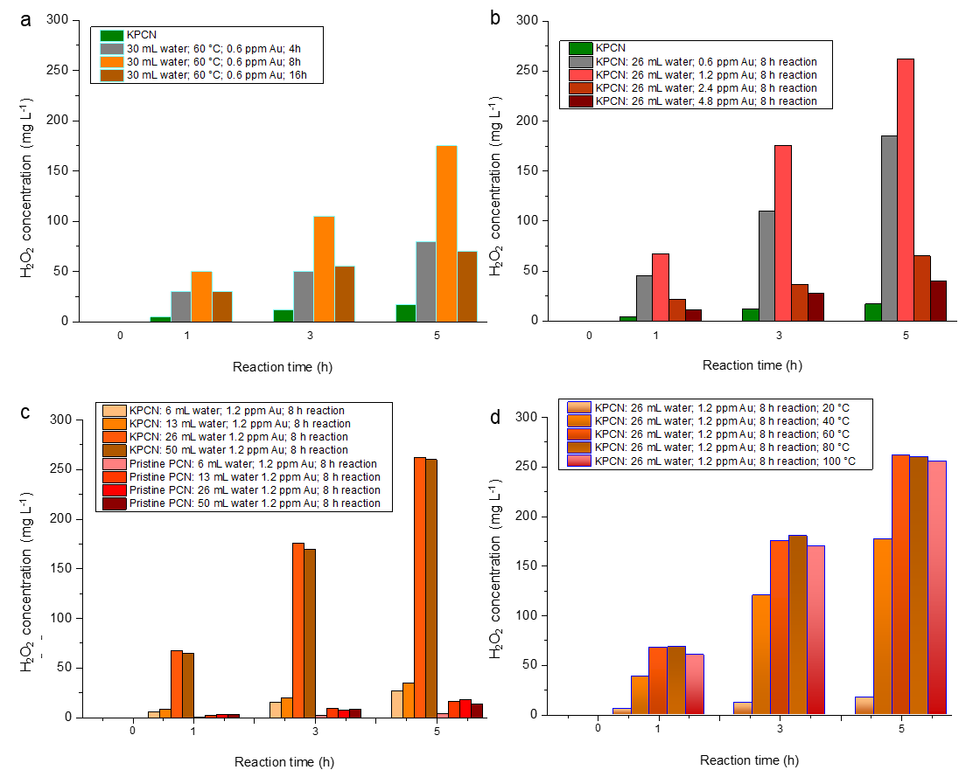

Supplementary Figure 3 | Optimization of preparation parameters for loading Au onto KPCN. a, Reaction time. b, Amount of Au. c, Solvent volume. d, Reaction temperature. Photocatalytic reaction condition: light source: Xe lamp; light intensity at 420−500 nm: 30.3 W m⁻²; reaction medium: a 10% (v/v) ethanol aqueous solution at pH around 10.

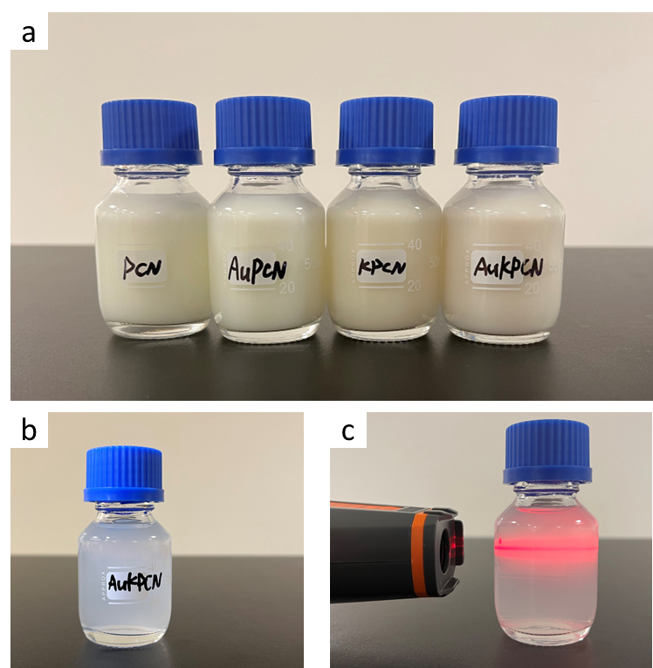

Supplementary Figure 4 | The photocatalyst suspension. a, Stock suspension (5 mg mL⁻¹) of the as-prepared PCN, AuPCN, KPCN and AuKPCN. b, The as-prepared suspension of AuKPCN (0.2 mg mL⁻¹) for making self-cleaning AuKPCN film. c, Tyndall effect of AuKPCN suspension.
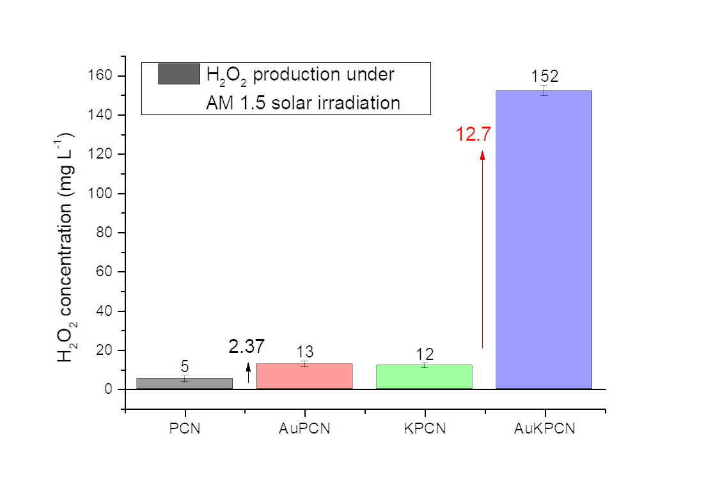

Supplementary Figure 5 | Photocatalytic H₂O₂ production in a 10% (v/v) ethanol aqueous solution over various samples under AM1.5 irradiation for 1 h.

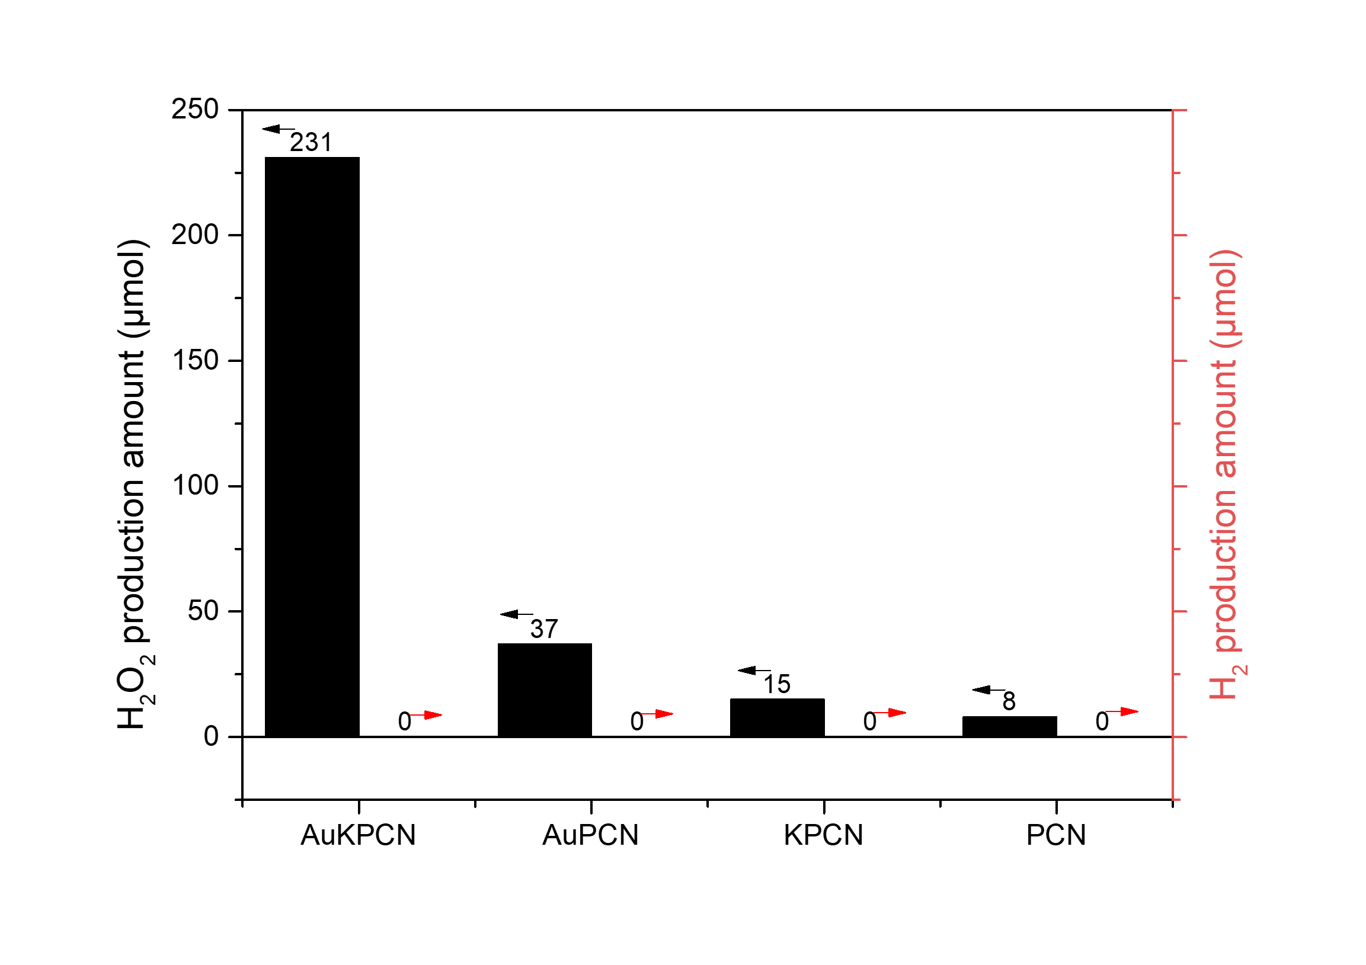

Supplementary Figure 6 | Selectivity comparison of various PCN samples for photocatalytic H₂O₂ and H₂ production (reaction time: 5 h). Left: comparison of photocatalytic H₂O₂ production activity of AuKPCN, AuPCN, KPCN and PCN in a 10% (v/v) ethanol aqueous solution. Right: comparison of photocatalytic H₂ production activity of pristine PCN, KPCN, AuPCN and AuKPCN in a phosphate buffer solution.

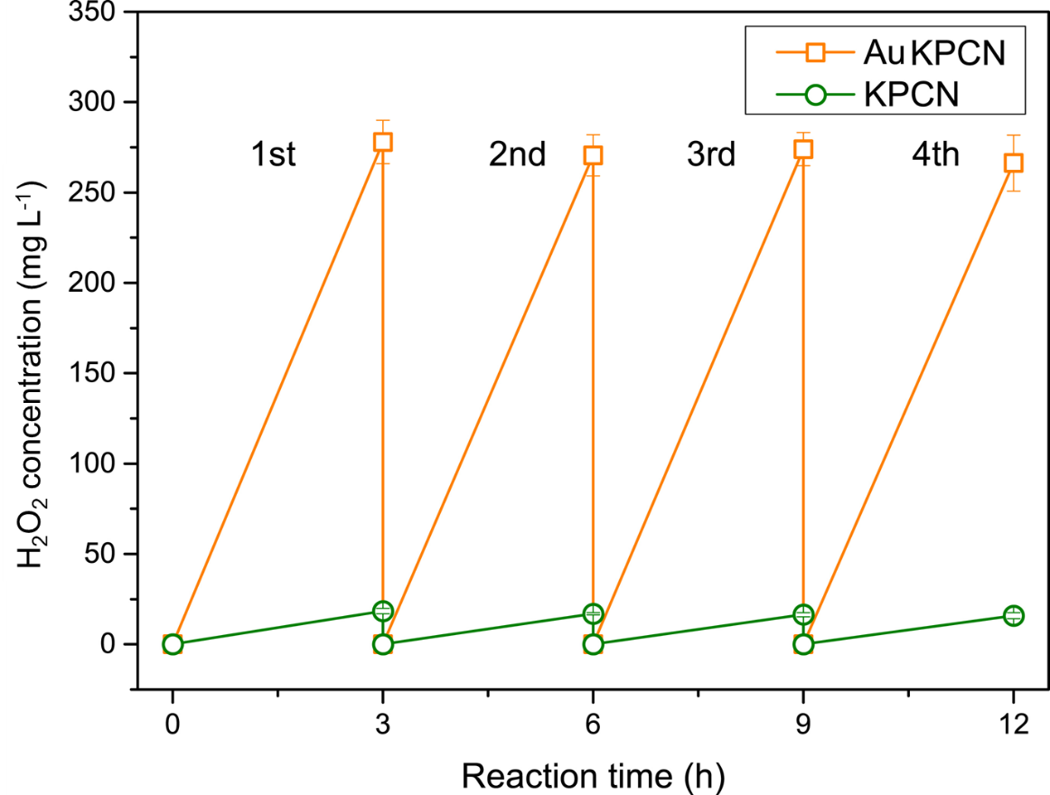

Supplementary Figure 7 | Photocatalytic stability. Repeatability of KPCN and AuKPCN for photocatalytic H₂O₂ production. After each run, the catalyst was filtered and re-suspended in a fresh solution with pH adjusted to 7 by HCl.

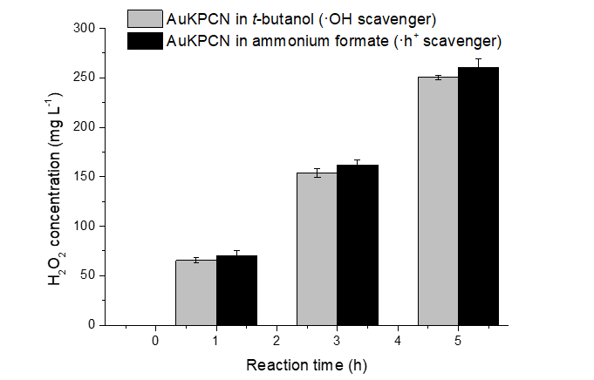

Supplementary Figure 8 | Scavenger experiments for investigating the photooxidation reaction. Comparison of photocatalytic activity of AuKPCN for H₂O₂ production in 0.1 M t-butanol and 0.1 M ammonium formate.
Note: Hole scavenger (ammonium formate) or hydroxyl radical scavenger (t-butanol) were added in the photocatalysis system. The photocatalytic performance (amount of H₂O₂ produced) of the AuKPCN system kept almost the same before and after adding hole/·OH scavenger.

Supplementary Figure 9 | ESR spectra. The ESR spectra under illumination were recorded after shining light for 5 min using a Xeon lamp of 100 mW cm⁻² (full spectrum) with a band cutoff filter at 420 nm.

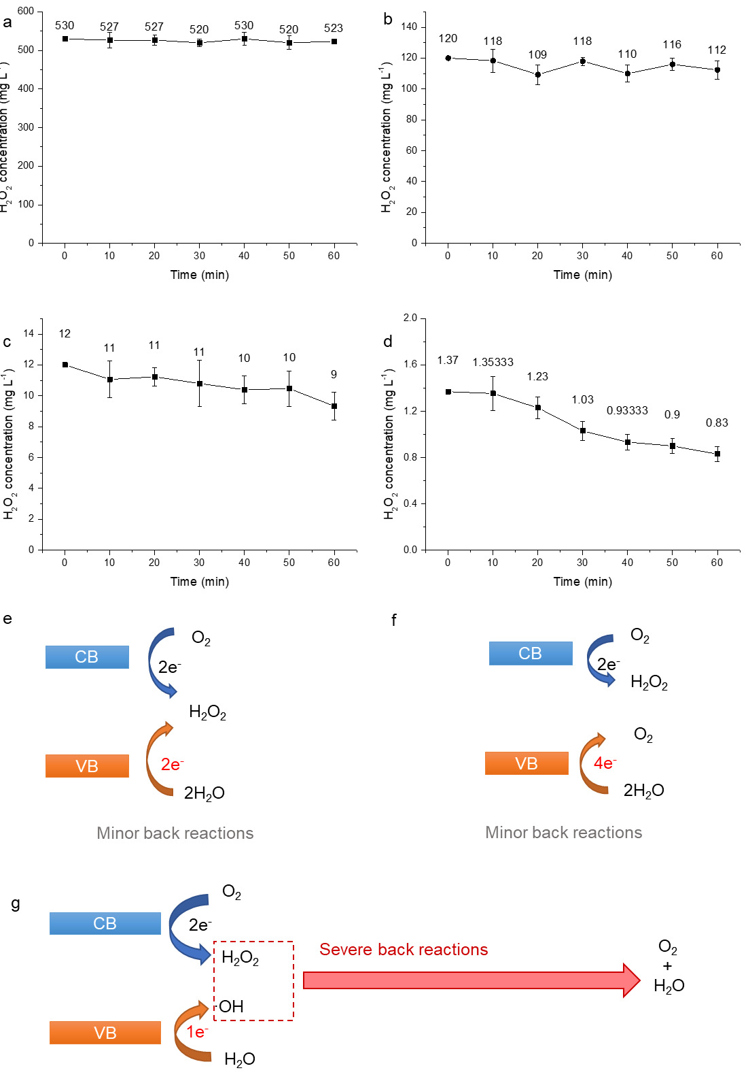

Supplementary Figure 10 | Photocatalytic decomposition of H₂O₂ over AuKPCN in solution with different initial H₂O₂ concentrations. a, 530 mg_{H2O2} L⁻¹. b, 120 mg_{H2O2} L⁻¹. c, 12 mg_{H2O2} L⁻¹. d,1.5 mg_{H2O2} L⁻¹. The solution was irradiated by a 300 W Xenon Lamp with a UV cutoff filter (light intensity: 30.3 W m⁻² at 420-500 nm). e-f, Back reactions of H₂O₂ production via 2e⁻ ORR coupled with 1e⁻ (e), 2e⁻ (f) or 4e⁻ (g) WOR.
Note: Because of the strong oxidizing capability, the ·OH can decompose H₂O₂. As a result, another convincing evidence to support the occurrence of 1e⁻ WOR over AuKPCN is that H₂O₂ concentration (Supplementary Fig. 10) was found to keep almost constant with reaction time in the reaction system having AuKPCN and different initial amounts of H₂O₂ under illumination (while in the system with 2e⁻ WOR or 4e⁻ WOR, the H₂O₂ concentration is expected to increase with reaction time)^{1, 2}. In a typical photocatalytic system, reduction reactions and oxidation reactions simultaneously occur on the surface of photocatalyst. In a non-sacrificial photocatalytic H₂O₂ production system (with O₂ and H₂O as the reactants), photogenerated electrons reduce O₂ to produce H₂O₂ while photogenerated holes oxidize H₂O. Depending on the number of electrons involved in the water oxidation reaction (WOR), H₂O can be oxidized to H₂O₂ or O₂, which can hardly react with the H₂O₂ generated from the photoreduction reaction (Supplementary Figures 10e-f). As a result, the production of H₂O₂ is expected to increase with photocatalytic reaction time. However, if 1e⁻ WOR takes place at the photooxidation side, the produced ·OH will react with the H₂O₂ generated from the photoreduction reaction, leading to severe consumption of H₂O₂ (Supplementary Figure 10g).

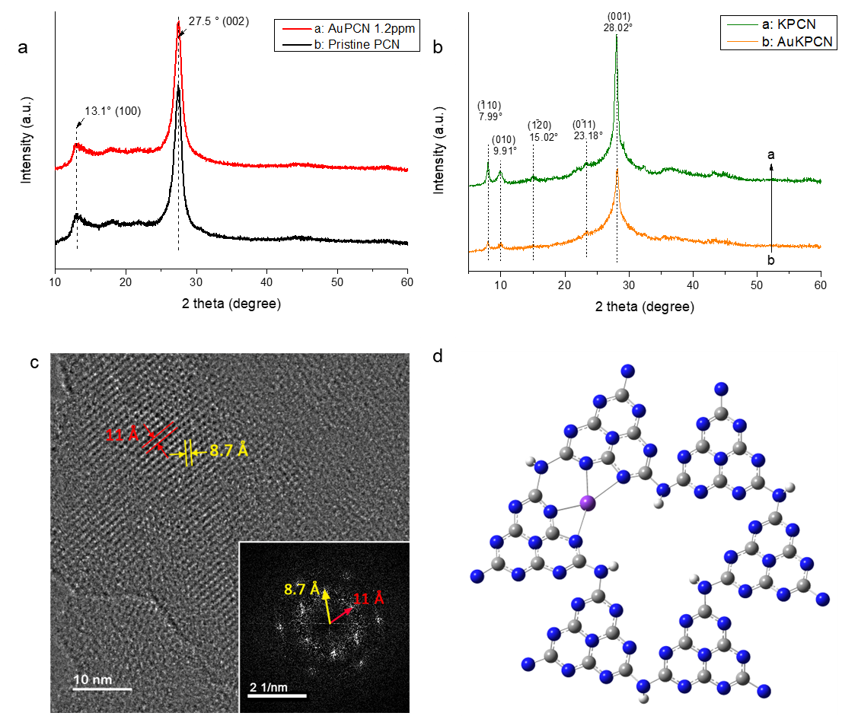

Supplementary Figure 11 | Crystallinity of the as-prepared carbon nitride samples. a, XRD patterns of pristine PCN and AuPCN. b, XRD patterns of KPCN and AuKPCN. c, High-resolution transmission electron microscopy (HR-TEM) image of KPCN. Inset shows the FFT pattern. d, Schematic diagram showing the structure of K incorporated poly(heptazine imides) (K-PHI).
Note: The crystal structures of the as-prepared samples were examined by XRD and HR-TEM. XRD patterns of pristine PCN and AuPCN samples show two diffraction peaks at about 27.5° and 13.1° (Supplementary Figure 11a), which can be ascribed to the interlayer stacking (002) and the interplanar structure packing (100) of tri-s-triazine units, respectively. There are no obvious changes of these two diffraction peaks after incorporation of Au species in the PCN matrix. To study the crystal structure of KPCN, XRD was performed (Supplementary Figure 11b). Obviously, KPCN displays a different XRD pattern and shows one main diffraction peak that is red-shifted by around 0.5° to 28.02° in comparison to PCN (27.5°), corresponding to an interlayer d-spacing of 0.318 nm. This interlayer spacing is smaller than that of PCN (0.322 nm), indicating that KPCN possesses a denser layered structure, which is consistent with previous research. Moreover, the low-angle diffraction peak of PCN at 13.1° is not observed in KPCN, while new diffraction peaks appear at around 7.99° and 9.91°. The characteristic diffraction peaks of KPCN are very similar to the K incorporated poly(heptazine imides) (K-PHI) previously reported by Prof. Lotsh3. The diffraction at 9.91°, 15.02° and 23.18° (Supplementary Figure 11) can be assigned to the lattice of (010), (1-20) and (0-11), respectively3. These results indicate that most of the potassium could be located at the structural vacancies of rings. It should be noted that salt-mediated synthesis is known to produce poly (heptazine imide) whereas heating the precursor without the salt melt produces the polymer melon4, 5. As is clear from these papers, even under controlled synthesis conditions, significant number of defects remain, particularly cyanamide. On the other hand, metal complexes (for instance, K) with cyanamide ligands, especially complexes of melonates (heptazine with three cyanamide groups) have been reported6, 7. The crystal structures of melonate complexes clearly demonstrate that cyanamide could also be a key ligating moiety coordinating to the metal species. The structures of K-PHI and neighboring units of carbon nitrides could significantly influence the electronic configurations of Au species.

Supplementary Figure 12 | HAADF-STEM images of AuPCN. a-c, HAADF-STEM image of AuPCN with a loading concentration of Au of 0.6 ppm (wt.) (a), 1.2 ppm (b) and 2.4 ppm (c). Inset shows the size distribution of the bright spots. d-f, Low-resolution HAADF-STEM images of AuPCN with an Au loading concentration of 0.6 ppm (wt.) (d), 1.2 ppm (e) and 2.4 ppm (f).

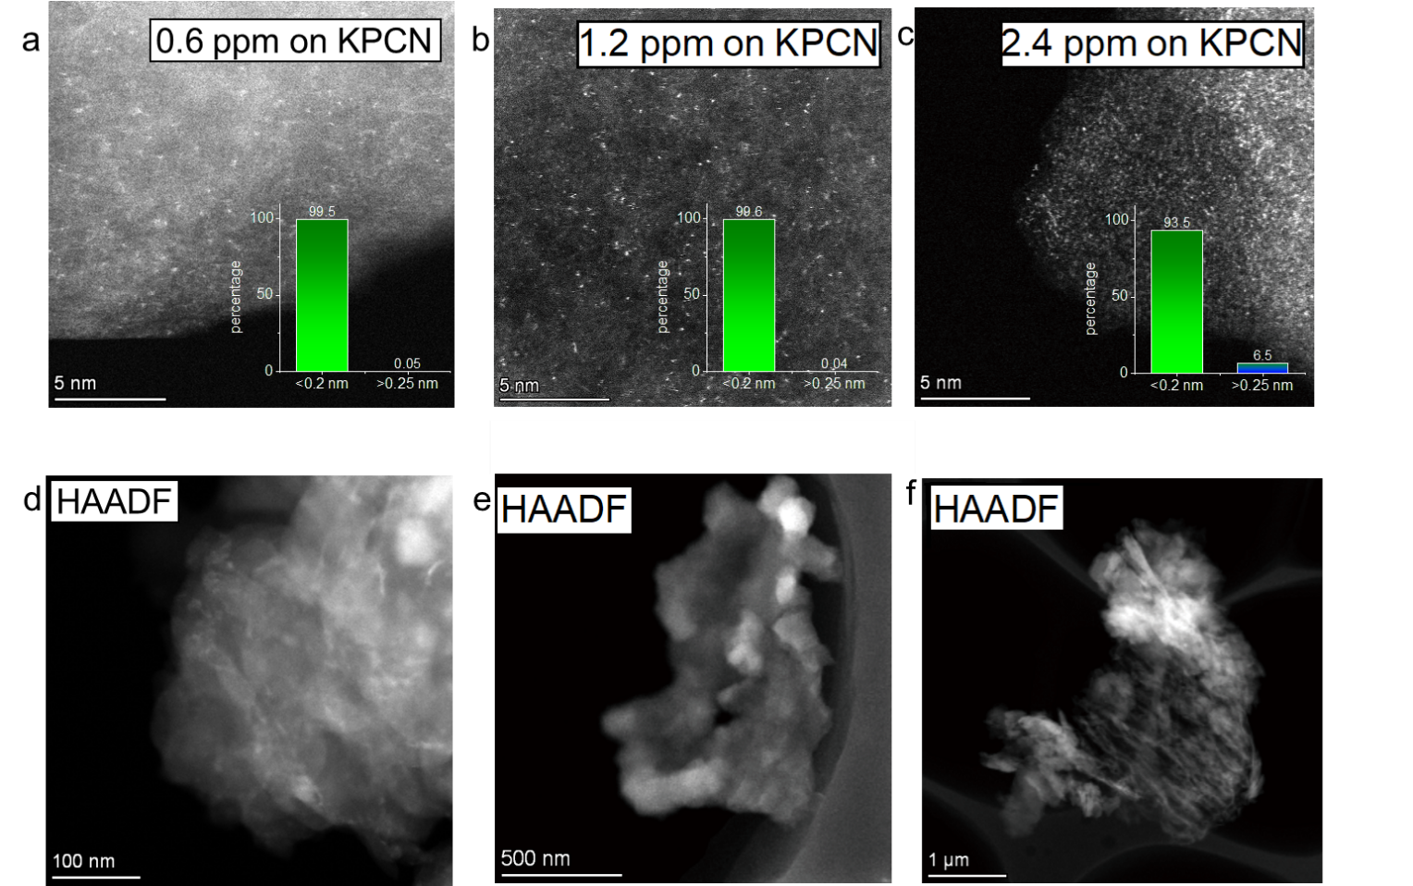

Supplementary Figure 13 | HAADF-STEM images of AuKPCN. a-c, HAADF-STEM image of AuKPCN with a loading concentration of Au of 0.6 ppm (wt.) (a), 1.2 ppm (b) and 2.4 ppm (c). Inset shows the size distribution of the bright spots. d-f, Low-resolution HAADF-STEM images of AuKPCN with an Au loading concentration of 0.6 ppm (wt.) (d), 1.2 ppm (e) and 2.4 ppm (f).

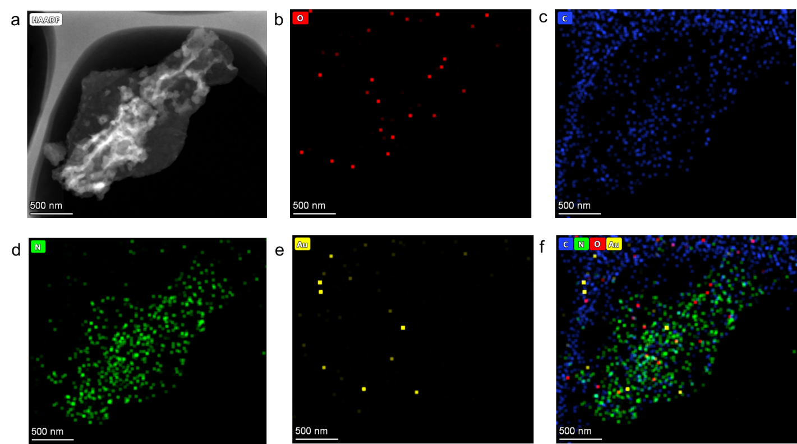

Supplementary Figure 14 | Elemental distribution in AuPCN. a, A HAADF-STEM image of AuPCN. b-e, The corresponding EDS elemental mapping images of O (b), C (c), N (d) and Au (e). f, An overlap mapping image of Au, N, C and O.

Supplementary Figure 15 | Elemental distribution in AuKPCN. a, A HAADF-STEM image of AuKPCN. b-f, The corresponding EDS elemental mapping images of Au (b), N (c), C (d), K (e), and O (f). g, An overlap mapping image of K and Au.

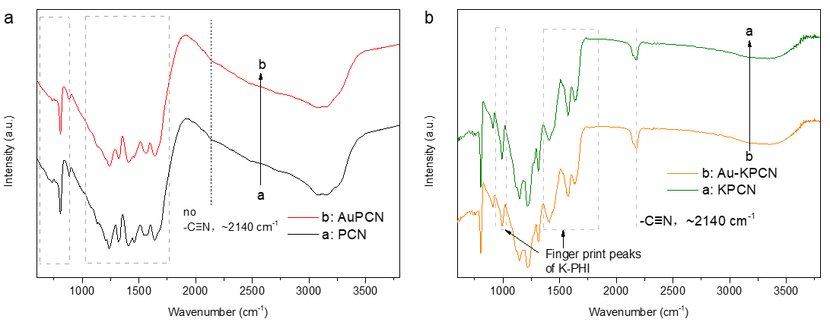

Supplementary Figure 16 | FTIR spectra. a, FTIR spectra of pristine PCN and AuPCN. b, FTIR spectra of KPCN and AuKPCN.

Supplementary Figure 17 | Surface chemical states of C, N and O in PCN. a, Schematic diagram of PCN. b-c, High-resolution XPS spectra of PCN: C 1s (b), N 1s (c) and O 1s (d).

Supplementary Figure 18 | Surface chemical states of C, N and O in KPCN. a, Schematic diagram of KPCN. b-c, High-resolution XPS spectra of KPCN: C 1s with K 2p_{3/2} and 2p_{1/2} (b), N 1s (c) and O 1s (d).

Supplementary Figure 19 | Surface chemical states of C, N and O in AuPCN. a, Schematic diagram of AuPCN. b-c, High-resolution XPS spectra of PCN: C 1s (b), N 1s (c) and O 1s (d).

Supplementary Figure 20 | Surface chemical states of C, N and O in AuKPCN. a, Schematic diagram of KPCN. b-c, High-resolution XPS spectra of AuKPCN: C 1s with K 2p_{3/2} and 2p_{1/2} (a), N 1s (b) and O 1s (c).

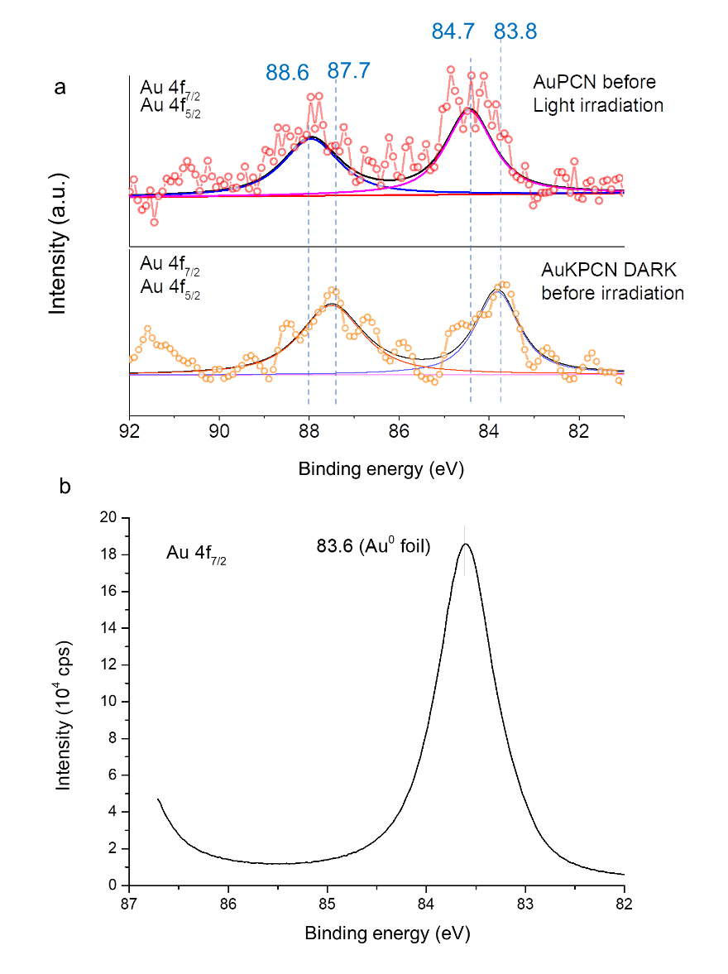

Supplementary Figure 21 | High-resolution XPS spectra to determine the surface chemical states of Au. a, Au (4 f_{7/2} and 4 f_{5/2}) spectra in AuPCN and AuKPCN. b, Au (4 f_{7/2}) spectrum in Au foil as a reference.
Note: the binding energy of Au 4f for AuKPCN (Au 4f_{5/2} at 87.7 eV and Au 4f_{7/2} at 83.8 eV) is quite close to that for Au foil (Au 4f_{7/2} at 83.6 eV), while the binding energy of Au 4f for AuPCN (Au 4f_{5/2} at 88.6 eV and Au 4f_{7/2} at 84.7 eV) is ~1 eV more positive than that for Au foil.
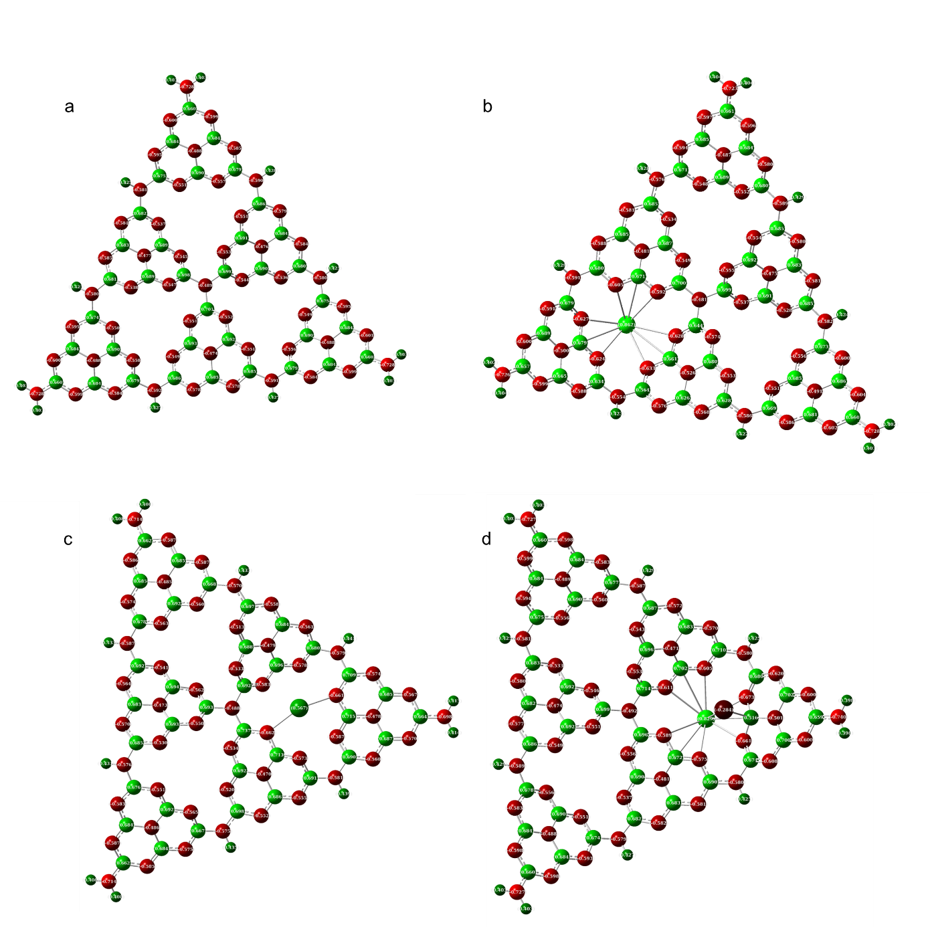

Supplementary Figure 22 | Natural population analysis of Melem_6-based models. a, Melem_6. b, Melem_6K. c, Melem_6Au. d, Melem_6KAu.
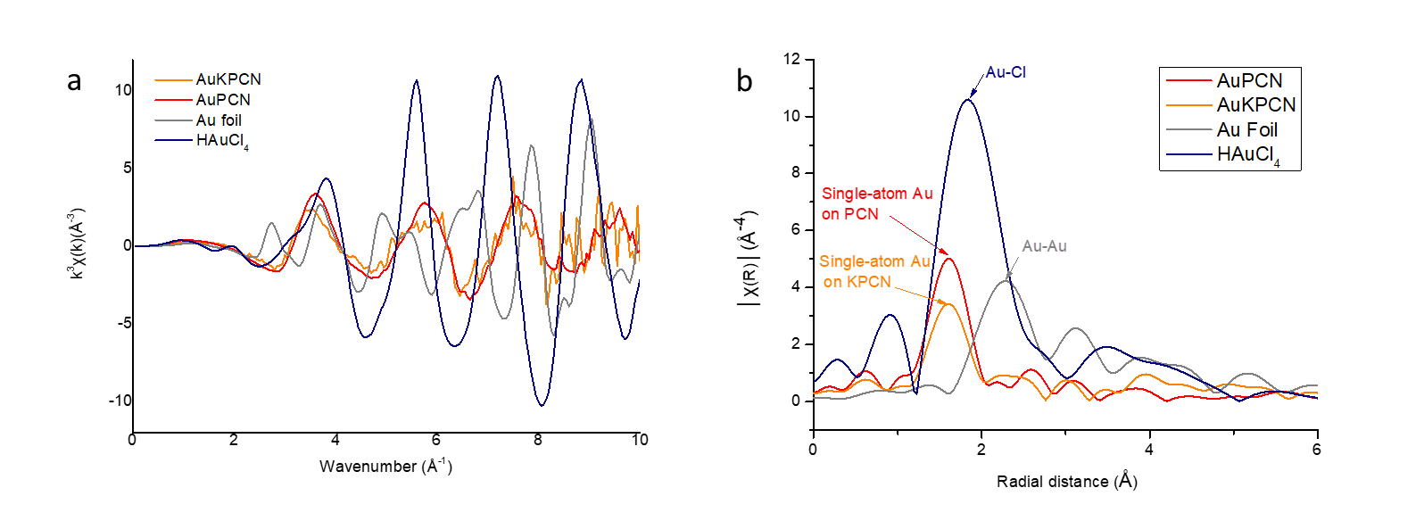

Supplementary Figure 23 | Extended X-ray absorption fine structure (EXAFS) spectra of PCN, KPCN, AuPCN and, AuKPCN. a, k³-weighted k-space spectra. b, Fourier transform extended X-ray absorption fine structure (FT-EXAFS) spectra.

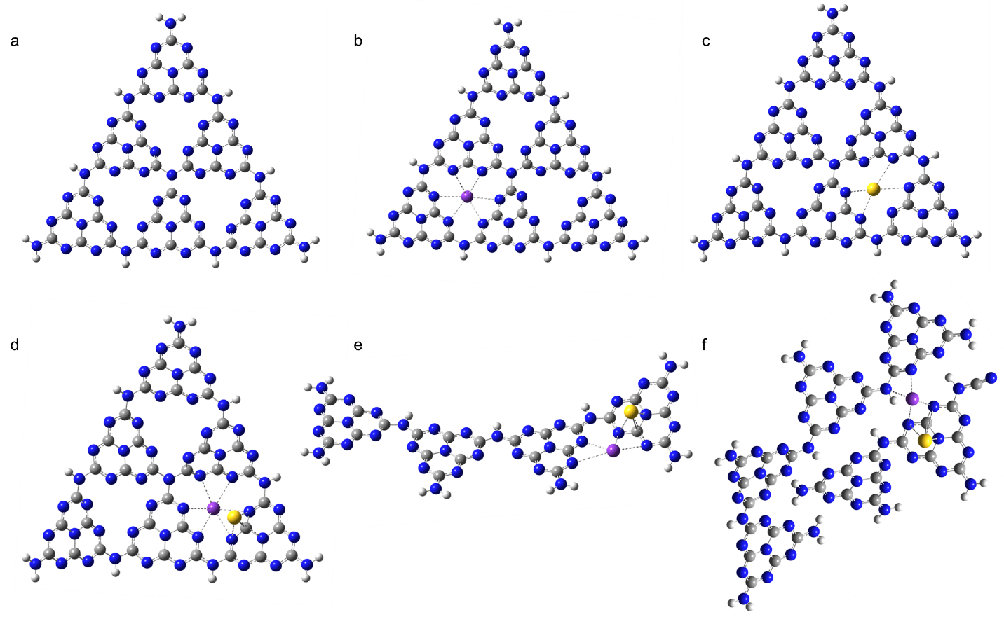

Supplementary Figure 24 | Cluster models for investigating the coordination status. a, A cluster model of Melem_6 to represent the melem sites on PCN. b, A cluster model of Melem_6K to represent the possible K sites on KPCN. c, A cluster model of Melem_6Au to represent the possible Au sites on AuPCN. d-e, Cluster models of Melem_6KAu, Melem_4KAu and Melem_4+2KAu to represent the possible Au sites on AuKPCN.

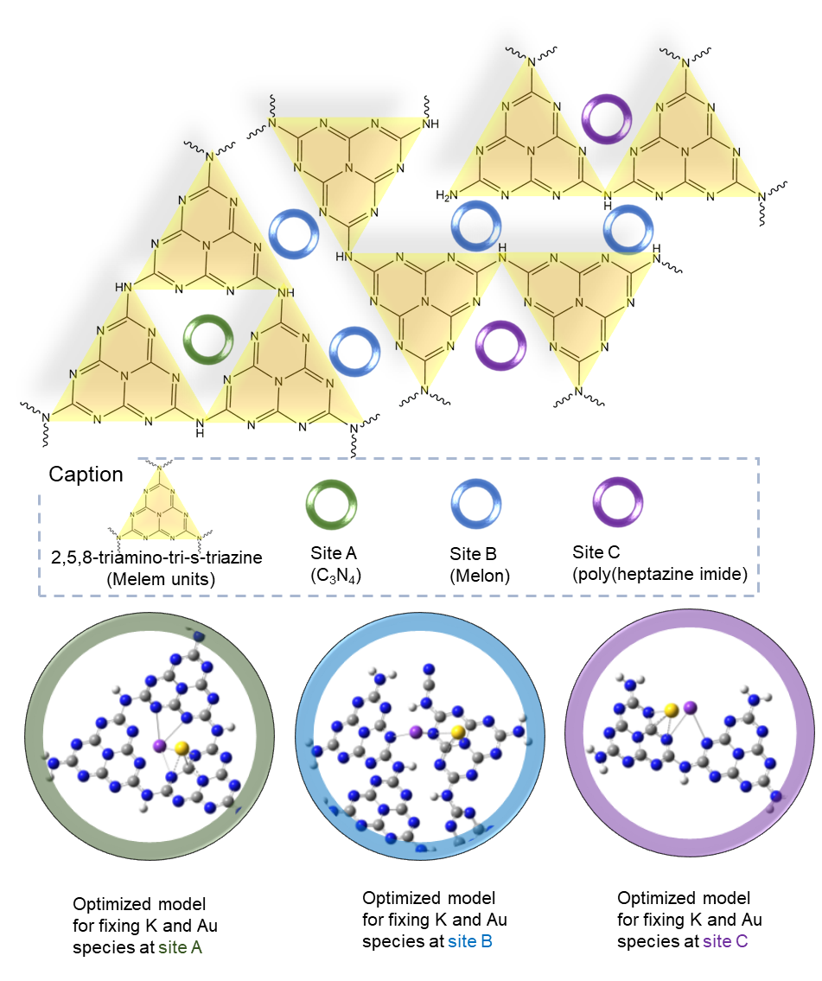
Supplementary Figure 25 | Coordination of K. Three different coordination of K for blocking possible N sites are considered based on the characterization data as well as the previously published works on highly crystalline PHI⁵⁻⁹.
Note: Based on the previous investigation of the structures of melons and PHI, 3 models have been built to represent the possible sites of K and Au on KPCN: 1. Melem_6KAu (sites on C₃N₄ framework); 2. Melem_4+2KAu (sites on pyridinic N at the edge of melon); 3. Melem_4KAu (sites near the melem units, near the zigzag edge of melon or in the structural hole of PHI framework).

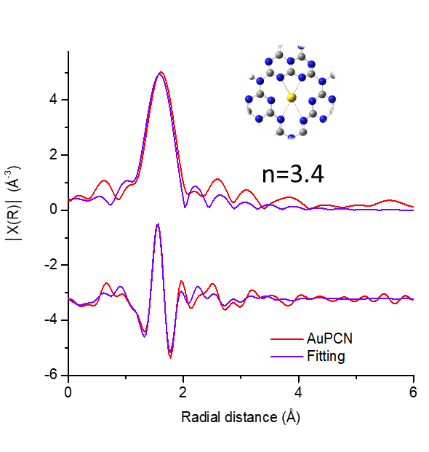

Supplementary Figure 26 | Fitting of the EXAFS data of AuPCN based on the model obtained from DFT optimization.

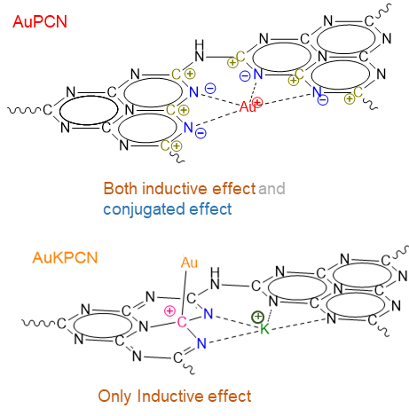

Supplementary Figure 27 | Schematic diagram showing the charge distribution resulted by introducing Au onto PCN or KPCN.

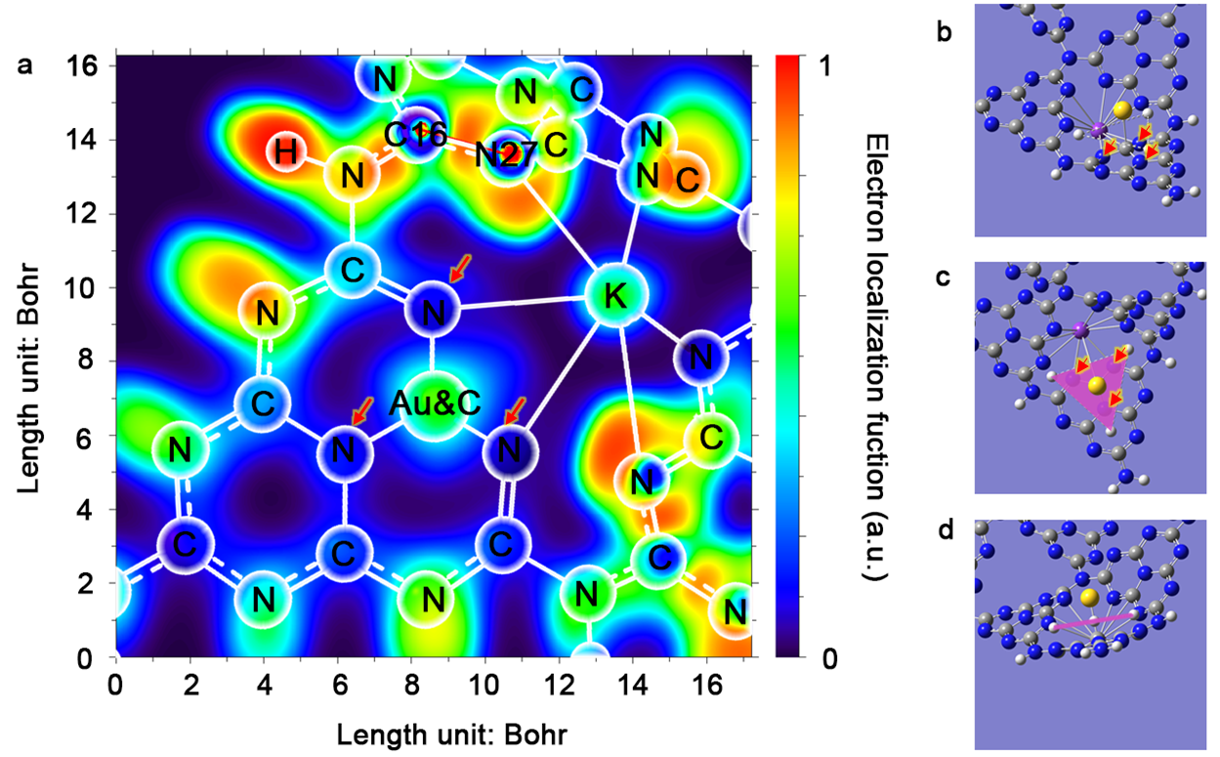

Supplementary Figure 28 | Electron localization function for analyzing Au-C and Au-N bonds in Melem_6KAu. (a–d) Electron localization function (ELF) maps of plane defined by the Cartesian coordinates (Point 1: 7.493154042, -4.472994491, -0.069043991; Point 2: 13.7090503, -0.284084903, 3.52028813; and Point 3: 8.137441273, 3.664612152, -1.733323071).
Note: A plane that is orthogonal to the line segment formed by Au-C is defined to check the electron localization functions of the Au atom with the neighboring C and N atoms. As shown in Supplementary Figure 28, Au only shows moderate electronic interaction with C, while has almost no interaction with the neighboring N atoms (marked by red arrows). These results suggest that Au tends to form a chemical bond with C, rather than with N atoms, on the surface of KPCN.

Supplementary Figure 29 | Electron localization function for analyzing K-N bonds in Melem_6KAu. a–d, Electron localization function (ELF) maps of plane defined by the Cartesian coordinates (Point 1: 1.77048542, -6.691702651, -3.009510397; Point 2: 14.25803988, -1.320176367, -3.091262248; and Point 3: 3.601774417, 6.422551874, -4.497184401).
Note: To check the blocking effect of K in the matrix of KPCN, a plane that intersects with the line segment formed by K and the neighboring 6 N atoms was defined. The electron localization functions of the plane were calculated the results are as shown in Supplementary Figure 29, which reveal that K atoms show strong electronic interactions with 4 N atoms. Notably, the intensities of the K-N bonds are pretty strong. Such strong electronic configuration of K-N may be due to the strong ionic effect of K species, which can extract electrons from the neighboring melem units and weaken the densities of the delocalized electron cloud (π-π conjugated system). The possible sp³ interaction between Au-N (Supplementary Figure 27) can also be notably weakened (Supplementary Figure 28) because of the weakened electron intensities of N atoms in the π-π conjugated system. Therefore, the strong interaction between K and N atoms can block the possible coordination sites of N on the KPCN surface.

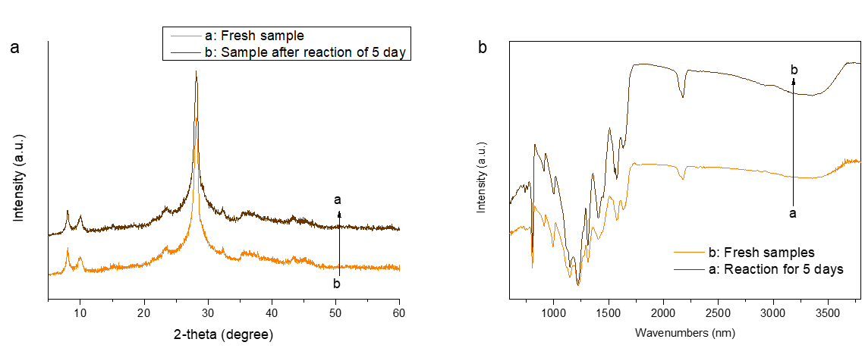

Supplementary Figure 30 | Stability of the as-prepared AuKPCN. a, Comparison of XRD pattens of the as-prepared AuKPCN and AuKPCN after 120 h of photoreaction. b, Comparison of FTIR spectra of the as-prepared AuKPCN and AuKPCN after 120 h of photoreaction.

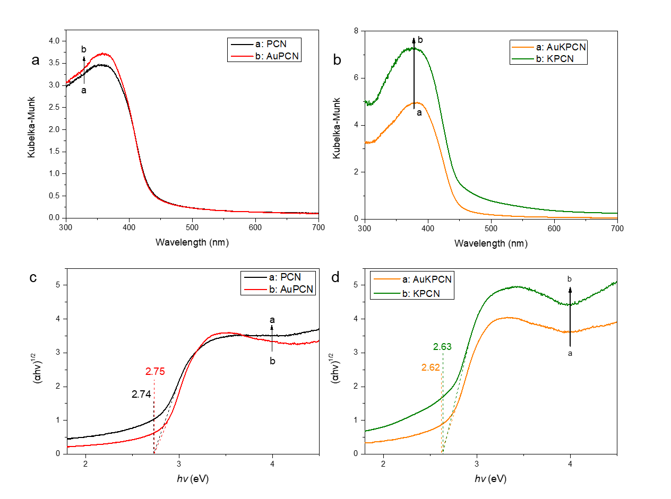

Supplementary Figure 31 | Light absorption properties. a-b, UV-vis diffuse reflection spectra of (a) pristine PCN and AuPCN and (b) KPCN and AuKPCN. c-d, The corresponding Tauc plots.
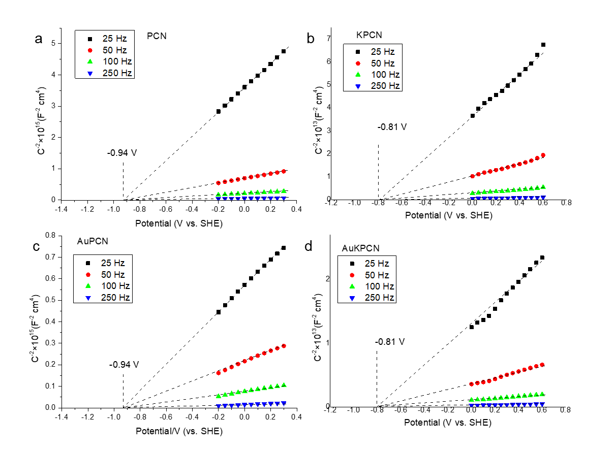

Supplementary Figure 32 | Characterization of conduction band maximum (CBM). a-d, Mott Schottky plots of (a) pristine PCN, (b) KPCN, (c) AuPCN and (d) AuKPCN.

Supplementary Figure 33 | Characterization of valence band minimum (VBM). a-d, Valence-band XPS spectra of (a) pristine PCN, (b) KPCN, (c) AuPCN and (d) AuKPCN. The Fermi level of the instrument (VB-XPS) is equilibrated at 4.5 eV utilizing Au metal basis as the reference. In this case, the numerical value of the binding energy in the calibrated VB-XPS spectrum is the same as the potential vs. normal hydrogen electrode.

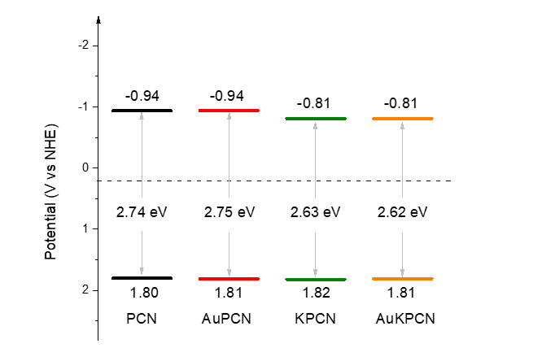

Supplementary Figure 34 | Band structure diagrams of pristine PCN, KPCN, AuPCN and AuKPCN.
Note: The optical properties and the band structure of pristine PCN, KPCN, AuPCN and AuKPCN were carefully investigated. The introduction of K into PCN slightly narrowed the bandgap (2.74 eV for PCN and 2.63 eV for KPCN) and significantly improved the light absorbance. Based on the valence-band XPS and Mott-Schottky measurements, the introduction of Au species onto KPCN slightly shifted the conduction band minimum (CBM) from ~-0.94 V to ~-0.81 V, while barely influenced the valence band maximum (VBM, ~1.85 V). Note that the redox potential of 1e⁻ WOR could be notably influenced by pH of the solution¹⁰. In case of PCN and KPCN systems, both of these two carbon nitrides could work as strong Lewis base. The pH value of the suspension (1 mg mL⁻¹) containing PCN, AuPCN, KPCN and AuKPCN was measured to be 10.1, 10.2, 10.9 and 10.8. The redox potential of 1e⁻ WOR in this pH region could be about 1.74~1.78 V. Therefore, the band structure of these samples showed sufficient thermodynamic driving force for both 2e⁻ ORR and 1e⁻ WOR in aqueous solution under photoexcitation

Supplementary Figure 35 | Transient infrared (IR) absorption spectra. a-d, Transient IR absorption spectra for PCN (a), KPCN (b), AuPCN (c) and AuKPCN (d) recorded after 420 nm laser pulse excitation under vacuum (6 ns, 5 mJ, 5 Hz).

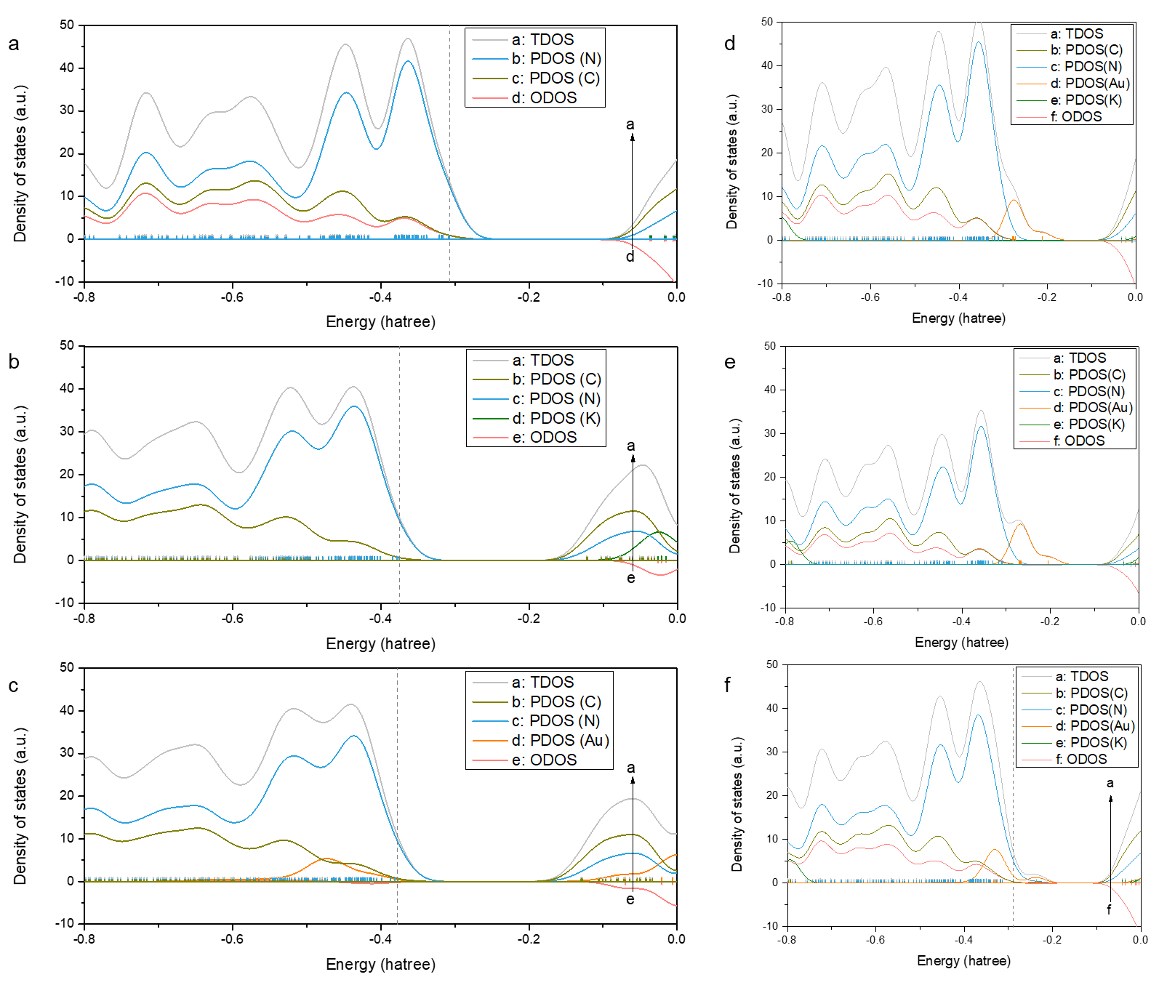

Supplementary Figure 36 | Density of states of various PCN samples. a-c, Total density of states (TDOS), partial density of states (PDOS) and overlapped density of states (ODOS) of Melem_6 (a), Melem_6K (b), Melem_6Au (c), Melem_6KAu (d), Melem_4KAu (e) and Melem_4+2KAu (f). We set the charge on Melem_6Au as +1, while that on other models (Melem_6KAu, Melem_4+2KAu and Melem_4KAu) as 0 to represent the change in chemical states revealed in XPS and XAS measurements².

Supplementary Figure 37 | Simulated excitation properties of Melem_6, Melem_6K and Melem_6Au. a-c, TDDFT-calculated absorption spectra for (a) Melem_6, (b) Melem_6K and (c) Melem_6Au. d-i, The population of electron and hole distribution (vertical excitation at the excited states 1-50). (d) Electron distribution and (g) hole distribution for Melem_6. (e) Electron distribution and (h) hole distribution for Melem_6K. (f) Electron distribution and (i) hole distribution for Melem_6Au.

Supplementary Figure 38 | Simulated excitation properties of Melem_6AuK, Melem_4AuK and Melem_4+2AuK. a-c, TDDFT-calculated absorption spectra for (a) Melem_6KAu, (b) Melem_4KAu and (c) Melem_4+2KAu. d-i, The population of electron and hole distribution (vertical excitation at the excited states 1-50). (d) Electron distribution and (g) hole distribution for Melem_6KAu. (e) Electron distribution and (h) hole distribution for Melem_4KAu. (f) Electron distribution and (i) hole distribution for Melem_4+2KAu.
Note: Most of the electrons are localized at the carbon and nitrogen atoms on the melem units, and the concentrations of electrons at these transitions only show a slight increase after introducing Au and K with a notably increased D index¹¹. These results suggest that the melem sites shall work as reduction sites in the AuKPCN sample for photocatalytic H₂O₂ production.

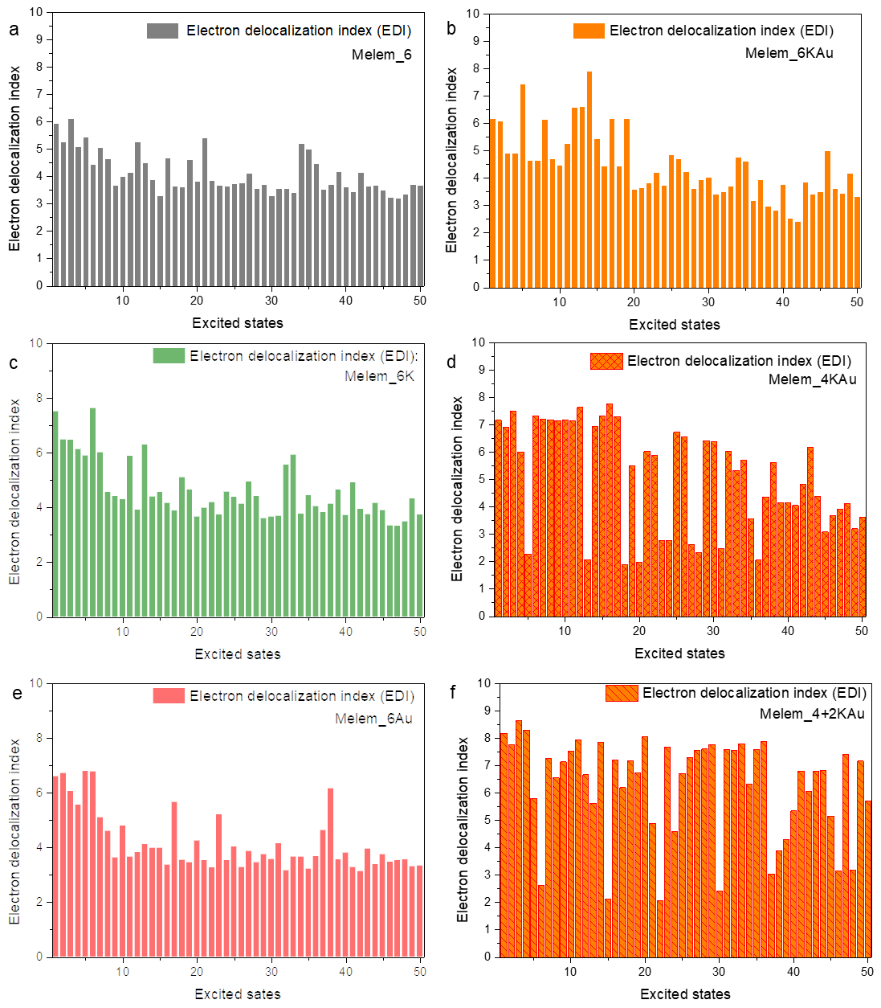

Supplementary Figure 39 | Simulated excitation properties of photogenerated electrons in the models of Melem_6, Melem_6K, Melem_6Au, Melem_6KAu, Melem_4KAu and Melem_4+2KAu for delocalization index of electrons (EDI). a, Melem_6. b, Melem_6K. c, Melem_6Au. d, Melem_6KAu. e, Melem_4KAu. f, Melem_4+2KAu.

Supplementary Figure 40 | Simulated excitation properties of photogenerated electrons in the models of Melem_6, Melem_6K, Melem_6Au, Melem_6KAu, Melem_4KAu and Melem_4+2KAu for D index. a, Melem_6. b, Melem_6K. c, Melem_6Au. d, Melem_6KAu. e, Melem_4KAu. f, Melem_4+2KAu.
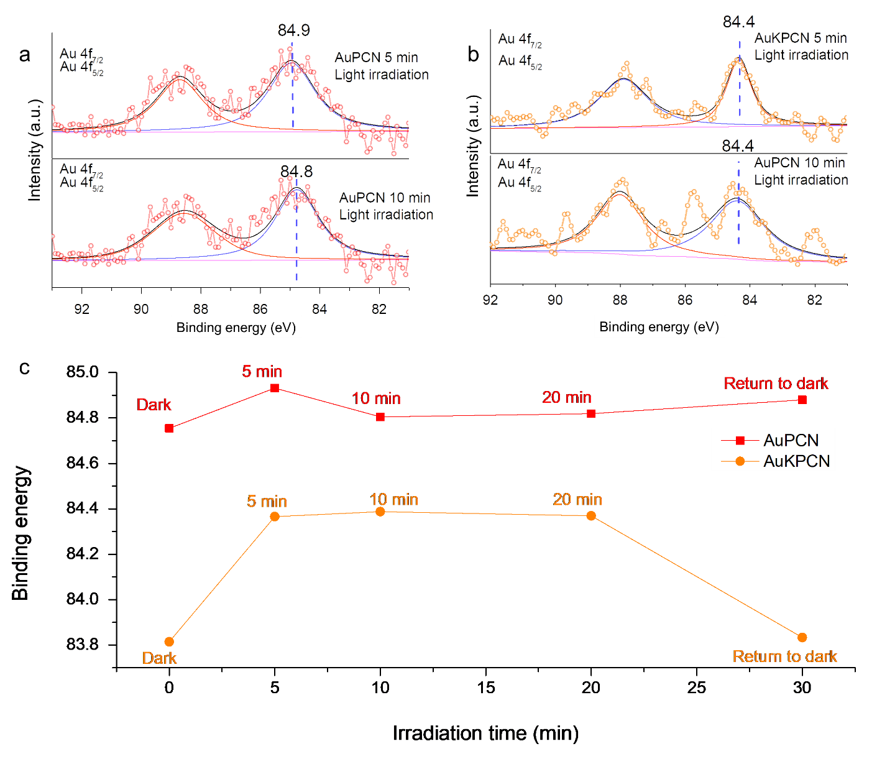

Supplementary Figure 41 | In-situ XPS spectra for AuPCN and AuKPCN recorded in dark and under visible light illumination. a, High-resolution XPS spectra of AuPCN: Au 4f_{7/2} and Au 4f_{5/2} under light irradiation for 5 min (up) and 10 min (down). b, High-resolution XPS spectra of AuKPCN: Au 4f_{7/2} and Au 4f_{5/2} under light irradiation for 5 min (up) and 10 min (down).

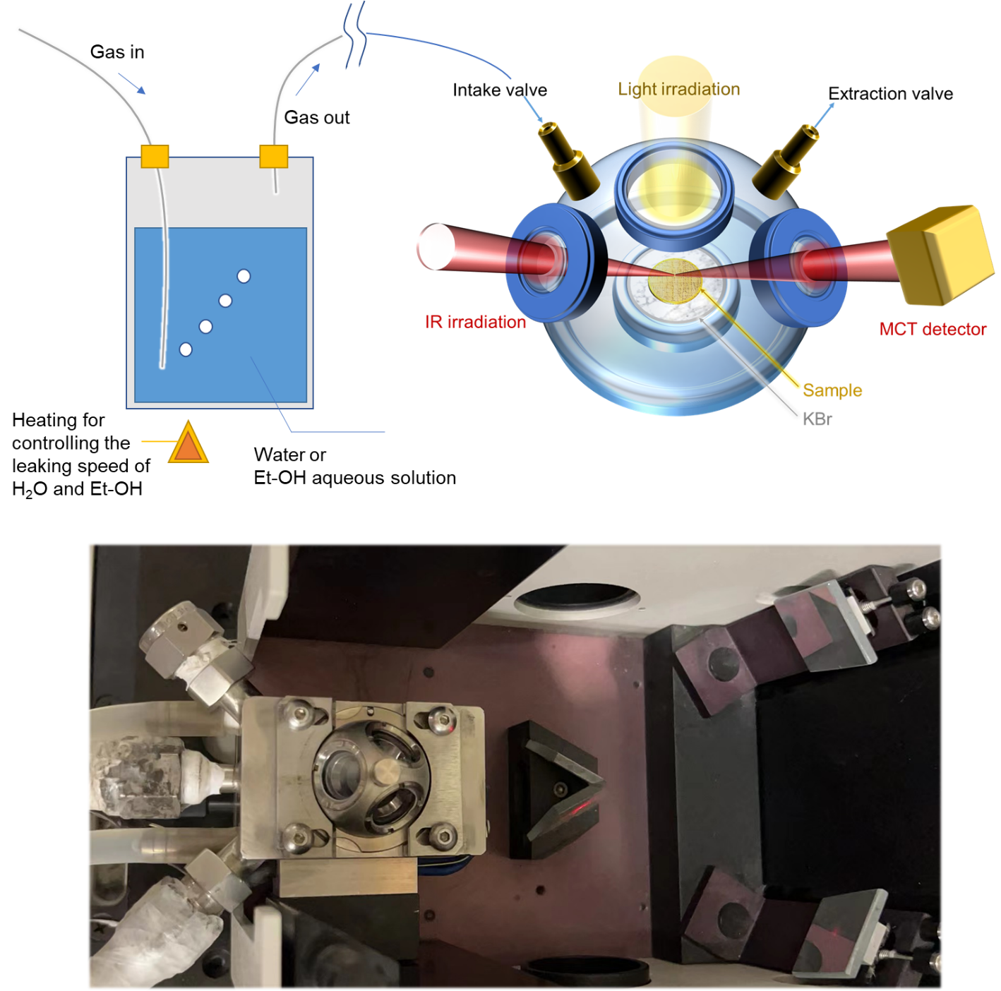

Supplementary Figure 42 | Schematic diagram (up) and the actual setup (down) for in-situ FTIR spectroscopy measurements.
Note: In-situ FTIR spectra of PCN, AuPCN, KPCN and AuKPCN exposed to humid O₂ (10% v/v ethanol aqueous solution was used for supplying the humid atmosphere of ethanol and H₂O) under light irradiation for 30 mins were recorded. Ethanol was used as a probe to investigate the oxidation process of photogenerated reactive species. Since both of the 2e⁻ ORR products (H₂O₂ and ⋅OH via further reduction of H₂O₂) and 1e⁻ WOR product (⋅OH) could oxidize ethanol, an isotopic experiment was conducted in humid O₂ and H₂O¹⁸ for investigating whether the 1e⁻ WOR dominated the ethanol oxidation process.

Supplementary Figure 43 | In-situ FTIR spectra of PCN, KPCN, AuPCN and AuKPCN exposed to water vapor (H₂O¹⁶) and O₂ under light irradiation. a-d, PCN (a), KPCN (b), AuPCN (c) and AuKPCN (d).

Supplementary Figure 44 | In-situ FTIR spectra of AuKPCN exposed to water vapor (H₂O¹⁸) and O₂ under light irradiation.

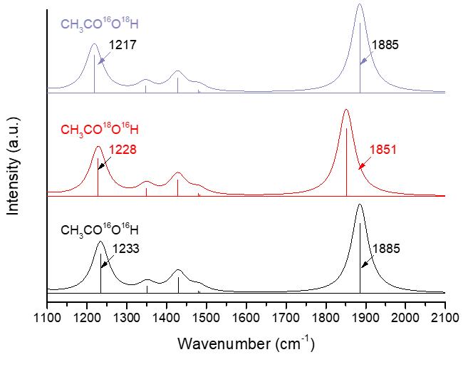

Supplementary Figure 45 | Simulated FTIR spectra of CH₃COOH. The movies of variations of CH₃CO¹⁸OH and CH₃C¹⁸OOH were presented as supplementary animations.

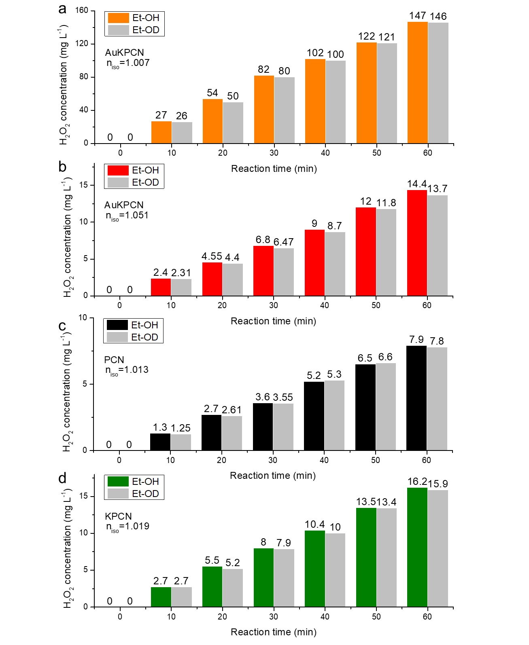

Supplementary Figure 46 | Isotopic experiments to investigate mass transfer of protons in the systems of AuKPCN (a), AuPCN (b), PCN (c) and KPCN (d) during photocatalytic H₂O₂ production in H₂O with addition of 10% (v/v) of CH₃CH₂OH (Et-OH) or CH₃CH₂OD (Et-OD).

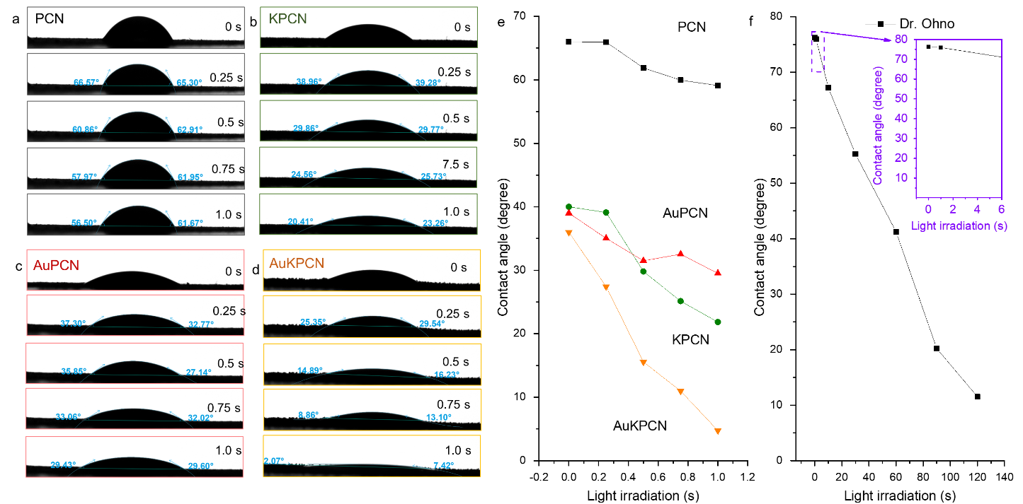

Supplementary Figure 47 | Surface hydrophilicity evolution. a-d, Contact angle images of PCN (a), KPCN (b), AuPCN (c) and AuKPCN (d) under light irradiation. e-f, The changing tendency of contact angles. The substrate used for contact angle measurement is 5160 steel.
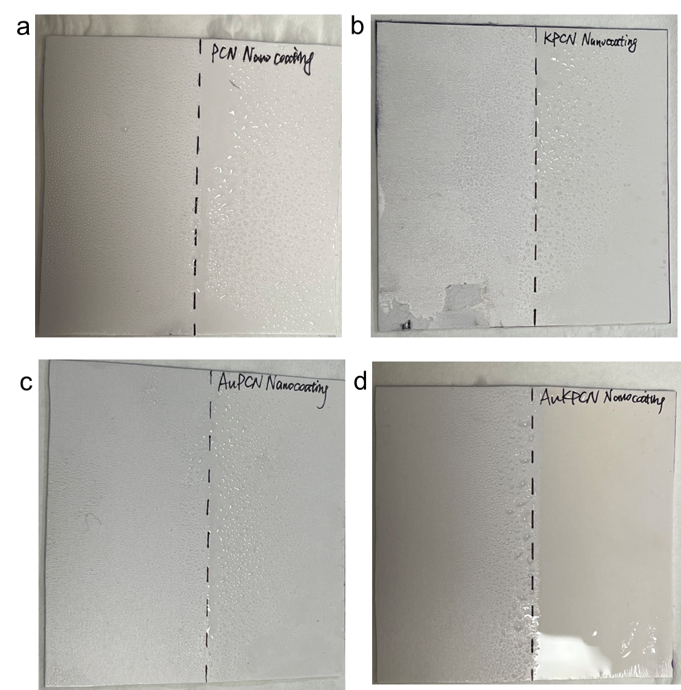

Supplementary Figure 48 | Self-cleaning coatings on polyvinyl chloride (PVC) sheets: PCN (a), AuPCN (b), KPCN (c) and AuKPCN (d).

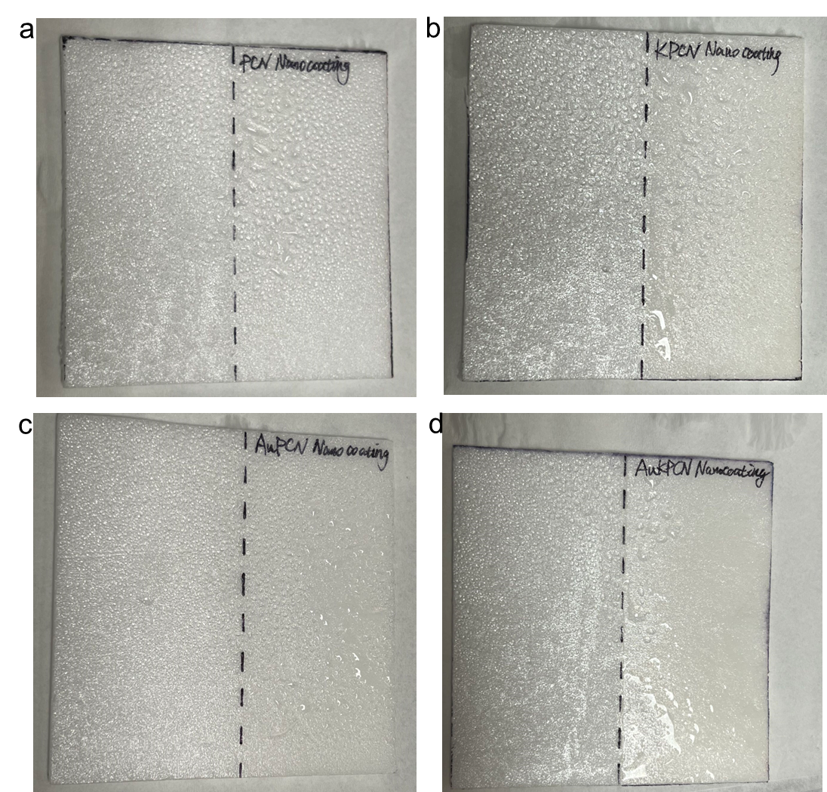

Supplementary Figure 49 | Self-cleaning coatings on melamine foam sheets: PCN (a), KPCN (b), AuPCN (c) and AuKPCN (d).

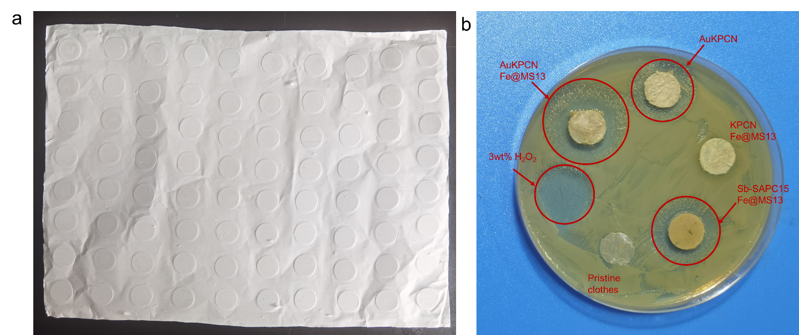

Supplementary Figure 50 | Zone inhibition test for the coating of nanocomposites towards S. aureus. a, A digital photograph of the as-prepared PLLA cloth. b, The bacteriostatic effect.

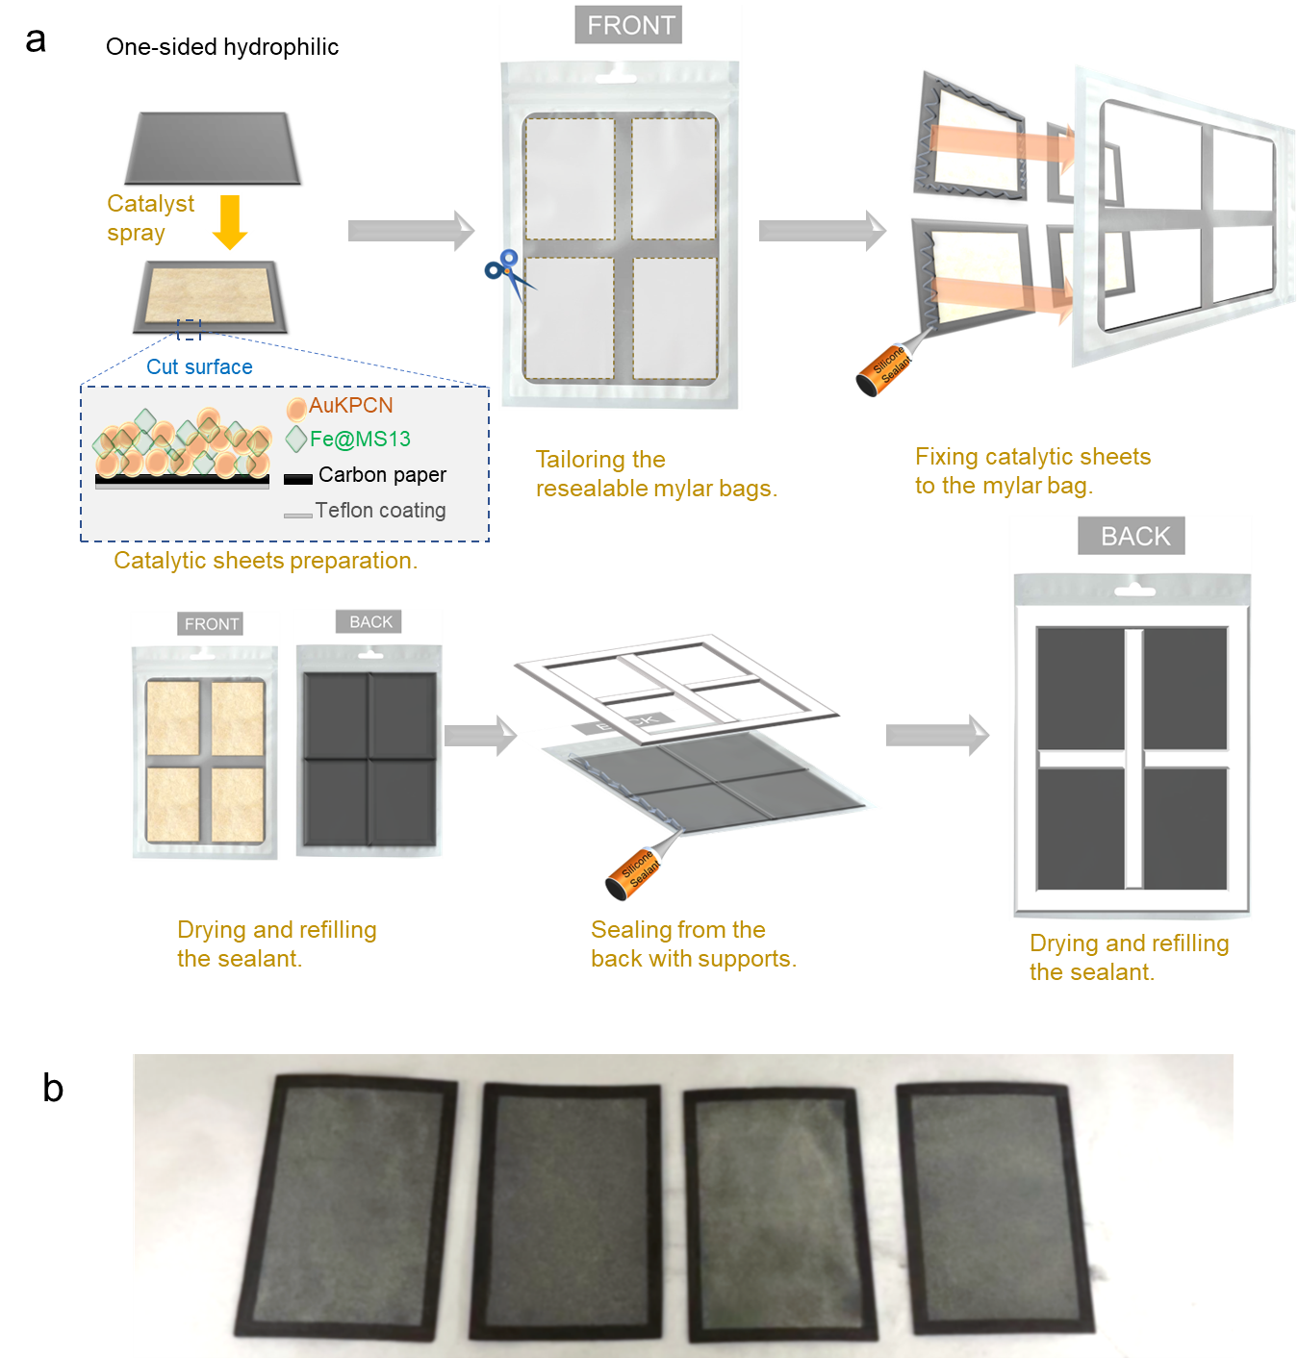

Supplementary Figure 51 | Preparation of onsite device for solar water purification. a, Schematic diagram of preparation. b, The as-prepared catalytic sheet on a carbon paper.

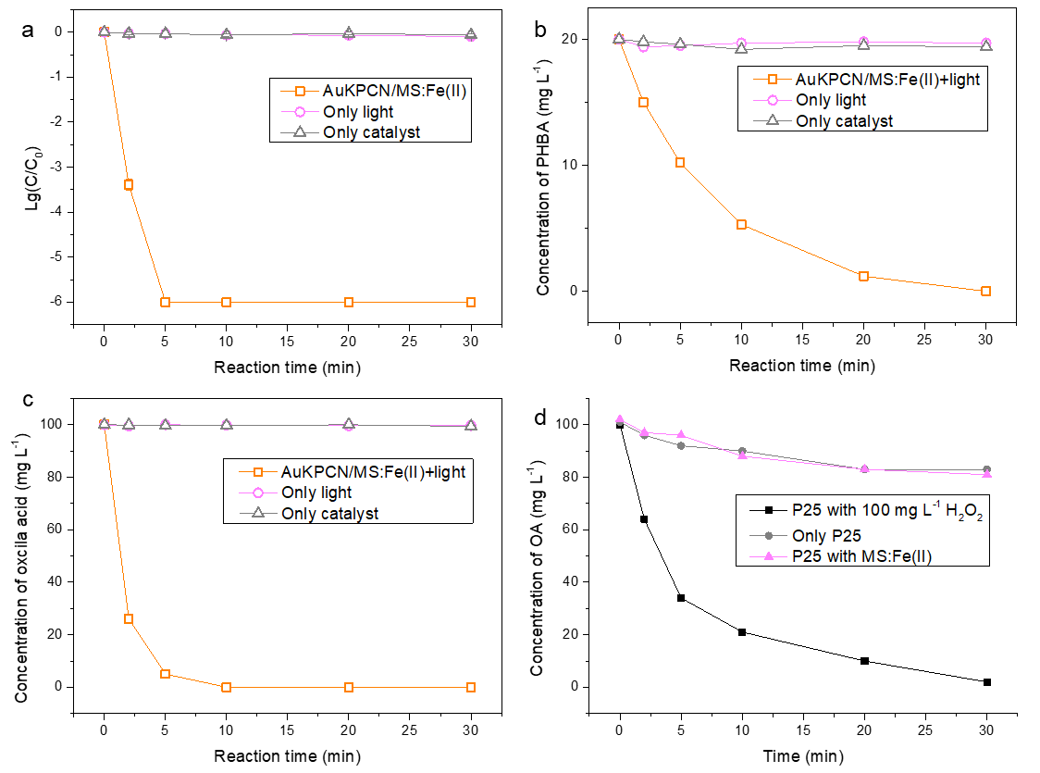

Supplementary Figure 52 | Control experiments of AuKPCN and P25. a-c, Comparison of the water purification performances of AuKPCN-based catalysts with control experiments. d, Control experiments of P25.

Supplementary Table 1. Heterogeneous photo/electro-Fenton oxidation of refractory organic matters.
Catalyst | System | Target | Operating conditions | Research result | Ref.
FeS₂/g-C₃N₄ | Heterogeneous  photo-Fenton | Tetracycline  (0.05 g L⁻¹) | [H₂O₂] = 50 mM (1700 mg L⁻¹)  pH = 7–8  150 W xenon lamp full spectra | Degradation efficiency = 93%  60 min | ¹²
g-C₃N₄/Fe₂O₃ | Heterogeneous  photo-Fenton | Tetracycline  (0.05 g L⁻¹) | [H₂O₂] = 50 mM (1700 mg L⁻¹)  pH = 3-11  300 W Xenon lamp (l_{r} = 2500 W·m⁻²) | Degradation efficiency = 94.2%  in 60 min | ¹³
g-C₃N₄ | Heterogeneous  Fenton-like reaction | Oxalic acid (100 mg L⁻¹) | Visible light+ O₃  pH=3  360 mW cm⁻² | > 99%  in 30 min | ¹⁴
NP g-C₃N₄ | Heterogeneous  Fenton-like reaction | p-hydroxybenzoic acid  (100 mg L⁻¹) | Visible light+ O₃  pH=3  360 mW cm⁻² | > 99%  in 60 min | ¹⁵
Fe₃O₄/MC800 | Heterogeneous  Fenton-like reaction | p-hydroxybenzoic acid  (10 mg L⁻¹) | peroxymonosulfate (PMS)  - g/L)  HBA: 10 mg/L | >99%  in 30 min | ¹⁶
Fe(II)+H₂O₂ | Fenton | p-hydroxybenzoic acid (0.01M)  1 L water | 5×10⁻³ M Fe, 2 M H₂O₂ | >90%  in 30 min | ¹⁷
C/Cu | Fenton | RhB (10 μM)  in 10 mL | 1000 mM H₂O₂ | > 99%  in 5 min | ¹⁸
AuKPCN/MS-13Fe(II) | Photocatalytic H₂O₂ synthesis & Heterogeneous Fenton reaction | Oxalic acid  (100 mg L⁻¹) or  p-hydroxybenzoic acid  (20 mg L⁻¹)  40 mL of  ~0.1 cm of water in a flatten bag | 1.5 AM sunlight  400 cm²  photocatalytic sheets  No oxidant is added except water and O₂ | > 99%  in 10 min for oxalic acid;  in 30 min for p-hydroxybenzoic acid | This work

Supplementary Table 2. Activity comparison for disinfection of E coil.
Target | System | Initial Conc.  of E. coli  (cfu ml⁻¹) | Operating conditions | Research result | Ref.
TiO₂/cellulose 6 | Photocatalytic | 6.5 x 10⁴  Volume of water was not provided. | UVB: 365nm  36 000 mJ cm⁻² | 30 min | ¹⁹
TiO₂/PS | Photocatalytic | 1x10⁵  Volume of water was not provided. | UVB: 365nm  1 mW cm⁻² | 45min | ²⁰
UV+ClO₂ | Non-catalytic | 3.57x10⁴  Volume of water was not provided. | 16 mJ cm⁻² | 24 h | ²¹
FeSO₄/H₂O₂ | Ultrasound coupled photo-Fenton | 1x10⁶  230 mL | 1200 W m⁻²  Xeon lamp | 240 min | ²²
Ni-Sb-SnO₂ | electrocatalytic | 1x10⁸  Volume of water was not provided. | Electrode area: 8 cm²  I =12.5 mA cm⁻² | 12 min | ²³
MoS₂ co-catalytic Fe²⁺ /H₂O₂ | Fenton | 1x10⁶  100 mL | 0.30 mg mL⁻² MoS₂  FeSO₄·7H₂O  (2 mg mL⁻¹) | 30 min | ²⁴
Ag/TiO₂ | Photocatalytic | 1x10⁸  100 mL | UVB 2 W m^{-2 **}  100 mL⁻¹ | 50 min | ²⁵
FLV-MoS₂\Cu | Photocatalytic reactions | 1x10⁵  25 mL | 1.5 AM;  1 cm × 2 cm × 40 nm | 20 min | ²⁶
1%AuPd/TiO₂ + H₂ + O₂ | Heterogeneous Catalysis | 1x10⁸  ~ 10 mL | 42 ml min^{–1} gas flow of 2% H₂/air | 0.5 min | ²⁷
AuKPCN/MS-13Fe(II) | Photocatalytic H₂O₂ synthesis & heterogeneous Fenton | 1x10⁶  40 mL  ~0.1 cm of water in a flatten bag | 1.5 AM sunlight  240 cm² photocatalytic sheets.  No oxidant is added except water and O₂ | 5 min | This work.
**UVB 2 W m⁻²; similar to the UVB region of AM1.5.

Supplementary Table 3. Mass percentage of Au and K in PCN, KPCN, AuPCN and AuKPCN.
 | Mass percentage of K  (%) | Mass percentage of Au  (%)
PCN | N/A | N/A
AuPCN0.6 | N/A | 0.06%
AuPCN1.2 | N/A | 0.11%
AuPCN2.4 | N/A | 0.23%
AuPCN4.8 | N/A | 0.48%
KPCN | 7.50% | N/A
AuKPCN0.6 | 7.50% | 0.06%
AuKPCN1.2 | 7.49% | 0.11%
AuKPCN2.4 | 7.48% | 0.23%
AuKPCN4.8 | 7.47% | 0.47%
Note: We have tried to wash the as-prepared KPCN and AuKPCN samples by hot water (90 °C) for extremely long time (24 hours) in order to remove K ions in the carbon nitride matrix. However, the ICP results showed that the K content kept almost constant after this treatment. As revealed in the simulations based on DFT, potassium tended to bond onto the matrix of PCN. However, the introduction of K into PCN only slightly enhanced its photocatalytic activity.

Supplementary Table 4. Fitting parameters of EXAFS data.
Sample | Shell | N | R/Å | ΔE | Debye-Waller factor σ² (Å²) | R-factor
AuPCN | Au-N | 3.4±0.2 | 1.619 | 9.567 | 0.00465 | 2.00506
AuKPCN | Au-C | 0.85±0.2 | 1.550 | 7.643 | 0.00300 | 1.86962
 | Au-N | 2.04±0.2 | 1.700 | 8.072 | 0.00100 | 2.00892
Shell: scattering pathway; N: coordination number; R: bond distance; ΔE: the inner potential correction. The obtained XAFS data was processed in Athena (version 0.9.25) for background, pre-edge line and post-edge line calibrations. The data range adopted for data fitting in k-space and R space are 3-10.5 Å⁻¹ and 1-3 Å, respectively.

Supplementary Table 5. Calculated coordination number and bond length of Melem_6Au and Melem_6KAu.
Sample | Bond | N | Bond length /Å | Bond length in average of Au-N or Au-C | Bond length in average of the 1st shell
Melem_6Au | Au-N(39) | 4 | 2.83123 | 2.762 | 2.762
 | Au-N(7) | 4 | 2.692 | 2.762 | 2.762
 | Au-N(27) | 4 | 2.786 | 2.762 | 2.762
 | Au-N(41) | 4 | 2.73994 | 2.762 | 2.762
Melem_6KAu | Au-C(4) | 1 | 2.267 | 2.267 | 2.764
 | Au-N(12) | 3 | 2.947 | 2.929 | 2.764
 | Au-N(10) | 3 | 2.951 | 2.929 | 2.764
 | Au-N(7) | 3 | 2.889 | 2.929 | 2.764
Bond: Au bonds formed in the optimized model; The atomic number of N and C of the 1st shell are marked in the table; N: coordination number; Bond length: atomic distance measured by Gaussian view.

Supplementary Table 6. Excitation properties based on the wavefunctions of Melem_6.
 | MOC (h⁺) |  | MOC (e⁻) |  |  | MOC (h⁺) |  | MOC (e⁻) |  |  | MOC (h⁺) |  | MOC (e⁻) |  |  | MOC (h⁺) |  | MOC (e⁻) |  |  | MOC (h⁺) |  | MOC (e⁻)
S0→S1 | 291 | 8.23% | 297 | 59.63% | S0→S11 | 281 | 5.89% | 297 | 19.21% | S0→S21 | 263 | 4.36% | 297 | 10.59% | S0→S31 | 291 | 6.56% | 297 | 10.23% | S0→S41 | 287 | 4.19% | 297 | 16.66%
S0→S1 | 292 | 3.11% | 298 | 12.72% | S0→S11 | 287 | 14.54% | 298 | 27.38% | S0→S21 | 265 | 5.80% | 298 | 40.59% | S0→S31 | 292 | 7.53% | 298 | 11.59% | S0→S41 | 288 | 9.55% | 298 | 8.09%
S0→S1 | 293 | 20.39% | 299 | 7.57% | S0→S11 | 288 | 4.94% | 299 | 5.98% | S0→S21 | 266 | 28.23% | 299 | 6.30% | S0→S31 | 293 | 10.24% | 301 | 13.82% | S0→S41 | 289 | 9.09% | 300 | 7.47%
S0→S1 | 295 | 16.33% | 301 | 5.24% | S0→S11 | 289 | 13.71% | 300 | 7.75% | S0→S21 | 267 | 5.28% | 300 | 5.55% | S0→S31 | 295 | 21.65% | 302 | 18.08% | S0→S41 | 290 | 10.86% | 303 | 15.08%
S0→S1 | 296 | 44.98% | 308 | 3.35% | S0→S11 | 295 | 6.90% | 301 | 13.80% | S0→S21 | 289 | 4.73% | 301 | 9.77% | S0→S31 | 296 | 14.67% | 303 | 8.31% | S0→S41 | 294 | 6.76% | 304 | 10.29%
S0→S2 | 291 | 3.45% | 297 | 22.20% | S0→S12 | 270 | 6.60% | 297 | 15.07% | S0→S22 | 265 | 6.59% | 297 | 30.60% | S0→S32 | 291 | 8.11% | 297 | 10.58% | S0→S42 | 265 | 5.98% | 298 | 13.90%
S0→S2 | 292 | 5.90% | 298 | 48.88% | S0→S12 | 271 | 9.71% | 298 | 9.46% | S0→S22 | 266 | 6.38% | 298 | 11.54% | S0→S32 | 292 | 18.27% | 299 | 15.17% | S0→S42 | 291 | 6.13% | 299 | 24.85%
S0→S2 | 293 | 25.23% | 299 | 8.37% | S0→S12 | 285 | 10.04% | 299 | 30.48% | S0→S22 | 267 | 13.31% | 299 | 11.80% | S0→S32 | 294 | 15.32% | 302 | 15.47% | S0→S42 | 293 | 24.20% | 300 | 8.17%
S0→S2 | 295 | 41.15% | 300 | 4.21% | S0→S12 | 287 | 18.88% | 300 | 12.19% | S0→S22 | 268 | 15.25% | 300 | 10.82% | S0→S32 | 295 | 13.24% | 303 | 8.66% | S0→S42 | 295 | 5.48% | 302 | 12.49%
S0→S2 | 296 | 15.85% | 301 | 4.14% | S0→S12 | 288 | 9.29% | 304 | 9.96% | S0→S22 | 278 | 6.13% | 301 | 7.66% | S0→S32 | 296 | 13.74% | 304 | 12.62% | S0→S42 | 296 | 11.96% | 304 | 7.14%
S0→S3 | 292 | 4.58% | 297 | 3.29% | S0→S13 | 270 | 6.63% | 297 | 23.36% | S0→S23 | 264 | 6.67% | 297 | 17.92% | S0→S33 | 291 | 9.34% | 297 | 13.77% | S0→S43 | 288 | 3.96% | 297 | 16.84%
S0→S3 | 293 | 29.04% | 298 | 10.76% | S0→S13 | 281 | 6.66% | 298 | 25.69% | S0→S23 | 265 | 4.77% | 298 | 16.52% | S0→S33 | 293 | 9.85% | 298 | 8.32% | S0→S43 | 290 | 14.03% | 298 | 10.13%
S0→S3 | 295 | 29.87% | 299 | 64.54% | S0→S13 | 285 | 5.36% | 300 | 7.34% | S0→S23 | 277 | 7.18% | 299 | 14.19% | S0→S33 | 294 | 8.20% | 300 | 16.99% | S0→S43 | 293 | 14.20% | 299 | 12.34%
S0→S3 | 296 | 26.99% | 300 | 5.99% | S0→S13 | 287 | 18.17% | 301 | 11.11% | S0→S23 | 278 | 5.14% | 300 | 11.69% | S0→S33 | 295 | 14.80% | 301 | 8.35% | S0→S43 | 295 | 6.98% | 302 | 7.60%
S0→S3 |  |  | 301 | 3.01% | S0→S13 | 289 | 7.29% | 303 | 7.78% | S0→S23 | 289 | 5.14% | 301 | 8.35% | S0→S33 | 296 | 22.82% | 302 | 12.08% | S0→S43 | 296 | 3.86% | 304 | 15.98%
S0→S4 | 291 | 24.56% | 297 | 20.56% | S0→S14 | 278 | 15.83% | 297 | 29.05% | S0→S24 | 263 | 7.03% | 297 | 9.70% | S0→S34 | 272 | 6.44% | 297 | 11.95% | S0→S44 | 288 | 10.38% | 297 | 12.97%
S0→S4 | 292 | 10.31% | 298 | 21.92% | S0→S14 | 284 | 6.10% | 298 | 10.47% | S0→S24 | 277 | 5.22% | 298 | 16.04% | S0→S34 | 273 | 24.25% | 298 | 9.37% | S0→S44 | 289 | 9.34% | 298 | 9.52%
S0→S4 | 294 | 34.53% | 299 | 9.17% | S0→S14 | 287 | 8.98% | 299 | 10.04% | S0→S24 | 280 | 5.05% | 299 | 22.03% | S0→S34 | 274 | 31.87% | 299 | 9.74% | S0→S44 | 290 | 7.46% | 300 | 11.48%
S0→S4 | 295 | 9.52% | 300 | 23.64% | S0→S14 | 288 | 13.85% | 300 | 17.61% | S0→S24 | 290 | 5.95% | 300 | 9.13% | S0→S34 | 288 | 2.98% | 300 | 15.68% | S0→S44 | 291 | 5.21% | 303 | 11.46%
S0→S4 | 296 | 11.64% | 301 | 8.94% | S0→S14 | 291 | 4.61% | 301 | 5.56% | S0→S24 | 295 | 5.33% | 301 | 9.31% | S0→S34 | 296 | 2.61% | 306 | 16.52% | S0→S44 | 294 | 5.22% | 304 | 8.96%
S0→S5 | 291 | 10.02% | 297 | 11.10% | S0→S15 | 283 | 6.76% | 297 | 23.44% | S0→S25 | 291 | 6.30% | 297 | 12.91% | S0→S35 | 272 | 32.85% | 298 | 15.93% | S0→S45 | 265 | 9.38% | 297 | 6.16%
S0→S5 | 292 | 36.26% | 298 | 22.93% | S0→S15 | 286 | 7.99% | 298 | 15.54% | S0→S25 | 292 | 7.48% | 298 | 9.92% | S0→S35 | 273 | 8.86% | 299 | 13.97% | S0→S45 | 283 | 7.40% | 298 | 7.53%
S0→S5 | 294 | 25.57% | 299 | 19.01% | S0→S15 | 293 | 6.68% | 299 | 12.26% | S0→S25 | 293 | 15.86% | 299 | 8.44% | S0→S35 | 289 | 4.14% | 301 | 13.77% | S0→S45 | 287 | 4.91% | 299 | 14.17%
S0→S5 | 295 | 10.67% | 300 | 7.41% | S0→S15 | 295 | 6.98% | 300 | 7.80% | S0→S25 | 295 | 27.84% | 303 | 11.51% | S0→S35 | 295 | 7.80% | 305 | 13.74% | S0→S45 | 290 | 12.08% | 302 | 14.31%
S0→S5 | 296 | 6.16% | 301 | 22.86% | S0→S15 | 296 | 8.79% | 303 | 8.80% | S0→S25 | 296 | 18.21% | 304 | 19.49% | S0→S35 | 296 | 4.54% | 307 | 7.77% | S0→S45 | 293 | 6.78% | 304 | 8.60%
S0→S6 | 291 | 27.77% | 297 | 18.08% | S0→S16 | 270 | 11.01% | 297 | 18.66% | S0→S26 | 291 | 5.28% | 298 | 11.71% | S0→S36 | 272 | 12.22% | 297 | 9.99% | S0→S46 | 291 | 8.32% | 297 | 8.11%
S0→S6 | 292 | 17.29% | 298 | 16.13% | S0→S16 | 271 | 17.75% | 298 | 13.94% | S0→S26 | 292 | 6.05% | 299 | 8.77% | S0→S36 | 273 | 23.92% | 299 | 12.22% | S0→S46 | 292 | 9.39% | 299 | 8.45%
S0→S6 | 294 | 28.50% | 299 | 15.76% | S0→S16 | 290 | 7.39% | 299 | 25.06% | S0→S26 | 293 | 16.32% | 302 | 13.58% | S0→S36 | 274 | 24.42% | 300 | 11.88% | S0→S46 | 294 | 12.37% | 305 | 8.92%
S0→S6 | 295 | 7.08% | 300 | 18.61% | S0→S16 | 295 | 7.25% | 300 | 8.33% | S0→S26 | 295 | 23.45% | 303 | 16.89% | S0→S36 | 278 | 3.00% | 305 | 10.36% | S0→S46 | 295 | 10.08% | 306 | 11.76%
S0→S6 | 296 | 9.58% | 301 | 13.91% | S0→S16 | 296 | 7.61% | 304 | 8.22% | S0→S26 | 296 | 25.55% | 304 | 11.20% | S0→S36 | 296 | 4.05% | 306 | 12.84% | S0→S46 | 296 | 8.36% | 307 | 11.11%
S0→S7 | 263 | 3.58% | 297 | 4.82% | S0→S17 | 263 | 6.44% | 297 | 11.72% | S0→S27 | 284 | 5.73% | 297 | 20.81% | S0→S37 | 272 | 16.73% | 297 | 12.88% | S0→S47 | 287 | 5.96% | 298 | 10.12%
S0→S7 | 283 | 9.25% | 298 | 6.87% | S0→S17 | 270 | 6.51% | 298 | 17.11% | S0→S27 | 291 | 4.70% | 298 | 8.13% | S0→S37 | 273 | 14.33% | 298 | 14.90% | S0→S47 | 289 | 4.90% | 299 | 6.85%
S0→S7 | 289 | 4.49% | 299 | 53.22% | S0→S17 | 277 | 5.66% | 299 | 15.88% | S0→S27 | 293 | 11.79% | 300 | 8.18% | S0→S37 | 274 | 9.89% | 299 | 16.68% | S0→S47 | 290 | 7.03% | 302 | 11.55%
S0→S7 | 290 | 49.14% | 301 | 11.71% | S0→S17 | 283 | 5.46% | 300 | 11.22% | S0→S27 | 295 | 9.51% | 303 | 23.12% | S0→S37 | 286 | 5.20% | 301 | 10.77% | S0→S47 | 292 | 8.21% | 303 | 6.87%
S0→S7 | 293 | 5.86% | 302 | 7.85% | S0→S17 | 290 | 15.96% | 301 | 10.16% | S0→S27 | 296 | 25.92% | 304 | 7.21% | S0→S37 | 287 | 7.04% | 305 | 9.94% | S0→S47 | 294 | 7.00% | 304 | 7.49%
S0→S8 | 288 | 10.68% | 297 | 12.90% | S0→S18 | 264 | 7.87% | 297 | 19.93% | S0→S28 | 292 | 8.72% | 297 | 13.99% | S0→S38 | 272 | 5.83% | 297 | 8.65% | S0→S48 | 283 | 5.38% | 302 | 12.52%
S0→S8 | 289 | 37.00% | 298 | 41.16% | S0→S18 | 275 | 4.67% | 298 | 17.35% | S0→S28 | 293 | 15.48% | 298 | 15.68% | S0→S38 | 279 | 4.71% | 298 | 17.67% | S0→S48 | 290 | 6.47% | 304 | 8.10%
S0→S8 | 292 | 5.22% | 299 | 6.42% | S0→S18 | 277 | 6.53% | 299 | 8.04% | S0→S28 | 294 | 10.18% | 299 | 10.64% | S0→S38 | 285 | 9.07% | 299 | 33.55% | S0→S48 | 292 | 5.60% | 305 | 6.62%
S0→S8 | 293 | 4.99% | 300 | 9.19% | S0→S18 | 278 | 5.54% | 300 | 12.99% | S0→S28 | 295 | 17.62% | 303 | 9.94% | S0→S38 | 286 | 14.05% | 301 | 9.22% | S0→S48 | 294 | 7.16% | 307 | 8.94%
S0→S8 | 294 | 5.04% | 301 | 10.60% | S0→S18 | 289 | 12.72% | 301 | 9.92% | S0→S28 | 296 | 10.25% | 304 | 10.85% | S0→S38 | 288 | 5.01% | 302 | 5.68% | S0→S48 | 295 | 9.18% | 310 | 6.55%
S0→S9 | 283 | 5.26% | 297 | 30.75% | S0→S19 | 267 | 10.24% | 297 | 37.15% | S0→S29 | 291 | 13.11% | 297 | 19.12% | S0→S39 | 271 | 3.99% | 297 | 25.40% | S0→S49 | 290 | 7.48% | 299 | 6.34%
S0→S9 | 288 | 20.53% | 298 | 14.10% | S0→S19 | 268 | 19.93% | 299 | 7.30% | S0→S29 | 293 | 13.03% | 298 | 15.42% | S0→S39 | 292 | 3.94% | 298 | 14.69% | S0→S49 | 291 | 8.25% | 304 | 6.85%
S0→S9 | 289 | 10.04% | 299 | 12.67% | S0→S19 | 270 | 5.36% | 300 | 15.59% | S0→S29 | 294 | 13.90% | 302 | 8.26% | S0→S39 | 293 | 8.14% | 299 | 18.17% | S0→S49 | 292 | 7.74% | 305 | 10.05%
S0→S9 | 290 | 7.13% | 300 | 11.37% | S0→S19 | 278 | 6.52% | 301 | 6.18% | S0→S29 | 295 | 10.45% | 303 | 8.59% | S0→S39 | 295 | 29.44% | 300 | 9.18% | S0→S49 | 294 | 12.69% | 306 | 10.70%
S0→S9 | 291 | 4.93% | 301 | 8.67% | S0→S19 | 288 | 6.78% | 308 | 8.64% | S0→S29 | 296 | 12.98% | 304 | 8.77% | S0→S39 | 296 | 25.77% | 301 | 7.67% | S0→S49 | 296 | 7.40% | 307 | 12.56%
S0→S10 | 283 | 18.19% | 297 | 13.63% | S0→S20 | 264 | 7.07% | 297 | 14.63% | S0→S30 | 291 | 6.94% | 297 | 9.85% | S0→S40 | 264 | 4.79% | 297 | 13.88% | S0→S50 | 287 | 7.01% | 297 | 10.29%
S0→S10 | 284 | 5.90% | 298 | 9.61% | S0→S20 | 265 | 14.95% | 298 | 10.61% | S0→S30 | 292 | 7.30% | 298 | 13.89% | S0→S40 | 289 | 11.11% | 298 | 14.09% | S0→S50 | 289 | 6.41% | 300 | 9.49%
S0→S10 | 288 | 7.00% | 299 | 29.18% | S0→S20 | 267 | 6.63% | 299 | 25.19% | S0→S30 | 294 | 10.42% | 299 | 19.42% | S0→S40 | 290 | 10.16% | 299 | 9.44% | S0→S50 | 293 | 6.53% | 303 | 10.88%
S0→S10 | 290 | 22.56% | 300 | 8.06% | S0→S20 | 283 | 9.31% | 300 | 9.99% | S0→S30 | 295 | 14.32% | 302 | 9.56% | S0→S40 | 293 | 13.87% | 301 | 8.70% | S0→S50 | 294 | 5.97% | 306 | 8.82%
S0→S10 | 296 | 4.40% | 301 | 15.52% | S0→S20 | 290 | 9.55% | 301 | 6.87% | S0→S30 | 296 | 12.70% | 304 | 10.32% | S0→S40 | 295 | 6.16% | 304 | 13.97% | S0→S50 | 295 | 5.53% | 311 | 7.60%

Supplementary Table 7. Excitation properties based on the wavefunctions of Melem_6K.
 | MOC (h⁺) |  | MOC (e⁻) |  |  | MOC (h⁺) |  | MOC (e⁻) |  |  | MOC (h⁺) |  | MOC (e⁻) |  |  | MOC (h⁺) |  | MOC (e⁻) |  |  | MOC (h⁺) |  | MOC (e⁻)
S0→S1 | 303 | 43.50% | 308 | 73.34% | S0→S11 | 278 | 5.46% | 306 | 10.30% | S0→S21 | 277 | 5.26% | 306 | 16.98% | S0→S31 | 273 | 13.97% | 306 | 21.92% | S0→S41 | 281 | 7.19% | 306 | 13.17%
S0→S1 | 304 | 5.53% | 309 | 7.14% | S0→S11 | 287 | 8.72% | 307 | 46.65% | S0→S21 | 278 | 9.16% | 307 | 24.74% | S0→S31 | 274 | 5.17% | 307 | 14.98% | S0→S41 | 293 | 6.11% | 307 | 8.29%
S0→S1 | 305 | 44.28% | 312 | 2.23% | S0→S11 | 289 | 12.66% | 308 | 7.48% | S0→S21 | 281 | 4.77% | 308 | 9.21% | S0→S31 | 301 | 6.54% | 308 | 7.68% | S0→S41 | 301 | 6.03% | 310 | 24.35%
S0→S1 |  |  | 317 | 3.69% | S0→S11 | 303 | 9.32% | 309 | 9.82% | S0→S21 | 302 | 6.69% | 310 | 7.61% | S0→S31 | 303 | 5.54% | 309 | 8.52% | S0→S41 | 303 | 6.46% | 311 | 8.30%
S0→S1 |  |  |  |  | S0→S11 | 305 | 12.41% | 310 | 8.17% | S0→S21 | 305 | 5.49% | 311 | 8.79% | S0→S31 | 305 | 5.86% | 311 | 7.74% | S0→S41 | 304 | 10.88% | 315 | 10.21%
S0→S2 | 300 | 4.29% | 306 | 26.51% | S0→S12 | 288 | 7.28% | 306 | 9.54% | S0→S22 | 281 | 3.13% | 306 | 9.86% | S0→S32 | 290 | 27.58% | 306 | 9.57% | S0→S42 | 284 | 9.56% | 306 | 11.33%
S0→S2 | 301 | 30.46% | 307 | 42.81% | S0→S12 | 295 | 10.44% | 307 | 28.64% | S0→S22 | 285 | 7.20% | 307 | 23.10% | S0→S32 | 291 | 5.40% | 307 | 8.96% | S0→S42 | 300 | 22.31% | 307 | 7.93%
S0→S2 | 302 | 25.48% | 308 | 3.12% | S0→S12 | 300 | 6.83% | 308 | 16.97% | S0→S22 | 303 | 8.68% | 308 | 17.30% | S0→S32 | 293 | 8.60% | 308 | 9.07% | S0→S42 | 303 | 8.75% | 308 | 10.06%
S0→S2 | 304 | 19.38% | 309 | 13.28% | S0→S12 | 303 | 11.12% | 309 | 6.53% | S0→S22 | 304 | 11.17% | 309 | 9.35% | S0→S32 | 294 | 9.45% | 309 | 8.84% | S0→S42 | 304 | 6.47% | 309 | 9.45%
S0→S2 | 305 | 4.15% | 317 | 3.27% | S0→S12 | 305 | 10.90% | 311 | 6.69% | S0→S22 | 305 | 24.63% | 312 | 8.37% | S0→S32 | 301 | 7.65% | 317 | 15.90% | S0→S42 | 305 | 8.92% | 312 | 15.52%
S0→S3 | 296 | 3.52% | 306 | 16.39% | S0→S13 | 283 | 8.05% | 306 | 6.18% | S0→S23 | 276 | 11.76% | 306 | 27.69% | S0→S33 | 291 | 13.72% | 308 | 13.68% | S0→S43 | 300 | 16.56% | 306 | 13.53%
S0→S3 | 301 | 19.95% | 307 | 48.43% | S0→S13 | 287 | 18.04% | 307 | 8.54% | S0→S23 | 302 | 6.53% | 307 | 14.16% | S0→S33 | 292 | 36.25% | 311 | 12.28% | S0→S43 | 301 | 3.93% | 307 | 7.88%
S0→S3 | 302 | 37.93% | 308 | 4.27% | S0→S13 | 289 | 16.67% | 308 | 40.63% | S0→S23 | 303 | 9.55% | 308 | 9.30% | S0→S33 | 296 | 9.06% | 318 | 7.36% | S0→S43 | 303 | 17.86% | 308 | 8.22%
S0→S3 | 304 | 6.63% | 309 | 10.69% | S0→S13 | 291 | 7.42% | 309 | 12.38% | S0→S23 | 304 | 14.16% | 309 | 9.51% | S0→S33 | 302 | 3.78% | 319 | 9.68% | S0→S43 | 304 | 8.46% | 309 | 8.80%
S0→S3 | 305 | 16.39% | 311 | 6.50% | S0→S13 | 302 | 7.64% | 312 | 4.42% | S0→S23 | 305 | 11.40% | 310 | 7.93% | S0→S33 | 305 | 4.84% | 320 | 7.04% | S0→S43 | 305 | 9.98% | 312 | 14.56%
S0→S4 | 301 | 4.76% | 306 | 5.52% | S0→S14 | 282 | 5.83% | 306 | 13.40% | S0→S24 | 276 | 27.86% | 306 | 32.58% | S0→S34 | 273 | 6.09% | 306 | 19.64% | S0→S44 | 284 | 7.70% | 308 | 11.83%
S0→S4 | 302 | 9.94% | 307 | 15.87% | S0→S14 | 287 | 9.06% | 307 | 39.09% | S0→S24 | 279 | 5.12% | 307 | 18.98% | S0→S34 | 276 | 4.87% | 307 | 16.09% | S0→S44 | 285 | 11.60% | 312 | 10.39%
S0→S4 | 303 | 13.42% | 308 | 23.94% | S0→S14 | 301 | 5.11% | 308 | 8.99% | S0→S24 | 281 | 4.94% | 308 | 5.16% | S0→S34 | 287 | 5.71% | 308 | 14.38% | S0→S44 | 295 | 6.80% | 313 | 6.89%
S0→S4 | 304 | 20.91% | 311 | 15.99% | S0→S14 | 303 | 10.84% | 310 | 6.44% | S0→S24 | 303 | 6.87% | 309 | 10.81% | S0→S34 | 297 | 4.79% | 309 | 7.99% | S0→S44 | 300 | 10.78% | 319 | 5.99%
S0→S4 | 305 | 38.83% | 319 | 4.91% | S0→S14 | 305 | 11.11% | 311 | 10.44% | S0→S24 | 304 | 17.18% | 310 | 7.60% | S0→S34 | 298 | 5.91% | 311 | 8.86% | S0→S44 | 305 | 18.73% | 322 | 13.31%
S0→S5 | 301 | 9.00% | 306 | 11.83% | S0→S15 | 279 | 4.38% | 306 | 14.59% | S0→S25 | 274 | 12.09% | 306 | 14.73% | S0→S35 | 283 | 4.99% | 307 | 21.63% | S0→S45 | 296 | 4.79% | 306 | 6.70%
S0→S5 | 302 | 6.74% | 307 | 17.32% | S0→S15 | 282 | 11.29% | 307 | 24.16% | S0→S25 | 302 | 7.10% | 307 | 30.66% | S0→S35 | 301 | 15.80% | 309 | 11.58% | S0→S45 | 302 | 5.01% | 307 | 25.86%
S0→S5 | 303 | 17.66% | 308 | 16.57% | S0→S15 | 296 | 12.12% | 308 | 11.39% | S0→S25 | 303 | 7.62% | 309 | 8.84% | S0→S35 | 302 | 19.38% | 310 | 9.51% | S0→S45 | 303 | 17.35% | 308 | 8.66%
S0→S5 | 304 | 45.30% | 309 | 13.54% | S0→S15 | 301 | 4.67% | 310 | 6.01% | S0→S25 | 304 | 8.78% | 311 | 8.81% | S0→S35 | 304 | 5.12% | 311 | 17.57% | S0→S45 | 304 | 16.98% | 311 | 6.30%
S0→S5 | 305 | 7.85% | 317 | 11.69% | S0→S15 | 302 | 8.83% | 311 | 11.64% | S0→S25 | 305 | 9.19% | 312 | 9.39% | S0→S35 | 305 | 5.92% | 312 | 9.38% | S0→S45 | 305 | 28.76% | 312 | 5.68%
S0→S6 | 296 | 3.24% | 306 | 64.76% | S0→S16 | 284 | 8.91% | 306 | 10.46% | S0→S26 | 273 | 9.22% | 306 | 32.15% | S0→S36 | 272 | 11.91% | 306 | 23.37% | S0→S46 | 298 | 5.29% | 306 | 10.46%
S0→S6 | 298 | 32.04% | 307 | 3.56% | S0→S16 | 288 | 5.74% | 307 | 15.83% | S0→S26 | 276 | 8.59% | 307 | 8.15% | S0→S36 | 273 | 11.07% | 307 | 12.48% | S0→S46 | 299 | 6.17% | 307 | 16.51%
S0→S6 | 299 | 43.59% | 309 | 16.08% | S0→S16 | 293 | 5.85% | 308 | 16.31% | S0→S26 | 278 | 7.59% | 309 | 10.18% | S0→S36 | 276 | 8.65% | 308 | 11.30% | S0→S46 | 303 | 9.70% | 308 | 9.10%
S0→S6 | 300 | 4.67% | 315 | 5.80% | S0→S16 | 300 | 6.93% | 309 | 12.22% | S0→S26 | 302 | 9.03% | 310 | 8.43% | S0→S36 | 301 | 6.40% | 310 | 8.60% | S0→S46 | 304 | 27.10% | 314 | 6.29%
S0→S6 | 302 | 2.39% |  |  | S0→S16 | 301 | 8.23% | 317 | 7.88% | S0→S26 | 305 | 10.94% | 313 | 7.28% | S0→S36 | 302 | 9.71% | 311 | 10.21% | S0→S46 | 305 | 8.88% | 317 | 7.71%
S0→S7 | 280 | 4.02% | 307 | 33.26% | S0→S17 | 279 | 6.71% | 306 | 13.22% | S0→S27 | 278 | 13.49% | 306 | 30.23% | S0→S37 | 300 | 5.21% | 308 | 10.86% | S0→S47 | 298 | 5.73% | 306 | 11.65%
S0→S7 | 296 | 34.56% | 308 | 11.70% | S0→S17 | 284 | 5.03% | 307 | 18.41% | S0→S27 | 279 | 7.84% | 309 | 12.03% | S0→S37 | 301 | 10.19% | 311 | 14.24% | S0→S47 | 299 | 6.14% | 307 | 10.99%
S0→S7 | 300 | 8.10% | 309 | 11.15% | S0→S17 | 285 | 11.69% | 308 | 21.69% | S0→S27 | 280 | 18.24% | 312 | 9.23% | S0→S37 | 302 | 11.19% | 312 | 8.39% | S0→S47 | 303 | 5.90% | 310 | 7.10%
S0→S7 | 301 | 5.79% | 310 | 4.75% | S0→S17 | 300 | 5.83% | 309 | 7.89% | S0→S27 | 303 | 9.85% | 313 | 10.02% | S0→S37 | 303 | 15.94% | 313 | 12.41% | S0→S47 | 304 | 14.17% | 311 | 7.09%
S0→S7 | 302 | 9.12% | 311 | 15.50% | S0→S17 | 305 | 8.09% | 310 | 5.56% | S0→S27 | 305 | 10.63% | 314 | 9.90% | S0→S37 | 305 | 14.88% | 314 | 10.94% | S0→S47 | 305 | 5.42% | 321 | 10.04%
S0→S8 | 293 | 5.69% | 307 | 11.70% | S0→S18 | 281 | 8.68% | 306 | 11.67% | S0→S28 | 290 | 10.81% | 306 | 15.11% | S0→S38 | 272 | 8.62% | 306 | 23.67% | S0→S48 | 284 | 5.90% | 306 | 8.42%
S0→S8 | 295 | 5.97% | 308 | 35.47% | S0→S18 | 286 | 5.52% | 307 | 20.22% | S0→S28 | 294 | 8.66% | 307 | 15.07% | S0→S38 | 276 | 5.38% | 307 | 17.70% | S0→S48 | 285 | 7.79% | 307 | 8.00%
S0→S8 | 300 | 25.54% | 309 | 8.84% | S0→S18 | 290 | 7.35% | 308 | 12.85% | S0→S28 | 301 | 12.46% | 309 | 9.28% | S0→S38 | 296 | 6.86% | 308 | 8.06% | S0→S48 | 300 | 11.07% | 312 | 9.18%
S0→S8 | 301 | 9.31% | 313 | 10.08% | S0→S18 | 300 | 5.88% | 309 | 15.89% | S0→S28 | 302 | 8.73% | 310 | 12.28% | S0→S38 | 298 | 9.89% | 309 | 5.60% | S0→S48 | 302 | 6.07% | 322 | 9.71%
S0→S8 | 304 | 6.46% | 314 | 6.54% | S0→S18 | 304 | 8.89% | 317 | 8.62% | S0→S28 | 304 | 9.48% | 311 | 10.29% | S0→S38 | 299 | 14.34% | 310 | 14.80% | S0→S48 | 305 | 13.50% | 323 | 8.63%
S0→S9 | 290 | 9.67% | 306 | 12.18% | S0→S19 | 285 | 17.35% | 306 | 7.58% | S0→S29 | 280 | 5.48% | 306 | 21.70% | S0→S39 | 272 | 4.69% | 306 | 22.50% | S0→S49 | 298 | 12.20% | 306 | 11.46%
S0→S9 | 293 | 8.39% | 307 | 23.08% | S0→S19 | 288 | 6.13% | 307 | 10.41% | S0→S29 | 288 | 5.63% | 307 | 13.96% | S0→S39 | 282 | 4.76% | 307 | 11.18% | S0→S49 | 299 | 19.26% | 307 | 12.01%
S0→S9 | 294 | 10.80% | 308 | 17.97% | S0→S19 | 292 | 4.86% | 308 | 26.92% | S0→S29 | 302 | 6.99% | 309 | 8.91% | S0→S39 | 296 | 16.96% | 310 | 22.60% | S0→S49 | 300 | 4.60% | 310 | 7.75%
S0→S9 | 300 | 10.78% | 309 | 15.73% | S0→S19 | 296 | 8.64% | 311 | 9.26% | S0→S29 | 303 | 11.22% | 310 | 7.61% | S0→S39 | 299 | 5.01% | 311 | 6.92% | S0→S49 | 301 | 5.40% | 313 | 16.07%
S0→S9 | 303 | 6.89% | 311 | 5.12% | S0→S19 | 300 | 5.62% | 312 | 5.89% | S0→S29 | 305 | 9.53% | 312 | 10.27% | S0→S39 | 302 | 5.36% | 315 | 7.20% | S0→S49 | 302 | 7.57% | 314 | 16.70%
S0→S10 | 293 | 10.20% | 307 | 8.69% | S0→S20 | 283 | 6.52% | 306 | 9.13% | S0→S30 | 292 | 15.40% | 306 | 12.42% | S0→S40 | 297 | 4.48% | 306 | 15.86% | S0→S50 | 286 | 4.92% | 306 | 15.71%
S0→S10 | 295 | 9.02% | 308 | 30.45% | S0→S20 | 288 | 6.36% | 307 | 19.65% | S0→S30 | 301 | 5.64% | 307 | 8.03% | S0→S40 | 298 | 13.65% | 307 | 19.96% | S0→S50 | 296 | 5.14% | 307 | 15.68%
S0→S10 | 300 | 16.93% | 312 | 8.73% | S0→S20 | 291 | 6.34% | 308 | 20.77% | S0→S30 | 302 | 7.64% | 308 | 14.15% | S0→S40 | 299 | 13.50% | 308 | 13.85% | S0→S50 | 303 | 5.55% | 309 | 6.82%
S0→S10 | 303 | 9.71% | 313 | 9.99% | S0→S20 | 304 | 5.42% | 309 | 9.22% | S0→S30 | 303 | 9.58% | 310 | 7.68% | S0→S40 | 300 | 4.91% | 310 | 15.67% | S0→S50 | 304 | 6.20% | 310 | 10.97%
S0→S10 | 305 | 9.00% | 314 | 7.72% | S0→S20 | 305 | 10.70% | 313 | 5.46% | S0→S30 | 305 | 8.93% | 313 | 8.42% | S0→S40 | 303 | 4.63% | 313 | 5.42% | S0→S50 | 305 | 4.91% | 311 | 9.66%

Supplementary Table 8. Excitation properties based on the wavefunctions of Melem_6Au.
 | MOC (h⁺) |  | MOC (e⁻) |  |  | MOC (h⁺) |  | MOC (e⁻) |  |  | MOC (h⁺) |  | MOC (e⁻) |  |  | MOC (h⁺) |  | MOC (e⁻) |  |  | MOC (h⁺) |  | MOC (e⁻)
S0→S1 | 301 | 6.584% | 306 | 2.546% | S0→S11 | 294 | 7.78% | 306 | 24.91% | S0→S21 | 286 | 7.30% | 306 | 19.39% | S0→S31 | 285 | 5.31% | 306 | 9.84% | S0→S41 | 291 | 13.33% | 306 | 10.88%
S0→S1 | 302 | 68.695% | 307 | 65.952% | S0→S11 | 296 | 6.67% | 307 | 14.71% | S0→S21 | 299 | 6.12% | 307 | 8.46% | S0→S31 | 299 | 4.84% | 307 | 13.02% | S0→S41 | 292 | 5.45% | 307 | 15.67%
S0→S1 | 303 | 2.342% | 308 | 3.543% | S0→S11 | 300 | 21.28% | 308 | 8.79% | S0→S21 | 301 | 4.77% | 308 | 9.00% | S0→S31 | 300 | 4.46% | 308 | 8.00% | S0→S41 | 294 | 5.58% | 309 | 9.42%
S0→S1 | 304 | 1.909% | 309 | 2.773% | S0→S11 | 301 | 12.53% | 309 | 16.67% | S0→S21 | 302 | 10.41% | 309 | 13.85% | S0→S31 | 301 | 23.97% | 309 | 10.68% | S0→S41 | 302 | 5.63% | 314 | 9.41%
S0→S1 | 305 | 7.557% | 310 | 15.139% | S0→S11 | 303 | 5.81% | 314 | 8.28% | S0→S21 | 305 | 7.38% | 310 | 6.35% | S0→S31 | 302 | 5.89% | 311 | 14.28% | S0→S41 | 305 | 4.51% | 319 | 8.45%
S0→S2 | 302 | 3.562% | 306 | 3.19% | S0→S12 | 292 | 10.77% | 306 | 36.01% | S0→S22 | 300 | 5.52% | 306 | 18.91% | S0→S32 | 299 | 5.92% | 306 | 11.95% | S0→S42 | 291 | 7.64% | 306 | 9.29%
S0→S2 | 303 | 35.696% | 307 | 3.29% | S0→S12 | 294 | 6.33% | 307 | 12.16% | S0→S22 | 301 | 7.52% | 308 | 14.18% | S0→S32 | 302 | 5.73% | 307 | 14.07% | S0→S42 | 298 | 5.68% | 307 | 11.61%
S0→S2 | 304 | 3.795% | 308 | 30.86% | S0→S12 | 299 | 5.81% | 308 | 8.91% | S0→S22 | 302 | 18.05% | 309 | 9.14% | S0→S32 | 303 | 12.76% | 310 | 8.52% | S0→S42 | 301 | 7.29% | 309 | 10.62%
S0→S2 | 305 | 49.679% | 309 | 34.82% | S0→S12 | 300 | 11.72% | 309 | 12.08% | S0→S22 | 304 | 4.86% | 310 | 8.21% | S0→S32 | 304 | 4.56% | 312 | 9.51% | S0→S42 | 303 | 5.86% | 311 | 9.75%
S0→S2 |  |  | 310 | 9.74% | S0→S12 | 301 | 6.91% | 310 | 5.75% | S0→S22 | 305 | 6.30% | 316 | 8.39% | S0→S32 | 305 | 12.67% | 313 | 10.77% | S0→S42 | 305 | 8.14% | 314 | 11.70%
S0→S3 | 298 | 24.104% | 306 | 66.581% | S0→S13 | 292 | 5.96% | 306 | 35.73% | S0→S23 | 284 | 18.66% | 308 | 11.75% | S0→S33 | 288 | 5.19% | 306 | 17.55% | S0→S43 | 280 | 7.03% | 306 | 21.80%
S0→S3 | 299 | 25.128% | 307 | 3.474% | S0→S13 | 299 | 6.30% | 307 | 17.53% | S0→S23 | 287 | 12.93% | 309 | 20.92% | S0→S33 | 299 | 5.53% | 307 | 18.38% | S0→S43 | 282 | 7.19% | 307 | 13.49%
S0→S3 | 301 | 4.239% | 308 | 3.265% | S0→S13 | 300 | 6.03% | 308 | 11.65% | S0→S23 | 288 | 5.58% | 310 | 7.36% | S0→S33 | 301 | 14.27% | 308 | 12.87% | S0→S43 | 299 | 6.81% | 308 | 8.55%
S0→S3 | 303 | 16.767% | 309 | 10.058% | S0→S13 | 303 | 12.70% | 309 | 10.14% | S0→S23 | 303 | 5.47% | 311 | 8.53% | S0→S33 | 303 | 5.45% | 311 | 6.89% | S0→S43 | 301 | 9.21% | 309 | 11.32%
S0→S3 | 304 | 16.767% | 318 | 3.851% | S0→S13 | 305 | 16.22% | 310 | 5.32% | S0→S23 | 305 | 6.44% | 314 | 13.14% | S0→S33 | 305 | 10.13% | 313 | 9.79% | S0→S43 | 302 | 9.95% | 313 | 12.16%
S0→S4 | 299 | 4.92% | 306 | 32.542%
S0→S4 | 301 | 10.466% | 309 | 24.355% | S0→S14 | 285 | 7.13% | 306 | 31.45% | S0→S24 | 282 | 6.44% | 306 | 18.72% | S0→S34 | 271 | 6.52% | 306 | 9.37% | S0→S44 | 278 | 6.96% | 308 | 13.16%
S0→S4 | 302 | 0.779% | 311 | 6.088% | S0→S14 | 292 | 6.32% | 307 | 21.03% | S0→S24 | 283 | 5.88% | 307 | 11.38% | S0→S34 | 280 | 9.76% | 307 | 13.31% | S0→S44 | 280 | 5.28% | 309 | 9.11%
S0→S4 | 303 | 17.815% | 314 | 11.763% | S0→S14 | 303 | 6.37% | 308 | 7.07% | S0→S24 | 285 | 6.00% | 308 | 12.53% | S0→S34 | 294 | 6.50% | 308 | 12.23% | S0→S44 | 294 | 12.88% | 312 | 9.10%
S0→S4 | 304 | 38.198% | 318 | 12.328% | S0→S14 | 304 | 5.59% | 309 | 9.49% | S0→S24 | 301 | 6.54% | 309 | 13.11% | S0→S34 | 301 | 8.37% | 312 | 13.59% | S0→S44 | 303 | 6.50% | 314 | 12.89%
S0→S5 | 282 | 5.731% | 306 | 16.809%
S0→S5 | 283 | 6.458% | 308 | 7.239% | S0→S15 | 293 | 6.24% | 307 | 12.70% | S0→S25 | 279 | 14.98% | 306 | 6.88% | S0→S35 | 275 | 5.21% | 306 | 10.88% | S0→S45 | 279 | 11.68% | 306 | 8.90%
S0→S5 | 300 | 14.015% | 309 | 7.642% | S0→S15 | 295 | 12.92% | 308 | 8.09% | S0→S25 | 280 | 9.23% | 307 | 26.83% | S0→S35 | 299 | 6.24% | 307 | 18.63% | S0→S45 | 296 | 8.97% | 307 | 9.07%
S0→S5 | 303 | 4.267% | 313 | 8.533% | S0→S15 | 300 | 14.13% | 309 | 19.23% | S0→S25 | 301 | 6.36% | 310 | 14.50% | S0→S35 | 301 | 4.85% | 308 | 9.32% | S0→S45 | 297 | 8.11% | 309 | 9.69%
S0→S5 | 305 | 4.635% | 316 | 14.529% | S0→S15 | 303 | 11.50% | 310 | 7.41% | S0→S25 | 302 | 11.03% | 311 | 7.65% | S0→S35 | 303 | 10.66% | 309 | 8.27% | S0→S45 | 301 | 6.05% | 310 | 9.81%
 |  |  |  |  | S0→S15 | 305 | 8.72% | 314 | 18.00% | S0→S25 | 305 | 6.39% | 313 | 7.73% | S0→S35 | 305 | 8.28% | 314 | 8.56% | S0→S45 | 302 | 7.02% | 312 | 8.93%
S0→S6 | 294 | 28.25% | 306 | 33.06% | S0→S16 | 288 | 7.39% | 306 | 16.41% | S0→S26 | 300 | 3.93% | 307 | 15.22% | S0→S36 | 275 | 10.23% | 306 | 10.17% | S0→S46 | 278 | 10.92% | 307 | 11.93%
S0→S6 | 296 | 6.77% | 307 | 40.64% | S0→S16 | 295 | 7.80% | 307 | 15.57% | S0→S26 | 301 | 9.53% | 309 | 9.95% | S0→S36 | 302 | 11.34% | 307 | 21.98% | S0→S46 | 294 | 5.06% | 309 | 8.15%
S0→S6 | 297 | 10.40% | 308 | 3.87% | S0→S16 | 299 | 5.31% | 308 | 7.40% | S0→S26 | 302 | 13.08% | 310 | 10.02% | S0→S36 | 275 | 21.43% | 308 | 8.68% | S0→S46 | 299 | 8.22% | 311 | 7.55%
S0→S6 | 300 | 7.13% | 310 | 7.45% | S0→S16 | 302 | 10.68% | 309 | 14.03% | S0→S26 | 304 | 3.90% | 311 | 13.54% | S0→S36 | 276 | 17.86% | 310 | 10.94% | S0→S46 | 301 | 6.02% | 312 | 10.93%
S0→S6 | 301 | 12.09% | 315 | 5.22% | S0→S16 | 305 | 7.31% | 310 | 12.11% | S0→S26 | 305 | 3.93% | 312 | 8.65% | S0→S36 | 280 | 11.05% | 312 | 10.25% | S0→S46 | 305 | 5.97% | 316 | 13.81%
S0→S7 | 296 | 22.23% | 306 | 5.10% | S0→S17 | 285 | 8.20% | 306 | 12.39% | S0→S27 | 277 | 4.81% | 306 | 25.98% | S0→S37 | 271 | 2.89% | 306 | 10.16% | S0→S47 | 279 | 5.50% | 306 | 11.01%
S0→S7 | 301 | 20.37% | 307 | 58.42% | S0→S17 | 286 | 15.85% | 307 | 6.53% | S0→S27 | 299 | 4.25% | 307 | 13.86% | S0→S37 | 275 | 21.43% | 307 | 19.66% | S0→S47 | 296 | 6.81% | 307 | 9.06%
S0→S7 | 299 | 12.31% | 309 | 3.48% | S0→S17 | 288 | 17.26% | 308 | 25.87% | S0→S27 | 303 | 8.48% | 308 | 9.53% | S0→S37 | 276 | 17.86% | 310 | 10.89% | S0→S47 | 297 | 6.15% | 309 | 10.46%
S0→S7 | 301 | 18.08% | 310 | 12.49% | S0→S17 | 300 | 5.74% | 309 | 13.72% | S0→S27 | 304 | 21.06% | 309 | 9.30% | S0→S37 | 280 | 11.05% | 312 | 16.37% | S0→S47 | 299 | 8.13% | 310 | 9.08%
S0→S7 | 302 | 12.60% | 311 | 6.57% | S0→S17 | 305 | 7.26% | 310 | 12.63% | S0→S27 | 305 | 13.93% | 310 | 8.25% | S0→S37 | 285 | 4.80% | 316 | 16.78% | S0→S47 | 301 | 6.82% | 311 | 14.29%
S0→S8 | 297 | 8.16% | 306 | 31.88% | S0→S18 | 283 | 6.23% | 306 | 16.71% | S0→S28 | 301 | 5.84% | 306 | 13.88% | S0→S38 | 289 | 28.79% | 306 | 7.93% | S0→S48 | 273 | 11.96% | 306 | 14.53%
S0→S8 | 299 | 12.31% | 307 | 23.24% | S0→S18 | 286 | 11.32% | 307 | 11.86% | S0→S28 | 302 | 7.29% | 307 | 16.95% | S0→S38 | 290 | 13.20% | 309 | 16.28% | S0→S48 | 274 | 10.13% | 307 | 9.06%
S0→S8 | 300 | 10.46% | 308 | 5.47% | S0→S18 | 300 | 9.09% | 308 | 8.65% | S0→S28 | 303 | 11.27% | 308 | 10.63% | S0→S38 | 292 | 12.92% | 314 | 14.99% | S0→S48 | 282 | 3.81% | 308 | 9.94%
S0→S8 | 301 | 18.08% | 310 | 7.36% | S0→S18 | 301 | 6.38% | 309 | 12.75% | S0→S28 | 304 | 20.22% | 310 | 10.83% | S0→S38 | 293 | 4.78% | 318 | 21.13% | S0→S48 | 303 | 6.62% | 312 | 14.99%
S0→S8 | 302 | 12.60% | 311 | 12.52% | S0→S18 | 302 | 6.62% | 311 | 10.91% | S0→S28 | 305 | 17.16% | 314 | 10.05% | S0→S38 | 305 | 3.85% | 321 | 10.00% | S0→S48 | 305 | 6.60% | 316 | 18.74%
S0→S9 | 292 | 6.12% | 306 | 29.23% | S0→S19 | 288 | 4.98% | 306 | 15.05% | S0→S29 | 280 | 4.31% | 306 | 18.74% | S0→S39 | 291 | 19.77% | 306 | 11.25% | S0→S49 | 278 | 6.32% | 306 | 18.85%
S0→S9 | 299 | 5.32% | 307 | 9.19% | S0→S19 | 300 | 4.94% | 307 | 12.54% | S0→S29 | 299 | 4.27% | 307 | 15.14% | S0→S39 | 299 | 4.53% | 307 | 9.64% | S0→S49 | 283 | 5.09% | 307 | 12.60%
S0→S9 | 300 | 15.779% | 308 | 8.99% | S0→S19 | 301 | 5.46% | 308 | 14.09% | S0→S29 | 301 | 7.22% | 311 | 12.34% | S0→S39 | 300 | 4.63% | 308 | 9.88% | S0→S49 | 294 | 6.37% | 308 | 8.87%
S0→S9 | 301 | 17.83% | 309 | 16.66% | S0→S19 | 302 | 11.86% | 309 | 12.97% | S0→S29 | 302 | 30.13% | 312 | 7.97% | S0→S39 | 301 | 10.06% | 311 | 15.17% | S0→S49 | 300 | 6.85% | 312 | 10.49%
S0→S9 | 304 | 6.76% | 314 | 8.08% | S0→S19 | 304 | 5.07% | 311 | 10.02% | S0→S29 | 305 | 6.03% | 316 | 10.30% | S0→S39 | 302 | 4.77% | 319 | 8.59% | S0→S49 | 301 | 6.42% | 316 | 10.72%
S0→S10 | 297 | 3.51% | 307 | 17.60% | S0→S20 | 279 | 12.16% | 306 | 10.73% | S0→S30 | 299 | 7.19% | 306 | 17.03% | S0→S40 | 275 | 4.17% | 307 | 13.56% | S0→S50 | 282 | 5.73% | 306 | 16.81%
S0→S10 | 299 | 7.22% | 308 | 13.99% | S0→S20 | 280 | 7.53% | 307 | 23.54% | S0→S30 | 301 | 13.95% | 307 | 16.91% | S0→S40 | 291 | 23.55% | 308 | 9.23% | S0→S50 | 283 | 6.46% | 308 | 7.24%
S0→S10 | 300 | 18.52% | 310 | 6.47% | S0→S20 | 296 | 9.58% | 309 | 10.51% | S0→S30 | 302 | 10.66% | 308 | 14.35% | S0→S40 | 294 | 4.53% | 311 | 9.80% | S0→S50 | 300 | 14.02% | 309 | 7.64%
S0→S10 | 301 | 36.69% | 312 | 12.07% | S0→S20 | 297 | 4.34% | 310 | 11.55% | S0→S30 | 303 | 10.27% | 311 | 9.05% | S0→S40 | 301 | 4.10% | 314 | 8.56% | S0→S50 | 303 | 4.27% | 313 | 8.53%
S0→S10 | 302 | 13.93% | 316 | 27.34% | S0→S20 | 302 | 14.73% | 311 | 13.74% | S0→S30 | 305 | 6.03% | 312 | 7.42% | S0→S40 | 305 | 5.86% | 319 | 11.22% | S0→S50 | 305 | 4.64% | 316 | 14.53%

Supplementary Table 9. Excitation properties based on the wavefunctions of Melem_6KAu.
 | MOC (h⁺) |  | MOC (e⁻) |  |  | MOC (h⁺) |  | MOC (e⁻) |  |  | MOC (h⁺) |  | MOC (e⁻) |  |  | MOC (h⁺) |  | MOC (e⁻) |  |  | MOC (h⁺) |  | MOC (e⁻)
S0→S1 | 315 | 93.67% | 318 | 25.73% | S0→S11 | 315 | 92.42% | 317 | 10.09% | S0→S21 | 299 | 24.39% | 316 | 29.06% | S0→S31 | 277 | 5.80% | 316 | 16.23% | S0→S41 | 301 | 8.10% | 318 | 6.69%
S0→S1 |  |  | 322 | 43.24% | S0→S11 |  |  | 318 | 15.76% | S0→S21 | 302 | 5.64% | 317 | 16.32% | S0→S31 | 298 | 6.68% | 317 | 14.03% | S0→S41 | 303 | 6.47% | 322 | 11.59%
S0→S1 |  |  | 324 | 5.76% | S0→S11 |  |  | 320 | 13.39% | S0→S21 | 305 | 4.38% | 318 | 8.30% | S0→S31 | 299 | 6.38% | 318 | 13.55% | S0→S41 | 305 | 4.32% | 328 | 9.22%
S0→S1 |  |  | 325 | 7.34% | S0→S11 |  |  | 322 | 15.73% | S0→S21 | 308 | 3.51% | 319 | 10.89% | S0→S31 | 313 | 7.70% | 319 | 11.03% | S0→S41 | 314 | 2.98% | 329 | 9.05%
S0→S1 |  |  | 326 | 6.51% | S0→S11 |  |  | 333 | 20.59% | S0→S21 | 314 | 12.49% | 322 | 6.72% | S0→S31 | 314 | 6.18% | 322 | 10.55% | S0→S41 | 315 | 49.67% | 330 | 20.46%
S0→S2 | 315 | 98.72% | 316 | 8.71% | S0→S12 | 306 | 7.67% | 316 | 17.54% | S0→S22 | 295 | 4.43% | 316 | 15.25% | S0→S32 | 276 | 5.74% | 316 | 12.15% | S0→S42 | 279 | 5.51% | 317 | 11.17%
S0→S2 |  |  | 317 | 58.85% | S0→S12 | 308 | 20.99% | 317 | 24.36% | S0→S22 | 296 | 7.30% | 317 | 25.88% | S0→S32 | 294 | 3.79% | 317 | 19.90% | S0→S42 | 300 | 3.97% | 322 | 6.90%
S0→S2 |  |  | 319 | 10.98% | S0→S12 | 309 | 13.89% | 318 | 15.48% | S0→S22 | 298 | 10.45% | 318 | 19.14% | S0→S32 | 299 | 6.13% | 318 | 11.27% | S0→S42 | 301 | 6.28% | 330 | 12.39%
S0→S2 |  |  | 320 | 5.83% | S0→S12 | 311 | 18.10% | 319 | 20.40% | S0→S22 | 299 | 9.40% | 319 | 9.20% | S0→S32 | 313 | 8.45% | 319 | 10.00% | S0→S42 | 310 | 4.56% | 335 | 7.97%
S0→S2 |  |  | 323 | 10.41% | S0→S12 | 312 | 19.42% | 324 | 5.29% | S0→S22 | 314 | 16.16% | 322 | 6.68% | S0→S32 | 314 | 5.96% | 322 | 7.59% | S0→S42 | 315 | 44.49% | 339 | 11.26%
S0→S3 | 315 | 94.46% | 316 | 4.01% | S0→S13 | 307 | 18.54% | 316 | 28.85% | S0→S23 | 315 | 86.61% | 316 | 15.59% | S0→S33 | 283 | 4.69% | 316 | 8.74% | S0→S43 | 304 | 5.93% | 317 | 15.68%
S0→S3 |  |  | 318 | 31.47% | S0→S13 | 308 | 16.37% | 317 | 10.81% | S0→S23 |  |  | 321 | 27.96% | S0→S33 | 305 | 5.51% | 317 | 14.92% | S0→S43 | 309 | 7.35% | 318 | 18.24%
S0→S3 |  |  | 324 | 12.67% | S0→S13 | 309 | 8.41% | 318 | 13.50% | S0→S23 |  |  | 331 | 4.96% | S0→S33 | 312 | 6.98% | 318 | 10.51% | S0→S43 | 310 | 7.61% | 320 | 7.51%
S0→S3 |  |  | 325 | 16.26% | S0→S13 | 311 | 28.82% | 319 | 24.44% | S0→S23 |  |  | 333 | 10.53% | S0→S33 | 313 | 14.24% | 322 | 11.62% | S0→S43 | 314 | 28.13% | 323 | 7.14%
S0→S3 |  |  | 326 | 22.18% | S0→S13 | 312 | 7.83% | 324 | 5.73% | S0→S23 |  |  | 334 | 7.89% | S0→S33 | 314 | 15.84% | 326 | 9.52% | S0→S43 | 315 | 5.72% | 326 | 6.02%
S0→S4 | 314 | 7.71% | 316 | 5.99% | S0→S14 | 305 | 3.07% | 318 | 8.25% | S0→S24 | 292 | 5.46% | 316 | 15.70% | S0→S34 | 278 | 9.26% | 316 | 15.31% | S0→S44 | 308 | 7.17% | 316 | 12.09%
S0→S4 | 315 | 89.54% | 317 | 4.78% | S0→S14 | 306 | 6.96% | 322 | 31.91% | S0→S24 | 296 | 9.11% | 317 | 21.89% | S0→S34 | 280 | 6.41% | 317 | 24.86% | S0→S44 | 310 | 8.16% | 317 | 13.55%
S0→S4 |  |  | 319 | 5.14% | S0→S14 | 307 | 15.10% | 324 | 13.13% | S0→S24 | 298 | 7.71% | 318 | 16.15% | S0→S34 | 281 | 6.43% | 318 | 14.38% | S0→S44 | 311 | 6.78% | 318 | 13.39%
S0→S4 |  |  | 323 | 52.66% | S0→S14 | 309 | 18.87% | 325 | 17.48% | S0→S24 | 314 | 8.42% | 319 | 8.88% | S0→S34 | 282 | 5.19% | 319 | 14.24% | S0→S44 | 312 | 10.96% | 320 | 11.90%
S0→S4 |  |  | 334 | 13.96% | S0→S14 | 310 | 52.53% | 326 | 17.74% | S0→S24 | 315 | 8.78% | 322 | 5.06% | S0→S34 | 296 | 5.43% | 327 | 6.87% | S0→S44 | 314 | 16.96% | 321 | 6.78%
S0→S5 | 316 | 5.99% | 316 | 67.84% | S0→S15 | 307 | 8.30% | 318 | 13.97% | S0→S25 | 291 | 6.69% | 316 | 34.15% | S0→S35 | 277 | 5.97% | 316 | 29.10% | S0→S45 | 307 | 4.97% | 316 | 10.30%
S0→S5 | 317 | 4.78% | 317 | 12.43% | S0→S15 | 309 | 15.51% | 322 | 30.84% | S0→S25 | 292 | 15.09% | 317 | 10.42% | S0→S35 | 280 | 4.77% | 317 | 13.00% | S0→S45 | 308 | 10.74% | 317 | 11.22%
S0→S5 | 319 | 5.14% | 318 | 4.40% | S0→S15 | 310 | 12.03% | 324 | 7.50% | S0→S25 | 294 | 8.33% | 318 | 12.78% | S0→S35 | 282 | 19.67% | 318 | 7.81% | S0→S45 | 311 | 10.79% | 318 | 15.56%
S0→S5 | 323 | 52.66% | 324 | 2.75% | S0→S15 | 314 | 22.81% | 325 | 9.44% | S0→S25 | 299 | 11.01% | 319 | 11.60% | S0→S35 | 299 | 4.96% | 319 | 8.63% | S0→S45 | 312 | 17.91% | 320 | 7.85%
S0→S5 | 334 | 13.96% | 331 | 2.05% | S0→S15 | 315 | 10.31% | 326 | 9.42% | S0→S25 | 312 | 4.41% | 321 | 7.84% | S0→S35 | 314 | 8.71% | 322 | 5.72% | S0→S45 | 313 | 6.66% | 321 | 17.08%
S0→S6 | 311 | 3.59% | 317 | 15.42% | S0→S16 | 314 | 2.02% | 316 | 11.43% | S0→S26 | 280 | 5.51% | 316 | 33.37% | S0→S36 | 282 | 6.19% | 316 | 8.88% | S0→S46 | 307 | 11.81% | 316 | 6.33%
S0→S6 | 315 | 87.12% | 318 | 11.59% | S0→S16 | 315 | 94.07% | 322 | 23.04% | S0→S26 | 290 | 9.38% | 317 | 15.43% | S0→S36 | 303 | 4.64% | 317 | 8.97% | S0→S46 | 308 | 2.87% | 317 | 38.17%
S0→S6 |  |  | 320 | 23.09% | S0→S16 |  |  | 326 | 8.79% | S0→S26 | 294 | 6.64% | 318 | 12.90% | S0→S36 | 305 | 6.12% | 318 | 9.09% | S0→S46 | 309 | 16.71% | 318 | 14.41%
S0→S6 |  |  | 328 | 7.77% | S0→S16 |  |  | 333 | 17.49% | S0→S26 | 297 | 5.29% | 319 | 8.26% | S0→S36 | 314 | 16.65% | 322 | 11.85% | S0→S46 | 310 | 30.34% | 319 | 8.24%
S0→S6 |  |  | 333 | 20.68% | S0→S16 |  |  | 334 | 9.26% | S0→S26 | 299 | 6.75% | 321 | 9.84% | S0→S36 | 315 | 17.12% | 326 | 6.83% | S0→S46 | 314 | 21.19% | 333 | 7.76%
S0→S7 | 306 | 2.65% | 316 | 29.65% | S0→S17 | 314 | 4.63% | 316 | 14.62% | S0→S27 | 303 | 4.34% | 316 | 9.67% | S0→S37 | 278 | 7.35% | 316 | 18.82% | S0→S47 | 305 | 9.37% | 316 | 9.37%
S0→S7 | 311 | 5.23% | 317 | 10.44% | S0→S17 | 315 | 87.49% | 317 | 5.96% | S0→S27 | 309 | 4.08% | 317 | 32.29% | S0→S37 | 279 | 6.25% | 317 | 13.90% | S0→S47 | 306 | 7.34% | 317 | 24.34%
S0→S7 | 313 | 2.77% | 321 | 21.37% | S0→S17 |  |  | 323 | 7.86% | S0→S27 | 312 | 5.62% | 318 | 11.35% | S0→S37 | 280 | 6.62% | 318 | 11.32% | S0→S47 | 310 | 18.07% | 318 | 9.31%
S0→S7 | 314 | 2.03% | 331 | 9.43% | S0→S17 |  |  | 334 | 34.51% | S0→S27 | 313 | 7.77% | 319 | 7.17% | S0→S37 | 299 | 7.01% | 319 | 12.56% | S0→S47 | 311 | 6.00% | 320 | 7.41%
S0→S7 | 315 | 78.80% | 333 | 9.08% | S0→S17 |  |  | 335 | 6.63% | S0→S27 | 314 | 31.26% | 323 | 8.34% | S0→S37 | 315 | 5.32% | 327 | 5.94% | S0→S47 | 314 | 13.60% | 333 | 7.62%
S0→S8 | 306 | 9.58% | 316 | 11.52% | S0→S18 | 298 | 4.45% | 317 | 15.08% | S0→S28 | 288 | 6.65% | 316 | 18.73% | S0→S38 | 300 | 4.32% | 316 | 7.52% | S0→S48 | 308 | 10.41% | 316 | 13.34%
S0→S8 | 309 | 7.41% | 317 | 35.61% | S0→S18 | 303 | 6.31% | 318 | 17.72% | S0→S28 | 292 | 5.66% | 317 | 23.68% | S0→S38 | 302 | 4.81% | 317 | 12.12% | S0→S48 | 309 | 9.32% | 317 | 17.32%
S0→S8 | 311 | 23.44% | 318 | 19.48% | S0→S18 | 304 | 19.84% | 322 | 20.16% | S0→S28 | 294 | 7.56% | 318 | 15.41% | S0→S38 | 305 | 9.42% | 318 | 14.09% | S0→S48 | 311 | 7.25% | 318 | 15.36%
S0→S8 | 313 | 7.95% | 319 | 7.88% | S0→S18 | 313 | 11.63% | 325 | 8.02% | S0→S28 | 295 | 5.19% | 319 | 9.48% | S0→S38 | 314 | 7.67% | 322 | 12.72% | S0→S48 | 312 | 9.55% | 320 | 9.20%
S0→S8 | 315 | 28.38% | 320 | 5.78% | S0→S18 | 314 | 13.20% | 326 | 8.68% | S0→S28 | 296 | 5.38% | 321 | 7.13% | S0→S38 | 315 | 11.63% | 323 | 6.08% | S0→S48 | 313 | 13.07% | 322 | 7.32%
S0→S9 | 306 | 10.53% | 316 | 5.97% | S0→S19 | 302 | 11.72% | 318 | 9.61% | S0→S29 | 276 | 3.88% | 316 | 10.18% | S0→S39 | 278 | 4.33% | 316 | 14.17% | S0→S49 | 307 | 4.40% | 317 | 27.13%
S0→S9 | 307 | 10.34% | 317 | 18.13% | S0→S19 | 303 | 10.08% | 322 | 25.62% | S0→S29 | 292 | 3.31% | 317 | 20.00% | S0→S39 | 281 | 3.98% | 317 | 13.60% | S0→S49 | 311 | 8.37% | 318 | 10.57%
S0→S9 | 311 | 10.55% | 318 | 27.32% | S0→S19 | 305 | 17.24% | 324 | 10.29% | S0→S29 | 294 | 8.19% | 318 | 10.36% | S0→S39 | 285 | 3.63% | 318 | 12.07% | S0→S49 | 312 | 10.08% | 319 | 6.84%
S0→S9 | 314 | 28.30% | 322 | 16.94% | S0→S19 | 306 | 6.26% | 325 | 13.56% | S0→S29 | 313 | 5.41% | 319 | 25.73% | S0→S39 | 289 | 5.72% | 319 | 8.01% | S0→S49 | 313 | 18.55% | 321 | 7.00%
S0→S9 | 315 | 8.76% | 323 | 4.98% | S0→S19 | 313 | 8.38% | 326 | 13.88% | S0→S29 | 315 | 34.28% | 320 | 12.99% | S0→S39 | 315 | 15.73% | 322 | 6.96% | S0→S49 | 314 | 15.12% | 323 | 8.40%

Supplementary Table 10. Excitation properties based on the wavefunctions of Melem_4KAu.
 | MOC (h⁺) |  | MOC (e⁻) |  |  | MOC (h⁺) |  | MOC (e⁻) |  |  | MOC (h⁺) |  | MOC (e⁻) |  |  | MOC (h⁺) |  | MOC (e⁻) |  |  | MOC (h⁺) |  | MOC (e⁻)
S0→S1 | 228 | 99.89% | 229 | 37.14% | S0→S11 | 223 | 96.41% | 229 | 35.77% | S0→S21 | 200 | 7.31% | 229 | 60.11% | S0→S31 | 223 | 61.73% | 233 | 17.29% | S0→S41 | 224 | 50.41% | 236 | 10.87%
S0→S1 |  |  | 230 | 36.16% | S0→S11 |  |  | 230 | 35.54% | S0→S21 | 209 | 2.59% | 230 | 15.37% | S0→S31 | 224 | 10.29% | 238 | 6.15% | S0→S41 | 225 | 13.00% | 237 | 7.20%
S0→S1 |  |  | 231 | 14.48% | S0→S11 |  |  | 231 | 14.50% | S0→S21 | 210 | 10.78% | 231 | 13.52% | S0→S31 | 225 | 2.64% | 243 | 6.03% | S0→S41 | 226 | 2.10% | 238 | 7.63%
S0→S1 |  |  | 235 | 2.60% | S0→S11 |  |  | 232 | 2.41% | S0→S21 | 211 | 29.51% |  |  | S0→S31 | 227 | 5.29% | 245 | 16.13% | S0→S41 | 228 | 23.35% | 239 | 6.72%
S0→S1 |  |  | 240 | 2.11% | S0→S11 |  |  | 235 | 2.85% | S0→S21 | 217 | 39.89% |  |  | S0→S31 | 228 | 18.96% | 246 | 8.18% | S0→S41 |  |  | 245 | 15.67%
S0→S2 | 228 | 99.71% | 229 | 18.05% | S0→S12 | 220 | 87.30% | 229 | 50.88% | S0→S22 | 200 | 4.76% | 229 | 32.87% | S0→S32 | 223 | 75.81% | 229 | 11.82% | S0→S42 | 199 | 8.43% | 229 | 31.87%
S0→S2 |  |  | 232 | 11.41% | S0→S12 | 221 | 6.49% | 230 | 25.80% | S0→S22 | 202 | 9.23% | 230 | 31.68% | S0→S32 | 226 | 12.61% | 235 | 12.20% | S0→S42 | 204 | 15.30% | 230 | 25.80%
S0→S2 |  |  | 235 | 14.87% | S0→S12 |  |  | 232 | 2.77% | S0→S22 | 210 | 10.80% | 231 | 22.67% | S0→S32 | 227 | 9.48% | 236 | 16.25% | S0→S42 | 205 | 14.43% | 231 | 12.90%
S0→S2 |  |  | 236 | 17.99% | S0→S12 |  |  | 234 | 10.44% | S0→S22 | 211 | 15.98% | 242 | 2.11% | S0→S32 |  |  | 238 | 10.22% | S0→S42 | 209 | 8.91% | 240 | 3.87%
S0→S2 |  |  | 239 | 20.76% | S0→S12 |  |  | 242 | 2.10% | S0→S22 | 217 | 49.44% |  |  | S0→S32 |  |  | 239 | 20.71% | S0→S42 | 228 | 7.02% | 245 | 3.21%
S0→S3 | 228 | 99.65% | 231 | 5.38% | S0→S13 | 227 | 2.03% | 241 | 27.02% | S0→S23 | 226 | 3.72% | 233 | 25.37% | S0→S33 | 223 | 6.60% | 236 | 9.93% | S0→S43 | 200 | 8.19% | 229 | 23.72%
S0→S3 |  |  | 236 | 10.91% | S0→S13 | 228 | 92.86% | 242 | 12.50% | S0→S23 | 227 | 89.92% | 243 | 5.95% | S0→S33 | 224 | 5.14% | 237 | 9.93% | S0→S43 | 202 | 53.00% | 230 | 31.13%
S0→S3 |  |  | 237 | 20.95% | S0→S13 |  |  | 243 | 9.29% | S0→S23 | 228 | 5.82% | 245 | 10.19% | S0→S33 | 226 | 25.79% | 238 | 14.48% | S0→S43 | 211 | 6.16% | 231 | 16.60%
S0→S3 |  |  | 238 | 24.79% | S0→S13 |  |  | 246 | 16.32% | S0→S23 |  |  | 246 | 10.33% | S0→S33 | 227 | 48.55% | 239 | 14.68% | S0→S43 | 217 | 18.00% | 234 | 5.89%
S0→S3 |  |  | 239 | 18.85% | S0→S13 |  |  | 247 | 11.10% | S0→S23 |  |  | 247 | 8.54% | S0→S33 | 228 | 11.56% | 247 | 9.56% | S0→S43 |  | 99.91% | 242 | 5.73%
S0→S4 | 228 | 99.80% | 229 | 31.55% | S0→S14 | 219 | 5.03% | 232 | 26.92% | S0→S24 | 225 | 2.39% | 233 | 25.31% | S0→S34 | 223 | 14.83% | 235 | 7.39% | S0→S44 | 223 | 4.53% | 229 | 9.96%
S0→S4 |  |  | 230 | 10.43% | S0→S14 | 228 | 92.86% | 235 | 7.98% | S0→S24 | 226 | 85.99% | 237 | 6.01% | S0→S34 | 224 | 3.07% | 236 | 14.28% | S0→S44 | 224 | 15.08% | 231 | 10.91%
S0→S4 |  |  | 231 | 24.07% | S0→S14 |  |  | 236 | 9.43% | S0→S24 | 227 | 7.54% | 245 | 9.71% | S0→S34 | 226 | 72.34% | 237 | 11.48% | S0→S44 | 225 | 13.57% | 234 | 16.80%
S0→S4 |  |  | 236 | 7.56% | S0→S14 |  |  | 240 | 29.04% | S0→S24 | 228 | 3.53% | 246 | 9.83% | S0→S34 | 228 | 6.58% | 238 | 14.51% | S0→S44 | 227 | 19.27% | 236 | 7.89%
S0→S4 |  |  | 240 | 9.98% | S0→S14 |  |  | 242 | 7.25% | S0→S24 |  |  | 247 | 6.72% | S0→S34 |  |  | 239 | 14.07% | S0→S44 | 228 | 43.69% | 237 | 6.95%
S0→S5 | 228 | 97.95% | 233 | 52.32% | S0→S15 | 219 | 85.07% | 229 | 65.40% | S0→S25 | 225 | 5.24% | 229 | 12.39% | S0→S35 | 223 | 7.03% | 236 | 9.71% | S0→S45 | 223 | 14.37% | 229 | 13.48%
S0→S5 |  |  | 234 | 9.21% | S0→S15 | 228 | 5.76% | 230 | 12.37% | S0→S25 | 226 | 82.33% | 235 | 12.33% | S0→S35 | 224 | 6.55% | 238 | 6.77% | S0→S45 | 224 | 48.02% | 231 | 10.56%
S0→S5 |  |  | 241 | 4.78% | S0→S15 |  |  | 231 | 2.35% | S0→S25 | 227 | 11.30% | 236 | 13.79% | S0→S35 | 226 | 33.32% | 239 | 7.56% | S0→S45 | 225 | 19.32% | 241 | 7.29%
S0→S5 |  |  | 243 | 6.81% | S0→S15 |  |  | 232 | 9.19% | S0→S25 |  |  | 238 | 12.22% | S0→S35 | 227 | 36.08% | 246 | 11.19% | S0→S45 | 226 | 4.13% | 246 | 19.55%
S0→S5 |  |  | 245 | 6.19% | S0→S15 |  |  | 240 | 3.19% | S0→S25 |  |  | 239 | 26.10% | S0→S35 | 228 | 15.32% | 247 | 11.47% | S0→S45 | 228 | 13.24% | 247 | 4.98%
S0→S6 | 228 | 98.91% | 232 | 42.71% | S0→S16 | 215 | 2.44% | 229 | 9.03% | S0→S26 | 226 | 13.83% | 229 | 12.96% | S0→S36 | 225 | 2.99% | 229 | 7.96% | S0→S46 | 223 | 36.16% | 229 | 11.77%
S0→S6 |  |  | 234 | 4.42% | S0→S16 | 220 | 5.30% | 230 | 30.84% | S0→S26 | 227 | 79.36% | 235 | 12.63% | S0→S36 | 226 | 2.68% | 231 | 5.92% | S0→S46 | 224 | 39.56% | 231 | 9.56%
S0→S6 |  |  | 237 | 3.45% | S0→S16 |  |  | 231 | 24.04% | S0→S26 | 228 | 3.85% | 236 | 14.99% | S0→S36 | 227 | 49.44% | 241 | 26.53% | S0→S46 | 225 | 9.73% | 237 | 6.82%
S0→S6 |  |  | 239 | 13.08% | S0→S16 |  |  | 234 | 10.90% | S0→S26 |  |  | 238 | 10.14% | S0→S36 | 228 | 41.48% | 246 | 29.05% | S0→S46 | 227 | 5.03% | 238 | 7.41%
S0→S6 |  |  | 240 | 23.99% | S0→S16 |  |  | 235 | 11.26% | S0→S26 |  |  | 239 | 24.00% | S0→S36 |  |  | 247 | 5.73% | S0→S46 | 228 | 7.43% | 246 | 13.42%
S0→S7 | 225 | 4.51% | 229 | 35.09% | S0→S17 | 218 | 3.42% | 229 | 18.19% | S0→S27 | 224 | 9.87% | 233 | 24.70% | S0→S37 | 212 | 14.82% | 229 | 47.13% | S0→S47 | 223 | 5.64% | 229 | 18.05%
S0→S7 | 226 | 87.45% | 230 | 35.38% | S0→S17 | 222 | 90.02% | 230 | 26.06% | S0→S27 | 225 | 76.97% | 241 | 6.38% | S0→S37 | 214 | 8.52% | 230 | 17.18% | S0→S47 | 225 | 5.83% | 231 | 13.21%
S0→S7 | 227 | 6.99% | 231 | 14.61% | S0→S17 | 225 | 2.07% | 231 | 14.39% | S0→S27 | 226 | 2.40% | 245 | 10.41% | S0→S37 | 215 | 8.28% | 231 | 10.99% | S0→S47 | 226 | 26.52% | 234 | 10.06%
S0→S7 |  |  | 235 | 3.08% | S0→S17 |  |  | 235 | 12.02% | S0→S27 | 227 | 2.65% | 246 | 10.52% | S0→S37 | 216 | 13.43% | 232 | 4.68% | S0→S47 | 227 | 23.20% | 240 | 7.67%
S0→S7 |  |  | 236 | 2.45% | S0→S17 |  |  | 236 | 14.87% | S0→S27 | 228 | 7.80% | 247 | 9.00% | S0→S37 |  |  | 234 | 2.54% | S0→S47 | 228 | 33.67% | 246 | 7.34%
S0→S8 | 226 | 6.65% | 229 | 35.13% | S0→S18 | 226 | 4.30% | 233 | 9.44% | S0→S28 | 223 | 3.04% | 233 | 21.86% | S0→S38 | 209 | 2.90% | 229 | 50.07% | S0→S48 | 223 | 19.42% | 229 | 16.57%
S0→S8 | 227 | 90.57% | 230 | 35.33% | S0→S18 | 227 | 3.21% | 243 | 14.92% | S0→S28 | 224 | 65.62% | 243 | 10.56% | S0→S38 | 210 | 6.06% | 230 | 13.57% | S0→S48 | 224 | 6.49% | 231 | 11.33%
S0→S8 |  |  | 231 | 14.58% | S0→S18 | 228 | 88.32% | 244 | 13.06% | S0→S28 | 225 | 10.48% | 245 | 9.90% | S0→S38 | 211 | 14.03% | 231 | 11.24% | S0→S48 | 226 | 40.32% | 236 | 8.19%
S0→S8 |  |  | 232 | 2.75% | S0→S18 |  |  | 246 | 21.19% | S0→S28 | 228 | 19.13% | 246 | 8.16% | S0→S38 | 217 | 7.31% | 232 | 4.28% | S0→S48 | 227 | 15.78% | 240 | 9.20%
S0→S8 |  |  | 235 | 3.00% | S0→S18 |  |  | 247 | 9.14% | S0→S28 |  |  | 247 | 8.59% | S0→S38 |  |  | 237 | 4.70% | S0→S48 | 228 | 17.17% | 247 | 6.25%
S0→S9 | 224 | 5.86% | 229 | 35.63% | S0→S19 | 228 | 97.80% | 229 | 6.73% | S0→S29 | 223 | 4.03% | 229 | 13.74% | S0→S39 | 224 | 14.88% | 229 | 7.94% | S0→S49 | 223 | 79.31% | 229 | 17.25%
S0→S9 | 225 | 86.10% | 230 | 35.59% | S0→S19 |  |  | 230 | 39.40% | S0→S29 | 224 | 4.81% | 235 | 13.02% | S0→S39 | 225 | 39.78% | 236 | 7.45% | S0→S49 | 225 | 10.20% | 230 | 4.36%
S0→S9 | 226 | 4.93% | 231 | 14.59% | S0→S19 |  |  | 231 | 30.20% | S0→S29 | 225 | 86.88% | 236 | 15.23% | S0→S39 | 226 | 17.41% | 238 | 10.27% | S0→S49 | 227 | 5.13% | 231 | 12.99%
S0→S9 |  |  | 235 | 3.03% | S0→S19 |  |  | 244 | 7.56% | S0→S29 | 226 | 2.28% | 238 | 9.69% | S0→S39 | 227 | 2.28% | 239 | 10.55% | S0→S49 | 228 | 3.23% | 241 | 10.65%
S0→S9 |  |  | 236 | 2.47% | S0→S19 |  |  | 249 | 3.26% | S0→S29 |  |  | 239 | 22.34% | S0→S39 | 228 | 18.32% | 245 | 12.01% | S0→S49 |  |  | 246 | 27.47%
S0→S10 | 224 | 90.49% | 229 | 35.44% | S0→S20 | 223 | 5.70% | 231 | 7.01% | S0→S30 | 223 | 12.21% | 229 | 11.74% | S0→S40 | 224 | 7.93% | 229 | 12.49% | S0→S50 | 223 | 32.66% | 229 | 18.21%
S0→S10 | 225 | 6.85% | 230 | 35.56% | S0→S20 | 224 | 2.68% | 233 | 8.23% | S0→S30 | 224 | 79.93% | 235 | 11.11% | S0→S40 | 225 | 48.37% | 231 | 9.38% | S0→S50 | 224 | 4.15% | 231 | 13.03%
S0→S10 |  |  | 231 | 14.64% | S0→S20 | 225 | 3.00% | 244 | 38.09% | S0→S30 | 225 | 5.72% | 236 | 12.37% | S0→S40 | 226 | 7.60% | 237 | 9.39% | S0→S50 | 225 | 37.44% | 240 | 5.95%
S0→S10 |  |  | 235 | 2.98% | S0→S20 | 228 | 86.41% | 246 | 7.61% | S0→S30 |  |  | 238 | 12.26% | S0→S40 | 227 | 18.07% | 238 | 9.39% | S0→S50 | 226 | 6.60% | 242 | 5.78%
S0→S10 |  |  | 236 | 2.36% | S0→S20 |  |  | 249 | 15.64% | S0→S30 |  |  | 239 | 25.07% | S0→S40 | 228 | 15.03% | 245 | 9.67% | S0→S50 | 228 | 16.86% | 245 | 12.37%

Supplementary Table 11. Excitation properties based on the wavefunctions of Melem_4+2KAu.
 | MOC (h⁺) |  | MOC (e⁻) |  |  | MOC (h⁺) |  | MOC (e⁻) |  |  | MOC (h⁺) |  | MOC (e⁻) |  |  | MOC (h⁺) |  | MOC (e⁻) |  |  | MOC (h⁺) |  | MOC (e⁻)
S0→S1 | 341 | 99.79% | 345 | 78.20% | S0→S11 | 339 | 44.76% | 345 | 76.54% | S0→S21 | 341 | 98.40% | 343 | 7.62% | S0→S31 | 339 | 3.08% | 344 | 3.81% | S0→S41 | 337 | 16.48% | 345 | 3.66%
S0→S1 |  |  | 349 | 14.32% | S0→S11 | 340 | 51.97% | 349 | 14.15% | S0→S21 |  |  | 344 | 9.00% | S0→S31 | 340 | 3.10% | 348 | 3.26% | S0→S41 | 338 | 73.84% | 349 | 48.01%
S0→S1 |  |  | 360 | 2.94% | S0→S11 |  |  |  |  | S0→S21 |  |  | 346 | 17.33% | S0→S31 | 341 | 90.70% | 352 | 54.46% | S0→S41 | 339 | 2.25% | 353 | 6.18%
S0→S1 |  |  |  |  | S0→S11 |  |  |  |  | S0→S21 |  |  | 348 | 43.42% | S0→S31 |  |  | 353 | 11.11% | S0→S41 | 340 | 4.00% | 356 | 10.47%
S0→S1 |  |  |  |  | S0→S11 |  |  |  |  | S0→S21 |  |  | 352 | 4.41% | S0→S31 |  |  | 360 | 4.20% | S0→S41 |  |  | 360 | 10.08%
S0→S2 | 341 | 99.90% | 342 | 85.86% | S0→S12 | 334 | 51.67% | 345 | 64.98% | S0→S22 | 336 | 4.12% | 344 | 11.15% | S0→S32 | 338 | 96.16% | 342 | 84.29% | S0→S42 | 337 | 13.82% | 349 | 10.57%
S0→S2 |  |  | 343 | 11.35% | S0→S12 | 335 | 7.59% | 346 | 5.24% | S0→S22 | 337 | 3.02% | 363 | 41.96% | S0→S32 | 341 | 2.10% | 343 | 10.66% | S0→S42 | 338 | 8.09% | 354 | 51.52%
S0→S2 |  |  |  |  | S0→S12 | 338 | 8.81% | 349 | 15.77% | S0→S22 | 339 | 3.10% | 367 | 8.22% | S0→S32 |  |  |  |  | S0→S42 | 340 | 73.86% | 355 | 7.88%
S0→S2 |  |  |  |  | S0→S12 | 339 | 12.10% | 354 | 2.26% | S0→S22 | 340 | 3.09% | 368 | 5.46% | S0→S32 |  |  |  |  | S0→S42 |  |  | 356 | 5.14%
S0→S2 |  |  |  |  | S0→S12 | 341 | 8.93% | 360 | 2.80% | S0→S22 | 341 | 84.00% | 370 | 3.77% | S0→S32 |  |  |  |  | S0→S42 |  |  | 362 | 3.03%
S0→S3 | 341 | 99.68% | 345 | 5.78% | S0→S13 | 328 | 7.40% | 342 | 6.57% | S0→S23 | 312 | 6.54% | 342 | 39.27% | S0→S33 | 340 | 94.31% | 345 | 4.61% | S0→S43 | 337 | 64.85% | 345 | 3.88%
S0→S3 |  |  | 349 | 64.60% | S0→S13 | 334 | 3.10% | 343 | 3.47% | S0→S23 | 317 | 7.51% | 343 | 24.88% | S0→S33 | 341 | 2.50% | 349 | 56.47% | S0→S43 | 338 | 2.81% | 349 | 42.27%
S0→S3 |  |  | 356 | 13.65% | S0→S13 | 340 | 2.11% | 344 | 9.96% | S0→S23 | 318 | 11.62% | 344 | 20.48% | S0→S33 |  |  | 353 | 1.93% | S0→S43 | 339 | 5.76% | 354 | 20.36%
S0→S3 |  |  | 360 | 12.02% | S0→S13 | 341 | 82.55% | 345 | 6.31% | S0→S23 | 320 | 13.15% | 357 | 4.13% | S0→S33 |  |  | 356 | 12.77% | S0→S43 | 340 | 22.11% | 356 | 9.98%
S0→S3 |  |  |  |  | S0→S13 |  |  | 346 | 60.60% | S0→S23 | 327 | 15.66% |  |  | S0→S33 |  |  | 360 | 12.59% | S0→S43 |  |  | 360 | 8.60%
S0→S4 | 341 | 99.66% | 353 | 9.74% | S0→S14 | 310 | 2.08% | 342 | 46.99% | S0→S24 | 341 | 96.82% | 343 | 8.66% | S0→S34 | 339 | 74.24% | 345 | 4.45% | S0→S44 | 337 | 5.01% | 349 | 6.67%
S0→S4 |  |  | 354 | 71.26% | S0→S14 | 328 | 78.94% | 343 | 23.86% | S0→S24 |  |  | 344 | 34.92% | S0→S34 | 340 | 18.81% | 349 | 45.32% | S0→S44 | 338 | 7.43% | 354 | 61.35%
S0→S4 |  |  | 355 | 8.57% | S0→S14 | 341 | 8.49% | 344 | 7.38% | S0→S24 |  |  | 348 | 23.23% | S0→S34 | 341 | 3.78% | 353 | 7.88% | S0→S44 | 339 | 86.67% | 355 | 9.04%
S0→S4 |  |  | 356 | 2.25% | S0→S14 |  |  | 346 | 14.52% | S0→S24 |  |  | 350 | 7.17% | S0→S34 |  |  | 356 | 9.69% | S0→S44 |  |  | 356 | 4.46%
S0→S4 |  |  |  |  | S0→S14 |  |  | 347 | 2.50% | S0→S24 |  |  | 363 | 6.96% | S0→S34 |  |  | 360 | 9.25% | S0→S44 |  |  | 362 | 2.17%
S0→S5 | 341 | 99.50% | 342 | 7.46% | S0→S15 | 338 | 6.32% | 345 | 7.37% | S0→S25 | 302 | 5.34% | 342 | 10.90% | S0→S35 | 337 | 90.22% | 342 | 83.08% | S0→S45 | 302 | 7.82% | 342 | 31.84%
S0→S5 |  |  | 343 | 57.73% | S0→S15 | 339 | 7.18% | 348 | 4.92% | S0→S25 | 322 | 6.57% | 343 | 43.83% | S0→S35 |  |  | 343 | 11.98% | S0→S45 | 304 | 10.11% | 343 | 28.87%
S0→S5 |  |  | 344 | 20.00% | S0→S15 | 340 | 3.85% | 361 | 29.03% | S0→S25 | 324 | 64.72% | 344 | 29.66% | S0→S35 |  |  |  |  | S0→S45 | 316 | 7.54% | 344 | 10.36%
S0→S5 |  |  | 352 | 3.15% | S0→S15 | 341 | 80.70% | 362 | 17.80% | S0→S25 | 326 | 6.65% | 351 | 4.37% | S0→S35 |  |  |  |  | S0→S45 | 317 | 7.84% | 348 | 4.03%
S0→S5 |  |  | 353 | 3.66% | S0→S15 |  |  | 365 | 22.58% | S0→S25 | 333 | 2.91% | 358 | 4.61% | S0→S35 |  |  |  |  | S0→S45 | 323 | 10.80% | 357 | 4.38%
S0→S6 | 336 | 1.09% | 343 | 6.06% | S0→S16 | 326 | 4.08% | 343 | 22.64% | S0→S26 | 340 | 2.02% | 345 | 11.74% | S0→S36 | 298 | 7.01% | 342 | 77.02% | S0→S46 | 336 | 2.79% | 349 | 10.17%
S0→S6 | 337 | 1.07% | 347 | 10.08% | S0→S16 | 332 | 4.27% | 344 | 34.74% | S0→S26 | 341 | 93.89% | 349 | 17.12% | S0→S36 | 299 | 7.11% | 343 | 15.90% | S0→S46 | 338 | 80.34% | 353 | 24.33%
S0→S6 | 338 | 0.75% | 353 | 42.36% | S0→S16 | 333 | 84.78% | 350 | 4.93% | S0→S26 |  |  | 352 | 3.76% | S0→S36 | 303 | 4.13% |  |  | S0→S46 | 339 | 5.33% | 354 | 8.33%
S0→S6 | 341 | 95.85% | 361 | 5.78% | S0→S16 |  |  | 351 | 20.59% | S0→S26 |  |  | 356 | 18.89% | S0→S36 | 336 | 60.82% |  |  | S0→S46 | 340 | 4.13% | 361 | 9.59%
S0→S6 |  |  | 362 | 5.57% | S0→S16 |  |  | 358 | 3.92% | S0→S26 |  |  | 360 | 37.74% | S0→S36 | 337 | 5.80% |  |  | S0→S46 | 341 | 6.17% | 364 | 7.81%
S0→S7 | 331 | 78.04% | 342 | 53.43% | S0→S17 | 335 | 58.23% | 345 | 60.23% | S0→S27 | 340 | 97.15% | 342 | 85.20% | S0→S37 | 338 | 2.94% | 353 | 31.01% | S0→S47 | 336 | 90.04% | 345 | 4.00%
S0→S7 | 332 | 13.91% | 343 | 6.41% | S0→S17 | 338 | 33.27% | 349 | 16.44% | S0→S27 |  |  | 343 | 10.58% | S0→S37 | 339 | 89.84% | 361 | 8.33% | S0→S47 | 337 | 4.51% | 349 | 53.45%
S0→S7 |  |  | 344 | 16.13% | S0→S17 |  |  | 356 | 12.02% | S0→S27 |  |  |  |  | S0→S37 | 340 | 3.59% | 362 | 5.91% | S0→S47 | 338 | 2.05% | 353 | 4.17%
S0→S7 |  |  | 348 | 14.09% | S0→S17 |  |  | 360 | 3.55% | S0→S27 |  |  |  |  | S0→S37 | 341 | 2.25% | 363 | 6.12% | S0→S47 |  |  | 356 | 11.60%
S0→S7 |  |  |  |  | S0→S17 |  |  |  |  | S0→S27 |  |  |  |  | S0→S37 |  |  | 364 | 9.51% | S0→S47 |  |  | 360 | 10.93%
S0→S8 | 331 | 13.66% | 342 | 24.11% | S0→S18 | 334 | 3.94% | 345 | 72.93% | S0→S28 | 339 | 97.80% | 342 | 85.79% | S0→S38 | 299 | 5.57% | 342 | 33.96% | S0→S48 | 336 | 21.71% | 349 | 6.48%
S0→S8 | 332 | 72.50% | 343 | 50.48% | S0→S18 | 335 | 9.81% | 349 | 14.88% | S0→S28 |  |  | 343 | 10.58% | S0→S38 | 336 | 16.84% | 343 | 10.29% | S0→S48 | 337 | 62.00% | 353 | 26.77%
S0→S8 | 333 | 6.57% | 344 | 3.68% | S0→S18 | 336 | 2.05% | 356 | 3.06% | S0→S28 |  |  |  |  | S0→S38 | 337 | 5.10% | 349 | 4.18% | S0→S48 | 338 | 2.80% | 354 | 13.18%
S0→S8 |  |  | 348 | 5.35% | S0→S18 | 337 | 58.42% | 360 | 3.26% | S0→S28 |  |  |  |  | S0→S38 | 339 | 5.11% | 353 | 13.02% | S0→S48 | 339 | 5.87% | 361 | 7.46%
S0→S8 |  |  | 350 | 7.36% | S0→S18 | 338 | 22.13% |  |  | S0→S28 |  |  |  |  | S0→S38 | 340 | 28.59% | 364 | 4.29% | S0→S48 | 341 | 2.92% | 364 | 6.81%
S0→S9 | 341 | 98.78% | 343 | 3.68% | S0→S19 | 334 | 15.65% | 345 | 69.39% | S0→S29 | 320 | 3.89% | 345 | 66.63% | S0→S39 | 298 | 5.62% | 342 | 36.55% | S0→S49 | 311 | 10.78% | 345 | 65.43%
S0→S9 |  |  | 347 | 82.61% | S0→S19 | 335 | 14.80% | 349 | 16.21% | S0→S29 | 323 | 2.79% | 349 | 14.23% | S0→S39 | 299 | 6.37% | 343 | 9.45% | S0→S49 | 313 | 6.85% | 349 | 6.74%
S0→S9 |  |  | 352 | 2.42% | S0→S19 | 337 | 37.76% | 356 | 4.23% | S0→S29 | 327 | 58.58% | 356 | 2.78% | S0→S39 | 336 | 19.21% | 349 | 4.96% | S0→S49 | 314 | 6.86% | 354 | 4.00%
S0→S9 |  |  | 353 | 2.39% | S0→S19 | 338 | 27.06% | 360 | 3.24% | S0→S29 | 329 | 8.01% | 360 | 9.03% | S0→S39 | 337 | 7.26% | 353 | 12.67% | S0→S49 | 320 | 16.71% | 356 | 5.13%
S0→S9 |  |  |  |  | S0→S19 |  |  |  |  | S0→S29 | 334 | 4.34% |  |  | S0→S39 | 340 | 27.43% | 364 | 4.18% | S0→S49 | 327 | 11.39% | 360 | 11.74%
S0→S10 | 334 | 13.45% | 345 | 72.38% | S0→S20 | 336 | 96.12% | 345 | 77.16% | S0→S30 | 336 | 4.64% | 349 | 5.76% | S0→S40 | 302 | 7.23% | 342 | 34.75% | S0→S50 | 336 | 22.59% | 353 | 8.91%
S0→S10 | 338 | 3.37% | 349 | 14.50% | S0→S20 |  |  | 349 | 14.31% | S0→S30 | 337 | 4.37% | 352 | 20.72% | S0→S40 | 304 | 10.60% | 343 | 28.56% | S0→S50 | 338 | 70.73% | 354 | 50.30%
S0→S10 | 339 | 37.56% | 360 | 3.23% | S0→S20 |  |  | 360 | 3.22% | S0→S30 | 339 | 11.69% | 353 | 12.09% | S0→S40 | 306 | 4.11% | 344 | 10.63% | S0→S50 | 341 | 3.74% | 355 | 6.97%
S0→S10 | 340 | 38.30% |  |  | S0→S20 |  |  |  |  | S0→S30 | 340 | 10.20% | 362 | 9.36% | S0→S40 | 320 | 4.15% | 348 | 3.32% | S0→S50 |  |  | 361 | 3.65%
S0→S10 | 341 | 4.22% |  |  | S0→S20 |  |  |  |  | S0→S30 | 341 | 65.86% | 367 | 8.50% | S0→S40 | 323 | 24.95% | 357 | 4.53% | S0→S50 |  |  | 365 | 3.50%

Supplementary Note 1: TEM analysis of KPCN.
The TEM image reported by Prof. Lotsch reveals sheet-like morphology of H-PHI and high crystallinity of the carbon nitride backbone. The lattice fringes correspond to intervals of 11 Å and 12.8 Å within the layer planes. The 100 lattice spacing of 11 Å corresponds to the pore-to-pore distance of 12.8 Å and is consistent with a hexagonal arrangement of trigonal pores and a 2D network topology, similar to that found in the triazine analogue poly(triazine imide) (PTI). On the contrary, the diffraction spots of K-PHI (along the [001] zone axis) imply the corresponding distances of 11 Å for the 110 and 8.7 Å for the 100 reflections (Supplementary Figure 11b). The HR-TEM image (Figure 2a and Supplementary Figure 11c) also points toward the existence of large crystalline domains, with FFT (inset) reproducing the pattern obtained from simulation as shown in Supplementary Figure 11d. The difference in symmetry suggests an altered stacking behavior of the PHI backbones in K-PHI and H-PHI, likely driven by the pore constituents (water in H-PHI or potassium ions in K-PHI). In our case, the existence of intervals of 8.7 Å indicates the K species has been incorporated into the matrix of PHI, forming strong interactions with N atoms of carbon nitride backbone.

Supplementary Note 2: The chemical bond analysis of Au species on AuKPCN.
The best fitting results of Au species on AuKPCN were also supported by the XANES of C 1s and N 1s. If Au forms strong Au-N bonds with the pyridinic N of PCN (Supplementary Figure 27, upper), both the inductive effect and conjugated effect will exist near the Au sites, leading to an increased oxidation number of N atoms in AuPCN. If Au forms a strong bond with C but weak bonds with N (Supplementary Figure 27, bottom), the short-distance inductive effect of N can only influence the sp³ C linked Au atoms, leading to nearly constant oxidation state of N (Figure 2e) in KPCN while notably enlarged signal for C 1s to δ* transition (Figure 2d). The short-distance inductive effect of sp³ C-Au bonds poses little influence on the oxidation number of Au²⁸ for Au has a higher electronegativity of 2.54 compared with other group 11 elements (The electron negativity of Cu and Ag is 1.90 and 1.93 respectively), close to carbon (2.55), but smaller than N (3.04)²⁸.

Supplementary Note 3: Oxidation numbers obtained from XPS and XAFS measurements.
The XPS results reveal that the binding energy of Au 4f for AuKPCN (Au 4f_{5/2} at 87.7 eV and Au 4f_{7/2} at 83.8 eV) is quite close to that of Au foil (Au 4f_{7/2}) at 83.6 eV, while the Au 4f for AuPCN (Au 4f_{5/2} at 88.6 eV and Au 4f_{7/2} at 84.7 eV) is about 1 eV more positive than the binding energies measured over Au foil and AuKPCN (Supplementary Figure 21). These results indicate that the oxidation number of Au on PCN and KPCN is close to 1 and 0, respectively. On the other hand, based on the linear fitting results obtained from XAFS, the average valence state of Au species on AuKPCN and AuPCN is estimated to be around 0.7 and 1.9. This may be attributed to the different testing conditions of XPS and XAFS. The XPS results as shown in Supplementary Figure 21 were obtained after heat treatment at 473 K under vacuum in the XPS chamber for 30 mins. The adsorbed H₂O and O₂ were mostly removed at this condition. If no heat treatment was performed prior to XPS measurement, a pair of Au peaks (Au 4f^{7/2}) would be observed at 85.8 eV and 83.8 eV on AuKPCN and AuPCN samples (Supplementary Figure 53), suggesting presence of Au-O. The oxidation number of Au-O species at 85.8 eV is very close to Au (III). Note that the sample preparation and XAFS measurement were performed at ambient temperature and pressure. Under this condition, moisture would influence the XANES results.
Supplementary Figure 53 | High-resolution XPS spectra to determine the surface chemical states of Au. a, AuPCN. b, AuKPCN.

Supplementary Note 4: The influence of Au oxidation number on H₂O adsorption.
K species were used to regulate a low-chemical state of Au for boosting photocatalytic 1e⁻ WOR. Previous literatures have revealed that introduction of K species into carbon nitride can also improve water adsorption⁸. Prof. Lotsch and co-workers found that the K species in K-PHI could form hydrate ions⁸. They constructed a solvated potassium ion model to conduct molecular dynamics simulation with a single potassium ion in a solvated water box. In our study, the effect of K on AuKPCN has to be considered during the reaction process. In our experiment, the in-situ IR results revealed strengthened H₂O adsorption on K-incorporated samples. Note that all PCN samples (PCN, AuPCN, KPCN, and AuKPCN) were heated to 200 °C under vacuum to remove residual moisture. In this case, the adsorption of H₂O on KPCN and AuKPCN could be directly observed. As shown in Supplementary Figures 43b and d, a tiny positive peak can be observed at 1596 cm⁻¹ after introducing K species into the carbon nitride matrix (i.e., K-PHI), indicating that K species can slightly enhance water adsorption during light irradiation, which is consistent with Prof. Lotsch’s observation. When Au is further introduced onto KPCN, the peak intensity at 1596 cm⁻¹ is notably increased, indicating greatly improved H₂O adsorption on AuKPCN.
The improved water adsorption induced by Au species (especially over AuKPCN) is consistent with the XPS results recorded under the condition with or without removing moisture (Supplementary Note 3). If H₂O adsorption was not removed before XPS measurement, an additional Au XPS peak could be observed at 85.8 eV, indicating presence of Au-O. The oxidation number of Au at 85.8 eV is quite close to Au (III) (Supplementary Figure 53). We cannot tell whether the appearance of this state (85.8 eV) is influenced by the introduced K since similar peaks can also be observed in the Au 4f XPS spectrum of AuPCN²⁹. Although the Au-O species would result in an increased oxidation number of Au²⁹, the peaks at 83.8 eV (for AuKPCN) and 84.7 eV (AuPCN) are still the dominate ones. The 85.8 eV peak will disappear if the sample is heated at 473 K in vacuum for 30 min. Note that the above in-situ FTIR measurement was conducted under similar heat treatment condition (473 K for 30 min), indicating that the low-valence Au (close to 0 at ground state, changing to 1 during excitation) was the dominant active species during the reaction.

Supplementary Note 5: Transient absorption spectroscopy measurements.
To probe the electron transfer to O₂ and hole transfer to H₂O, the decay kinetics of deeply trapped electrons (at 5000 cm⁻¹)³⁰ in PCN, KPCN, AuPCN and AuKPCN were investigated (Supplementary Figure 35, Figure 3a) and compared under N₂, O₂ and H₂O atmosphere. The decay of deeply trapped electrons at 5000 cm⁻¹ in these PCN-based samples were slightly accelerated (Figure 3a) in O₂ environment as compared to that in N₂ (I_{O2}/I_{N2} = 0.991)^{2, 31, 32}. By comparing AuPCN with PCN, it is found that the introduction of Au onto PCN brings almost no effect on the surface redox reaction. On the other hand, when Au was introduced onto KPCN, we observed accelerated decay of deeply trapped electrons in O₂ as compared to that in N₂ (I_{O2}/I_{N2} = 0.632). This indicates that molecular O₂ would preferentially react with the deeply trapped electrons. It is noteworthy that the decay of electrons in KPCN is much more prominent than that in AuKPCN, although the photocatalytic activity of KPCN is only 1/10 that of AuKPCN, suggesting that the interactions between electrons and O₂ should not be the rate determining step for photocatalytic H₂O₂ production. For holes, the hole decay on pristine PCN and AuPCN showed no obvious change in H₂O environment as compared to that in N₂, indicating that the Au sites on PCN barely influenced the reactivity of photogenerated holes. On the contrary, the hole decay on AuKPCN was significantly retarded in H₂O as compared to that in N₂ (I_{H2O}/I_{N2} = 2.25), much larger than that on KPCN (I_{H2O}/I_{N2} = 1.51), suggesting that the photogenerated holes could readily transfer to H₂O molecules: hole-consuming reaction by H₂O reduced the number of surviving holes in the catalyst and hence elongated the lifetime of electrons^{30, 31}. Although the introduction of Au onto KPCN weakened the interactions between electrons and O₂, the photocatalytic activity of AuKPCN for H₂O₂ production was notably boosted (12.7 folds the activity of KPCN, Supplementary Figure 5). On the other hand, no obvious improvement in photocatalytic activity could be observed when Au was introduced onto pristine PCN (Supplementary Figure 5). These results suggest that the water oxidation reaction boosted by photogenerated holes on AuKPCN simultaneously accelerates the 2e⁻ ORR on the melem sites.

Supplementary Note 6: Quantitative determination of excitation properties of carbon nitride models.
The excited properties of Melem_6KAu, Melem_4+2KAu and Melem_4KAu were further studied by time dependent DFT (TDDFT)^{33, 34}. The possible simulated excited states (ES) that could contribute to the photocatalytic reaction (in the wavelength between 400 nm and 470 nm) were confirmed by comparing the action spectra (Figure 1c) with the simulated ones (Supplementary Figures 37a-c). All of the 50 excited states of Melem_6, Melem_6K, Melem_6Au, Melem_6KAu, Melem_4+2KAu and Melem_4KAu were investigated. The simulated absorption spectra of Melem_6, Melem_6K and Melem_6Au are similar, while the simulated spectra of Melem_6KAu, Melem_4+2KAu and Melem_4KAu show increased absorption from 270 nm to 350 nm, indicating that the intermediate gap generated by Au species do contribute to the excitations³³. Additionally, the holes at these excited states (ES1-ES50) accumulate at the Au sites (Supplementary Figure 38)¹¹.
To quantitatively determine whether the introduced Au species could participate in the photooxidation reaction, we defined two factors by normalizing the oscillator strength to describe charge concentration (Figure 3c, Supplementary Figure 39) and charge separation (Supplementary Figure 40) at a certain transition, including weighted arithmetic electron/hole strength (I_{WA-x}) and weighted arithmetic distance (D_{A-x}). I_{WA-x} can be used for estimating charge concentration at a certain point or molecular fragment in each excited state, and D_{A-x} can be used for estimating the level of charge separation in each excited state. By multiplying I_{WA-x} and D_{A-x} together, a weighted arithmetic electron-hole distance index (Figure 3d) is created to simultaneously describe charge separation and charge concentration.

Supplementary Note 7: Accelerated ORR kinetics by 1e⁻ WOR.
Water could be oxidized via 1e⁻ photocatalytic WOR to produce ·OH and proton, and subsequently the produced proton would diffuse to the neighboring melem sites to participate in the ORR process. To investigate the influence of mass transfer of proton, isotopic experiments were conducted. As shown in Figures 4c-f and Supplementary Figure 46, only the photocatalytic activity of AuKPCN was not influenced by changing the reactant from H₂O to D₂O ³⁵, indicating the faster mass transfer on AuKPCN than on AuPCN. To identify the intermediates in the photocatalytic ORR process, Raman spectroscopy measurements (Figure 4g) were performed under quasi-operando conditions. Over PCN, KPCN and AuPCN in the presence of ethanol as an electron donor under visible light irradiation for 30 min, a vibration band appears at around 900 cm⁻¹, which can be assigned to the C−O vibration and O−O stretching on the melem³⁶. While over AuKPCN, besides the 900 cm⁻¹ vibration, a new absorption band at 859 cm⁻¹ develops with irradiation time, which can be assigned to the O-O stretching of μ-peroxide (-OOH) species with end-on adsorption configuration combining with the significantly accelerated ORR kinetics ^{37, 38}.

Supplementary Note 8: The theoretical upper limit of AuKPCN for solar water disinfection of E coli.
The high reactivity (∼10⁹ M⁻¹ s⁻¹ for many organic contaminants) and non-specificity of ·OH are generally considered advantages for AOPs. However, the presence of natural organic matter (NOM), carbonate species, and other background constituents can greatly limit the effectiveness of photocatalytic processes by scavenging ROS and absorbing light in the TiO₂ system. Note that this phenomenon is because only holes can generate ·OH in the TiO₂ system (3e⁻ ORR on TiO₂ for generating ·OH is not effective). Studies conducted at pilot and full-scale have indeed observed these effects to be exacerbated by the presence of multiple interfering compounds coexisting at variable concentrations in the TiO₂ system. Taking the analysis results based on photocatalytic AOP over TiO₂ reported by Prof. Kim and coworkers³⁹, as an example, the geospatial factor, or sunlight intensity, has a relatively small effect on the uncertainty of the disinfection capacity, accounting for 6% of the overall uncertainty. By contrast, the material properties such as bandgap and quantum yield have substantial impacts on the uncertainty (41% in total), accounting for 20% and 21%, respectively. Other parameters, such as the concentration of NOM and CT values, have a slightly greater influence on the total uncertainty (53% in total), accounting for 30% and 23%, respectively. Consistently, large differences in the three box plots of each of these parameters were observed, and the median disinfection capacity under the best condition for a given parameter was about eight times larger than that under the worst condition. The dispersion of the distribution, expressed in terms of the interquartile range (IQR), was also eight times greater; for example, the disinfection capacity ranged from 1 to 4 L m⁻² d⁻¹ at the maximum CT value (worst condition about lg4 disinfection efficiency), while it ranged from 7 to 29 L m⁻² d⁻¹ at the minimum CT value (the best condition)³⁹.
Taking the maximum CT value, i.e., a lg4 disinfection efficiency is required, the best efficiency for TiO₂ system is 4 L m⁻² d⁻¹. This is based on the photons absorbed by the catalyst can then produce e_{cb}⁻ and h_{vb}⁺, which further perform redox reactions at the catalyst surface to generate ROS. Regardless of the source of light, a majority (>90%) of photogenerated e_{cb}⁻/h_{vb}⁺ pairs recombine rapidly (within sub μs), leading to quantum yields (Φ) of less than 10% for most materials⁴⁰. The UV region of the solar light is less than 4%. Even if TiO₂ shows high external quantum efficiency, the maximized overall energy efficiency of converting photons into ·OH is only 0.0005-0.4%⁴⁰. However, the experimentally reported bench-scale material Φ for ·OH production is only 0.27~5% when using organics as probes⁴⁰. The ratio of ·OH participating in oxidation to the overall photon numbers (if AM 1.5 is used as the light source) is only 0.05 × 0.004 = 0.02% energy efficiency at most.
Traditional AOP usually displays extremely high conversion efficiency in organic-free water. Taking UV/H₂O₂ AOP as an example, the photolytic decomposition of H₂O₂ at 254 nm has a reported Φ of 50% and a resulting ·OH production yield near 100%. If we can divide the H₂O₂ production and H₂O₂ conversion into ·OH, i.e., the photocatalyst is only used for H₂O₂ production, coupled with a Fenton reaction to convert H₂O₂ into ·OH, the theoretical photon to ·OH efficiency can equal to the solar to chemical conversion efficiency (SCC). Taking our previously published Sb-SAPC15 sample as an example², the SCC is 0.68%. Note that the apparent quantum yield (AQY) at 420 nm is only 17.6% with water being used as an electron donor for hole consumption. The 4 e⁻ WOR to consume photogenerated holes is kinetically sluggish. Besides 4 e⁻ WOR, the photogenerated holes can also be consumed by 1 e⁻ WOR that is kinetically much faster and the non-specificity of the produced ·OH via 1 e⁻ WOR can be effectively consumed in the presence of natural organic matter (NOM), carbonate species, and other background constituents. These substances can also serve as electron donors for hole consumption and greatly improve the charge separation during the photocatalytic H₂O₂ production. It is worthy stating that the generation of ·OH by 1 e⁻ WOR is extremely important for hole consumption since ·OH can oxidize almost all organic species in aqueous solution. Unfortunately, most of the carbon nitride-based materials are not able to generate ·OH by the water oxidation process. The photogenerated holes are usually not effective enough for oxidation of refractory organic matters such as OA and PHBA, which are common intermediate products in the decomposition of organics. Thus, these carbon nitride-based photocatalytic systems can be hardly used in high standard water purification process since the mineralization of organic compounds is not complete, and in the meanwhile the photocatalytic ORR for H₂O₂ generation would stop if WOR for hole consumption stopped. On the contrary, a photocatalytic system with simultaneous production of H₂O₂ (via 2 e⁻ ORR) and ·OH (via 1 e⁻ WOR) is one of the most ideal systems, and the AQY for H₂O₂ production can be maintained high in the presence of refractory organic matters. If AQY for H₂O₂ production could reach 100% in practical conditions, the solar to ·OH conversion efficiency would reach about 200 times (from H₂O₂ generated by photocatalytic 2 e⁻ ORR only, Case 1) and 600 times higher (from H₂O₂ generated by photocatalytic 2 e⁻ ORR and ·OH generated by 1 e⁻ WOR, Case 2) compared with the most efficient photocatalytic AOP system based on TiO₂. In this case, the upper limit of the treatment efficiency for a PCN based photocatalytic system should reach 800 L m⁻² d⁻¹ (Case 1) or 2400 L m⁻² d⁻¹ (Case 2). Although our fixed bed reactor only reaches 132.5 L m⁻² d⁻¹, about 1/10 (Case 1) and 5/100 (Case 2) of the ideal case for PCN samples. It is already more than 30 times higher compared with the most ideal case of TiO₂ AOP system calculated by Prof. Kim and coworkers.
References:
1. Kou, M. et al. Molecularly engineered covalent organic frameworks for hydrogen peroxide photosynthesis. Angew. Chem. Int. Ed. 61, e202200413 (2022).
2. Teng, Z. et al. Atomically dispersed antimony on carbon nitride for the artificial photosynthesis of hydrogen peroxide. Nat. Catal. 4, 374-384 (2021).
3. Qiu, C. et al. Highly crystalline K-intercalated polymeric carbon nitride for visible-light photocatalytic alkenes and alkynes deuterations. Adv. Sci. 6, 1801403 (2019).
4. Kessler, F.K. et al. Functional carbon nitride materials — design strategies for electrochemical devices. Nat. Rev. Mater. 2, 17030 (2017).
5. Lau, V.W.-h. & Lotsch, B.V. A tour-guide through carbon nitride-land: Structure- and dimensionality-dependent properties for photo(electro)chemical energy conversion and storage. Adv. Energy Mater. 12, 2101078 (2022).
6. Schwarzer, A., Saplinova, T. & Kroke, E. Tri-s-triazines (s-heptazines)—From a “mystery molecule” to industrially relevant carbon nitride materials. Coord. Chem. Rev. 257, 2032-2062 (2013).
7. Makowski, S.J., Schwarze, A., Schmidt, P.J. & Schnick, W. Rare-earth melonates LnC₆N₇(NCN)₃·xH₂O (Ln = La, Ce, Pr, Nd, Sm, Eu, Tb; x = 8–12): Synthesis, crystal structures, thermal behavior, and photoluminescence properties of heptazine salts with trivalent cations. Eur. J. Inorg. Chem. 2012, 1832-1839 (2012).
8. Schlomberg, H. et al. Structural Insights into poly(heptazine imides): A light-storing carbon nitride material for dark photocatalysis. Chem. Mater. 31, 7478-7486 (2019).
9. Banerjee, T., Podjaski, F., Kröger, J., Biswal, B.P. & Lotsch, B.V. Polymer photocatalysts for solar-to-chemical energy conversion. Nat. Rev. Mater. 6, 168-190 (2021).
10. Nosaka, Y. & Nosaka, A.Y. Generation and detection of reactive oxygen species in photocatalysis. Chem. Rev. 117, 11302-11336 (2017).
11. Lu, T. & Chen, F. Multiwfn: A multifunctional wavefunction analyzer. J. Comput. Chem. 33, 580-592 (2012).
12. Li, L. et al. Study on FeS₂/g-C₃N₄ as a photo-Fenton heterojunction catalyst for tetracycline degradation with H₂O₂ under visible light irradiation. J. Taiwan Inst. Chem. Eng. 126, 134-144 (2021).
13. Zhao, H., Tian, C., Mei, J., Yang, S. & Wong, P.K. Faster electron injection and higher interface reactivity in g-C₃N₄/Fe₂O₃ nanohybrid for efficient photo-Fenton-like activity toward antibiotics degradation. Environ. Res. 195, 110842 (2021).
14. Xiao, J. et al. Towards effective design of active nanocarbon materials for integrating visible-light photocatalysis with ozonation. Carbon 107, 658-666 (2016).
15. Xiao, J. et al. Dramatic coupling of visible light with ozone on honeycomb-like porous g-C₃N₄ towards superior oxidation of water pollutants. Appl. Catal. B: Environ. 183, 417-425 (2016).
16. Fu, H. et al. Fabrication of Fe₃O₄ and graphitized porous biochar composites for activating peroxymonosulfate to degrade p-hydroxybenzoic acid: Insights on the mechanism. Chem. Eng. J. 375, 121980 (2019).
17. Rivas, F.J., Beltrán, F.J., Frades, J. & Buxeda, P. Oxidation of p-hydroxybenzoic acid by Fenton's reagent. Water Res. 35, 387-396 (2001).
18. Xu, J. et al. Organic wastewater treatment by a single-atom catalyst and electrolytically produced H₂O₂. Nat. Sustain. 4, 233-241 (2021).
19. De Vietro, N. et al. Photocatalytic inactivation of Escherichia coli bacteria in water using low pressure plasma deposited TiO₂ cellulose fabric. Photochem. Photobiol. Sci. 18, 2248-2258 (2019).
20. Varnagiris, S. et al. Floating TiO₂ photocatalyst for efficient inactivation of E. coli and decomposition of methylene blue solution. Sci. Total Environ. 720, 137600 (2020).
21. Murphy, H.M., Payne, S.J. & Gagnon, G.A. Sequential UV- and chlorine-based disinfection to mitigate Escherichia coli in drinking water biofilms. Water Res. 42, 2083-2092 (2008).
22. Giannakis, S. et al. Ultrasound enhancement of near-neutral photo-Fenton for effective E. coli inactivation in wastewater. Ultrason. Sonochem. 22, 515-526 (2015).
23. Yang, S.Y., Kim, D. & Park, H. Shift of the reactive species in the Sb–SnO₂-electrocatalyzed inactivation of E. coli and degradation of phenol: effects of nickel doping and electrolytes. Environ. Sci. Technol. 48, 2877-2884 (2014).
24. Liu, J. et al. Molybdenum sulfide Co-catalytic Fenton reaction for rapid and efficient inactivation of Escherichia coli. Water Res. 145, 312-320 (2018).
25. Sontakke, S., Modak, J. & Madras, G. Effect of inorganic ions, H₂O₂ and pH on the photocatalytic inactivation of Escherichia coli with silver impregnated combustion synthesized TiO₂ catalyst. Appl. Catal. B: Environ. 106, 453-459 (2011).
26. Liu, C. et al. Rapid water disinfection using vertically aligned MoS₂ nanofilms and visible light. Nat. Nanotechnol. 11, 1098-1104 (2016).
27. Richards, T. et al. A residue-free approach to water disinfection using catalytic in situ generation of reactive oxygen species. Nat. Catal. 4, 575-585 (2021).
28. (IUPAC), I.U.o.P.a.A.C. Compendium of Chemical Terminology. (International Union of Pure and Applied Chemistry, USA; 1997).
29. Cao, S. et al. Single-atom gold oxo-clusters prepared in alkaline solutions catalyse the heterogeneous methanol self-coupling reactions. Nat. Chem. 11, 1098-1105 (2019).
30. Yamakata, A., Ishibashi, T.-a. & Onishi, H. Water- and oxygen-induced decay kinetics of photogenerated electrons in TiO₂ and Pt/TiO₂: A time-resolved infrared absorption study. J. Phys. Chem. B 105, 7258-7262 (2001).
31. Zhang, P. et al. Heteroatom dopants promote two-electron O₂ reduction for photocatalytic production of H₂O₂ on polymeric carbon nitride. Angew. Chem. Int. Ed. 59, 16209-16217 (2020).
32. Kim, S. et al. Selective charge transfer to dioxygen on KPF₆-modified carbon nitride for photocatalytic synthesis of H₂O₂ under visible light. J. Catal. 357, 51-58 (2018).
33. Bredas, J.-L. Mind the gap! Mater. Horiz. 1, 17-19 (2014).
34. Ghuman, K.K. et al. Photoexcited surface frustrated lewis pairs for heterogeneous photocatalytic CO₂ reduction. J. Am. Chem. Soc. 138, 1206-1214 (2016).
35. Hisatomi, T., Maeda, K., Takanabe, K., Kubota, J. & Domen, K. Aspects of the water splitting mechanism on (Ga_{1−x}Zn_{x})(N_{1−x}O_{x}) photocatalyst modified with Rh_{2−y}CryO₃ Cocatalyst. J. Phys. Chem. C 113, 21458-21466 (2009).
36. Shiraishi, Y. et al. Sunlight-driven hydrogen peroxide production from water and molecular oxygen by metal-free photocatalysts. Angew. Chem. Int. Ed. 53, 13454-13459 (2014).
37. Jones, R.D., Summerville, D.A. & Basolo, F. Synthetic oxygen carriers related to biological systems. Chem. Rev. 79, 139-179 (1979).
38. Nakamura, R. & Nakato, Y. Primary intermediates of oxygen photoevolution reaction on TiO₂ (Rutile) particles, revealed by in situ ftir absorption and photoluminescence measurements. J. Am. Chem. Soc. 126, 1290-1298 (2004).
39. Jeon, I., Ryberg, E.C., Alvarez, P.J.J. & Kim, J.-H. Technology assessment of solar disinfection for drinking water treatment. Nat. Sustain. 5, 801-808 (2022).
40. Loeb, S.K. et al. The technology horizon for photocatalytic water treatment: Sunrise or sunset? Environ. Sci. Technol. 53, 2937-2947 (2019).

