Supporting Information for

Environmental-friendly regenerated lignocellulose functionalized cotton fabric to prepare multi-functional degradable membrane for efficient oil-water separation and solar seawater desalination

Jiangyi Li¹, Junkai Gao¹, Jiangyu Fang¹, Tian Ling¹, Mengsheng Xia¹, Xue Cao¹, Zhi Han², Yan Chen¹∗
¹ School of Naval Architecture and Maritime, Zhejiang Ocean University, Zhoushan 316022, China.
² School of Energy and Power Engineering, Jiangsu University, Zhenjiang 212013, China

Corresponding author. Tel.: +86 580 2550623. E-mail: chenyan@zjou.edu.cn.

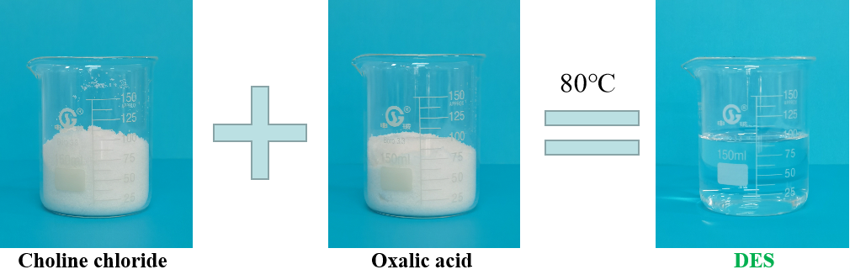
Fig.S1 The preparation process of DES

Table S1. Elemental compositions of membrane surface
Membranes | Composition (%) |  |  | Element ratio
Membranes | C | O | N | O/C
CF | 74.57 | 25.06 | 0.37 | 0.34
LC@CF | 65.29 | 34.47 | 0.24 | 0.53
LCPT@CF | 62.35 | 37.09 | 0.56 | 0.59

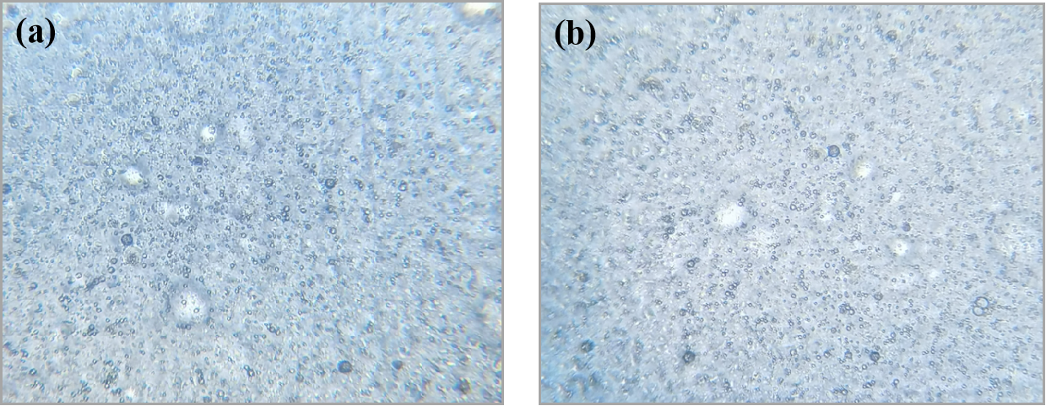
Fig.S2 (a) Biomicroscope image of olive oil-in-water emulsion. (b) Biomicroscope image of olive oil-in-water emulsion after 48 hours.

Comparison of LCPT@CF and other cotton fabric membranes used for the emulsion separation
As shown in Table S2, the LCPT@CF and other cotton fabric membranes used for the emulsion separation were compared in terms of separation efficiency, materials and environmental hazards. The results proved that the LCPT@CF possessed outstanding separation efficiency for oil-in-water emulsion. In addition, the LCPT@CF had excellent environmental friendliness, which was attributed to that lignocellulose and PT complexes had no pollution to the environment. Moreover, the preparation of the LCPT@CF was simple and cost-effective. Therefore, the LCPT@CF possessed great potential for the real-life application in oil-water separation.

Table S2. Comparison of LCPT@CF and other cotton fabric membranes used for the emulsion separation
Membranes | Coating material | Environmental hazard | Separation  efficiency (%) | Ref.
Mg(OH)₂@cotton fabric | Mg(OH)₂ | Middle | >99.5 | ¹
Caffeic acid/Fe@cotton fabric | Caffeic acid/Fe | Middle | >99.0 | ²
Robustly superhydrophobic  cotton fibers | ZnO | Middle | >91.0 | ³
Eleostearic acid-SiO₂@cotton fabric | SiO₂ and eleostearic acid | Middle | >99.5 | ⁴
CS@CF | Cement-sand | Small | >97.2 | ⁵
Cellulose-coated  cotton fabric | Cellulose | Small | >93.2 | ⁶
Superwetting cellulose II based membranes | Cellulose | Small | >99.0 | ⁷
LCPT@CF | Regenerated lignocellulose | None | >99.9 | This work

References
1. Hu, R. et al. Fabrication of special wettability functionalized Mg(OH)2@cotton fabric for oil/water mixtures and emulsions separation. Cellulose 27, 7739–7749 (2020).
2. Zhou, Q., Yan, B., Xing, T. & Chen, G. Fabrication of superhydrophobic caffeic acid/Fe@cotton fabric and its oil-water separation performance. Carbohydrate Polymers 203, 1–9 (2019).
3. Wang, J., Han, F., Liang, B. & Geng, G. Hydrothermal fabrication of robustly superhydrophobic cotton fibers for efficient separation of oil/water mixtures and oil-in-water emulsions. Journal of Industrial and Engineering Chemistry 54, 174–183 (2017).
4. Lin, H. et al. Facile fabrication of natural superhydrophobic eleostearic acid-SiO2@cotton fabric for efficient separation of oil/water mixtures and emulsions. Sustainable Materials and Technologies 32, e00418 (2022).
5. Yang, S., Li, M., Fang, G., Xue, M. & Lu, Y. Flexible cement-sand coated cotton fabrics with superhydrophilic and underwater superoleophobic wettability for the separation of water/oil mixtures and oil-in-water emulsions. Colloids and Surfaces A: Physicochemical and Engineering Aspects 608, 125611 (2021).
6. Zhang, Y.-R., Chen, J.-T., Hao, B., Wang, R. & Ma, P.-C. Preparation of cellulose-coated cotton fabric and its application for the separation of emulsified oil in water. Carbohydrate Polymers 240, 116318 (2020).
7. Yang, S., Chen, L., Wang, S. & Liu, S. Production of superwetting cellulose II based membranes with excellent oil/water emulsions separation performance. Industrial Crops and Products 177, 114554 (2022).

 Corresponding author. Tel.: +86 580 2550623. E-mail: chenyan@zjou.edu.cn.

