Supplementary Online Material (SOM)
Early presence of Homo sapiens by 86-68 kyr in Southeast Asia at Tam Pà Ling cave, Northern Laos.

Sarah E. Freidline¹, Kira Westaway², Renaud Joannes-Boyau^{3, 4}, Philippe Duringer⁵, Jean-Luc Ponche⁶, Mike W. Morley⁷, Vito Paolo C. Hernandez⁷, Meghan S. McAllister-Hayward⁷, Hugh McColl⁸, Clément Zanolli⁹, Philipp Gunz¹⁰, Inga Bergmann¹⁰, Phonephanh Sichanthongtip¹¹, Daovee Sihanam¹¹, Souliphane Boualaphane¹¹, Thonglith Luangkhoth¹¹, Viengkeo Souksavatdy¹¹, Anthony Dosseto¹², Quentin Boesch⁵, Elise Patole-Edoumba¹³, Françoise Aubaile¹⁴, Françoise Crozier¹⁵, Eric Suzzoni¹⁶, Sébastien Frangeul¹⁶, Nicolas Bourgon^{10,17}, Alexandra Zachwieja¹⁸ Tyler E. Dunn¹⁹, Anne-Marie Bacon²⁰, Jean-Jacques Hublin^{10, 21}, Laura Shackelford^{22, 23*}, Fabrice Demeter^{8, 14*}

¹Department of Anthropology, University of Central Florida, 4000 Central Florida Blvd., Howard Phillips Hall, Orlando, USA
²School of Natural Sciences, Faculty of Science and Engineering, Macquarie University, NSW 2109, Australia
³Geoarchaeology and Archaeometry Research group (GARG), Southern Cross University, NSW, Australia.
⁴Centre for Anthropological Research, University of Johannesburg, Gauteng Province, South Africa.
⁵Ecole et Observatoire des Sciences de la Terre, Institut de Physique du Globe de Strasbourg (IPGS), UMR 7516 CNRS, Université de Strasbourg, France.
⁶Université de Strasbourg, Laboratoire Image, Ville Environnement, UMR 7362 UdS CNRS, France.
⁷Archaeology, College of Humanities and Social Sciences, Flinders University, Sturt Road, Bedford Park, Adelaide, Australia.
⁸Lundbeck Foundation GeoGenetics Centre, Globe Institute, University of Copenhagen, Copenhagen, Denmark.
⁹ Univ. Bordeaux, CNRS, MCC, PACEA, UMR 5199, 33600 Pessac, France.
¹⁰ Department of Human Evolution, Max Planck Institute for Evolutionary Anthropology, Deutscher Platz 6, Leipzig, Germany
¹¹ Ministry of Information, Culture and Tourism, Laos PDR
¹² WIGL, University of Wollongong, NSW, Australia
¹³ Museum d’histoire naturelle de La Rochelle, France.
¹⁴ Eco-anthropologie (EA), Muséum national d'Histoire naturelle, CNRS, Université de Paris, Musée de l'Homme 17 place du Trocadéro 75016 Paris, France.
¹⁵ IRD, DIADE, Montpellier, France.
¹⁶ Spitteurs Pan, technical cave supervision and exploration, La Chapelle en Vercors, France.
¹⁷ Applied and Analytical Palaeontology, Institute of Geosciences, Johannes Gutenberg University, 55128 Mainz, Germany
¹⁸ Department of Biomedical Sciences, University of Minnesota Medical School, Duluth, MN, USA.
¹⁹ Anatomical Sciences Education Center, Oregon Health Sciences University, Portland, OR, USA.
²⁰ Université de Paris, BABEL CNRS UMR 8045 Paris, France.
²¹ Chaire de Paléoanthropologie, CIRB (UMR 7241 – U1050), Collège de France. 11, Place Marcelin-Berthelot, 75231 Paris Cedex 05, France.
²² Department of Anthropology, University of Illinois at Urbana-Champaign, Urbana, IL, USA.
²³ Carle Illinois College of Medicine, University of Illinois at Urbana-Champaign, Urbana, IL, USA.

Location
Tam Pà Ling (TPL) is located in northeast Laos, about 260 km NNE from Vientiane, in the Huà Pan Province (Supplementary Fig. 1). The cave is situated in a limestone karstic tower known as Pà Hang, located on the south-eastern side of P’ou Loi Mountain. The latter belongs to the septentrional Annamitic Chain, oriented broadly NNW-SSE. The nearest major city is Vieng Thong (Supplementary Fig. 1), also known as Ban That Hium on Google Earth mapping. From there, the site can be reached traveling north by road for ~20 km along the Nam Kam River to the small Hmong village of Long Nguapha. Surrounding Pà Hang, there are multiple cavities explored by us in the past and located in a radius of 1 km from the center of the village.
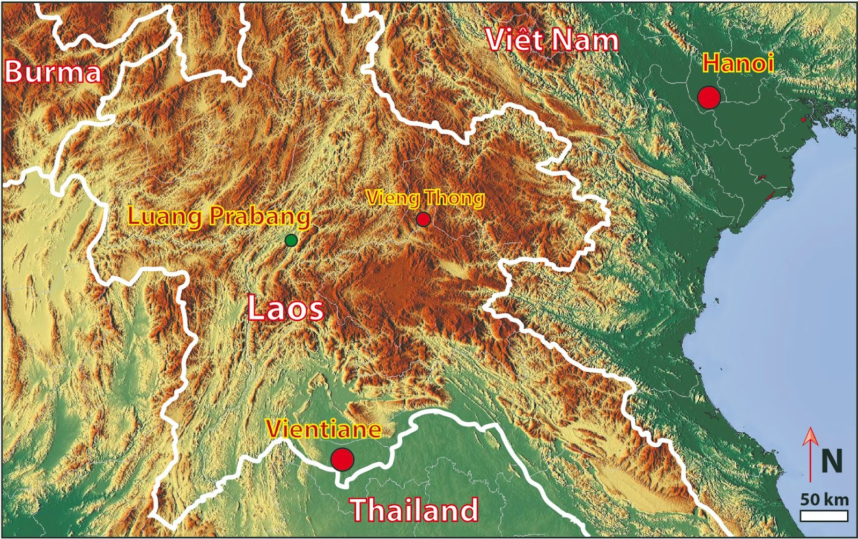
Supplementary Figure 1 – Location of the site of Tam Pà Ling (Vieng Thong village).

Geology
The geology of TPL consists of Palaeozoic granite and diorite¹ covered with a widespread folded poorly metamorphic sedimentary formation characterized by gray to yellow pelites, siltites and arkosic sandstones attributed to the Silurian, or perhaps partly Devonian¹. This poorly metamorphic unit is capped by a thick limestone unit, which is badly dated at present, but which has been attributed by Saurin¹ to an interval between the Late Carboniferous (Moscovian) and the Permian. The limestone unit consists of a pluri-decametric massive sparitic dark-gray carbonate without marl intercalation. Coral fossils are quite common according to place. On the way to the fossiliferous sites starting from Vieng Thong, the road successively incises through the three main formations of the region, namely the granite massif, the weakly metamorphic folded series, and the carbonate unit. In the studied region, the landscape consists of tower karsts formed through the dissolution of Moscovian limestone beds, containing a dense network of caves and galleries. Most tower karsts in the region display widespread karstic networks and at present at least half a dozen sites rich in fossils have been discovered and are in the process of being analyzed.
The TPL cavity (Cave of the Monkeys -20° 12′ 31.4′′ N, 103 ° 24′ 35.2′′ E) is located on the top of the Pa Hang Mountain 1,170 m above sea level. It has one main chamber (40 m width × 30 m length × 10-18 m height) with a south-facing large entrance (Supplementary Fig. 2). From the main chamber, close to the roof, exists a second network ~5 to 10 m wide, 2 to 4 m high and 100 m long. At the end of the gallery, a very narrow gallery ~20 m long crosses the mountain to another outside exit (Supplementary Fig. 2).

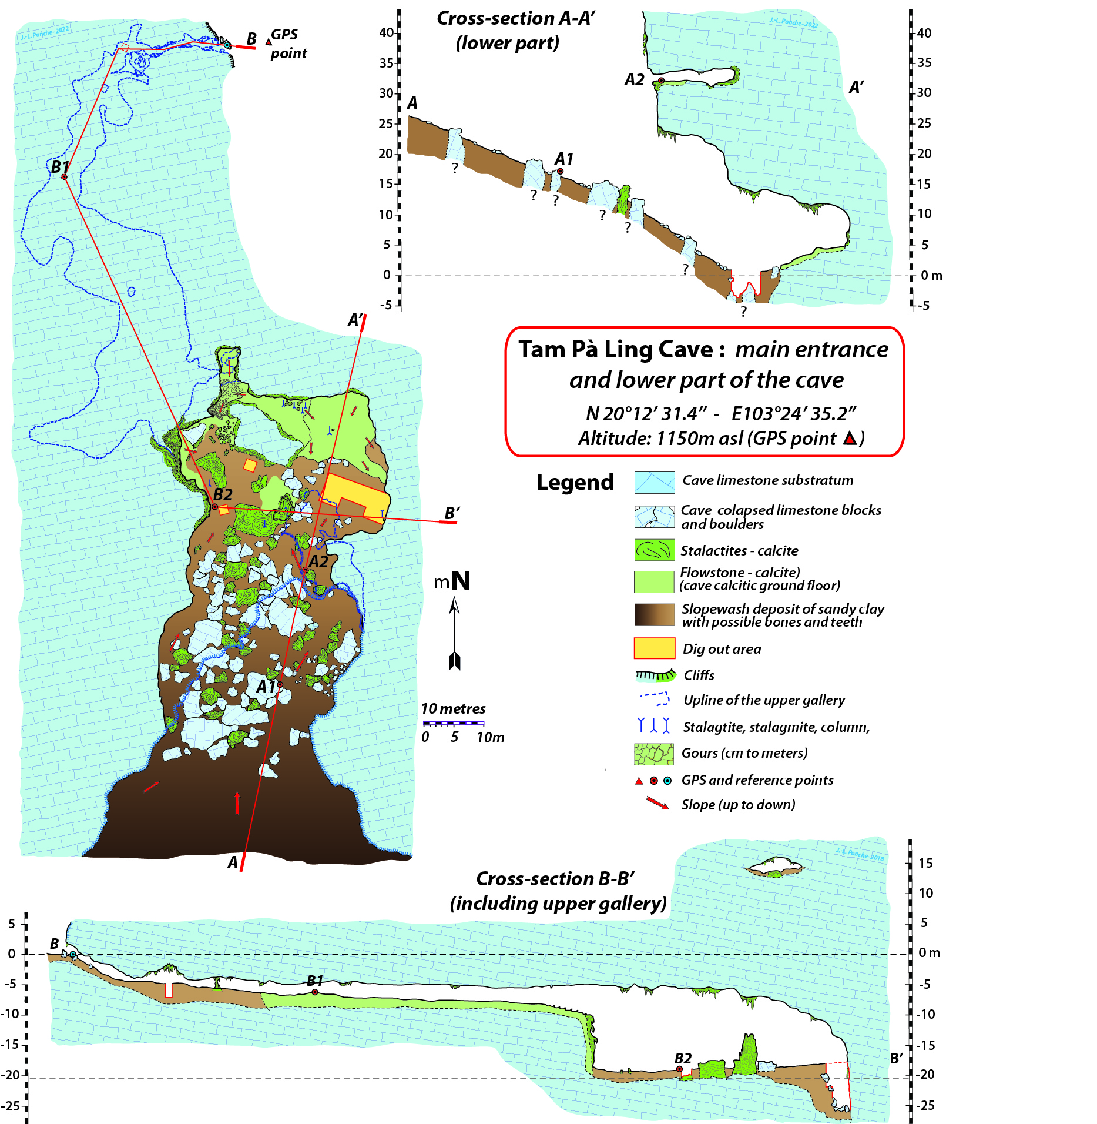
Supplementary Figure 2. Map of the cave of Tam Pà Ling.

In the main entrance and down the main talus slope, the presence of large limestone blocks and slabs testify to collapse of the roof of the cave through slab failure, allowing the formation of the current large opening of the cave. The collapse of a part of the roof at the entrance is argued by a cutting of the roof according to the directions of diaclases as well as by the presence of stalactites much smaller (younger) than inside the cave (Supplementary Fig. 3).

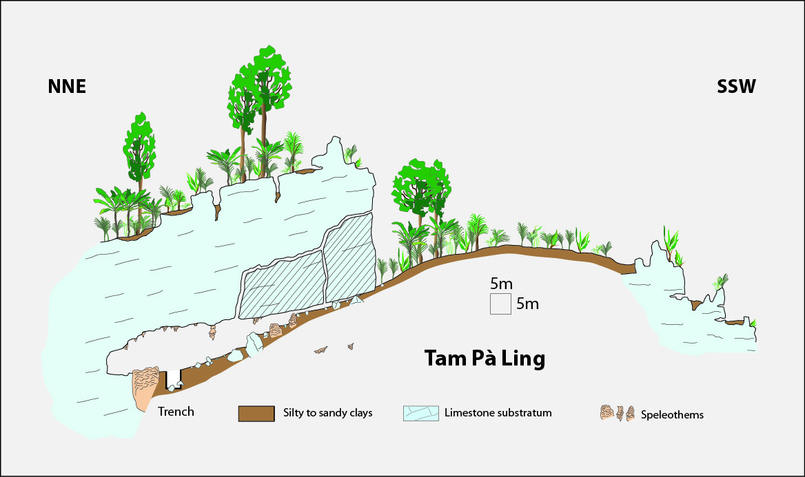
Supplementary Figure 3. Possible model of the collapse of the southern part of the main entrance of the cave which allowed the opening of the site.

In 2008, three test pits were opened on the cave floor to examine stratigraphy and sedimentology: Trenches 1 and 2 on the west side and Trench 3 on the east side. Trench 3, where the fossils were found, can be reached by a steep slope ~60 m in length. In 2020, the excavators reached the bottom of the limestone base of the cavity. The whole profile is currently 7 m deep.
The TPL sediment consists primarily of brown silty clays that alternate with coarser, sandier layers. The sandy layers are themselves intermixed with clay and exhibit a very slight color change (Stratigraphic section Fig. 3). The main cavity of the cave does not have any other obvious connections to the wider karst system which leads us to believe that the primary or only source of sediment can be via the current main entrance. During heavy rainfall we can clearly see water running down the slope, and occasionally small ephemeral pools of water temporarily form at the base of the cave. It is evident that the sediment originated near the cave entrance and was introduced to the cave interior via relatively slow, low-energy slopewash transport (Supplementary Fig. 4), although changes in sediment characteristics do indicate that higher-energy processes did sometimes occur.
Clay-rich layers contain small limestone clasts and iron-oxide pisolites. The former is derived from the host limestone bedrock (the autogenic component), whereas the quartz, clays, and secondary iron oxides are primarily derived from the platform in front of the cave entrance where these elements are present in abundance. The clay composition (vermiculite and kaolinite associated with iron and aluminum oxides) indicates hydrolysing conditions that are characteristic of “ferralsols-nitisols,” which are strongly weathered soil types that suggest that they were deposited in a humid, subtropical climate.

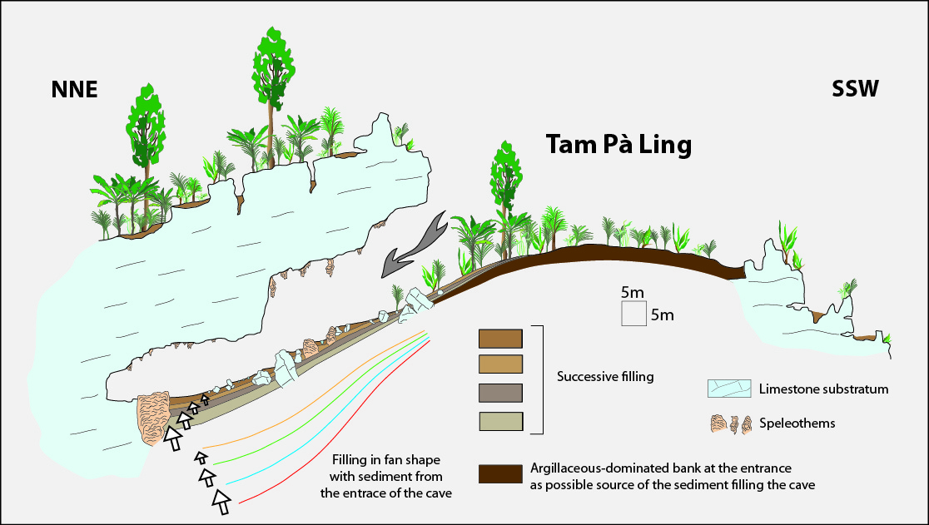
Supplementary Figure 4. Possible mechanism of filling the cave from the erosion of sediment accumulated at the entrance of the cave.

A first profile was documented during initial excavations of Trench 3 (right part of Stratigraphic section Fig. 3). Subsequent excavations of Trench 3 near the wall of the cave led to the documentation of a second profile, which is ~5 m from the first (left part of Stratigraphic section Fig. 3). By correlating the two profiles we find that the stratigraphy and sedimentation are consistent between the two trenches and the individual strata and laminae are contiguous and can be followed laterally across the excavated area of the chamber; alternations of sandy and silty clay layers are punctuated by ~12 calcareous layers—similar to moon milk—which are sometimes cemented; and that there is no evidence in the excavated strata of bioturbations, post depositional modifications, soft deformations, reworking or mixing. Ongoing microstratigraphic analyses by MWM and VPCH is likely to support many of these observations².
The ongoing microstratigraphic analyses by VPCH and MWM have identified some combustion residues in the sediments sampled from the main excavation areas^{2,3} that may suggest human activity in close vicinity of the cave or even from areas of the cave now covered in limestone slabs. Small traces of calcareous ash which are not likely to survive longer distance transport (e.g., downslope from the entrance area) as well as intact charcoal fragments that retain morphologies consistent with very short distance travel have been identified in thin section using optical microscopy and further work will quantify the amount and context of this material. However, despite ongoing microstratigraphic analyses, and the presence of the H. sapiens skeletal material found in the sediments, Tam Pà Ling was not likely an occupation site. No artifacts have been found in the cave and at this stage we must presume that while they were clearly out in the landscape, the cave was either not habitable or accessible at the time that these early humans were present in this area.

Magnetic Susceptibility
To assess inputs of pedogenic material from the cave mouth area, we have used magnetic susceptibility (MS) as a proxy for intensity of pedogenesis and the reworking of this material into the cave. Previously, MS has been used as a palaeoclimatic proxy in archaeological cave settings (e.g., refs.^{4,5}), but these studies serve to highlight the issues with disentangling elevated MS values being related either to pedogenesis or burning occurring at the site. Warmer and wetter climatic conditions can certainly accelerate pedogenesis, forming magnetic minerals such as maghemite and magnetite and resulting in elevated MS values. Conversely, when cooler and drier conditions prevail, a reduction in pedogenesis occurs and the MS signature is correspondingly lower^{6,7}. As the East Asian Monsoon (EAM) controls much of Southeast Asian rainfall, MS was performed on bulk sediment samples from TPL to determine if—and to what extent—MS serves as a proxy for wetter or drier conditions and the flux of soil into the cave interior.
A total of 39 bulk sediment samples (18 from sediment Profile 1 and 21 from Profile 2, respectively left and right on the Stratigraphic section Fig. 3) were analyzed for MS. Samples were dried at 30ºC for 72 hours. Once dry, samples were pestle and mortared (with rock fragments and/or artefacts, i.e.,shell and bone fragments, removed prior) and sieved via a 2 mm sieve. All equipment used on the samples were cleaned between each sample with Triple 7 EnviroLab LabPower, 3 rinses in water, ethanol, DI (deionized) water and acetone. Samples weighing between 29-31 grams were run on a Bartington MS2 Magnetic Susceptibility System as detailed in Dearing⁸, using standard international (SI) units. Low frequency (LF) results are displayed in Supplementary Fig. 5 as it has the highest sensitivity to magnetic changes⁵.
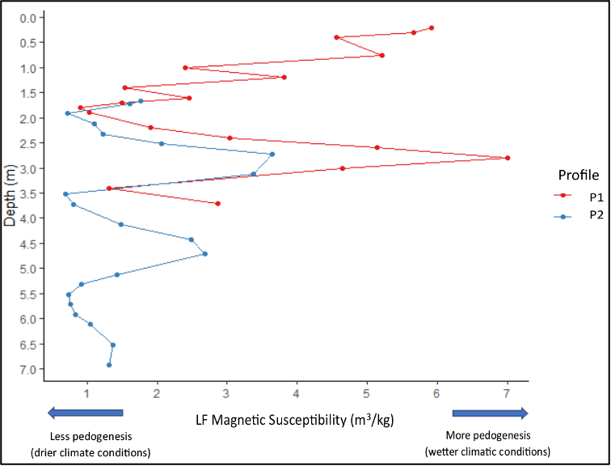
Supplementary Figure 5. Low frequency (LF) magnetic susceptibility results for profile 1 (P1; 0.2-3.7 m below ground level [bgl.]) and profile 2 (P2) (1.67-6.92 m bgl). Samples from both P1 and P2 are taken to investigate the potential correlation of sediment characteristics, given their similar deposition history (Stratigraphic section Fig. 3).

MS values support observations that periods of increased precipitation (resulting in increased pedogenesis) correlate with greater soil delivery to the interior of the cave from the cave mouth area during periods of greater rainfall and slopewash activity. This is supported by the rise in MS values between 5.32-3.72 m (P2), with sediment at these depths comprising predominantly silty clays (Stratigraphic section Fig. 3). The same pattern is observed between 3.4 – 1.8 m (P1) and 3.52 – 1.92 m (P2), where higher MS values occur when sediment is predominantly composed of silty clays. We note that higher MS values are less pronounced in P2 than P1, likely due to the fact these sediment columns are laterally 5 m apart (Stratigraphic section Fig. 3) and therefore other spatial aspects are controlling sediment delivery.
The MS data suggest a decline in overall moisture availability during much of MIS 4, potentially linked to higher seasonal variability related to a weakening of the EAM. A similar decline in rainfall in MIS 4 is also observed by Bacon et al.⁹ at Duoi U’Oi, northern Vietnam. Wetter conditions return towards the MIS 4–3 transition related to a strengthening of the EAM, which aligns well with similar interpretations by Milano et al.¹⁰. A steady rise in MS values during MIS 3 (peaking around 2.8 m, ~46 ka), declining towards the end of MIS 3 and into MIS 2 also corresponds with the general drying trend observed by Milano et al.¹⁰ at Tam Pa Ling and Yamaoh et al.¹¹ at Lake Pa Kho, northeastern Thailand. This shift towards drier conditions is recorded slightly later at Tham Lod (noting this record only extends to 34.1 ka), with Marwick and Gagan¹² determining a wet and unstable climate persisted during 33 – 20 ka, beginning to shift towards drier conditions between 20 – 11.5 ka. The notable decline in moisture availability during MIS 2 recorded by both Milano et al and Marwick & Gagan is also observed in this TPL MS record. Towards the end of MIS 2 and into the Holocene, MS values begin a staggered but steady rise, indicating a return of wetter conditions, likely due to strengthening of the EAM.

Bulk organic and carbonate content (Loss on ignition)
To further interrogate the formation of the TPL stratigraphy, the loss-on-ignition (LOI) technique was applied to TPL bulk sediment samples to provide a broad estimate of the amounts of organic matter (OM) and carbonate content (CC) in the sediment¹³⁻¹⁵. When combined with other sedimentological parameters, such as magnetic susceptibility (MS), LOI data can assist in determining the source and character of sediments deposited in caves.
LOI was undertaken on the same 39 bulk samples analysed for MS following standard protocols¹⁵ using a time-programmed Across International CF1200 series muffle furnace with a 36-L chamber capacity. Results were calculated using the below equations from the same protocol¹⁵ and presented in Supplementary Tables 1 and 2.
For OM: LOI₅₅₀ = ((DW₁₀₅–DW₅₅₀)/DW₁₀₅) *100
For CC: LOI₉₅₀ = ((DW₅₅₀–DW₉₅₀)/DW₁₀₅) *100

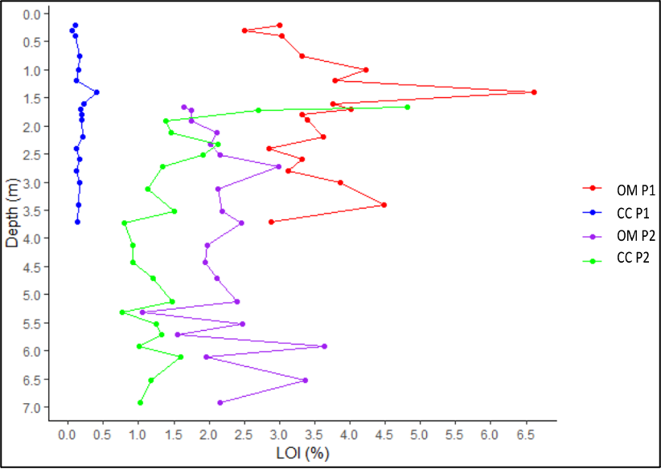
Supplementary Figure 6. Results of loss-on-ignition (LOI) from Trench 3, showing % organic matter (OM) and % carbonate content (CC) % in sediments from Profile 1 (P1, 0.2-3.7 m) below ground level [bgl] and Profile 2 (P2, 1.67-6.92 m below ground level [bgl]) (Fig. 4).

The difference between amounts of OM and CC at similar depths in each profile are due to their positions in the cave (Stratigraphic section Fig. 3). The higher CC in Profile 2 is attributed to its location near the cave wall, with more calcium carbonate being transferred into the sediment in this area of the site. Conversely, the higher OM in Profile 1 is most likely related to its location towards the base of the slope beneath the cave entrance, which regularly receives allogenic clay-rich colluvial slopewash sediments (Supplementary Fig. 4).
Values of OM and CC (Supplementary Fig. 6) recorded between ~6.92 – 5.52 m suggest relatively dry colluvial input, probably originating from in and around the cave entrance (Supplementary Fig. 4). This is, punctuated by cave roof slab failure during MIS 4, and the associated deposition of calcareous sediments, probably as crushed and comminuted rock powder and small limestone clasts (Stratigraphic section Fig. 3). The OM and CC values at ~5.32 – 3.72 m (Supplementary Fig. 6) are indicative of wetter, low-energy sedimentation at around ~62 – 50 ka (MIS 4 – 3). The higher OM content in sediment deposited between 3.5 – 1.9 m (~51–41 ka and 50–42 ka) suggests a shift towards dominantly wet colluviation from the entrance of the cave during MIS 3. Notably, the greater amount of CC than OM at ~2.32 m in Profile 2, and increased amount of CC in Profile 1 at ~2.2 m, may be due to a collapse of the cave roof occuring between ~50 – 42 ka and 36 – 30 ka (Supplementary Fig. 4). Major collapse events are evidenced by the large limestone boulders recorded in the site (Stratigraphic section Fig. 3). The highest OM and CC values occur ~1.67 m and ~1.4 m in Profile 1 ~25 – 21 ka and 16 – 12 ka and correlate with the alternating sandy and silty clay infilling showing slight color changes (Stratigraphic section Fig. 3). When interpreted together with increasing humidity shown by MS (associated with the strengthening of the EAM during MIS 2–1) (Supplementary Fig. 6) this likely represents periods of increased pedogenesis.
The elevated amounts of CC we record in the sediment (Supplementary Fig. 6) coincide with drier conditions as observed from the MS data. This is characterized in the stratigraphy by increased frequency of limestone clasts which may relate to periods of increased slab failure (autogenic limestone generation) (Stratigraphic section Fig. 3). These are often immediately followed or accompanied by an increase in the amounts of OM such as ~6.52, 5.92, and 5.52 m in Profile 2, and ~3.4 and 2.2 m in Profile 1 suggesting that these slab failures in the sequence relate to episodes of cave opening which then respectively allows greater deposition of organic-rich clays further into the cave. The observations on these aspects of the sedimentological record of TPL support the idea that it was a collapse of the cave ceiling that formed its large cave opening. Although these also suggest that it took several of these events to gradually open the cave to its current size beginning from at least ~86 ± 8 kyr.

Supplementary Table 1. Profile 1 magnetic susceptibility (MS) and loss on ignition (LOI) data.
P1 Sample I.D. (m) | MS LF (m³/kg) | MS HF  (m³/kg) | MS FD (%) | LOI OM (%) | LOI CC (%)
0.2 | 5.9121 | 5.2442 | 11.2967 | 3.0018 | 0.1048
0.3 | 5.6635 | 4.9975 | 11.7542 | 2.4969 | 0.0531
0.4 | 4.5571 | 3.9427 | 13.4553 | 3.0287 | 0.0982
0.75 | 5.2084 | 4.5908 | 11.8881 | 3.3125 | 0.1676
1.0 | 2.4019 | 2.0904 | 13.0366 | 4.2199 | 0.1488
1.2 | 3.8184 | 3.3290 | 12.8210 | 3.7835 | 0.1212
1.4 | 1.5362 | 1.3391 | 12.8093 | 6.6118 | 0.4079
1.6 | 2.4528 | 2.1730 | 11.514 | 3.7627 | 0.2251
1.7 | 1.5018 | 1.2968 | 13.7784 | 4.0079 | 0.1717
1.8 | 0.9100 | 0.7936 | 12.9706 | 3.3247 | 0.1864
1.9 | 1.0323 | 0.8921 | 13.4978 | 3.3924 | 0.1874
2.2 | 1.9019 | 1.6341 | 14.0931 | 3.6173 | 0.2093
2.4 | 3.0314 | 2.6161 | 13.7388 | 2.8467 | 0.1164
2.6 | 5.1331 | 4.4737 | 12.8498 | 3.3224 | 0.1640
2.8 | 7.0040 | 6.1495 | 12.1404 | 3.1267 | 0.1196
3.0 | 4.6477 | 4.1061 | 11.7014 | 3.8679 | 0.1574
3.4 | 1.3166 | 1.1281 | 14.3118 | 4.4850 | 0.1478
3.7 | 2.8734 | 2.4872 | 13.4608 | 2.8839 | 0.1334

Supplementary Table 2. Profile 2 magnetic susceptibility (MS) and loss on ignition (LOI) data.
P2 Sample I.D. (m) | MS LF (m³/kg) | HF  (m³/kg) | MS FD (%) | LOI OM (%) | LOI CC (%)
1.67 | 1.7729 | 1.554 | 12.3071 | 1.6457 | 4.8154
1.72 | 1.6122 | 1.4251 | 11.8229 | 1.7476 | 2.7035
1.92 | 0.7215 | 0.6290 | 13.4783 | 1.7522 | 1.3912
2.12 | 1.1030 | 0.9523 | 13.7066 | 2.1166 | 1.4564
2.32 | 1.2306 | 1.0574 | 14.0961 | 2.0161 | 2.1310
2.52 | 2.0666 | 1.7921 | 13.2943 | 2.1547 | 1.9088
2.72 | 3.6471 | 3.1801 | 12.7936 | 2.9926 | 1.3380
3.12 | 3.3773 | 2.9712 | 12.0305 | 2.1292 | 1.1248
3.52 | 0.6990 | 0.5919 | 14.7282 | 2.1864 | 1.5147
3.72 | 0.8062 | 0.7030 | 13.0702 | 2.4655 | 0.7901
4.12 | 1.4786 | 1.2723 | 14.0499 | 1.9828 | 0.9128
4.42 | 2.4918 | 2.1889 | 12.1823 | 1.9488 | 0.9126
4.72 | 2.6862 | 2.3575 | 12.3161 | 2.1130 | 1.2049
5.12 | 1.4257 | 1.2419 | 1.4257 | 2.3998 | 1.4720
5.32 | 0.9245 | 0.7883 | 0.9245 | 1.0507 | 0.7635
5.52 | 0.7341 | 0.6243 | 0.7341 | 2.4794 | 1.2434
5.72 | 0.7658 | 0.6554 | 0.7658 | 1.5538 | 1.3318
5.92 | 0.8386 | 0.7248 | 0.8386 | 3.6322 | 1.0137
6.12 | 1.0528 | 0.8987 | 1.0528 | 1.9538 | 1.6013
6.52 | 1.3761 | 1.1824 | 14.1718 | 3.3692 | 1.1738
6.92 | 1.3021 | 1.1202 | 14.0015 | 2.1508 | 1.0309

Fauna from Tam Pà Ling
Tam Pà Ling yielded abundant microvertebrates (rodents, insectivores, reptiles, and amphibians), but a few remains of large mammals (since 2010, only 28 isolated teeth, the most identifiable elements, have been recovered in the ~7 meters high stratigraphy). Half of this set of teeth belong to Caprinae, either Naemorhedus or Capricornis genus.
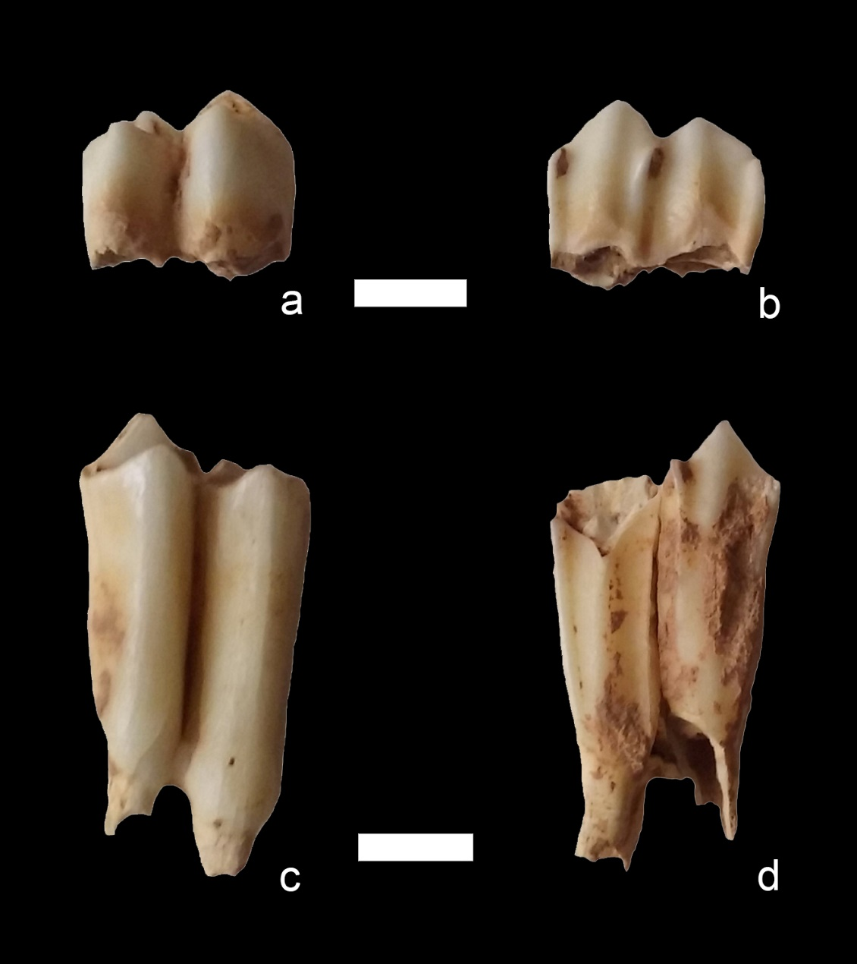

Supplementary Figure 7. Teeth used from U-series/ESR dating. ESR TPL-01 (TPL-73), (a) buccal view and (b) lingual view of a lower molar (m1/m2) of Caprinae recovered in the Tam Pà Ling stratigraphic sequence at a depth of 6.40 m. ESR TPL-02 (TPL-74), (c) buccal view and (d) lingual view of a lower molar (m1/m2) of Caprinae recovered at a depth of 6.67 m.

Geometric Morphometrics

Supplementary Figure 8. Between group PCA (bgPCA) of frontal shape in H. sapiens. TPL 1 and TPL 6 (3 reconstructions TPL6-R1, R2, R3) were projected into the plot; Minatogawa (Min); Zhoukoudian Upper Cave (Zhouk UC).
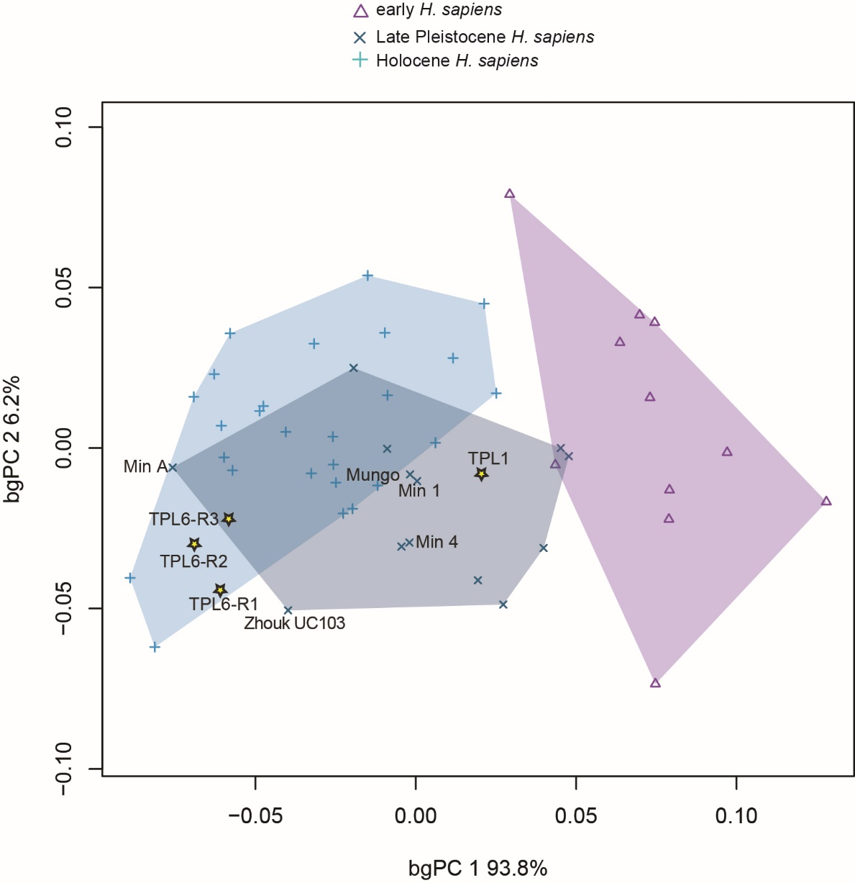

Supplementary Figure 9. TPL 1 and 6 frontal centroid sizes. Box plots depicting log centroid size for each group. Horizontal lines represent the median of each group. Boxes show the interquartile range (IQR, 25th to 75th percentile). Whiskers extend to 1.5 times IQR. Outliers are represented by circles. There is a clear difference in brow ridge size between archaic humans, including early H. sapiens, and later humans, and the TPL fossils fall within the range of the latter. TPL 1 is larger than TPL 6 (3 reconstructions TPL6-R1, R2, R3), falls within the interquartile range of Late Pleistocene and Holocene humans, and is comparable in size to Minatogawa 1 (M1). The TPL 6 frontal, on the other hand, is small, and comparable in size to Late Pleistocene Minatogawa 4 (M4) and A (MA) and two Holocene individuals.

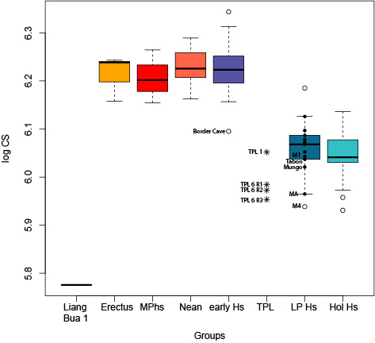

Supplementary Figure 10. TPL 6 frontal superimposed onto group mean shapes. TPL 6 (gray) superimposed on group mean shapes, anterior (A) and lateral (B) views (yellow: H. erectus; red: Neanderthal; purple: early H. sapiens; blue: Late Pleistocene Asian H. sapiens; green: Holocene H. sapiens). TPL 6 has a gracile brow ridge. Compared to all groups, its frontal bone is wider with a flatter frontal squama, and it has a more projecting lateral brow ridge. It is most similar to Late Pleistocene Asian and Holocene H. sapiens.

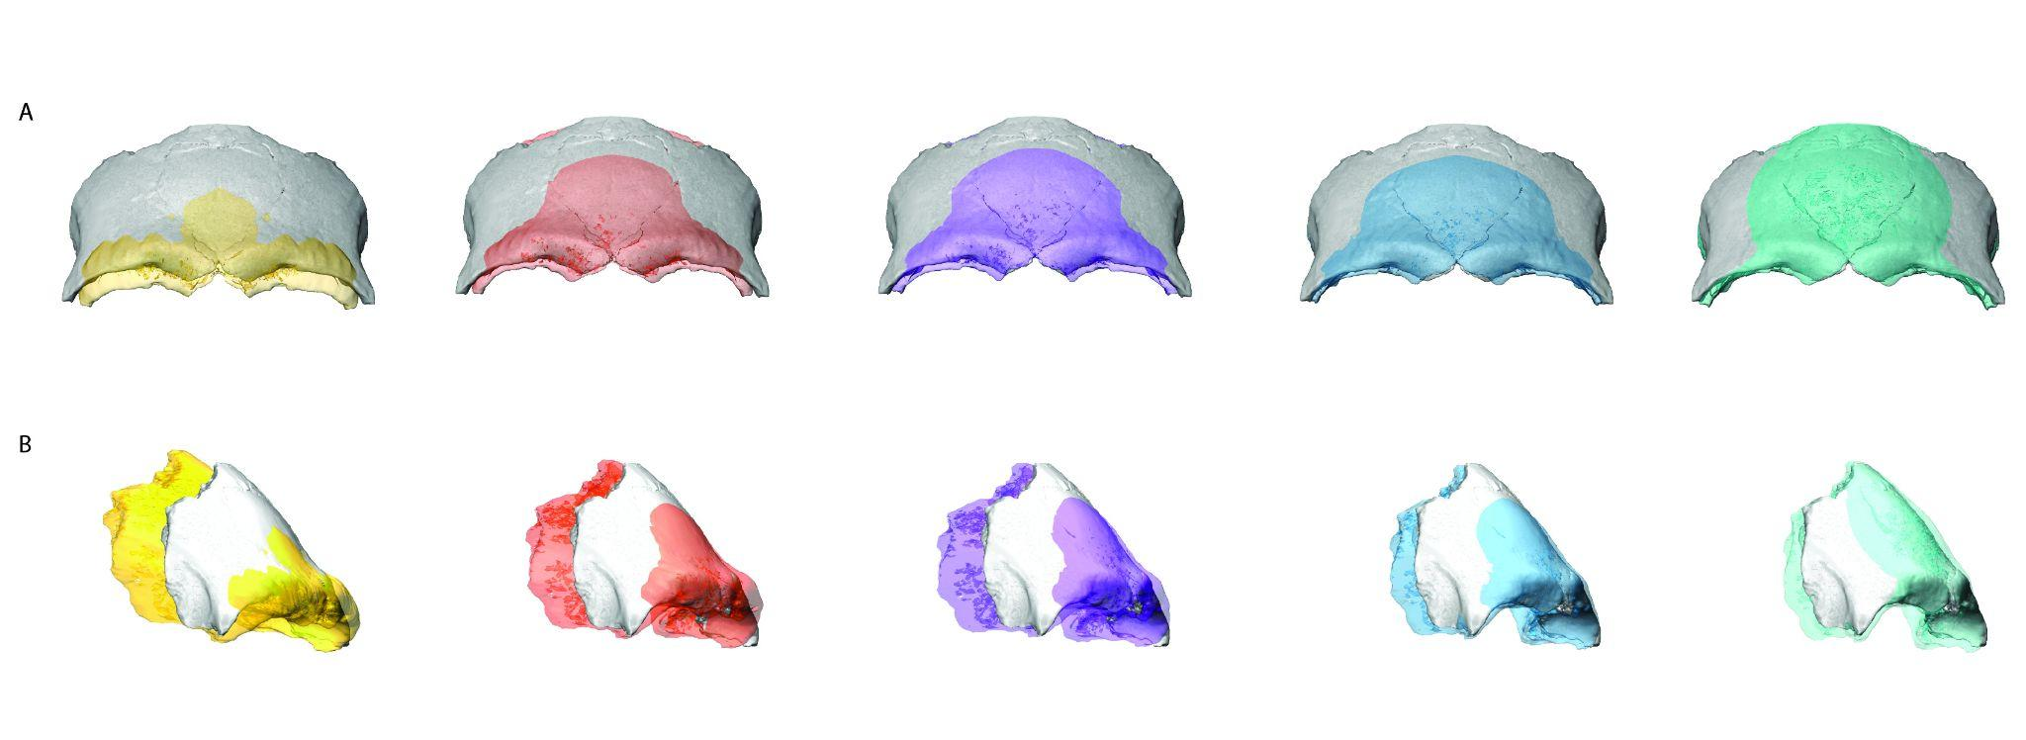

Supplementary Figure 11. Between group PCA (bgPCA) of maxillary shape in H. sapiens. TPL 1 was projected into the plot; Minatogawa (Min); Zhoukoudian Upper Cave (Zhouk UC); Laetoli Hominin (LH).
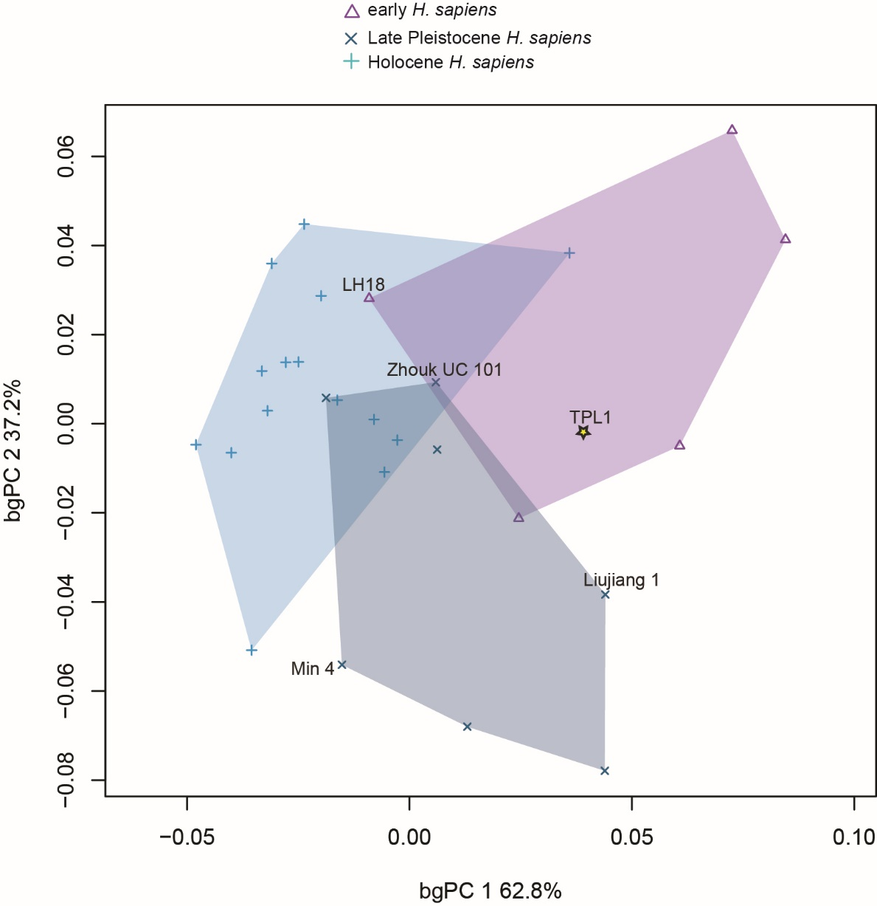

Supplementary Figure 12. TPL 1 maxilla superimposed onto group mean shapes. TPL 1 (gray) superimposed on group mean shapes, anterior (A) and lateral (B) views (yellow: H. erectus; red: Neanderthal; purple: early H. sapiens; blue: Late Pleistocene Asian H. sapiens; green: Holocene H. sapiens).

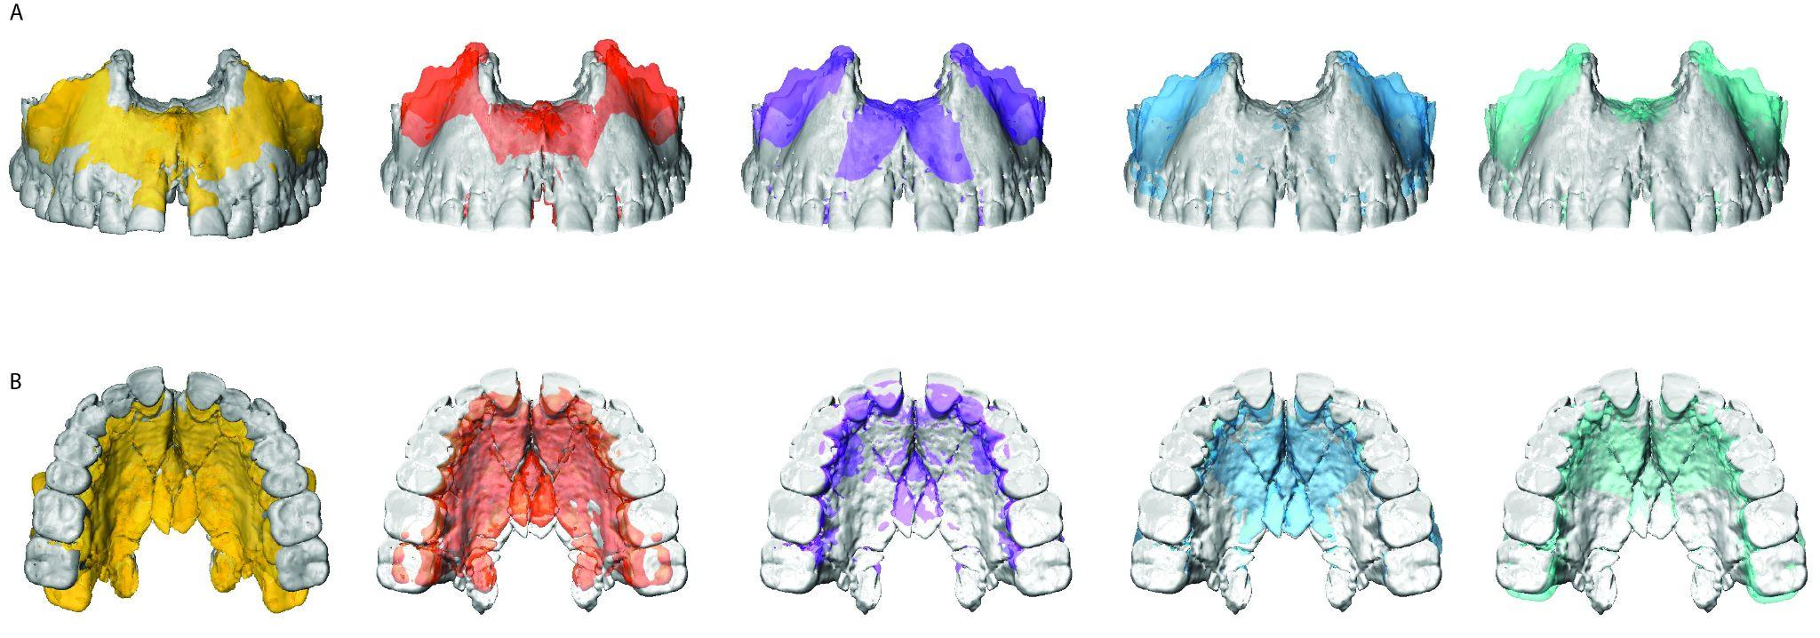

Supplementary Figure 13. TPL 1 maxilla centroid sizes. Box plots depicting log centroid size for each group. Horizontal lines represent the median of each group. Boxes show the interquartile range (IQR, 25th to 75th percentile). Whiskers extend to 1.5 times IQR. Outliers are represented by circles; Zhoukoudian Upper Cave 101 (Zh 101) and 103 (Zh 103), Minatogawa 1 (M1) and 4 (M4).

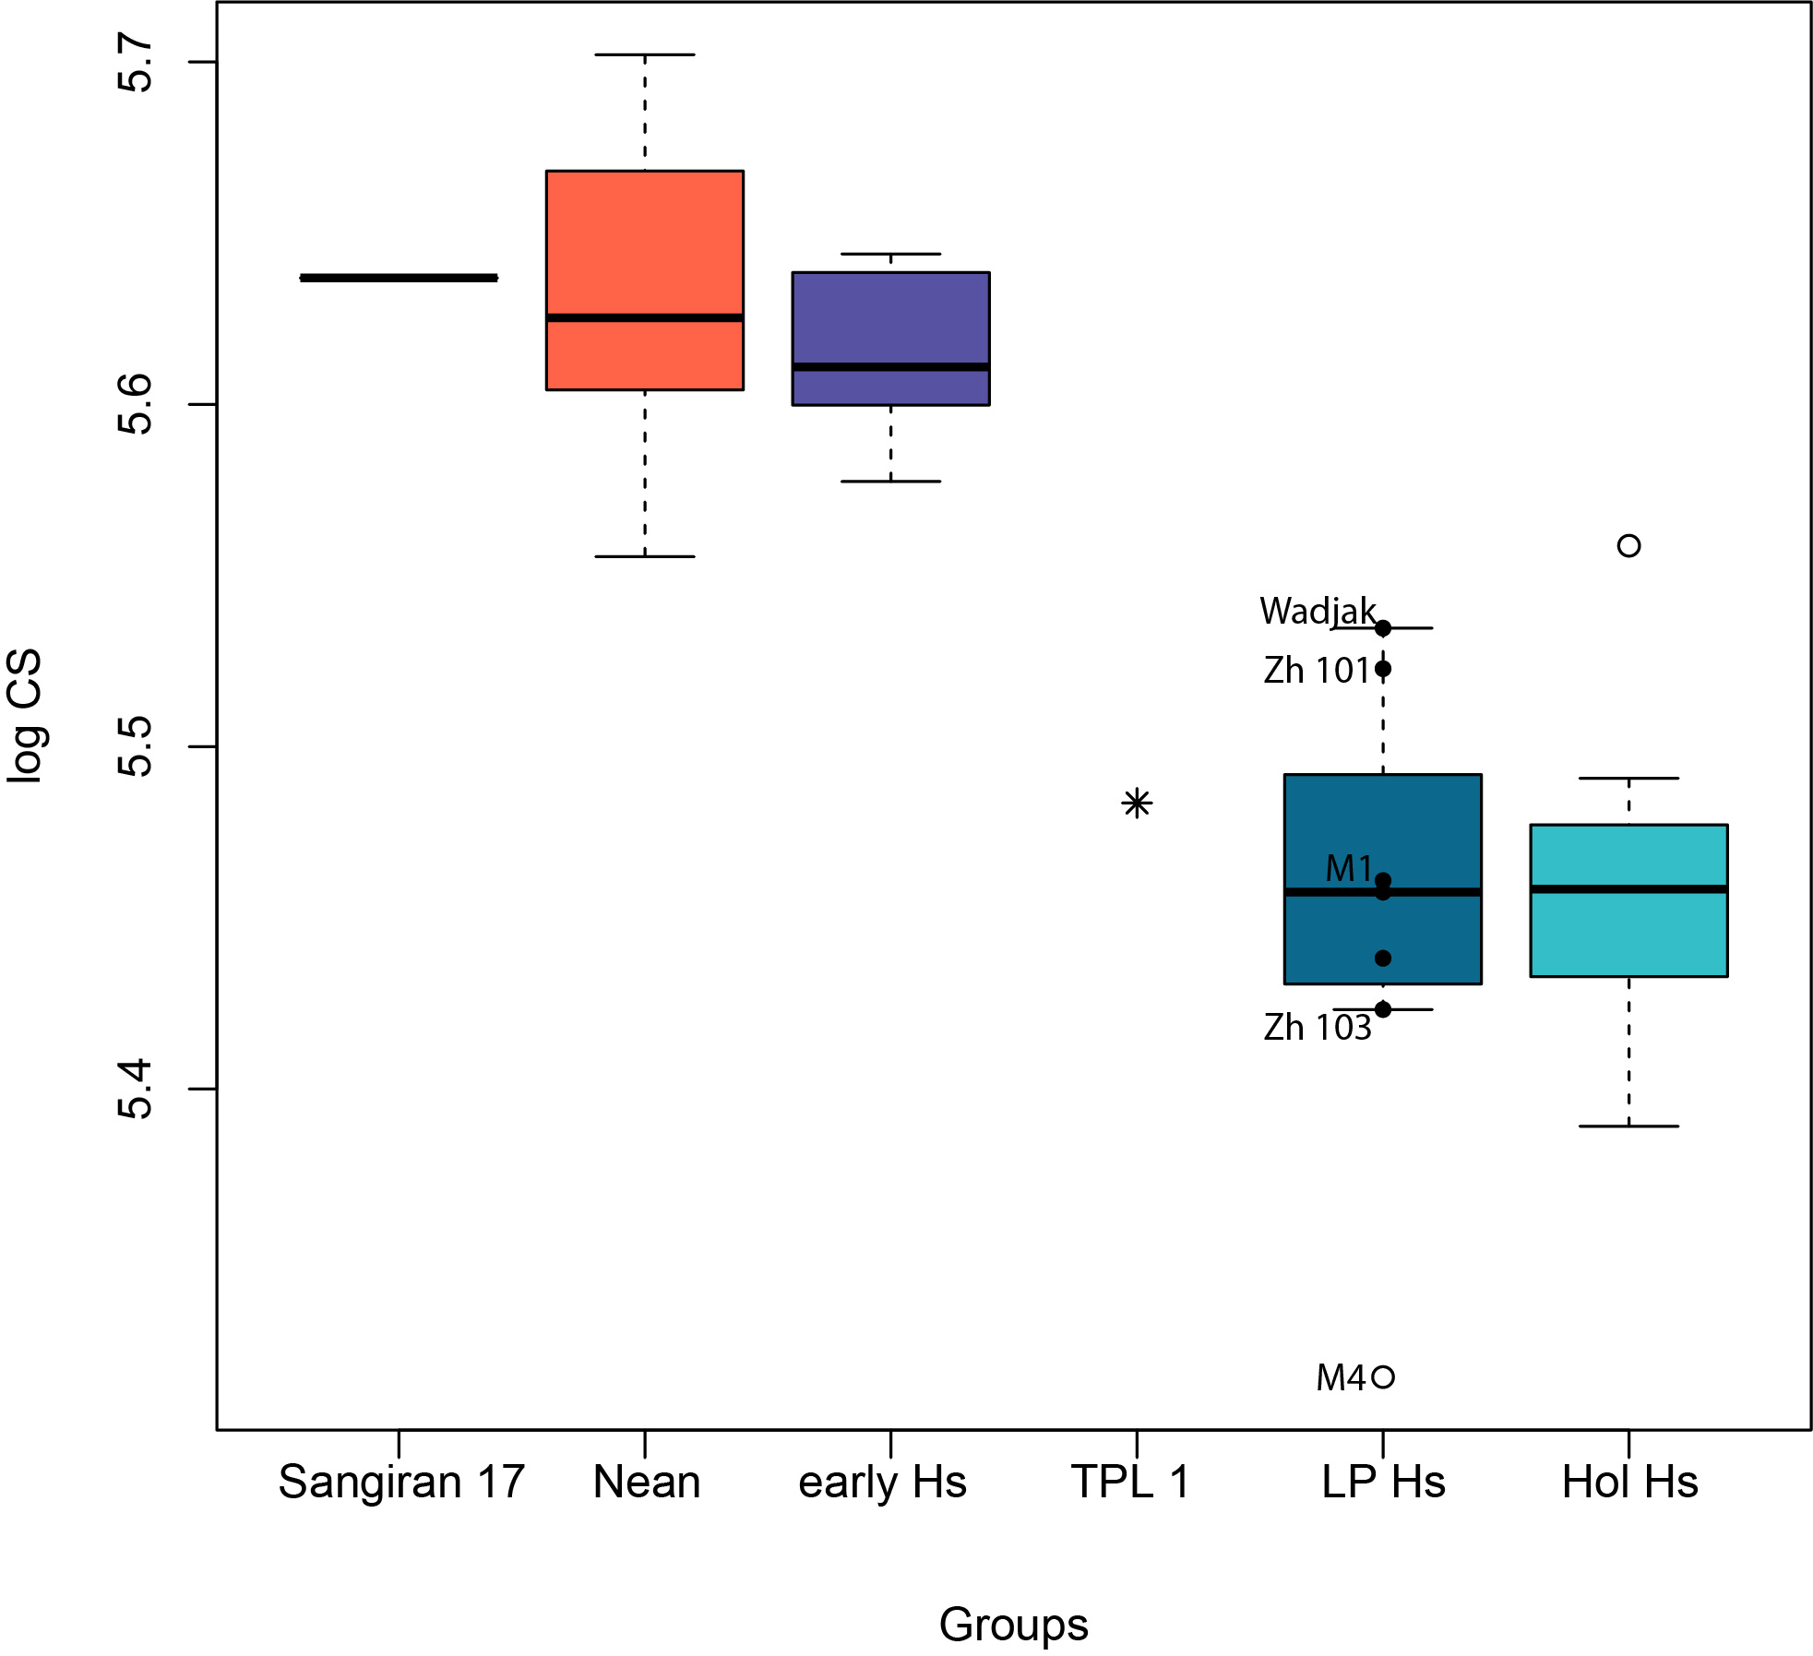

Supplementary Figure 14. Between group PCA (bgPCA) of mandibular shape in H. sapiens. TPL 2 reconstructions (TPL2, TPL2-R) were projected into the plot.
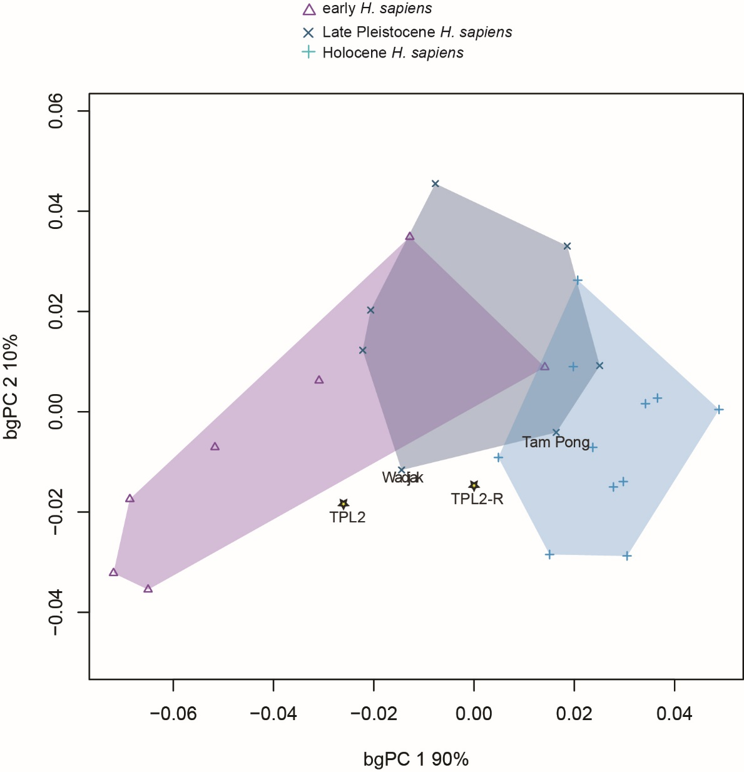

Supplementary Figure 15. TPL 2 mandible superimposed onto group mean shapes. TPL 1 (gray) superimposed on group mean shapes, anterior (A) and lateral (B) views (yellow: H. erectus; red: Neanderthal; purple: early H. sapiens; blue: Late Pleistocene Asian H. sapiens; green: Holocene H. sapiens).

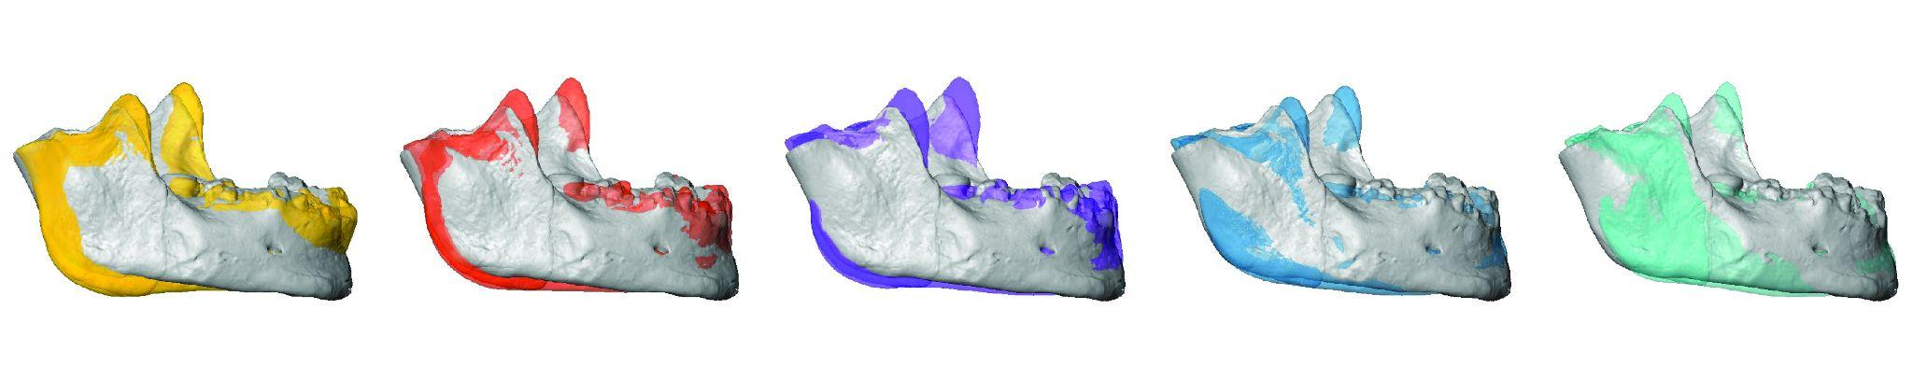

Supplementary Figure 16. TPL 2 mandible centroid sizes. Box plots depicting log centroid size for each group. Horizontal lines represent the median of each group. Boxes show the interquartile range (IQR, 25th to 75th percentile). Whiskers extend to 1.5 times IQR. Outliers are represented by circles; TPL 2 original reconstruction (TPL 2 O) and new reconstruction (TPL 2 R), Minatogawa A (MA).
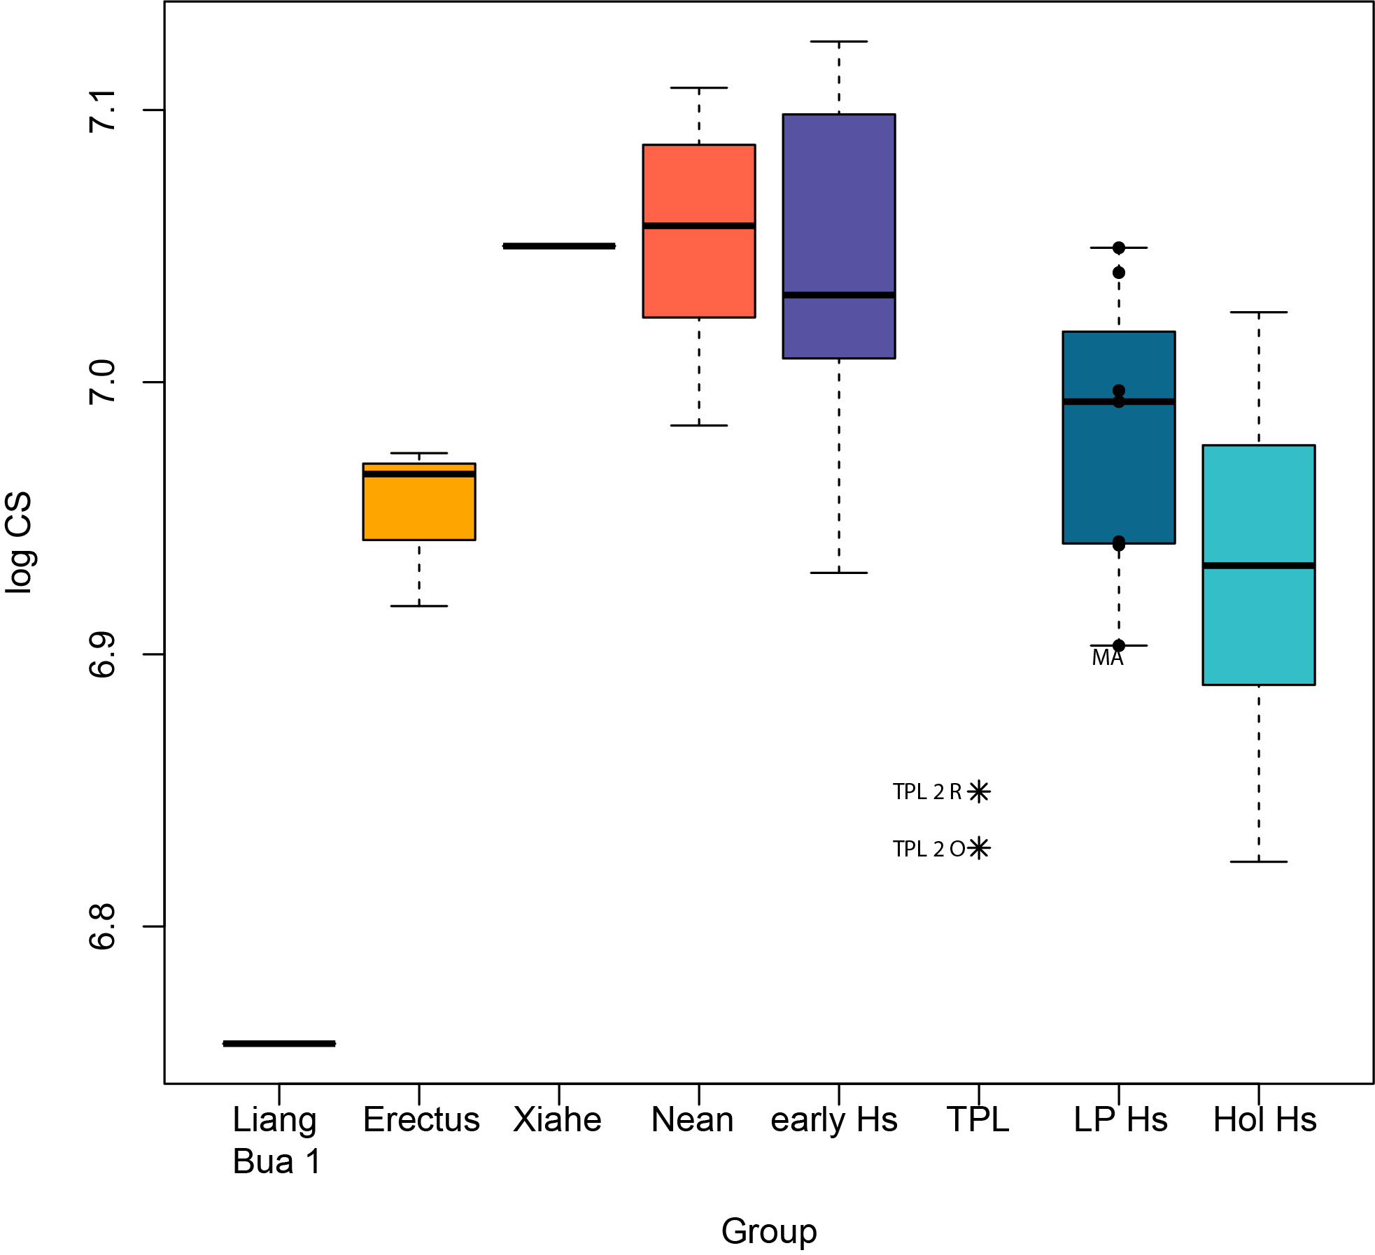

Supplementary Figure 17. TPL 3 mandible superimposed onto group mean shapes. TPL 1 (gray) superimposed on group mean shapes, anterior (A) and lateral (B) views (yellow: H. erectus; red: Neanderthal; purple: early H. sapiens; blue: Late Pleistocene Asian H. sapiens; green: Holocene H. sapiens).
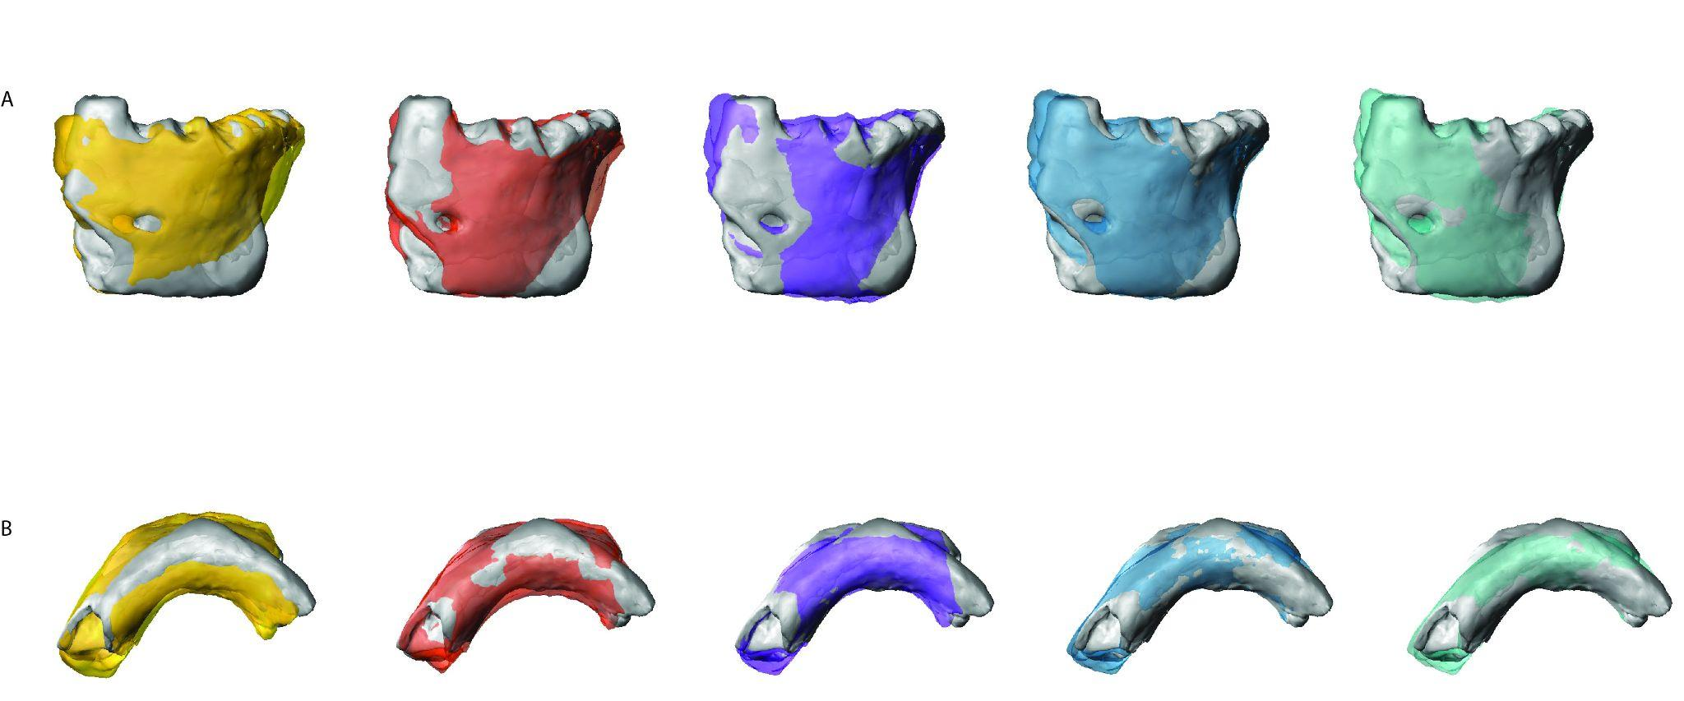

Supplementary Figure 18. Between group PCA (bgPCA) of anterior corpus shape in H. sapiens. TPL 2 reconstructions (TPL2, TPL2-R) and TPL 3 were projected into the plot; Minatogawa (Min) and Zhoukoudian Upper Cave (Zhouk UC).
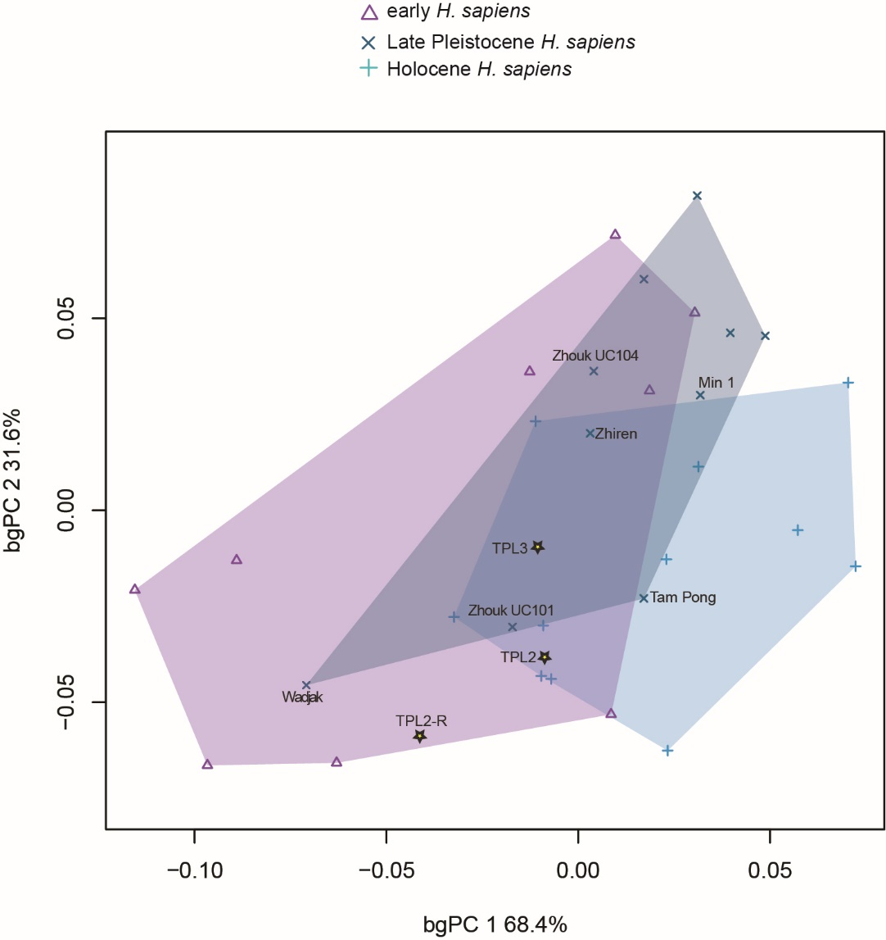

Supplementary Figure 19. TPL 3 anterior corpus centroid sizes. Box plots depicting log centroid size for each group. Horizontal lines represent the median of each group. Boxes show the interquartile range (IQR, 25th to 75th percentile). Whiskers extend to 1.5 times IQR. Outliers are represented by circles; TPL 2 original reconstruction (TPL 2 O) and new reconstruction (TPL 2 R), Minatogawa A (MA), 1 (M1), and Zhoukoudian 108 (Zh 108).

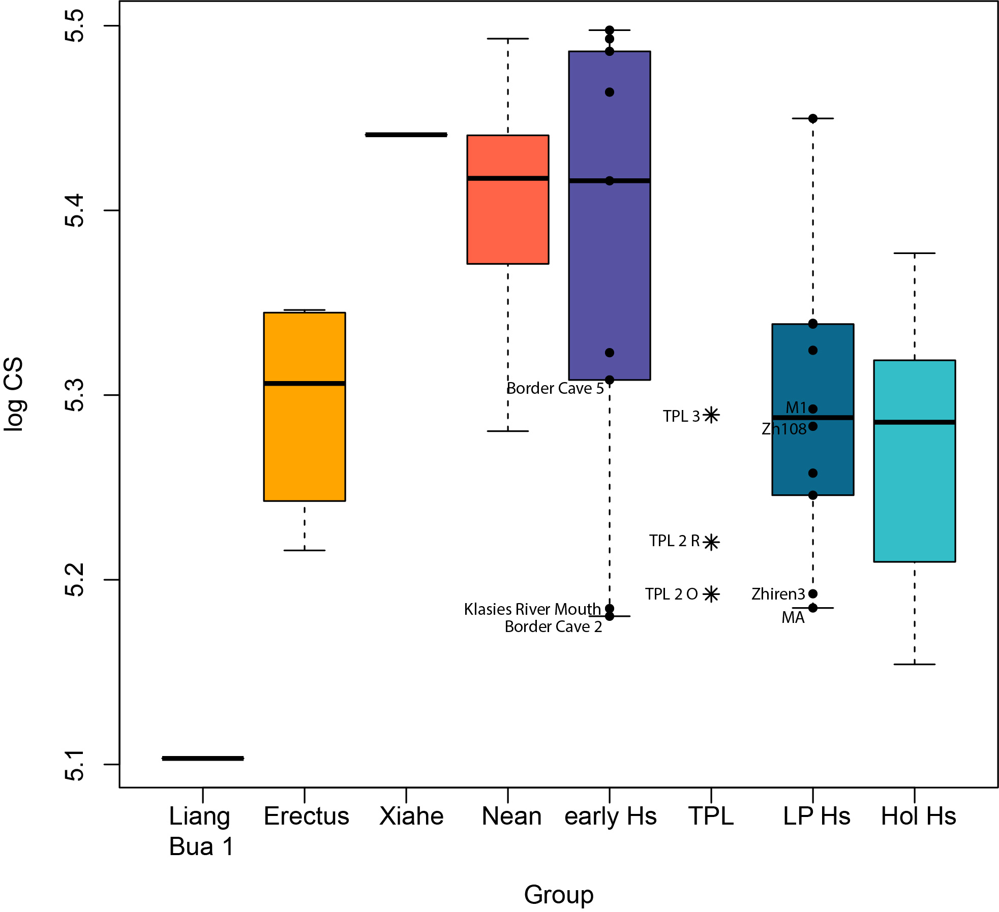

Table 3. Results of the cross-validated linear discriminant analysis (LDA) and posterior probabilities using the H. sapiens sample and three groups (early, Late Pleistocene, and Holocene). The highest classification rates occurred in the maxilla, followed by the frontal, mandible, and anterior corpus. Highest probabilities in bold.

Dataset | Correct classification | Posterior probability early H. sapiens | Posterior probability LP H. sapiens | Posterior probability Hol. H. sapiens
Frontal | 70.0%
TPL 1 |  | 27.7% | 64.7% | 7.6%
TPL 6 R1 |  | 0% | 34.0% | 66.0%
TPL 6 R2 |  | 0% | 18.0% | 82.0%
TPL 6 R3 |  | 0% | 18.7% | 81.3%
Maxilla | 70.3%
TPL 1 |  | 88.0% | 10.5% | 1.4%
Mandible | 60.0%
TPL 2 |  | 13.0% | 35.2% | 51.8%
TPL 2 R |  | 0.8% | 7.8% | 91.4%
Anterior Corpus | 41.4%
TPL 2 |  | 5.4% | 35.0% | 59.5%
TPL 2 R |  | 27.3% | 28.6% | 44.2%
TPL 3 |  | 35.5% | 31.9% | 32.6%

Supplementary Table 4. Procrustes distances (PD) between TPL 1 and 6 frontal shape and all samples in the study (CG = Cau Giat; LC = Lang Cuom; THS = Tam Hang South; THN = Tam Hang North).
Tam Pa Ling 1 | PD | Tam Pa Ling 6R1 | PD | Tam Pa Ling 6R2 | PD | Tam Pa Ling 6R3 | PD
LC 11 | 0.064 | Tam Pa Ling 6R2 | 0.025 | Tam Pa Ling 6R1 | 0.025 | Tam Pa Ling 6R2 | 0.030
Zhoukoudian UC 101 | 0.069 | Tam Pa Ling 6R3 | 0.039 | Tam Pa Ling 6R3 | 0.030 | Tam Pa Ling 6R1 | 0.039
Tabon | 0.073 | THS 13 | 0.057 | THS 13 | 0.058 | LC 5 | 0.066
Tam Pong 1 | 0.073 | LC 5 | 0.065 | LC 5 | 0.064 | THS 13 | 0.076
LC 7 | 0.076 | Minatogawa A | 0.068 | Minatogawa A | 0.066 | Minatogawa A | 0.078
LC 10 | 0.076 | Tam Pong 1 | 0.071 | THS 14 | 0.077 | Tam Pong 1 | 0.084
LC 9 | 0.076 | CGA3 | 0.077 | CGA3 | 0.079 | CGA3 | 0.084
CGA3 | 0.076 | Long Gao | 0.079 | Tam Pong 1 | 0.080 | THS 14 | 0.084
Lake Mungo | 0.078 | THS 14 | 0.081 | LC 13 | 0.082 | Long Gao | 0.085
Saint-Cesaire | 0.079 | LC 10 | 0.082 | Long Gao | 0.082 | LC 10 | 0.086
Minatogawa 1 | 0.080 | LC 13 | 0.083 | THS 11 | 0.083 | LC 13 | 0.089
Shanidar 1 | 0.080 | LC 8 | 0.085 | LC 10 | 0.084 | LC 2 | 0.089
Tabun 1 | 0.080 | THS 11 | 0.086 | LC 8 | 0.086 | Long Gao 24958BIS | 0.092
Salkhit | 0.082 | LC 9 | 0.087 | LC 2 | 0.087 | THS 11 | 0.093
CG 1 | 0.083 | Zhoukoudian UC 103 | 0.087 | Long Gao 24958BIS | 0.088 | Minatogawa 4 | 0.095
Liujiang 1 | 0.084 | CG 1 | 0.088 | THS 10 | 0.093 | THS 10 | 0.095
Niah Cave | 0.084 | Tam Nang An | 0.088 | LC 9 | 0.093 | LC 9 | 0.095
Long Gao | 0.085 | THS 10 | 0.091 | THS 3 | 0.096 | Minatogawa 1 | 0.097
Da But | 0.087 | LC 2 | 0.093 | CG 1 | 0.096 | Da But | 0.101
LC 12 | 0.088 | Liujiang 1 | 0.094 | Tam Nang An | 0.099 | LC 8 | 0.102
Spy 2 | 0.088 | Minatogawa 4 | 0.094 | Zhoukoudian UC 103 | 0.099 | CG 1 | 0.104
Lang Bon | 0.088 | Long Gao 24958BIS | 0.097 | Liujiang 1 | 0.100 | Liujiang 1 | 0.105
LC 1 | 0.088 | THS 3 | 0.098 | Da But | 0.100 | THS 3 | 0.109
Zeyang | 0.089 | Minatogawa 1 | 0.098 | Minatogawa 4 | 0.101 | Lang Bon | 0.110
Skhul 5 | 0.089 | THN 3 | 0.100 | THN 3 | 0.103 | THN 3 | 0.111
Minatogawa 4 | 0.090 | Da But | 0.102 | Minatogawa 1 | 0.105 | Zhoukoudian UC 103 | 0.113
Jebel Irhoud 1 | 0.092 | LC 11 | 0.106 | Lang Bon | 0.110 | LC 11 | 0.115
THS 10 | 0.092 | Lang Bon | 0.109 | LC 11 | 0.111 | Tam Nang An | 0.115
Wadjak | 0.092 | Tam Pa Ling 1 | 0.110 | Niah Cave | 0.116 | Tam Pa Ling 1 | 0.117
Gibraltar 1 | 0.092 | Tabon | 0.112 | Tam Pa Ling 1 | 0.119 | Niah Cave | 0.121
Amud 1 | 0.093 | Niah Cave | 0.115 | Lake Mungo | 0.124 | Kow Swamp 5 | 0.125
Krapina 6 | 0.093 | Lake Mungo | 0.116 | Tabon | 0.124 | Tabon | 0.126
Dong Thuoc | 0.094 | Wadjak | 0.121 | LC 1 | 0.125 | LC 1 | 0.127
Kow Swamp 5 | 0.094 | Salkhit | 0.124 | Wadjak | 0.131 | Lake Mungo | 0.129
Florisbad | 0.094 | Zeyang | 0.124 | Zeyang | 0.131 | Dong Thuoc | 0.130
THS 14 | 0.095 | LC 1 | 0.124 | LC 7 | 0.132 | Florisbad | 0.132
THN 3 | 0.096 | LC 7 | 0.129 | Salkhit | 0.134 | LC 7 | 0.132
Shanidar 5 | 0.097 | Zhoukoudian UC 101 | 0.132 | Kow Swamp 5 | 0.136 | Salkhit | 0.137
Border Cave 1 | 0.098 | Kow Swamp 5 | 0.133 | Zhoukoudian UC 101 | 0.137 | Wadjak | 0.137
LC 13 | 0.098 | Florisbad | 0.134 | Florisbad | 0.139 | Zhoukoudian UC 101 | 0.138
Lang Cuom 19455 | 0.098 | Dong Thuoc | 0.136 | Dong Thuoc | 0.139 | Zeyang | 0.141
LC 5 | 0.100 | Shanidar 1 | 0.141 | Lang Cuom 19455 | 0.141 | Lang Cuom 19455 | 0.146
Zuttiyeh | 0.100 | Lang Cuom 19455 | 0.141 | Shanidar 1 | 0.147 | Shanidar 1 | 0.150
Qafzeh 6 | 0.100 | Tabun 1 | 0.148 | LC 12 | 0.152 | Tabun 1 | 0.152
La Chapelle | 0.101 | Saint-Cesaire | 0.148 | Saint-Cesaire | 0.155 | LC 12 | 0.152
Dar es-Soltane H5 | 0.102 | LC 12 | 0.150 | Tabun 1 | 0.156 | Shanidar 5 | 0.153
Jebel Irhoud 2 | 0.103 | Krapina 6 | 0.152 | Krapina 6 | 0.159 | Saint-Cesaire | 0.155
Singa | 0.103 | Omo Kibish 1 | 0.155 | Qafzeh 6 | 0.160 | Krapina 6 | 0.155
THS 3 | 0.103 | Shanidar 5 | 0.156 | Shanidar 5 | 0.162 | Qafzeh 6 | 0.155
Omo Kibish 1 | 0.105 | Qafzeh 6 | 0.158 | Border Cave 1 | 0.164 | Zuttiyeh | 0.158
LC 8 | 0.107 | Skhul 5 | 0.158 | Zuttiyeh | 0.165 | Border Cave 1 | 0.159
THS 11 | 0.107 | Zuttiyeh | 0.158 | Skhul 5 | 0.167 | Liang Bua 1 | 0.162
Guattari 1 | 0.109 | Jebel Irhoud 1 | 0.163 | Omo Kibish 1 | 0.169 | Skhul 5 | 0.164
Zhoukoudian UC 103 | 0.109 | Border Cave 1 | 0.163 | Liang Bua 1 | 0.171 | Jebel Irhoud 2 | 0.167
La Ferrassie 1 | 0.110 | Liang Bua 1 | 0.165 | Jebel Irhoud 1 | 0.172 | Jebel Irhoud 1 | 0.170
Tam Pa Ling 6R1 | 0.110 | Spy 2 | 0.168 | Jebel Irhoud 2 | 0.174 | Omo Kibish 1 | 0.171
LC 2 | 0.111 | Gibraltar 1 | 0.171 | Spy 2 | 0.174 | Spy 2 | 0.172
Forbes Quarry | 0.112 | Amud 1 | 0.171 | Dar es-Soltane H3 | 0.177 | Gibraltar 1 | 0.172
Dali | 0.112 | Jebel Irhoud 2 | 0.171 | Amud 1 | 0.177 | Guattari 1 | 0.174
Long Gao 24958BIS | 0.113 | Guattari 1 | 0.175 | Gibraltar 1 | 0.177 | Amud 1 | 0.175
Minatogawa A | 0.114 | Dar es-Soltane H3 | 0.178 | Guattari 1 | 0.181 | Dar es-Soltane H3 | 0.178
Maba 1 | 0.115 | La Ferrassie 1 | 0.179 | La Ferrassie 1 | 0.183 | Forbes Quarry | 0.181
Spy 1 | 0.115 | Singa | 0.180 | Singa | 0.185 | Singa | 0.182
Tam Pa Ling 6R3 | 0.117 | Dar es-Soltane H5 | 0.183 | Forbes Quarry | 0.190 | La Ferrassie 1 | 0.183
Tam Pa Ling 6R2 | 0.119 | La Chapelle | 0.185 | Maba 1 | 0.190 | Maba 1 | 0.184
Dar es-Soltane H3 | 0.119 | Dali | 0.185 | La Chapelle | 0.191 | Dar es-Soltane H5 | 0.188
Liang Bua 1 | 0.120 | Forbes Quarry | 0.185 | Dar es-Soltane H5 | 0.191 | La Chapelle | 0.188
Sima de los Huesos 5 | 0.128 | Maba 1 | 0.188 | Dali | 0.194 | Dali | 0.189
THS 13 | 0.131 | Spy 1 | 0.192 | Spy 1 | 0.199 | Spy 1 | 0.192
Tam Nang An | 0.133 | Sima de los Huesos 5 | 0.203 | Sima de los Huesos 5 | 0.210 | Zhoukoudian 12 | 0.201
Omo Kibish 2 | 0.139 | Zhoukoudian 12 | 0.205 | Zhoukoudian 12 | 0.210 | Sima de los Huesos 5 | 0.201
Krapina 3 | 0.140 | Omo Kibish 2 | 0.208 | Omo Kibish 2 | 0.214 | Omo Kibish 2 | 0.203
La Quina 5 | 0.142 | Krapina 3 | 0.218 | La Quina 5 | 0.222 | La Quina 5 | 0.217
Zhoukoudian 12 | 0.154 | La Quina 5 | 0.220 | Krapina 3 | 0.224 | Krapina 3 | 0.218
Ngandong 10 | 0.199 | Ngandong 10 | 0.253 | Ngandong 10 | 0.256 | Ngandong 10 | 0.239
Sangiran 17 | 0.224 | Sangiran 17 | 0.292 | Sangiran 17 | 0.297 | Sangiran 17 | 0.284

Supplementary Table 5. Procrustes distances (PD) between TPL 1 maxilla shape and all samples in the study (CG = Cau Giat; LC = Lang Cuom; THS = Tam Hang South; THN = Tam Hang North).
Tam Pa Ling 1 | PD
Tam Nang An | 0.096
THS 11 | 0.101
Lang Bon | 0.111
Liujiang 1 | 0.112
Qafzeh 6 | 0.112
Long Gao 24958BIS | 0.113
Lang Cuom 19455 | 0.116
Laetoli Hominin 18 | 0.116
Minatogawa 1 | 0.117
THS 14 | 0.119
Zhoukoudian UC 101 | 0.119
THS 13 | 0.121
Skhul 5 | 0.121
THS 3 | 0.125
Zhoukoudian UC 103 | 0.130
Amud 1 | 0.130
Da But | 0.131
Wadjak | 0.132
Jebel Irhoud 10 | 0.134
LC 9 | 0.134
Gibraltar 1 | 0.139
LC 13 | 0.142
THN 3 | 0.142
Niah Cave | 0.143
Tam Pong 1 | 0.143
Sima de los Huesos 5 | 0.148
Jebel Irhoud 1 | 0.148
Sangiran 17 | 0.149
Minatogawa 4 | 0.150
THS 10 | 0.152
LC 11 | 0.156
La Chapelle | 0.159
Saint-Cesaire | 0.160
Tabun 1 | 0.166
La Ferrassie 1 | 0.169
Guattari 1 | 0.179
Shanidar 1 | 0.187

Supplementary Table 6. Procrustes distances (PD) between TPL 2 original and reconstructed (Recon) mandible shape and all samples in the study (THS = Tam Hang South).
Tam Pa Ling 2 Recon | PD | Tam Pa Ling 2 Original | PD
THS 10 | 0.053 | Tam Pa Ling 2 R | 0.064
Tam Pa Ling 2 O | 0.064 | THS 10 | 0.076
THS 11 | 0.065 | Tabun 2 | 0.079
THS 3 | 0.065 | Tianyuandong | 0.086
Tam Pong 1 | 0.069 | THS 2 | 0.092
THS 13 TER | 0.074 | Tam Pong 1 | 0.093
Contrebandiers 1 | 0.075 | THS 11 | 0.095
Wadjak 2 | 0.076 | THS 3 | 0.095
Xiahe | 0.077 | Skhul 4 | 0.096
Skhul 4 | 0.079 | El Sidron | 0.099
THS 4 | 0.079 | La Ferrassie 1 | 0.101
THS 13 BIS | 0.079 | Contrebandiers 1 | 0.101
Tianyuandong | 0.080 | THS 13 TER | 0.103
El Sidron | 0.080 | Zhoukoudian UC 101 | 0.104
THS 2 | 0.081 | Guattari 3 | 0.106
Krapina 59 | 0.085 | Skhul 5 | 0.107
THS 13 | 0.090 | Krapina 59 | 0.109
Guattari 3 | 0.090 | Wadjak 2 | 0.109
Zhoukoudian UC 101 | 0.090 | THS 13 BIS | 0.109
Minatogawa A | 0.091 | Xiahe | 0.112
Minatogawa 1 | 0.091 | THS 4 | 0.115
Liang Bua 1 | 0.092 | Zafarraya 2 | 0.115
La Quina 9 | 0.093 | Zhoukoudian LC H1.12 | 0.116
THS 22 | 0.094 | Liang Bua 1 | 0.117
Klasies River Mouth 41815 | 0.096 | Minatogawa A | 0.118
Zhoukoudian LC H1.12 | 0.099 | Minatogawa 1 | 0.119
Tabun 2 | 0.100 | Banyoles | 0.122
Zhoukoudian UC 104 | 0.101 | Klasies River Mouth 41815 | 0.122
Regourdou | 0.102 | Zhoukoudian LC G1.G2 | 0.123
Banyoles | 0.104 | La Quina 9 | 0.123
Zafarraya 2 | 0.105 | Jebel Irhoud 11 | 0.124
Tam Nang An | 0.107 | Dar es-Soltane H5 | 0.125
Tabun 1 | 0.109 | THS 13 | 0.125
Skhul 5 | 0.109 | Regourdou | 0.126
THS 14 | 0.110 | Zhoukoudian UC 104 | 0.129
Lantian | 0.111 | Tam Nang An | 0.131
Dar es-Soltane H5 | 0.113 | THS 22 | 0.131
Jebel Irhoud 11 | 0.116 | Tabun 1 | 0.136
Zhoukoudian LC G1.G2 | 0.119 | THS 14 | 0.142
Chaise Bourgeois Delaunay 1 | 0.122 | Lantian | 0.145
La Ferrassie 1 | 0.134 | Chaise Bourgeois Delaunay 1 | 0.161

Supplementary Figure 20. TPL 1 frontal virtual reconstruction. The TPL 1 frontal bone was discovered in several pieces and manually reconstructed. It is nearly complete, missing some bone on the right side around the temporal line and small fragments near bregma and the frontal squama. We mirror-imaged the more complete left side (left) and merged it with the corresponding region on the right side (center, right). All visible cracks and holes on the bone were filled and smoothed in Geomagic Studio.

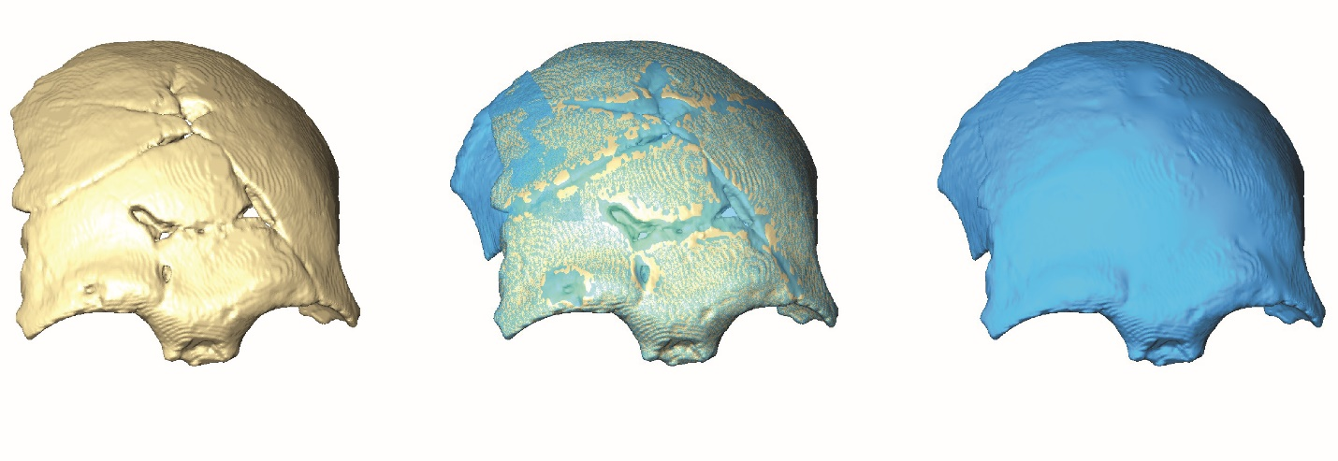

Supplementary Figure 21. TPL 1 maxilla virtual reconstruction. The TPL 1 maxilla consists of a lower left and right side (left), preserving the inferior nasal aperture, anterior nasal spine, alveolar process, left nasoalveolar clivus, palate and most of the dentition. The right side is in better condition, especially at the nasoalveolar clivus, and it preserves some of the inferior infraorbital plate including the inferior extension of the canine fossa. To achieve a more complete maxilla, the better-preserved right side was mirrored-imaged, and aligned to the left side (left center) according to the preserved morphology and the midline palatal suture.
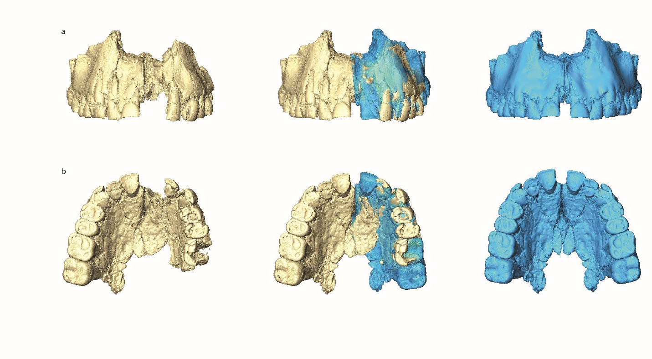

Supplementary Figure 22. TPL 2 mandible virtual reconstruction. Original reconstruction (left) and new reconstruction (right; see Methods), aligned to the original and mirror-imaged (center, right).

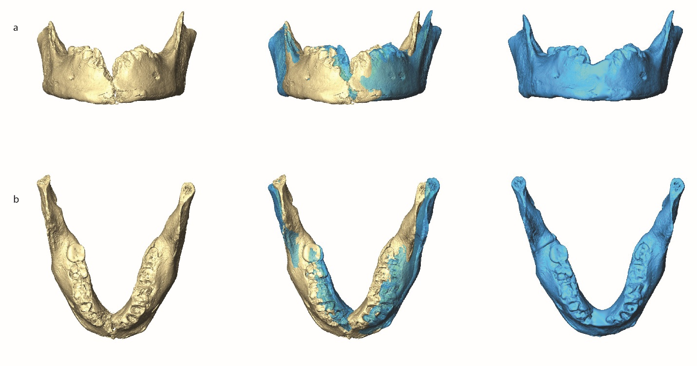

Supplementary Figure 23. TPL 6 frontal virtual reconstruction. Three different reconstructions of TPL 6 were made by reflecting its mirror image along the midsagittal plane (see Methods). Each reconstruction differs by rotating a few millimeters antero-inferiorly; (a) exterior surface, (b) interior surface.

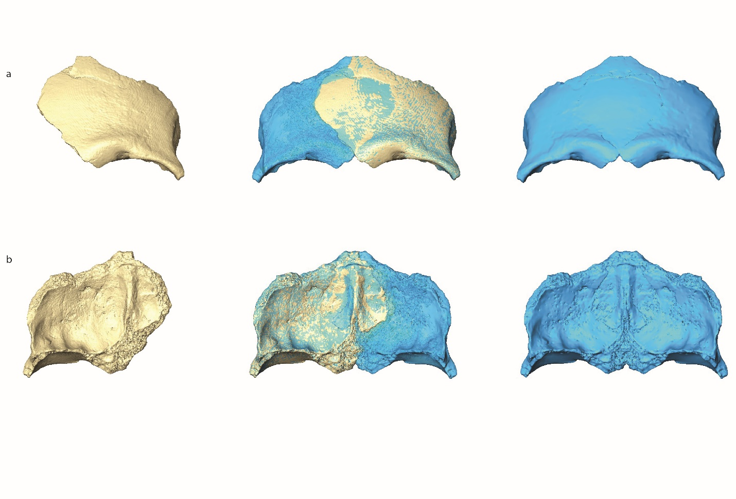

Supplementary Figure 24. TPL 6 frontal virtual reconstructions superimposed. Three different reconstructions of TPL 6 were made (see Methods): reconstruction 1 – a simple reflection mirror image along the midsagittal plane (red), and reconstruction 2 and 3 – rotating the frontal a few millimeters antero-inferiorly (blue and gray, respectively). Reconstruction 1 has the most projecting lateral brow ridge and reconstruction 2 the widest frontal bone. To keep the two halves in correct anatomical positions, all reconstructions were aligned along the frontal crest.
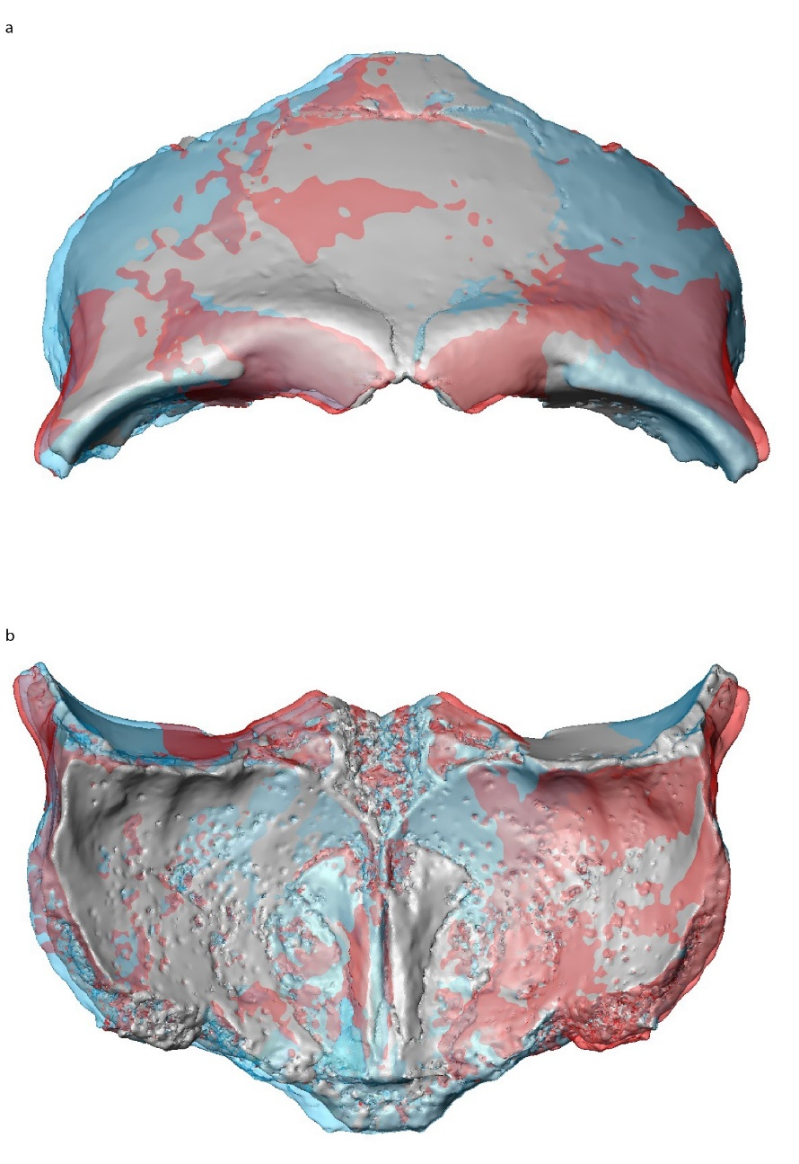

Supplementary Fig. 25. Landmarks and semilandmarks used in the geometric morphometric analyses. (a) frontal; (b) maxilla; (c) anterior corpus; (d) mandible. Landmarks are red, curve semilandmarks in blue, and surface semilandmarks in green. Curves are abbreviated in capital letters and landmarks in lower case. See Supplementary Table 9 for landmark and curve and surface semilandmark definitions.
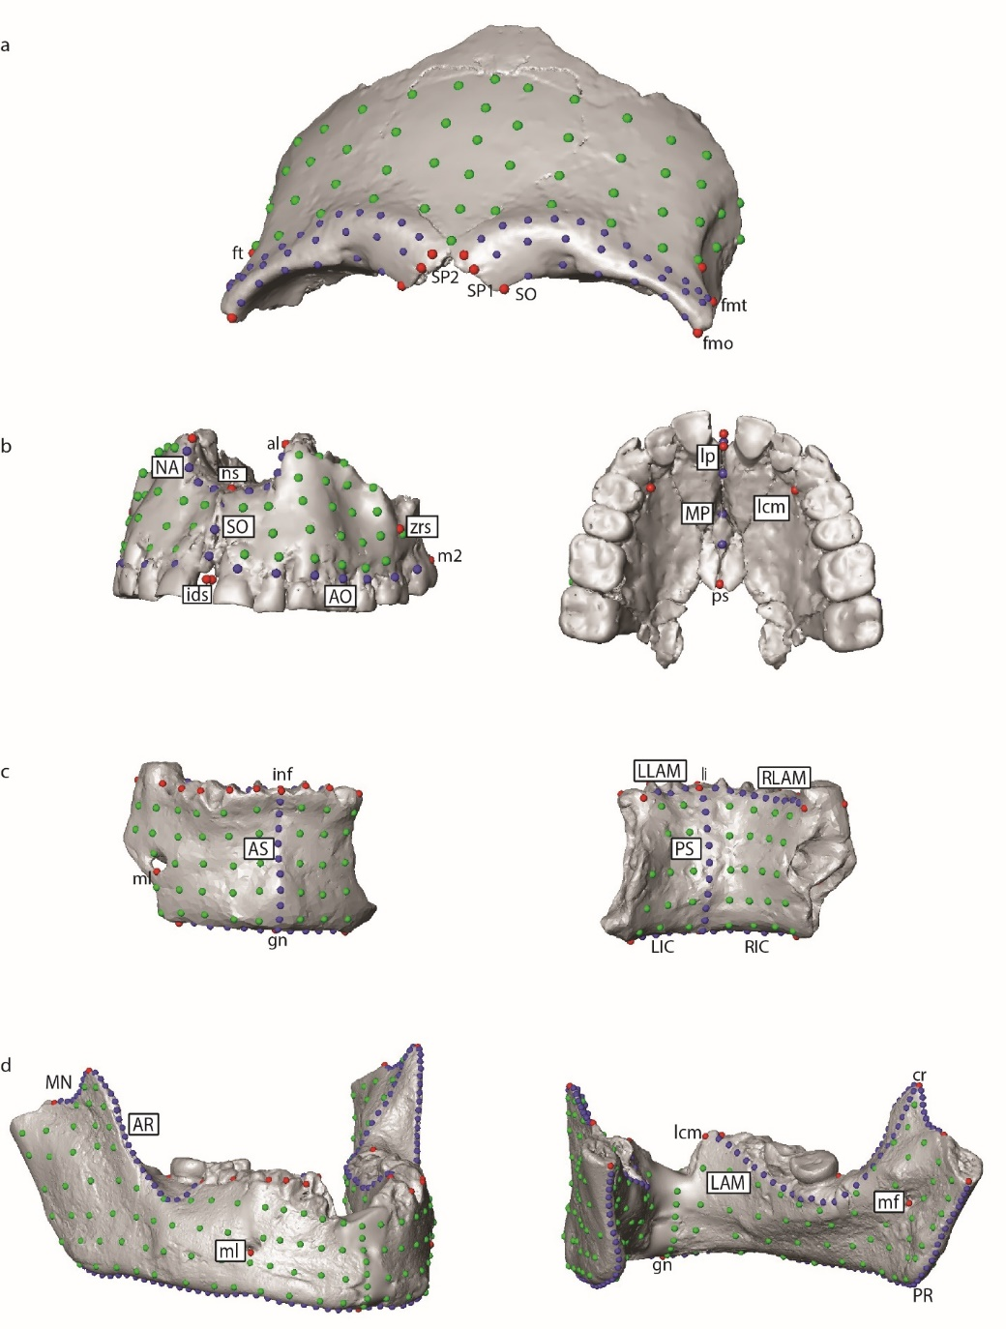

Supplementary Table 8. Fossil and recent human scans used in this study; underlined specimens were casts.
Specimen | Origin | Group Affiliation | Data
Lantian | China | Homo erectus | Mandible, Anterior corpus
Ngandong 10 | Indonesia | Homo erectus | Frontal
Sangiran 17 | Indonesia | Homo erectus | Frontal, Maxilla
Zhoukoudian 12 | China | Homo erectus | Frontal
Zhoukoudian LC G1.G2 | China | Homo erectus | Mandible, Anterior corpus
Zhoukoudian LC H1.12 | China | Homo erectus | Mandible, Anterior corpus
Zhoukoudian LC G1.66 | China | Homo erectus | Anterior corpus
Dali | China | Middle Pleistocene hominin | Frontal
Maba 1 | China | Middle Pleistocene hominin | Frontal
Zuttiyeh | Israel | Middle Pleistocene hominin | Frontal
Amud 1 | Israel | Neanderthal | Frontal, Maxilla
Banyoles | Spain | Neanderthal | Mandible, Anterior corpus
La Chaise: Bourgeois-Delaunay 1 (BD 1) | France | Neanderthal | Mandible, Anterior corpus
El Sidrón 1 + 2 | Spain | Neanderthal | Mandible, Anterior corpus
Gibraltar 1 | Gibraltar | Neanderthal | Frontal, Maxilla
Guattari 1 | Italy | Neanderthal | Frontal, Maxilla
Guattari 2 | Italy | Neanderthal | Anterior corpus
Guattari 3 | Italy | Neanderthal | Mandible, Anterior corpus
Kebara 2 | Israel | Neanderthal | Anterior corpus
Krapina 3 | Croatia | Neanderthal | Frontal
Krapina 6 | Croatia | Neanderthal | Frontal
Krapina 58 | Croatia | Neanderthal | Anterior corpus
Krapina 59 | Croatia | Neanderthal | Mandible, Anterior corpus
La Chapelle | France | Neanderthal | Frontal, Maxilla
La Ferrassie 1 | France | Neanderthal | Frontal, Maxilla, Mandible, Anterior corpus
La Quina 5 | France | Neanderthal | Frontal, Anterior corpus
La Quina 9 | France | Neanderthal | Mandible, Anterior corpus
Forbes Quarry | Germany | Neanderthal | Frontal
Le Regourdou 1 | France | Neanderthal | Mandible, Anterior corpus
Saint-Cesaire | France | Neanderthal | Frontal, Maxilla
Shanidar 1 | Iraq | Neanderthal | Frontal, Maxilla
Shanidar 5 | Iraq | Neanderthal | Frontal
Sima de los Huesos 5 | Spain | Neanderthal | Frontal, Maxilla
Spy 1 | Belgium | Neanderthal | Frontal
Spy 2 | Belgium | Neanderthal | Frontal
Spy 3 | Belgium | Neanderthal | Anterior corpus
Tabun 1 | Israel | Neanderthal | Frontal, Maxilla, Mandible, Anterior corpus
Zafarraya 2 | Spain | Neanderthal | Mandible, Anterior corpus
Border Cave 1 | South Africa | early H. sapiens | Frontal
Border Cave 2 | South Africa | early H. sapiens | Anterior corpus
Border Cave 5 | South Africa | early H. sapiens | Anterior corpus
Dar es-Soltane H3 | Morocco | early H. sapiens | Frontal
Dar es-Soltane H5 | Morocco | early H. sapiens | Frontal, Mandible, Anterior corpus
Florisbad | South Africa | early H. sapiens | Frontal
Jebel Irhoud 1 | Morocco | early H. sapiens | Frontal, Maxilla
Jebel Irhoud 2 | Morocco | early H. sapiens | Frontal
Jebel Irhoud 10 | Morocco | early H. sapiens | Maxilla
Jebel Irhoud 11 | Morocco | early H. sapiens | Mandible, Anterior corpus
Klasies River Mouth 41815 | South Africa | early H. sapiens | Mandible, Anterior corpus
Laetoli Hominin 18 | Tanzania | early H. sapiens | Maxilla
Omo Kibish 1 | Ethiopia | early H. sapiens | Frontal
Omo Kibish 2 | Ethiopia | early H. sapiens | Frontal
Qafzeh 6 | Israel | early H. sapiens | Frontal, Maxilla
Singa | Sudan | early H. sapiens | Frontal
Skhul 4 | Israel | early H. sapiens | Mandible, Anterior corpus
Skhul 5 | Israel | early H. sapiens | Frontal, Maxilla, Mandible, Anterior corpus
Tabun 2 C2 | Israel | early H. sapiens | Mandible, Anterior corpus
Contrebandiers 1 | Morocco | early H. sapiens | Mandible, Anterior corpus
Kow Swamp 5 | Australia | Late Pleistocene H. sapiens | Frontal
Liujiang 1 | China | Late Pleistocene H. sapiens | Frontal, Maxilla
Minatogawa 1 | Japan | Late Pleistocene H. sapiens | Frontal, Maxilla, Mandible, Anterior corpus
Minatogawa 4 | Japan | Late Pleistocene H. sapiens | Frontal, Maxilla
Minatogawa A | Japan | Late Pleistocene H. sapiens | Frontal, Mandible, Anterior corpus
Lake Mungo | Australia | Late Pleistocene H. sapiens | Frontal
Niah Cave | Malaysia | Late Pleistocene H. sapiens | Frontal, Maxilla
Salkhit | Mongolia | Late Pleistocene H. sapiens | Frontal
Tabon | Philippines | Late Pleistocene H. sapiens | Frontal
Tam Pong 1 (20541) | Laos | Late Pleistocene H. sapiens | Frontal, Maxilla, Mandible
Tianyuandong 1 (PA1281) | China | Late Pleistocene H. sapiens | Mandible, Anterior corpus
Wadjak 2/WH23 | Indonesia | Late Pleistocene H. sapiens | Frontal, Maxilla, Mandible, Anterior corpus
Zeyang | China | Late Pleistocene H. sapiens | Frontal
Zhirendong 3 | China | Late Pleistocene H. sapiens | Anterior corpus
Zhoukoudian Upper Cave 101 | China | Late Pleistocene H. sapiens | Frontal, Maxilla, Anterior corpus
Zhoukoudian UC 103 | China | Late Pleistocene H. sapiens | Frontal, Maxilla
Zhoukoudian UC 104 | China | Late Pleistocene H. sapiens | Mandible, Anterior corpus
Zhoukoudian UC 108 | China | Late Pleistocene H. sapiens | Anterior corpus
Zhoukoudian UC 109 | China | Late Pleistocene H. sapiens | Anterior corpus
Xiahe | China | Denisovan | Mandible, Anterior corpus
Liang Bua 1 | Indonesia | Homo floresiensis | Frontal, Mandible, Anterior corpus
Tam Hang South (n = 11) | Laos | Holocene H. sapiens | Frontal, Maxilla, Mandible, Anterior corpus
Tam Hang North (n = 1) | Laos | Holocene H. sapiens | Frontal, Maxilla
Tam Nang An (20543) | Laos | Holocene H. sapiens | Frontal, Maxilla, Mandible, Anterior corpus
Cau Giat (A3: 23105; 1: 24964) | Vietnam | Holocene H. sapiens | Frontal
Da But (19454) | Vietnam | Holocene H. sapiens | Frontal, Maxilla
Dong Thuoc (19424) | Vietnam | Holocene H. sapiens | Frontal
Lang Bon (23107) | Vietnam | Holocene H. sapiens | Frontal, Maxilla
Lang Cuom | Vietnam | Holocene H. sapiens | Frontal (n = 26), Maxilla (n=15)
Long Gao (23106; 2495BIS) | Vietnam | Holocene H. sapiens | Frontal

Supplementary Table 9. Landmarks, curves, and surface semilandmarks used in the analyses. Midline landmarks (i.e., non-bilateral) italicized. ¹One end of curve defined with curve semilandmark and set as a true landmark when sliding.

Landmark/Semilandmark | Abbreviation | Definition
Frontal Landmarks (n = 118)
Frontomalare orbitale | fmo | Point on orbital rim marked by the zygomaticofrontal suture
Frontomalare temporale | fmt | Most lateral part of the zyomaticofrontal suture
Frontotemporale | ft | Point of deepest indentation of the temporal crest of frontal bone
Frontal Curve Semilandmarks
Superior orbital margin¹ (n = 6) | SO | Frontomalare to 7th curve semilandmark (original to dacryon)
Supraorbital profile 1¹ (n = 8) | SP1 | Anterior projection of superciliary arch from frontomalare temporale to 9th curve semilandmark (original to nasion)
Supraorbital profile 2¹ (n = 12) | SP2 | Superior outline of superciliary arch from frontomalare temporale to 13th curve semilandmark (original to glabella)
Frontal Surface Semilandmarks (n = 54) |  | Surface patch on frontal bone
Maxilla Landmarks (n = 94)
Alare | al | Most lateral points on nasal margin
Nasospinale | ns | Lowest point of nasal margin in the midsagittal plane
Alveolare² | ids | The midpoint between both central incisors sockets at the buccal side of the alveolar margin
Zygomatic process root superior | zrs | The point where malar root arises from the maxilla; often a point of concavity between alveolar region and zygomaxillare
M²-M³ contact | m2 | Midpoint between M²-M³
Lingual prosthion | lp | The midpoint between both central incisors sockets at the lingual side of the alveolar margin
Lingual canine margin | lcm | Base of canine crown at lingual alveolar margin
Palatine suture | ps | Taken at suture in midsagittal plane
Maxilla Curve Semilandmarks
Alveolar outline (n = 7) | AO | Alveolare to M²
Subnasal outline (n = 3) | SO | Alveolare to nasospinale
Inferior nasal aperture (n = 4) | NA | Alare to nasospinale
Midsagittal palate (n = 3) | MP | Lingual prosthion to palatine suture
Maxilla Surface Semilandmarks (= 54) |  | Surface patch on maxilla
Mandible Anterior corpus Landmarks (n = 133)
Gnathion | gn | The most basal point on the symphysis
Infradentale | inf | The midpoint between both central incisors sockets at the external side of the alveolar margin
Linguale | li | The most superior point of symphysis at the lingual side
Mentale | ml | The most inferior point on the margin of the mental foramen
Right I₁, I₂, C₁, P₃, P₄, M₁ (buccal and lingual) |  | The midpoint between the tooth and its distal neighbor at the external side of the alveolar margin and the distobuccal corner of the molar (buccal and lingual)
Left I₁, I₂, C₁ (buccal and lingual) |  | The midpoint between the tooth and its distal neighbor at the external side of the alveolar margin
Mandible Anterior Corpus Curve Semilandmarks
Anterior corpus (n = 10) | AS | Anterior symphysis at midsagittal plane
Posterior symphysis (n = 10) | PS | Posterior symphysis at midsagittal plane
Right lingual alveolar margin (n = 9) | RLAM | Superior alveolar margin on lingual side from linguale to M₁
Left lingual alveolar margin (n = 3) | LLAM | Superior alveolar margin on lingual side from linguale to C₁
Right inferior corpus¹ (n = 5) | RIC | Base of mandible from gnathion to 6th curve semilandmark (originally to most superior point of condyle)
Left inferior corpus¹ (n = 4) | LIC | Base of mandible from gnathion to 5th curve semilandmark (originally to most superior point of condyle)
Mandible Anterior Corpus Surface Semilandmarks (n = 75) |  | Surface patch on buccal (n = 42) and lingual surfaces (n = 33)
Mandible Landmarks (n =474)
Gnathion | gn | see above
Mentale | ml | see above
Mandibular foramen | mf | Most inferior point on the foramen
Coronion | cr | Most superior point on coronoid process
C₁, P₃, P₄, M₁, M₂, M₃ |  | see above
Lingual canine margin | lcm | see above
Mandible Curve Semilandmarks
Anterior ramus (n = 20) | AR | Along anterior ramus from coronoid to distobuccal corner of M₃
Lingual alveolar margin (n = 25) | LAM | Superior alveolar margin on lingual side from lingual canine margin to coronoid
Mandibular notch¹ (n = 8) | MN | Along notch from coronoid to 9th curve semilandmark (originally to most superior point of condyle)
Posterior ramus¹ (n = 44) | PR | Along posterior ramus and base of mandible from gnathion to 45th curve semilandmark (originally to most superior point of condyle)
Mandible Surface Semilandmarks (n = 255) |  | Surface patch on buccal (n = 144) and lingual surfaces (n = 111)

Supplementary Figure 26. Code used for Bayesian modeling of samples from Tam Pà Ling.
Options()
{
Resolution=500;
};
Plot()
{
Sequence()
{
Boundary("base");
Phase("OSL15")
{
Date("TPOSL15 - pIR", N(calBP(80000), 10000));
Date("TPOSL15 - fines", N(calBP(86000), 12000));
Date("US teeth 1", N(calBP(71000), 1500));
Date("US-ESR teeth 1", N(calBP(84000), 8000));
};
Boundary("1");
Phase("OSL14")
{
Date("US teeth 2", N(calBP(67000),1800));
Date("TPLOSL14 pIR", N(calBP(74000),11000));
Date("TPLOSL14 fines", N(calBP(63000),12000));
};
Boundary("2");
Phase("OSL13")
{
Date("TPLOSL13 pIR", N(calBP(71000),5000));
Date("TPLOSL13 fines", N(calBP(65000),20000));
};
Boundary("3");
Phase("OSL12")
{
Date("TPLOSL12 pIR", N(calBP(67000),5000));
};
Boundary("4");
Phase("OSL10")
{
Date("TPLOSL10 pIR", N(calBP(70000),8000));
Before("TPLOSL10 OSLSG", N(calBP(48000),5000))
{
};
};
Boundary("5");
Phase("OSL3")
{
Date("TPLOSL3 pIR", N(calBP(56000),6000));
Before("TPLOSL3 OSLSG", N(calBP(48000),5000))
{
};
Before("TPLOSL3 14C", N(calBP(40000), 3000))
{
};
};
Boundary("6");
Phase("OSL2")
{
Date("TPLOSL2 pIR", N(calBP(46000), 6000));
Date("TPLOSL2 OSLSG", N(calBP(46000), 5000));
Before("TPLOSL2 US bone", N(calBP(44000), 5000))
{
};
After("TPLOSL2 US carb", N(calBP(64000), 1000))
{
};
};
Boundary("7");
Phase("OSL1")
{
Date("TPLOSL1 OSLSG", N(calBP(46000), 4000));
Date("TPLOSL1 pIR", N(calBP(43000), 7000));
After("TPLOSL1 US bone", N(calBP(64000), 6000))
{
};
Before("TPLOSL1 14C", N(calBP(40000), 3000))
{
};
};
Boundary("8");
Phase("OSL4")
{
Date("TPLOSL4 OSLSG", N(calBP(32000), 3000));
After("TPLOSL4 14C", N(calBP(39000), 1000))
{
};
};
Boundary("9");
Phase("OSL5")
{
After("TPLOSL5 14C", N(calBP(36000), 1000))
{
};
Date("TPLOSL5 OSLSG", N(calBP(22000), 2000));
};
Boundary("10");
Phase("OSL6")
{
Date("TPLOSL6 OSLSG", N(calBP(13000), 2000));
After("TPLOSL6 14C", N(calBP(25000), 1000))
{
};
};
Boundary("11");
Phase("OSL7")
{
Date("TPLOSL7 OSLSG", N(calBP(12000), 1000));
Before("TPLOSL7 14C", N(calBP(2800), 20))
{
};
};
Boundary("12");
Phase("OSL8")
{
Date("TPLOSL8 OSLSG", N(calBP(2400), 30));
Before("TPLOSL8 14C", N(calBP(1100), 20))
{
};
};
Boundary("top");
};
};

1 Saurin, E. Carte géologique du Laos, feuille Luang Prabang. Publication du service geographique national du Vietnam (1961).
2 Hernandez, V. P. C. Early human occupation of Mainland Southeast Asia: Preliminary microstratigraphic results from Tam Pà Ling, Laos. (forthcoming).
3 Hernandez, V. P. C., Shackelford, L., Bacon, A-M., Duringer, P., Westaway, K., Ponché, J-L., Boualaphane, S., Demeter, F., Morley, M.W. . in Indo-Pacific Prehistory Association Congress (Chang Mai, Thailand, 2022).
4 Ellwood, B. B. et al. Magnetic susceptibility applied as an age–depth–climate relative dating technique using sediments from Scladina Cave, a Late Pleistocene cave site in Belgium. Journal of Archaeological Science 31, 283-293, doi:https://doi.org/10.1016/j.jas.2003.08.009 (2004).
5 Lowe, K. M. et al. Using Soil Magnetic Properties to Determine the Onset of Pleistocene Human Settlement at Gledswood Shelter 1, Northern Australia. Geoarchaeology 31, 211-228, doi:https://doi.org/10.1002/gea.21544 (2016).
6 Heller, F. & Evans, M. E. Loess magnetism. Reviews of Geophysics 33, 211-240, doi:https://doi.org/10.1029/95RG00579 (1995).
7 Maher, B. A. Magnetic properties of modern soils and Quaternary loessic paleosols: paleoclimatic implications. Palaeogeography, Palaeoclimatology, Palaeoecology 137, 25-54, doi:https://doi.org/10.1016/S0031-0182(97)00103-X (1998).
8 Dearing, J. Environmental Magnetic Susceptibility Using the Bartington MS2 System (ed.2). (Chi Publishing, 1999).
9 Bacon, A.-M. et al. Nam Lot Southeast Asian sites revisited: Zooarchaeological and isotopic evidences. Palaeogeography, palaeoclimatology, palaeoecology 512, 132, doi:10.1016/j.palaeo.2018.03.034 (2018).
10 Milano, S. et al. Environmental conditions framing the first evidence of modern humans at Tam Pà Ling, Laos: A stable isotope record from terrestrial gastropod carbonates. Palaeogeography, Palaeoclimatology, Palaeoecology 511, 352-363, doi:10.1016/j.palaeo.2018.08.020 (2018).
11 Yamoah, K. A. et al. A muted El Niño-like condition during late MIS 3. Quaternary Science Reviews 254, 106782, doi:https://doi.org/10.1016/j.quascirev.2020.106782 (2021).
12 Marwick, B. & Gagan, M. K. Late Pleistocene monsoon variability in northwest Thailand: an oxygen isotope sequence from the bivalve Margaritanopsis laosensis excavated in Mae Hong Son province. Quaternary Science Reviews 30, 3088-3098, doi:https://doi.org/10.1016/j.quascirev.2011.07.007 (2011).
13 Dean, W. E. Determination of carbonate and organic matter in calcareous sediments and sedimentary rocks by loss on ignition; comparison with other methods. Journal of Sedimentary Research 44, 242-248, doi:10.1306/74d729d2-2b21-11d7-8648000102c1865d (1974).
14 Nelson, D. W. & Sommers, L. E. in Methods of Soil Analysis 961-1010 (1996).
15 Heiri, O., Lotter, A. F. & Lemcke, G. Loss on ignition as a method for estimating organic and carbonate content in sediments: reproducibility and comparability of results. Journal of Paleolimnology 25, 101-110, doi:10.1023/A:1008119611481 (2001).

