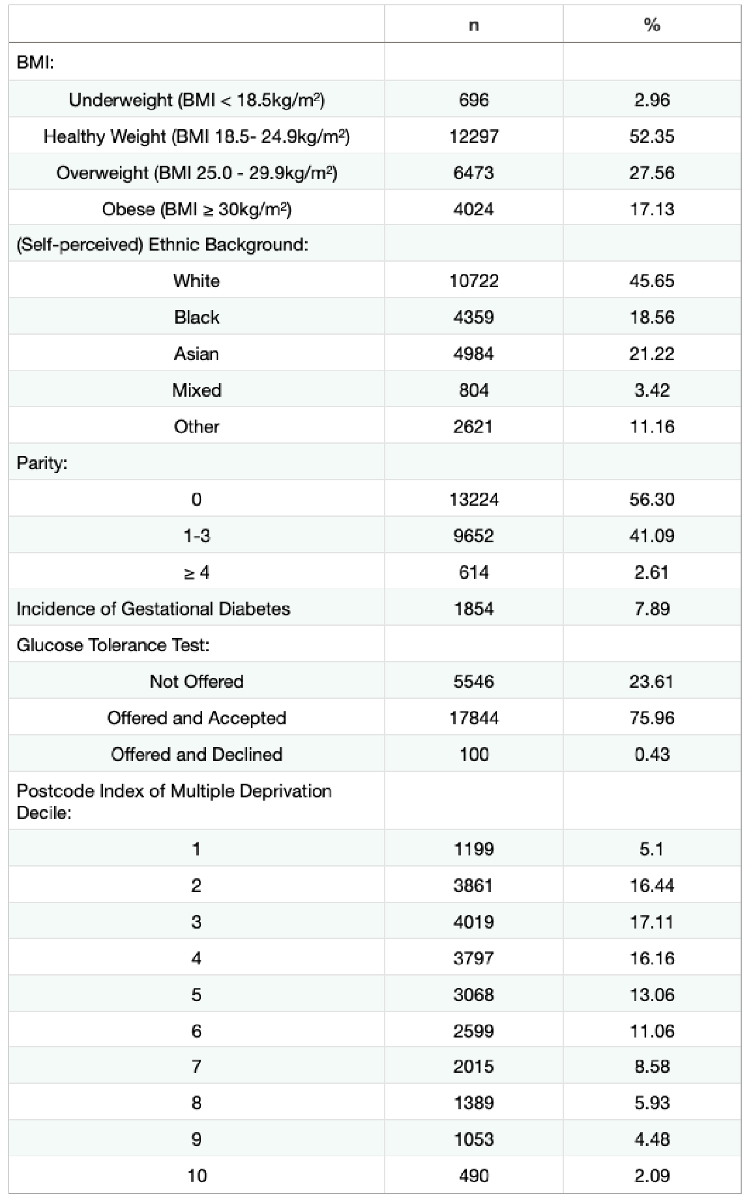
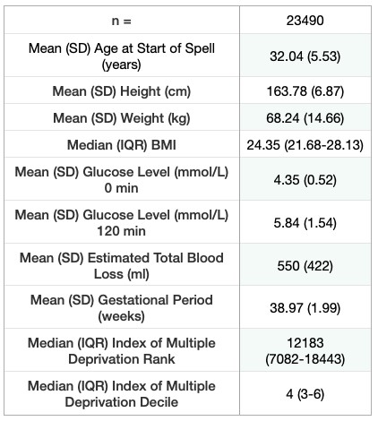
Tables 1A & 1B: Baseline Maternal Characteristics
A
B
*
**
†

* Weight measured at first booking
**75g 2-hour oral glucose tolerance test
† Decile a postcode’s deprivation rank falls into, according to IMD2019

Tables 2A & 2B: Baseline Neonatal Characteristics

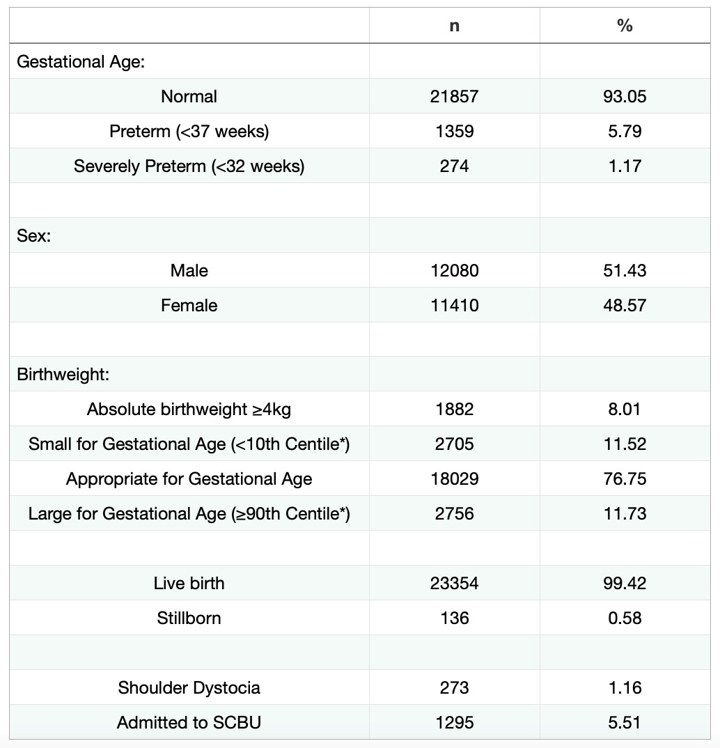
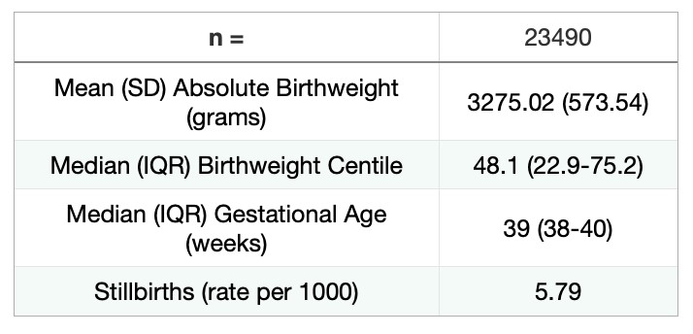
A
B
*

* Special Care Baby Unit

Table 3: Maternal Delivery Outcomes

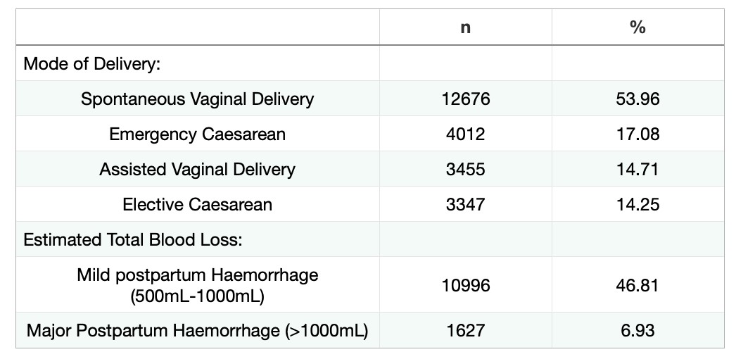

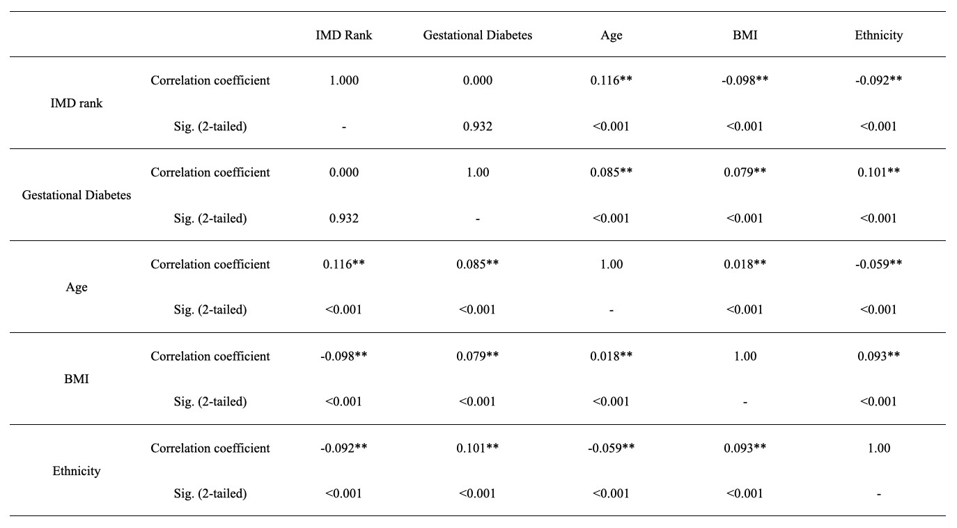
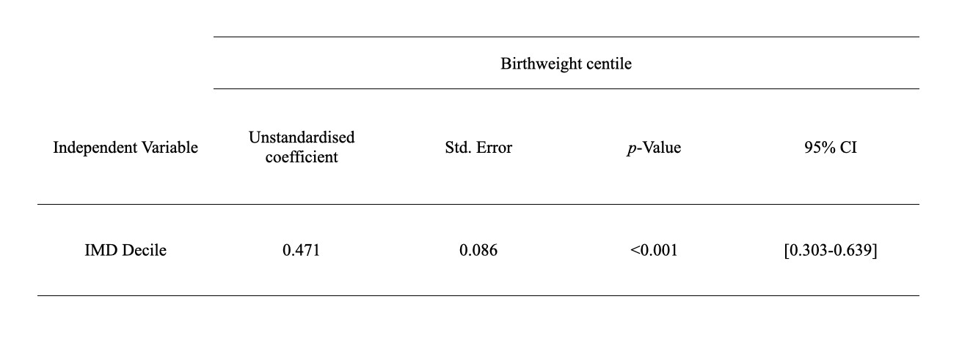
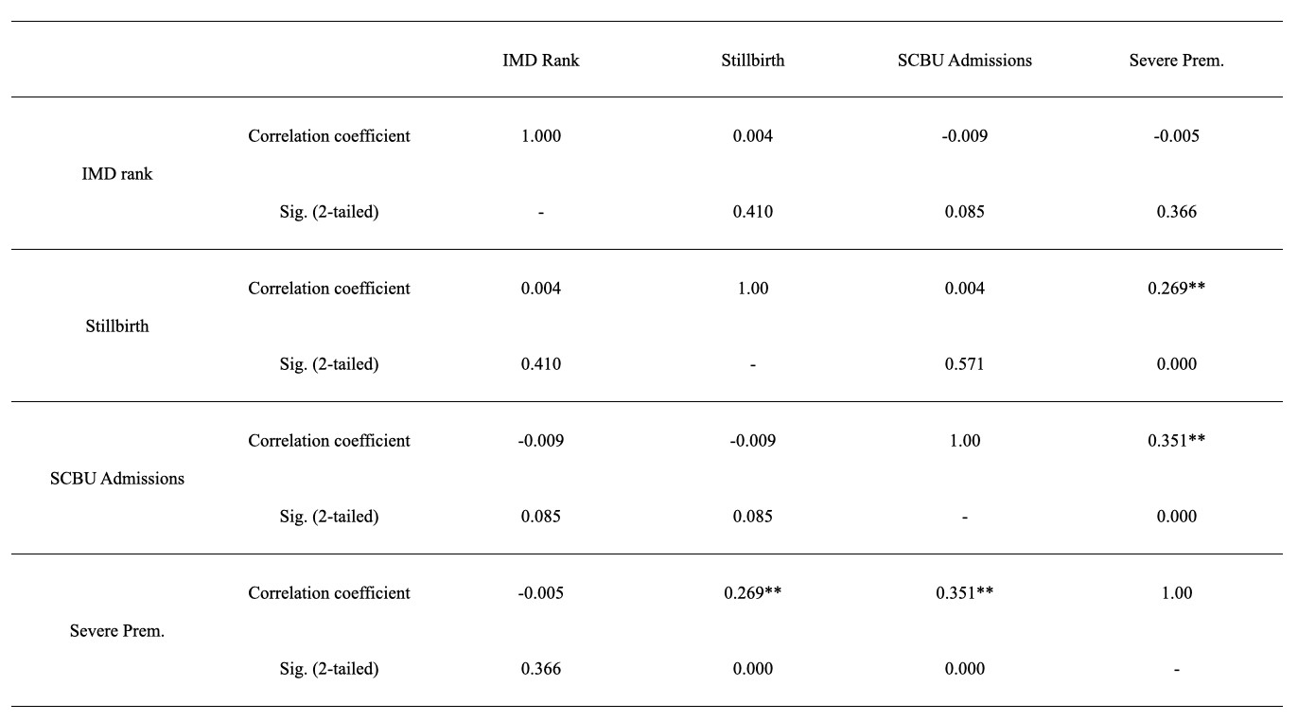
Table 4: Tables showing results of: A) Kendall’s Tau correlation analysis between IMD Rank, Gestational Diabetes Incidence, Age, BMI and Ethnicity; B) Ordinal Logistic regression analysis between IMD Decile and birthweight centile; C) Kendall’s Tau correlation analysis between IMD Rank, Stillbirths, SCBU Admissions and Severely Preterm births.
A
B
C

**: Correlation is significant at the 0.01 level (2-taile

