Appendices:

Appendix 1. Breakdown of CERNER-recorded ethnicity to neonatal birthweight centile calculator ethnic origin input
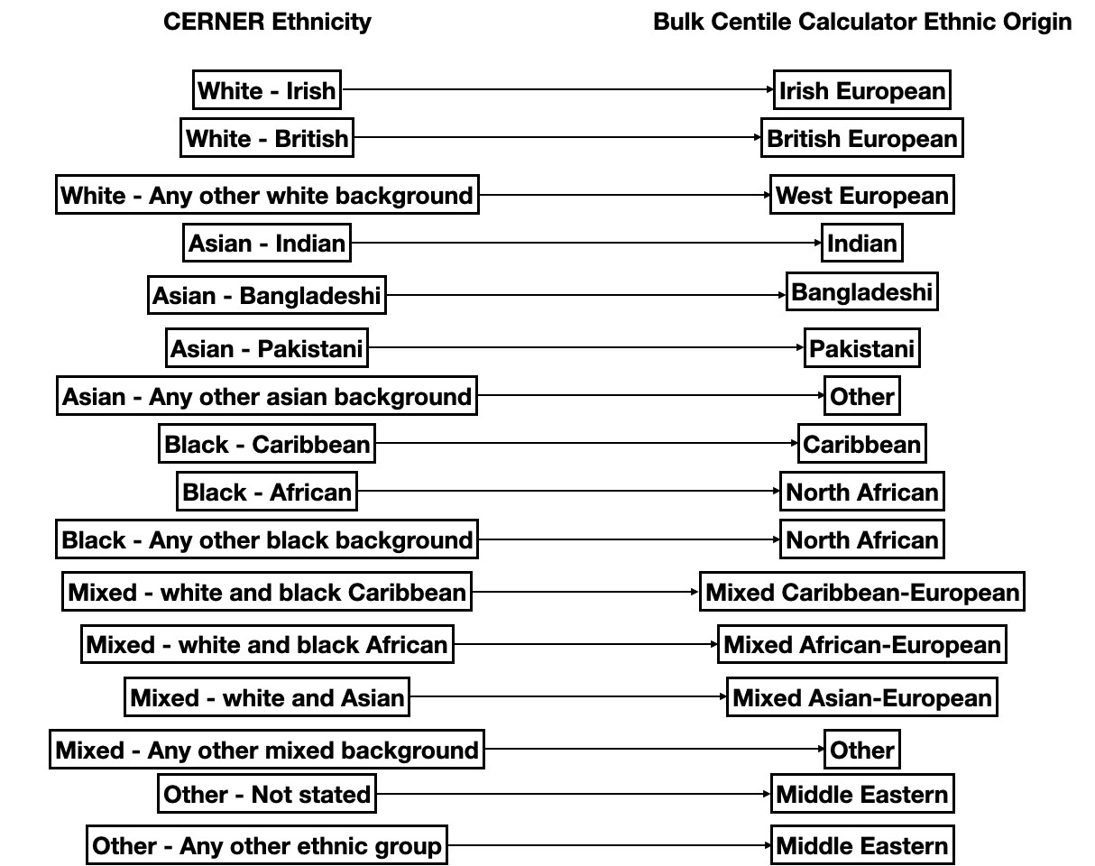

Appendix 2. Assumptions testing for multiple logistic regression model

Figure S1. Assumptions test for multicollinearity (Spearman’s)

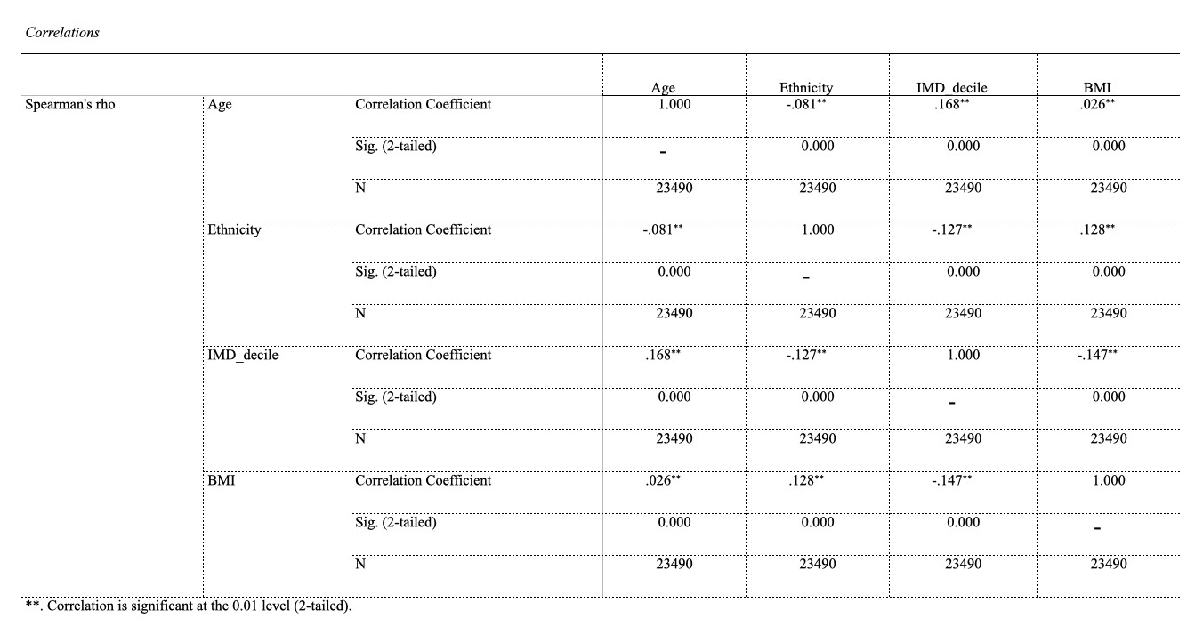

Figure S2. Assumptions test for outliers (ROUT, Q=1%)

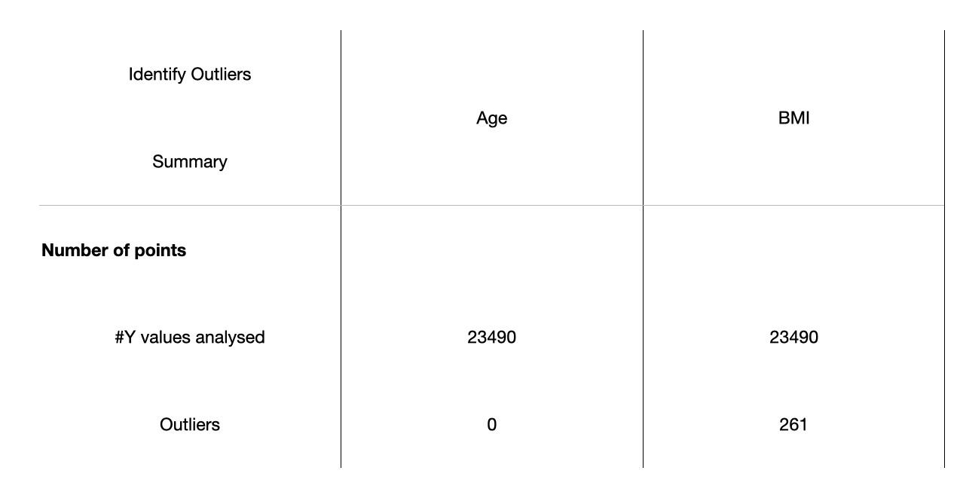

Appendix 3. Multiple regression model details

