Supplementary Figures:

- Flesch-Kincaid Score
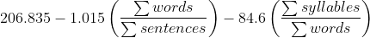

- Flesch-Kincaid Grade Level
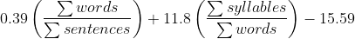

- Automated Readability Index
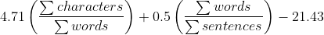

- Gunning Fog Index
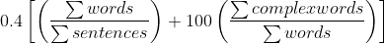

Supplementary Figure 1A-D: Programmatic Approach Distributions of Pre and Post Processing Readability Scores
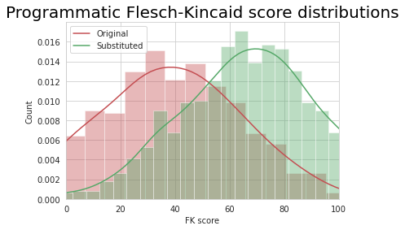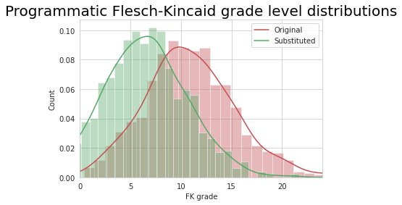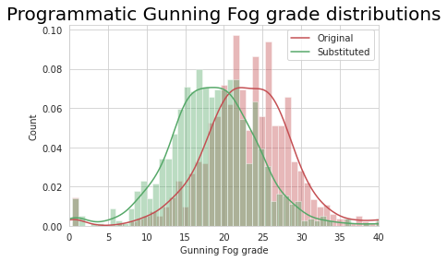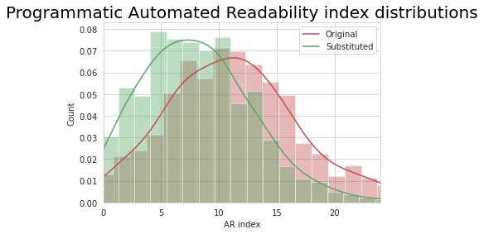

Supplementary Figure 2A-D: In this figure we show the distributions of FKS, FKG, GFI, and ARI; red = distributions of original pre-substitution definitions, green = distributions of post-substitution definitions. These figures show change in simplicity distribution for: A) FKS - increase in score is considered increase in readability. B) FKG contrasting the logic of FKS where a decrease in grade level is considered and increase in readability. C) GFI grade distributions, a decrease in grade level is considered and increase in readability. D) ARI grade, a decrease in grade level is considered an increase in readability. Here we show with the programmatic approach, we increase readability across all metrics.

Supplementary Figure 3A-D: T5 Approach Distributions of Pre and Post Processing Readability Scores
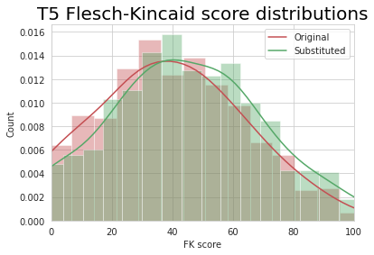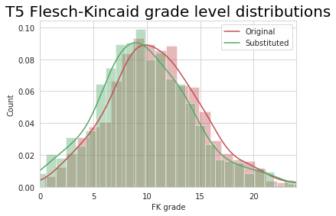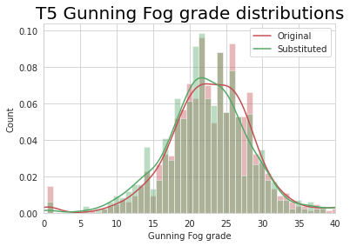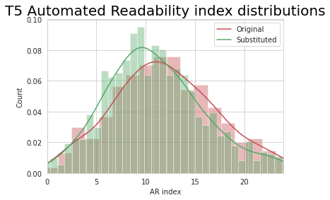
Figure 3A-D: Similarly as in Figure 2A-D, FKS, FKG, GFI, and ARI; red = distributions of original pre-substitution definitions, green = distributions of post-substitution definitions. As with the programmatic approach, the T5 approach showed an increase in readability across all metrics.

Figure 4: A-D - T5 Approach Distributions of Pre and Post Processing Readability Scores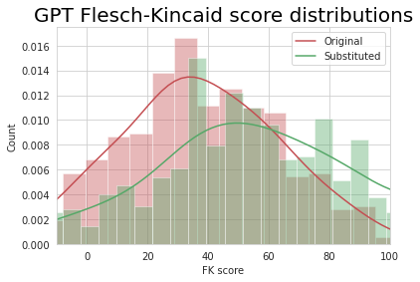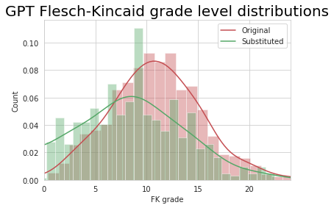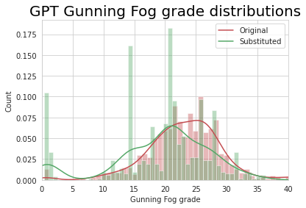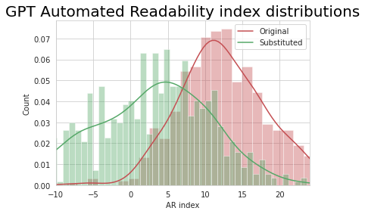
Figure 4A-D: Similarly as in Figure 2A-D, FKS, FKG, GFI, and ARI; red = distributions of original pre-substitution definitions, green = distributions of post-substitution definitions. As with the programmatic and T5 approach, the GPT approach showed an increase in readability across all metrics.

Supplementary Tables 1A-C

Supplementary Table 2A: Programmatic Approach Readability Metrics Welch T-Test 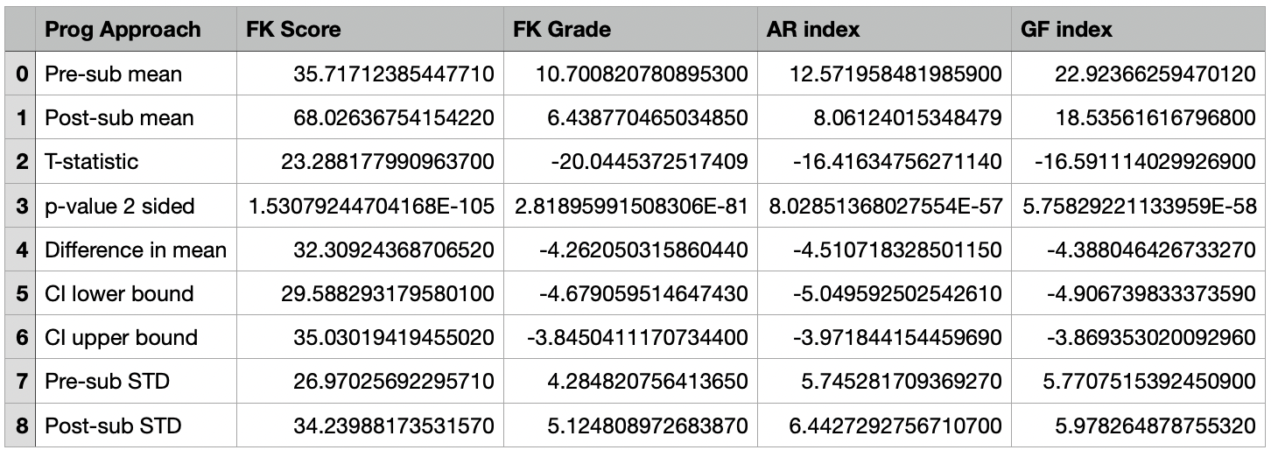

A) The programmatic approach had a mean FKS increase of 32.31 (p-value 1.53e-105, CI 29.58 to 35.030), mean FKG reduction of 4.30 (p-value 2.58e-81, CI -4.67 to -3.85), mean ARI grade reduction of 4.51 (p-value 8.02e-57, CI -5.04 to -3.97), and mean GFI reduction of 4.39 (p-value 5.76e-58, CI -4.91 to -3.87).

Supplementary Table 2B: T5 Approach Readability Metrics Welch T-Test
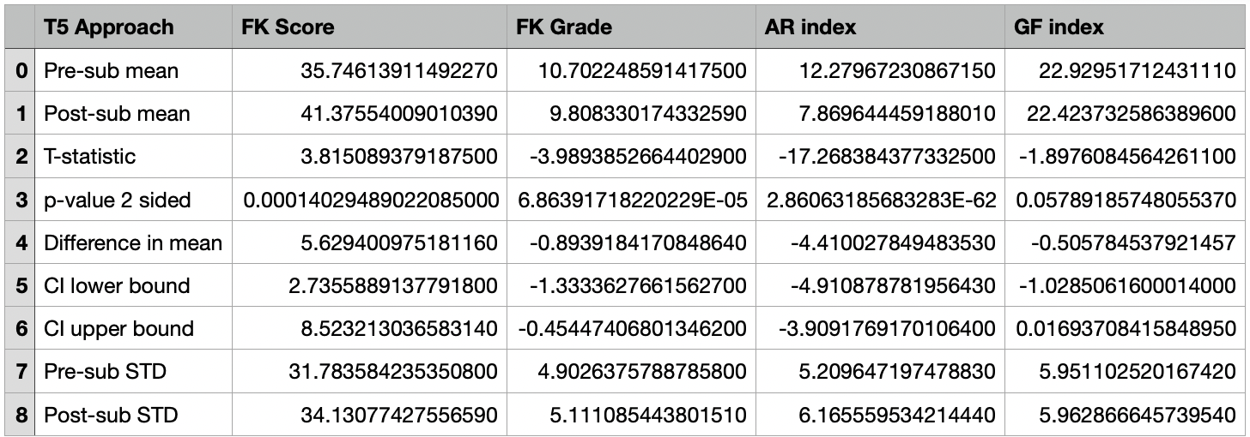
B) The T5 approach had a mean FKS increase of 5.63 (p-value 1.53e-105, CI 29.58 to 35.030), mean FKG reduction of 0.89 (p-value 6.86e-05, CI -1.33 to -0.45), mean ARI grade reduction of 4.41 (p-value 2.86e-62, CI -4.91 to -3.91), and mean GFI reduction of 0.51 (p-value 0.06, CI -1.02 to 0.02).

Supplementary Table 2C: GPT Approach Readability Metrics Welch T-Test
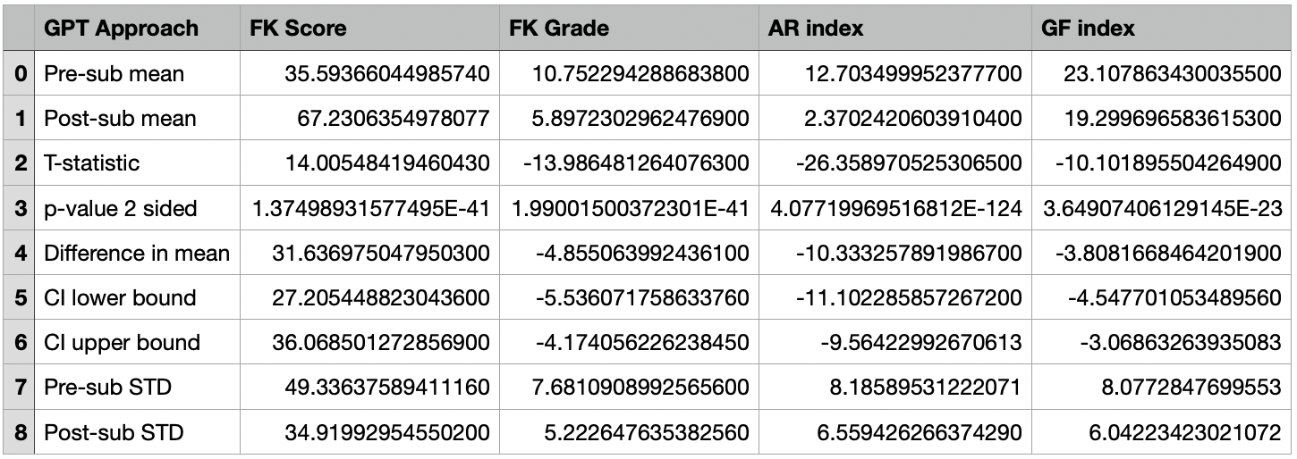
C) The GPT-J-6b approach had a mean FKS increase of 31.64 (p-value 1.37e-41, CI 27.21 to 36.07), mean FKG reduction of 4.86 (p-value 1.99e-41, CI -5.54 to -4.17), mean ARI grade reduction of 10.33 (p-value 4.08e-124, CI -11.10 to -9.56), and mean GFI grade reduction of 3.81 (p-value 3.65e-23, CI -4.55 to -3.06).

