Supplementary information

Occurrence and concentrations of organic micropollutants (OMPs) in highway stormwater: A comparative field study in Sweden
Ali Beryani^{(1)(*)}, Kelsey Flanagan⁽¹⁾, Maria Viklander⁽¹⁾, Godecke-Tobias Blecken⁽¹⁾
⁽¹⁾ Department of Civil, Environmental, and Natural Resources Engineering, Luleå University of Technology, 97187 Luleå, Sweden
^{(*)} Corresponding Author: ali.beryani@ltu.se

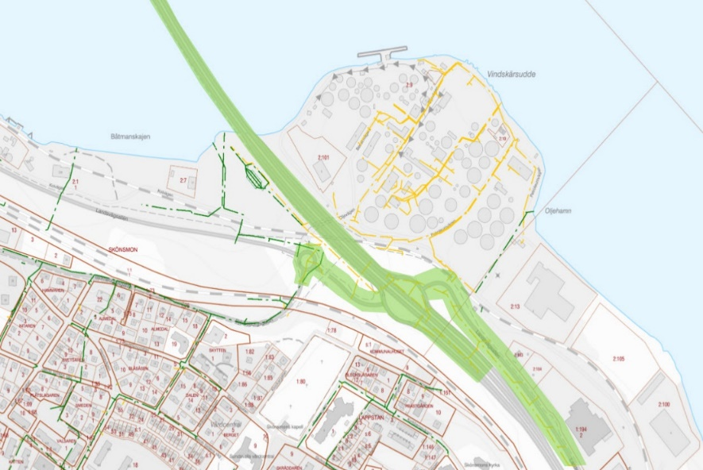
Rain gauge
Sampling point
Pipeline
100 m
Figure S1. Site plan of the catchment area (denoted in green) in Sundsvall, Sweden

Table S1. Standard analytical methods used for determining the concentrations of organic substances and other parameters
Parameter | Analytical method
PHCs | Determination of extractable compounds in the range of hydrocarbons C10−C₄₀, fractions were calculated from the measured values by gas chromatography with FID detection according to the following methods: CSN EN ISO 9377-2; US EPA 8015; US EPA 3510; TNRCC Method 1006.
PAHs | Determination of semi-volatile organic compounds by gas chromatography with MS or MS/MS detection according to methods US EPA 8270D, US EPA 8082A, CSN EN ISO 6468, and US EPA 8000D. Samples were prepared as per CZ_SOP_D06_03_P01 chap. 9.1, 9.4.1. Calculation of semi-volatile organic compounds sums from measured values.
BPA and APs | Determination of alkylphenols and alkylphenol ethoxylates by gas chromatography with MS or MS/MS detection according to method CSN EN ISO 18857-2. Total alkylphenols and alkylphenol ethoxylates were calculated based on the measured values.
TOC | Total organic carbon (TOC) was determined by IR detection according to methods CSN EN 1484 and SM 5310.
TSS | Gravimetrical determination of suspended solids according to method SS-EN 872-2:2005.
Turbidity | Determined with a 2100Q IS Portable Turbidimeter, HACH (Loveland, CO), calibrated with Formazin primary StablCal Standards.
Conductivity and temperature | Determined with pHenomenal® Conductivity/TDS/°C Meter, Handheld, CO 3100 H, VWR (Radnor, PA), calibrated using the control standard KCl solution.
pH | Determined with a pH 330i meter, Handheld, WTW GmbH (Weilheim, Germany), calibrated by buffer solutions.

Table S2. Characteristics of various Polycyclic Aromatic Hydrocarbons (PAHs)
PAH | Abbr. | Molecular mass$ (Daltons) | No. of rings | fraction | Carcino-genicity group* | Water solubility¥ (mg/L at 25˚C) | Vapor pressure# (Pa at 25˚C) | Log K_{ow}$ | Log K_{oc} (calc.) £
Naphthalene | Nap | 128 | 2 | LWM | 2B | 31.6 | 10.4 | 3.37 | 2.95
Acephthylene | Acyl | 152 | 3 | LWM | − | 16 | 9.0e-1 | 4.00 | 3.13
Acephthene | Acen | 154 | 3 | LWM | 3 | 4.5 | 30e-1 | 3.92 | 3.46
Fluorene | Flu | 166 | 3 | LWM | 3 | 1.8 | 9.0e-2 | 4.18 | 3.71
Phenthrene | Phen | 178 | 3 | LWM | 3 | 1.3 | 2.0e-2 | 4.57 | 3.79
Anthracene | Anth | 178 | 3 | LWM | 3 | 0.07 | 1.0e-3 | 4.54 | 4.57
Fluoranthene | Flth | 202 | 4 | MWM | 3 | 0.24 | 1.2e-3 | 5.22 | 4.24
Pyrene | Pyr | 202 | 4 | MWM | 3 | 0.14 | 6.0e-4 | 5.18 | 4.39
Benz(a) anthracene | BaA | 228 | 4 | HWM | 2B | 0.01 | 2.8e-5 | 5.91 | 5.09
Chrysene | Chry | 228 | 4 | HWM | 2B | 0.003 | 5.7e-7 | 1.65 | 5.41
Benzo(b) fluoranthene | BbF | 252 | 5 | HWM | 2B | <0.001 | − | 5.80 | 5.70 <
Benzo(k) fluoranthene | BkF | 252 | 5 | HWM | 2B | <0.001 | 5.2e-8 | 6.00 | 5.70 <
Benzo(a)pyrene | BaP | 252 | 5 | HWM | 1 | <0.001 | 7.0e-7 | 6.04 | 5.70 <
Dibenz(a.h) anthracene | DahA | 278 | 5 | HWM | 2A | <0.001 | 3.7e-10 | 6.75 | 5.70 <
Benzo(g.h.i) perylene | Bper | 276 | 6 | HWM | 3 | <0.001 | − | 6.50 | 5.70 <
Indeno(1.2.3.cd) pyrene | InP | 276 | 6 | HWM | 2B | <0.001 | 6e-8 | 6.58 | 5.70 <
¥ (Monaco et al., 2017)
# (Joa et al., 2009)
$ K_{ow}: Octanol-water partition coefficient (Joa et al., 2009)
£ K_{oc}: Sediment organic carbon-water partition coefficient (Khodadoust et al., 2005)
* (1): carcinogenic to humans; (2A): probably carcinogenic to humans; (2B): possibly carcinogenic to humans; (3): not classifiable as carcinogenic to humans (IARC Working Group, 2010).

Table S3. Characteristics of various Petroleum Hydrocarbons (PHCs) (Reed & Stemer, 2002)
Petroleum Hydrocarbons  (only C10< fractions) | Molecular Weight | Water solubility¥ (mg/L at 25˚C) | Vapor pressure$ (Pa at 25˚C) | Boiling point (˚C) | Log K_{oc} (calc.) £
Aliphatic
C₁₀−C₁₂ | 160 | 0.026 | 7.9e+1 | 200 | 5.4
C₁₂−C₁₆ | 200 | 5.9e-4 | 3.5 | 260 | 6.7
C₁₆−C₂₁ | 270 | 1.0e-6 | 1.7e-1 | 320 | 8.8
Aromatic
C₁₀−C₁₂ | 130 | 25 | 7.8e+1 | 200 | 3.4
C₁₂−C₁₆ | 150 | 5.8 | 3.5 | 260 | 3.7
C₁₆−C₂₁ | 190 | 0.51 | 1.7e-1 | 320 | 4.2
C₂₁−C₃₅ | 240 | 0.0066 | 7.9e-4 | 340 | 5.1
Note: Values are based on pure substances; behaviour may differ in complex mixtures.
£ K_{oc}: Sediment organic carbon-water partition coefficient

(a) 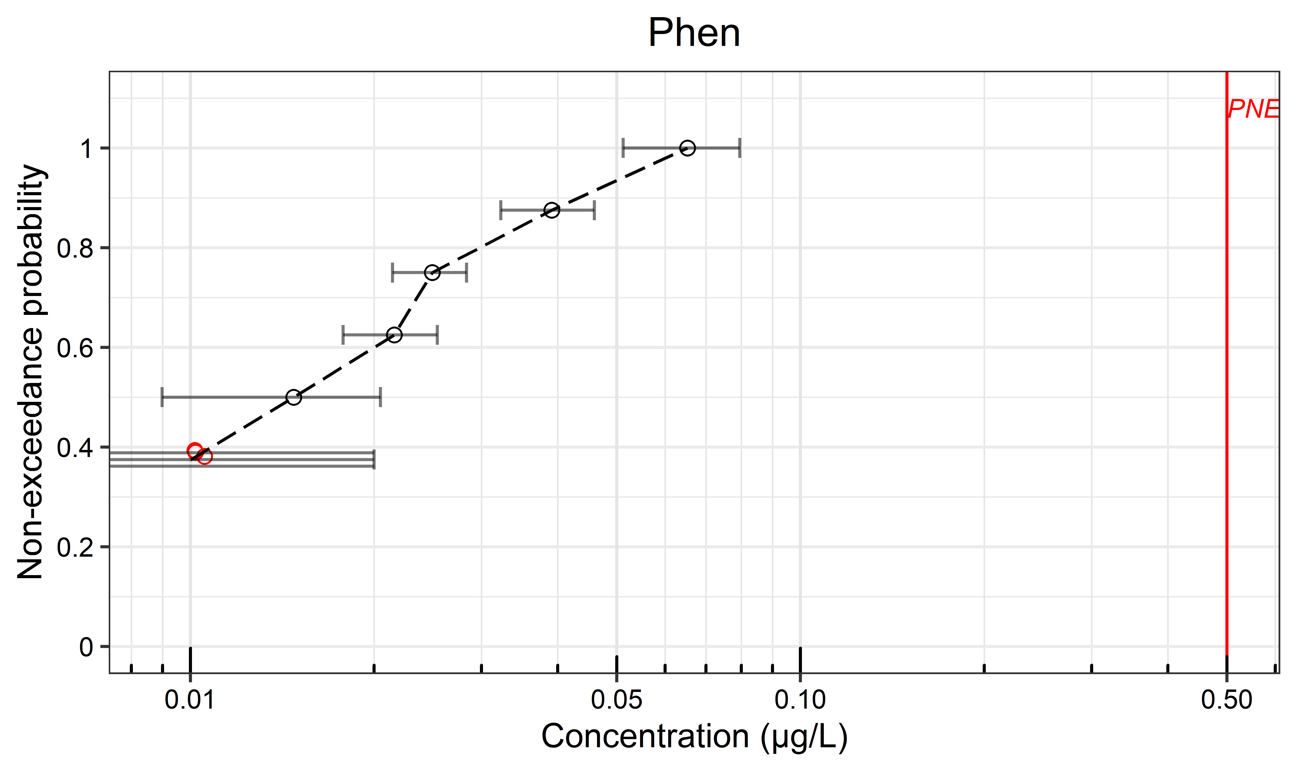 | (b) 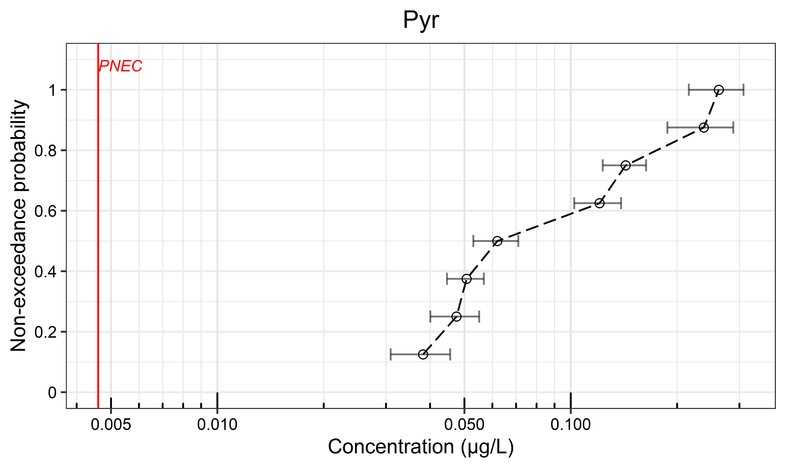 | (c) 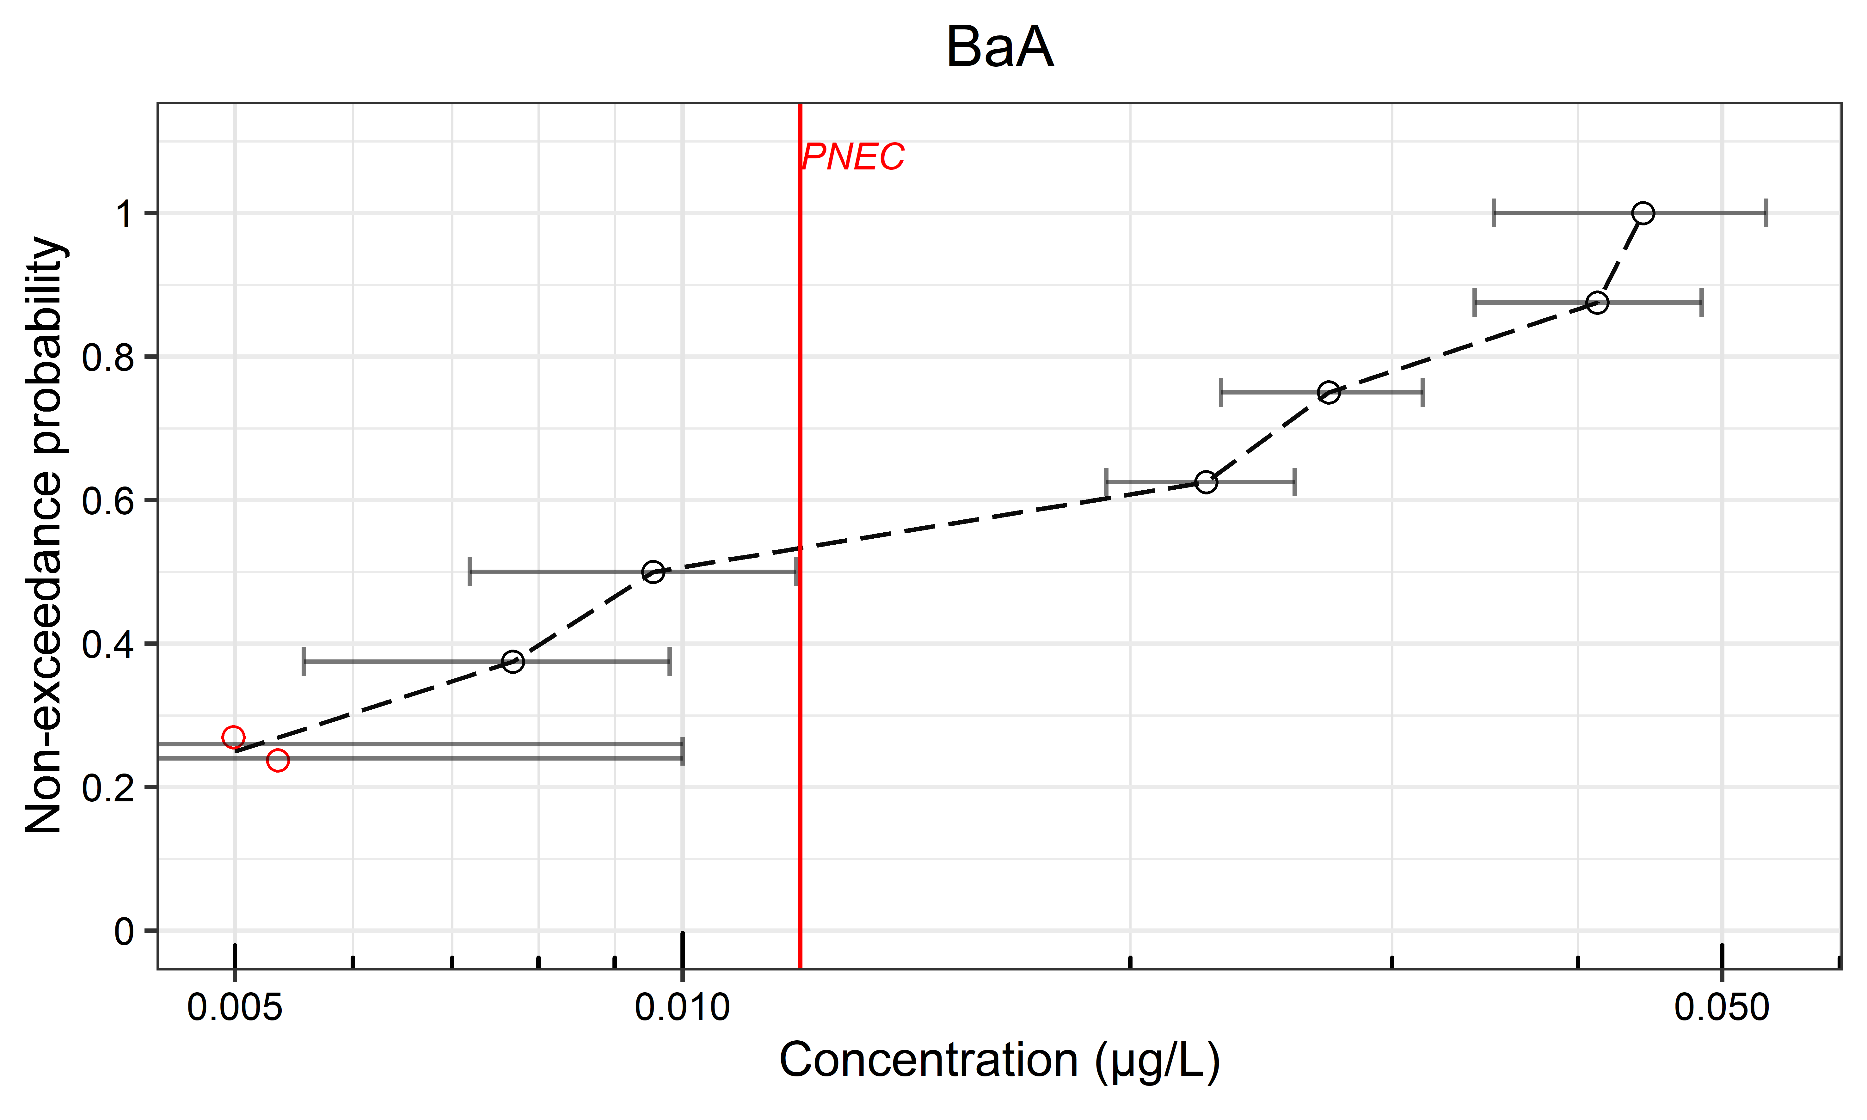
(d) 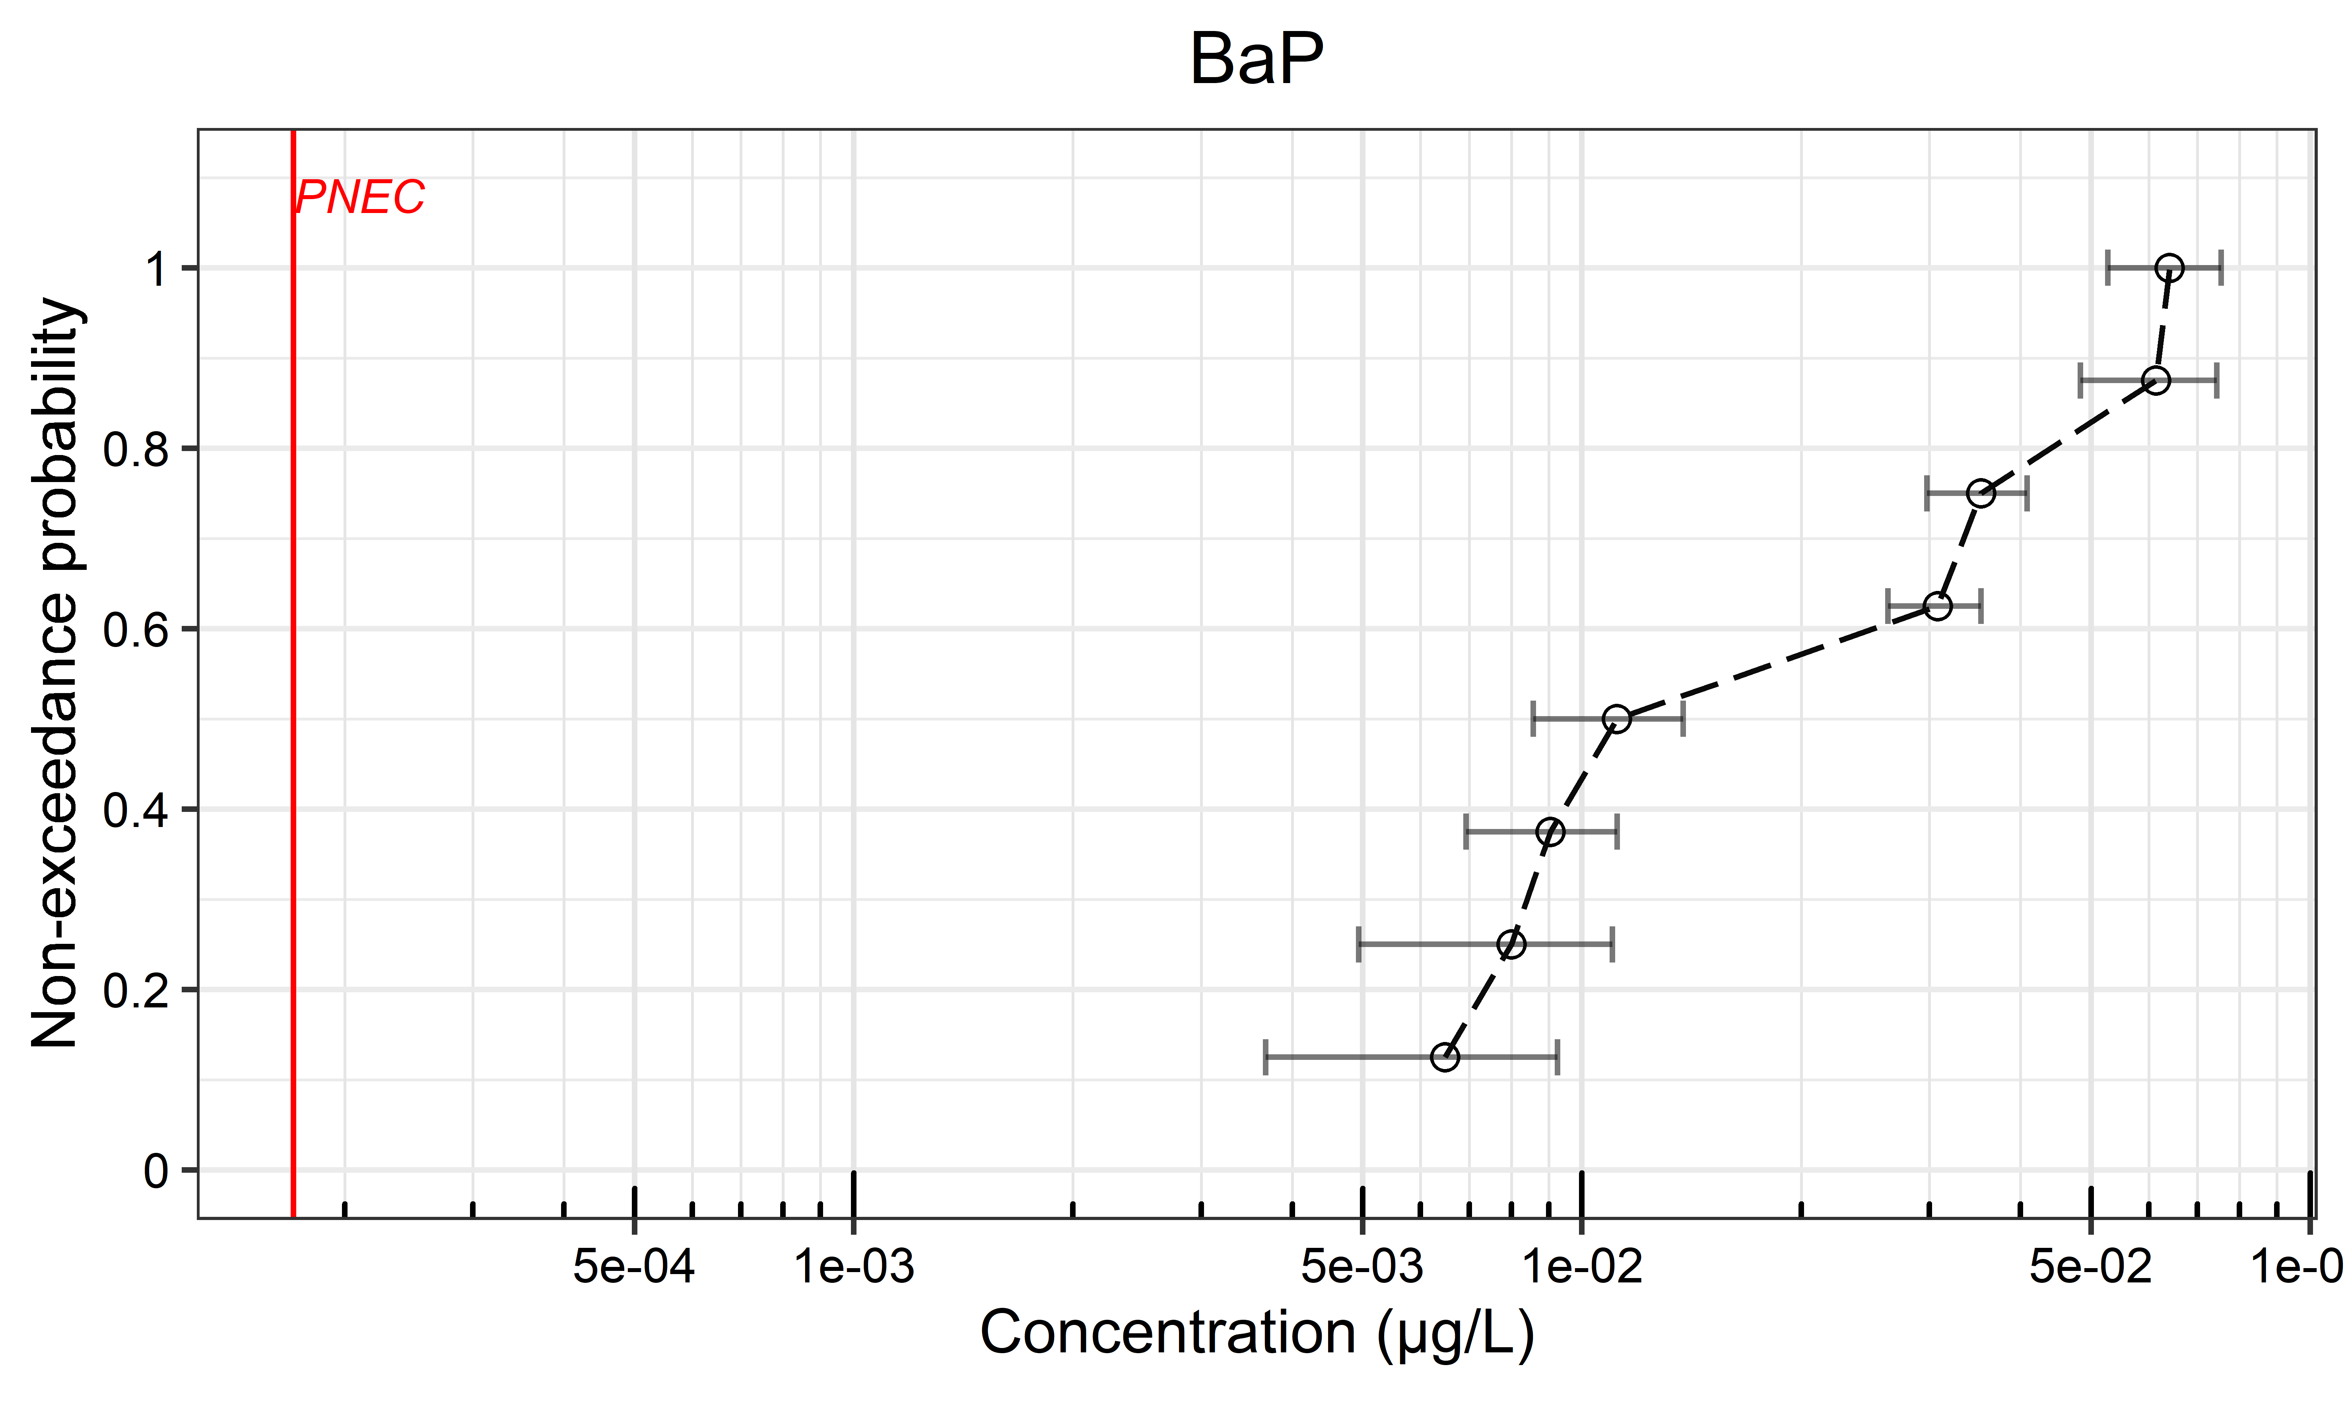 | (e) 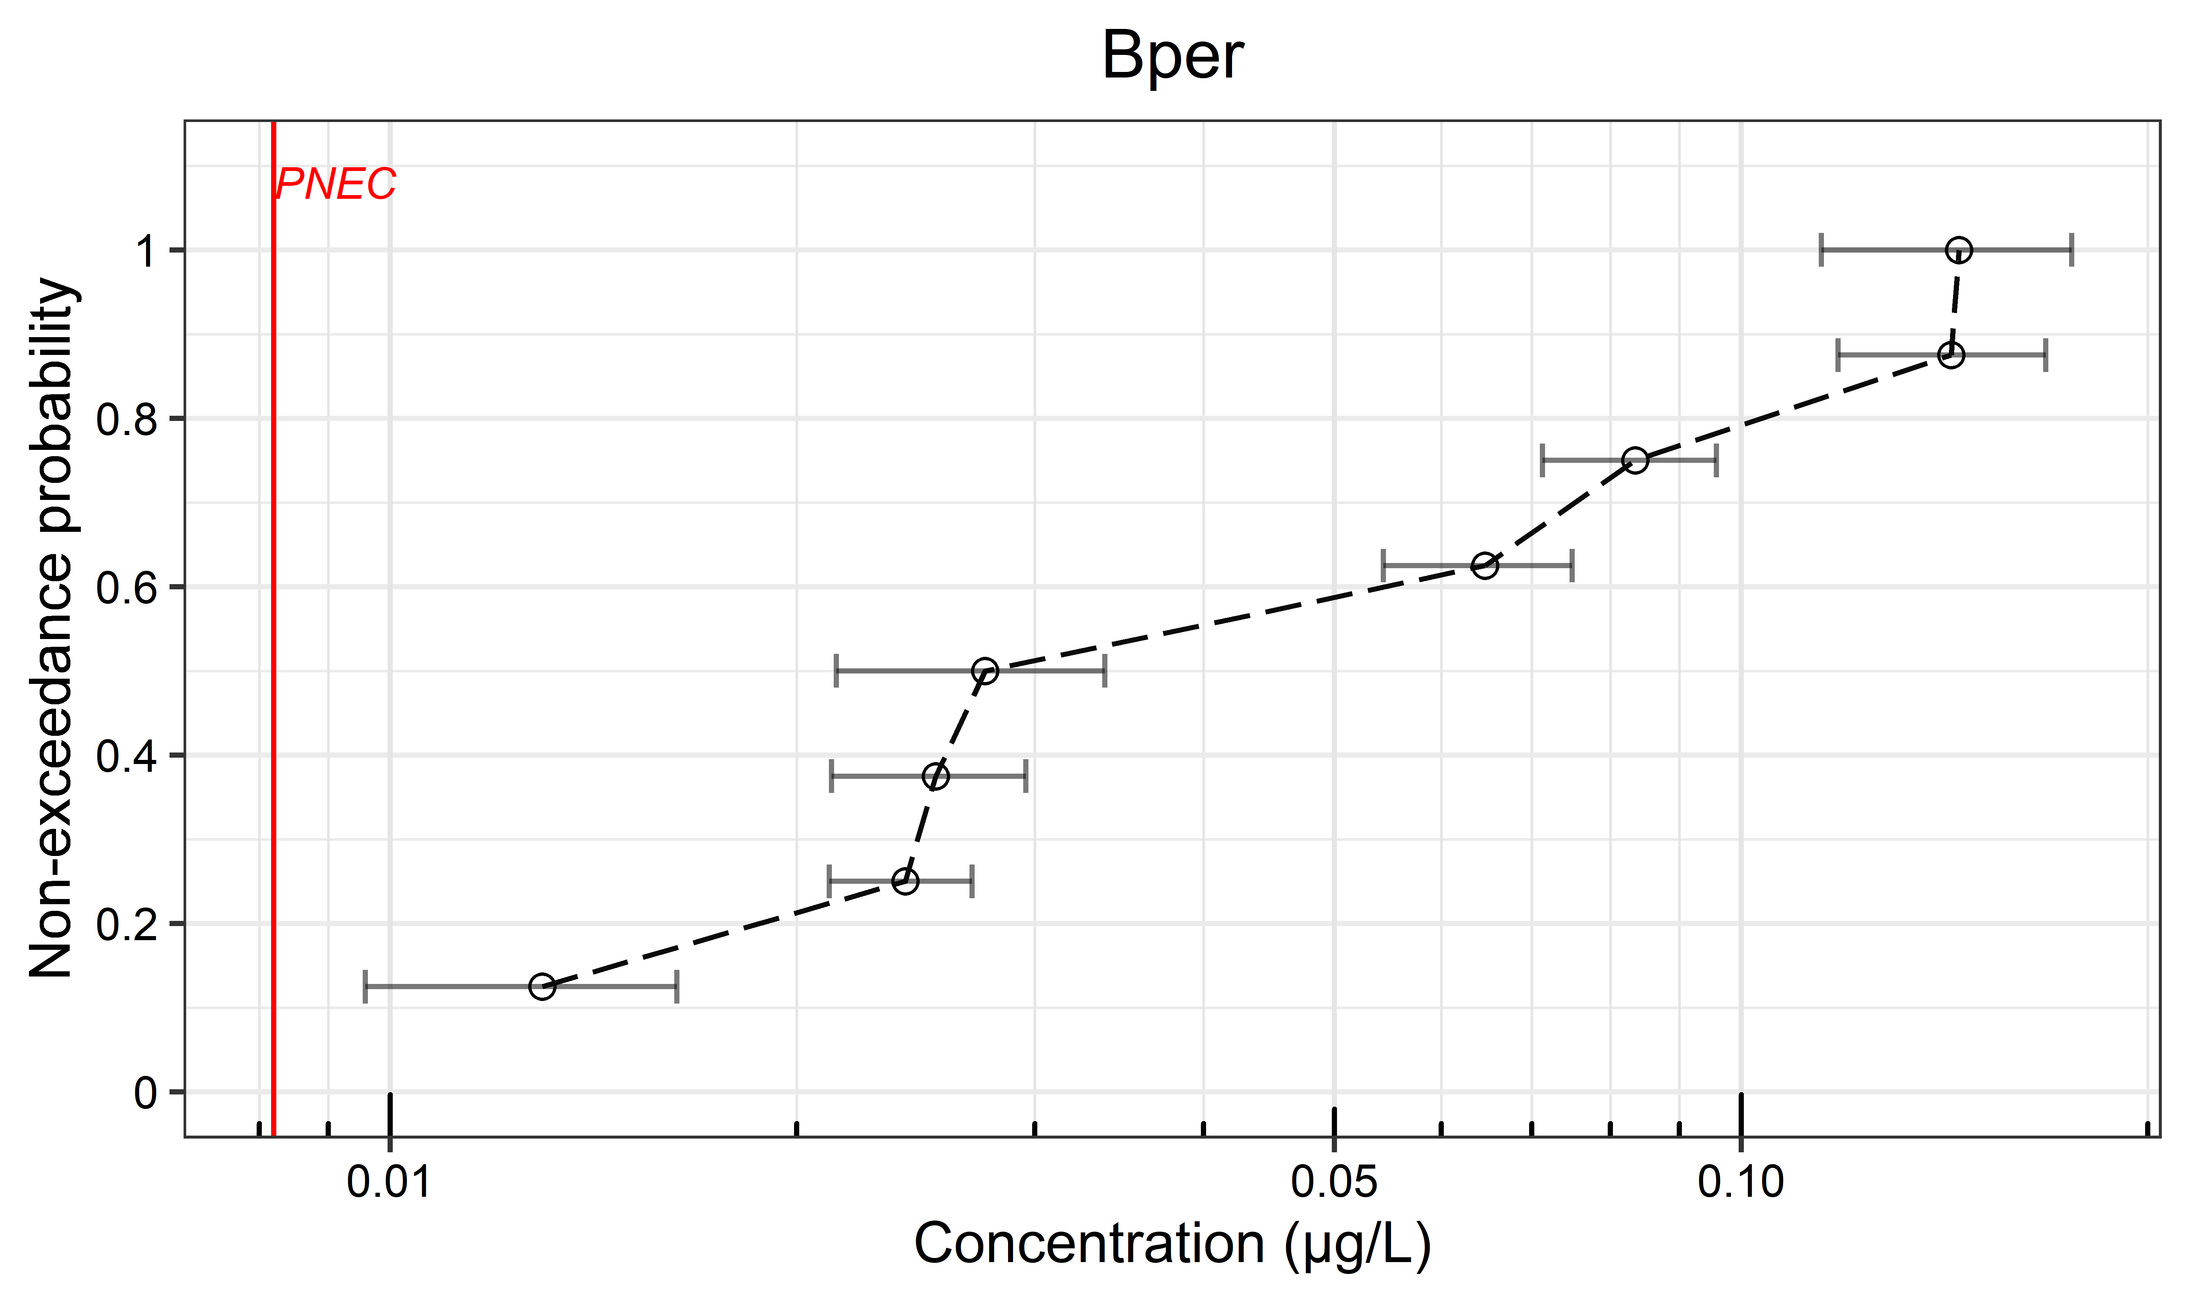 | (f) 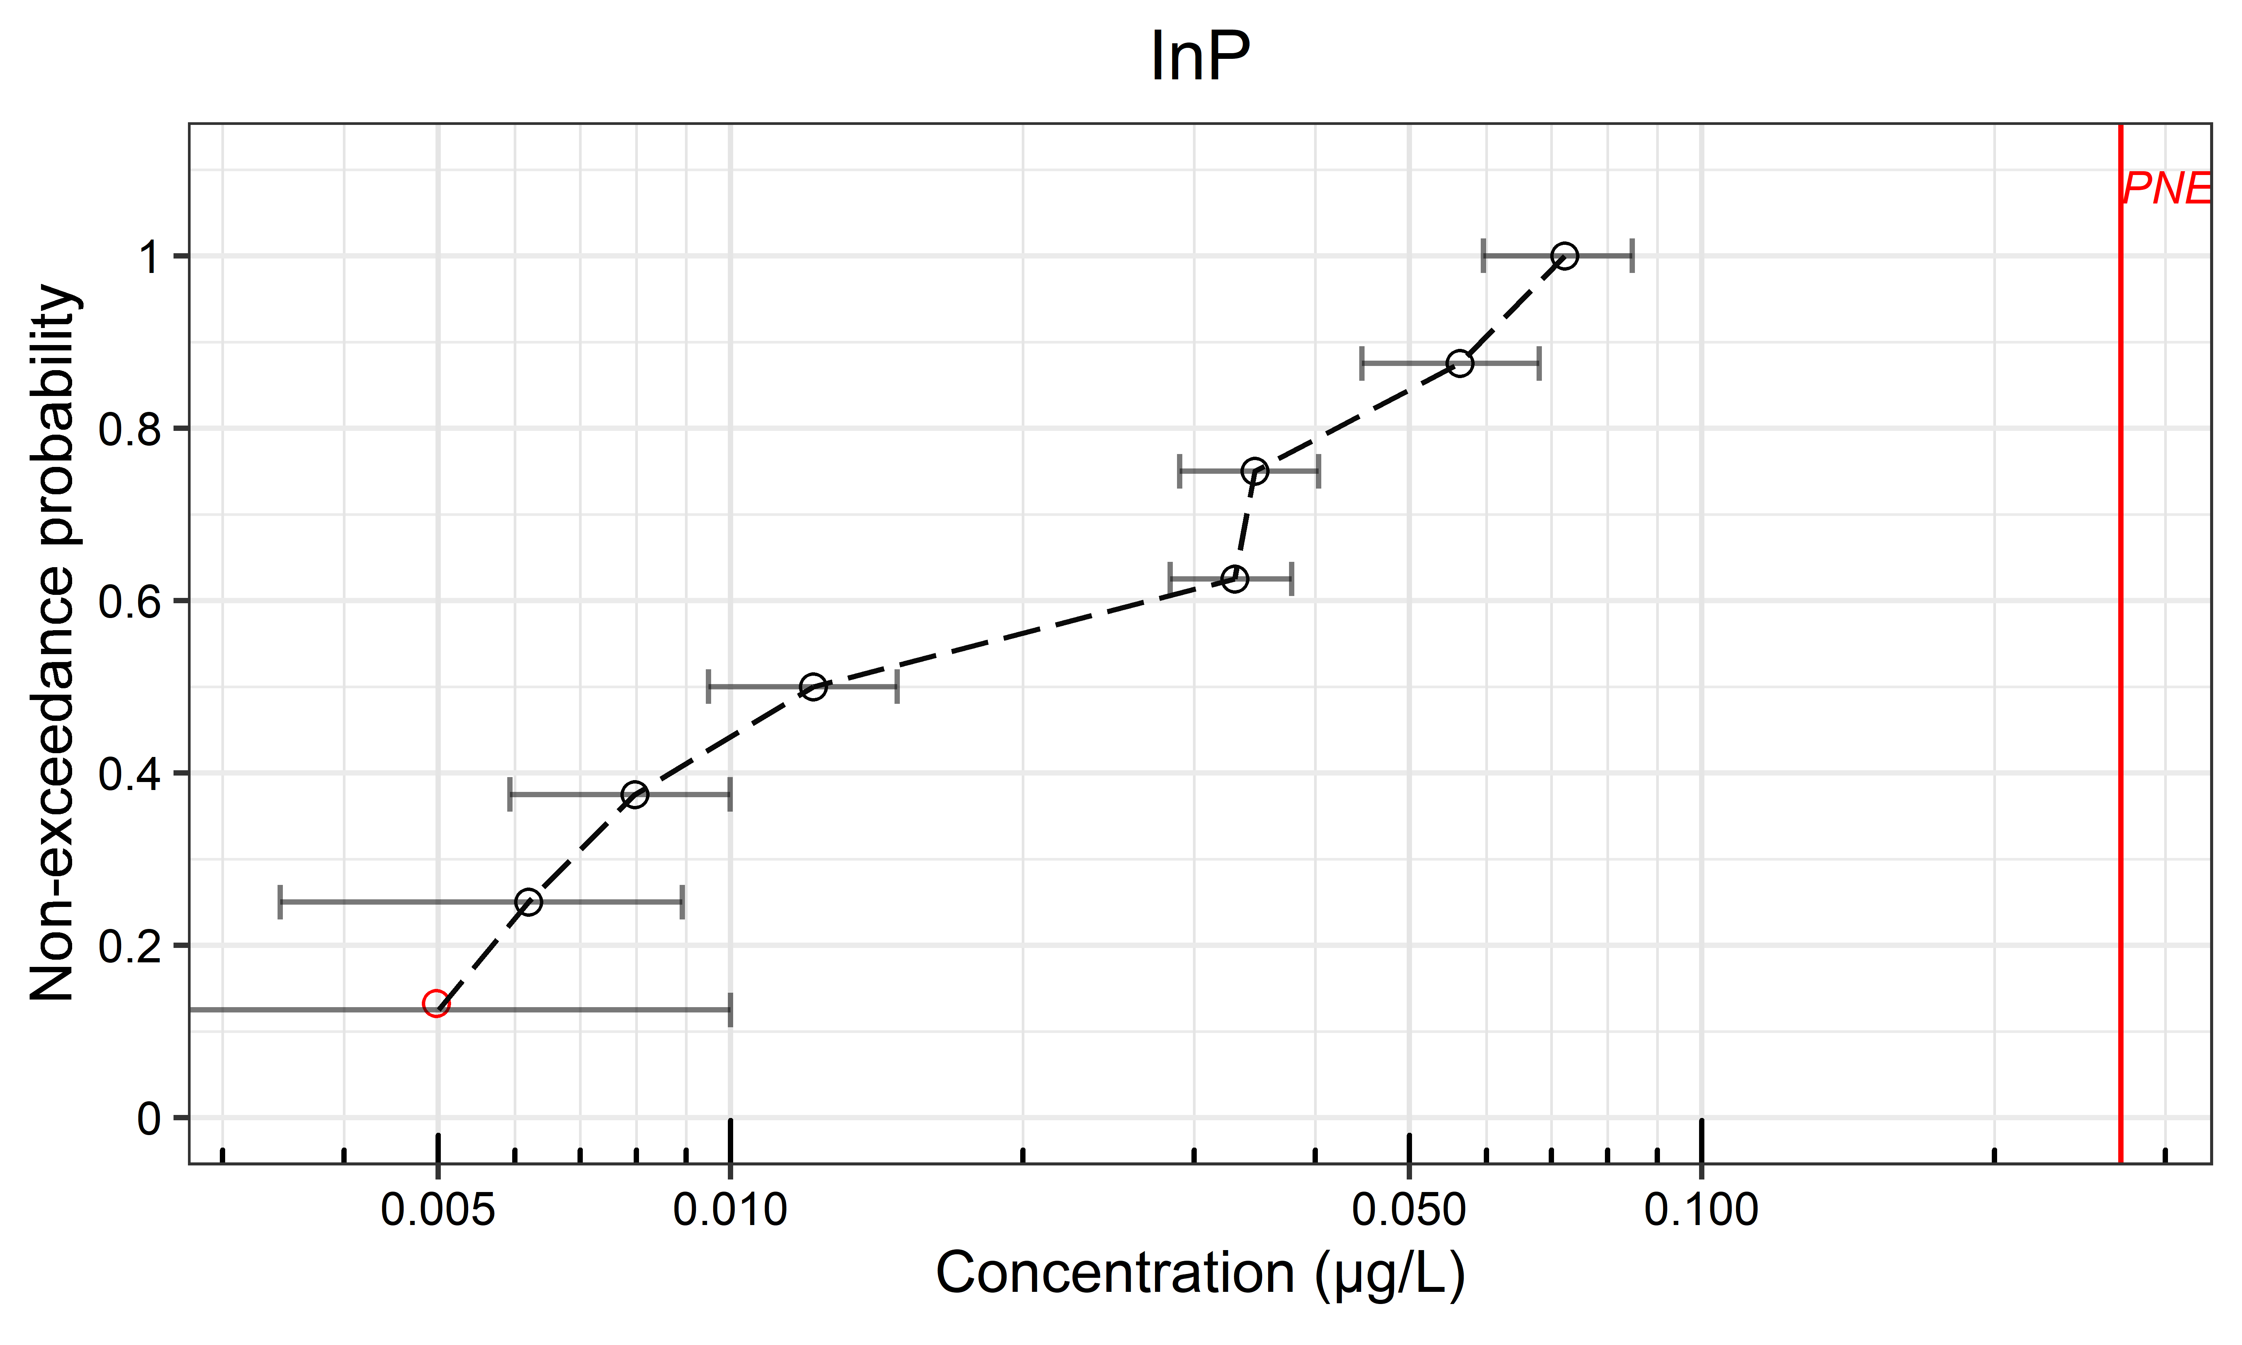
(g) 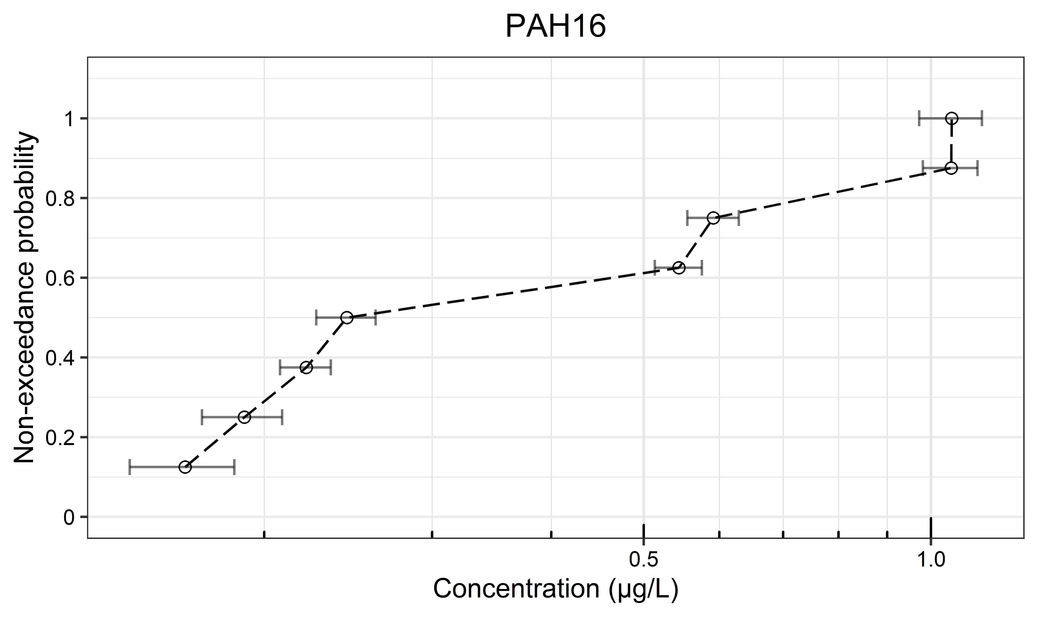 | (h) 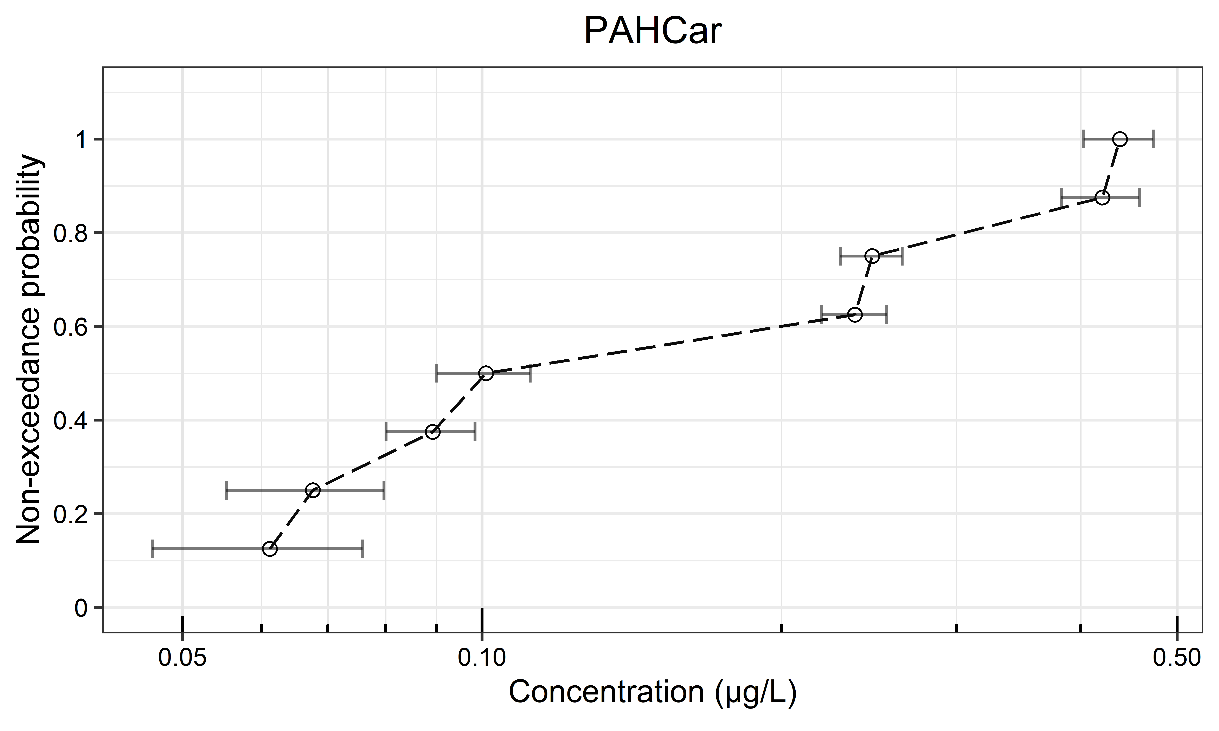 | (i) 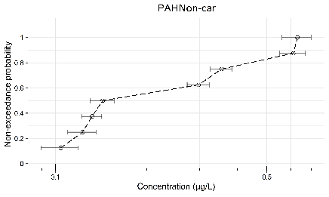
(j) 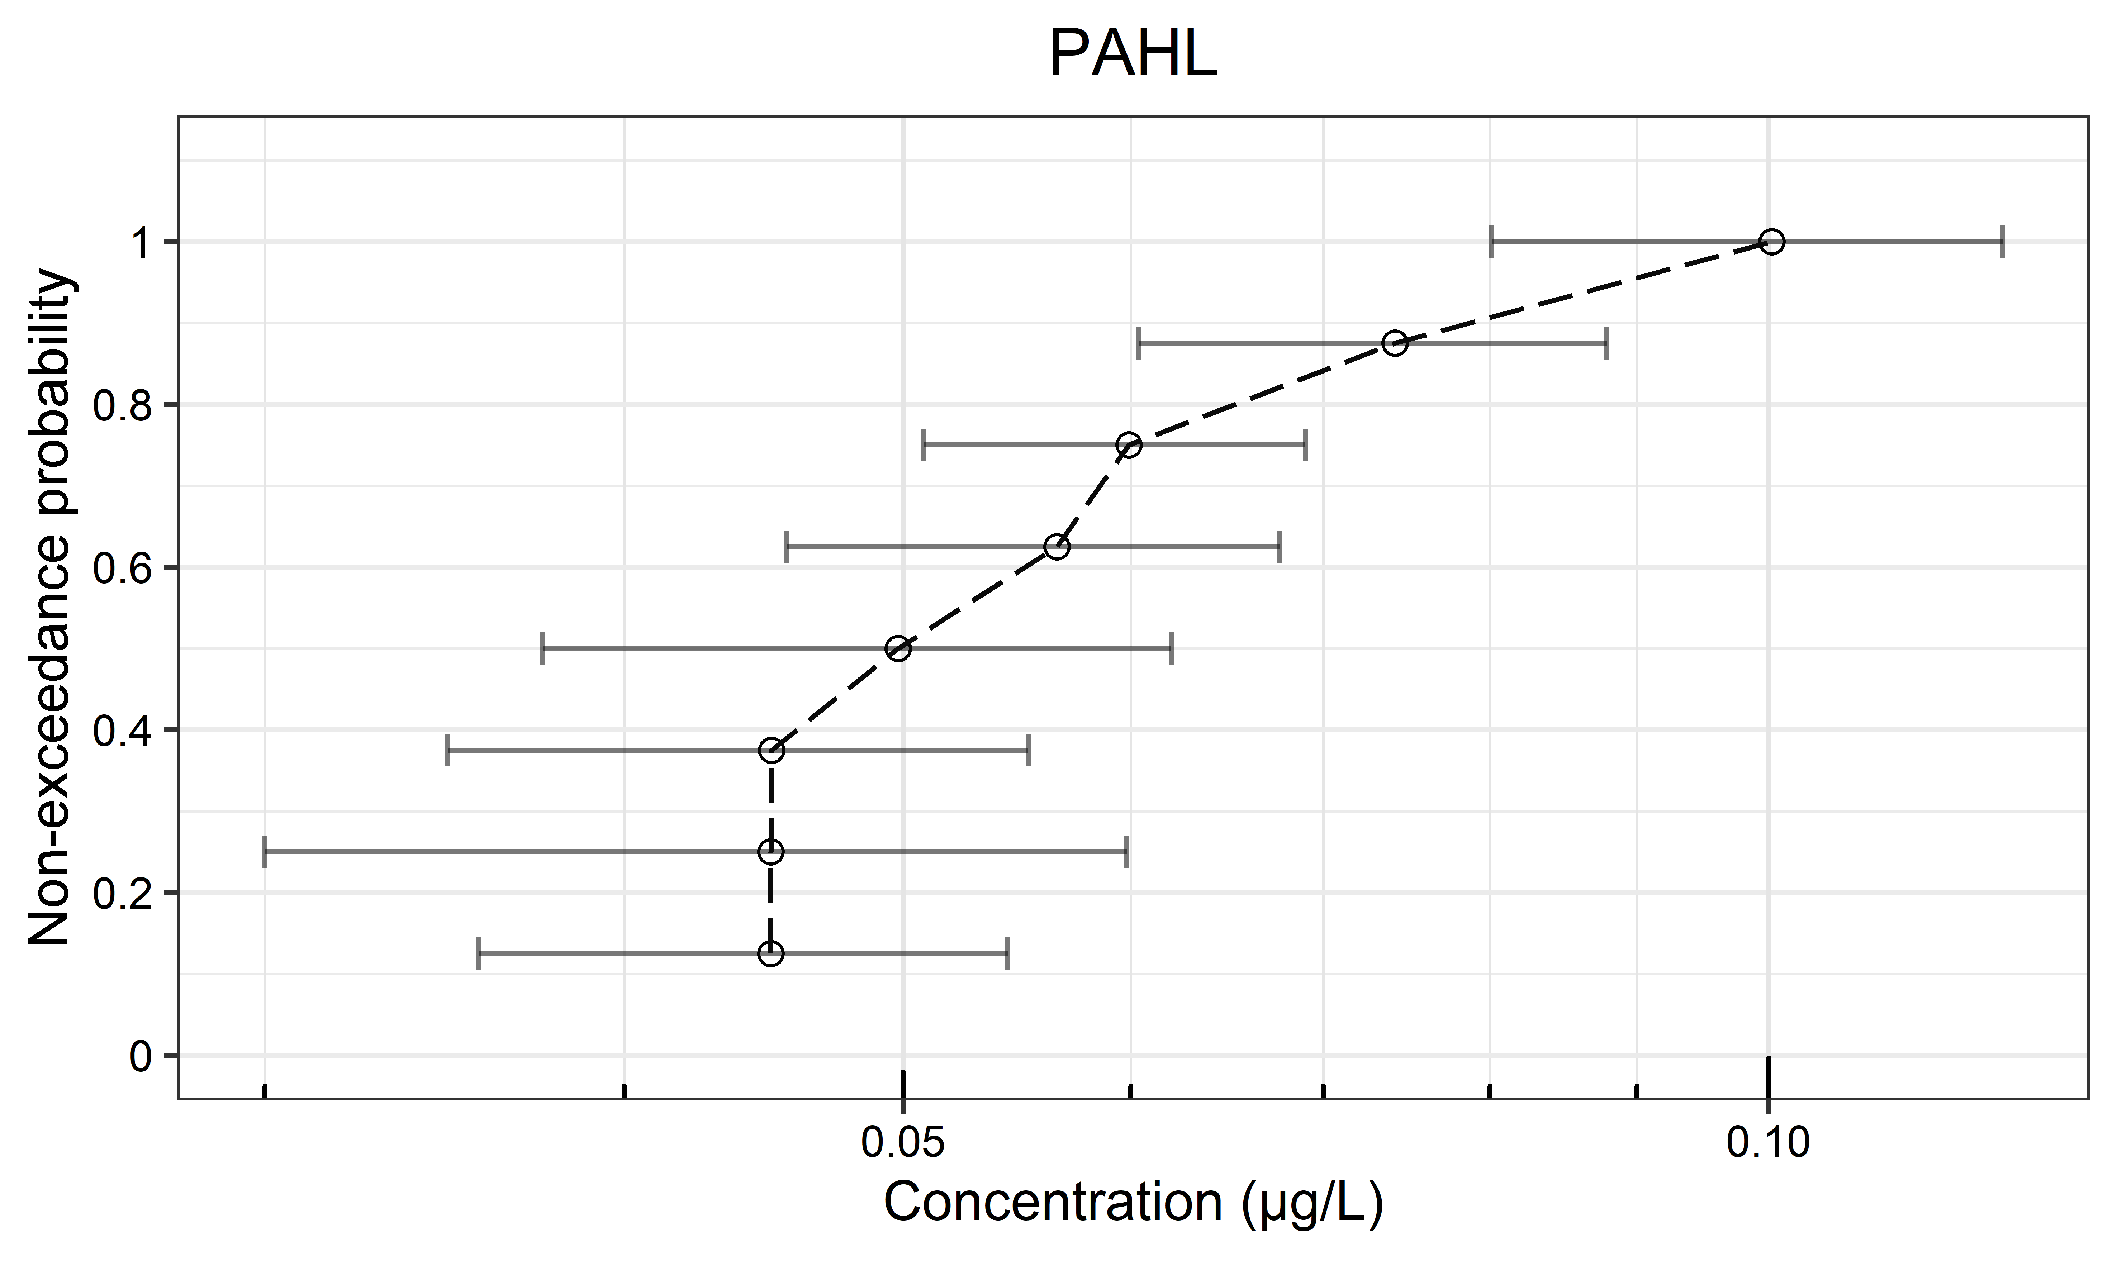 | (k) 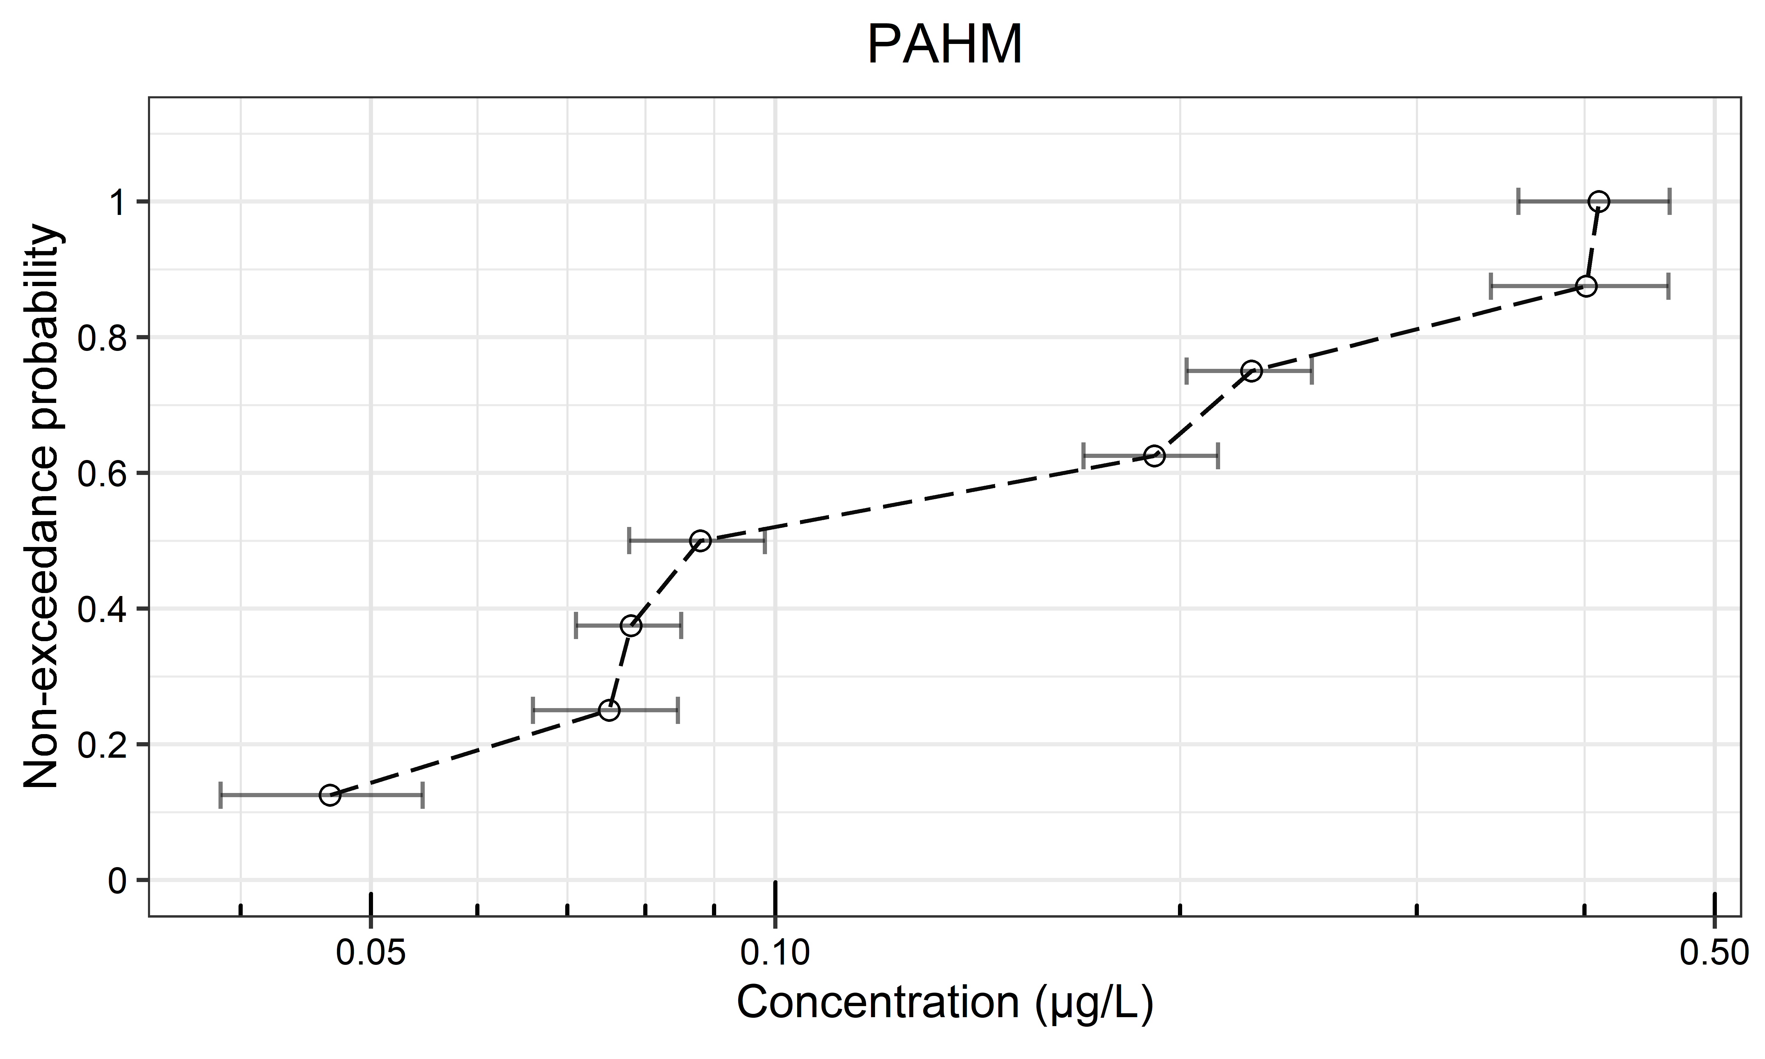 | (l) 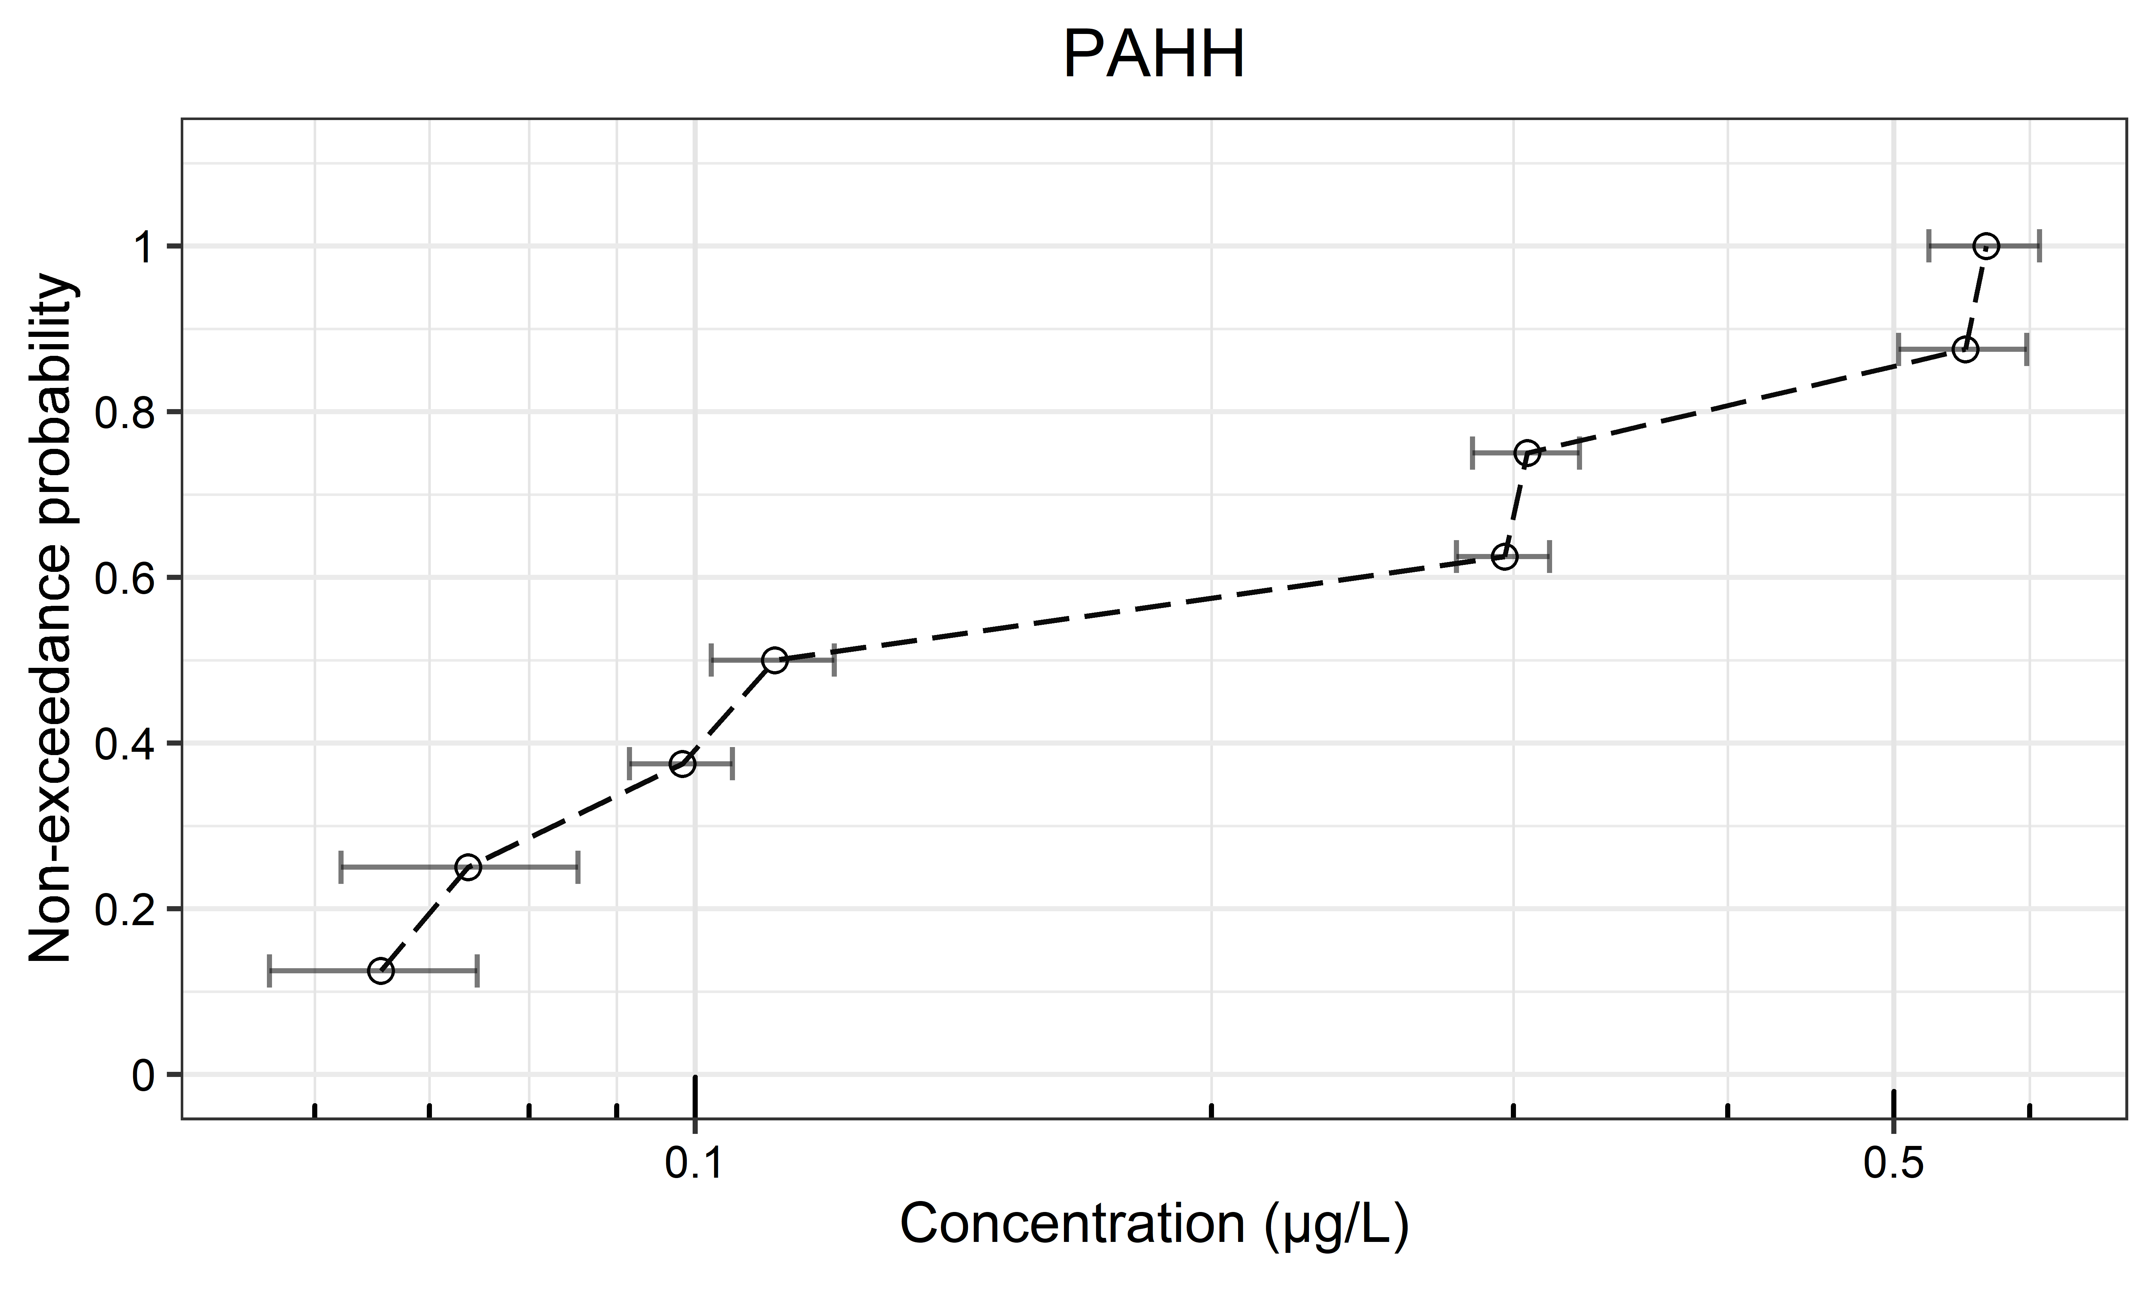
(m) 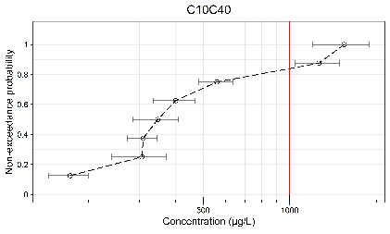 | (n) 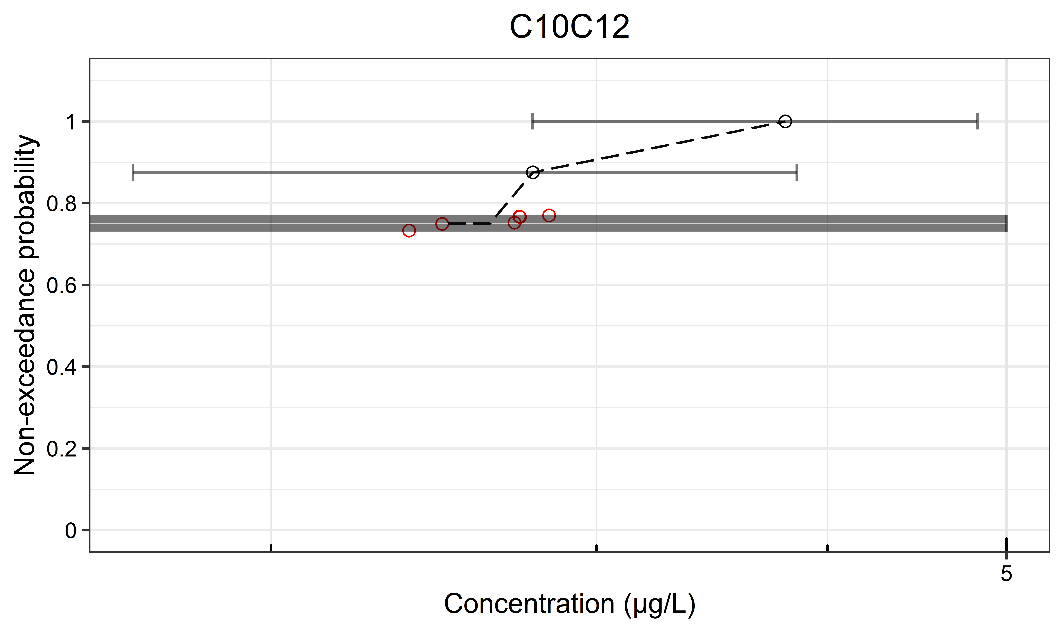 | (o) 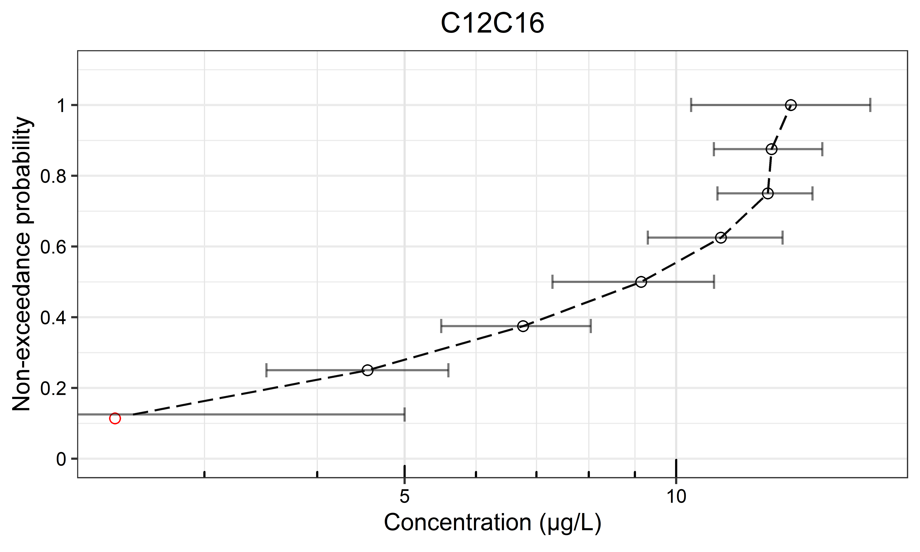
(p) 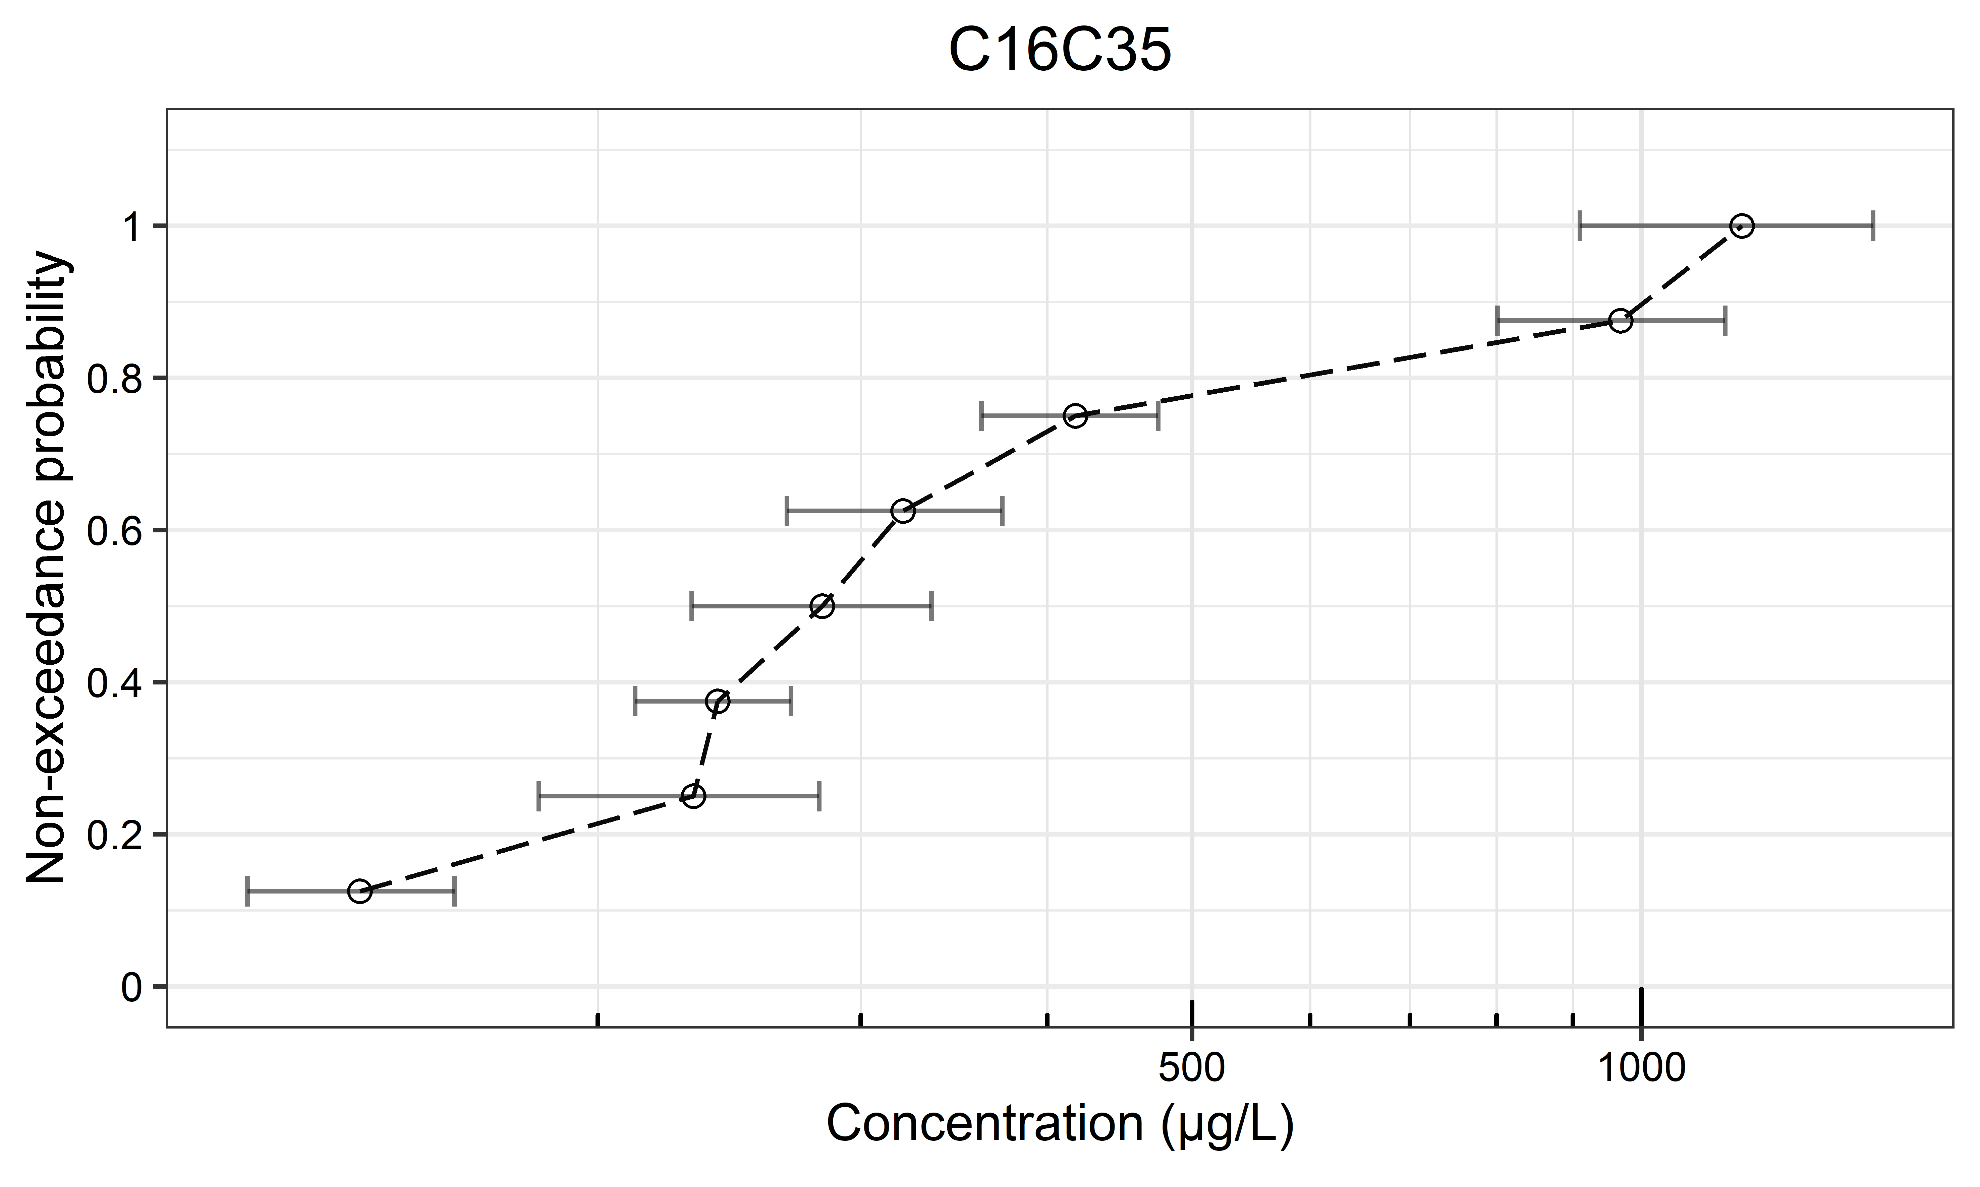 | (q) 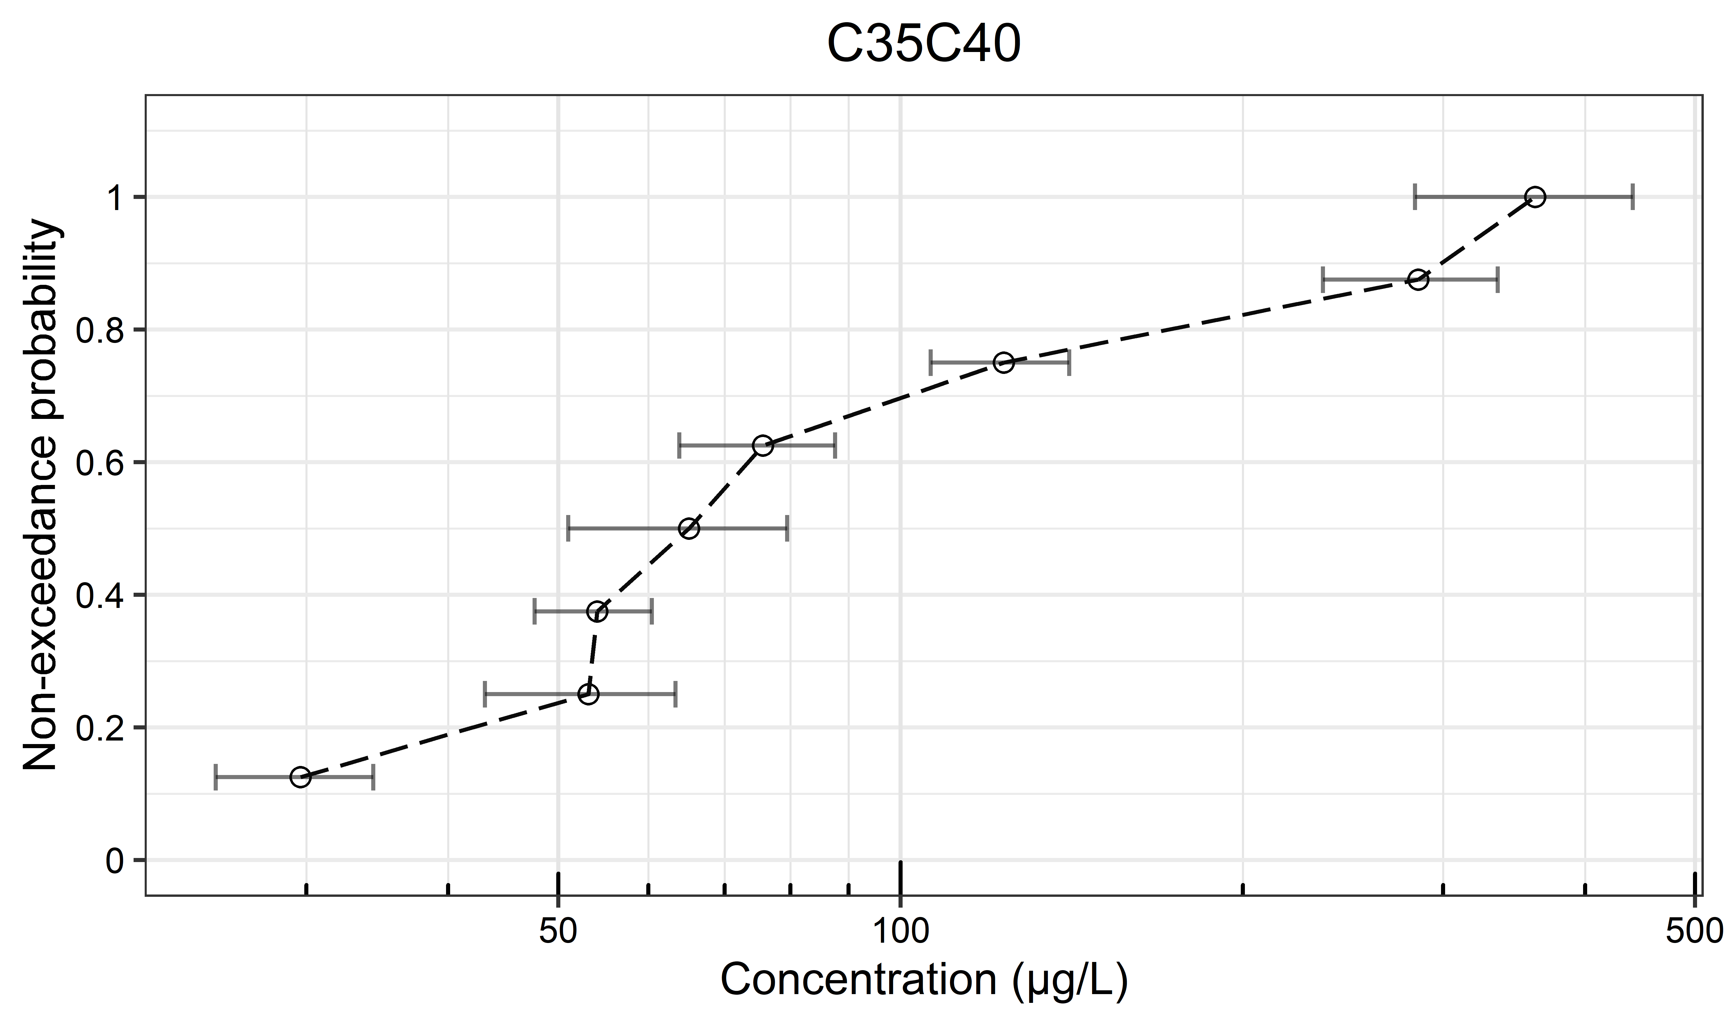 | (r) 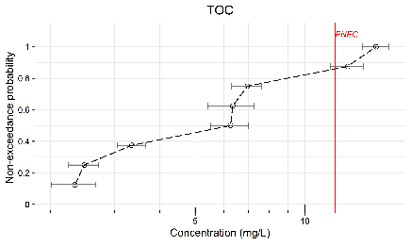
(s) 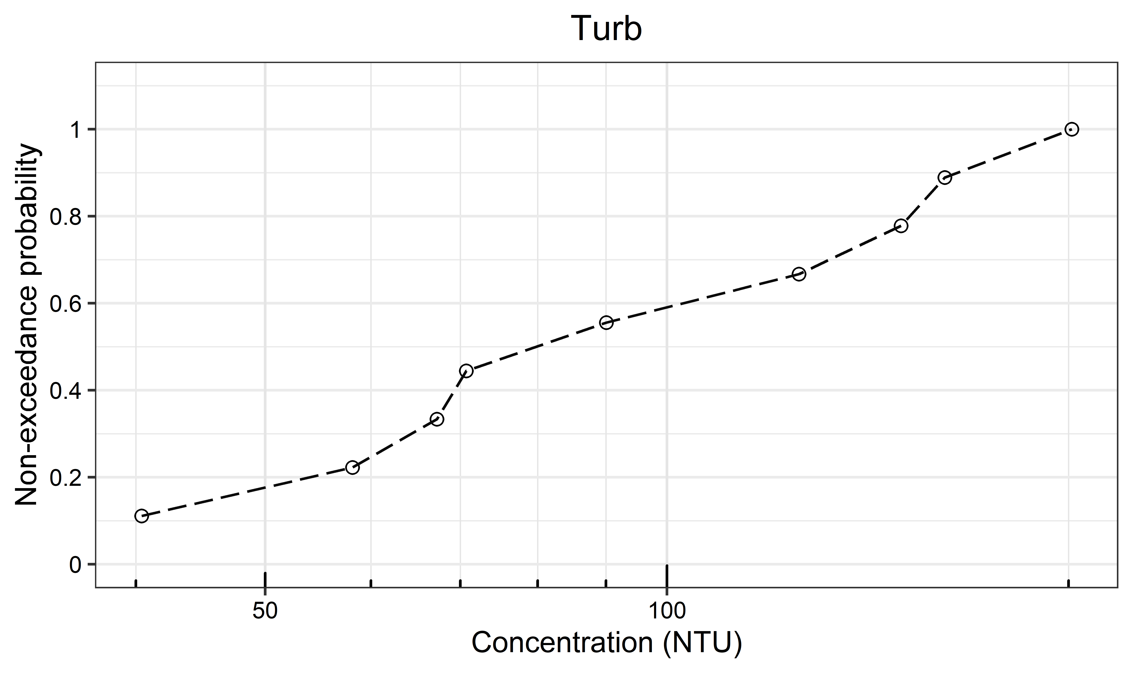 | (t) 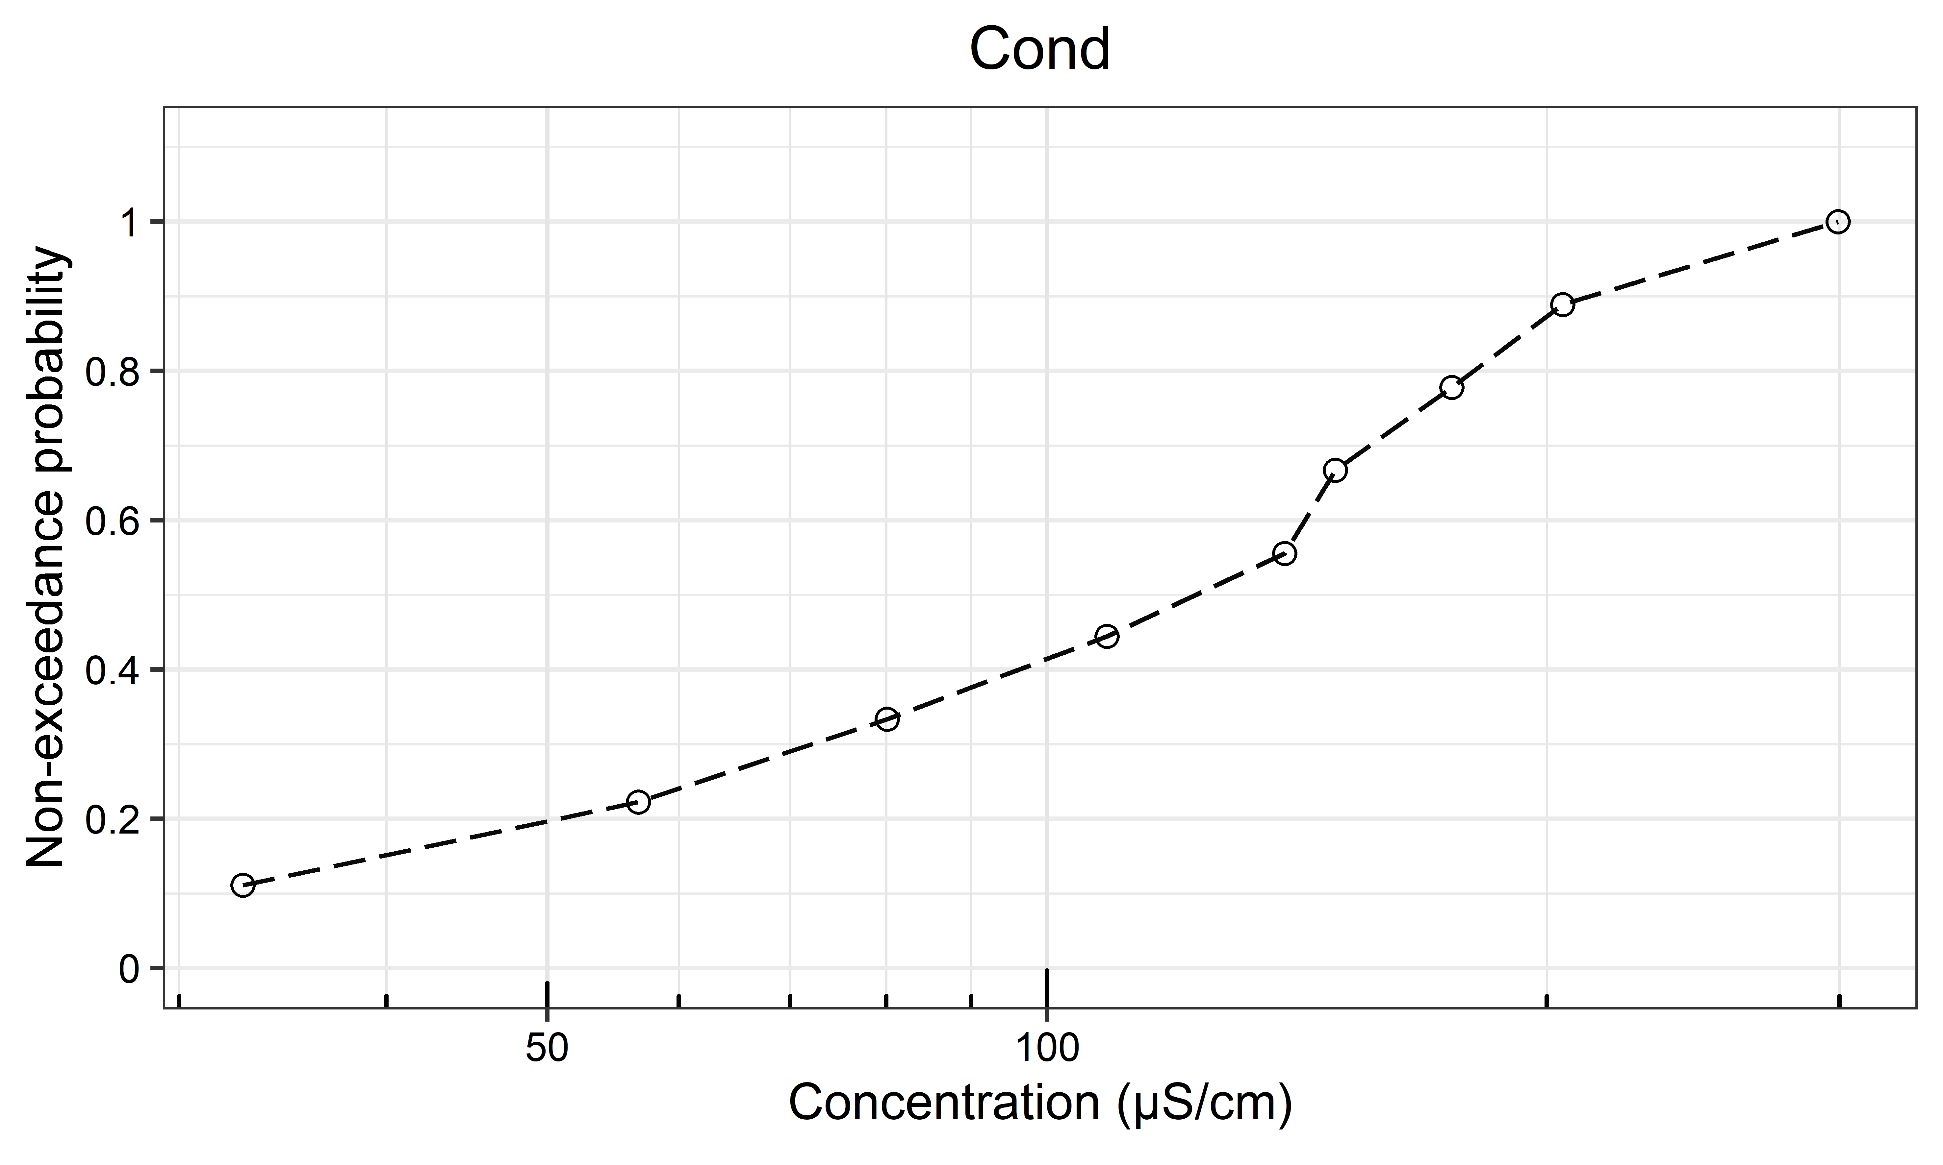
Figure S2. Non-exceedance probability (NEP) plots based on the estimated EMC values for each OMP (Black points are detects and red points censored data (non-detects); Error bars show EMC errors (uncertainties); Red lines represent lowest PNEC levels for freshwater based on water quality objectives (WQOs))

Table S4. Correlation coefficients matrix for all parameters (Kendall’s Tau ranks are underlined while Spearman’s correlation ranks are not) (Dark green: very strong; Green: strong; Yellow: moderate; Orange: weak; Red: very weak). The values shown in black are statistically significant (p-value < 0.05), while those in grey are not.
Phen | Flth | Pyr | BaA | Chry | BbF | BkF | BaP | DahA | Bper | InP | PAH16 | PAHCar | PAHNon-car | PAHL | PAHM | PAHH | OP | NP | BPA | C₁₀-C₄₀ | C₁₀-C₁₂ | C12-C₁₆ | C₁₆-C₃₅ | C₃₅-C₄₀ | TOC | TSS | Turb | Cond | pH | Depth | ADP | I_{mean} | I_{peak}
0.79 | 0.79 | 0.71 | 0.71 | 0.71 | 0.71 | 0.64 | 0.64 | 0.71 | 0.79 | 0.64 | 0.79 | 0.64 | 0.79 | 0.79 | 0.71 | 0.71 | 0.50 | -0.11 | -0.14 | 0.79 | 0.04 | 0.39 | 0.79 | 0.79 | -0.21 | 0.57 | 0.80 | 0.40 | 0.00 | -0.14 | -0.07 | 0.21 | -0.07 | Phen
 | 1.00 | 0.88 | 0.68 | 0.75 | 0.88 | 0.61 | 0.79 | 0.71 | 0.76 | 0.57 | 0.91 | 0.86 | 0.91 | 0.93 | 0.88 | 0.81 | 0.46 | -0.04 | -0.17 | 0.83 | 0.04 | 0.39 | 0.83 | 0.79 | -0.29 | 0.88 | 0.83 | 0.60 | -0.20 | -0.14 | -0.14 | 0.31 | -0.10 | Flth
 |  | 1.00 | 0.68 | 0.75 | 1.00 | 0.75 | 0.95 | 0.71 | 0.83 | 0.86 | 0.98 | 0.98 | 0.98 | 0.86 | 1.00 | 0.98 | 0.61 | 0.04 | -0.29 | 0.95 | 0.04 | 0.39 | 0.95 | 0.81 | -0.26 | 0.76 | 0.94 | 0.37 | 0.14 | 0.10 | -0.14 | 0.38 | 0.10 | Pyr
 |  |  | 0.82 | 0.75 | 0.68 | 0.75 | 0.75 | 0.62 | 0.75 | 0.75 | 0.75 | 0.75 | 0.75 | 0.75 | 0.68 | 0.68 | 0.61 | -0.14 | -0.18 | 0.75 | 0.04 | 0.29 | 0.75 | 0.68 | -0.25 | 0.46 | 0.73 | 0.33 | 0.20 | -0.11 | -0.11 | 0.25 | -0.18 | BaA
 |  |  |  | 0.96 | 0.75 | 0.68 | 0.82 | 0.62 | 0.68 | 0.79 | 0.82 | 0.82 | 0.82 | 0.61 | 0.75 | 0.75 | 0.68 | 0.04 | -0.39 | 0.82 | 0.04 | 0.50 | 0.82 | 0.75 | -0.39 | 0.46 | 0.77 | 0.14 | 0.09 | 0.11 | -0.25 | 0.32 | 0.04 | Chry
 |  |  |  |  | 1.00 | 0.75 | 0.95 | 0.71 | 0.83 | 0.86 | 0.98 | 0.98 | 0.98 | 0.86 | 1.00 | 0.98 | 0.61 | 0.04 | -0.29 | 0.95 | 0.04 | 0.39 | 0.95 | 0.81 | -0.26 | 0.76 | 0.94 | 0.37 | 0.14 | 0.10 | -0.14 | 0.38 | 0.09 | BbF
 |  |  |  |  |  | 0.82 | 0.82 | 0.62 | 0.68 | 0.82 | 0.68 | 0.82 | 0.68 | 0.68 | 0.75 | 0.75 | 0.54 | -0.07 | -0.11 | 0.68 | 0.04 | 0.21 | 0.68 | 0.61 | -0.18 | 0.54 | 0.73 | 0.33 | 0.20 | -0.04 | -0.04 | 0.32 | -0.11 | BkF
 |  |  |  |  |  |  | 1.00 | 0.62 | 0.88 | 0.93 | 0.93 | 0.98 | 0.93 | 0.79 | 0.95 | 0.98 | 0.68 | 0.04 | -0.45 | 0.95 | 0.04 | 0.39 | 0.95 | 0.86 | -0.43 | 0.64 | 0.89 | 0.26 | 0.31 | 0.17 | -0.21 | 0.45 | 0.10 | BaP
 |  |  |  |  |  |  |  | 0.71 | 0.71 | 0.62 | 0.71 | 0.62 | 0.71 | 0.71 | 0.71 | 0.71 | 0.33 | -0.10 | -0.05 | 0.71 | 0.05 | 0.38 | 0.71 | 0.71 | -0.14 | 0.62 | 0.70 | 0.10 | -0.30 | -0.05 | 0.14 | 0.05 | -0.05 | DahA*
 |  |  |  |  |  |  |  |  | 1.00 | 0.71 | 0.86 | 0.81 | 0.86 | 0.83 | 0.83 | 0.91 | 0.54 | -0.18 | -0.21 | 0.93 | 0.04 | 0.39 | 0.93 | 0.98 | -0.33 | 0.69 | 0.94 | 0.37 | 0.14 | -0.07 | -0.21 | 0.31 | -0.12 | Bper
 |  |  |  |  |  |  |  |  |  | 0.93 | 0.79 | 0.93 | 0.79 | 0.64 | 0.86 | 0.86 | 0.64 | 0.00 | -0.21 | 0.79 | 0.04 | 0.32 | 0.79 | 0.64 | -0.21 | 0.43 | 0.89 | 0.26 | 0.31 | 0.07 | -0.07 | 0.29 | -0.00 | InP
 |  |  |  |  |  |  |  |  |  |  | 1.00 | 0.95 | 1.00 | 0.88 | 0.98 | 0.95 | 0.68 | -0.04 | -0.31 | 0.98 | 0.04 | 0.46 | 0.98 | 0.83 | -0.33 | 0.74 | 0.94 | 0.37 | 0.14 | 0.05 | -0.19 | 0.26 | -0.00 | PAH16
 |  |  |  |  |  |  |  |  |  |  |  | 1.00 | 0.95 | 0.83 | 0.98 | 0.95 | 0.68 | 0.04 | -0.41 | 0.93 | 0.04 | 0.32 | 0.93 | 0.79 | -0.38 | 0.69 | 0.89 | 0.26 | 0.31 | 0.12 | -0.17 | 0.41 | 0.07 | PAHCar
 |  |  |  |  |  |  |  |  |  |  |  |  | 1.00 | 0.88 | 0.98 | 0.95 | 0.68 | -0.04 | -0.31 | 0.98 | 0.04 | 0.46 | 0.98 | 0.83 | -0.33 | 0.74 | 0.94 | 0.37 | 0.14 | 0.05 | -0.19 | 0.26 | -0.00 | PAHNon-car
 |  |  |  |  |  |  |  |  |  |  |  |  |  | 1.00 | 0.86 | 0.81 | 0.46 | -0.18 | 0.05 | 0.83 | 0.04 | 0.25 | 0.83 | 0.79 | -0.12 | 0.81 | 0.94 | 0.71 | 0.03 | -0.33 | -0.02 | 0.10 | -0.32 | PAHL
 |  |  |  |  |  |  |  |  |  |  |  |  |  |  | 1.00 | 0.98 | 0.61 | 0.04 | -0.29 | 0.95 | 0.04 | 0.39 | 0.95 | 0.81 | -0.26 | 0.76 | 0.94 | 0.37 | 0.14 | 0.10 | -0.14 | 0.38 | 0.10 | PAHM
 |  |  |  |  |  |  |  |  |  |  |  |  |  |  |  | 1.00 | 0.61 | 0.04 | -0.33 | 0.98 | 0.04 | 0.46 | 0.98 | 0.88 | -0.31 | 0.71 | 0.94 | 0.37 | 0.14 | 0.14 | -0.19 | 0.43 | 0.12 | PAHH
 |  |  |  |  |  |  |  |  |  |  |  |  |  |  |  |  | 0.89 | -0.04 | -0.46 | 0.68 | -0.04 | 0.21 | 0.68 | 0.46 | -0.54 | 0.18 | 0.40 | 0.00 | 0.53 | -0.04 | -0.39 | 0.18 | -0.11 | OP
 |  |  |  |  |  |  |  |  |  |  |  |  |  |  |  |  |  | 0.54 | -0.39 | -0.04 | 0.00 | 0.04 | -0.04 | -0.11 | -0.18 | -0.04 | -0.20 | -0.33 | -0.47 | 0.46 | 0.04 | 0.25 | 0.54 | NP
 |  |  |  |  |  |  |  |  |  |  |  |  |  |  |  |  |  |  | 1.00 | -0.36 | 0.04 | -0.25 | -0.36 | -0.31 | 0.88 | 0.05 | 0.14 | 0.66 | -0.09 | -0.60 | 0.52 | -0.52 | -0.38 | BPA
 |  |  |  |  |  |  |  |  |  |  |  |  |  |  |  |  |  |  |  | 1.00 | 0.04 | 0.54 | 1.00 | 0.91 | -0.38 | 0.69 | 0.94 | 0.37 | 0.14 | 0.10 | -0.24 | 0.31 | 0.02 | C₁₀-C₄₀
 |  |  |  |  |  |  |  |  |  |  |  |  |  |  |  |  |  |  |  |  | 0.04 | 0.04 | 0.04 | 0.04 | 0.04 | 0.04 | 0.07 | 0.07 | -0.07 | -0.04 | 0.04 | -0.04 | -0.04 | C₁₀-C₁₂
 |  |  |  |  |  |  |  |  |  |  |  |  |  |  |  |  |  |  |  |  |  | 0.96 | 0.54 | 0.46 | -0.25 | 0.25 | 0.13 | 0.00 | -0.40 | 0.11 | -0.46 | 0.04 | 0.18 | C₁₂-C₁₆
 |  |  |  |  |  |  |  |  |  |  |  |  |  |  |  |  |  |  |  |  |  |  | 1.00 | 0.91 | -0.38 | 0.69 | 0.94 | 0.37 | 0.14 | 0.10 | -0.24 | 0.31 | 0.02 | C₁₆-C₃₅
 |  |  |  |  |  |  |  |  |  |  |  |  |  |  |  |  |  |  |  |  |  |  |  | 1.00 | -0.43 | 0.74 | 0.83 | 0.26 | -0.09 | 0.00 | -0.29 | 0.45 | -0.02 | C₃₅-C₄₀
 |  |  |  |  |  |  |  |  |  |  |  |  |  |  |  |  |  |  |  |  |  |  |  |  | 1.00 | 0.19 | 0.33 | 0.78 | -0.13 | -0.52 | 0.66 | -0.17 | -0.28 | TOC
 |  |  |  |  |  |  |  |  |  |  |  |  |  |  |  |  |  |  |  |  |  |  |  |  |  | 1.00 | 0.90 | 0.42 | -0.25 | -0.02 | 0.20 | 0.46 | 0.12 | TSS
 |  |  |  |  |  |  |  |  |  |  |  |  |  |  |  |  |  |  |  |  |  |  |  |  |  |  | 1.00 | 0.53 | 0.13 | -0.13 | 0.33 | 0.38 | 0.05 | Turb
 |  |  |  |  |  |  |  |  |  |  |  |  |  |  |  |  |  |  |  |  |  |  |  |  |  |  |  | 1.00 | 0.20 | -0.87 | 0.20 | -0.12 | -0.73 | Cond
 |  |  |  |  |  |  |  |  |  |  |  |  |  |  |  |  |  |  |  |  |  |  |  |  |  |  |  |  | 1.00 | -0.10 | 0.03 | -0.15 | -0.32 | pH
 |  |  |  |  |  |  |  |  |  |  |  |  |  |  |  |  |  |  |  |  |  |  |  |  |  |  |  |  |  | 1.00 | 0.01 | 0.45 | 0.93 | Depth
 |  |  |  |  |  |  |  |  |  |  |  |  |  |  |  |  |  |  |  |  |  |  |  |  |  |  |  |  |  |  | 1.00 | -0.13 | 0.14 | ADP
 |  |  |  |  |  |  |  |  |  |  |  |  |  |  |  |  |  |  |  |  |  |  |  |  |  |  |  |  |  |  |  | 1.00 | 0.63 | I_{mean}
 |  |  |  |  |  |  |  |  |  |  |  |  |  |  |  |  |  |  |  |  |  |  |  |  |  |  |  |  |  |  |  |  | 1.00 | I_{peak}
* One of the EMC values of DahA (rain event C), which returned misleading correlation coefficients, was excluded from the data set as a suspicious outlier. No extra water was available to reanalyze the sample.

References:
IARC Working Group. (2010). Some non-heterocyclic polycyclic aromatic hydrocarbons and some related exposures. IARC Monographs on the Evaluation of Carcinogenic Risks to Humans, 92. https://www.cabdirect.org/cabdirect/abstract/20113201374
Joa, K., Panova, E., Irha, N., Teinemaa, E., Lintelmann, J., & Kirso, U. (2009). Determination of polycyclic aromatic hydrocarbons (PAHs) in oil shale processing wastes: Current practice and new trends. https://doi.org/10.3176/OIL.2009.1.07
Khodadoust, A. P., Lei, L., Antia, J. E., Bagchi, R., Suidan, M. T., & Tabak, H. H. (2005). Adsorption of Polycyclic Aromatic Hydrocarbons in Aged Harbor Sediments. Journal of Environmental Engineering, 131(3), 403–409. https://doi.org/10.1061/(ASCE)0733-9372(2005)131:3(403)
Monaco, D., Chianese, E., Riccio, A., Delgado-Sanchez, A., & Lacorte, S. (2017). Spatial distribution of heavy hydrocarbons, PAHs and metals in polluted areas. The case of “Galicia”, Spain. Marine Pollution Bulletin, 121(1), 230–237. https://doi.org/10.1016/j.marpolbul.2017.06.003
Reed, D. A., & Stemer, T. R. (2002). Total Petroleum Hydrocarbon Criteria Working Group (TPHCWG) Field Demonstration Report: Air Force Number 6 Fuel Farm, Dobbins AFB, GA (AFRL-HE-WP-TR-2002-0158; p. 84). OPERATIONAL TECHNOLOGIES. https://apps.dtic.mil/sti/pdfs/ADA425422.pdf

