Supplementary material

Figure S1. Ordination map presenting classification of the Aquatic Warbler song phrases in the Koe software. Each of the colour symbols indicates a different whistle or rattle phrases from repertoire of male no. 6.
Figure S2. Exemplars window of Koe showing exemplary sonograms of the most frequent song phrases classified as different in the repertoire of male no. 6.
Table S1. Within-sperm measurement repeatability of individual sperm traits.

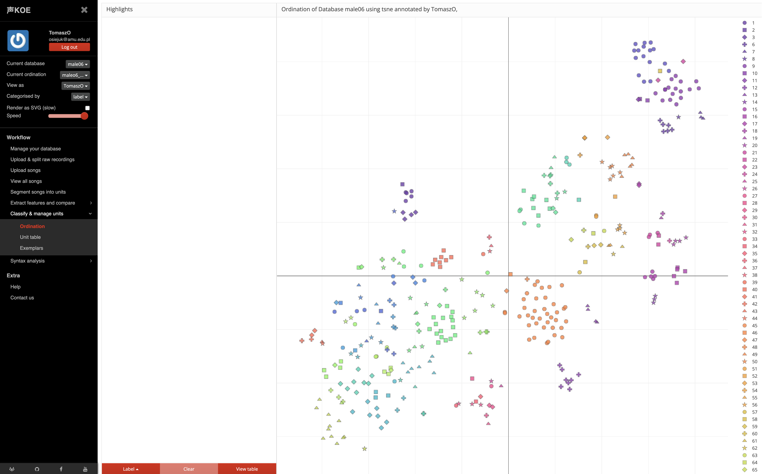
Figure S1. Ordination map presenting classification of the Aquatic Warbler song phrases in the Koe software. Each of the colour symbols indicates a different whistle or rattle phrases from repertoire of male no. 6.

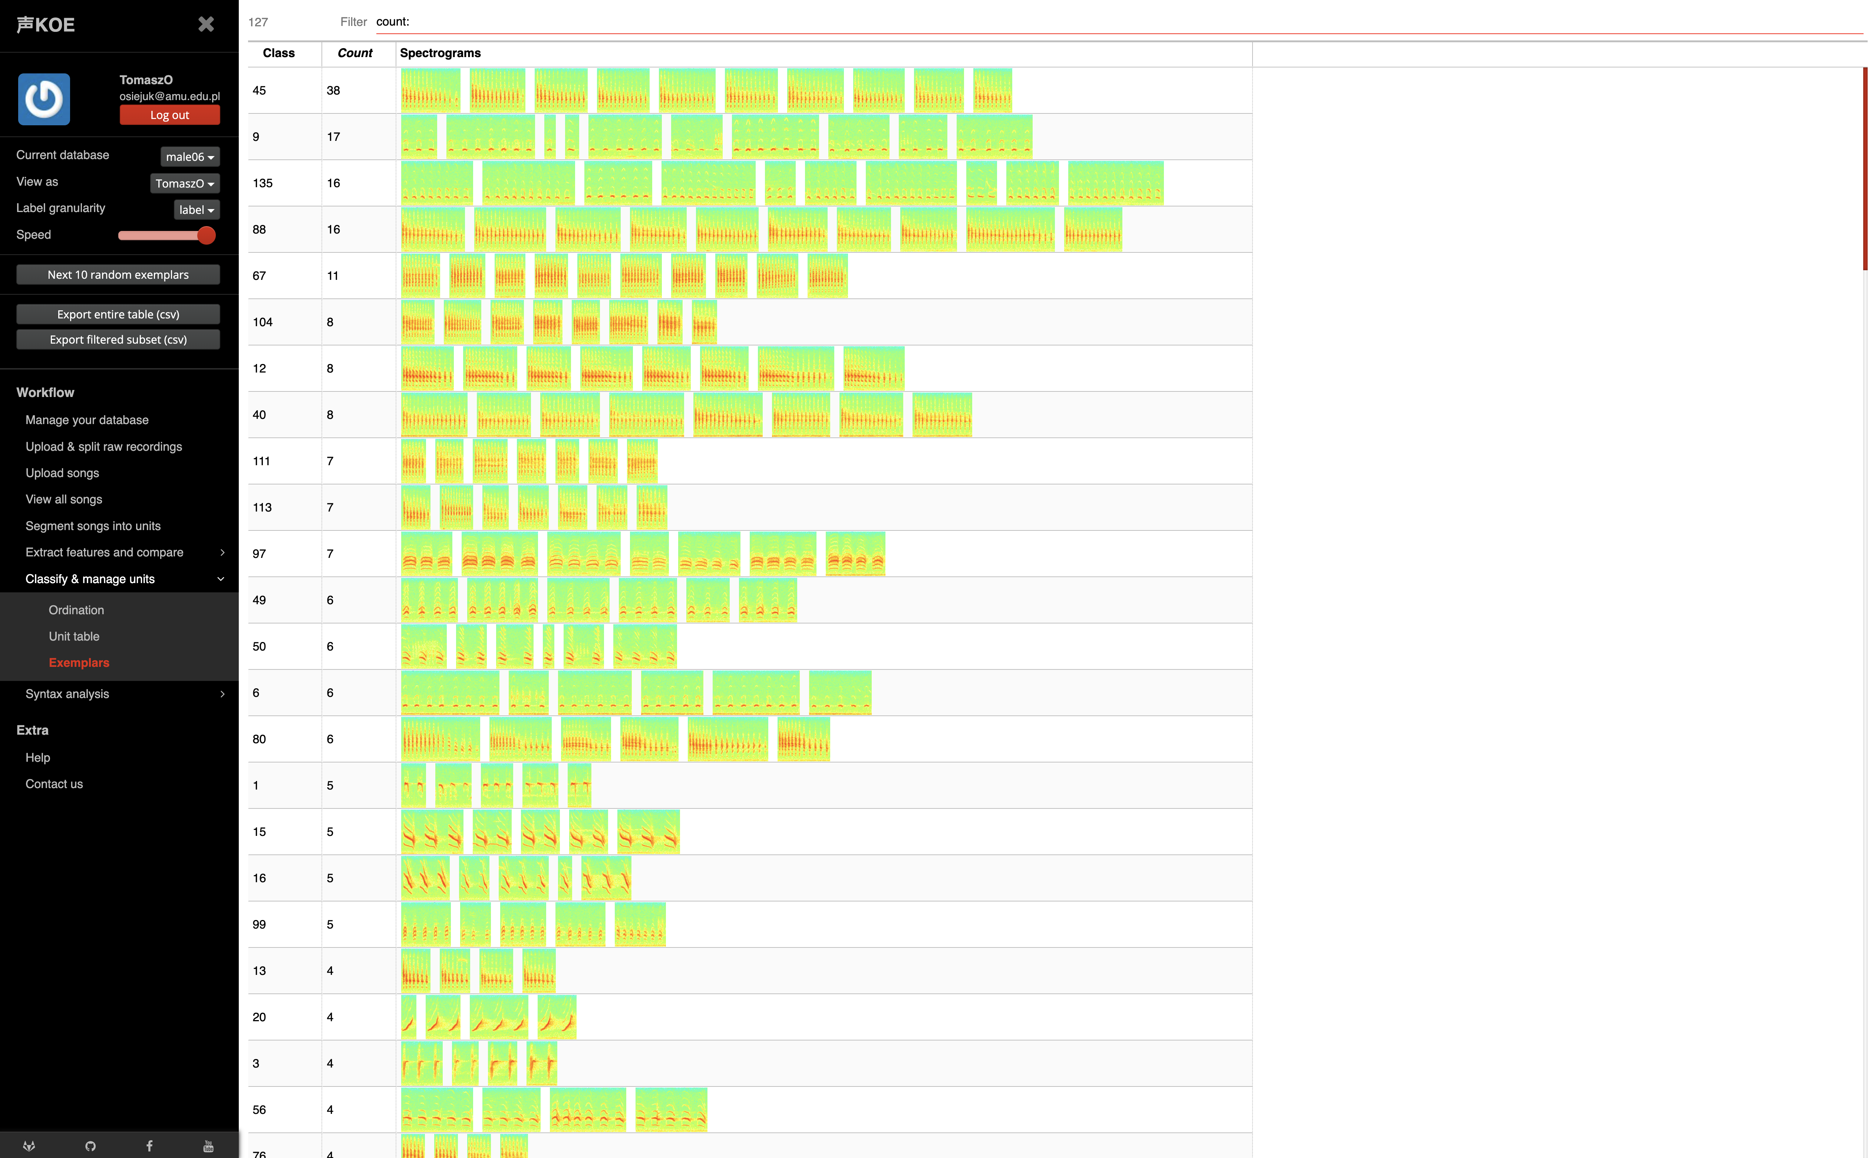
Figure S2. Exemplars window of Koe showing exemplary sonograms of the most frequent song phrases classified as different in the repertoire of male no. 6.

Table S1. Parameters of song feature extractions in Koe.
We extracted the following sound features for each phrase: spectral_flatness, spectral_bandwidth, spectral_centroid, spectral_contrast, spectral_rolloff, mfcc, max_frequency, frequency_modulation, amplitude_modulation, goodness_of_pitch, mean_frequency, spectral_continuity, dominant _frequency, spectral_flux, spectral_crest, spectral_skewness, spectral_kurtosis, spectral_decrease, harmonic_ratio, fundamental_frequency, mfc, mfc_delta, mfcc_delta2, log_attack_time.

For the aggregation of features we used the following KOE parameters: mean, median, std, min, max, variance, begin, end.

