Supplementary Materials

Comparison of the performance of SARS-CoV-2 RNA qRT-PCR testing based on expectorated and drooled saliva samples

Supplementary Tables

 | ES + DS
 | ≥ 60 years | <60 years | p value
True Positive | 20 | 236 | -
True Negative | 297 | 2023 | -
False Positive | 0 | 30 | -
False Negative | 2 | 22 | -
Sensitivity (95% CI) | 90.9%  (70.8, 98.9) | 91.5%  (87.4, 94.6) | 1
Specificity (95% CI) | 100.0%  (98.8, 100.0) | 98.5%  (97.9, 99.0) | 0.07
Supplementary Table S1: Comparison of sensitivity and specificity of saliva-based with respect to MT/OP swab-based qPCR testing for participants aged 60+ years and for participants aged less than 60 years.

 | ES + DS
 | Smokers | Non-smokers | p value
True Positive | 65 | 194 | -
True Negative | 126 | 1685 | -
False Positive | 0 | 28 | -
False Negative | 0 | 19 | -
Sensitivity (95% CI) | 92.9%  (84.1, 97.6) | 91.1%  (86.4, 94.5) | 0.82
Specificity (95% CI) | 99.6%  (98.8, 99.9) | 98.4%  (97.7, 98.9) | 0.03

Supplementary Table S2: Comparison of sensitivity and specificity of saliva-based with respect to MT/OP swab-based qPCR testing for smoking/vaping participants and non-smoking/non-vaping participants.

Supplementary Figures

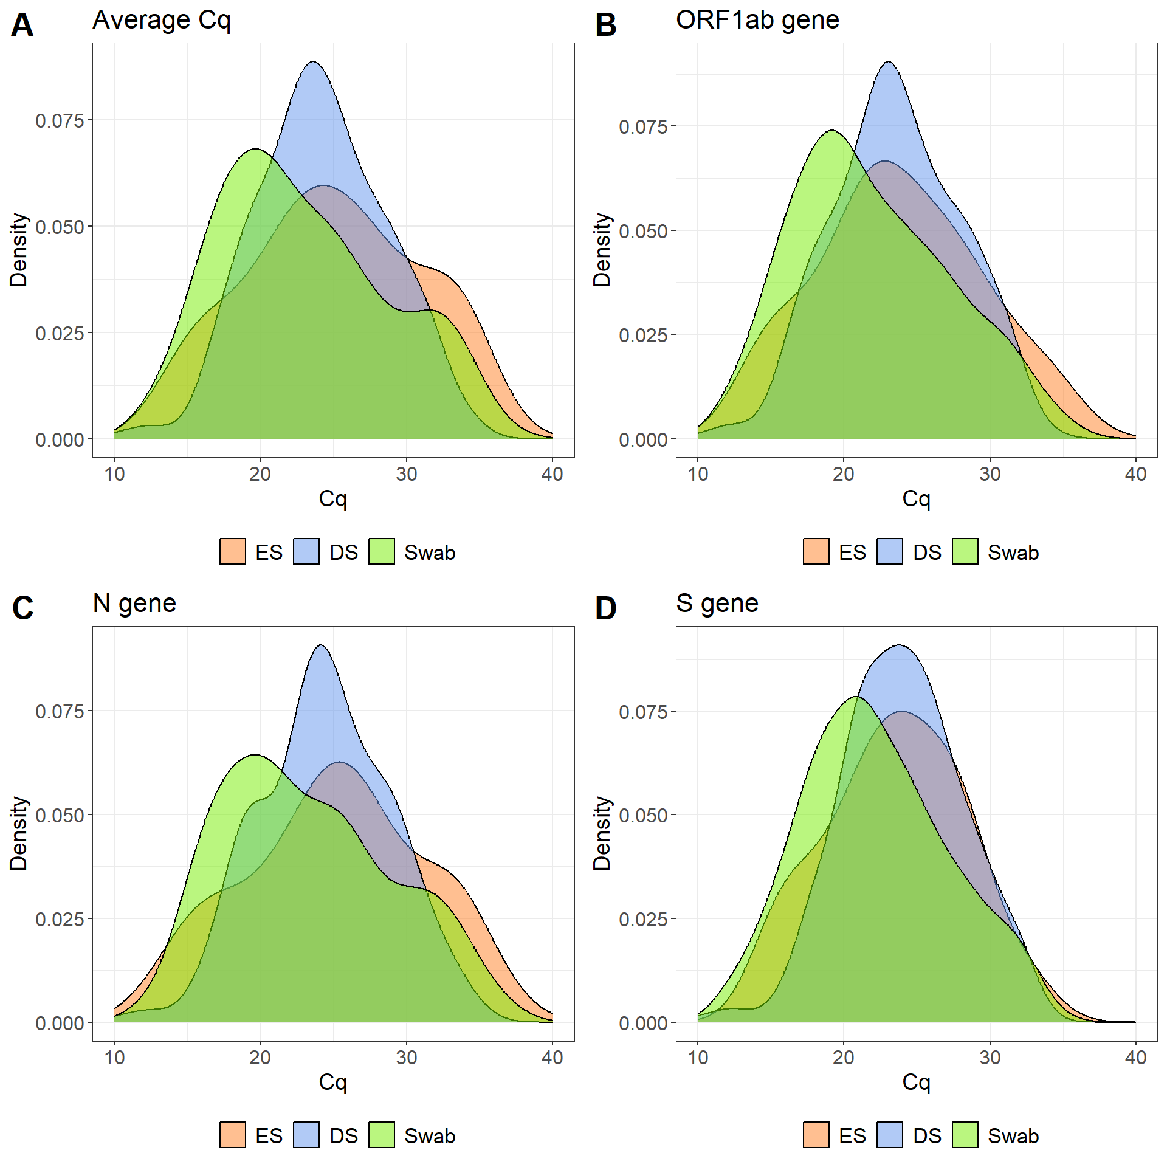

Figure S1: Distribution of Cq values for saliva and swab. The plots are based on Gaussian kernel density estimates.

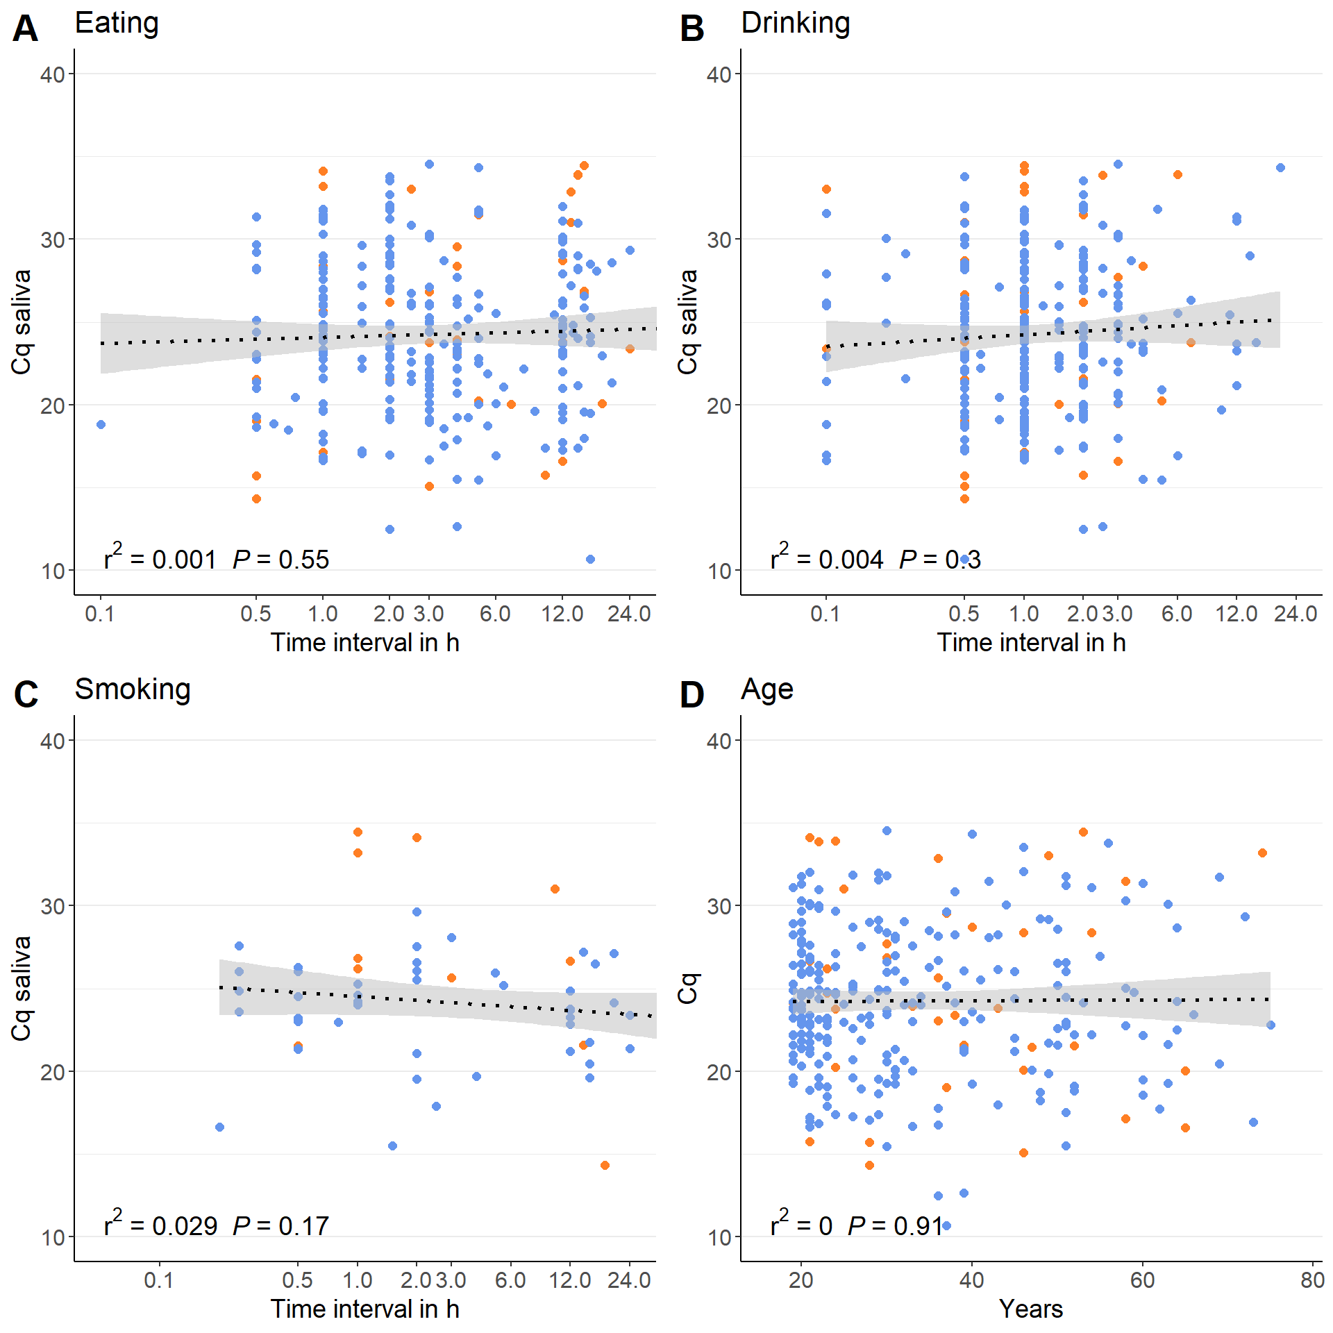

Figure S2: Linear regression of Cq values on saliva samples on log₁₀-transformed time intervals to last meal (A), drink (B) and smoke/vape (C). Linear regression of Cq values on age in years (D). R² values and p-values are displayed in the lower, left corner. Blue dots represent DS samples, while orange dots represent ES samples.

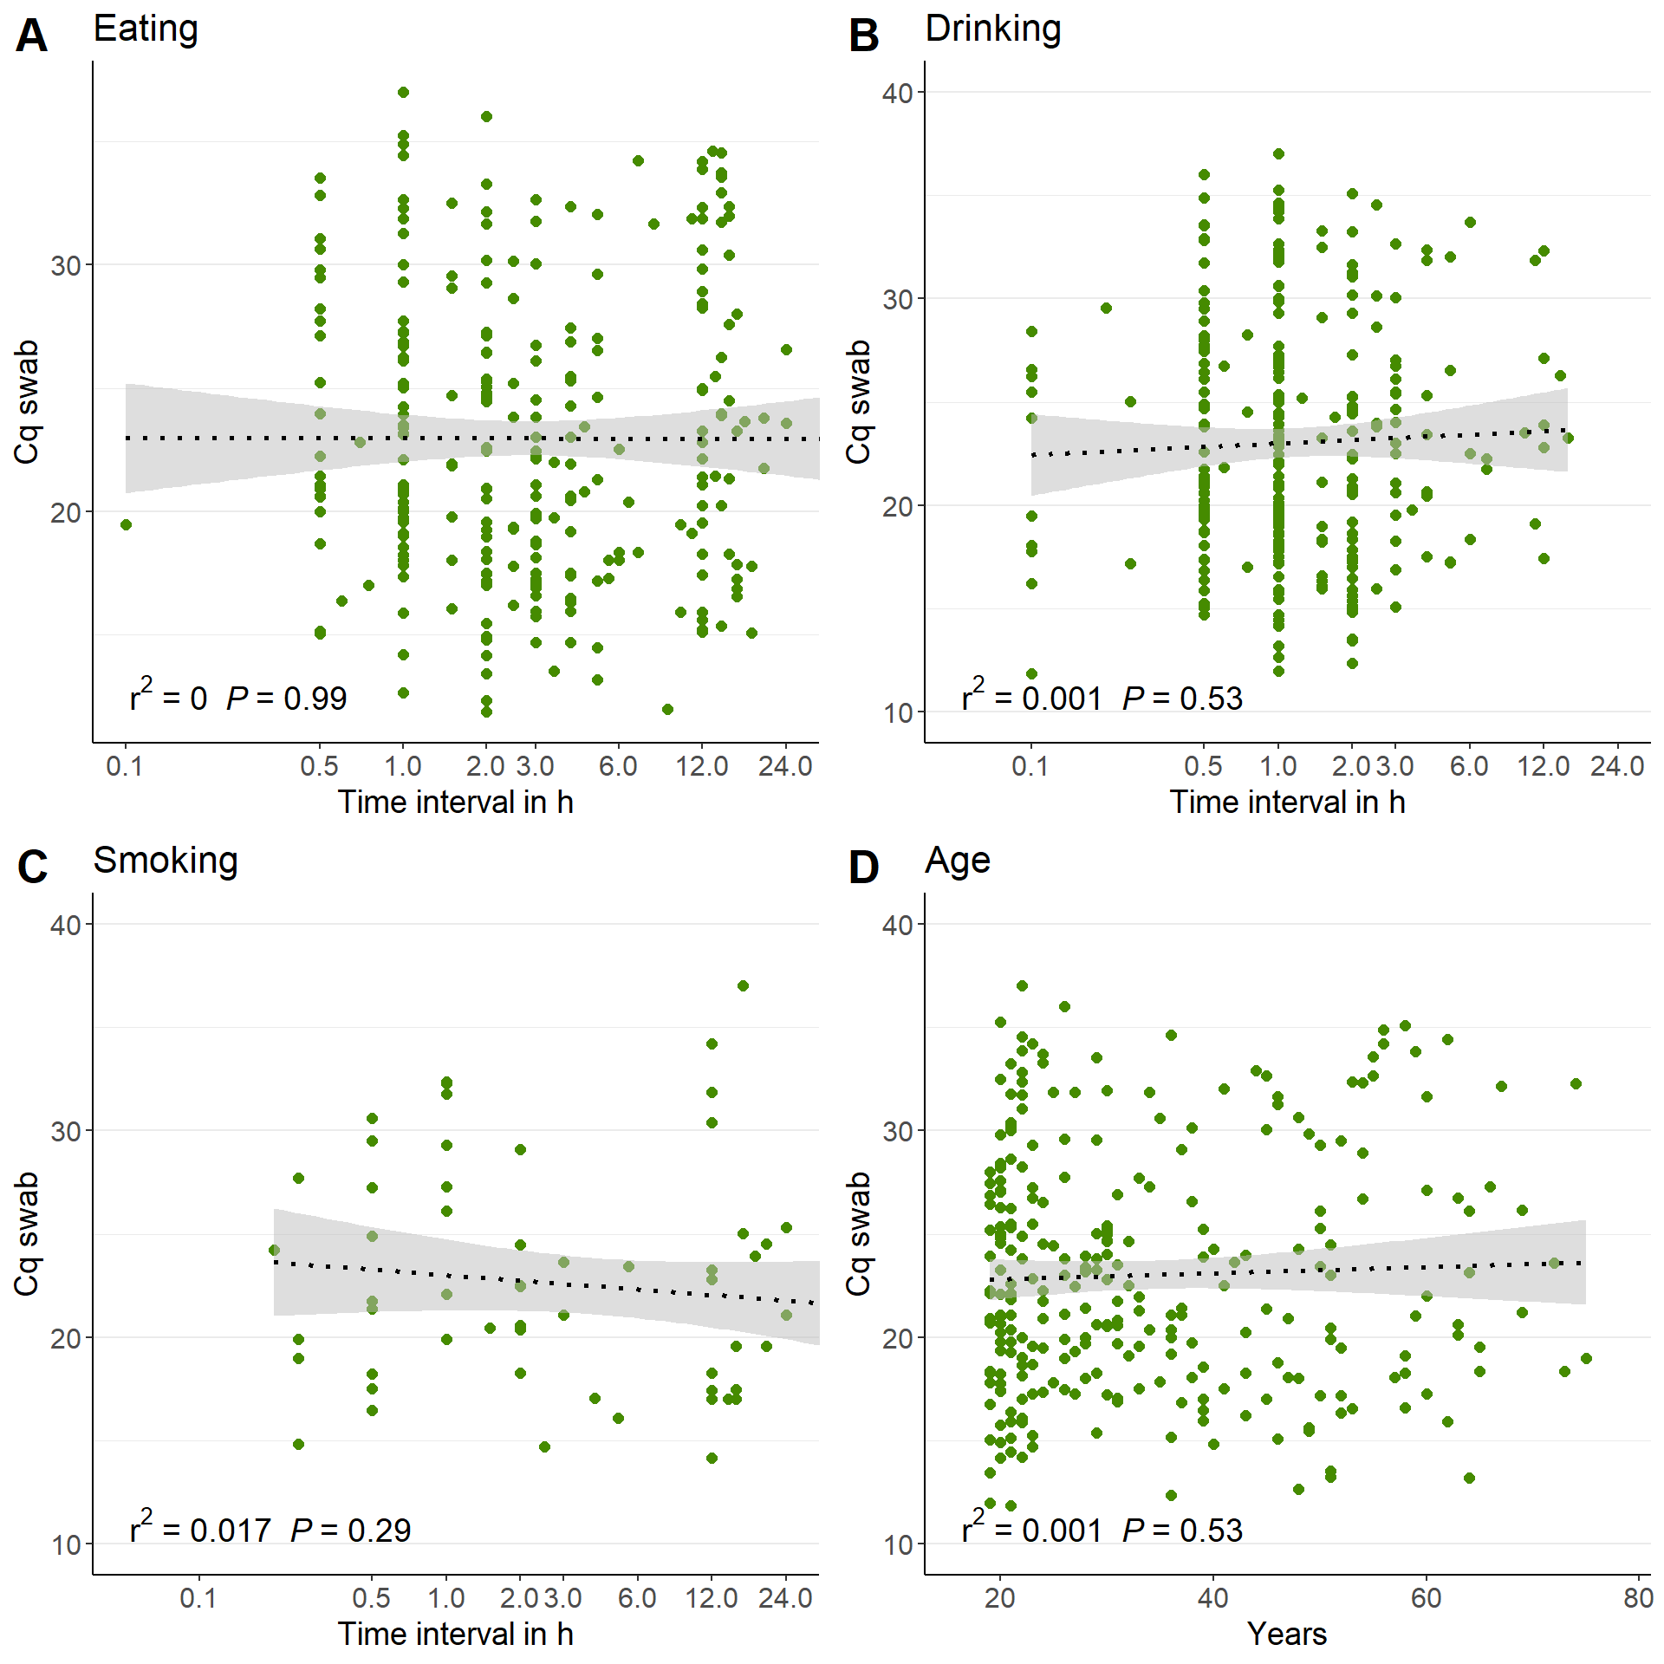

Figure S3: Linear regression of Cq values of swab samples on log₁₀-transformed time intervals to last meal (A), drink (B) and smoke/vape (C). Linear regression of Cq values on age in years (D). R² values and p values are displayed in the lower, left corner.

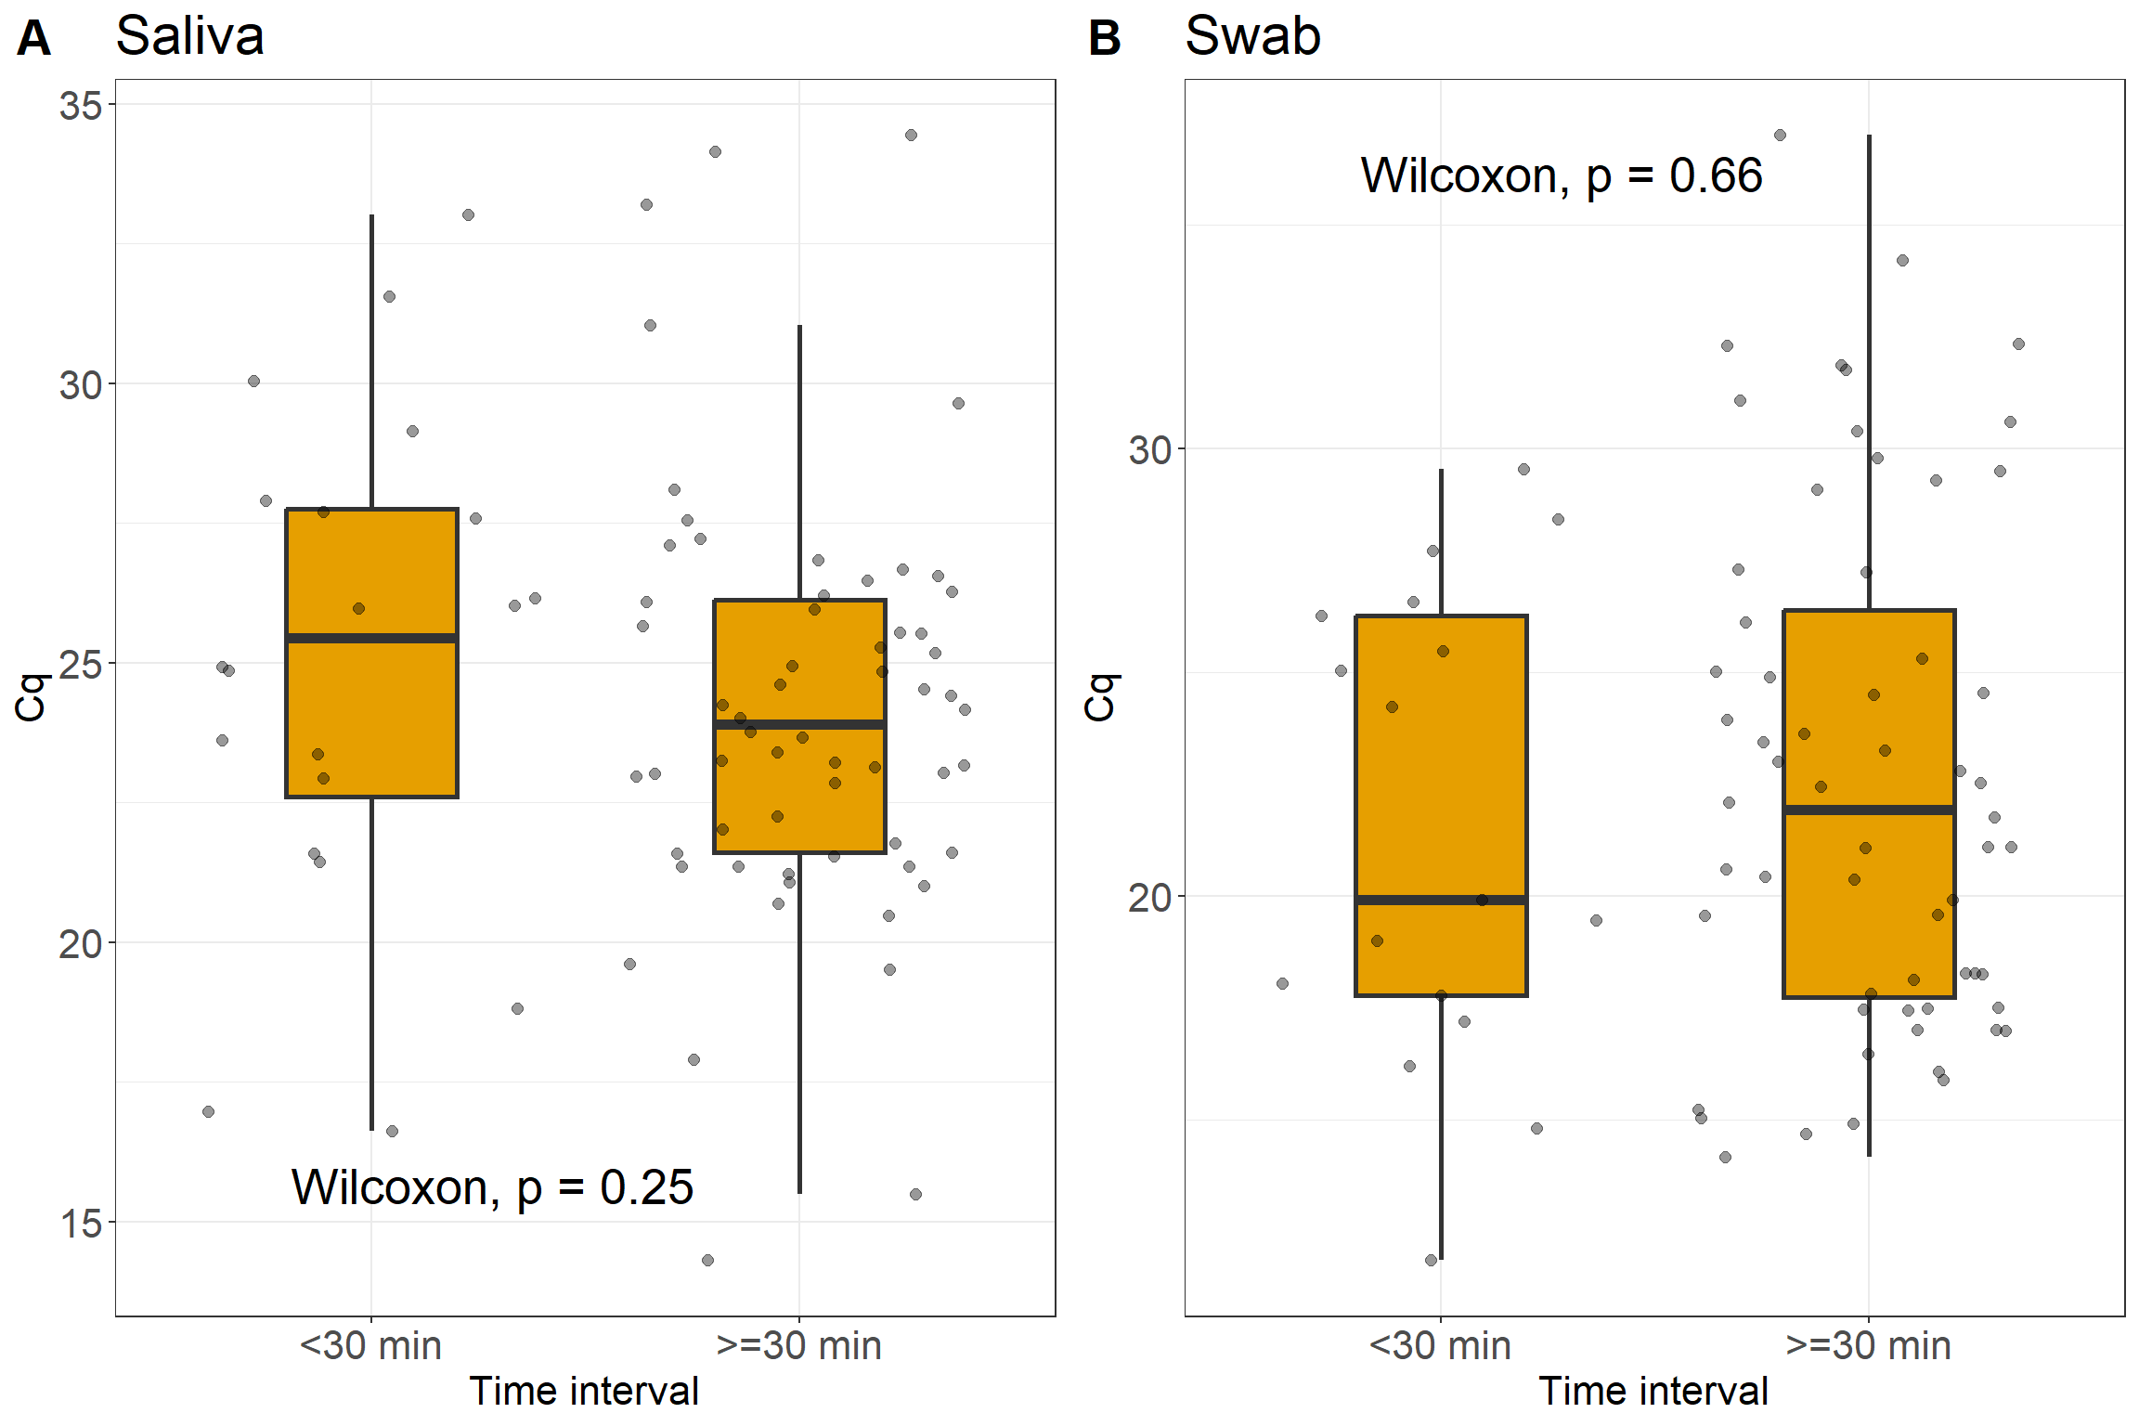

Figure S4: Box-and-whisker-plots comparing Cq values of saliva (A) and swab (B) samples from individuals, who had their last meal, drink, or smoke/vap within the last 30min (< 30 min) before testing, to those who had these earlier (≥30 min). P values from Wilcoxon rank tests are also displayed. For saliva, 20 positive samples were associated with the former case and 60 with the latter case. For swab, 17 positive samples values were associated with former case and 60 with the latter case. Note that not all participants gave relevant information.

A
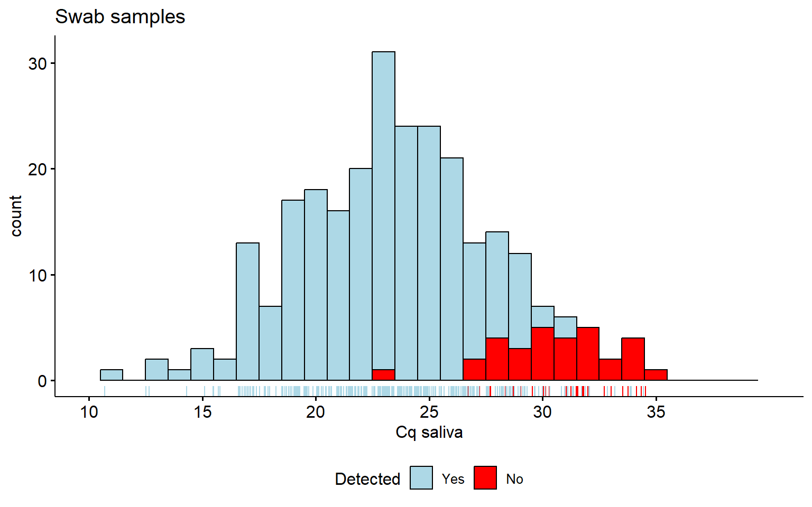

B
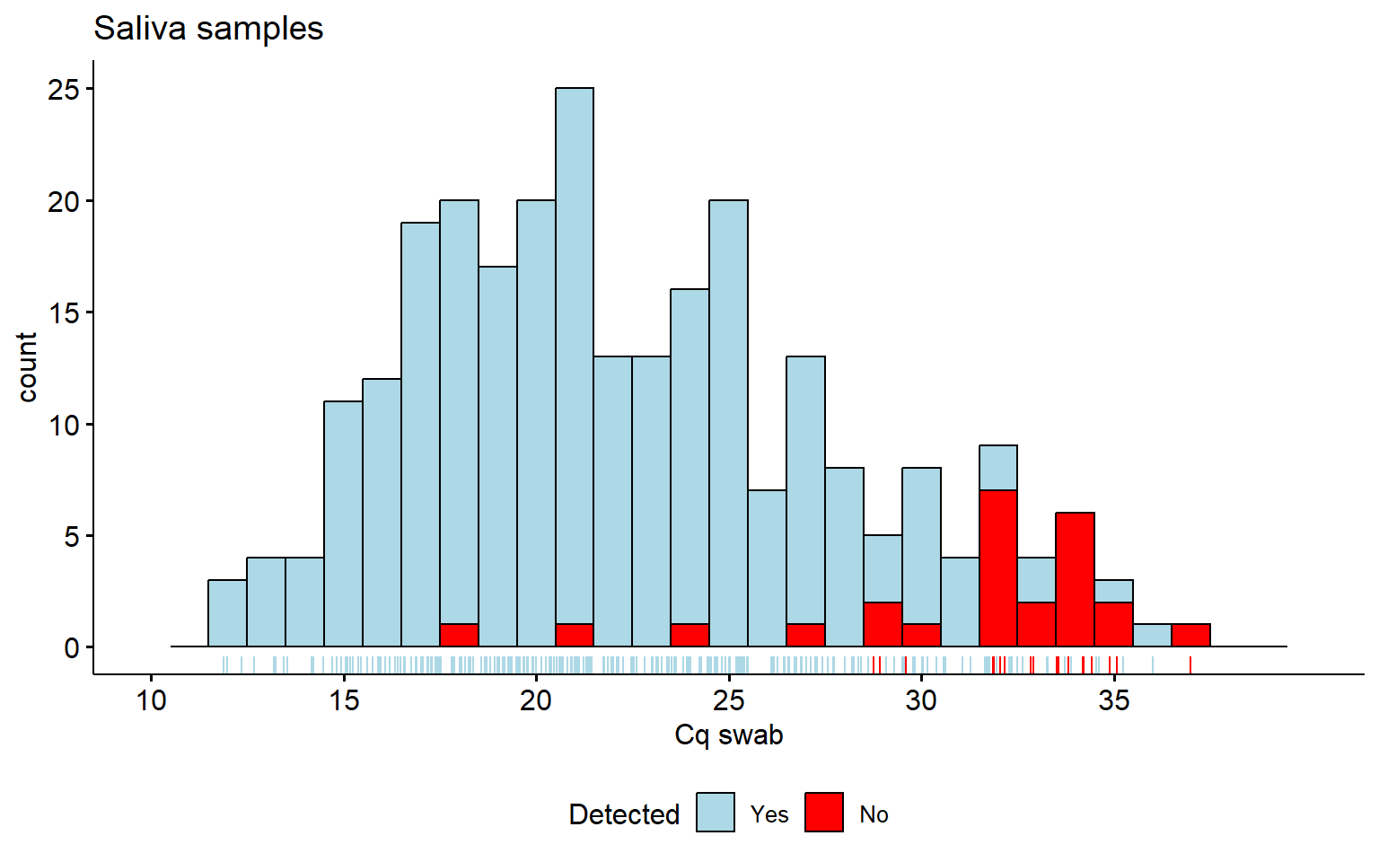

Figure S5: Histograms for Cq value for concordant and discordant tests. A) Distributions of Cq values of the positive saliva qPCRs, for which the corresponding swab qPCR sample was also detected (blue) or not detected (in red). B) Distributions of Cq values of the positive swab qPCRs, for which the corresponding saliva qPCR sample was also detected (blue) or not detected (in red).

