Table of Contents
Compound 5 ¹H NMR and ¹³C NMR 2
Compound 14P ¹H NMR and ¹³C NMR 3
Compound 14D ¹H NMR and ¹³C NMR 4
Compound 15D ¹H NMR and ¹³C NMR 5
Compound 16D ¹H NMR and ¹³C NMR 6
Compound 17D¹H NMR and ¹³C NMR 7
Compound 17P ¹H NMR and ¹³C NMR 8
Compound 6D ¹H NMR and ¹³C NMR 9
Compound 7D ¹H NMR and ¹³C NMR 10
Compound 8D ¹H NMR and ¹³C NMR 11
Compound 8P ¹H NMR and ¹³C NMR 12
Compound 9D ¹H NMR and ¹³C NMR 13
Compound 10D ¹H NMR and ¹³C NMR 14
Compound 11D ¹H NMR and ¹³C NMR 15
Compound 11P(a) and 11P(b) ¹H NMR and NOESY 16
Compound 21 ¹H NMR and ¹³C NMR 17
Compound 22 ¹H NMR and ¹³C NMR 18
Compound 23 ¹H NMR and ¹³C NMR 19
Compound 6D-d₆ ¹H NMR 20
Compound 6D-Mo ¹H NMR 20
Experimental Procedures & Characterizations 21
DFT Calculation 33
Crystallographic Data 35

Figure S-1. Compound 5 ¹H NMR and ¹³C NMR

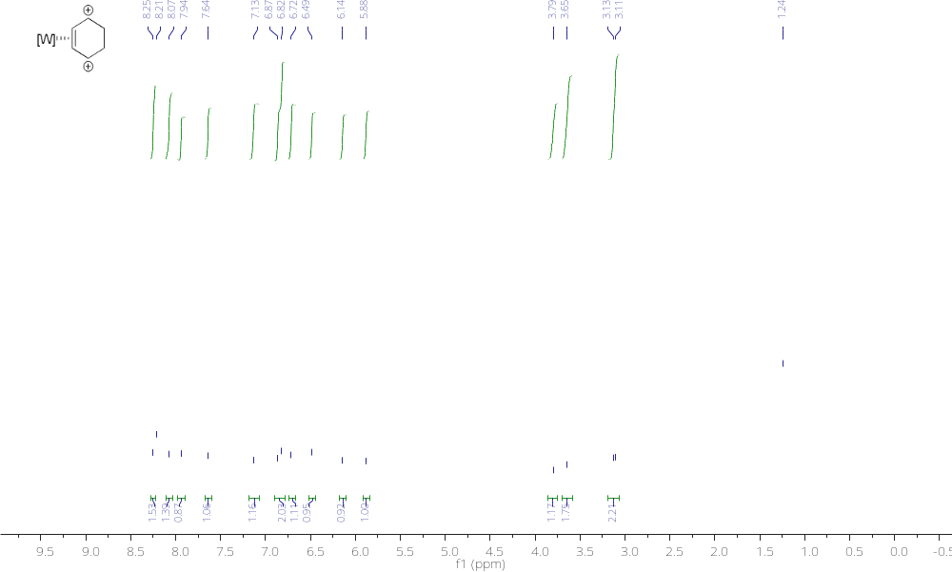

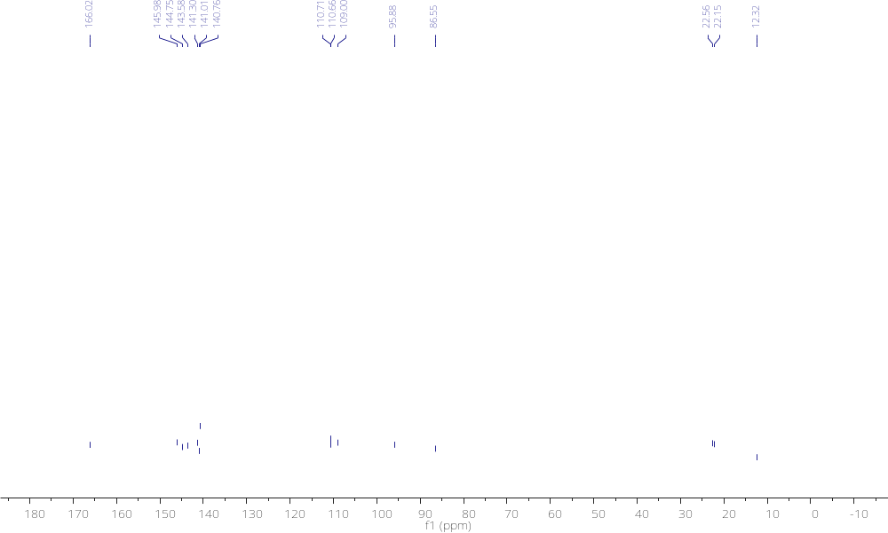

Figure S-2. Compound 14P ¹H NMR and ¹³C NMR

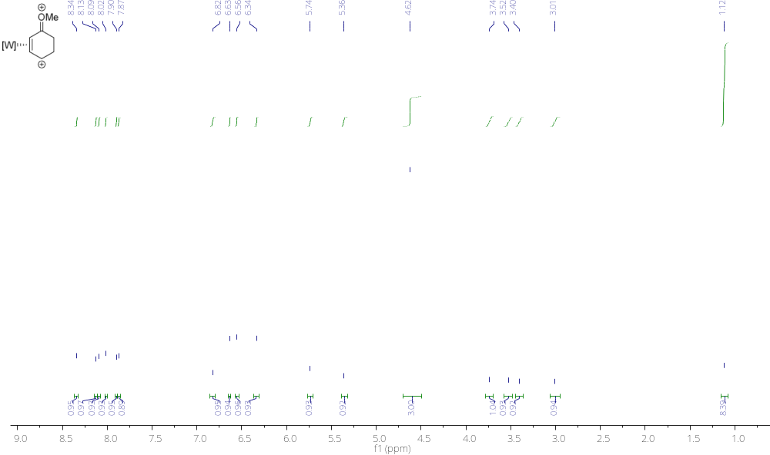

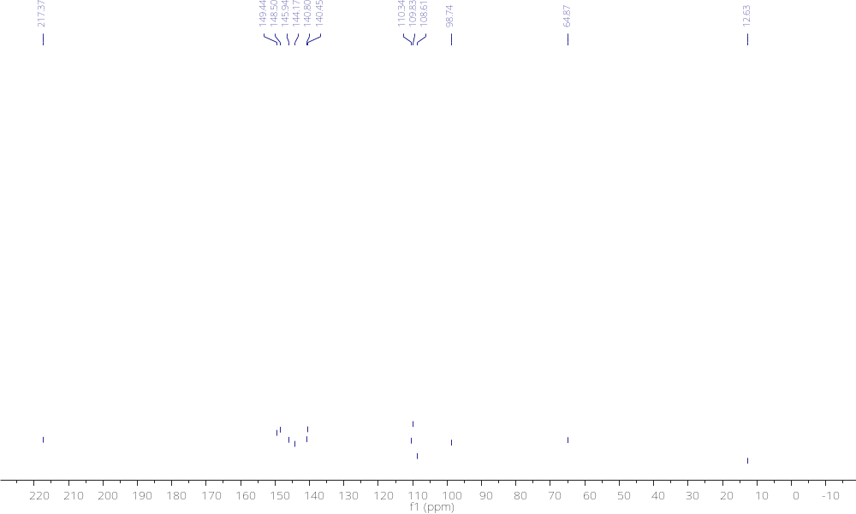

Figure S-3. Compound 14D ¹H NMR and ¹³C NMR

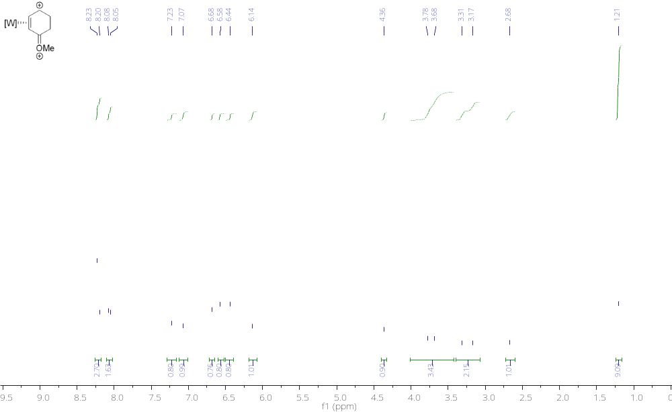
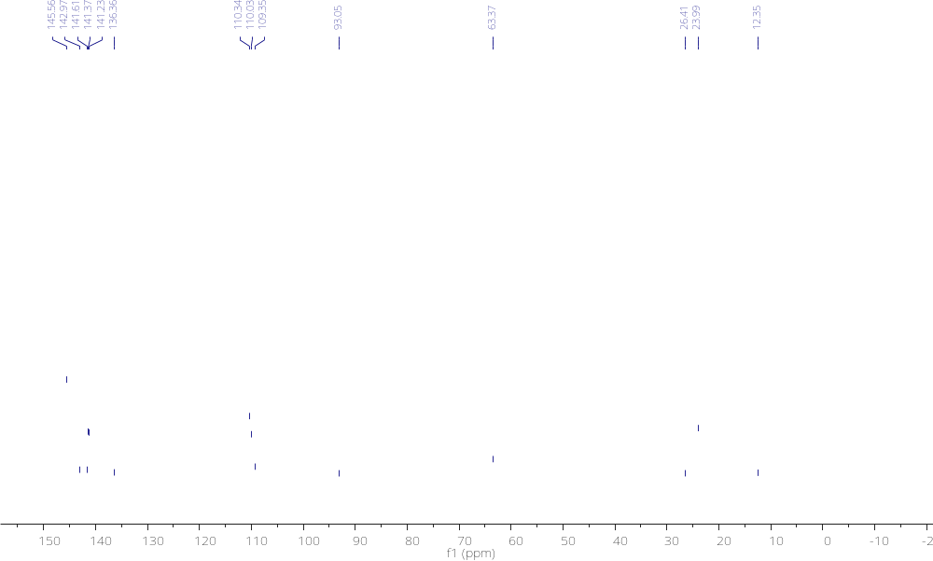

Figure S-4. Compound 15D ¹H NMR and ¹³C NMR

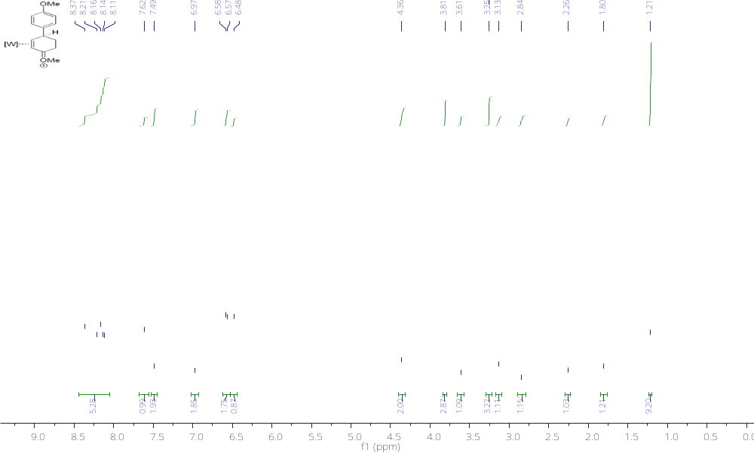
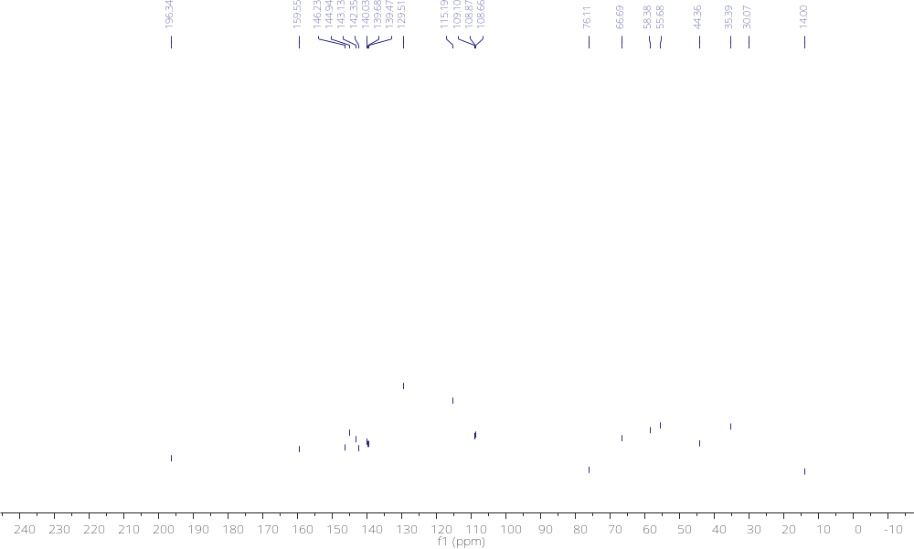

Figure S-5. Compound 16D ¹H NMR and ¹³C NMR

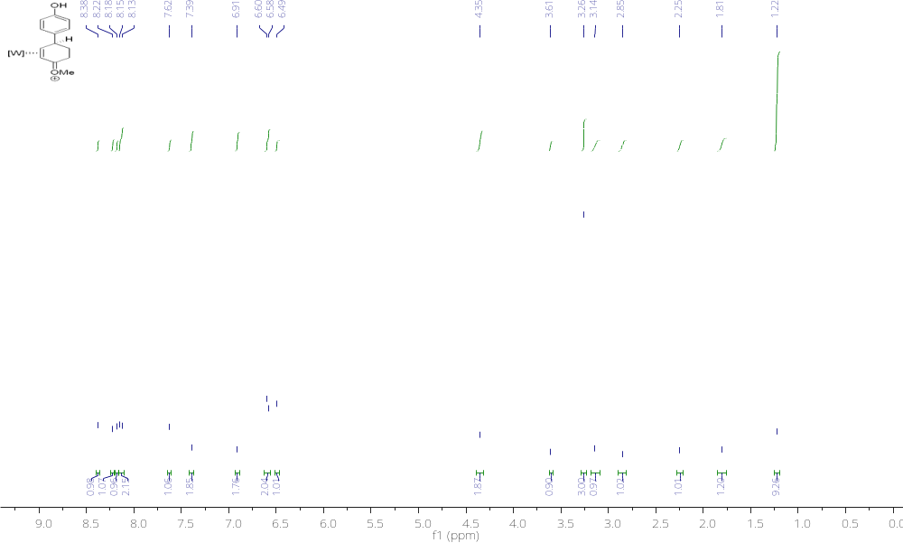
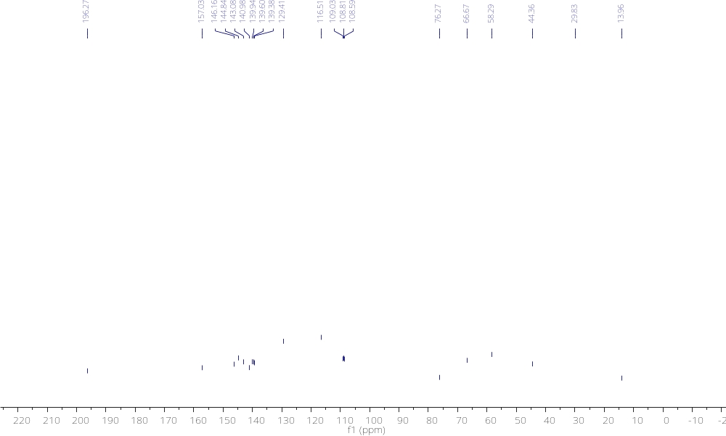

Figure S-6. Compound 17D¹H NMR and ¹³C NMR

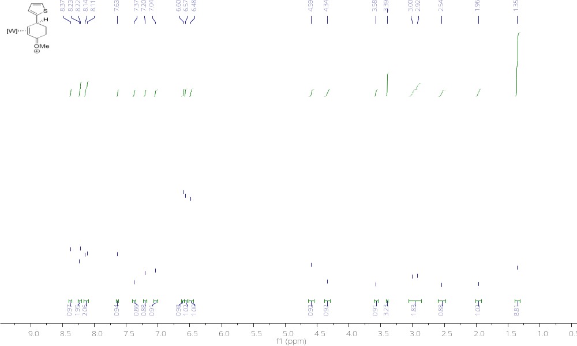
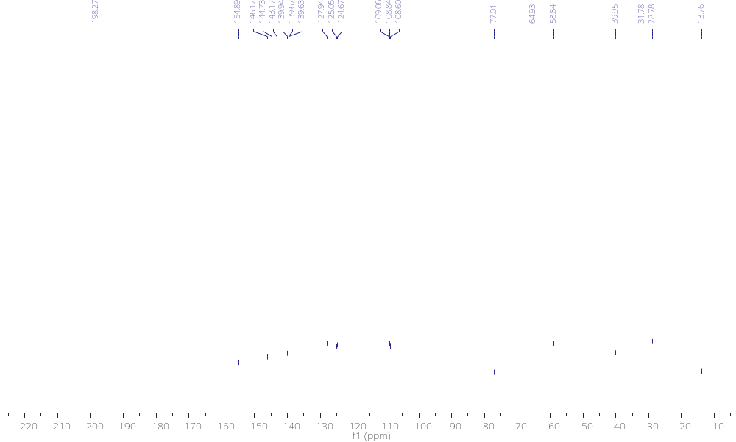

Figure S-7. Compound 17P ¹H NMR and ¹³C NMR

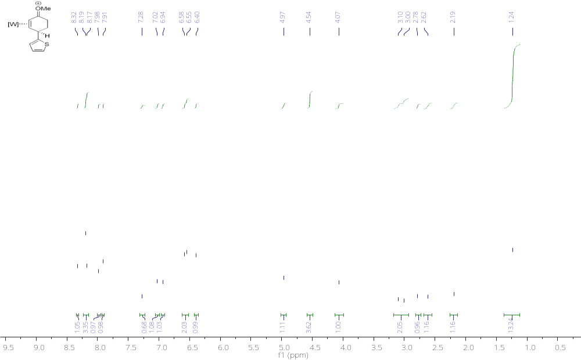
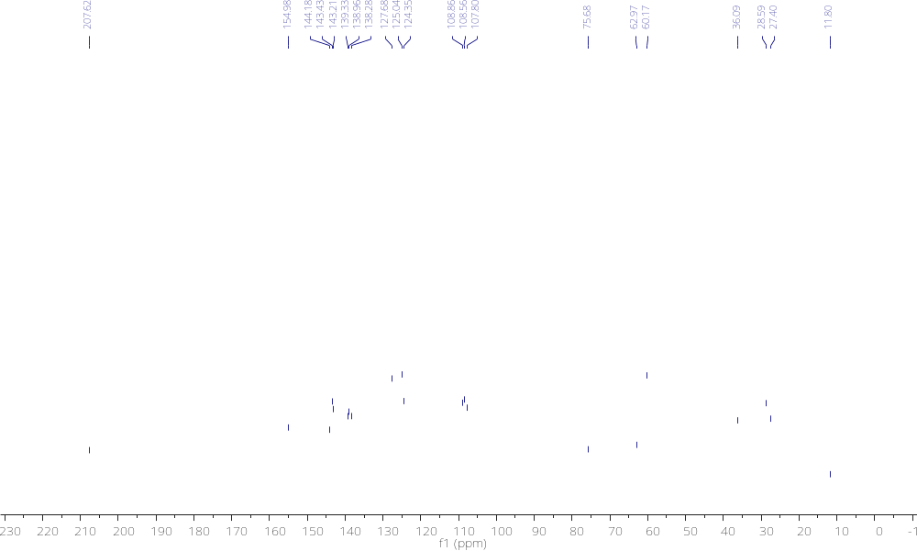

Figure S-8. Compound 6D ¹H NMR and ¹³C NMR

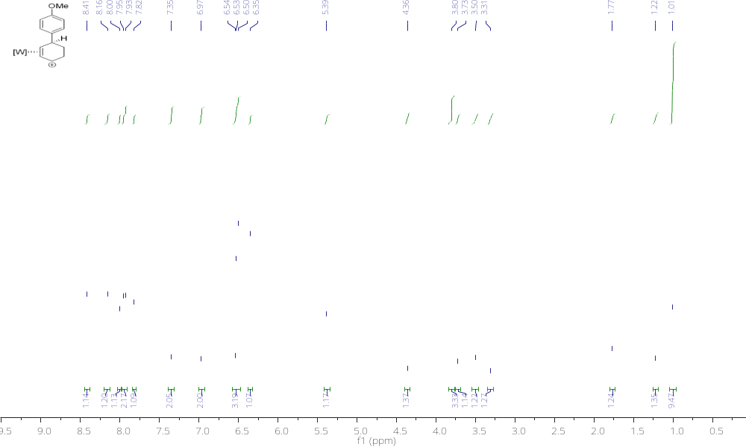
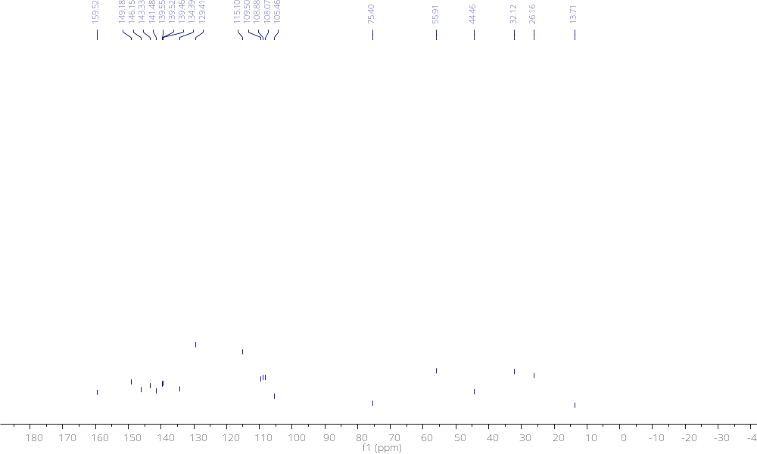

Figure S-9. Compound 7D ¹H NMR and ¹³C NMR

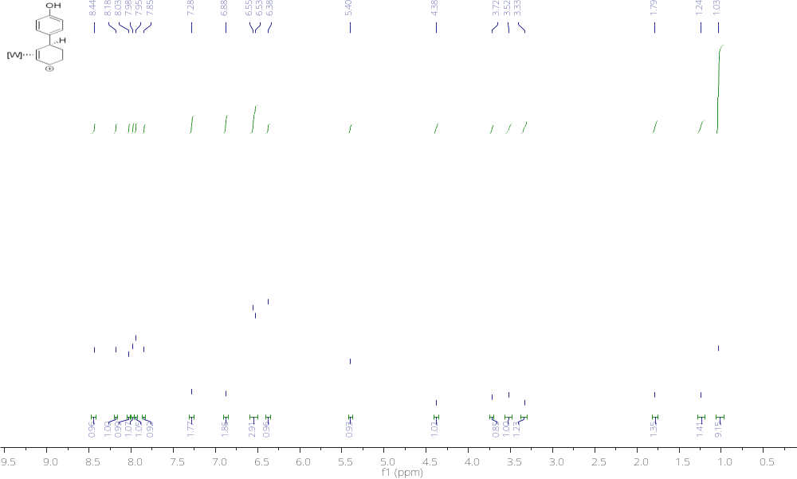
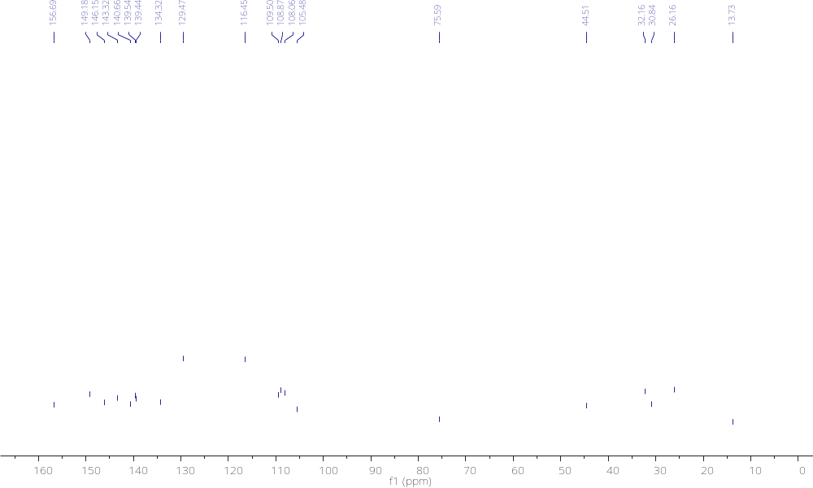

Figure S-10. Compound 8D ¹H NMR and ¹³C NMR

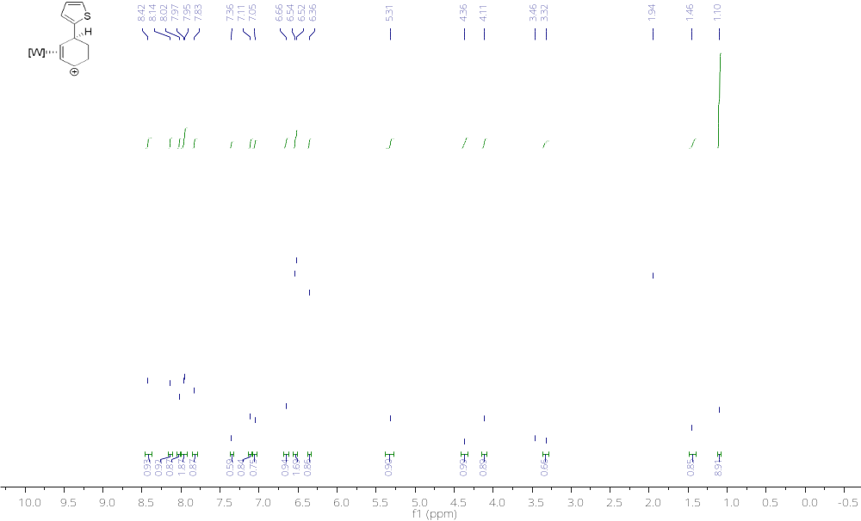
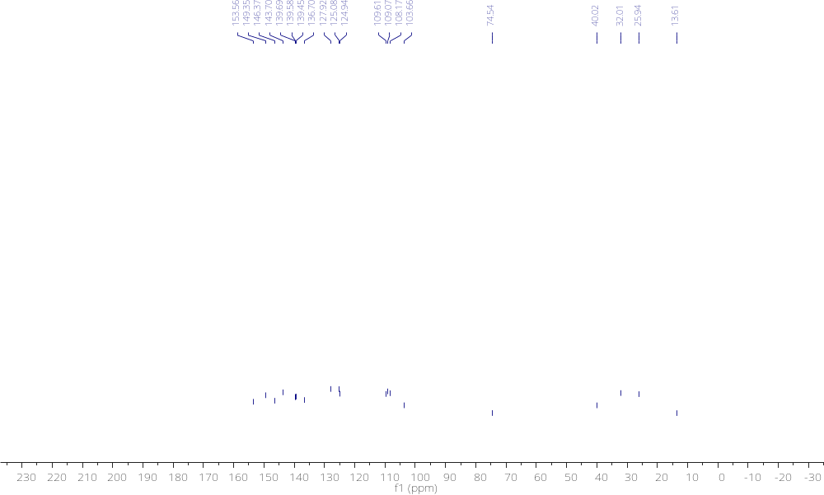

Figure S-11. Compound 8P ¹H NMR and ¹³C NMR

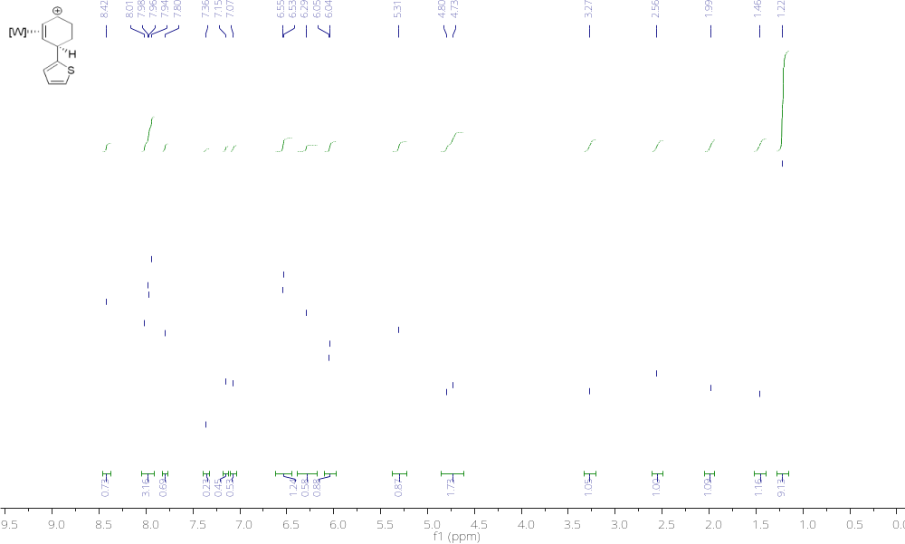
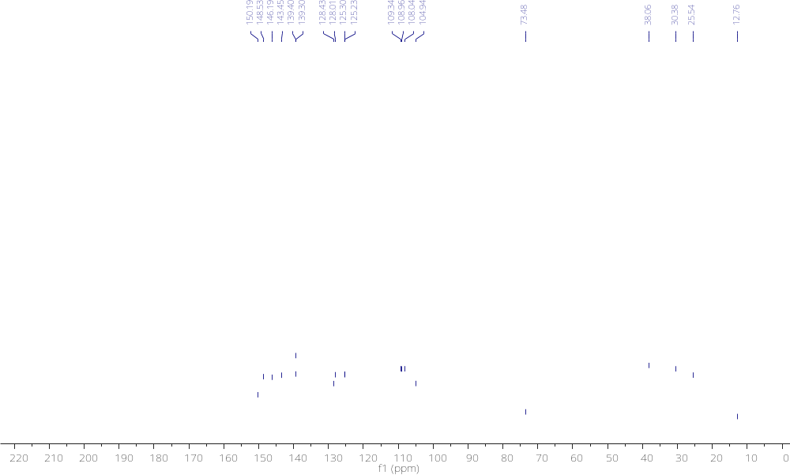

Figure S-12. Compound 9D ¹H NMR and ¹³C NMR

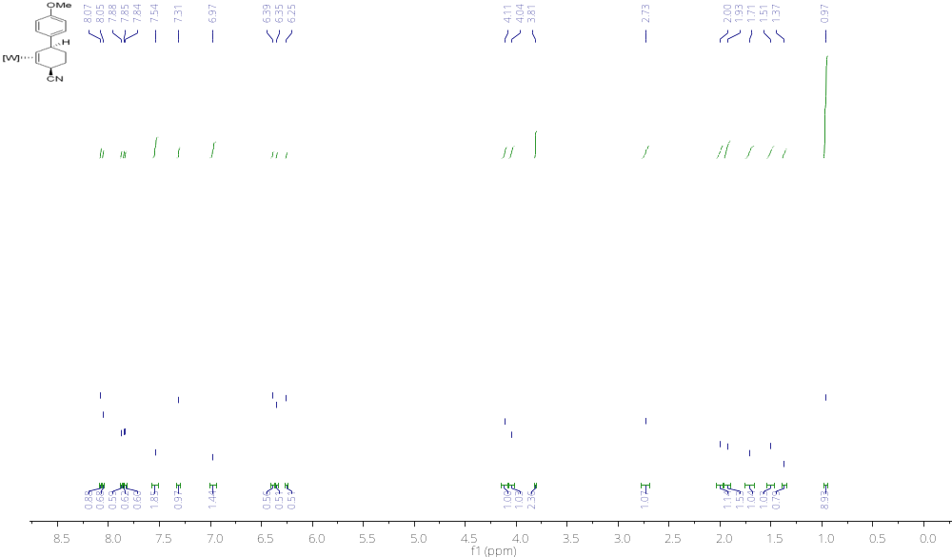

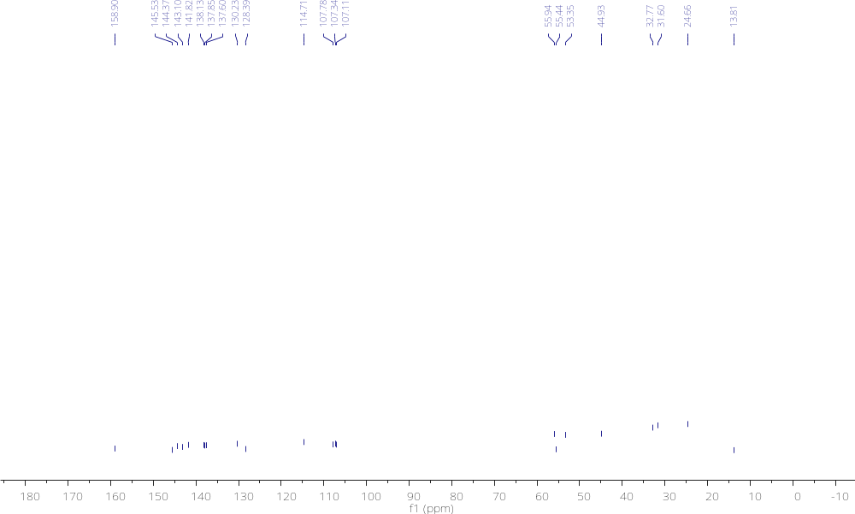

Figure S-13. Compound 10D ¹H NMR and ¹³C NMR

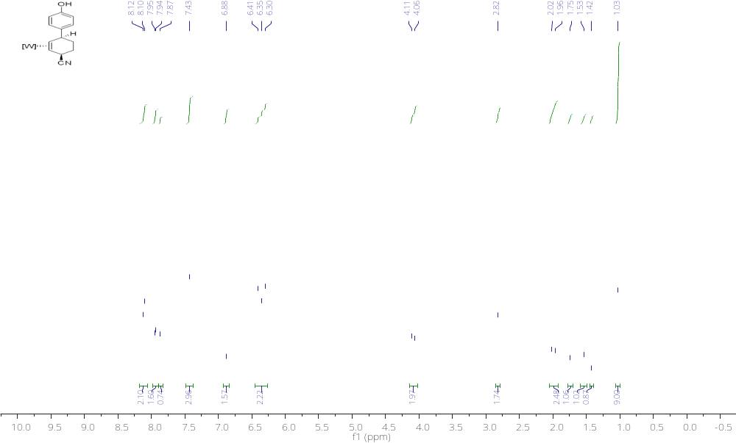

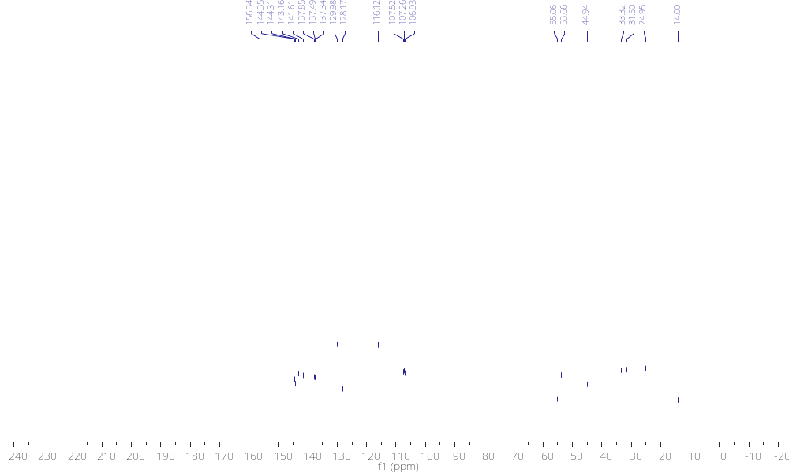

Figure S-14. Compound 11D ¹H NMR and ¹³C NMR

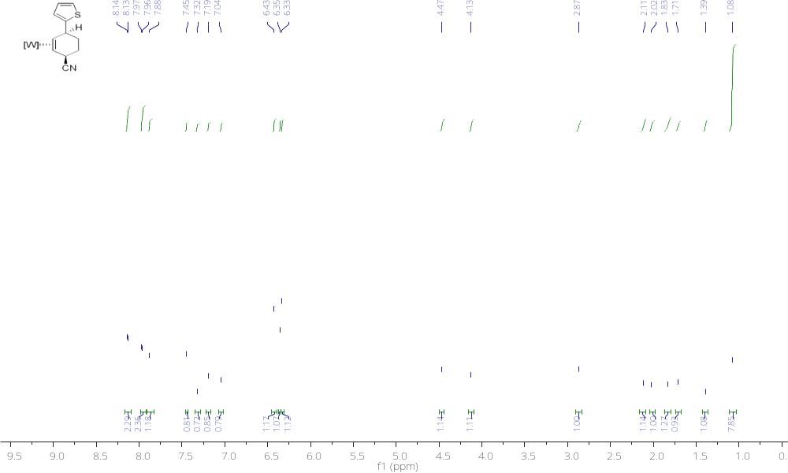
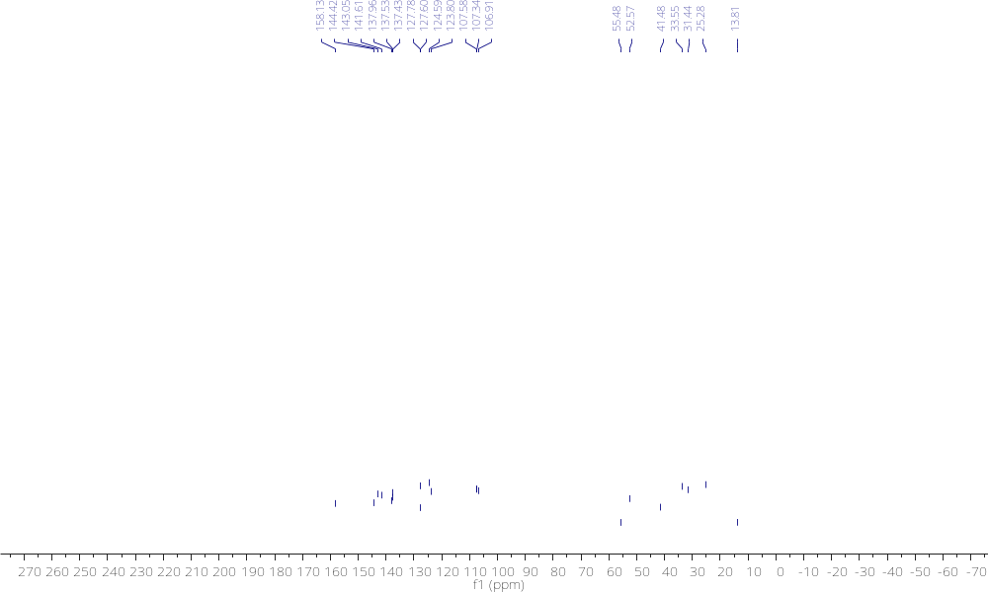

Figure S-15. Compound 11P(a) and 11P(b) ¹H NMR and NOESY

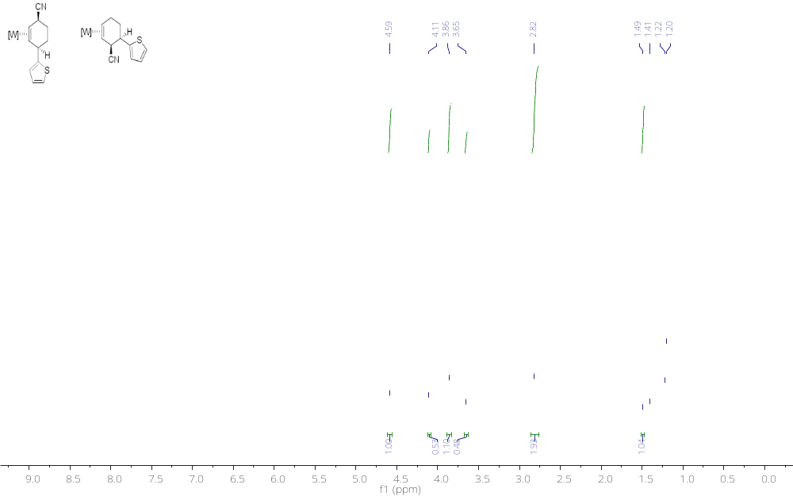

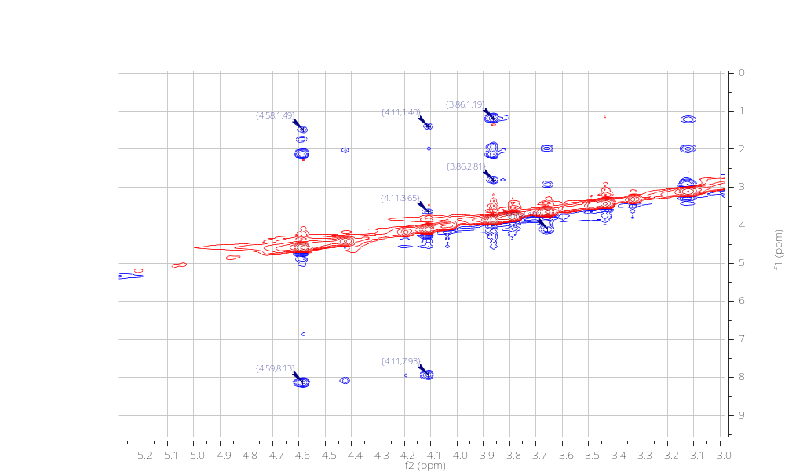

Figure S-16. Compound 21 ¹H NMR and ¹³C NMR

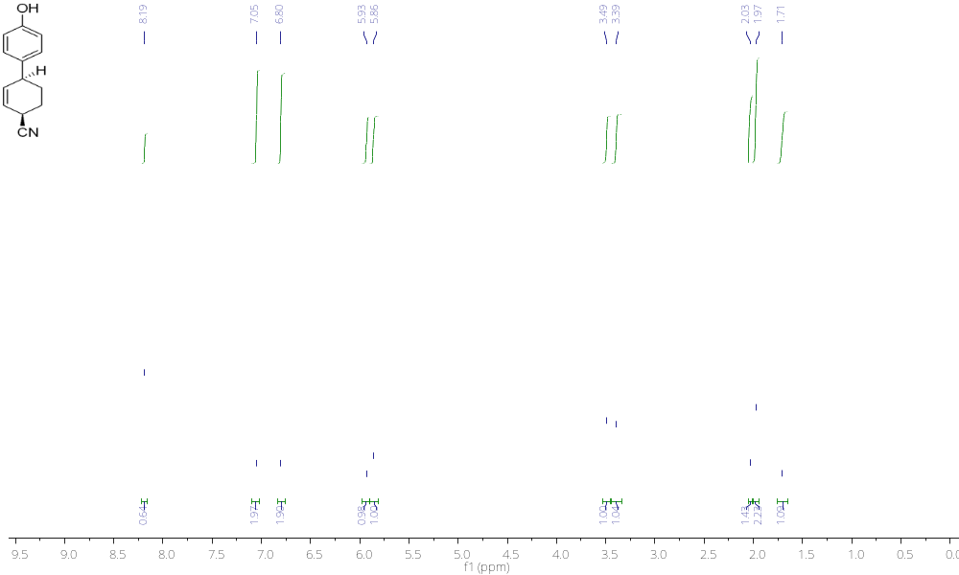

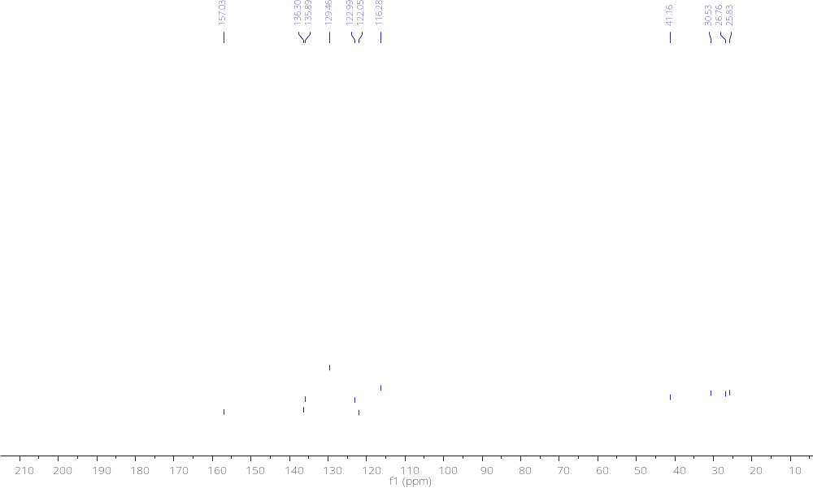

Figure S-17. Compound 22 ¹H NMR and ¹³C NMR

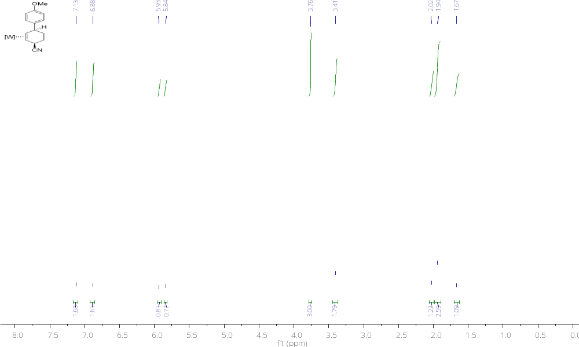
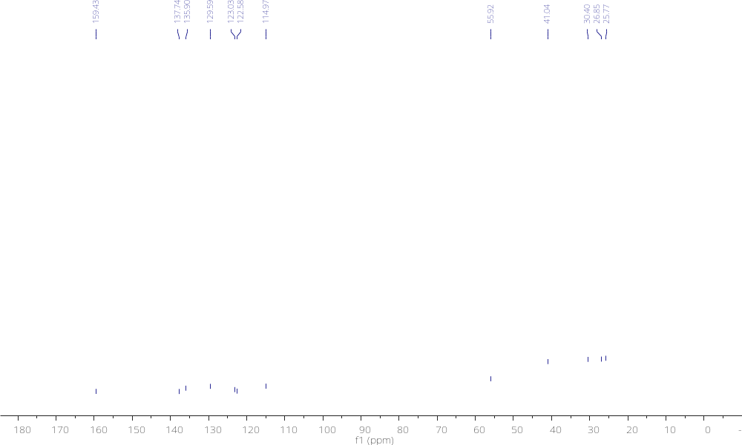

Figure S-18. Compound 23 ¹H NMR and ¹³C NMR

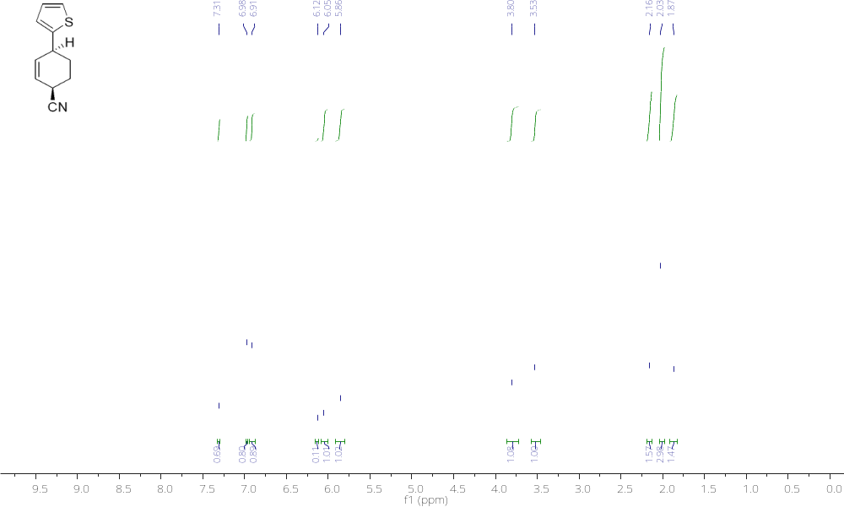
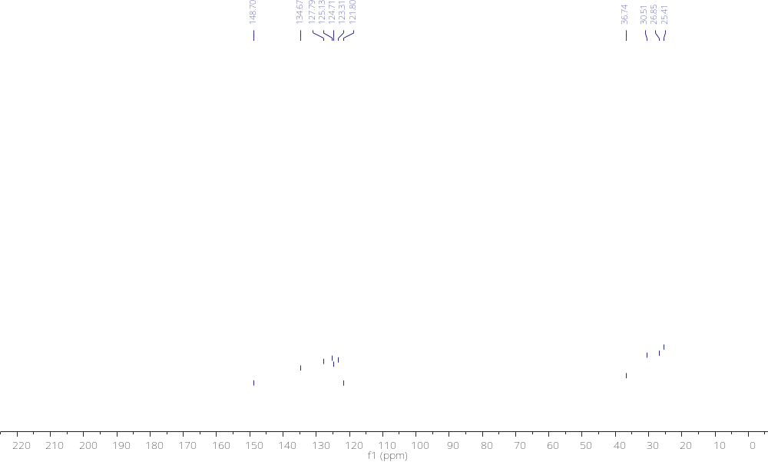

Figure S-19. Compound 6D-d₆ ¹H NMR

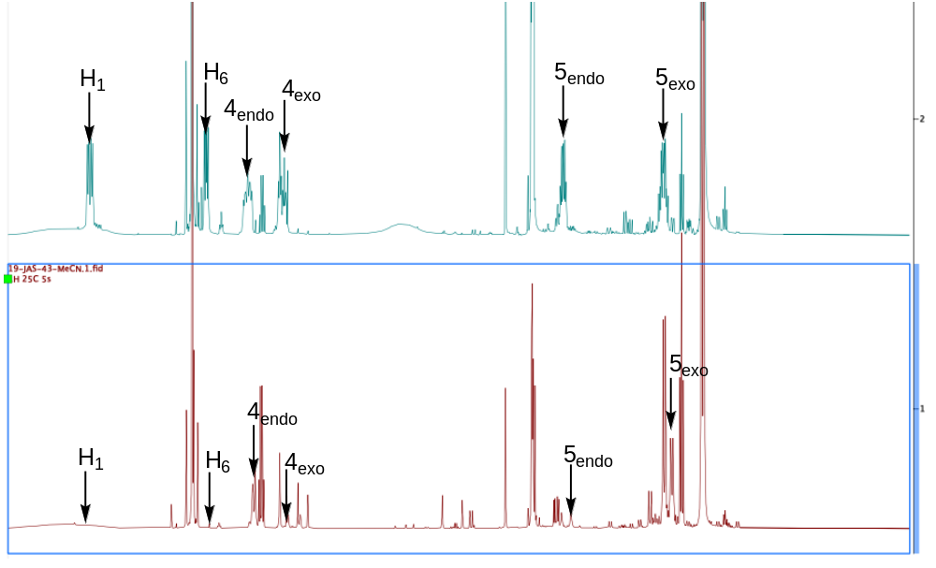

Figure S-20. Compound 6D-Mo ¹H NMR

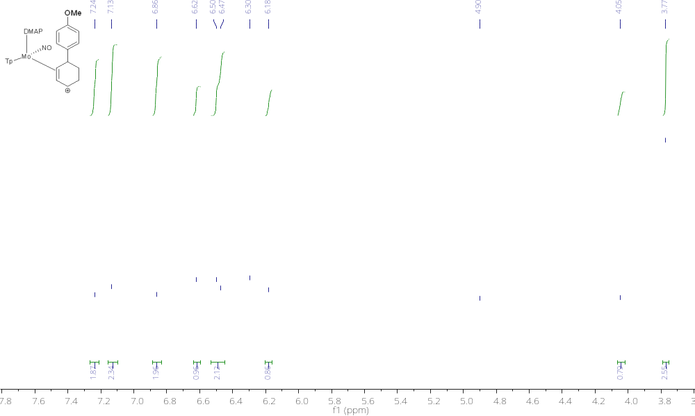

Experimental Procedures & Characterizations

General Methods: NMR spectra were obtained on 500, 600, or 800 MHz spectrometers. Chemical shifts are referenced to tetramethylsilane (TMS) utilizing residual ¹H or ¹³C signals of the deuterated solvents as internal standards. Phosphorus NMR signals are referenced to 85% H₃PO₄ (δ 0.00) using a triphenyl phosphate external standard (δ −16.58). Chemical shifts are reported in ppm, and coupling constants (J) are reported in hertz (Hz). Infrared (IR) spectra were recorded on a spectrometer as a glaze on a diamond anvil ATR assembly, with peaks reported in cm^{−1.} Electrochemical experiments were performed under a nitrogen atmosphere. Cyclic voltametric data were recorded at ambient temperature at 100 mV/s, unless otherwise noted, with a standard three electrode cell from +1.8 to −1.8 V with a glassy carbon working electrode, tetrabutylammonium hexafluorophosphate (TBAH) electrolyte (∼1.0 M), and acetonitrile (MeCN) or tetrahydrofuran (THF) as the solvent. All potentials are reported versus the normal hydrogen electrode (NHE) using cobaltocenium hexafluorophosphate (E_{1/2} = −0.78, −1.75 V) or ferrocene (E_{1/2} = 0.55 V) as an internal standard. Peak separation of all reversible couples was less than 100 mV. All synthetic reactions were performed in a glovebox under a dry nitrogen atmosphere unless otherwise noted. All solvents were sparged with nitrogen prior to use. Deuterated solvents were used as received from Cambridge Isotopes. When possible, pyrazole (Pz) protons of the (trispyrazolyl) borate (Tp) ligand were assigned as “Pz3/5 or Pz4”. B-H peaks (around 4−5 ppm) in the ¹H NMR spectra are not assigned due to their quadrapole broadening; however, confirmation of the BH group is provided by IR data (around 2500 cm⁻¹). Compounds 1, 12, and 13D were prepared according to previous literature procedures with some modifications.^{1, 2}
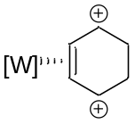
5
To an NMR tube was added 1 along with CD₂Cl₂. This homogeneous yellow reaction mixture was allowed to cool to -60 °C for 5 min before adding recently thawed HOTF (8 drops). The NMR tube was then removed from a glovebox and placed in a small dewar filled with N₂(l) that froze the contents of the NMR tube solution. The reaction mixture was allowed to thaw to reveal a homogeneous red reaction mixture. The resulting NMR solution was analyzed at 0 °C in CD₂Cl₂.
¹H NMR (CD₂Cl₂, δ, 0 °C): 8.25 (1H, broad s, Tp3/5), 8.21 (buried, broad s, Tp3/5), 8.07 (1H, broad s, Tp3/5), 7.94 (1H, broad s, Tp3/5), 7.54 (1H, broad s, Tp3/5), 7.13 (1H, broad s, benzenium), 6.87 (1H, broad s, benzenium), 6.82 (1H, broad s, Tp4), 6.72 (1H, broad s, Tp4), 6.49 (1H, broad s, Tp4), 6.14 (1H, broad s, benzenium), 5.88 (1H, broad s, benzenium), 3.79 (1H, broad s, benzenium), 3.65 (1H, broad s, benzenium), 3.13 (1H, broad s, benzenium), 3.11 (1H, broad s, benzenium), 1.24 (9H, d, J_{PH} = 10.4, PMe₃). ¹³C NMR (CD₂Cl₂, δ, 0 °C): 166.0 (benzenium), 146.0 (Tp3/5), 144.8 (Tp3/5), 143.6 (Tp3/5), 141.3 (Tp3/5), 141.0 (Tp3/5), 140.8 (2C, Tp3/5 and benzenium), 110.7 (Tp4), 110.6 (Tp4), 109.0 (Tp4), 95.9 (benzenium), 86.6 (benzenium), 22.6 (benzenium), 22.1 (benzenium), 12.3 (d, J_{PC} = 33.9, PMe₃).
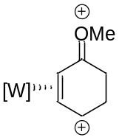
14P
To an NMR tube was added 12 and the sample was chilled to -30 °C for 5 min before adding a chilled (-30 °C) solution of HOTf (1 drop) in d₃-MeCN. This red homogenous solution was then analyzed by NMR at 0 °C.
¹H NMR (d3-MeCN, δ, 0 °C): 8.34 (1H, d, J = 2.2 Hz, Tp3/5), 8.13 (1H, d, J = 2.3 Hz , Tp3/5), 8.09 (1H, d, J = 2.2 Hz, Tp3/5), 8.02 (1H, d, J = 1.9 Hz, Tp3/5), 7.90 (1H, d, J = 2.2 Hz, Tp3/5), 7.87 (1H, d, J = 2.2 Hz, Tp3/5), 6.82 (1H, m, H4), 6.63 (1H, t, J = 2.3 Hz, Tp4), 6.56 (1H, t, J = 2.4 Hz, Tp4), 6.34 (1H, t, J = 2.4 Hz, Tp4A), 5.74 (1H, , m, H3), 5.36 (1H, dd, J = 10.5, 5.5 Hz, H2), 4.62 (3H, s, OMe), 3.74 (1H, m, H5-anti), 3.52 (1H, dd, J = 21.9, 9.9 Hz, H5-syn), 3.40 (1H, dd, J = 22.6, 10.1 Hz, H6), 3.01 (1H, dd, J = 22.5, 9.7 Hz, H6’), 1.12 (9H, d, J_{PH} = 10.5 Hz, PMe₃).³¹P NMR (d₃-MeCN-d3, δ): 0.76 (J_{WP} = 248.0 Hz). ¹³C NMR (d₃-MeCN, δ, 0 °C): 217.4 (C1), 149.4 (C4), 148.5 (Tp3/5), 145.9 (Tp3/5), 144.2 (Tp3/5, d, J_{PC} = 3.8 Hz), 140.8 (2C, overlapping Tp3/5), 140.4 (Tp3/5), 110.3 (Tp4, d, J_{PC} = 2.5), 109.8 (Tp4), 108.6 (Tp4, d, J_{PC} = 6.7 Hz), 98.7 (C3), 64.9 (2C, overlap, - OMe and C2), 27.1 (C6), 24.5 (C5), 12.6 (PMe₃, d, J_{PC} = 34.0 Hz).
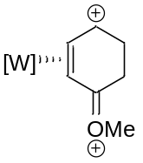
14D
To an NMR tube was added 13D along with d₃-MeCN (~1 mL). This orange homogenous solution was chilled to -30 °C for 5 min. A drop of chilled (-30 °C) HOTf was then added to produce a homogenous red solution which was subsequently analyzed by NMR at 0 °C.
¹H NMR (d₃-MeCN, δ, 0 °C): 8.23 (2H, overlapping, Tp3/5), 8.20 (1H, d, J = 2.2 Hz, Tp5C), 8.08 (1H, d, J = 2.0 Hz Tp3/5), 8.05 (1H, d, J = 2.0 Hz, Tp3/5), 7.23 (1H, s, Tp3/5), 7.07 (1H, m, H4), 6.68 (1H, t, J = 2.2 Hz, Tp4), 6.58 (1H, t, J = 2.3 Hz, Tp4), 6.44 (1H, t, J = 2.3 Hz, Tp4), 6.14 (1H, m, H5), 4.36 (1H, d, J = 5.3 Hz, H6), 3.78 (1H, m, H3), 3.68 (3H, b, OMe), 3.31 (1H, dd, J = 21.1, 10.5 Hz H3’), 3.17 (1H, dd, J = 22.3, 10.6 Hz, H2), 2.68 (1H, ddd, J = 22.2, 10.2, 4.3 Hz, H2’), 1.21 (9H, d, J_{PH} = 10.4, PMe₃). ³¹P NMR (d₃-MeCN, δ): - 0.20 (J_{WP} = 240.0 Hz). ¹³C NMR (d₃-MeCN, δ, 0 °C): 212.2 (C1), 145.5 (2C, overlapping Tp3/5), 143.0 (Tp3/5), 141.6 (Tp3/5), 141.4 (Tp3/5), 141.2 (Tp3/5), 136.4 (C4), 110.3 (2C, overlapping, Tp4), 110.0 (Tp4), 93.0 (C5), 64.1 (C6), 53.0 (OMe), 26.6 (C2), 23.9 (C3), 12.4 (PMe₃, d, J_{PC} = 34.3 Hz).
General Procedure 1: To a test tube was added 13D and MeCN (1 mL). This solution was chilled to -30 °C for 5 min before adding a chilled (-30 °C) solution of HOTf in MeCN. A chilled (-30 °C) solution of the nucleophile in MeCN (1 mL) was then added. The reaction was monitored by ³¹P NMR and determined to be complete based on the disappearance of 14D and the formation of a new signal with J_{WP} ~285 Hz. The reaction mixture was then diluted with DCM (5 mL) and washed with DI H₂O (3 x 5 mL). The organic layer was dried over anhydrous MgSO₄ and concentrated in vacuo. The film was dissolved in minimal DCM and added to stirring Et₂O (300 mL). The resulting precipitate was collected on a fine porosity frit and washed with Et₂O (30 mL).
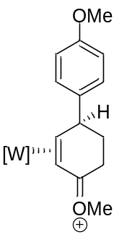
15D
Used General Procedure 1 with 13D (1.015 g, 1.33 mmol), HOTf in MeCN (2 mL, 7.83 mmol), anisole in MeCN (3.17 mL, 20.0 mmol). Orange-tan solid (0.880 g (76%)).
¹H NMR (d₆-acetone, δ): 8.37 (1H, d, J = 1.9 Hz), 8.21 (1H, d, J = 2.2 Hz), 8.16 (1H, d, J = 2.0 Hz), 8.14 (1H, d, J = 2.3 Hz), 8.11 (1H, d, J = 2.4 Hz), 7.62 (1H, d, J = 1.9 Hz), 7.49 (2H, d, J = 8.5 Hz), 6.97 (2H, d, J = 8.6 Hz), 6.58 (1H, t, J = 2.3 Hz), 6.57 (1H, t, J = 2.3 Hz), 6.48 (1H, t, J = 2.3 Hz), 4.36 (2H, overlapping), 3.81 (3H, s), 3.61 (1H, d, J = 8.0), 3.25 (3H, s), 3.13 (1H, ddd, J = 17.2, 10.6, 6.0 Hz), 2.84 (1H, dt, J = 18.3, 4.1 Hz), 2.26 (1H, m), 1.80 (1H, m), 1.21 (9H, d, J_{PH} = 9.6). ³¹P NMR (d₃-MeCN, δ): -9.43 (J_{WP} = 284 Hz). ¹³C NMR (d₆-acetone, δ): 196.3, 159.6, 146.2, 144.9, 143.1, 142.4, 140.0, 139.7, 139.5, 129.5, 115.2, 109.1, 108.9, 108.7, 76.1 (d, J_{PC} = 15.0 Hz), 66.7, 58.4, 55.7, 44.4, 35.4, 30.1, 14.0 (d, J_{CP} = 31.6 Hz). HRMS (ESI) calculated for M+: 718.2197, observed 718.2201. CV (MeCN): E_{p,c} = - 1.26 V (NHE). IR (ATR, cm⁻¹): ν(BH) = 2518 cm⁻¹, ν(NO) = 1600 cm⁻¹.
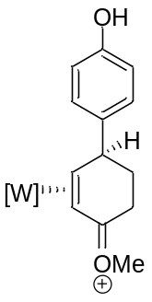
16D
Used General Procedure 1 with 13D (0.5773 g, 0.7584 mmol), HOTf in MeCN (2 mL, 2.475 mmol), phenol in MeCN (2 mL, 3.42 mmol). Orange-tan solid (0.5049 g (77.8%)).
¹H NMR (d₆-acetone, δ): 8.38 (1H, d, J = 2.0 Hz), 8.22 (1H, d, J = 2.2 Hz), 8.18 (1H, d, J = 2.1 Hz), 8.15 (1H, d, J = 2.3 Hz), 8.13 (1H, d, J = 2.4 Hz), 7.62 (1H, d, J = 2.0 Hz), 7.39 (2H, d, J = 8.5 Hz), 6.91(2H, d, J = 8.5 Hz), 6.60 (1H, t, J = 2.3 Hz), 6.58 (1H, t, J = 2.3 Hz), 6.49 (1H, t, J = 2.3 Hz), 4.35 (2H, overlapping), 3.61 (1H, d, J = 8.0), 3.26 (3H, s), 3.14 (1H, ddd, J = 17.0, 10.7, 5.8 Hz), 2.85 (1H, dt, J = 18.2, 3.8 Hz), 2.25 (1H, m), 1.81 (1H, m), 1.22 (9H, d, J_{PH} = 9.6). ³¹P NMR (d₃-MeCN, δ): -9.34 (J_{WP} = 285 Hz). ¹³C NMR (d₆-acetone, δ): 196.3, 157.0, 146.2, 144.8, 143.1, 141.0, 139.9, 139.6, 139.4, 129.4, 116.5, 109.0, 108.8, 108.6, 76.3 (d, J_{PC} = 16.1 Hz), 66.7, 58.3, 44.4, 35.4, 29.8, 14.0 (d, J_{CP} = 31.3 Hz). HRMS (ESI) calculated for M+: 704.2041, observed 704.2045. CV (MeCN): E_{1/2} = - 1.17 V (NHE). IR (ATR, cm⁻¹): ν(BH) = 2523 cm⁻¹, ν(NO) = 1609 cm⁻¹.
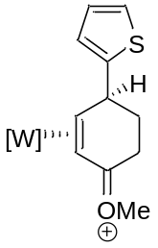
17D
Used General Procedure 1 with 13D (0.5995 g, 0.7876 mmol), HOTf in MeCN (2 mL, 2.251 mmol), thiophene in MeCN (2 mL, 5.051 mmol). Orange-tan solid (0.4914 g (73.8%)).
¹H NMR (d₆-acetone, δ): 8.37 (1H, d, J = 2.2 Hz), 8.23 (1H, d, J = 2.3 Hz), 8.22 (1H, d, J = 2.3 Hz), 8.14 (1H, d, J = 2.4 Hz), 8.11 (1H, d, J = 2.5 Hz), 7.63 (1H, d, J = 2.2 Hz), 7.37 (1H, dd, J = 5.1, 1.2 Hz), 7.20 (1H, ddd, J = 3.5, 1.2, 0.7 Hz), 7.04 (1H, dd, J = 5.1, 3.5 Hz), 6.60 (1H, t, J = 2.3 Hz), 6.57 (1H, t, J = 2.3 Hz), 6.48 (1H, t, J = 2.3 Hz), 4.59 (1H, td, J = 6.0, 2.2 Hz), 4.34 (1H, ddd, J = 14.1, 8.1, 2.3 Hz), 3.58 (1H, d, J = 8.1 Hz), 3.39 (3H, s), 3.00 (1H, dt, J = 19.8, 6.6 Hz), 2.92 (1H, dt, J = 19.7, 6.7 Hz), 2.54 (1H, m), 1.96 (1H, m), 2.91 (1H, m), 1.35 (9H, d, J_{PH} = 9.5 Hz). ³¹P NMR (d₃-MeCN, δ): -9.2 (J_{WP} = 280 Hz). ¹³C NMR (d₆-acetone, δ): 198.3, 154.9, 146.1, 144.7, 143.2, 139.9, 139.7, 139.6, 127.9, 125.0, 124.7, 109.1, 108.8, 108.6, 77.0 (d, J_{PC} = 16.1 Hz), 64.9, 58.8, 40.0, 31.8, 28.8, 13.8 (d, J_{CP} = 31.5 Hz). HRMS (ESI) calculated for M+: 694.1655, observed 694.1659. CV (MeCN): E_{p,c}= - 1.37 V (NHE). IR (ATR, cm⁻¹): ν(BH) = 2521 cm⁻¹, ν(NO) = 1612 cm⁻¹.
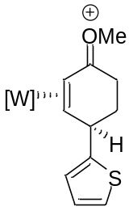
17P
To a 15-mL test tube was added 12 (0.7377 g, 1.207 mmol). The complex was chilled to -60 °C for 15 min before adding a chilled (-60 °C) solution of HOTf in EtCN (2ml, 3.709 mM). After 5 min, a chilled (-60 °C) solution of the thiophene in EtCN (2 mL, 10.02 mM)) was added. The reaction was then allowed to stir at room temperature and was monitored by ³¹P NMR and determined to be complete based on the disappearance of 14P and the formation of a new signal with J_{WP} = 300 Hz. The reaction mixture was then diluted with DCM (5 mL) and washed with DI H₂O (3 x 5 mL). The organic layer was dried over anhydrous MgSO₄ and concentrated in vacuo. The film was dissolved in minimal DCM and added to stirring Et₂O (300 mL). The resulting precipitate was collected on a fine porosity frit, washed with Et₂O (30 mL), and desiccated to give 17P (0.7046 g (69.0%)).
¹H NMR (d₆-acetone, δ): 8.32 (1H, d, J = 2.0 Hz), 8.19 (2H, d, J = 2.2 Hz), 8.17 (1H, d, J = 2.1 Hz), 7.98 (1H, d, J = 2.2 Hz), 7.91 (1H, d, J = 1.9 Hz), 7.28 (1H, dd, J = 5.1, 1.0 Hz), 7.02 (1H, d, J = 3.4 Hz), 6.94 (1H, dd, J = 5.1, 3.5 Hz), 6.58 (1H, t, J = 2.2 Hz), 6.55 (1H, t, J = 2.2 Hz), 6.40 (1H, t, J = 2.2 Hz), 4.97 (1H, t, J = 9.1 Hz), 4.54 (3H, s), 4.07 (1H, b), 3.10 (1H, m), 3.00 (1H, dd, J = 21.1, 7.5 Hz), 2.78 (1H, d, J = 8.4 Hz), 2.62 (1H, m), 2.19 (1H, dd, J = 14.0, 7.7 Hz), 1.24 (9H, d, J_{PH} = 9.4 Hz). ³¹P NMR (d₆-acetone-d6, δ): -6.2 (J_{WP} = 297 Hz). ¹³C NMR (d₆-acetone, δ, δ): 207.6, 155.0, 144.2, 143.4, 143.2, 139.3, 139.0, 138.3, 127.7, 125.0, 124.4, 108.9, 108.6, 107.8, 75.7, 63.0, 60.2, 36.1, 28.6, 27.4, 11.8 (d, J_{CP} = 30.6). CV (MeCN): E_{1/2}= - 1.13 V (NHE). IR (ATR, cm⁻¹): ν(BH) = 2516 cm⁻¹, ν(NO) = 1600 cm⁻¹. Composition confirmed by single crystal X-ray diffraction.

General Procedure 2: To a 15-mL test tube was added 15D, 16D, 17D, or 17P and MeOH (5 mL). This solution was chilled to -30 °C for 5 min before adding NaBH₄. The reaction mixture was allowed to stir at -30 °C for 30 min before diluting with DCM (5 mL) and washing with DI H₂O (2 x 5 mL). The organic layer was dried over anhydrous Na₂SO₄ and concentrated in vacuo. A solution of HOTf in DME was added to the resulting oil to give a dark red homogenous solution. This solution was then added to stirring Et₂O (300 mL) to produce a precipitate which was collected on a 30 mL medium-porosity fritted funnel, washed with Et₂O (30 mL), and desiccated to give 6D, 7D, 8D, or 8P.
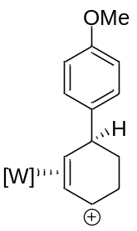
6D
Used General Procedure 2 with 15D (0.740 g, 0.851 mmol), NaBH₄ (0.195 g, 5.15 mmol), and HOTf in DME (3 mL, 0.11 M). Tan solid (0.525 g, (74%)).
¹H NMR (d₃-MeCN, δ): 8.41 (1H, d, J = 2.1 Hz), 8.16 (1H, d, J = 2.1 Hz), 8.00 (1H, d, J = 2.3 Hz), 7.95 (1H, d, J = 2.4 Hz), 7.93 (1H, d, J = 2.2 Hz), 7.82 (1H, d, J = 2.4 Hz), 7.35 (2H, d, J = 8.6 Hz), 6.97 (2H, d, J = 8.7 Hz ), 6.54 (1H, t, J = 6.7 Hz), 6.53 (1H, t, J = 2.2 Hz), 6.50 (1H, t, J = 2.3 Hz), 6.35 (1H, t, J = 2.3 Hz), 5.39 (1H, t, J = 7.4 Hz), 4.36 (1H, dd, J = 15.8, 7.1 Hz), 3.80 (3H, s), 3.73 (1H, dd, J = 10.8, 6.1 Hz), 3.50 (1H, dt, J = 18.0, 7.9 Hz), 3.31 (1H, dt, J = 19.5, 6.2 Hz), 1.77 (1H, m), 1.22 (1H, m), 1.01 (9H, d, J_{PH} = 9.8 Hz). ¹³C NMR (d₃-MeCN, δ): 159.5, 149.2, 146.1, 143.3, 141.5, 139.6, 139.5, 139.5, 134.4, 129.4, 115.1, 109.5, 108.9, 108.1, 105.4 (d, J_{PC} = 3.3 Hz) 75.4 (d, J_{PC} = 12.2), 55.9, 44.5 (d, J_{PC} = 2.4 Hz), 32.1, 26.2, 13.8 (d, J_{CP} = 32.7 Hz). CV (DMA): E_{p,c} = - 0.93 V (NHE). IR (ATR, cm⁻¹): ν(BH) = 2519 cm⁻¹, ν(NO) = 1635 cm⁻¹.
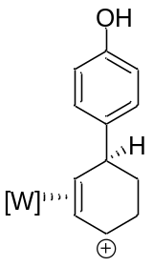
7D
Used General Procedure 2 with 16D (0.5049 g, 0.5903 mmol), NaBH₄ (0.1793 g, 4.740 mmol), and HOTf in DME (2 mL, 0.6960 mM). Tan solid (0.3739 g, (76.7%)).
¹H NMR (d₃-MeCN, δ): 8.44 (1H, d, J = 2.1 Hz), 8.18 (1H, d, J = 2.1 Hz), 8.03 (1H, d, J = 2.3 Hz), 7.98 (1H, d, J = 2.3 Hz), 7.95 (1H, d, J = 2.1 Hz), 7.85 (1H, d, J = 2.4 Hz), 7.28 (2H, d, J = 8.5 Hz), 6.88 (2H, d, J = 8.5 Hz), 6.55 (2H, overlapping), 6.53 (1H, t, J = 2.3 Hz), 6.38(1H, t, J = 2.3 Hz), 5.40 (1H, t, J = 7.4 Hz,), 4.38 (1H, dd, J = 15.9, 7.1 Hz), 3.72 (1H, dd, J = 10.8, 6.1 Hz), 3.52 (1H, m), 3.33 (1H, dt, J = 19.5, 6.2 Hz), 1.79 (1H, m), 1.24 (1H, m), 1.03 (9H, d, J_{PH} = 9.8 Hz). ¹³C NMR (d₃-MeCN, δ): 156.7, 149.2, 146.2, 143.3, 140.7, 139.5, 139.4, 134.3, 129.5, 116.5, 109.5, 108.9, 108.1, 105.5 (J_{PC} = 3.4 Hz), 75.6 (d, J_{PC} = 12.0 Hz), 44.5 (d, J_{PC} = 2.2 Hz), 32.2, 30.8, 26.2, 13.7 (d, J_{CP} = 32.7 Hz). CV (MeCN): E_{p,c}= - 0.92 V (NHE). IR (ATR, cm⁻¹): ν(BH) = 2523 cm⁻¹, ν(NO) = 1635 cm⁻¹.
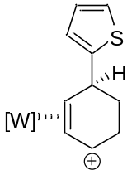
8D
Used General Procedure 2 with 17D (0.4914 g, 0.5813 mmol), NaBH₄ (0.1625 g, 4.296 mmol), and HOTf in DME (2 mL, 0.9780 mM). Tan solid (0.3803 g, (80.2%)).
¹H NMR (d₃-MeCN, δ): 8.42 (1H, d, J = 2.1 Hz), 8.14 (1H, d, J = 2.2 Hz), 8.02 (1H, d, J = 2.3 Hz), 7.97 (1H, m), 7.95 (1H, d, J = 2.2 Hz), 7.83 (1H, m), 7.36 (1H, m), 7.11 (1H, m), 7.05 (1H, dd, J = 5.1, 3.5 Hz), 6.66 (1H, t, J = 7.1 Hz), 6.54 (1H, t, J = 2.4 Hz), 6.52 (1H, t, J = 2.3 Hz), 6.36 (1H, t, J = 2.4 Hz), 5.31 (1H, t, J = 7.5 Hz), 4.36 (1H, dd, J = 15.3, 7.2 Hz), 4.11 (1H, m), 3.46 (1H, burried), 3.32 (1H, m), 1.94 (1H, burried), 1.46 (1H, m), 1.10 (9H, d, J_{PH} = 9.9).¹³C NMR (d₆-acetone, δ): 153.6, 149.4, 146.4, 143.7, 139.7, 139.6, 139.4, 136.7, 127.9, 125.1, 124.9, 109.6, 108.2, 103.7 (d, J_{PC} = 2.8 Hz), 74.5 (d, J_{PC} = 12.8 Hz), 40.0 (d, J_{PC} = 2.5 Hz), 32.0, 25.9, 13.6 (d, J_{CP} = 32.8 Hz). CV (DMA): E_{p,c} = - 1.05 V (NHE). IR (ATR, cm⁻¹): ν(BH) = 2530 cm⁻¹, ν(NO) = 1633 cm⁻¹.
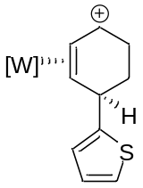
8P
Used General Procedure 2 with 17P (0.4165 g, 0.4828 mmol), NaBH₄ (0.1141 g, 3.02 mmol), and HOTf in DME (2 mL, 0.3292 mM). Tan-pink solid (0.1812 g, (45.1%)).
¹H NMR (d₃-MeCN, δ): 8.42 (1H, d, J = 1.8 Hz), 8.01 (1H, d, J = 2.2 Hz), 7.98 (1H, d, J = 2.0 Hz), 7.96 (1H, d, J = 2.0 Hz), 7.94 (1H, d, J = 2.1 Hz), 7.80 (1H, d, J = 2.2 Hz), 7.36 (1H, dd, = 5.1, 1.0 Hz), 7.15 (1H, d, J = 3.3 Hz), 7.07 (1H, dd, J = 5.1, 3.5 Hz), 6.55 (1H, t, J = 2.3 Hz), 6.53 (1H, t, J = 2.3 Hz), 6.29 (1H, t, J = 2.3 Hz), 6.04 (1H, d, J = 6.5 Hz), 5.31 (1H, t, J = 7.3 Hz), 4.80 (1H, m), 4.73 (1H, dt, J = 15.1, 7.2 Hz), 3.27 (1H, m), 2.56 (1H, m), 1.99 (1H, buried), 1.46 (1H, m), 1.22 (9H, d, J_{PH} = 9.9 Hz).
¹³C NMR (d₆-acetone, δ, 0 °C): 150.2, 148.5, 146.2, 143.4, 139.4, 139.3, 128.4, 128.0, 125.3, 125.2, 109.3, 109,0 108.0, 104.9, 73.5 (d, J_{CP} = 11.3 Hz), 38.0, 30.4, 25.5, 12.8 (d, J_{CP} = 32.9 Hz). CV (MeCN): E_{p,c}= - 0.95 V (NHE). IR (ATR, cm⁻¹): ν(BH) = 2515 cm⁻¹, ν(NO) = 1634 cm⁻¹.
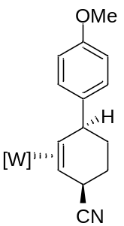
9D
A solution of 6d (0.405 g, 0.483 mmol) was prepared in MeCN (12.15 mL) in a large test-tube with a stir-pea. A NaCN/MeOH solution (20 mg/mL, 2.37 mL, 0.966 mmol) was added to the solution and the reaction mixture was allowed to stir at room temperature for 22 hrs. At this time, a white solid was observed to have precipitated out of solution, which was then collected on a 30 mL F frit and desiccated to give 9P (0.160 g (46%)).

¹H NMR (d₃-MeCN, δ): 8.07 (1H, d, J = 2.1 Hz), 8.05 (1H, d, J = 2.1 Hz), 7.88 (1H, d, J = 2.4 Hz), 7.85 (1H, d, J = 2.3 Hz), 7.84 (1H, d, J = 2.5 Hz), 7.54 (2H, d, J = 8.7 Hz), 7.31 (1H, d, J = 2.2 Hz), 6.97 (2H, d, J = 8.7 Hz), 6.39 (1H, t, J = 2.2 Hz), 6.35 (1H, t, J = 2.2 Hz), 6.25 (1H, t, J = 2.2 Hz), 4.11 (1H, t, J = 6.3 Hz), 4.04 (1H, m), 3.81 (3H, s), 2.73 (1H, t, J = 12.2 Hz), 2.00 (m, 1H), 1.93 (buried, m, 1H), 1.71 (1H, m), 1.51 (1H, m), 1.37 (1H, dt, J = 11.3, 2.4 Hz), 0.97 (9H, d, J_{PH} = 8.4 Hz). ¹³C NMR (d₃-MeCN, δ): 158.9, 145.5, 144.4, 143.1, 141.8, 138.1, 137.9, 137.6, 130.2, 128.4, 114.7, 107.8, 107.3, 107.1, 55.9, 55.4 (d, J_{CP} = 11.0 Hz), 53.4, 44.9 (d, J_{CP} = 3.3 Hz), 32.8, 31.6, 24.7, 13.8 (d, J_{CP} = 28.3 Hz). CV (MeCN): E_{p,a} = 0.59 V (NHE). Composition confirmed by single crystal X-ray diffraction.
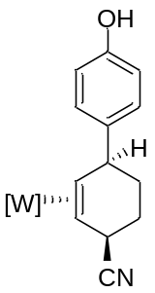
10D
To a 4-dram vial was added 7D (0.3243 g, 0.3929 mmol), NaCN (0.0963 g, 1.965 mmol), DMSO (1 mL), and MeCN (1 mL). After stirring for 18 hrs, the heterogenous reaction mixture was passed through a 30 mL M frit to collect an off-white precipitate. The precipitate was washed with DI H₂O (3 x 10 mL), Et₂O (3 x 10 mL), pentanes (3 x 10 mL), then desiccated overnight to give 10D (0.1422 g (51.5%)).

¹H NMR (d₆-acetone, δ): 8.12 (1H, d, J = 1.8 Hz), 8.10 (1H, d, J = 1.9 Hz), 7.95 (1H, d, J = 2.3 Hz), 7.94 (1H, d, J = 2.2 Hz), 7.87 (1H, d, J = 2.4 Hz), 7.43 (3H, overlapping), 6.88 (1H, d, J = 8.5 Hz), 6.41 (1H, t, J = 2.2 Hz), 6.35 (1H, t, J = 2.2 Hz), 6.30 (1H, t, J = 2.2 Hz), 4.11 (1H, t, J = 6.4 Hz), 4.06 (1H, m), 2.82 (1H, m), 2.02 (1H, m), 1.96 (1H, m), 1.75 (1H, m), 1.53 (1H, m), 1.42 (1H, d, J = 11.3 Hz), 1.03 (9H, d, J = 8.4 Hz). ¹³C NMR (d₆-acetone, δ): 156.3, 144.4, 144.3, 143.2, 141.6, 137.8, 137.5, 137.3, 130.0, 128.2, 116.1, 107.5, 107.3, 106.9, 55.1 (d, J_{CP} = 10.8 Hz), 53.7, 44.9, 33.3, 31.5, 25.0, 14.0 (d, J_{CP} = 28.2 Hz). CV (THF): E_{p,a}= 0.63 V (NHE). IR (ATR, cm⁻¹): ν(BH) = 2503 cm⁻¹, ν(NO) = 1513 cm⁻¹, ν(CN) = 2222 cm⁻¹. Composition confirmed by single crystal X-ray diffraction.

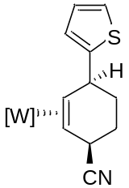
11D
To a 4-dram vial was added 8D (0.7111 g, 0.8722 mmol), NaCN (0.1542 g, 3.146 mmol), DMSO (1 mL), and MeCN (1 mL). After stirring for 18 hrs, the reaction mix was diluted with DCM (5 mL) and washed with DI H₂O (3 x 15 mL). The organic layer was dried over anhydrous MgSO₄ and diluted with pentanes (200 mL). Evaporated down to ~100 mL before diluting with pentanes (50 mL). A white solid was collected on a 30 mL F frit, washed with pentanes (30 mL), and desiccated overnight to give 11D (0.4216 g (69.8%)).

¹H NMR (d₆-acetone, δ): 8.14 (1H, d, J = 1.8 Hz), 8.13 (1H, d, J = 1.9 Hz), 7.97 (1H, d, J = 2.3 Hz), 7.96 (1H, d, J = 2.2 Hz), 7.88 (1H, d, J = 2.4 Hz), 7.45 (1H, d, J = 2.1 Hz) 7.32 (1H, dd, J = 5.1, 1.1 Hz), 7.19 (1H, dt, J = 3.4, 0.9 Hz), 7.04 (1H, dd, J = 5.1, 3.4 Hz), 6.43 (1H, t, J = 2.0 Hz), 6.35 (1H, t, J = 2.1 Hz), 6.33 (1H, t, J = 2.1 Hz), 4.47 (1H, t, J = 6.1), 4.13 (1H, m), 2.87 (1H, m), 2.11 (1H, m), 2.02 (1H, m), 1.83 (1H, m), 1.71 (1H, m), 1.39 (1H, dt, J = 11.2, 2.1 Hz), 1.08 (9H, d, J_{PH} = 8.4). ¹³C NMR (d₆-acetone, δ): 158.1, 144.4, 143.0, 141.6, 138.0, 137.5, 137.4, 127.8, 127.6, 124.6, 123.8, 107.6, 107.3, 106.9, 55.5 (d, J_{CP} = 12.8 Hz), 52.6, 41.5, 33.6, 31.4, 25.3, 13.8 (d, J_{CP} = 28.2 Hz). CV (MeCN): E_{p,a}= 0.70 V (NHE). IR (ATR, cm⁻¹): ν(BH) = 2492 cm⁻¹, ν(NO) = 1549 cm⁻¹, ν(CN) = 2228 cm⁻¹. Composition confirmed by single crystal X-ray diffraction.

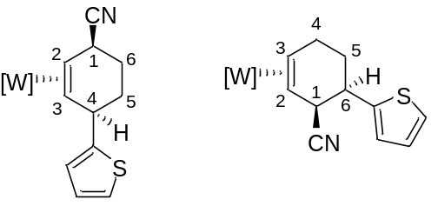

11P(a) 11P(b)
To a 4-dram vial was added 8P (0.0986 g, 0.1209 mmol), NaCN in methanol solution (2.2 M, 0.5 mL), and MeCN (1 mL). After stirring for 18 hrs, the reaction mix was diluted with DCM (5 mL) and washed with DI H₂O (3 x 5 mL). The organic layer was dried over anhydrous MgSO₄ and diluted with pentanes (100 mL). Evaporated down to ~50 mL before diluting with pentanes (25 mL). A white solid was collected on a 15 mL F frit, washed with pentanes (15 mL), and desiccated overnight to give a 2:1 mixture of 11P(a) and 11P(b) (0.0447 g (53.4%)). Full characterization of 11P was made difficult due to overlapping peaks of the two products. However, an NOE interaction between H1 (4.11 ppm) and H6 (3.65 ppm) for 11P(b) suggests the minor product has a 3,4-substituion pattern. In product 11P(a), H1 (3.86 ppm) and H4 (4.59 ppm) have NOE interactions with the PMe₃ ligand (1.20 ppm) and a pyrazole ring proton (8.13 ppm), respectively, but not with each other. Key ¹H NMR peaks of the cyclohexene ligand are given.

¹H NMR (CD₂Cl₂, δ): 11P(a): 8.13 (1H, d, J = 2.1 Hz, Pz 3/5), 4.59 (1H, m, H4), 3.86 (1H, t, J = 5.4 Hz, H1), 2.82 (overlapping, t, J = 11.5 Hz, H2), 1.49 (1H, m, H3), 1.20 (9H, d, J = 8.9 Hz, PMe₃). 11P(b): 7.93 (0.5H, d, J = 2.0 Hz, Pz 3/5), 4.11 (0.5H, m, H1), 3.65 (0.5H, dt, J = 9.4, 4.4 Hz, H6), 2.82 (overlapping, m, H3), 1.41 (0.5H, m, H2), 1.22 (4.5H, d, J = 8.3 Hz, PMe₃).

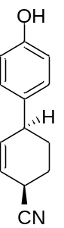
21
To a 4-dram vial was added 10D (0.1466 g, 0.2088 mmol), NOPF₆ (0.0613 g, 0.3503 mmol), and acetone (1 mL). After stirring for 30 min, the reaction mix was evaporated to a film, dissolved in minimal CH₂Cl₂, and added to a 1:1 solution of hexanes and Et₂O (200 mL). A dark-brown precipitate was collected on a 30 mL F frit and washed with Et₂O (100 mL). The filtrate was evaporated to dryness, dissolved in minimal CH₂Cl₂, and purified via silica gel flash chromatography (EtOAc:hexanes, ~40%). Product isolated as an off-white solid and desiccated overnight to give 21 (0.0290 g (69.7%)).

¹H NMR (d₆-acetone, δ) 8.19 (1H, s), 7.05 (2H, d, J = 8.5 Hz), 6.80 (2H, d, J = 8.5 Hz), 5.93 (1H, dt, J = 9.9, 2.4 Hz), 5.86 (1H, ddd, J = 9.9, 4.2, 2.4 Hz), 3.49 (1H, m), 3.39 (1H, m), 2.03 (1H, buried), 1.97 (2H, overlapping), 1.71 (1H, m). ¹³C NMR (d₆-acetone, δ): 157.0, 136.3, 135.9, 129.5, 123.0, 122.0, 116.3, 41.2, 30.5, 26.8, 25.8. IR (ATR, cm⁻¹): ν(CN) = 2249 cm⁻¹. Composition confirmed by single crystal X-ray diffraction.

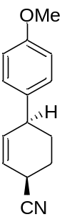
22
To a 4-dram vial was added 9D (0.100 g, 0.140 mmol), NOPF₆ (0.035 g, 0.200 mmol), and acetone (1 mL). After stirring for 30 min, the reaction mix was evaporated to a film, dissolved in minimal CH₂Cl₂, and added to a 1:1 solution of hexanes and Et₂O (200 mL). A dark-brown precipitate was collected on a 30 mL F frit and washed with Et₂O (100 mL). The filtrate was evaporated to dryness, dissolved in minimal CH₂Cl₂, and purified via silica gel flash chromatography (EtOAc:hexanes, ~40%). Product isolated as tan oil and desiccated overnight to give 20 (0.010 g (34%)).

¹H NMR (d₃-MeCN, δ): 7.13 (2H, d, J = 8.6 Hz), 6.88 (2H, d, J = 8.4 Hz), 5.93 (1H, m), 5.84 (1H, m), 3.76 (3H, s), 3.41 (2H, m), 2.02 (1H, m), 1.94 (2H, buried, m), 1.67 (1H, m). ¹³C NMR (d₃-MeCN, δ): 159.4, 137.7, 135.9, 129.6, 123.0, 122.6, 115.0, 55.9, 41.0, 30.4, 26.9, 25.8. GCMS (EI) calculated: 213.28, observed 213.05. IR (ATR, cm⁻¹): ν(CN) = 2236 cm⁻¹.

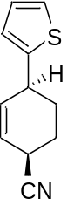
23
To a 4-dram vial was added 11D (0.1346 g, 0.1944 mmol), NOPF₆ (0.0608 g, 0.3475 mmol), and acetone (1 mL). After stirring for 30 min, the reaction mix was evaporated to a film, dissolved in minimal CH₂Cl₂, and added to a 1:1 solution of hexanes and Et₂O (200 mL). A dark-brown precipitate was collected on a 30 mL F frit and washed with Et₂O (100 mL). The filtrate was evaporated to dryness, dissolved in minimal CH₂Cl₂, and purified via silica gel flash chromatography. Product isolated as light-yellow oil and desiccated overnight to give 23 (0.0212 g (57.6%)). An 11% impurity was observed in the ¹H NMR spectrum that is believed to be a diene (additional alkene peak a 6.12 ppm). The identity of this impurity is also supported by GCMS (m/z = 162.05), which, corresponding to loss of HCN and a molecular formula of C₁₀H₁₀S.
¹H NMR (d₆-acetone, δ) 7.31 (1H, dd, J = 5.1, 1.1 Hz), 6.98 (1H, dd, J = 5.1, 3.5 Hz), 6.91 (1H, d, J = 3.5 Hz), 6.05 (1H, dt, J = 9.8, 2.5 Hz), 5.86 (1H, m), 3.80 (1H, m), 3.53 (1H, m), 2.16 (1H, m), 2.03 (2H, overlapping), 1.87 (1H, m).¹³C NMR (d₆-acetone, δ): 148.7, 134.7, 127.8, 125.1, 124.7, 123.3, 121.8, 36.7, 30.5, 26.8, 25.4. GCMS (EI) calculated: 189.05, observed 189.06. IR (ATR, cm⁻¹): ν(CN) = 2239 cm⁻¹.

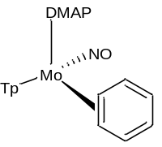
1-Mo

To a 1 L oven-dried Erlenymeyer flask was added MoTp(NO)(DMAP)(η2 -3,4-α,α,α-trifluorotoluene) (8.28 g, 0.0165 mmol) followed by anhydrous benzene (1 L, 11.2 mol) and the homogeneous red reaction mixture was allowed to stir over a period of 2.5 h. This reaction mixture was then added to 1 L of stirring hexanes in a 2 L filter flask and the resulting mixture was filtered through a fine 350 mL fine porosity fritted disc. The filtrate from this reaction was then concentrated in vacuo to ~ 1700 mL and a vibrant orange solid was isolated on a new 350 mL fine porosity fritted disc and washed with hexanes (2 x 100 mL). The solvent of the resulting filtrate was then removed in vacuo until ~ 1200 mL of solvent remained upon removal of solvent and cooling more orange solid precipitates from solution. The resulting heterogeneous orange solution was filtered through another fine 350 mL fritted disc to isolate an orange solid and this solid was washed with hexanes (2 x 100 mL) before it too was allowed to desiccate. After several hours of desiccation under dynamic vacuum the orange solids were combined and the ¹H NMR signals were consistent with those previously reported for 2 (4.94 g, 55%).

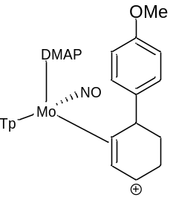
6D-Mo
To a solution of DCM (1 mL) complex 1-Mo (0.122 g, 0.220 mmol) was added and this solution was frozen in N₂ (l). To this solution as added a recently thawed solution of HOTf (10 drops) and the reaction mixture was allowed to thaw at - 40 °C over the course of 15 min. This reaction mixture was then added to a standing solution of Et₂O (15 mL) and this solution as allowed to sit at -40 °C over a period of 16 hrs to induce precipitation. The next day a yellow solid had developed form solution. The organic layer was decanted and the solid was dried under active vacuum for 1 h before the solid was analyzed by ¹H NMR spectroscopy. Given the obvious signs of decomposition a mass was not taken of the isolated solid. Key ¹H NMR peaks of the cyclohexene ligand are given.

¹H NMR (d₆-acetone, δ) 7.24 (2H, d, J = 8.4 Hz, anisole-H3/H5) , 7.13 (2H, d, J = 6.8 Hz, DMAP H2/H6), 6.86 (2H, d, J = 8.5 Hz, anisole-H2/H6), 6.62 (1H, t, J = 2.0 Hz, Tp4), 6.50 (1H, t, J = 2.0 Hz, Tp4), 6.47 (1H, m), 6.30 (1H, t, J = 2.0 Hz, Tp4), 6.18 (1H, t, J =7.2 Hz, H2), 4.90 (1H, d, J = 7.0 Hz, H3), 4.05 (1H, dd, J = 10.1, 6.0 Hz, H4), 3.77 (3H, s, OMe).

Figure S-21. DFT Calculations for 1

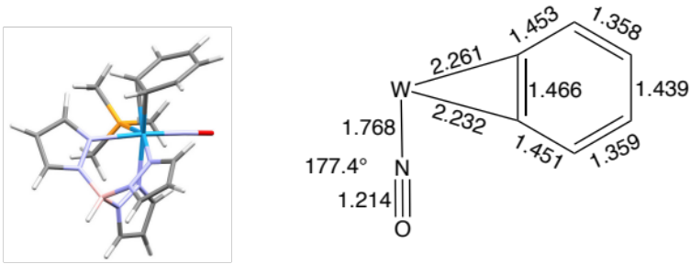
[WTp(NO)(PMe₃)(C₆H₆)] (1) (reference)

Figure S-22. DFT Calculations for 1H, 1H ---- 2, & 2
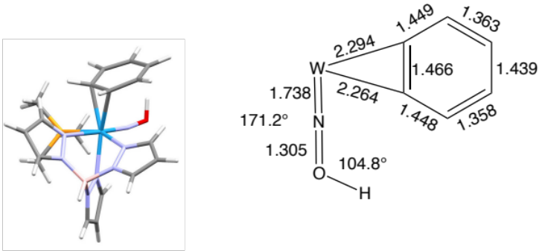
[WTp(NOH)(PMe₃)(C₆H₆)]⁺ (1H) (E = 0)

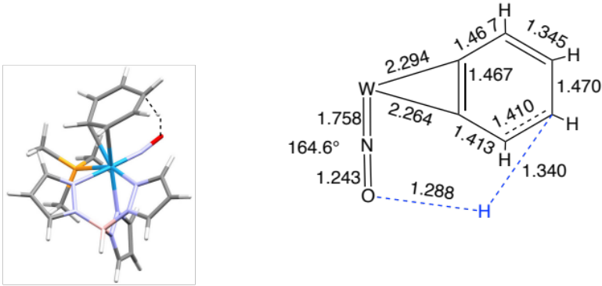
TS: 1H ---- 2 (E = 8.3 kcal/mol)
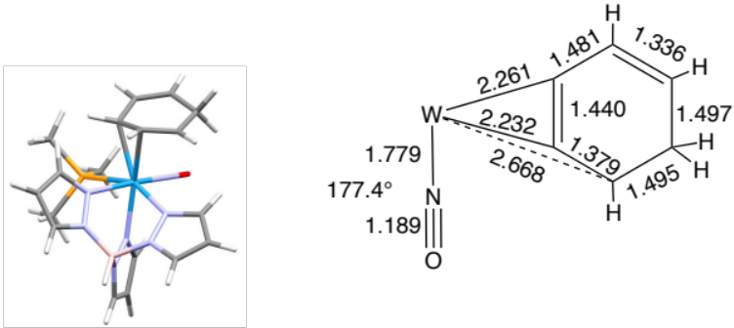

[WTp(NO)(PMe₃)(C₆H₇)]⁺ (2) (E = -7.9 kcal/mol)

Figure S-23. DFT Calculations for 2H, 2H --- 5, & 5

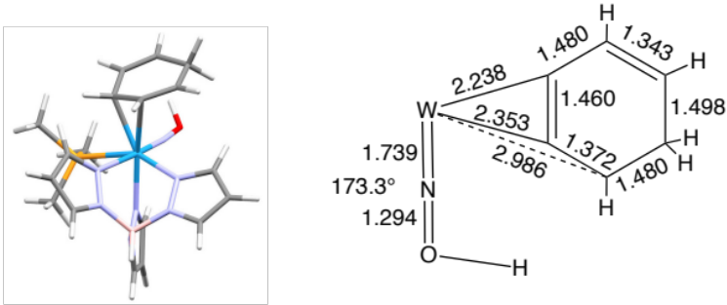
[WTp(NOH)(PMe₃)(C₆H₇)]²⁺ (2H) (E = 0 kcal/mol)

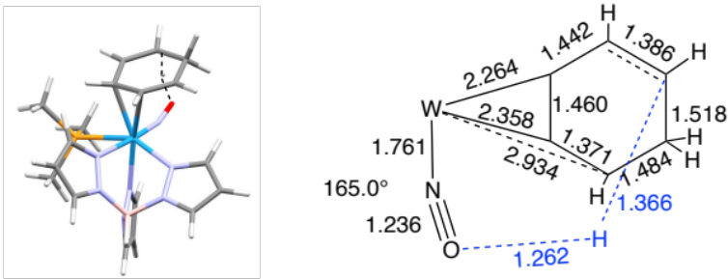
TS: 2H --- 5 ) (E = 6.7 kcal/mol)

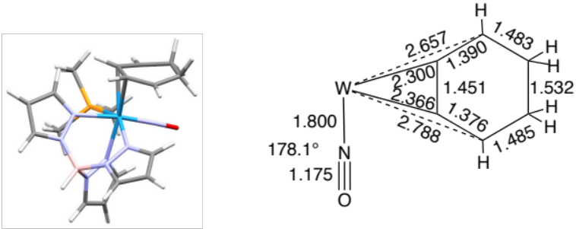
[WTp(NOH)(PMe₃)(C₆H₇)]²⁺ (5) (E = -14.2 kcal/mol)

* hydrogens on bound carbons not shown.

Structures presented in the main text were located using the Gaussian 16 (Revision B.01) program with the M06 functional and 6-31G** basis set for all atoms except W, where the LANL2DZ basis set and pseudopotential was used. The default optimization criteria and UtraFine integration grid were used. All ground state structures were verified to ensure no imaginary frequencies, and all transition state structures were verified to have a single imaginary frequency.

To evaluate the feasibility of proton transfer from the nitrosyl to the bound benzene ligand, we performed DFT calculations on the relevant reactant, transition state, and product structures. Calculations indicate that the transition state is only 8 kcal/mol above the protonated nitrosyl species, suggesting that this is a viable protonation pathway.

A second proton transfer from the nitrosyl ligand to the bound benzenium ligand was also investigated, and it was found that this reaction was also fairly facile (TS barrier: ~7 kcal/mol), suggesting that in either the first or the second protonation sequences, the nitrosyl ligand may serve as an aid towards proton transfer.

Crystallographic Data
A single crystal of 16D, 17P, 9P, 10D, 11D or 21 was coated with Paratone oil and mounted on a MiTeGen MicroLoop. The X-ray intensity data for 16D were measured on a Bruker Kappa APEXII Duo system equipped with a Incoatec Microfocus IμS (Cu K_{α}, λ = 1.54178 Å) and a multi-layer mirror monochromator. The X-ray intensity data for all other crystals were measured on a Bruker D8 Venture PhotonIII Kappa four-circle diffractometer system. An Incoatec IμS 3.0 micro-focus sealed X-ray tube (Mo Kα, λ = 0.71073 Å) and a HELIOS double bounce multilayer mirror monochromator were used for 9P, and 21. An Incoatec IμS 3.0 micro-focus sealed X-ray tube (Cu Kα, λ = 1.54178 Å) and a HELIOS MX double bounce multilayer mirror monochromator were used for 17P, 10D, and 11D. All frames were integrated with the Bruker SAINT software package using a narrow-frame algorithm. Data were corrected for absorption effects using the Multi-Scan method (SADABS).¹ Each structure was solved and refined using the Bruker SHELXTL Software Package within APEX3 or APEX4 ¹ and OLEX2. Non-hydrogen atoms were refined anisotropically. The O-H hydrogen atoms of 16D, 10D, 21, and the B-H hydrogen atom as well as H10 and H11 of 9P and 11D were located in the diffraction map and refined isotropically. All other hydrogen atoms were placed in geometrically calculated positions with U_{iso} = 1.2U_{equiv} of the parent atom (U_{iso} = 1.5U_{equiv} for methyl).
For 16D and 10D, solvent molecules located in the crystal lattice were severely disordered and could not be adequately modeled with or without restraints. Thus, the structure factors were modified using the PLATON SQUEEZE technique, in order to produce a “solvate-free” structure factor set. PLATON reported a total electron density of 319 e⁻ and total solvent accessible volume of 1676 Å³ for 16D and 187 e⁻ and a total solvent accessible volume of 893 Å³ for 10D. The relative occupancy of the disordered atoms in 9P, 11D and 21 was freely refined. Constraints and restraints were used as need on the anisotropic displacement parameters and bond lengths of the disordered atoms.

Table 1. Crystal Data

 | 16D | 17P | 9P | 10D | 11D | 21
CCDC number | 2220172 | 2220173 | 2220174 | 2220175 | 2220176 | 2220177
Formula | C₂₆H₃₄BF₃N₇O₆PSW | C₂₄H₃₂BF₃N₇O₅PS₂W | C_{27.84}H_{36.84}BCl_{0.32}N_{8.84}O₂PW | C₂₅H₃₂BN₈O₂PW | C₂₃H₃₀BN₈OPSW | C₁₃H₁₃NO
FW (g/mol) | 855.29 | 845.31 | 764.27 | 702.21 | 692.24 | 199.24
Temp (K) | 100(2) | 100(2) | 100(2) | 100(2) | 100(2) | 100(2)
λ (Å) | 1.54178 | 1.54178 | 0.71073 | 1.54178 | 1.54178 | 0.71073
Size (mm) | 0.034 x 0.047 x 0.067 | 0.010 x 0.120 x 0.150 | 0.070 x 0.152 x 0.388 | 0.012 x 0.013 x 0.112 | 0.036 x 0.052 x 0.152 | 0.194 x 0.550 x 0.567
Crystal habit | yellow plate | colorless plate | colorless plate | colorless needle | colorless plate | colorless block
Crystal system | monoclinic | triclinic | monoclinic | orthorhombic | monoclinic | monoclinic
Space group | P 2₁/c | P -1 | I 2/a | P c c n | P 2₁/n | P 2₁/c
a (Å) | 22.0195(5) | 9.9268(6) | 15.9366(5) | 32.2576(18) | 13.6835(6) | 10.9372(4)
b(Å) | 14.5709(3) | 10.5902(8) | 12.0562(3) | 11.9426(10) | 12.2825(5) | 8.9098(3)
c (Å) | 24.4871(5) | 16.4598(16) | 32.3564(13) | 15.6550(9) | 15.8207(7) | 11.4878(4)
α (°) | 90 | 100.543(7) | 90 | 90 | 90 | 90
β (°) | 102.934(2) | 106.964(6) | 96.4240(10) | 90 | 95.549(3) | 107.7370(10)
γ (°) | 90 | 94.688(6) | 90 | 90 | 90 | 90
Volume (Å³) | 7657.2(3) | 1610.2(2) | 6177.8(4) | 6030.9(7) | 2646.5(2) | 1066.25(6)
Z | 8 | 2 | 8 | 8 | 4 | 4
Density (g/cm³) | 1.484 | 1.743 | 1.643 | 1.547 | 1.737 | 1.241
µ (mm⁻¹) | 7.008 | 8.889 | 3.861 | 7.890 | 9.668 | 0.079
F(000) | 3392 | 836 | 3049 | 2784 | 1368 | 424
θ range (°) | 2.06 to 68.36 | 2.88 to 59.12 | 1.80 to 30.53 | 2.74 to 68.27 | 4.08 to 68.46 | 2.95 to 28.27
Index ranges | -24 ≤ h ≤ 26  -17 ≤ k ≤ 17  -29 ≤ l ≤ 26 | -11 ≤ h ≤ 10  -11 ≤ k ≤ 11  -18 ≤ l ≤ 18 | -22 ≤ h ≤ 22  -16 ≤ k ≤ 17  -46 ≤ l ≤ 46 | -38 ≤ h ≤ 38  -13 ≤ k ≤ 14  -18 ≤ l ≤ 18 | -16 ≤ h ≤ 16  -14 ≤ k ≤ 14  -16 ≤ l ≤ 19 | -14 ≤ h ≤ 14  -9 ≤ k ≤ 11  -15 ≤ l ≤ 15
Reflns collected | 57698 | 20146 | 55469 | 33273 | 37659 | 17388
Independent reflns | 14046 [R_{int} = 0.0847] | 4627 [R_{int} = 0.1572] | 9439 [R_{int} = 0.0487] | 5518 [R_{int} = 0.1549] | 4852 [R_{int} = 0.0923] | 2644 [R_{int} = 0.0342]
Data / restraints /parameters | 14046 / 2 / 843 | 4627 / 0 / 404 | 9439 / 2 / 418 | 5518 / 1 / 350 | 4852 / 156 / 386 | 2644 / 5 / 156
GOF on F² | 1.019 | 1.026 | 1.049 | 0.996 | 1.068 | 1.089
R₁ (I>2σ(I)) | 0.0439 | 0.0929 | 0.0275 | 0.0622 | 0.0478 | 0.0423
wR₂ (all data) | 0.1109 | 0.2617 | 0.0610 | 0.1869 | 0.1343 | 0.1172

References

Bruker (2012). Saint; SADABS; APEX3; APEX4. Bruker AXS Inc., Madison, Wisconsin, USA.
Sheldrick, G. M. (2015). Acta Cryst. A71, 3-8.
Dolomanov, O. V.; Bourhis, L. J.; Gildea, R. J.; Howard, J. A. K.; Puschmann, H. J. Appl. Cryst. (2009). 42, 339-341.
Spek, A. L. Acta Crystallogr. Sect C: Struct. Chem. 2015, C71, 9-18.

