Supplementary Information for
“Unusual magnetotransport properties and surface Dirac cone state in single crystalline Pt₃Te₄: a new candidate of Dirac semimetal”

Kuan Hsu, I-Nan Chen, Chia-Nung Kuo, Zhu-Jia-Lei Lei, Chin-Shan Lue, and Li-Min Wang

CONTENTS
Supplementary 1: The temperature-dependent magnetoresistance, Hall coefficient, and Hall mobility characteristics of two typical Pt₃Te₄ single crystals from the same batch 1
Supplementary 2: Magnetoresistance for several angles of the applied field with respect to the current 4
Supplementary 3: Abrikosov’s “quantum MR” mechanism and classic Parish Littlewood model 6
Supplementary 4: The magnetoresistance and magnetoconductivity characteristics of Pt₃Te₄ single crystals from different batches 7
Supplementary 5: In-plane transport characters for two Pt₃Te₄ single crystals with different orientations of applied current for measurements 9
Supplementary 6: Experimental tests of the chiral anomaly NLMR in the Pt₃Te₄ single crystal 12
Supplementary References 13

Supplementary 1: The temperature-dependent magnetoresistance, Hall coefficient, and Hall mobility characteristics of two typical Pt₃Te₄ single crystals from the same batch
Hall measurements for two typical Pt₃Te₄ single crystals, samples S1 and S2, obtained from the same batch, were carried out to clarify the basic transport properties of Pt₃Te₄. Figures S1a and b illustrate the temperature dependence of the Hall coefficient R_{H} for S1 and S2, respectively, measured at B = 6 T. As shown, the R_{H} values at measured temperatures are positive, reaching a maximum value at around 220 K, and signify that hole-type carriers dominate the electrical transport in both S1 and S2 samples. The insets of Figs. S1a and b respectively show the magnetic-field dependence of the transverse Hall resistivity ρ_{xy} for S1 and S2 samples at different temperatures. As seen, the straight-line-like data correspond to a linear dependence, revealing an ordinary Hall effect in Pt₃Te₄. Recently, Boukhvalov et al.[1] and Bae et al. [2] reported electronic band structure calculations of bulk Pt₃Te₄. With a more careful examination of the energy band of the bulk Pt₃Te₄, one can see a linear-like bulk band dispersion in a hole pocket close to the zone center (Γ point, refer to Fig. S1e of Ref. [1]or Fig. S1b of Ref. [2]). Our results of the positive Hall coefficient of Pt₃Te₄ seem to be in agreement with the hole-pocket transport predicted by the electronic band structure.

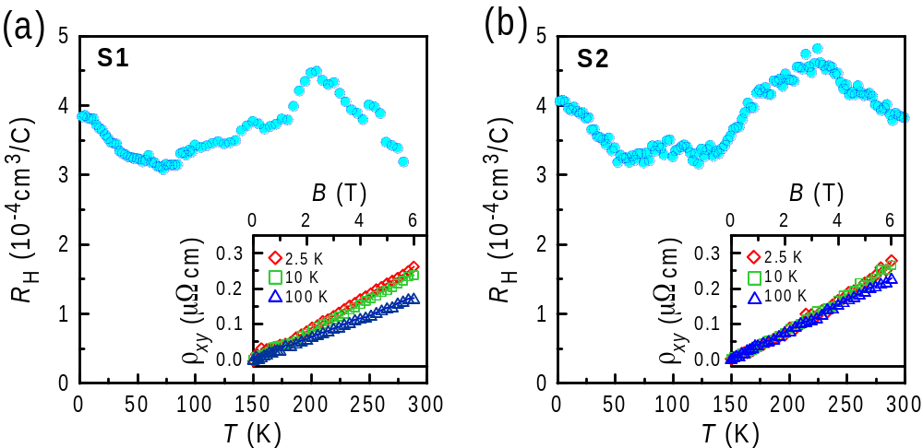

Figure S1. Temperature dependence of Hall coefficient R_{H} determined with B = 6 T for samples (a) S1 and (b) S2. The insets display the magnetic-field dependence of the transverse Hall resistivity ρ_{xy} at different temperatures

Figures S2a and b display the temperature dependences of the Hall carrier concentration n_{H} and Hall mobility μ_{H} (shown in the insets), which were determined by n_{H} = 1/eR_{H} and μ_{H} = R_{H}/ρ_{xx}(B = 0 T) for samples S1 and S2, respectively. As seen, the values of n_{H} vary slightly within the temperatures studied, while the values of μ_{H} decrease with the increase in temperature. Both n_{H} and μ_{H} show that Pt₃Te₄ possesses one-band transport characteristics dominated by the hole carriers. Figure S3a shows the temperature dependences of the transverse magnetoresistance (TMR) for samples S1 and S2. Here, the magnetoresistance (MR) is calculated by MR% = [ρ_{xx}(B = 6 T) − ρ_{xx}(0)]/ρ_{xx}(0) × 100%. As seen, TMR values decrease drastically with the increase in temperature. The results show that the TMR of our Pt₃Te₄ single crystals is over 50% at 10 K under 6 T. Figure S3b shows the ln(TMR) against the mobility ln(μ_{H}) for samples S1 and S2 at temperatures below 100 K. This result is correlated with the mechanism of the observed linear TMR behavior and will be discussed in the next section.

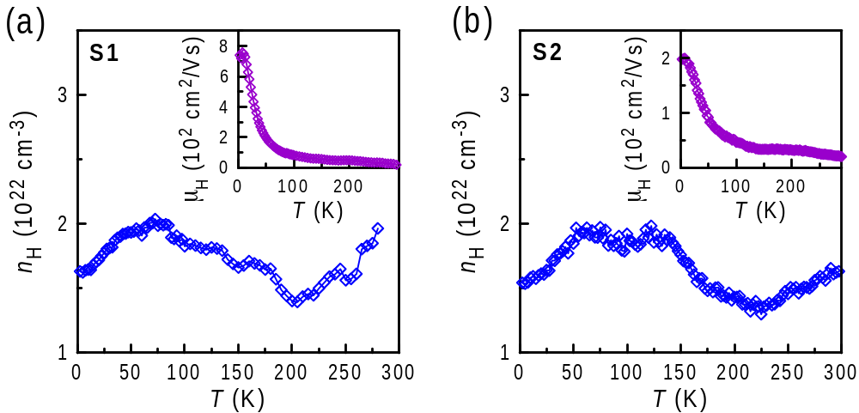

Figure S2. Temperature dependences of the Hall carrier concentration n_{H} and Hall mobility μ_{H} (shown in the insets) for samples (a) S1 and (b) S2.

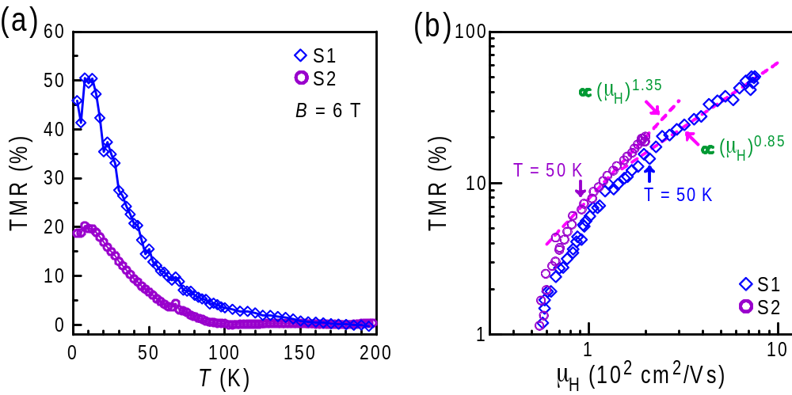

Figure S3. (a) Temperature dependences of the TMR for samples S1 and S2. (b) A plot of the ln(TMR) against the mobility ln(H) for samples S1 and S2 at temperatures below 100 K. The dashed line denotes the TMR behavior at T < 50 K obeying the (H) dependence.

Supplementary 2: Magnetoresistance for several angles of the applied field with respect to the current
Magnetoresistance and magnetoconductivity (MC) of Pt₃Te₄ for several angles of the applied field with respect to the current are debated. As mentioned in the main article, chiral-anomaly-induced negative longitudinal magnetoresistance (NLMR) should be sensitive to the relative angle direction between the magnetic field and the electrical current, thus, it is worthwhile examining this subject more closely. Figure S4a shows the whole MR data measured at 2.5 K by tilting magnetic field B at an angle α with respect to the electric current I for sample S1a, which was cut from the same crystal piece as sample S1, as described in the main article. In the low-field region (B < 0.4 T), the negative MR shows a complex phenomenon that there are seemingly two contributions of negative MR originating from the NLMR and negative TMR (NTMR) components, as discussed in the main article. As mentioned, the NTMR is rarely observed on the non-ferromagnetic materials. In particular, the quadratic-band magnetic semimetal GdPtBi reveals NTMR in the low-field region even at temperatures above the antiferromagnetic transition temperature of ~ 8.9 K [3]. The MR behavior for Pt₃Te₄ upon rotation of B from longitudinal to the perpendicular configuration is similar to that observed on GdPtBi explained by Weyl physics [3, 4], but the “anomalous” NTMR could not be examined in detail therein. A possible scenario for the observed low-field NTMR of Pt₃Te₄ has been discussed in the main article.
To explore the acute sensitivity of the axial current to misalignment at large B, referring to the work done by Xiong et al. [5] for the Dirac semimetal Na₃Bi, we plot the conductivity variation curves of Δσ_{xx}(B, α) = σ_{xx}(B, α) – σ_{xx}(B, 90°) versus α, with B fixed at values 2, 3, and 6 T, as seen in Fig. S4b. One can see that the Δσ_{xx}(B, α) values fall rapidly to lower values as α deviates from 0°, showing a cusp-like feature at angles near zero. Xiong et al. showed a cusp-like feature of negative MR curves (corresponding to a pronounced negative slope in resistance against magnetic field plot) in the region of B < ~ 2 T for Na₃Bi. They also presented an observation that the low-field Δσ_{xx} curves of Na₃Bi (B = 1, 1.5, and 2 T) can be described with cos ^{p}α with p = 4, while the angular widths of high-field curves (B ≥ 3 T) narrow considerably and deviate the cos⁴α behavior. This phenomenon remains to be theoretically proved. In addition, the angular dependences of conductivity variation for Weyl semimetal TaAs with different directions of the current with respect to the crystallographic direction have also been presented by Zhang et al. [6], who show that the negative MR exhibits a very strong angular dependence, and is accompanied with a negative LMR observed at small magnetic fields (for example, 0.1 T < 0.5 T for sample a1 as shown therein). Both the NLMRs observed on Dirac-semimetal Na₃Bi and Weyl-semimetal TaAs were ascribed to the chiral magnetic effect. For comparison, we try to fit the Δσ_{xx}(α) curves for Pt₃Te₄ with the cos ^{p}α formula. As shown in Fig. S4b, however, the cusp-like Δσ_{xx}(α) behavior for Pt₃Te₄ cannot be well described with the cos⁴α formula. It is only roughly described with the cos ^{p}α formula with p = 5.8, 10, and 14 for B = 2, 3, and 6 T, respectively; even so, the obtained larger p values (p > 4) for Pt₃Te₄ indicate that the conductivity variation of Pt₃Te₄ is indeed more sensitive to the relative angle direction between B and I than that of Na₃Bi. The inset of Fig. S4b also illustrates the duplicated values of normalized conductivity variation, Δσ_{xx}(B, α) / σ_{xx}(B, 0°), extracted from those reported in earlier studies [5, 6], as well as the data of Pt₃Te₄ (T = 2.5 K and B = 2 T) for comparison. As shown, the normalized Δσ_{xx}(α) behavior for Na₃Bi (T = 4.5 K and B = 2 T) can be well described with the cos⁴α formula, while the normalized Δσ_{xx}(α) of TaAs (T = 2 K and B = 5 T) cannot be well described with the cos⁴α formula, and is only roughly described with the cos ^{p}α formula with p = 7.9, being similar to that observed on Pt₃Te₄. Thus, one can see that both the conductivity variations of Pt₃Te₄ and TaAs are more sensitive to the relative angle direction between B and I than that observed on Na₃Bi, especially at angles α < 30º. We may note that if the Δσ_{xx}(α) data are taken at fields < 1 T, a minimum σ_{xx}(α) at α = 30º is obtained, which is due to the complex low-field NTMR as described previously. This would not allow a complete comparison with the reported data based on the definition of Δσ_{xx} = Δσ_{xx}(α) − Δσ_{xx}(90º). Actually, if the Δσ_{xx}(α) data are taken at fields < 0.4 T (the cusp-shaped negative MR region) with Δσ_{xx}(α) ≡ Δσ_{xx}(α) − Δσ_{xx}(30º), more stronger angular dependence of Δσ_{xx}(α) is obtained. Without exception, the conductivity variations of Pt₃Te₄ at angles α < 30º are very sensitive to the relative angle α, regardless of whether the Δσ_{xx}(α) is derived from the low-field (0.1 T < B < 1 T) or high-field (B > 1 T) regions. This result confirms the possible existence of chiral-anomaly-dominant NLMR in Pt₃Te₄. Nevertheless, one possibility is to assume that the NLMR and NTMR can have the same origin; for example, the anisotropic weak-localization effect due to the quantum interference [7]. The localization can arise from the interaction and disorder scattering in Weyl semimetals, leading to a crossover from the weak antilocalization (WAL) to weak localization. During the crossover, the $-\sqrt{B}$ MC turns to $\sqrt{B}$ in the vicinity of the zero field [7]. However, both the TMR and LMR of Pt₃Te₄ show a positive MR dip near zero field ( ⎜B⎟ < 0.05 T, as seen in Fig. 3 in the main article and Fig. S5 in the next section), which is believed to arise from the WAL effect as mentioned and analyzed in the main article. Meanwhile, both the NLMR and NTMR, corresponding to a cusp-like feature, are observed in a higher region of ⎜B⎟ < 0.4 T. Obviously, the observed data of Pt₃Te₄ do not follow up the behavior predicted in the vicinity of the zero field. Therefore, the possibility of NLMR and NTMR arising from the weak-localization effect is excluded. The observed NLMR characteristics of Pt₃Te₄ are similar to those reported for Dirac and Weyl semimetals and the quadratic-band GdPtBi, as discussed in the main article (referring to Refs. [4−17] in the main article). Focusing on the origin of NLMR, the coexistence between the WAL and chiral-anomaly effects for the NLMR of Pt₃Te₄ is analyzed with the Adler-Bell-Jackiw (ABJ) anomaly in the presence of WAL corrections, as proposed by Kim et al. for topological Bi_{0.97}Sb_{0.03} [8].The possibility of the other mechanisms without invoking chiral anomaly for the interpretation of NLMR is also debated in the main article.

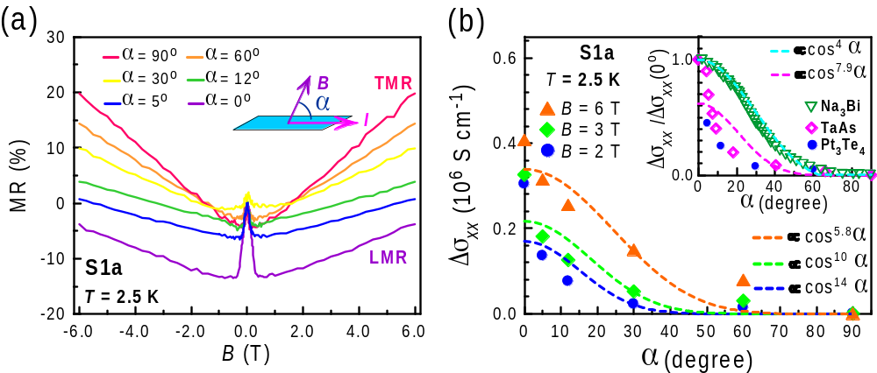

Figure S4. (a) The whole MR data of sample S1a was measured at 2.5 K by tilting the magnetic field B at angle α with respect to the electric current I. The inset is a schematic drawing of a tilt experimental setup. (b) The conductivity variation curves of Δσ_{xx}(B, α) = σ_{xx}(B, α) –σ_{xx}(B, 90°) versus α (B in the x-z plane at angle α to $\hat{x}$, as sketched in (a)), with B fixed at values 2, 3, and 6 T. The dashed lines represent the fittings of cos ^{p}α with p = 5.8, 10, and 14 for B = 6, 3, and 2 T, respectively. The inset illustrates the duplicated values of normalized conductivity variation, Δσ_{xx}(B, α) / σ_{xx}(B, 0°) for Na₃Bi (T = 4.5 K and B = 2 T) and TaAs (T = 2 K and B = 5 T), extracted from earlier studies [15, 16]. The data of Pt₃Te₄ (T = 2.5 K and B = 2 T) are also shown for comparison.

Supplementary 3: Abrikosov’s “quantum MR” mechanism and classic Parish and Littlewood’s model
So far, many topological materials have shown a common magnetotransport characteristic of non-saturating linear-like MR at low temperatures [9−14].This particular linear-like MR was explained by Abrikosov’s “quantum linear MR” mechanism [15, 16]and a classic model was proposed by Parish and Littlewood [11].Abrikosov interpreted this phenomenon by considering a quantum limit where all of the carriers in the Dirac cone states occupy only the lowest Landau level (LL). That is, the LL splitting Δ_{LL} exceeds the Fermi energy E_{F} and the thermal fluctuations k_{B}T, where E_{F} is the Fermi energy for the Dirac cone state of the system. In such a quantum limit, MR can no longer be described within the framework of the conventional Born scattering approximation and is instead expressed by MR∝ (N_{i}/en_{D}²)B, where the surface Dirac carriers density n_{D} and the density of scattering centers N_{i} determine the MR. Therefore, the resulting MR is linear in relation to B. The Δ_{LL} in a Dirac cone state scales with the square root of B, as described by Δ_{LL}= ±v_{F}$\sqrt{2ℏeB}$, can lead to a much larger LL splitting than that in a conventional parabolic band under the same B strength, where v_{F} is the Fermi velocity. Accordingly, the quantum limit of Dirac cone states can be realized in a moderate B associated with a proper temperature. In contrast, in a conventional parabolic band, the LL splitting Δ_{LL} is proportional to B, Δ_{LL} = ħeB/m*, where m* is the effective mass, and thus a very large value of the magnetic field is needed for common materials to satisfy the quantum limit condition, Δ_{LL} > k_{B}T.
As mentioned in the main article, in addition to Abrikosov’s “quantum MR” mechanism, a classic Parish and Littlewood’s model (PL model) [17]was also proposed to explain the mechanisms of the linear MR behavior. This PL model was proposed to solve the mystery of the linear MR found in disordered systems such as silver chalcogenides [18].The PL model claims that the high-field linear MR in inhomogeneous conductors can be given by MR ≈ μ_{H}B with a crossover field which can be estimated by B_{c} = μ_{H}⁻¹ (Ref. [17]), where μ_{H} is the carrier Hall mobility. Considering the PL model and μ_{H} ~ 700 cm²/Vs for Pt₃Te₄, we estimated B_{c} of ~ 14 T, which is much larger than B* of < 1.5 T observed. To examine this model closely, we plotted the ln(TMR) against the mobility ln(μ_{H}) for samples S1 and S2 at temperatures below 100 K, as shown in Fig. S3b. The TMR behavior at temperatures below 50 K roughly obeyed TMR∝ μ_{H}^{α} with α = 0.85 and 1.35 for S1 and S2 respectively, obviously deviating from MR ∝ μ_{H} predicted in the PL model. The results indicate that the observed linear TMR behavior may not be close to the mechanism of the PL model.

Supplementary 4: The magnetoresistance and magnetoconductivity characteristics of Pt₃Te₄ single crystals from different batches
Figures S5a and b respectively show the TMR and longitudinal magnetoresistance (LMR) behaviors at T = 2.5 K for four samples, S1− S4, from different batches. All the samples reveal a metallic-like character (dρ_{xx}/dT > 0), with the residual resistivity ratio RRR = 28, 10, 13, and 11 for S1, S2, S3, and S4, respectively, where the values of RRR are determined by ρ_{xx}(300 K)/ρ_{xx}(2.5 K). The samples show unexpected NTMR as well as the NLMR in low fields. This phenomenon implies that the unexpected TMR and the anomalous NLMR are the intrinsic properties of high-quality Pt₃Te₄ samples.
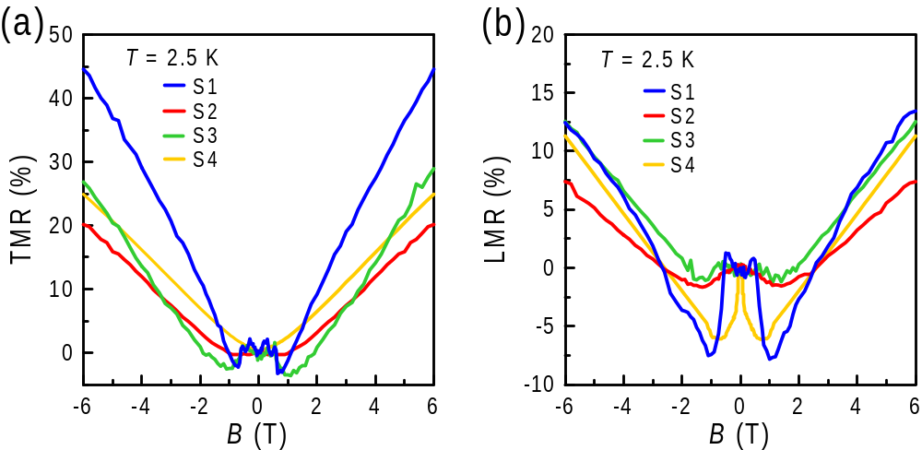

Figure S5. The (a) TMR and (b) LMR behaviors for four samples, S1−4, from different batches.

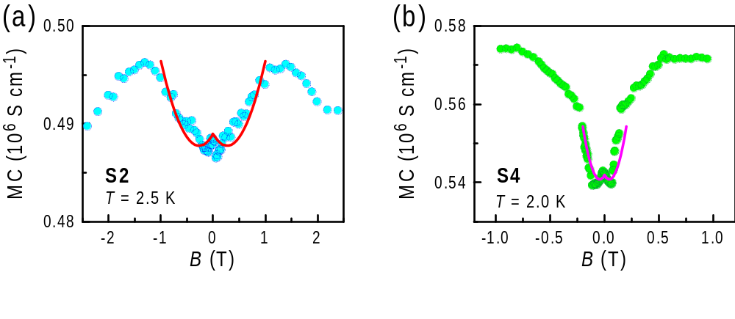

Figure S6. Field-dependent longitudinal MC for samples (a) S2 at 2.5 K and (b) S4 at 2.0 K. Solid lines denote the fittings of Eq. (2), as described in the main article.

Figures S6a and b show the field-dependent longitudinal MC for samples S2 and S4, respectively, as well as the fitting curves by using Eq. (2) in the main article. The shape of MC curves is similar to that observed on S1 (see Fig. 5 in the main article). Although the exact shape of both samples is different, the primary characteristics of the NLMR are similar and have also been consistently described by the chiral anomaly associated with the WAL transport formula. It was pointed out that samples with different chemical potentials will show different NLMR shapes as observed on TaAs[16,19].
To explain the linearly field-dependent TMR within the framework of Abrikosov’s “quantum linear MR” mechanism [15,16],we plotted the differential TMR versus the field to determine the critical field B* for sample S2 as shown in Fig. S7a. Note that the dTMR/dB of sample S2 shows a reduced slope above B* rather than a field-independent plateau as seen for sample S1, implying an additional conductive channel due to the contribution from other semiclassical parabolic bands [20]in S2. The critical field B* was determined by an intersection of two linear fitting lines, as shown by the guidelines in Fig. 7a. As mentioned in the main article, here the derivative anomalies of dTMR/dB due to the negative TMR at the near-zero fields and low temperatures are not presented. The variations in derived B* values with temperatures for sample S2 are shown in Fig. S7b. According to Abrikosov’s model of the quantum linear MR in layered semimetals [16], as stated in the main article, the critical field B*(T), corresponding to the limit of B*(T) = (1/2eħv_{F}²)( E_{F} + k_{B}T)², can be examined via the plot of $\sqrt{B^{*}}$ versus T, as shown in the inset of Fig. S7b for sample S2. As shown, the temperature dependence of critical field B* for sample S2 also fits well with the $\sqrt{B^{*}}$-T plotting at temperatures below 60 K, being similar to that observed for sample S1. The fitting result yields Fermi level of the Dirac cone state E_{F} ≈ 18.7 meV and Fermi velocity v_{F} ≈ 6.45 × 10⁵ m/s for sample S2. The obtained value of E_{F} for sample S2 is much larger than the temperatures for B*(T) analyzed, being accordant with the condition of quantum limit.

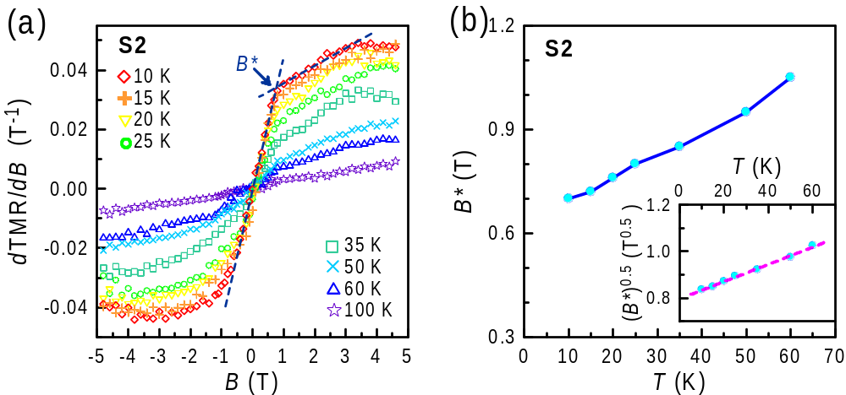
TMR ∝ B²
TMR ∝ B

Figure S7. (a) The plot of dTMR/dB versus field for sample S2 at T < 100 K. The critical field B* is determined by an intersection of two linear fitting lines, as shown by the guidelines. (b) The obtained B*(T) for sample S2. The inset shows the plots of $\sqrt{B^{*}}$ versus T, and the linear fitting of $\sqrt{B^{*}}$ ∝ T is illustrated by the dashed line.

Supplementary 5: In-plane transport characters for two Pt₃Te₄ single crystals with different orientations of applied current for measurements
The anisotropy of in-plane transport characters for Pt₃Te₄ was examined with different orientations of applied current for measurements. Two Pt₃Te₄ single crystals could be extracted from the same batch (samples S_{[100]} and S_{[110]}), which were respectively cut along crystalline axes of [100] and [110] prior to orientation using the Laue diffraction pattern. Figs. S8a and b show the Laue diffraction patterns for single-crystalline Pt₃Te₄ samples S_{[100]} and S_{[110]}, respectively. Note that here thicker samples S_{[100]} (0.4-mm-thick) and S_{[110]} (0.24-mm-thick) were prepared to achieve a clear Laue diffraction pattern. The insets herein are the photos of corresponding samples, in which the orientations of applied current for measurements are indicated and confirmed by Laue diffraction patterns. Figure S8c shows the zero-field resistivity ρ_{xx} in the entire temperature range for samples S_{[100]} and S_{[110]}. The zero-field resistivities ρ_{xx}(T) for both samples S_{[100]} and S_{[110]} reveal a metallic-like character with RRR values of 14 and 18 for samples S_{[100]} and S_{[110]}, respectively. The inset of Fig. S8c shows the temperature dependences of the TMR for samples S_{[100]} and S_{[110]}. As seen, both the TMR values decrease drastically with the increase in temperature and show a TMR value of ~40% at 5 K under 6 T.
Figure S8d displays the temperature dependences of the Hall carrier concentration n_{H} and Hall mobility μ_{H} (shown in the insets) for samples S_{[100]} and S_{[110]}. The samples S_{[100]} and S_{[110]} show approximate values of n_{H} and μ_{H} and reveal similar behaviors of n_{H}(T) and μ_{H}(T). Figure S8e illustrates the TMR behaviors at T = 5 K for samples S_{[100]} and S_{[110]}, in which both the S_{[100]} and S_{[110]} samples exhibit a linear-like and non-saturating TMR behavior but without the negative TMR at low fields as observed on other samples, S1− 4 (see Fig. S5a). The different shape of TMR curves for samples S_{[100]} and S_{[110]} compared with those for other samples may be due to different chemical potentials in samples S_{[100]} and S_{[110]}, as mentioned previously. Nevertheless, confining our attention to the S_{[100]} and S_{[110]} samples that were extracted from the same batch, both the samples display similar magnetotransport characteristics, even though the measuring currents are applied along different crystalline orientations. Our results strongly imply that Pt₃Te₄ possesses weakly anisotropic in-plane transport properties.

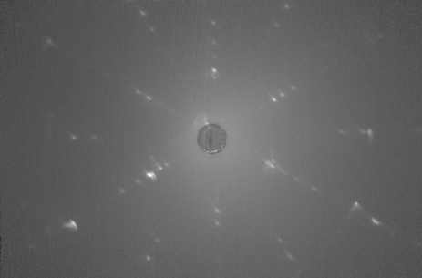
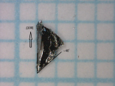
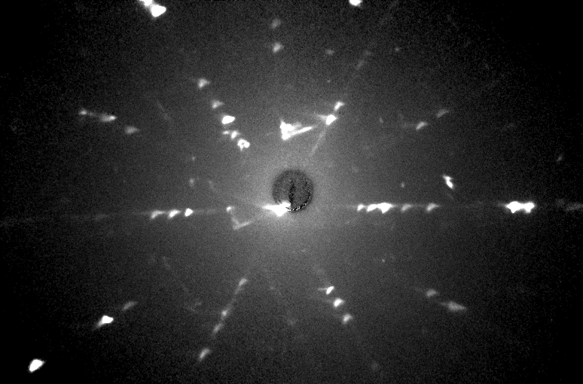
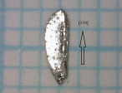
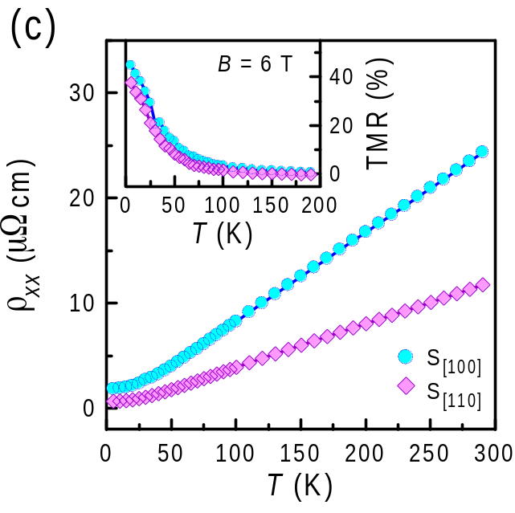
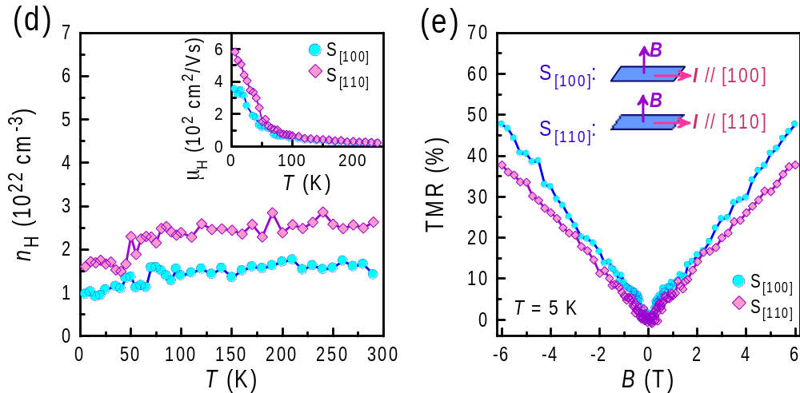
[100]
(a)
[110]
(b)
S_{[100]}
S_{[110]}
B = 0 T

Figure S8. Laue diffraction patterns for single-crystalline Pt₃Te₄ samples (a) S_{[100]} and (b) S_{[110]}. The insets show the photos of corresponding samples, in which the orientations of applied current for measurements are indicated and confirmed by Laue diffraction patterns. (c) The zero-field resistivity ρ_{xx} for the entire temperature range for samples S_{[100]} and S_{[110]}. The inset shows the temperature dependences of the TMR for samples S_{[100]} and S_{[110]}. (d) Temperature dependences of the Hall carrier concentration n_{H} and Hall mobility μ_{H} (shown in the insets) for samples S_{[100]} and S_{[110]}. (e) The TMR behaviors at T = 5 K for samples S_{[100]} and S_{[110]}, showing a linear-like and non-saturating behavior.

Supplementary 6: Experimental tests of the chiral anomaly NLMR in the Pt₃Te₄ single crystal
As mentioned in the main article, Liang et al. [21] implemented a litmus test that allows the intrinsic LMR in Na₃Bi and GdPtBi to be sharply distinguished from pure current-jetting effects in pure Bi via a point-contact measurement configuration (small diameters of current contacts). They showed in full detail that the current jetting enhances current density J along the mid-line (spine) of the sample while decreasing it at the edge, and thus one can measure the distortion by comparing the local voltage drop at the spine (expressed as the resistance R_{spine}) with that at the edge (R_{edge}), being the so-called squeeze test. As demonstrated, in pure bismuth, R_{spine} sharply increases with B, but R_{edge} decreases, indicating that jetting effects are dominant in it. However, in Na₃Bi and GdPtBi, where jetting effects are subdominant, both R_{spine} and R_{edge} decrease [21]. In accordance with their experiments, we selected a shiny plate-like Pt₃Te₄ crystal with dimensions of ~2.0 × 1.5 × 0.1 mm³ for the squeeze test. Six leads were soldered with indium and mounted with small contacts (about 0.15 mm) in the configuration sketched as seen in the inset of Fig. S9a. The photo of corresponding sample is shown in the inset of Fig. S9b. Figures S9a and b show the field profiles of R_{edge} and R_{spine} measured in Pt₃Te₄ at different temperatures, respectively. As seen, both R_{spine} and R_{edge} show the low-field NLMR at temperatures of 2.5 and 5 K, being similar to those reported for Na₃Bi and GdPtBi [21]. This feature is in accordance with the inference that the observed NLMR due to the current-jetting effect should be negligible in the low-mobility Pt₃Te₄, as discussed in the main article. These results considerably strengthen the evidence for the intrinsic nature of the chiral-anomaly-induced NLMR in Pt₃Te₄.
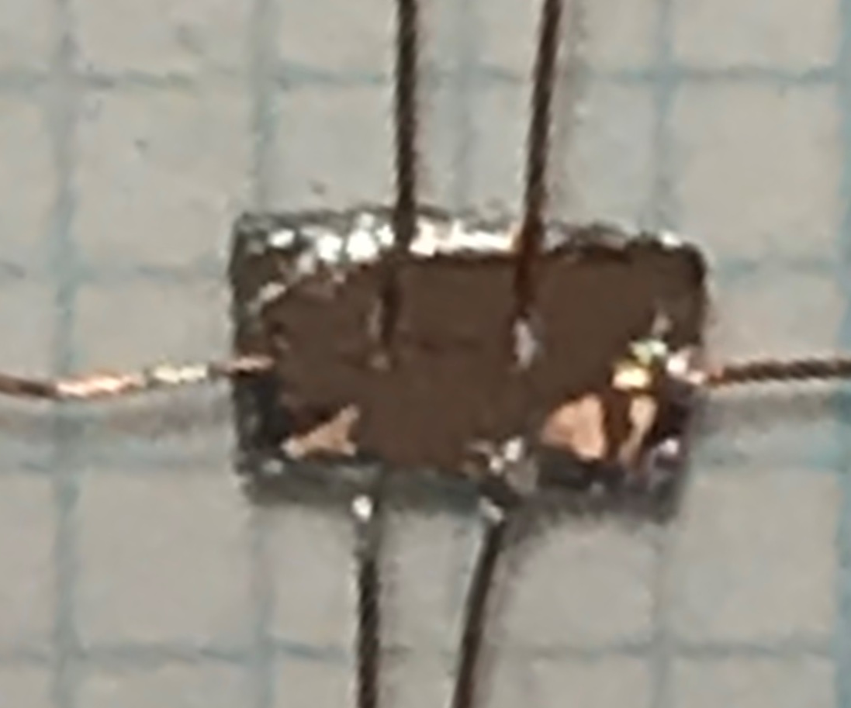
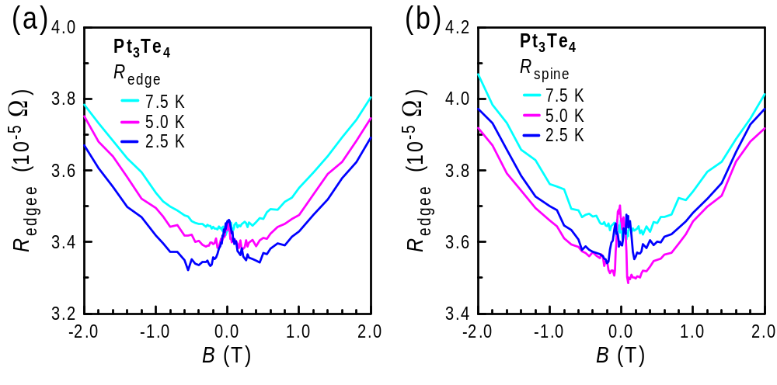
I
B
R_{spine}
R_{edge}
1 mm

Figure S9. Comparison of squeeze-test results of field-dependent (a) R_{edge} and (b) R_{spine} measured in Pt₃Te₄. Both R_{spine} and R_{edge} show the low-field NLMR at temperatures of 2.5 and 5 K, while the low-field NLMR disappears at 7.5 K. The inset of (a) illustrates a schematic drawing of the squeeze test. The inset of (b) shows a photo of the corresponding sample.

Supplementary References
- Boukhvalov, D. W. et al. Unveiling the Mechanisms Ruling the Efficient Hydrogen Evolution Reaction with Mitrofanovite Pt₃Te₄. J. Phys. Chem. Lett 12, 8627-8636 (2021).
- Bae, D. et al. Hydrogen bubble-assisted growth of Pt₃Te₄ for electrochemical catalysts. Curr. Appl. Phys. 30, 20-26 (2021).
- Yan, Y., Wang, L.-X., Yu, D.-P. & Liao, Z.-M. Large magnetoresistance in high mobility topological insulator Bi₂Se₃. Appl. Phys. Lett. 103, 033106 (2013).
- Singh, A. et al. Tuning of carrier type, enhancement of Linear magnetoresistance and inducing ferromagnetism at room temperature with Cu doping in Bi₂Te₃ Topological Insulators. Mater. Res. Bull. 98, 1-7 (2018).
- Singh, A. et al. Enhancement in power factor due to anti-correlation between electrical conductivity and thermoelectric power and induced magnetic ordering in high mobility Zn doped Bi₂Te₃ topological insulator. J. Alloys Compd. 731, 297-302 (2018).
- Qu, D.-X. et al. Quantum Oscillations and Hall Anomaly of Surface States in the Topological Insulator Bi₂Te₃. Science 329, 821 (2010).
- He, H.-T. et al. Impurity Effect onWeak Antilocalization in the Topological Insulator Bi₂Te₃. Phys. Rev. Lett. 106, 166805 (2011).
- Zhang, S. X. et al. Magneto-resistance up to 60 Tesla in topological insulator Bi₂Te₃ thin films. Appl. Phys. Lett. 101, 202403 (2012).
- Abrikosov, A. A. Quantum magnetoresistance. Phys. Rev. B 58, 2788-2794 (1998).
- Abrikosov, A. A. Quantum magnetoresistance of layered semimetals. Phys. Rev. B 60, 4231-4234 (1999).
- Parish, M. M. & Littlewood, P. B. Non-saturating magnetoresistance in heavily disordered semiconductors. Nature 426, 162-165 (2003).
- Xu, R. et al. Large magnetoresistance in non-magnetic silver chalcogenides. Nature 390, 57-60 (1997).
- Schindler, C. et al. Anisotropic electrical and thermal magnetotransport in the magnetic semimetal GdPtBi. Phys. Rev. B 101, 125119 (2020).
- Hirschberger, M. et al. The chiral anomaly and thermopower of Weyl fermions in the half-Heusler GdPtBi. Nat. Mater. 15, 1161-1165 (2016).
- Xiong, J. et al. Evidence for the chiral anomaly in the Dirac semimetal Na₃Bi. Science 350, 413 (2015)
- Zhang, C.-L. et al. Signatures of the Adler–Bell–Jackiw chiral anomaly in a Weyl fermion semimetal. Nat. Commun. 7, 10735 (2016).
- Lu, H.-Z. & Shen, S.-Q. Weak antilocalization and localization in disordered and interacting Weyl semimetals. Phys. Rev. B 92, 035203 (2015).
- Kim, H.-J. et al. Dirac versus Weyl Fermions in Topological Insulators: Adler-Bell-Jackiw Anomaly in Transport Phenomena. Phys. Rev. Lett. 111, 246603 (2013).
- Xu, X.-T. & Jia, S. Recent observations of negative longitudinal magnetoresistance in semimetal. Chin. Phys. B 25, 117204 (2016).
- Sun, Y., Yamada, T., Pyon, S. & Tamegai, T. Structural-transition-induced quasi-two-dimensional Fermi surface in FeSe. Phys. Rev. B 94, 134505 (2016).
- Liang, S. et al. Experimental Tests of the Chiral Anomaly Magnetoresistance in the Dirac-Weyl Semimetals Na₃Bi and GdPtBi. Phys. Rev. X 8, 031002 (2018).

