Supplementary Materials

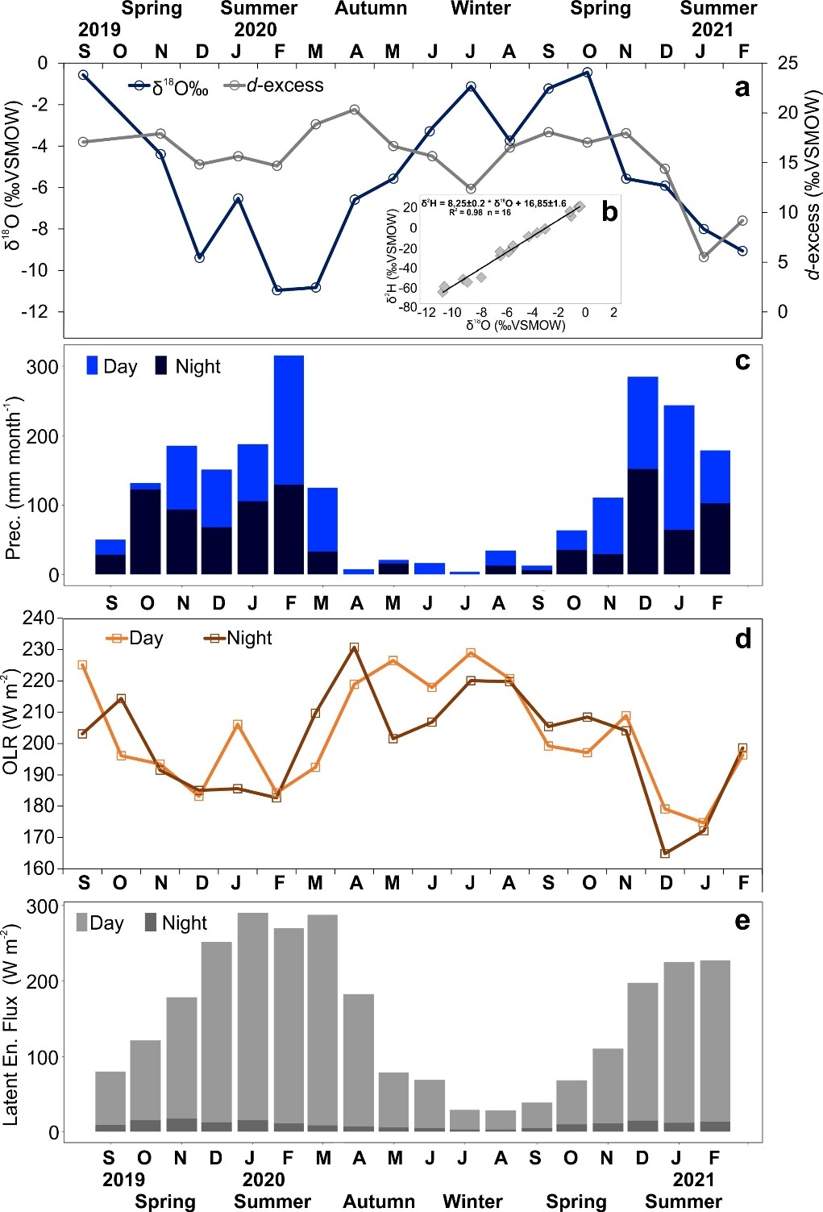
Figure 1 SM. Seasonal evolution of selected isotope and meteorological data recorded at Rio Claro GNIP station (September 2019 – February 2021): (a) Seasonal variation of δ¹⁸O and d-excess values in fully aggregated monthly precipitation. The inserted graph (b) shows monthly δ²H and δ¹⁸O rainfall data plotted in the δ²H/δ¹⁸O dual isotope space. (c) - Aggregated monthly precipitation amounts at Rio Claro separated into day and night fraction. (d) - MERRA-2 outgoing longwave radiation (monthly averaged daytime and night-time data) (e) - Aqua/AIRS latent heat flux.

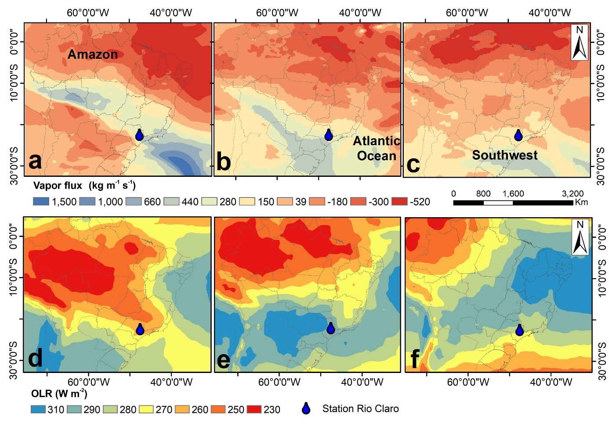
Figure 2 SM Regional moisture transport by ERA-5 vertical integral of eastward water vapor flux combined with HYSPLIT origin from Amazon (a) Atlantic Ocean (b) and Southwest Brazil (c) for the days when the convective rain events occurred, and MERRA-2 outgoing longwave radiation between 2019 and 2021 during summer (d), autumn (e) and spring (f). The position of the names indicates the origin of HYSPLIT trajectories. Positive values indicate that moisture vapor flux occurs from left to right, and negative values from right to left. Lower OLR values indicate higher convective activity.

Figure 3 SM. Rainfall intensity by HYSPLIT backward trajectories (240 hours) related to the moisture origin (see figure 1b) for all convective events analyzed in this study. The Amazon trajectories reveal quasi-continuous rainout during pathway of moist air masses over Amazon Basin down to the collection site at Rio Claro.

