Supplementary Information
Phase regulation to obtain dense composite polymer-based electrolytes for high-voltage solid-state lithium metal batteries

Qian Wu^{1,2}, Mandi Fang³, Shizhe Jiao⁴, Siyuan Li^{1,2}, Shichao Zhang^{1,2}, Zeyu She^{1,2}, Shulan Mao^{1,2}, Jiale Mao^{1,2}, Jiahui Zhang^{1,2}, Yuanzhong Tan⁶, Kang Shen⁶, Jiaxing Lv⁶, Wei Hu⁴, Yi He^{3,5} & Yingying Lu^{1,2*}

¹ State Key Laboratory of Chemical Engineering, Institute of Pharmaceutical Engineering, College of Chemical and Biological Engineering, Zhejiang University, Hangzhou 310027, Zhejiang, China
² ZJU-Hangzhou Global Scientific and Technological Innovation Center, Hangzhou 311200, Zhejiang, China
³ College of Chemical and Biological Engineering, Zhejiang University, Hangzhou, 310058, Zhejiang, China
⁴ School of Future Technology, Department of Chemical Physics, and Anhui Center for Applied Mathematics, University of Science and Technology of China, Hefei, 230026, China.
⁵ Department of Chemical Engineering, University of Washington, Seattle, Washington, 98195, USA.
⁶ Innovation Research Institute of Technology Center, Zhejiang Xinan Chemical Industrial Group Co. ltd, Hangzhou, 311600, Zhejiang, China
Correspondence and requests for materials should be addressed to Y.L. (email: yingyinglu@zju.edu.cn)
Supplementary Figures
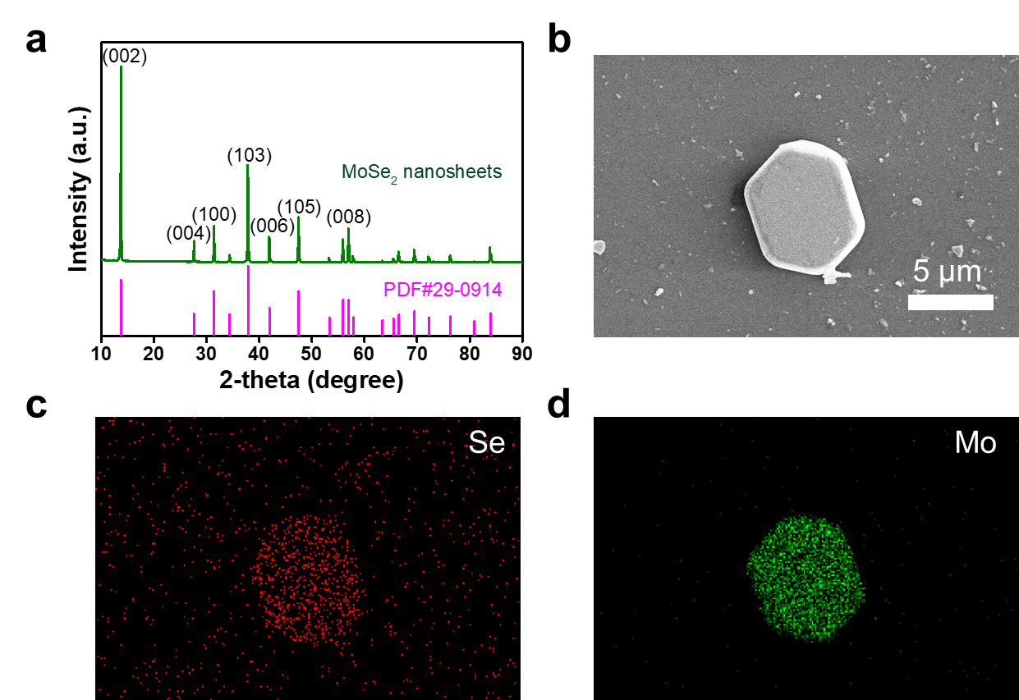
Supplementary Figure 1. Morphology and structural characterizations of Mss. a XRD pattern of MoSe₂ nanosheet. b SEM image of MoSe₂ nanosheet and its EDS mapping of Se (c) and Mo (d) element.
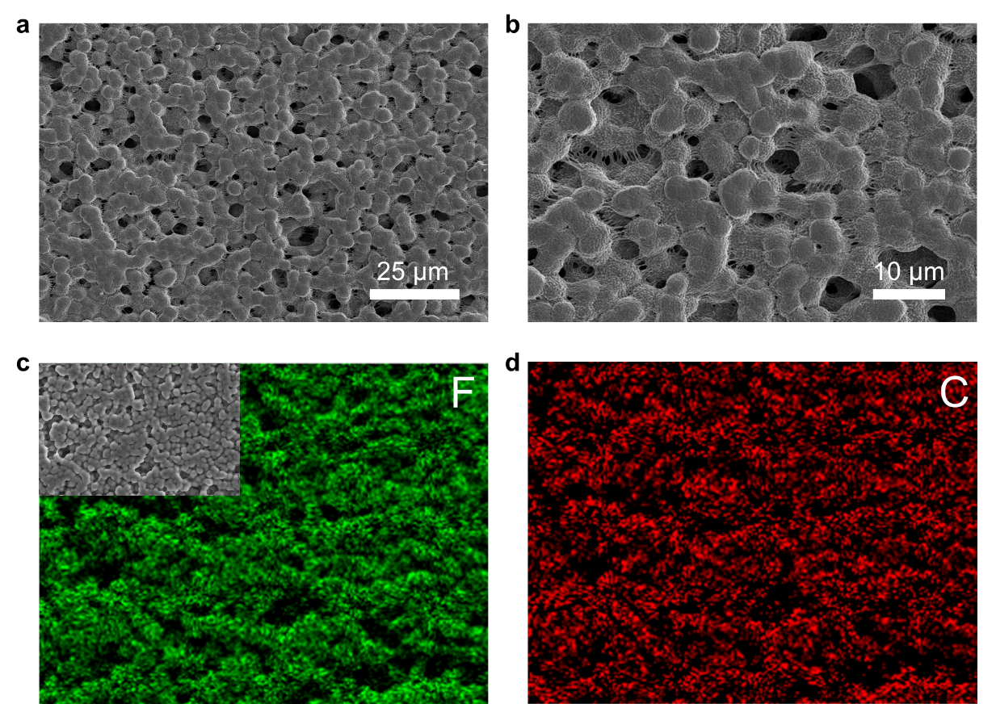
Supplementary Figure 2. SEM images of PVDF electrolyte and its EDS mappings.
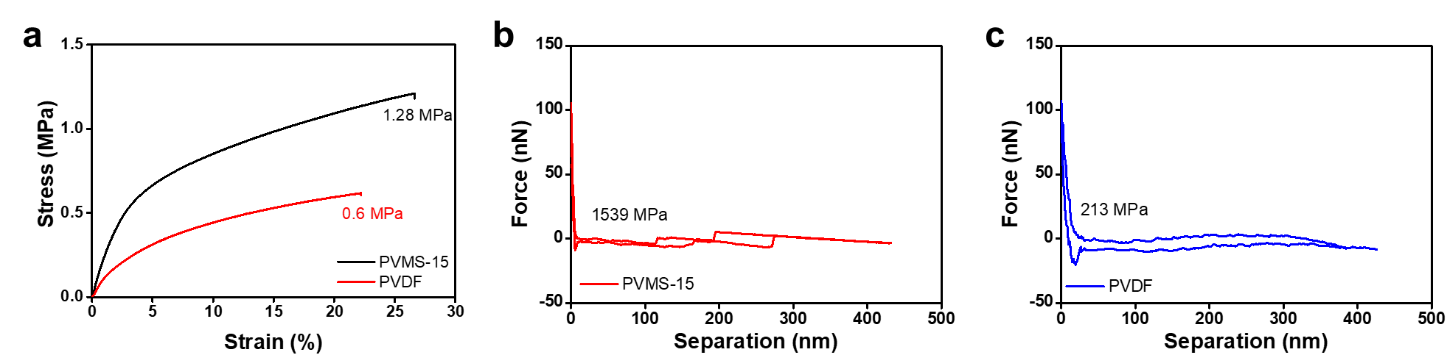
Supplementary Figure 3. Mechanical properties of electrolyte. a Tensile strength tested by stress-strain curves of PVDF and PVMS-15 electrolyte. Young’s modules tested by force-separation curves of PVMS-15 (b) and PVDF (c) electrolyte.
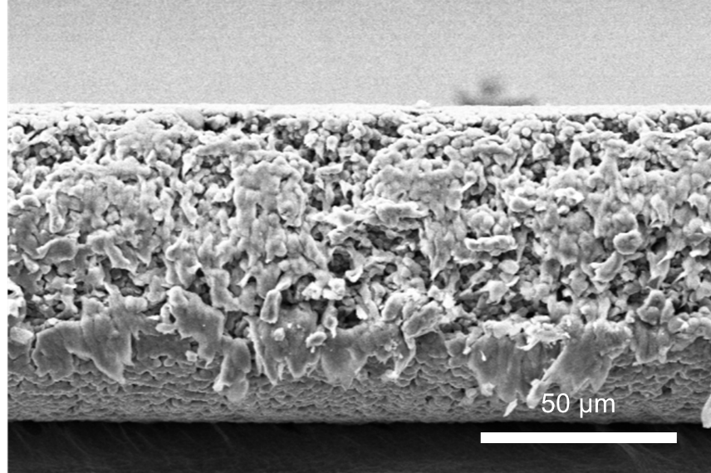
Supplementary Figure 4. Cross sectional SEM image of PVDF electrolyte.
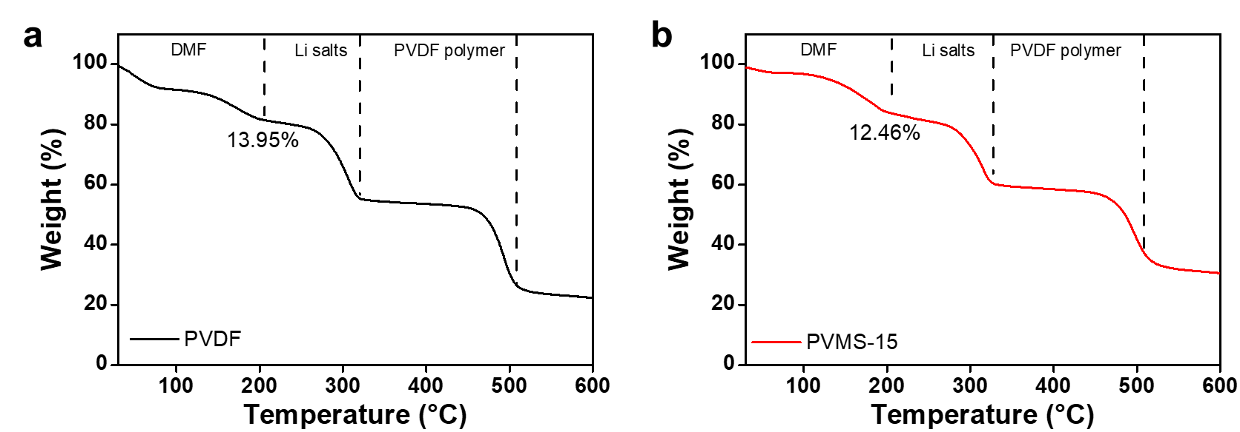
Supplementary Figure 5. Solvent content tested by TGA. TGA curves of PVDF (a) and PVMS-15 (b) electrolyte.
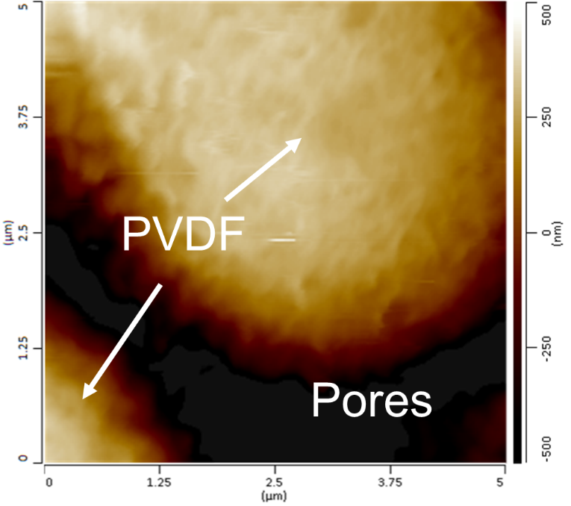
Supplementary Figure 6. AFM image of PVDF electrolyte.
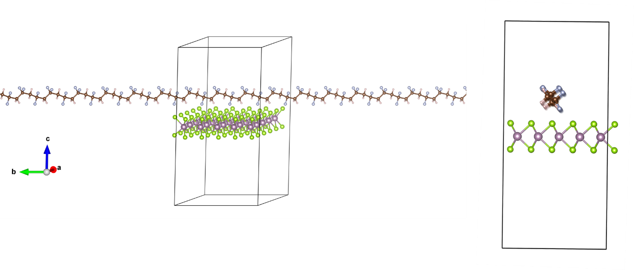
Supplementary Figure 7. Geometry optimization at step 1.
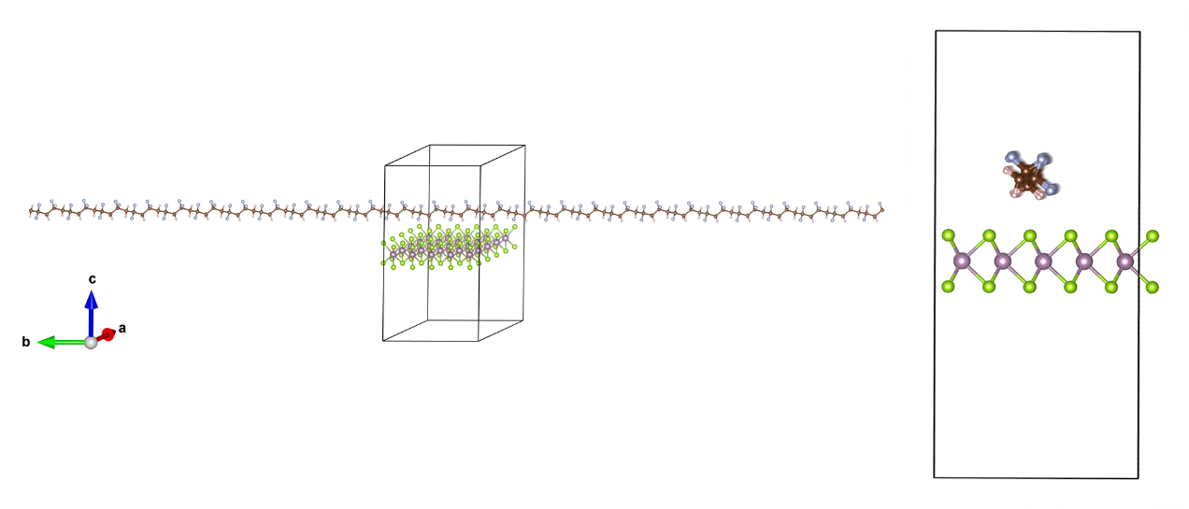
Supplementary Figure 8. Geometry optimization at step 60.
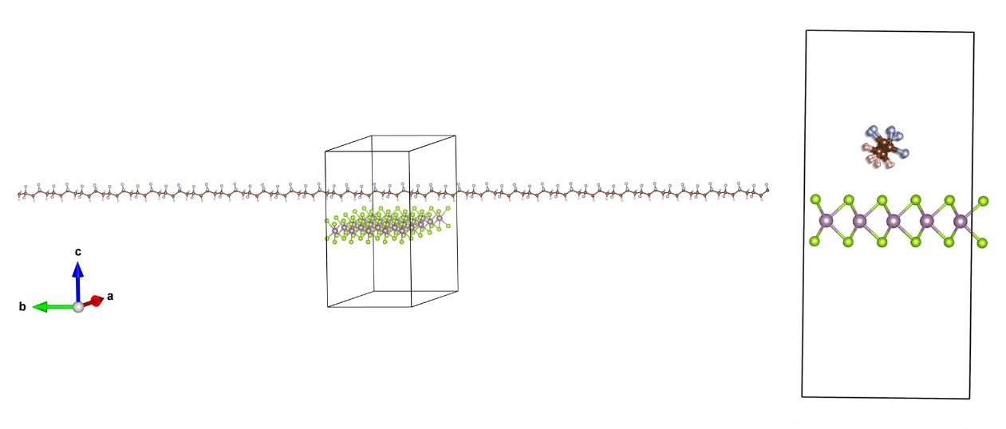
Supplementary Figure 9. Geometry optimization at step 80.
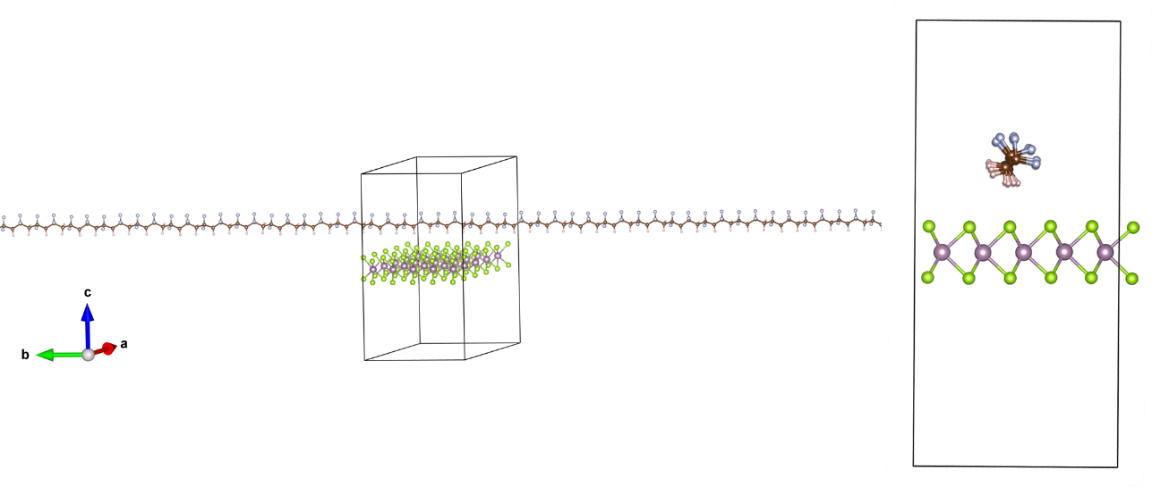
Supplementary Figure 10. Geometry optimization at step 90.
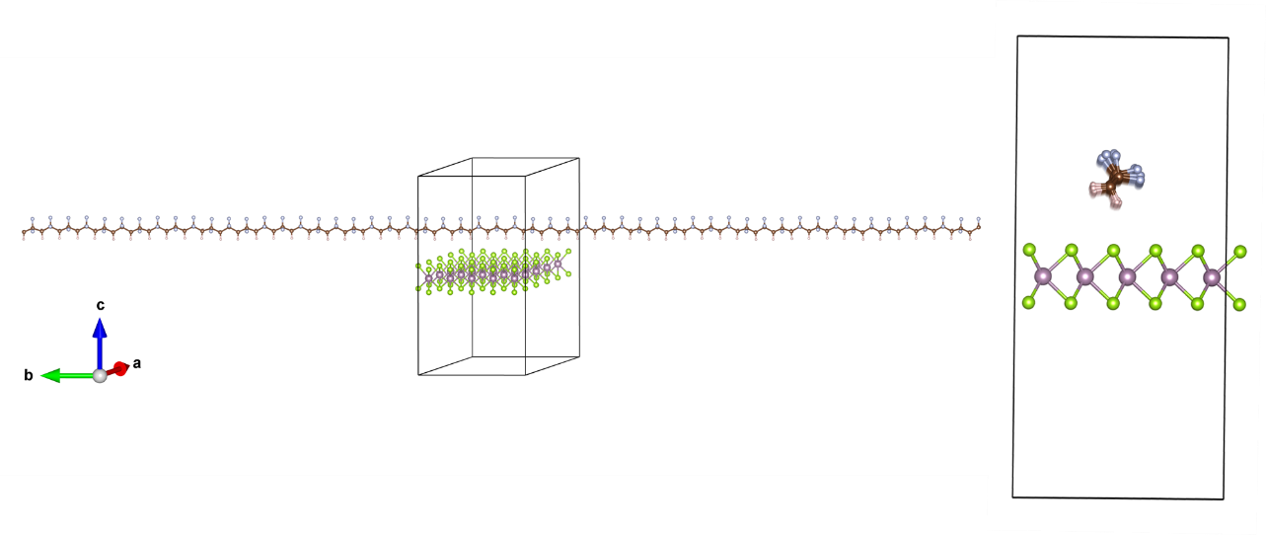
Supplementary Figure 11. Geometry optimization at step 110.
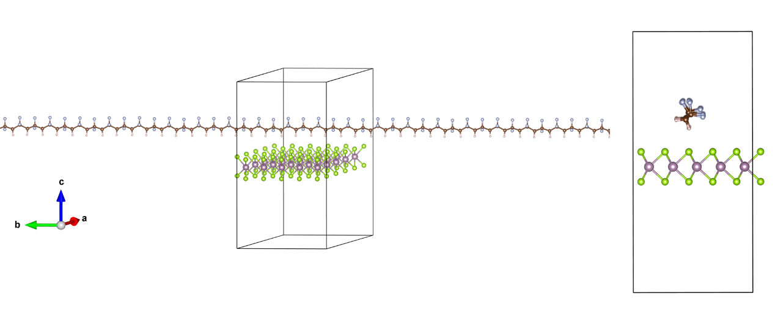
Supplementary Figure 12. Geometry optimization at step 189.
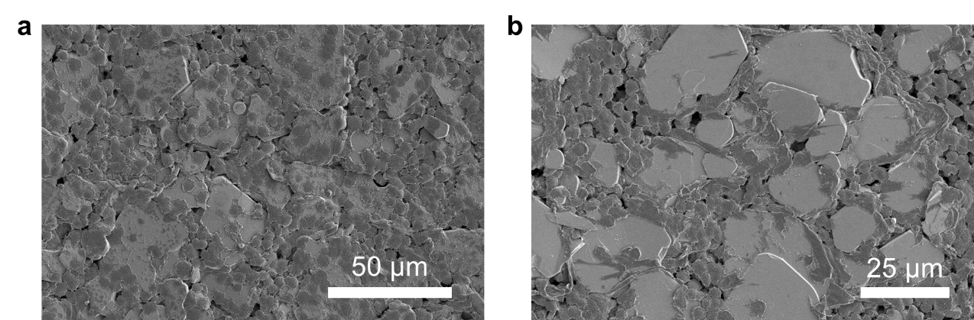
Supplementary Figure 13. SEM images of PVMS-20 electrolyte.
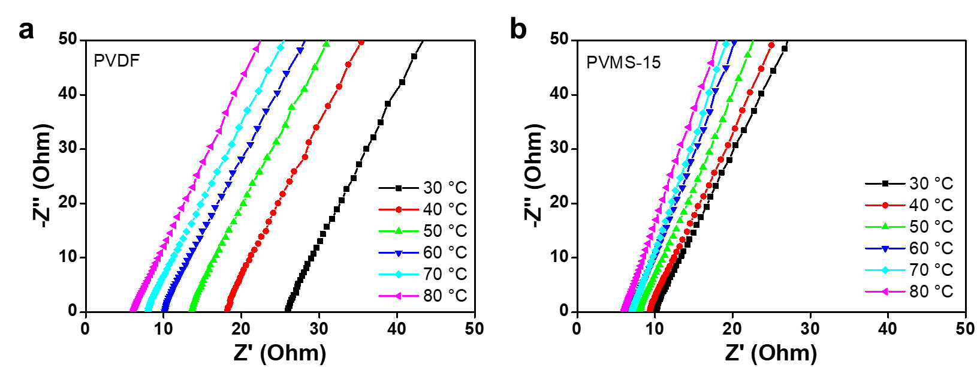
Supplementary Figure 14. Ionic conductivity tests. EIS of SS||SS cells at different temperatures using PVDF (a) and PVMS-15 (b) electrolyte.
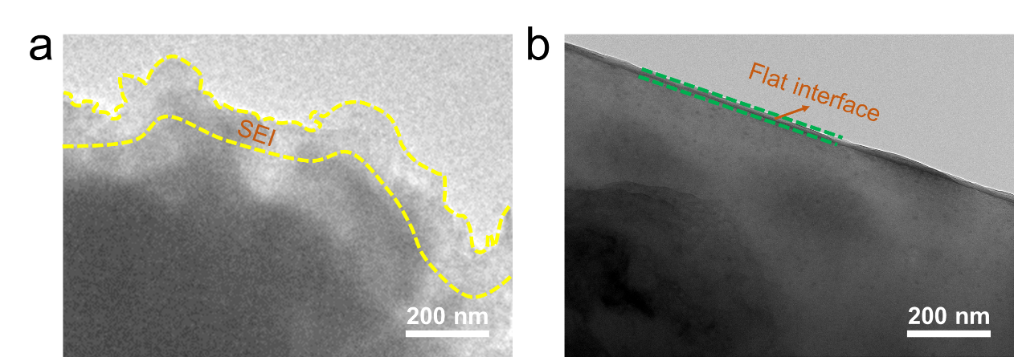
Supplementary Figure 15. SEI characterizations. Cryo-TEM images of SEI formed by PVDF (a) and PVMS-15 (b) electrolyte.
Supplementary Figure 16. Nanostructures of SEI. HRTEM images of Li₂CO₃ (a), Li (b), Li₂O (c) and LiOH (d).
Supplementary Figure 17. SEI image formed by PVDF electrolyte. a Enlarged TEM image of SEI formed by PVDF electrolyte. b FFT pattern.
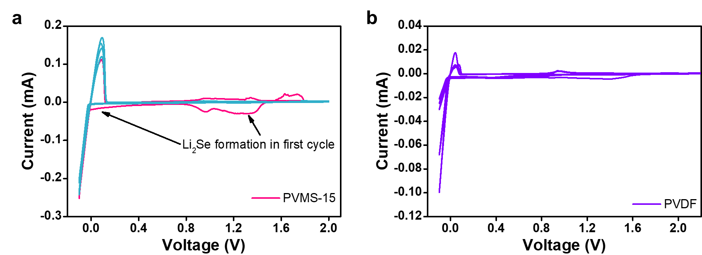
Supplementary Figure 18. Li metal compatibility tests. CV curves of Li||Cu cells using PVMS-15 (a) and PVDF (b) electrolyte.
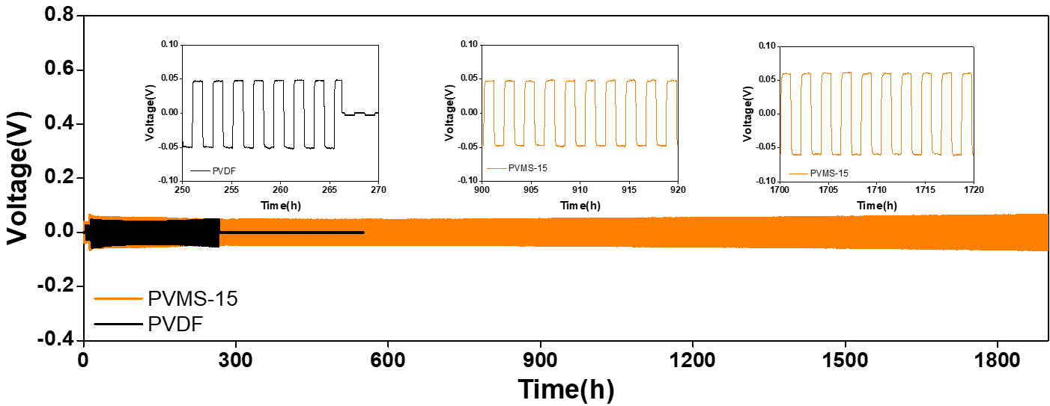
Supplementary Figure 19. Galvanostatic cycling curves of Li||Li symmetrical cells with PVDF and PVMS-15 electrolyte at current density of 0.1 mA cm⁻².
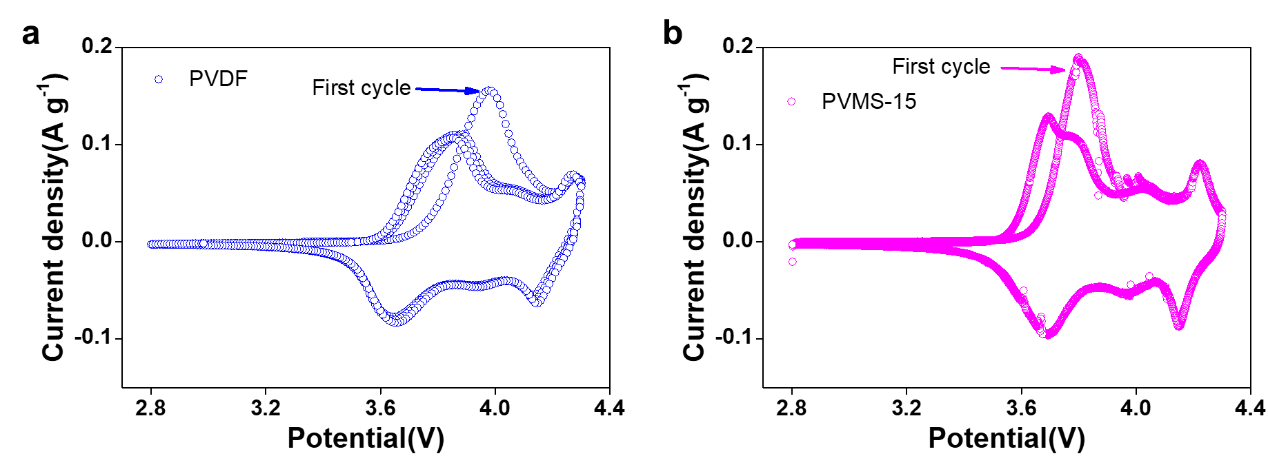
Supplementary Figure 20. CV tests of Li||NCM811 full cells. CV curves of Li||PVDF||NCM811 (a) and Li||PVMS-15||NCM811 (b) cells in voltage range of 2.8~4.3 V at scanning rate of 0.05 mV s⁻¹.
Supplementary Figure 21. EIS of Li||PVDF||NCM811 and Li||PVMS-15||NCM811 cells before rate tests.
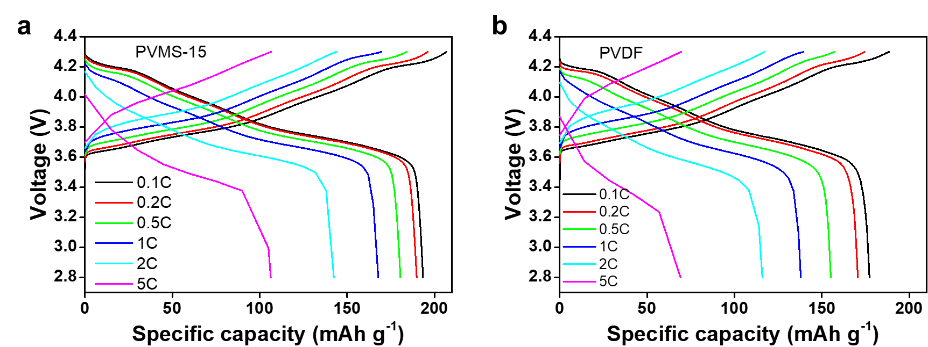
Supplementary Figure 22. Charge/discharge curves at different rates of Li||PVDF||NCM811 and Li||PVMS-15||NCM811 cells.
Supplementary Figure 23. EIS of Li||PVDF||NCM811 and Li||PVMS-15||NCM811 cells after rate tests.
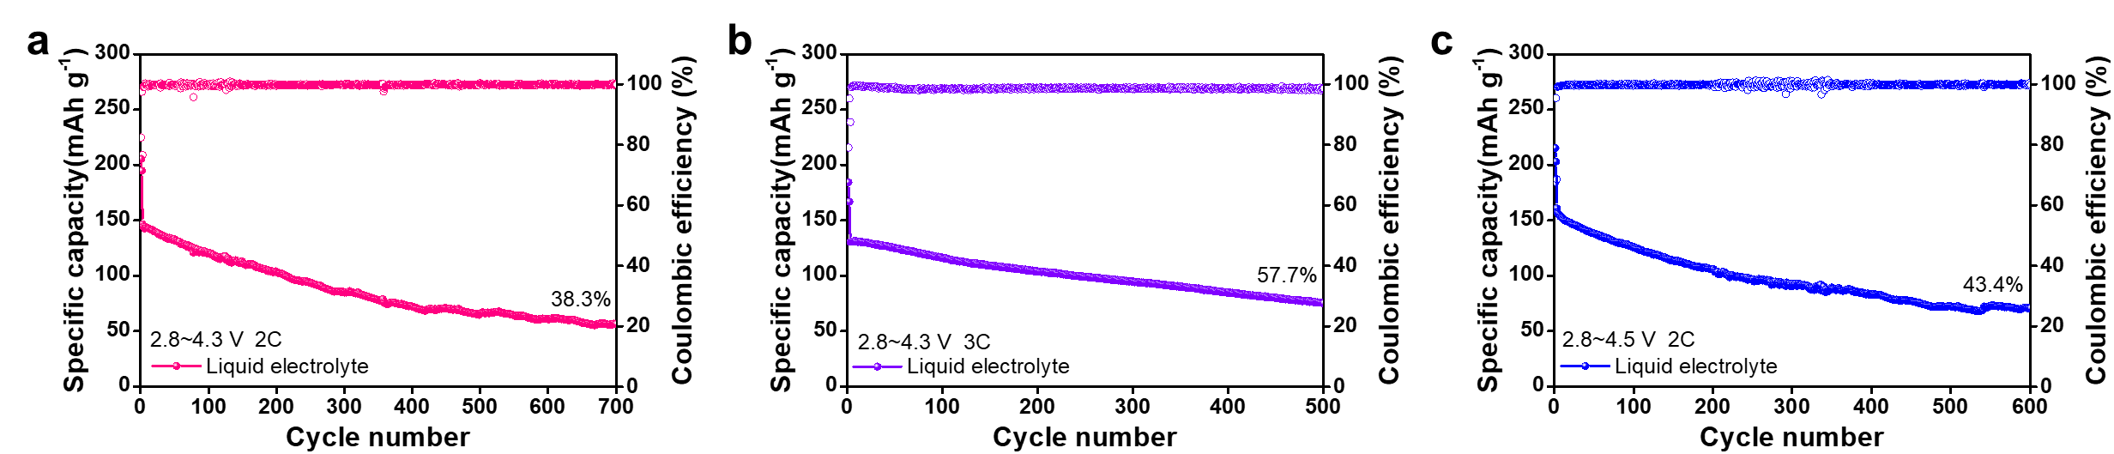
Supplementary Figure 24. Cycling stability of commercial liquid Li||NCM811 cells.
Supplementary Figure 25. Charge/discharge curves of Li||PVDF||NCM811 cells under cut-off voltage of 4.5 V.
Supplementary Figure 26. Electrochemical performance of Li||NCM811 full cells at 2.8~4.3 V with 1 mAh cm⁻².
Supplementary Figure 27. Electrochemical performance of Li||NCM811 full cells at -20 °C.
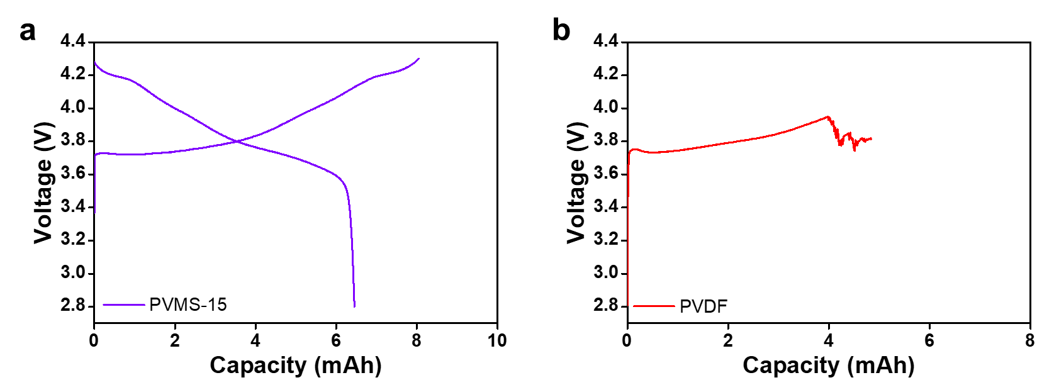
Supplementary Figure 28. Electrochemical tests of single layer pouch cells. Charge/discharge curve of Li||PVMS-15||NCM811 (a) and Li||PVDF||NCM811 (b) pouch cell.
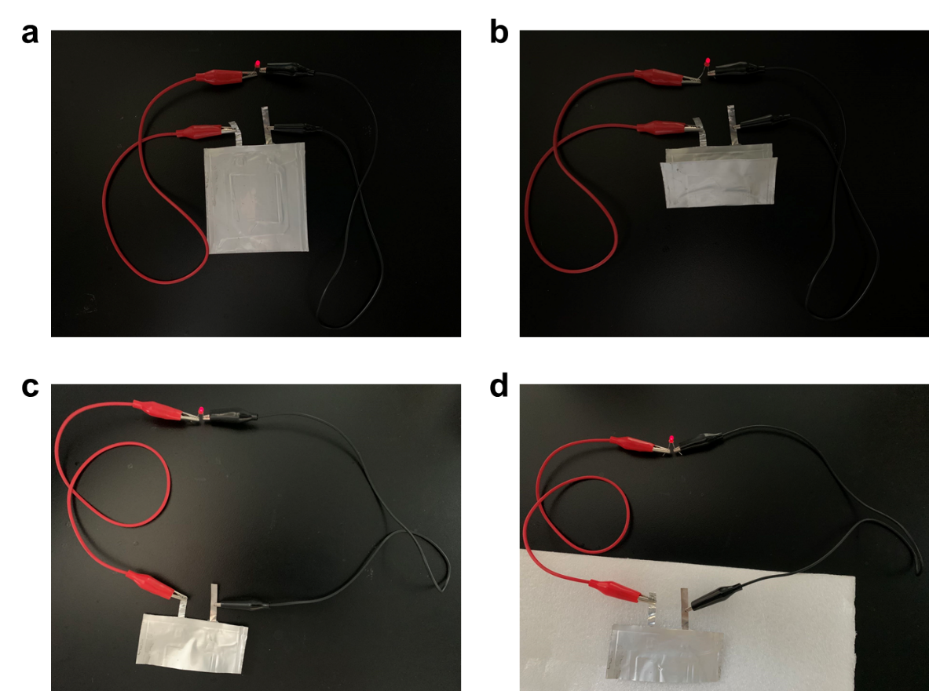
Supplementary Figure 29. Optical photographs of pouch cells. a Optical photograph of Li||PVMS-15||NCM811 pouch cell. b Flexible test. c Cutting test. d Puncturing test.
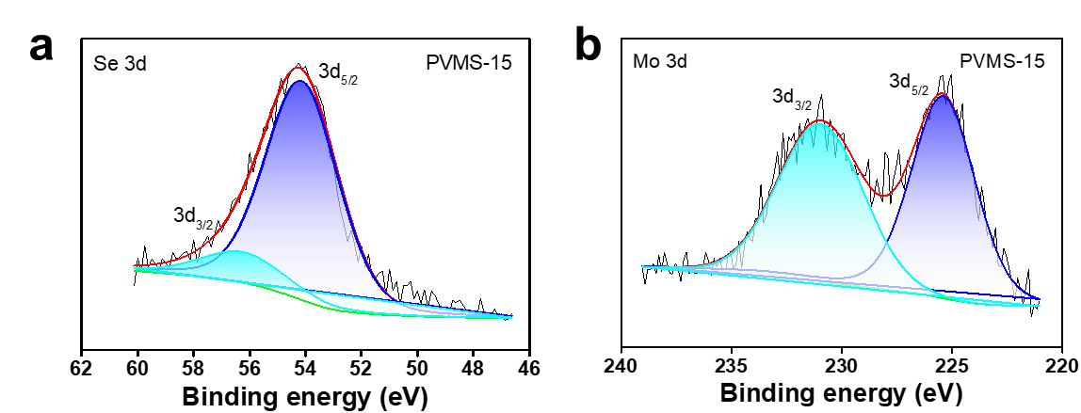
Supplementary Figure 30. XPS results of interfacial components for cycled Li metal anode using PVMS-15 electrolyte.
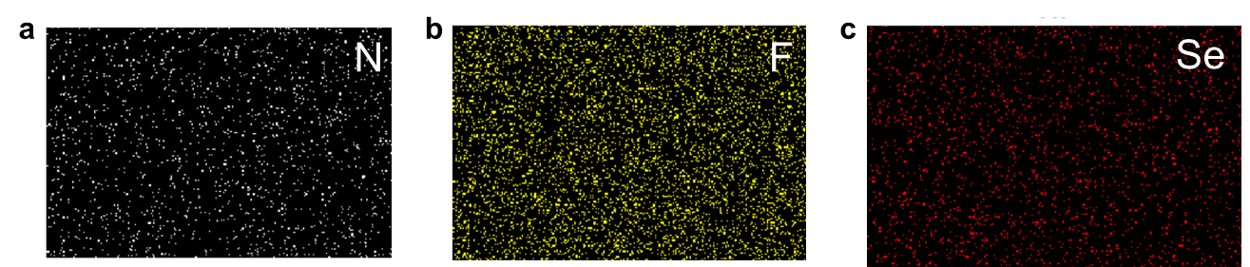
Supplementary Figure 31. Element EDS mappings for cycled Li metal anode using PVMS-15 electrolyte.
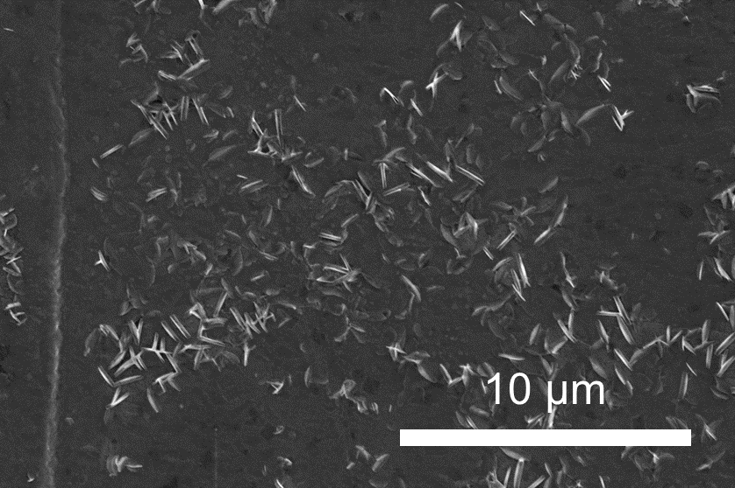
Supplementary Figure 32. Surface SEM image of cycled Li metal anode using PVDF electrolyte.
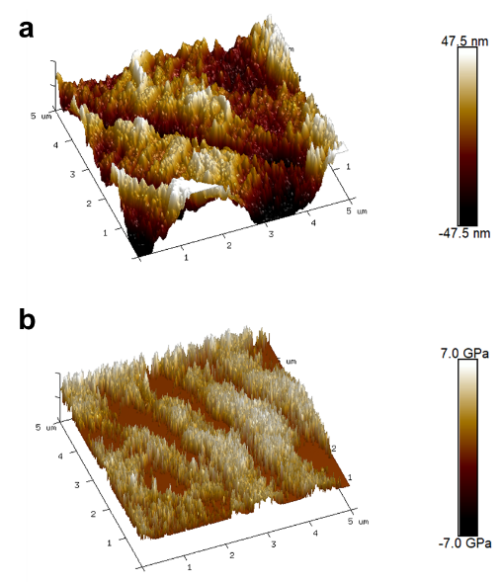
Supplementary Figure 33. 3D AFM image of roughness and Young’s modulus tests of cycled Li metal using PVDF electrolyte.
Supplementary Figure 34. XPS results of interfacial components for cycled NCM811.
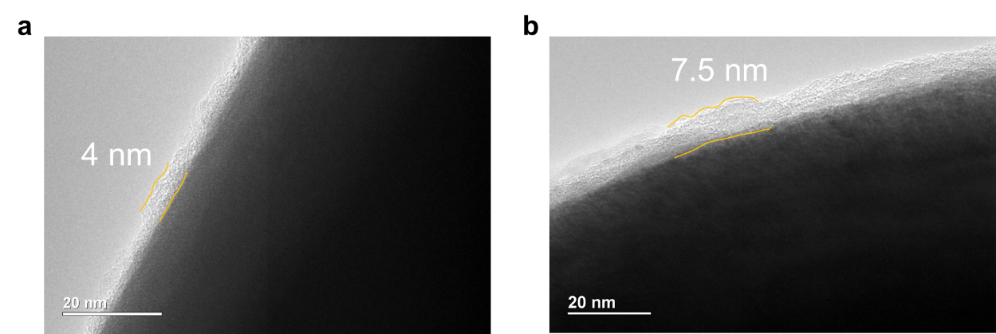
Supplementary Figure 35. CEI images. TEM images of the cycled NCM811 using PVMS-15 (a) and PVDF (b) electrolyte.
Supplementary Tables
Supplementary Table 1 Calculated lattice parameters for Li₂Se, LiOH, Li₂CO₃, and Li₂O.
Crystals | Calculated | Reported | Space Group
Li₂Se | a= b=c=5.89 Å  α=β=γ=90° | a=b=6.02 Å  α=β=γ=90° | Fm3m (No. 225)
LiOH | a=b=3.51 Å c= 4.11 Å  α=β=γ=90° | a=b=3.59 Å c=4.41 Å  α=β=γ=90° | P4/nmm (No.129)
Li₂CO₃ | a=8.37 Å b=5.02 Å c=6.32 Å  α=γ=90° β=114.08° | a=8.42 Å b=5.04 Å c=6.35 Å  α=γ=90° β=114.24° | C2/c (No. 15)
Li₂O | a= b=c=4.55 Å  α=β=γ=90° | a=b=c=4.66 Å  α=β=γ=90° | Fm3m (No. 225)

Supplementary Table 2 Calculated surface energies along different orientations for Li₂Se, LiOH, Li₂CO₃, and Li₂O.
Crystals | Surfaces | Surface energy (J m⁻²)
Li₂Se | 002 | 2.07
Li₂Se | 111 | 0.64
LiOH | 001 | 0.25
Li₂CO₃ | 002 | 0.17
Li₂O | 111 | 0.99
Li₂O | 110 | 1.16

Supplementary Table 3. Comparison of our developed batteries with other reported batteries.
Electrolyte | Ionic conductivity  (S cm⁻¹) | Cycle rate (C) | Cycle number | References
PVDF/LLZTO | 5 | 0.4 | 120 | 1
PVDF-b-PTFE/LLTO | 1.38 | 0.5 | 550 | 2
PVDF-HFP/LiTFSI | 1.24 | 0.2 | 200 | 3
PVDF-HFP/LiTFSI | 2.7 | 1 | 800 | 4
P(VDF-TrFE-CTFE)/LiTFSI | 3.1 | 0.5 | 200 | 5
PVDF/LATP | 6 | 2 | 1500 | 6
BC-g-PLiSTFSI-b-PEGM | 3.1 | 1 | 300 | 7
PVDF-HFP/BSiO | 4.1 | 1 | 300 | 8
Li-RCC1-ClO₄ | 1.2 | 1 | 750 | 9
COF/LiTFSI | 1.65 | 0.1 | 130 | 10
PVMS-15 | 6.5 | 3 | 2000 | This work

Supplementary references
1. Zhang X, et al. Synergistic Coupling between Li_{6.75}La₃Zr_{1.75}Ta_{0.25}O₁₂ and Poly(vinylidene fluoride) Induces High Ionic Conductivity, Mechanical Strength, and Thermal Stability of Solid Composite Electrolytes. J. Am. Chem. Soc. 139, 13779-13785 (2017).
2. Liu S, Zhao Y, Li X, Yu J, Yan J, Ding B. Solid-State Lithium Metal Batteries with Extended Cycling Enabled by Dynamic Adaptive Solid-State Interfaces. Adv. Mater. 33, e2008084 (2021).
3. Liu W, et al. Designing Polymer-in-Salt Electrolyte and Fully Infiltrated 3D Electrode for Integrated Solid-State Lithium Batteries. Angew. Chem. Int. Ed. 60, 12931-12940 (2021).
4. Xu S, et al. Decoupling of ion pairing and ion conduction in ultrahigh-concentration electrolytes enables wide-temperature solid-state batteries. Energy Environ. Sci. 15, 3379-3387 (2022).
5. Huang Y-F, et al. A relaxor ferroelectric polymer with an ultrahigh dielectric constant largely promotes the dissociation of lithium salts to achieve high ionic conductivity. Energy Environ. Sci. 14, 6021-6029 (2021).
6. Yang K, et al. Stable Interface Chemistry and Multiple Ion Transport of Composite Electrolyte Contribute to Ultra-long Cycling Solid-State LiNi_{0.8}Co_{0.1}Mn_{0.1}O₂/Lithium Metal Batteries. Angew. Chem. Int. Ed. 60, 24668-24675 (2021).
7. Zhou M, et al. Ultrathin Yet Robust Single Lithium-Ion Conducting Quasi-Solid-State Polymer-Brush Electrolytes Enable Ultralong-Life and Dendrite-Free Lithium-Metal Batteries. Adv. Mater. 33, e2100943 (2021).
8. Liang HP, et al. Polysiloxane‐Based Single‐Ion Conducting Polymer Blend Electrolyte Comprising Small‐Molecule Organic Carbonates for High‐Energy and High‐Power Lithium‐Metal Batteries. Adv. Energy Mater. 12, 2200013 (2022).
9. Li J, et al. Room temperature all-solid-state lithium batteries based on a soluble organic cage ionic conductor. Nat. Commun. 13, 2031 (2022).
10. Guo D, et al. Foldable Solid-State Batteries Enabled by Electrolyte Mediation in Covalent Organic Frameworks. Adv. Mater. 34, e2201410 (2022).

