Table 1. Significance Scale Values and Definitions

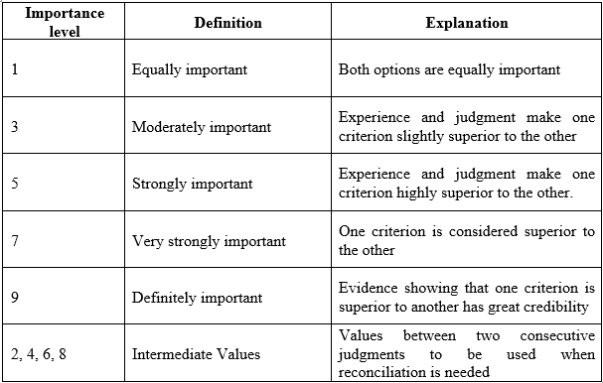
Table 2. RI Values for Different Values of n

Table 4. Preference Functions (Brans and Mareschal 2005).
