Appendices – Figures and Tables

Figure S1 – Risk of bias evaluation for RCTs
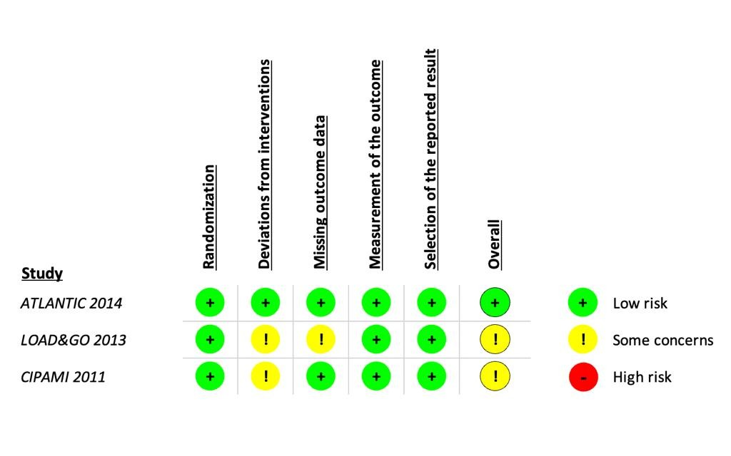
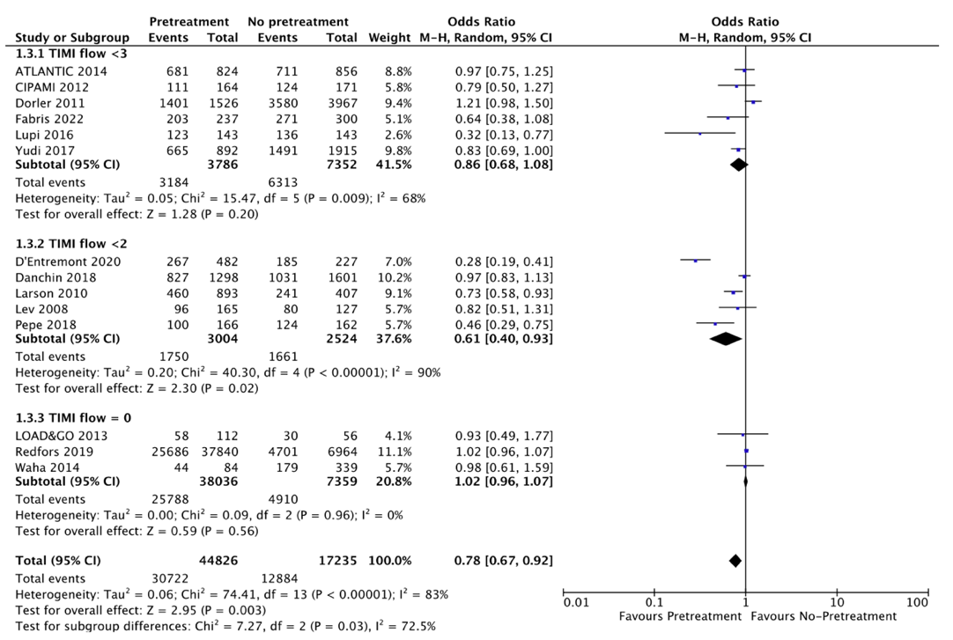
Figure S2 – Forest plot comparing pretreatment vs downstream treatment regarding TIMI flow before PCI

Figure S3 – Forest plot comparing pretreatment vs downstream treatment regarding No Reflow
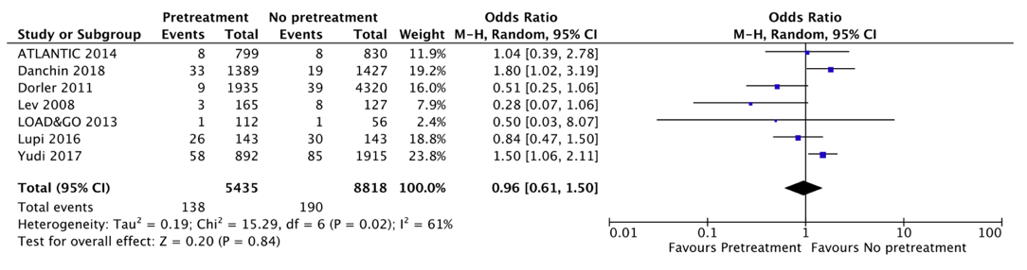

Table S1 – Risk of bias evaluation for non-randomized trials

 | Selection |  |  |  | Comparability | Outcome
 | Representativeness of the exposed cohort | Selection of the non exposed cohort | Ascertainment of exposure | Incident disease | Comparability | Assessment of outcome | Lenght of follow-up | Adequacy of follow-up | Total number of stars
Redfords et al | * | * | * | * | ** | * | * | * | 9
Effron et al | * | * | * | * |  | * | * |  | 6
Yudi et al | * | * | * | * | ** | * |  |  | 7
Larson et al |  |  | * | * |  | * | * |  | 4
Danchin et al | * | * | * | * | ** | * | * | * | 9
Lupi et al | * | * | * | * | ** | * | * |  | 8
Lev et al | * | * |  | * | ** | * | * | * | 8
Dorler et al | * | * | * | * | ** | * | * | * | 9
Fefer et al | * | * | * | * | ** |  | * |  | 7
Fabris et al | * | * | * | * |  | * | * | * | 7
Alexander et al | * | * | * | * |  | * | * | * | 7
D'Entremont et al | * | * | * | * | ** | * | * | * | 9
Guedes et al |  |  | * | * | ** | * | * |  | 6
Pepe et al | * | * | * | * | ** | * | * |  | 8
Waha et al | * | * | * | * |  | * | * |  | 6
Wiviott et al | * | * | * | * | ** | * | * | * | 9

Table S2 – Other studies characteristics and reported outcomes
 | Anterior STEMI | Time from pretreatment to PPCI | Clopidogrel | Ticagrelor | Prasugrel | GP IIb/IIIa Inhibitor | Pre-PPCI TIMI flow | Post-PCI TIMI flow | No reflow | Definitive stent thrombosis | Cardiogenic shock | Acute myocardial infarction | Major bleeding | All cause mortality
Redfords et al | - | - | 57.2% vs. 64.5% | 37.0% vs. 25.2% | 5.8% vs. 2.3% | 32.4% vs. 43.7% | TIMI 0: 67.9% vs. 67.5%, p=0.602 | - | - | At 30 days: 0.6% vs. 0.6%, p=0.672 | Inhospital: 2.7% vs. 5.3%, p<0.001 * | - | Inhospital: 2.6% vs. 3.4%, p<0.001 * | At 30 days: 5.8% vs. 7.6%, p=0.023 *
Effron et al | - | - | 53.2% vs. 49.7% | - | 67.4% vs. 57.7% | 39.3% vs. 50.9%, p<0.001 | - | - | - | - | - | - | 3.1% vs. 3.4%, p=NS | -
Yudi et al | - | - | 86.0% vs. 77%.0 | not reported | not reported | 69.6% vs. 76.2%, p<0.01 | TIMI < 3: 78.0% vs. 80.7%, p=0.18 | TIMI 3: 93.0% vs. 93.4%, p=0.46 | 5.7% vs. 5.0% p=0.05 | Inhospital: 0.8% vs. 0.9%, p=0.73 | Inhospital: 3.6% vs. 6.4%, p<0.01 | - | Inhospital: 3.6% vs. 3.9%, p=0.67 | Inhospital: 2.3% vs. 4.4%, p=0.007
Larson et al | 36.5% vs. 34%, p=0.66 | - | 100% ** | - | - | not reported | TIMI 0/1: OR 0.71 (0.57-0.90) | TIMI 0/1: OR 0.47 (0.21-1.05) | - | At 30 days: OR 0.32 (0.12-0.80) | - | - | Inhospital: OR 0.71 (0.26-1.99) | Inhospital: OR 1.22 (0.63-2.35)
Danchin et al | 41.9% vs. 40.6%, p=0.42 | - | 35.3% vs. 55.2%, p<0.001 | 28.4% vs. 25.3%, p<0.001 | 36.3% vs. 19.5%, p<0.001 | 41.2% vs. 39.9%, p=0.45 | TIMI 0/1: 63.7% vs. 64.4%, p=0.703 | TIMI 2/3: 97.6% vs. 94.3%, p<0.001 | 1.3% vs. 2.4%, p=0.005 | - | Inhospital: 1.9% vs. 2.4%, p=363 | Inhospital: 0.6% vs. 0.6%, p=0.932 | Inhospital: 2.2% vs. 2.0%, p=0.645 | Inhospital: 1.8% vs. 3.7%, p=0.001
Lupi et al | 49.0% vs. 49.0% | 2.1 hours | - | 100% ** | - | 13.3% vs. 34.4%, p<0.001 | TIMI < 3: 86.0% vs. 95.1%, p=0.01 | - | 18.2% vs. 21%, p=0.55 | Inhospital: 1.4% vs. 1.4%, p=1.0 | - | Inhospital: 2.1% vs. 1.4%, p=0.65 | Inhospital: 6.3% vs. 7.7%, p=0.48 | Inhospital: 3.5% vs. 9.1%, p=0.09
Lev et al | 42.0% vs. 43.0% | - | 100% ** | - | - | 80% vs. 75%, p=NS | TIMI 0/1: 58% vs. 63%, p=NS | TIMI 3: 98% vs. 95%, p=NS | 1.3% vs. 6.8%, p=0.06 | At 30 days: 0% vs. 2.4%, p=0.08 | - | At 30 days: 0% vs. 3.2%, p=0.04 | - | At 30 days: 0.6% vs. 1.6%, p=0.60
Dorler et al | 48.0% vs. 47.4%, p=0.32 | - | 100% ** | - | - | 54.2% vs. 52.2%, p=0.18 | TIMI < 3: 91.8% vs. 90.2%, p=0.10 | TIMI 3: 89.7% vs. 86.6%, p=0.01 | 0.6% vs. 1.0%, p=NS | - | - | Inhospital: 0.6% vs. 1.4%, p<0.01 | Inhospital: 0.8% vs. 0.9%, p=0.39 | Inhospital: 3.4% vs. 6.1%, p<0.01
Fefer et al | 55.0% vs. 56.0%, p=0.8 | - | 100% ** | - | - | 70.0% vs. 67.0%, p=0.60 | - | - | - | At 30 days: 2% vs. 7%, p=0.04 | - | At 30 days: 8% vs. 11%, p=0.30 | Inhospital: 1% vs. 1%, p=0.46 | At 30 days: 6% vs. 4%, p=0.38
Alexander et al | - | - | 100% ** | - | - | 89.7% vs. 92.8%, p<0.01 | - | - | - | - | 4.0% vs. 5.5%, p=0.04 | Inhospital: 2.5% vs. 1.0%, p<0.01 | Inhospital: 10.5% vs. 11.9%, p=0.23 | Inhospital: 1.2% vs. 2.0%, p=0.12
D'Entremont et al | 38.9% vs. 29.5%, p=0.015 | 81 (69-95) minutes | - | 100% ** | - | 10.0% vs. 26.2%, p<0.001 | TIMI 0/1: 55.4% vs. 81.5%, p<0.001 | TIMI 2/3: 97.3% vs. 99.1%, p=0.16 | - | At 24 hours: 0.6% vs. 2.6%, p=0.03 | - | - | Inhospital: 0.4% vs. 0%, p=NS | Inhospital: 3.5% vs. 3.1%, p=0.34
Guedes et al | 48.6% vs. 49.1%, p=0.8 | - | not reported | not reported | not reported | 26.0% vs. 80.9%, p<0.001 | - | - | - | - | - | Inhospital: 1.0% vs. 0.1%, p=0.006 | Inhospital: 2.2% vs. 2.4%, p=0.678 | Inhospital: 4.0% vs. 2.9%, p=0.07
Pepe et al | 46.3% ** | 50.6% in < 60 minutes from PPCI | - | 54.8% vs. 54.3%, p=0.79 | 45.2% vs. 45.7%, p=0.79 | 9.0% vs. 17.4%, p=0.209 | TIMI 0/1: 74.5% vs. 60.2%, p=0.002 | TIMI 3: 85.2% vs. 92.8%, p=0.013 | - | - | - | At 30 days: 2.5% vs. 2.5%, p=0.976 | Inhospital: 1.2% vs. 1.2%, p=0.998 | At 30 days: 3.1% vs. 3.1%, p=0.465
Waha et al | 56.0% vs. 43.4%, p=0.05 | - | 100% ** | - | - | 96.4% vs. 88.2%, p=0.03 | TIMI 0: 52.4% vs. 52.8%, p=1.0 | TIMI 3: 85.7% vs. 79.9%, p=0.28 | - | - | - | - | - | At FUP (19 [11-27] months): 9.5% vs. 5.5%, p=0.13
Wiviott et al | 54.5% ** | - | 25% vs. 75% ** | - | 26% vs. 74% ** |  | - | - | - | At 48 hours: 0.6% vs. 0.5%, p=NS | - | - | - | -
Montalescot et al | 45.2% vs. 50.2%, p=0.04 | 31 minutes | - | 100% ** | - | 33.7% vs. 30.7%, p=0.2 | TIMI < 3: OR 0.95 (0.69-1.25), p=0.82 | TIMI < 3: OR 0.88 (0.68-1.14), p=0.64 | - | At 30 days: OR 0.19 (0.04-0.86), p=0.002 | - | At 30 days: OR 0.73 (0.28-1.94), p=0.53 | At 30 days: 1.3% vs. 1.3%, p=0.91 | At 30 days: OR 1.68 (0.94-3.01), p=0.08
Ducci et al | - | 65±33 minutes | 100% ** | - | - | 84.8% vs. 92.9%, p=0.14 | TIMI 0: 51.8% vs. 53.6%, p=0.83 | TIMI 3: 89.3% vs. 91.1%, p=0.72 | 0.9% vs. 1.8%, p=0.62 | - | - | - | 1.8% vs. 0%, p=0.55 | -
Fabris et al | - | 33 minutes | not reported | not reported | not reported | 12.2% vs. 24.5%, p<0.001 | TIMI < 3: 85.7% vs. 90.3%, p=0.09 | - | - | At 30 days: 1.3% vs. 1.7%, p=0.7 | - | At 30 days: 1.3% vs. 2.0%, p=0.51 | Inhospital: 2.1% vs. 2.0%, p=0.93 | In hospital: 7.2% vs. 5.0%, p=0.29
Zeymer et al | - | 47 minutes | 100% ** | - | - | 47.2% vs. 48.8%, p=0.80 | TIMI < 3: 67.4% vs. 72.6%, p=0.50 | TIMI 3: 89.3% 88.6%, p=0.90 | - | - | - | At 7 days or discharge: 0.6% vs. 1.8%, p=0.20 | At 7 days or discharge: 9.1% vs. 8.2%, p=0.80 | At 7 days or discharge: 0.6% vs. 2.3%, p=0.10
* Unadjusted results
** Refers to the entire study population

Table S3 – Bleeding outcomes definition for each included study.

 | Definition
Redfords et al | Puncture site hematoma>5 cm or pseudo-aneurysm requiring intervention, cardiac tamponade, drop in hemoglobin>20 g/L, intracranial bleeding, prolonged compression-treatment (>6 hours), transfusion, or surgical intervention
Effron et al | Hemoglobin drop ≥3 g/dL, transfusion of whole blood or packed red blood cells, or procedural intervention/surgery at the bleeding site to reverse/stop or correct the bleeding
Yudi et al | Any bleeding requiring a blood transfusion and/or prolonged hospital admission and/or a drop of hemoglobin >3 g/dl
Larson et al | Major bleeding events according to TIMI bleeding criteria
Danchin et al | Major bleeding events according to TIMI bleeding criteria
Lupi et al | Bleeding events according to BARC classification, type ≥3
Lev et al | -
Dorler et al | Any intracranial hemorrhage, a drop of hemoglobin of ≥5 g/dL (decrease in hematocrit of ≥15% if hemoglobin was unavailable), need for blood transfusion, or surgical intervention.
Fefer et al | Specific criteria unavailable – only identified as major bleeding events
Alexander et al | Absolute hematocrit decrease ≥12%, intracranial hemorrhage stroke, witnessed retroperitoneal bleeding event, baseline hematocrit ≥28% with red blood cell transfusion, or baseline hematocrit <28% with red blood cell transfusion and witnessed bleeding event
D'Entremont et al | Bleeding events according to BARC classification, type ≥3
Guedes et al | Major bleeding events according to GUSTO bleeding criteria
Pepe et al | Major bleeding events according to TIMI bleeding criteria
Waha et al | -
Wiviott et al | -
Montalescot et al | Major bleeding events according to TIMI bleeding criteria
Ducci et al | -
Fabris et al | -
Zeymer et al | Major bleeding events according to TIMI bleeding criteria

