Supplementary Information for manuscript:
“Persistent T cell unresponsiveness associated with chronic VL disease in VL-HIV patients”.
de Vrij et al.

Supplementary Figures
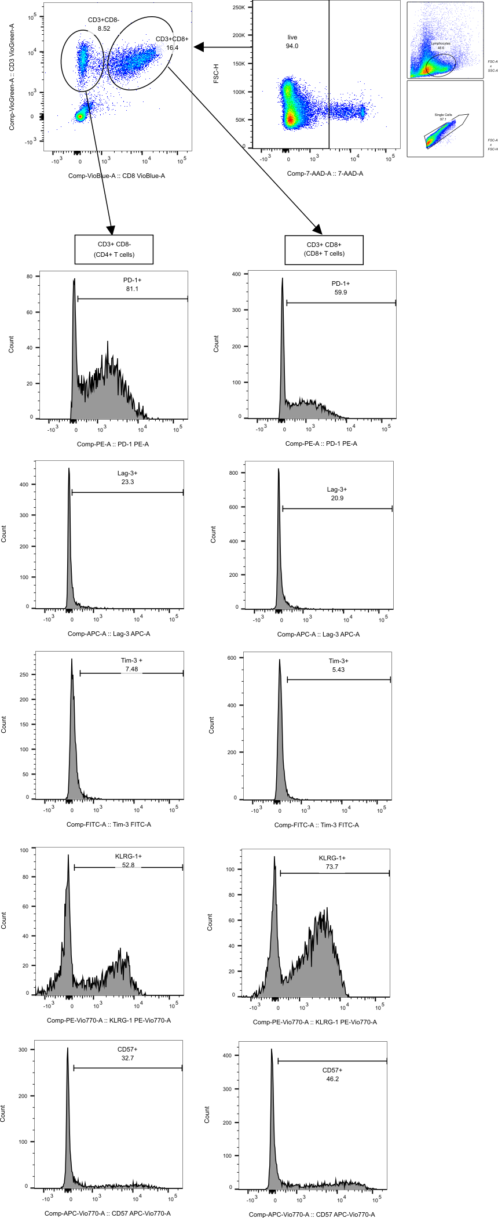
Supplementary Figure 1 | Gating strategy for the T cell exhaustion panel. Patient PBMCs were isolated and stained for flow cytometry. After exclusion of doublets and non-lymphocytes, single lymphocytes were gated for live cells. Next, CD8⁺ and CD8⁻ T cells were gated out by plotting CD3-VioGreen versus CD8-VioBlue. Out of these subsets, those positive for a range of exhaustion and senescence markers (CD57-APC-Vio770, LAG3-APC, KLRG1-PE-Vio770, PD-1-PE, TIM3-VioBright-FITC) were gated out.
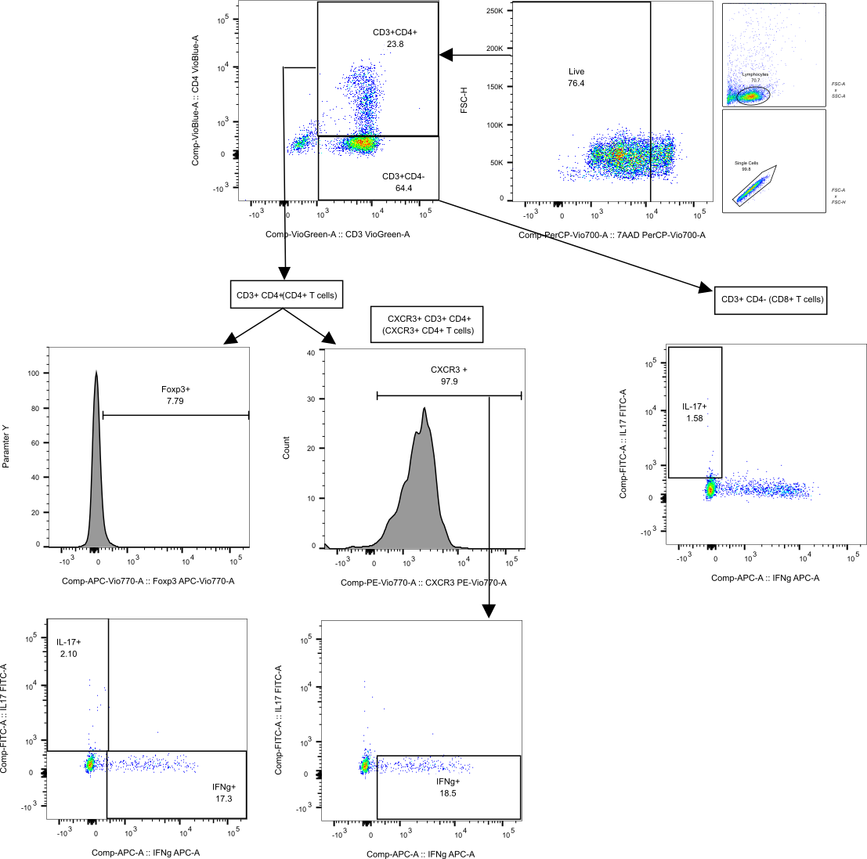
Supplementary Figure 2 | Gating strategy for the CD4-targeted panel. Patient PBMCs were isolated and stained for flow cytometry. After exclusion of doublets and non-lymphocytes, single lymphocytes were gate for live cells. Next, CD4⁺ and CD4⁻ T cells were gated out by plotting CD3-VioGreen versus CD4-VioBlue. Out of these subsets, those positive for FoxP3-AlexaFluor750, IFNy-Vio667, CXCR3-PE-Vio770, IL10-PE, and IL17A-Vio515 were gated out. Within the CXCR3⁺ CD4⁺ T cell subset, those positive for IFNy-Vio667 were gated out.
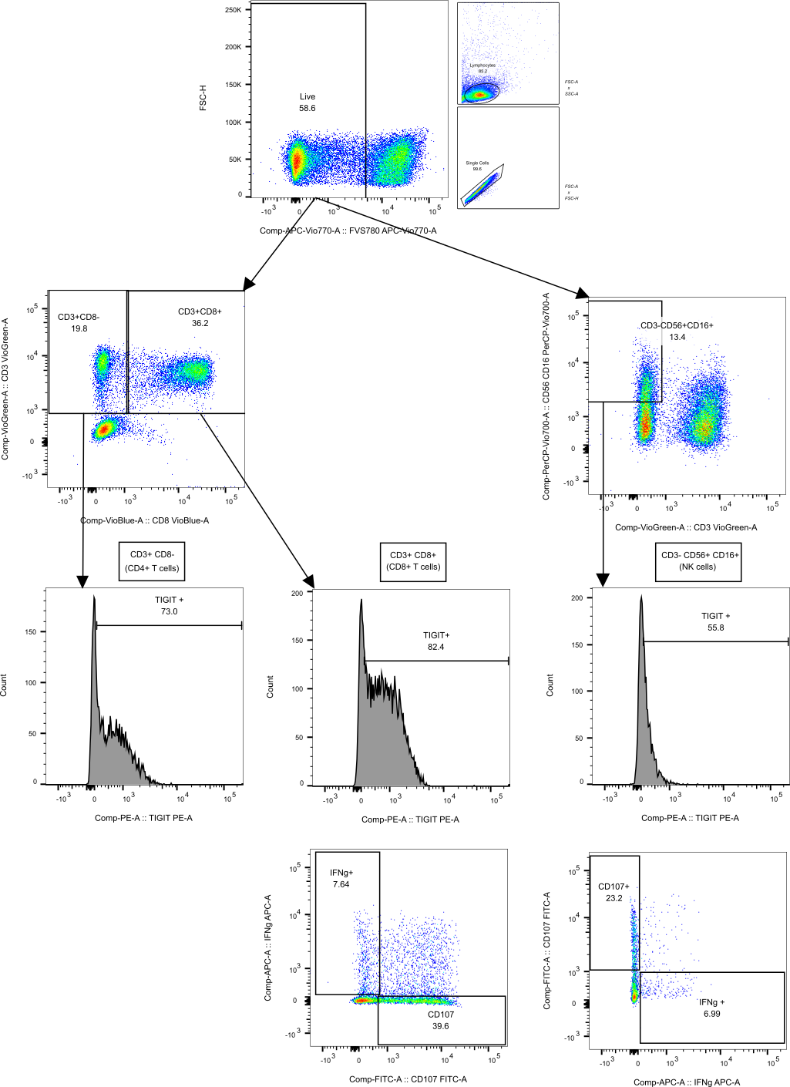
Supplementary Figure 3 | Gating strategy for the CD8/NK-targeted panel. Patient PBMCs were isolated and stained for flow cytometry. After exclusion of doublets and non-lymphocytes, single lymphocytes were gate for live cells. Next, CD8⁺ and CD8⁻ T cells were gated out by plotting CD3-VioGreen versus CD8-VioBlue. Subsequently, NK cells were gated out by plotting CD3-VioGreen versus CD56-CD16-PerCP-Vio700. Out of these subsets, those positive for TIGIT-PE, IFNy-Vio667, and CD107a-FITC were gated out.

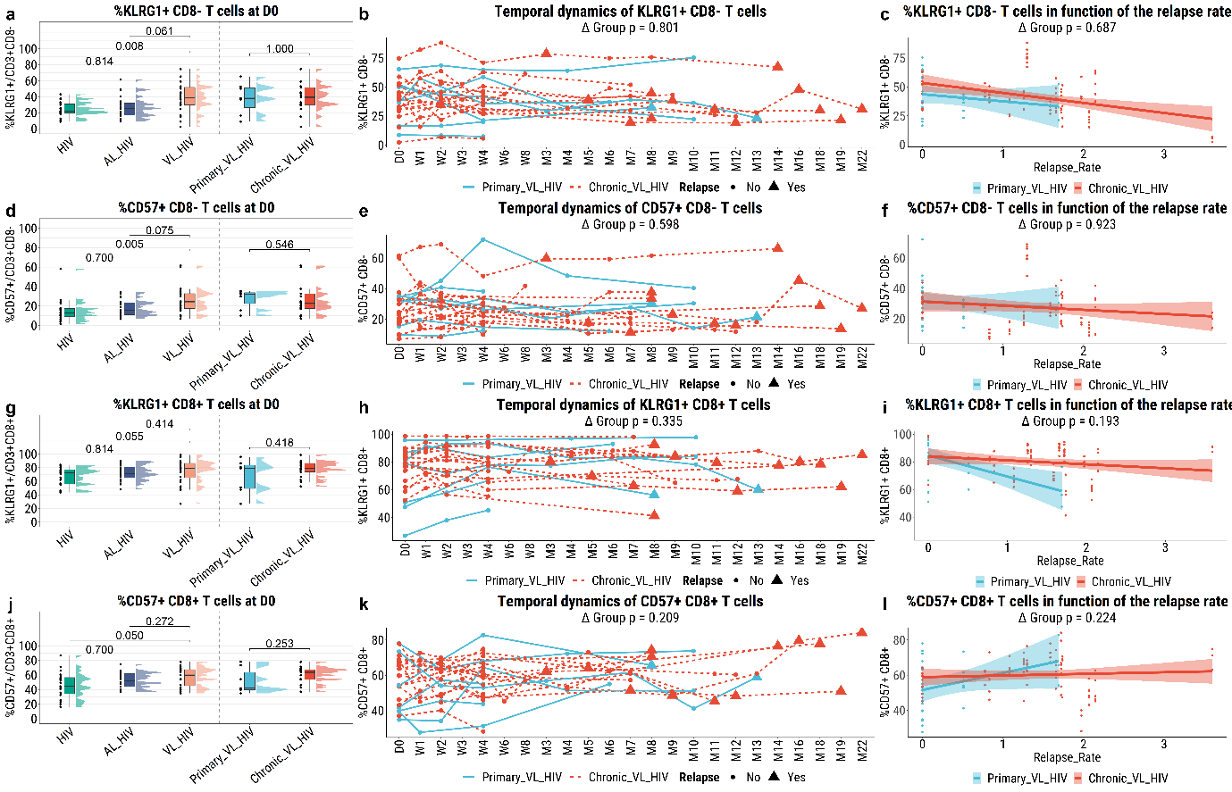
Supplementary Figure 4 | Immunosenescence in the CD4⁺ T cell (CD3⁺CD8⁻) and CD8⁺ T cell (CD3⁺CD8⁺) fractions of PBMCs isolated from the different patient groups as measured by flow cytometry. (A, D, G, J) Cross-sectional profiling of the proportions of KLRG1⁺ CD8⁻ T cells (CD3⁺CD8⁻/KLRG1⁺), CD57⁺ CD8⁻ T cells (CD3⁺CD8⁻/CD57⁺), KLRG1⁺ CD8⁺ T cells (CD3⁺CD8⁺/KLRG1⁺), and CD57⁺ CD8⁺ T cells (CD3⁺CD8⁺/CD57⁺), using a Benjamini-Hochberg corrected pairwise Mann-Whitney U test to test for statistical differences. (B, E, H, K) Longitudinal characterisation of the proportions of the same cellular subsets, for primary and chronic VL-HIV patients only, using linear mixed-effects models (see Methods). (C, F, I, L) Characterisation of the proportions of the same cellular subsets, in function of the annualised relapse rate, using linear mixed-effects models. Cross-sectional analysis total N = 63. Longitudinal analysis N = 24. Relapse rate analysis N = 21.

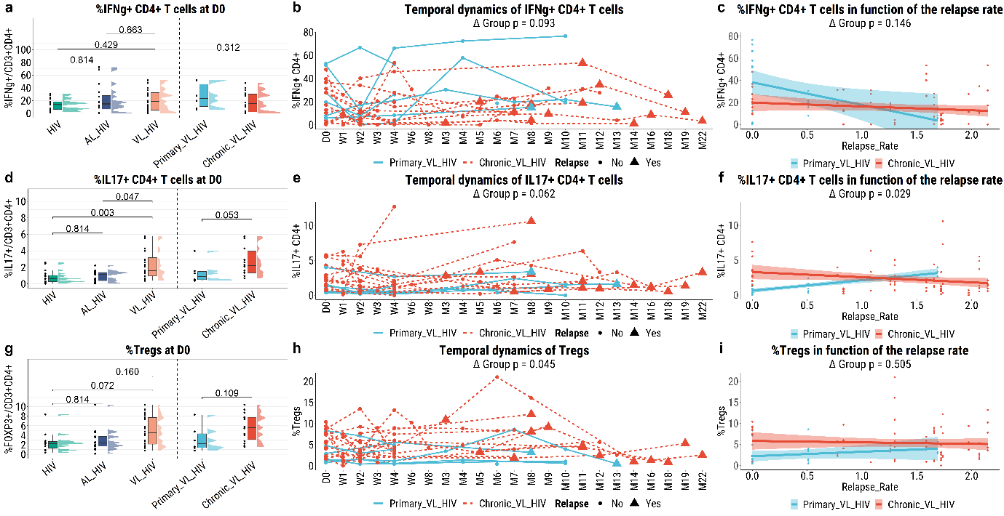
Supplementary Figure 5 | Cytokine response in the CD4⁺ T cell (CD3⁺CD4⁺) fraction of PBMCs isolated from the different patient groups as measured by flow cytometry. (A, D, G) Cross-sectional profiling of the proportions of IFNγ⁺ CD4⁺ T cells (CD3⁺CD4⁺/IFNγ⁺), IL17⁺ CD4⁺ T cells (CD3⁺CD4⁺/IL17⁺), and Tregs cells (CD3⁺CD4⁺/FOXP3⁺), using a Benjamini-Hochberg corrected pairwise Mann-Whitney U test to test for statistical differences. (B, E, H) Longitudinal characterisation of the proportions of the same cellular subsets, for primary and chronic VL-HIV patients only, using linear mixed-effects models (see Methods). (C, F, I) Characterisation of the proportions of the same cellular subsets, in function of the annualised relapse rate, using linear mixed-effects models. Cross-sectional analysis total N = 63. Longitudinal analysis N = 24. Relapse rate analysis N = 21.
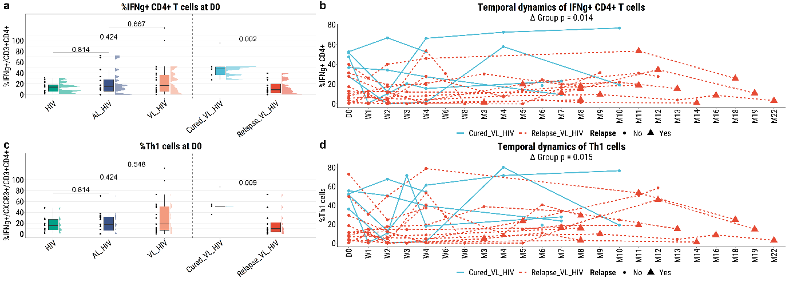
Supplementary Figure 6 | IFNγ response in the CD4⁺ T cell (CD3⁺CD4⁺) fraction of PBMCs isolated from long-term cured and relapsed VL-HIV patients as measured by flow cytometry. (A, C) Cross-sectional profiling of the proportions of IFNγ⁺ CD4⁺ T cells (CD3⁺CD4⁺/IFNγ⁺), and IFNγ⁺ Th1 cells (CD3⁺CD4⁺/CXCR3⁺/IFNγ⁺), using a Benjamini-Hochberg corrected pairwise Mann-Whitney U test to test for statistical differences. (B, D) Longitudinal characterisation of the proportions of the same cellular subsets, for long-term cured and relapsed VL-HIV patients only, using linear mixed-effects models (see Methods). Cross-sectional analysis total N = 63. Longitudinal analysis N = 24. Relapse rate analysis N = 21.
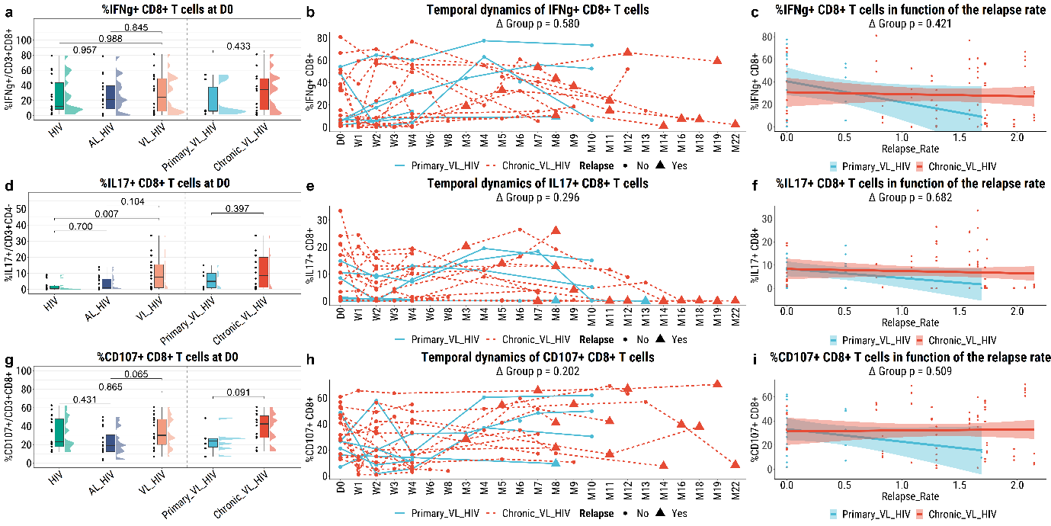
Supplementary Figure 7 | Effector response in the CD8⁺ T cell (CD3⁺CD8⁺) fraction of PBMCs isolated from the different patient groups as measured by flow cytometry. (A, D, G) Cross-sectional profiling of the proportions of IFNγ⁺ CD8⁺ T cells (CD3⁺CD8⁺/IFNγ⁺), IL17⁺ CD8⁺ T cells (CD3⁺CD4⁻/IL17⁺), and CD107⁺ CD8⁺ T cells (CD3⁺CD8⁺/CD107⁺), using a Benjamini-Hochberg corrected pairwise Mann-Whitney U test to test for statistical differences. (B, E, H) Longitudinal characterisation of the proportions of the same cellular subsets, for primary and chronic VL-HIV patients only, using linear mixed-effects models (see Methods). (C, F, I) Characterisation of the proportions of the same cellular subsets, in function of the annualised relapse rate, using linear mixed-effects models. Cross-sectional analysis total N = 63. Longitudinal analysis N = 24. Relapse rate analysis N = 21.

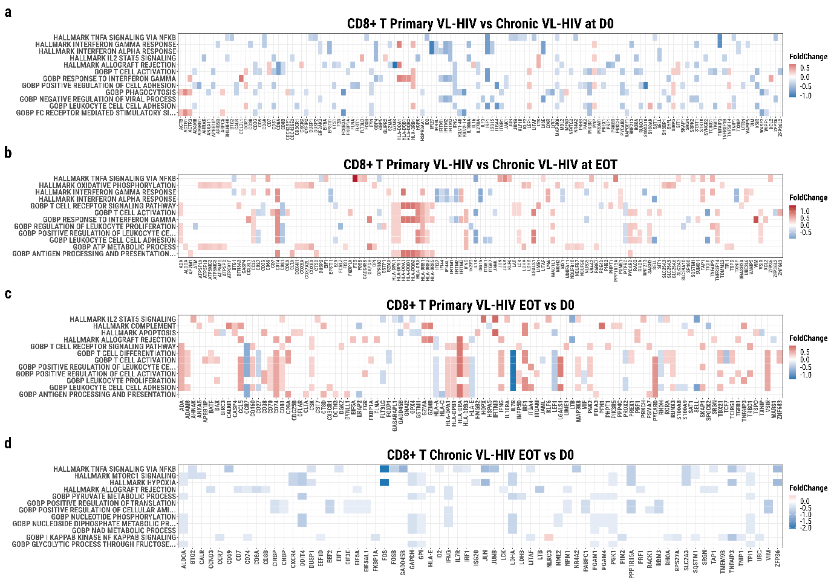
Supplementary Figure 8 | Pathway overrepresentation visualised as a heatmap performed on the differentially expressed genes between (A) CD8⁺ T cells of primary VL-HIV patients and chronic VL-HIV patients at D0, (B) CD8⁺ T cells of primary VL-HIV patients and chronic VL-HIV patients at EOT, (C) CD8⁺ T cells of primary VL-HIV patients at EOT and D0, (D) CD8⁺ T cells of chronic VL-HIV patients at EOT and D0. N = 2 each group and timepoint.
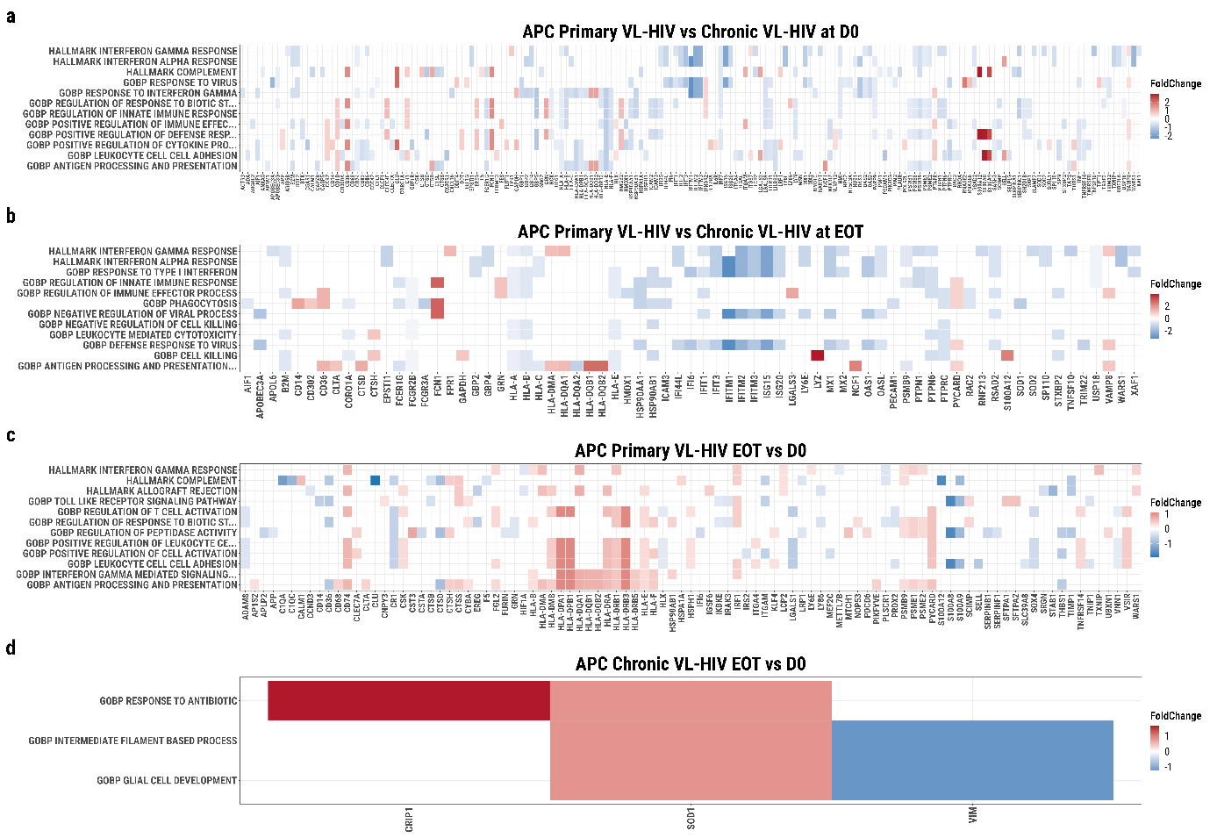
Supplementary Figure 9 | Pathway overrepresentation visualised as a heatmap performed on the differentially expressed genes between (A) APC of primary VL-HIV patients and chronic VL-HIV patients at D0, (B) APC of primary VL-HIV patients and chronic VL-HIV patients at EOT, (C) APC of primary VL-HIV patients at EOT and D0, (D) APC of chronic VL-HIV patients at EOT and D0. N = 2 each group and timepoint.

Supplementary Table 1 | Patient socio-demographic, clinical, and biochemical characteristics, for the patient subset included in the single-cell analyses, at various timepoints, including at time of recruitment for HIV and AL-HIV patients or active disease development for VL-HIV patients (D0), at End-of-Treatment (EOT; VL-HIV only) and at six months post-treatment (Post M6; VL-HIV only). Patient characteristics for the healthy endemic controls (HEC) are not reported.
 | Total (n=8) | HIV (n=2) | AL-HIV (n=2) | VL-HIV (n=4) | Primary VL-HIV (n=2) | Chronic VL-HIV (n=2)
Socio-demographic characteristics
Age in years, median (IQR) | 42.5 (36.5-45.5) | 39 (37-41) | 31 (28-34) | 46 (44-52.5) | 58 (52.5-63.5) | 43.5 (43-44)
Male, n (%) | 8 (80) | 2 (100) | 2 (100) | 4 (100) | 2 (100) | 2 (100)
BMI in kg/m2, median (IQR) | 17.6 (15.8-19) | 17.5 (17.1-18) | 16.8 (15.7-17.8) | 17.6 (15.8-19.3) | 17.6 (16.7-18.4) | 17.6 (16.7-18.5)
Literacy, n (%) | 6 (60) | 1 (50) | 2 (100) | 3 (75) | 2 (100) | 1 (50)
Daily labourer | 5 (50) | 0 (0) | 2 (100) | 3 (75) | 1 (50) | 2 (100)
Farmer | 1 (10) | 0 (0) | 0 (0) | 1 (25) | 1 (50) | 0 (0)
Other | 2 (20) | 2 (100) | 0 (0) | 0 (0) | 0 (0) | 0 (0)
Clinical history and characteristics
VL history, n (%) | 2 (20) | 0 (0) | 0 (0) | 2 (50) | 0 (0) | 2 (100)
Past VL episodes, median (IQR) | 0 (0-2.25) | 0 (0-0) | 0 (0-0) | 4.5 (0-9.5) | 0 (0-0) | 10 (9.5-10.5)
Months since previous VL episode, median (IQR) | 3.5 (3-4) | NA | NA | 3.5 (3-4) | NA | 3.5 (3-4)
Microscopically confirmed, n (%) | 2 (20) | 0 (0) | 0 (0) | 2 (50) | 0 (0) | 2 (100)
Parasite grading, n (%)
+4 to +6 | 2 (20) | 0 (0) | 0 (0) | 2 (50) | 0 (0) | 2 (100)
VL treatment regimen, n (%)
AmBisome + Miltefosine | 4 (100) | 0 (0) | 0 (0) | 4 (100) | 2 (100) | 2 (100)
On ART, n (%) | 8 (80) | 2 (100) | 2 (100) | 4 (100) | 2 (100) | 2 (100)
Concomitant diseases, n (%) | 0 (0) | 0 (0) | 0 (0) | 0 (0) | 0 (0) | 0 (0)
Laboratory markers at D0
CD4 count, median (IQR); (cells/μl) | 100 (73-238) | 416 (296-536) | 249 (164-334)) | 76 (55-97) | 54 (52-55) | 100 (97-102)
Lymphocytes, median (IQR); (x10³/µl) | 0.7 (0.26-1.08) | 1.31 (1.19-1.44) | 0.93 (0.83-1.04) | 0.24 (0.19-0.38) | 0.17 (0.15-0.19) | 0.48 (0.38-0.57)
Platelets, median (IQR); (x10³/µl) | 140 (107-145) | 142 (138-145) | 136 (91-181) | 136 (100-144) | 136 (131-140) | 82 (52-113)
Hemoglobin, median (IQR); (g/dL) | 10 (7.9-11.3) | 13.6 (12.2-14.9) | 9.6 (9-10.1) | 7.8 (6.1-10.1) | 5.9 (5.7-6.1) | 10.9 (10.1-11.7)
Laboratory markers at EOT
Lymphocytes, median (IQR); (x10³/µl) | NA | NA | NA | 0.57 (0.28-0.89) | 0.49 (0.32-0.65) | 0.73 (0.52-0.93)
Platelets, median (IQR); (x10³/µl) | NA | NA | NA | 184 (140-242) | 282 (242-322) | 111 (82-140)
Hemoglobin, median (IQR); (g/dL) | NA | NA | NA | 10 (8.5-11.3) | 8 (7.5-8.5) | 11.7 (11.3-12)
Laboratory markers at Post M6
CD4 count, median (IQR); (cells/μl) | NA | NA | NA | 273 (210-448) | 448 (360-536) | 146 (146-146)*
Lymphocytes, median (IQR); (x10³/µl) | NA | NA | NA | 0.78 (0.74-1.04) | 1.04 (0.91-1.16) | 0.7 (0.7-0.7)*
Platelets, median (IQR); (x10³/µl) | NA | NA | NA | 158 (124-231) | 272 (231-314) | 122 (120-124)
Hemoglobin, median (IQR); (g/dL) | NA | NA | NA | 10.4 (9.6-11.3) | 10.2 (9.8-10.7) | 10.6 (10.2-11.1)
NA = Not Applicable. * = missing value for one out of two patients.

