3-NAntC: a novel Crotoxin B-derived peptide for the treatment of triple-negative breast cancer

Patrícia Heloise Alves Bezerra ^{1,}* and Eduardo Motti ^{1,}*.

¹ PHP Biotech International Inc.

* Corresponding author.

PHP Biotech International Inc, 2317 Watercrest Drive, Keller, TX 76248
e-mail: ________@________.com

Supplementary results.

Absorbance (AU)
Retention time (min)
Supplementary Figure S1. HPLC chromatogram of 3-NantC. The peptide had purity higher than 95%. Absorbance at the wavelength of 220 nm.

Relative abundance
m/z
Supplementary Figure S2. MS spectrum of 3-NAntC. The mass spectrometry characterization with ESI ionization confirmed the peptide sequence [H]-MFYPDSRCRGPSET-[OH] (Molecular weight = 1,645.95 g/mol).

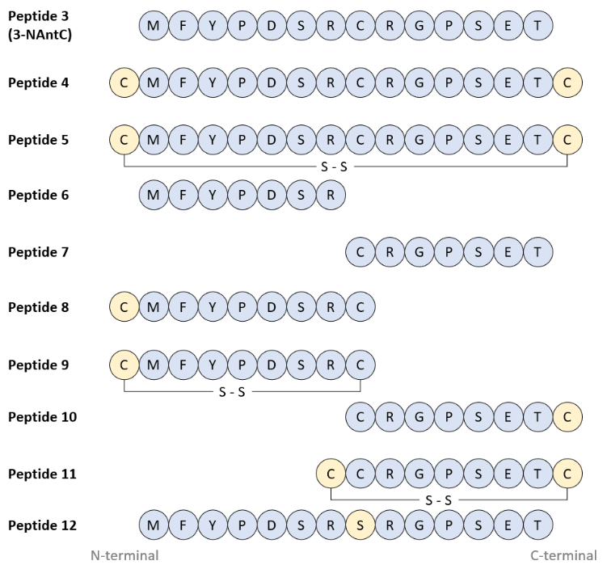
Supplementary Figure S3. Aminoacid sequences of the 3-NAntC-derived peptides. The amino acids matching the original 3-NAntC sequence are shown in blue, while the additional amino acids are shown in light orange. Intramolecular disulfide bonds are denoted as ‘S-S’. The sequences are shown from the N- to the C-terminal regions.

Supplementary Figure S4. Effect of 3-NAntC-derived peptides on TNBC cells (MDA-MB-231) viability. (A) MDA-MB-231 cells were treated with 3-NAntC or peptides 4 – 12 for 72 hours at the concentration range of 0.4 – 1.0 µg/mL. (B) Antitumor effect of 3-NAntC in comparison with the combination of the peptides 6 and 7. Cellular viability assay was conducted using the MTT method for TNBC cell line. Data are shown as mean ± s.e.m. of at least three independent assays in triplicate. Treatment groups for each peptide were compared versus the respective negative control (without treatment) using two-way ANOVA and Bonferroni post hoc test. *p<0.05, **p<0.01, ***p<0.001 and ****p<0.0001 denote statistically significant differences for all the groups at a specific concentration.

Supplementary Figure S5. Effect of 3-methyladenine (3-MA) (an autophagy inhibitor) on the decrease of MDA-MB-231 cells viability mediated by 3-NAntC. MDA-MB-231 cells were treated with increasing concentrations of 3-NAntC in the presence or not of 3-methyladenine (3-MA) for 24 (A) or 48 hours (B). Cell viability was measured using MTT assay. Data are shown as mean ± s.e.m. of at least three independent assays in triplicate. Groups treated with 3-NAntC alone were compared to those treated with 3-NAntC + 3-MA (the autophagy inhibitor) using one-way ANOVA and Bonferroni post-hoc test. No statistically significant differences were observed between the groups, p>0.05.

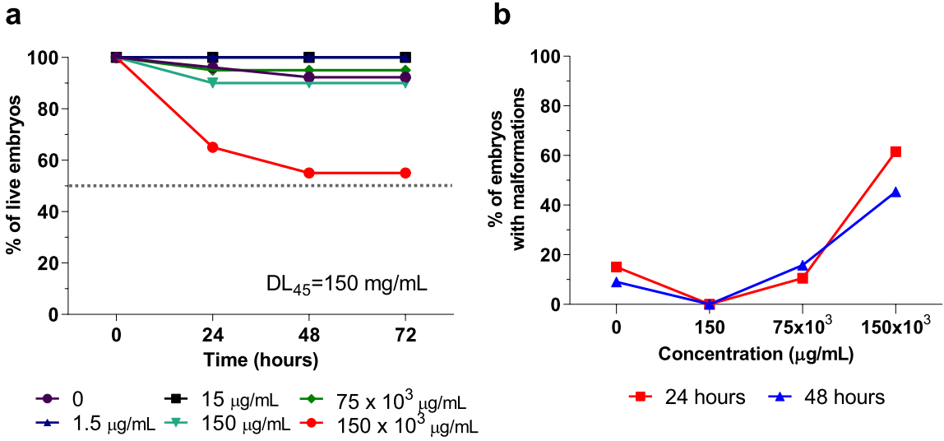
Supplementary Figure S6. 3-NAntC safety evaluation using zebrafish embryos. Embryo survival (A) and malformation in live embryos (B) were assessed following exposure to 3-NAntC (1.5 – 150 x 10³ µg/mL) for up to 72 hours. 3-NAntC exhibits low toxicity and malformation to zebrafish embryos up to 75 mg/mL. Data is shown as the percentage of live embryos and percentage of live embryos with malformation after the treatment with 3-NAntC (n=20 embryos/group).

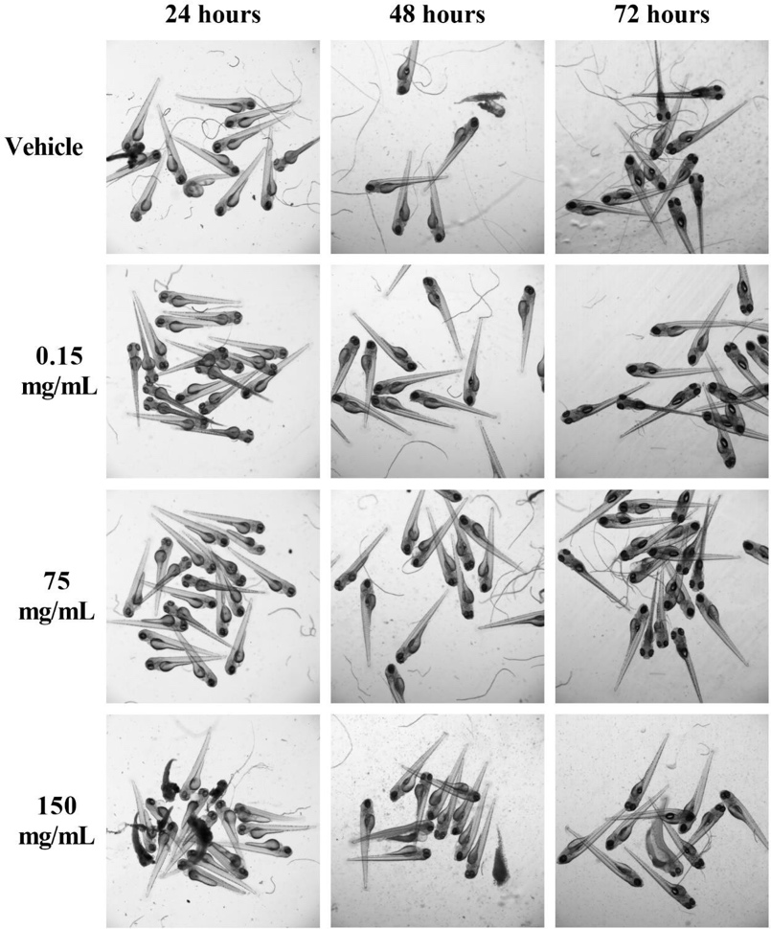
Supplementary Figure S7. Representative images of the tolerability test of 3-NAntC in zebrafish embryos. Zebrafish embryos were incubated with vehicle (control) or 3-NAntC peptide (0.15, 75 and 150 mg/mL) for 24, 48 or 72 hours.

