Supplementary Information:

Title: Unexpected worker mating and colony-founding in a superorganism.
Authors: Mingsheng Zhuang, Thomas J Colgan, Yulong Guo, Zhengyi Zhang, Fugang Liu, Zhongyan Xia, Xueyan Dai, Zhihao Zhang, Yuanjian Li, Liuhao Wang, Jin Xu, Yueqing Guo, Yingping Qu, Jun Yao, Huipeng Yang, Fan Yang, Jun Guo, Mark JF Brown, and Jilian Li.

Supplementary Information: 1
Supplementary Data 2
A) Transcriptomic analyses of reproductive tissues (spermatheca, vagina, and median oviduct) of inseminated and non-inseminated (control) bumble bee castes 2
B) Transcriptomic analyses of the brains of inseminated and non-inseminated (control) bumble bee castes 3
C) Transcriptomic analyses of the fat body of inseminated and non-inseminated (control) bumble bee castes 4
D) Transcriptomic analyses of the ovaries of inseminated and non-inseminated (control) bumble bee castes 5
Extended Data Figures 7
Supplementary Tables 29
Supplementary Videos 29

Supplementary Data

A) Transcriptomic analyses of reproductive tissues (spermatheca, vagina, and median oviduct) of inseminated and non-inseminated (control) bumble bee castes
Raw FASTQ files for 40 reproductive tissue (spermatheca, vagina and median oviduct) samples (n = 20 workers; n = 20 queens: Supplementary Table 7) were filtered for quality using fastp³⁶(v.0.23.0) to remove adaptors and low-quality sequences. We next aligned filtered sequences from each sample against the latest B. terrestris reference genome assembly (obtained from Ensembl Metazoa; release 53, GCA_000214255.1) using the short read aligner, STAR³⁹(v.2.7.10a). Mean mapping rate was high (99% of reads mapped per samples) and using gene-level read counts calculated by STAR, transcript expression was detected for 94% of all known genes (n = 11,284/12,008) across all samples. Gene-level counts were loaded into DESeq2⁴⁰ (v.1.26.0) to create a DESeq2 object. We provide these raw gene-level counts to aid independent reanalysis (Supplementary Table 7). We next filtered out genes with low read counts across samples before we generated variance-stabilization transformed (VST) counts. Using these counts, we performed hierarchical clustering based on Euclidean distances finding separation of individual based on caste, with the exception for one worker that clustered with queens (Extended Data Fig.9). We removed one aberrant queen sample and performed a principal component analysis (PCA), which also separated samples based on caste: principal component (PC) 1 explained 73% of the variance in the dataset, largely separating workers and queens into two clusters (Extended Data Fig.10). The second principal component (PC2) separated individuals based on insemination status, explaining a smaller proportion of the variance in the dataset (13%, Extended Data Fig.10).
Using VST counts from DESeq2, we performed a weighted co-expression network analysis for samples from reproductive tissues using WGCNA. Genes clustered into six modules, which ranged in gene assignment from 79 genes (“pink” module) to 9,392 genes (“turquoise” module). We examined correlations between each module and insemination status (treatment), caste, and age (stage), respectively, finding two modules (“red”, n = 154 genes; “yellow”, n = 840 genes) that had strong positive correlations with treatment (“red”, R = 0.67, p = 3e-06; “yellow”, R = 0.94, p = 2e-18; Extended Data Fig.11a). The “yellow” module was also positively correlated (R = 0.45, p = 0.005) with age but the significant of correlation was not as strong as for treatment. For both “red” and “yellow” modules, we identified the hub (driver) genes as a ribosome biogenesis protein BOP1 homologue (LOC100642762), a gene required for ribosomal maturation, essential for translation, and a double-stranded RNA-specific editase Adar (LO100651176), a gene associated with behavior, reproduction, and glucose metabolism in the fruit fly, respectively. Independent Gene Ontology enrichment analyses was performed for genes assigned to each module identifying enrichment of 13 and 54 enriched GO terms for the “red” and “yellow” modules, respectively. For the “yellow” module, enriched terms included 32 BP terms, identifying a diverse range of processes influenced by insemination, including enriched GO terms associated with translation, neurology, immunity, and development (Extended Data Fig.11b).

Transcriptomic analyses of the brains of inseminated and non-inseminated (control) bumble bee castes
To determine genes expressed in the brain, an important regulator of behavior, nervous system function, and reproduction, we performed RNA-seq analysis for 72 brain-derived libraries consisting of 48 worker and 24 queen samples, respectively. For the generation of RNA-seq libraries, brains were collected and pooled for bees at three stages of ovarian development and from one of four treatment groups: insemination group (AI Group 1), insemination with diluent (AI Group 2), injection only (AI Group 3), and control (non-inseminated) bees (Supplementary Table 7). For the worker samples, there was four pooled samples per ovarian development stage for each of the four treatments while for the queens, only insemination group (AI Group 1) and control bees were collected. The mean library size for the raw brain samples was 23.9 million PE reads (min: 20.8 million PE reads; max: 25.4 million PE reads) with a mean alignment rate of 99.9% against the reference genome assembly. Of the genes detected as expressed in the brain, 78% of genes (n = 9,103/11,549) were expressed in all samples (Supplementary Table 7). Similar to as outlined above, we created a DESeq2 object using all brain samples and performed variance-stabilization transformation on counts. Using these counts, we assessed outliers through a hierarchical clustering-based analysis identifying three samples with aberrant expression profiles (Extended Data Fig.12), which were removed from further analysis. A subsequent PCA separated individuals based on stage of ovarian development (PC1: 31% of variance explained) while PC2, which explained 18% of the variance, largely separated individuals based on caste (Extended Data Fig.13).
Given the differences in number of treatments and associated samples per caste, for differential gene expression analysis we analyzed the datasets of each caste independently. For both caste-specific analyses, we used a likelihood ratio test (LRT) that compared a full model consisting of stage of ovarian development (“stage”) and treatment with a reduced model consisting of stage only. For the workers, we additionally compared the log₂ fold change values for each treatment group against the control samples applying a significant threshold of FDR < 0.05 and an absolute log₂FC greater than or equal to one (|log₂FC| >= 1) to determine genes that were significantly differentially expressed between a particular treatment group and the control group. Using these criteria, we found that the artificial insemination treatment (AI Group 1), which included bees that received a transfer of semen, had the greatest transcriptional changes compared to control bees with 224 genes differentially expressed, of which 211 had elevated expression in response to treatment (Supplementary Table 7). We found that the other insemination treatments also, in general, resulted in elevated gene expression when compared to the control group but the overall number of differentially expressed genes was lower (AI Group 2 = 80 elevated genes / 86 total genes; AI Group 3 = 63 / 85) than the artificial insemination group. A comparison of differentially expressed genes across the three treatment groups identified 40 DEGs with consistently elevated expression in all three treatments suggestive of a conserved response to the insemination procedure (Extended Data Fig.14). A further 64 DEGs were found in two treatment groups while 123 DEGs were unique to insemination group (AI Group 1, Extended Data Fig.15a), which were enriched for GO terms associated with development, metamorphosis, and transcription (Extended Data Fig.15b).
For the queen samples, which consisted of two treatment groups (insemination group (AI Group 1) and control), we found 59 DEGs (FDR < 0.05; |log₂FC| >= 1) with the majority (n = 52) having elevated expression in response to insemination (Supplementary Table 7). Of this number, 25 genes were also elevated in response to the insemination treatment in workers while one gene was reduced in both castes highlighting certain conserved responses in the brain to insemination across castes.

Transcriptomic analyses of the fat body of inseminated and non-inseminated (control) bumble bee castes
To investigate how insemination affects genes expressed in the fat bodies, an important producer of proteins involved in reproduction and egg development, we performed RNA-seq analysis for 72 fat body-derived libraries consisting of 48 worker and 24 queen samples. The mean library size for the raw fat body samples was 24.2 million PE reads (min: 22.3 million PE reads; max: 25.5 million PE reads) with a mean alignment rate similar to the brain samples of 99.9% against the reference genome assembly. Of the genes detected as expressed in the fat bodies, 75% of genes (n = 8,603/11,440) were expressed in all samples (Supplementary Table 7).
Initial clustering-based analysis based on Euclidean distance between samples and principal component analysis revealed three outlier samples, which were removed from downstream analyses. Hierarchical clustering using the reduced sample dataset revealed clustering of samples based on both caste but also stage of ovarian development (Extended Data Fig.16). A similar pattern was also observed with a principal component analysis, whereby the first PC, which explained 40% of the variance in the dataset, separated samples based on stage of ovarian development, while the second PC separated individuals based on caste (Extended Data Fig.17).
Similar to the brain samples, we analyzed each caste dataset independently. For the workers, we compared each treatment group against the control samples finding the artificial insemination treatment (AI Group 1), which included the transfer of semen, induced the greatest transcriptional changes with 208 genes differentially expressed of which 191 had elevated expression in response to treatment (Supplementary Table 7). The diluent treatment (AI Group 2) elicited a similar response in terms of number of DEGs although the proportion of genes with elevated expression (n = 89/114) was reduced compared to AI Group 1. The last treatment group (AI Group 3), which involved bees that were exposed to the injection without liquid elicited the largest response with 185 DEGs in response to treatment with a similar number of genes having elevated (n = 161) or reduced (n = 24) expression in comparison to control samples. Across all treatments, 39 genes were consistently differentially expressed (Extended Data Fig.18). The most unique DEGs were found for the insemination (AI Group 1; n = 108), followed by the injection (AI Group 3) and diluent (AI Group 2) groups, respectively (Extended Data Fig.18 and 19).
For the queens, differential expression analysis between inseminated and control bees identified a total of 125 DEGs (FDR < 0.05; |log2FC| >= 1). In contrast to the brains where inseminated induced elevated gene expression, the directional change in expression was less strong with approximately a third of DEGs (n = 45) having elevated expression in the fat bodies of inseminated bees with the majority (n = 80) displaying reduced expression compared to control bees. There was only a small number of DEGs that overlapped between the castes with three DEGs having elevated expression in response to artificial insemination in both castes while four genes had reduced expression.

Transcriptomic analyses of the ovaries of inseminated and non-inseminated (control) bumble bee castes
To determine the influence of insemination on ovarian gene expression, we performed RNA-seq analysis for 72 ovary-derived libraries consisting of 48 worker and 24 queen samples. The mean library size for the raw ovary samples was 24 million PE reads (min: 20.9 million PE reads; max: 25.5 million PE reads) with a mean alignment rate similar to the other tissues of 99.9% against the reference genome assembly. Of the genes detected as expressed in the ovaries, 81.8% of genes (n = 9487/11602) were expressed in all samples (Supplementary Table 7).
Initial clustering-based analyses of VST gene-level counts using hierarchical clustering and PCA revealed the presence of two outlier samples, which were removed from downstream analyses. Using the filtered dataset, we found samples primarily clustered based on stage of ovarian development (Extended Data Fig. 20 and 21). We performed differential expression analysis identifying 156 genes that differed in expression between inseminated (AI Group 1) and control bees, of which, the majority (n = 143 genes) had elevated expression. Insemination with diluent only (AI Group 2) resulted in the significant differential expression of 63 genes with approximately two-thirds (n = 42) having elevated expression in comparison to control. The last group comparison (AI Group 3) identified that injection alone affected the expression of 41 genes of which 28 had elevated expression compared to control. Across all three treatments, 14 genes were consistently differentially expressed in comparison to the control samples (Extended Data Fig. 22). We identified a total of 111 genes uniquely differentially expressed in inseminated workers compared to control (Extended Data Fig. 22 and 23). These genes were significantly enriched (Fisher’s exact test; P < 0.05) for GO terms (n = 7 terms) associated with transcription factor activity, neuron projection, and signal transduction (Extended Data Fig. 23).
For the queens, we identified 51 genes that differed significantly in expression in response to insemination (LRT, FDR < 0.05; |log2FC| >=1) with the majority (n = 40) have reduced expression. Three DEGs had conserved elevated expression in inseminated workers compared to the control treatment while two DEGs had conserved reduced expression.

Extended Data Figures
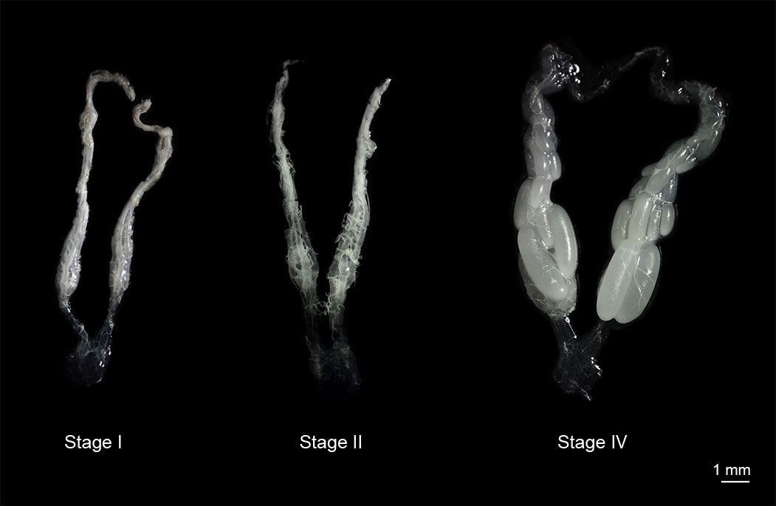
Extended Data Fig.1. Stages of bumble bee ovarian development. In the present study, we characterized ovarian development of reproductive workers and queens as belonging to the following stages: stage I, immature ovary with a thread-like appearance; stage II, presence of nutritive cells (i.e., nurse cells) larger than egg cells; and stage IV, the presence of mature eggs (after oviposition). Ovaries were photographed using a camera (Canon. EOS 650D) under a light microscope with 15x magnification.
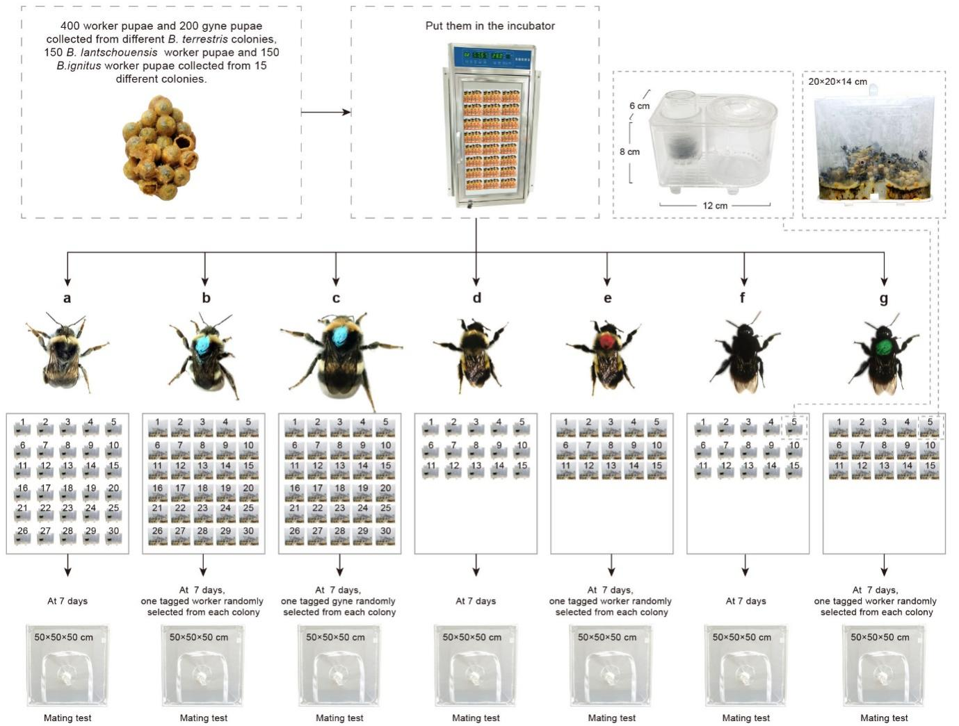
Extended Data Fig.2. The effects of social constraints on mating success in worker bumble bees. Pupae for both workers and queens were collected and incubated to assist in development and monitored daily to track emergence. Newly emerged callows of each species were entered into the following treatments: a) after hatching, each B. terrestris worker callow was kept in an individual small plastic box in solitary; b) after hatching, each of three B. terrestris callows were tagged and placed in a queen-right colony; c) after hatching, each of three B. terrestris gynes were tagged and placed in a queen-right colony; d) after hatching, each B. lantschouensis callow was kept in an individual small plastic box in solitary; e) after hatching, each of two B. lantschouensis callows were tagged and placed in a queen-right colony; f) after hatching, each B. ignitus callow was kept in an individual small plastic box in solitary; g) after hatching, each of two B. ignitus callows were tagged and placed in a queen-right colony. After seven days, the isolated workers, and one tagged worker and one tagged gyne randomly selected from each colony, were given the opportunity to mate with males.

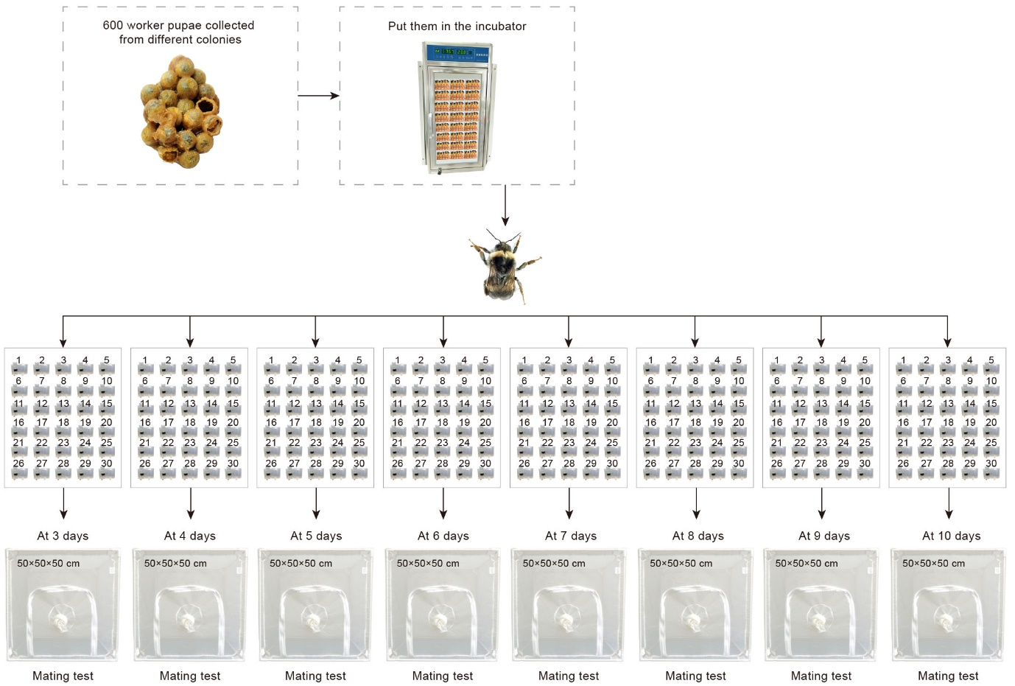
Extended Data Fig. 3. Worker age influences mating success. To determine how age may influence mating, we first collected worker pupae and placed them into individual boxes before incubating to stimulate development and monitoring daily to track eclosion. We then randomly chose callows to be given the opportunity to mate at days 3, 4, 5, 6, 7, 8, 9, and 10 post-hatching.

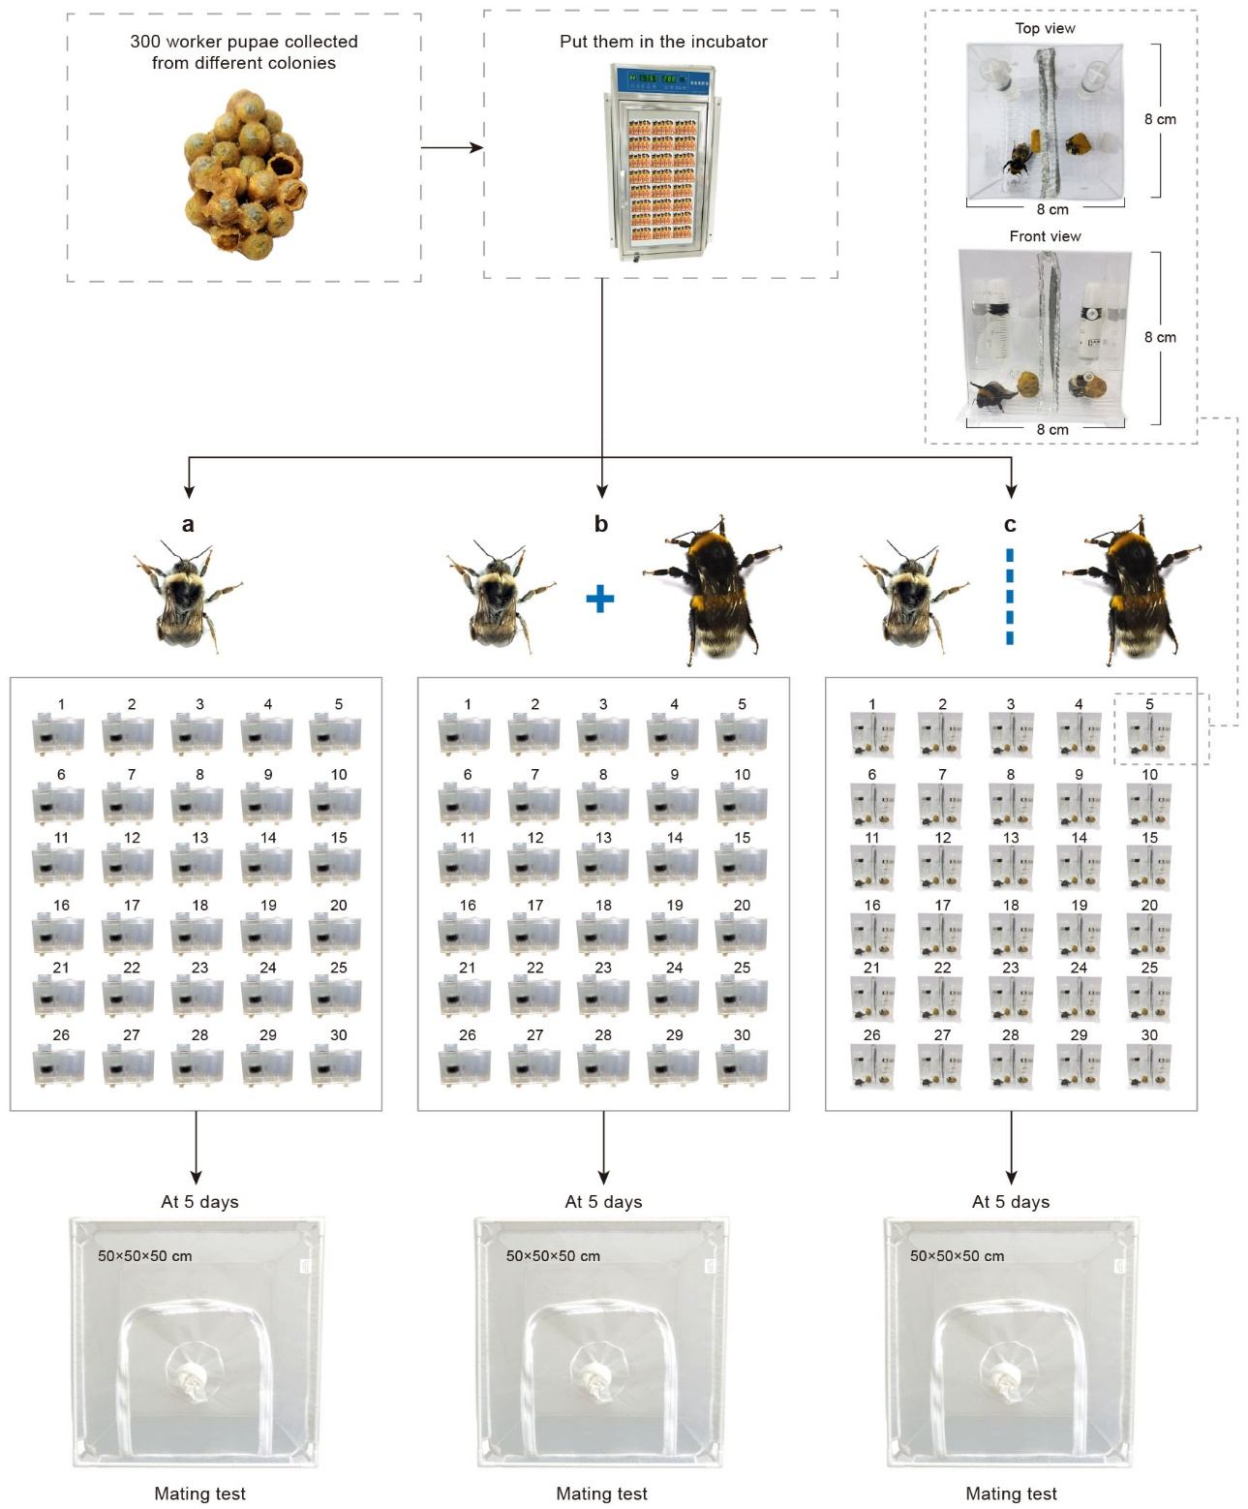

Extended Data Fig. 4. The mating potential of workers is influenced by physical contact with queens. Worker pupae were collected, kept individually, incubated to assist in development and monitored daily to track emergence. Newly emerged workers were entered into one of three treatments: a) after hatching, each callow was kept in an individual small plastic box in solitary; b) after hatching, each callow was kept with one egg-laying queen, allowing physical contact between worker and queen; or c) after hatching, each callow was kept with one egg-laying queen but separated by a metal mesh (ϕ 1mm) that prevented physical contact. After five days, workers from each of the three treatments were exposed to mating trials.

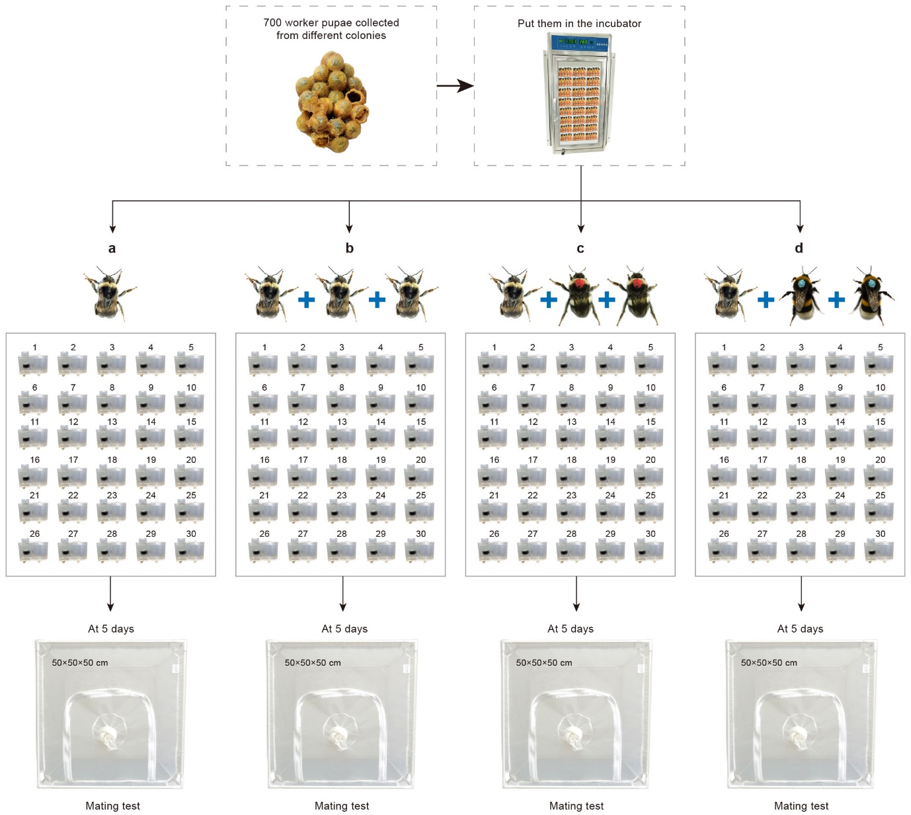
Extended Data Fig. 5. Worker presence inhibits the mating ability of newly-emerged workers. Worker pupae were collected, kept individually, incubated to assist in development and monitored daily to track emergence. Newly emerged workers were entered into one of four treatments: a) after hatching, each callow was kept in an individual box on its own; b) after hatching, each of three callows sampled on the same day of eclosion were kept together in a single box; c) one callow was kept alone in a single box for 24 hours, after which, two tagged callows were added, which subsequently, were replaced with two new callows every 24 hours; and d) after hatching, each callow was kept with two tagged, egg-laying workers. After five days in their respective treatment groups, workers were exposed to mating trials.
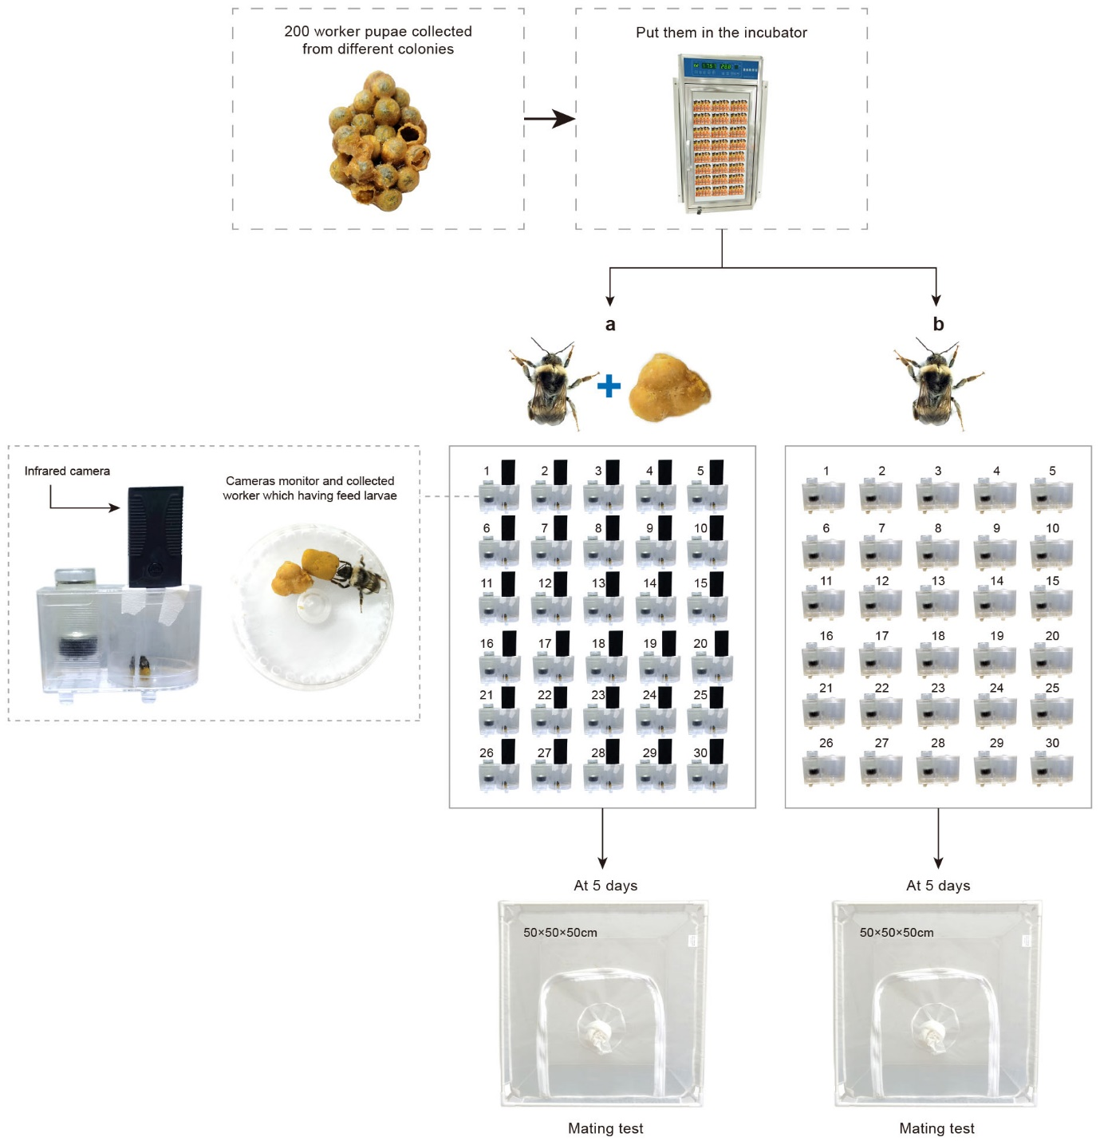
Extended Data Fig. 6. Feeding behavior affects the mating ability of workers. Worker pupae were collected, kept individually, incubated to assist in development and monitored daily to track emergence. Newly emerged callows were randomly assigned to one of two treatments: a) after hatching, each callow was kept in an individual box with three larvae; or b) after hatching, each callow was kept in an individual box alone. After five days in their respective treatment groups, workers were exposed to mating trials.
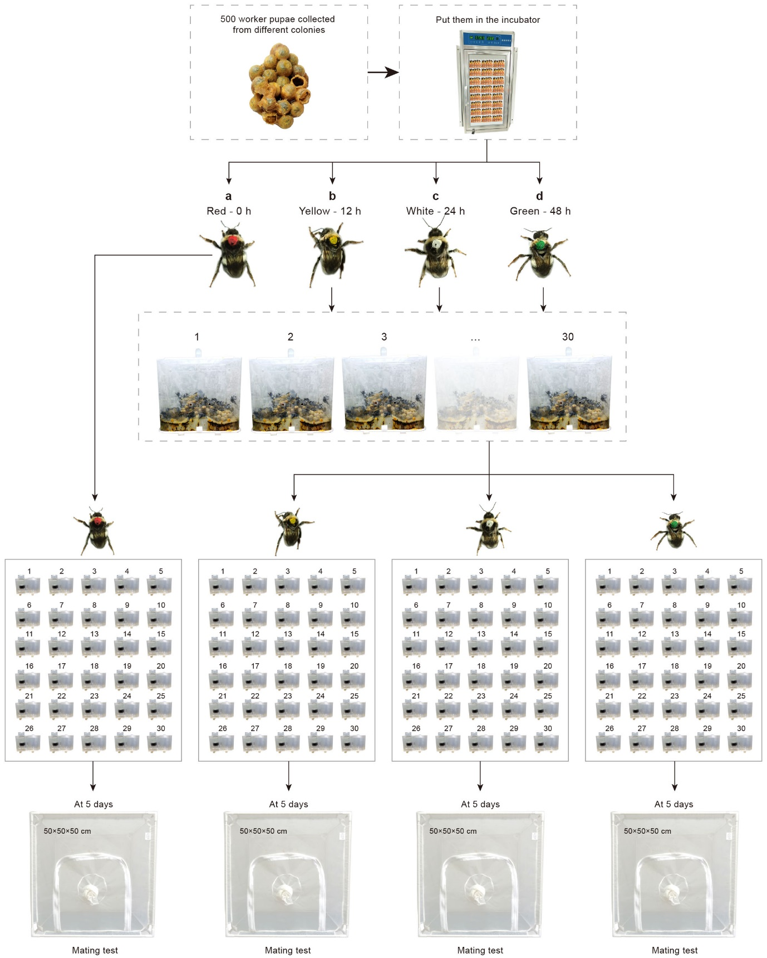
Extended Data Fig. 7. The duration in a social environment post-eclosion influences mating success. We collected 360 newly emerged callow workers from pupae population (sampled from 100 different colonies) and allocated them into four groups (n = 90 callows per group), with individuals in each group tagged with a specific color indicating the time spent in a queen-right colony post-emergence: a) red = 0h in social environment (i.e., no time spent in colony post-tagging); b) yellow = 12h spent in colony post-tagging; c) white = 24h spent in colony post-tagging; and d) green = 48h spent in colony post-tagging. For each treatment group, 30 workers were randomly subsampled, and after social exposure each bee was kept in an individual box. When they were 5 days old, workers were exposed to mating trials.

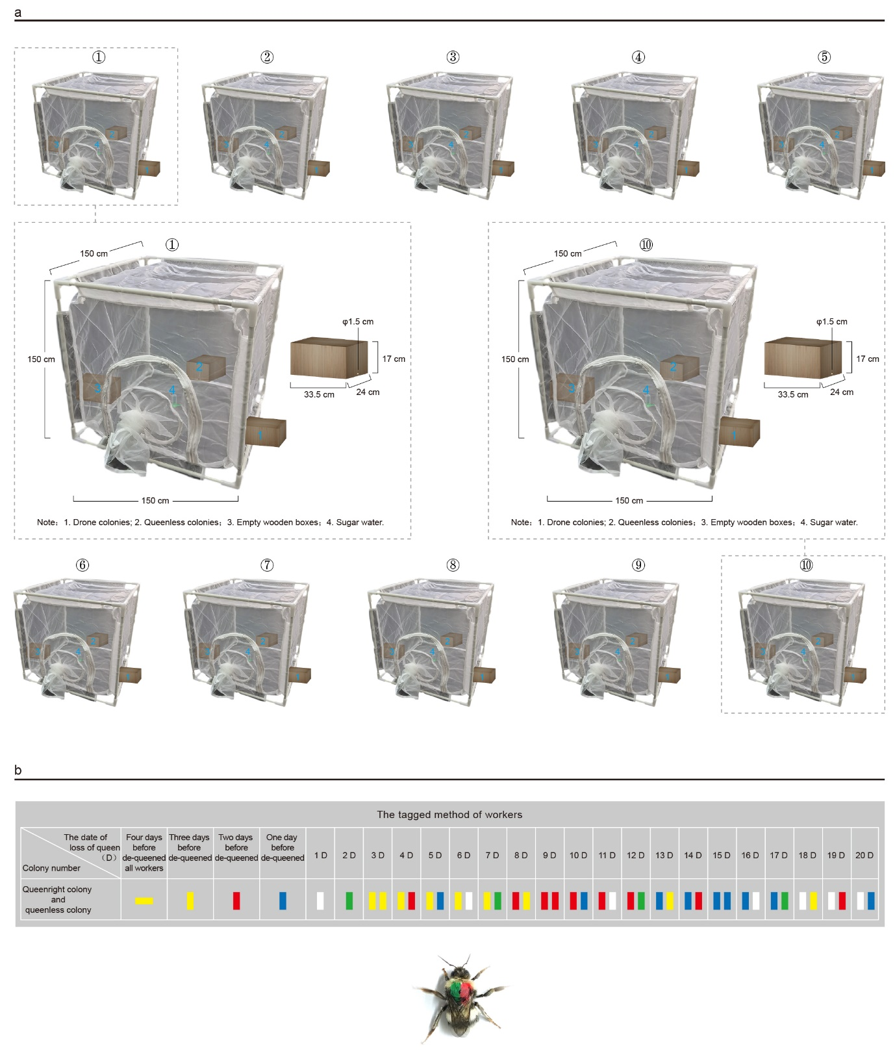Extended Data Fig. 8. Queen-loss enables worker mating under semi-field conditions. a) For this experiment, we used ten queen-right colonies which were randomly allocated into one of two treatments: dequeened colonies, here outlined as test cages numbered: ① ② ③ ④ ⑤; and queenright colonies with test cages numbered: ⑥ ⑦ ⑧ ⑨ ⑩. For the purposes of the mating exposure, each colony was entered into a mating cage, which was supplied with three boxes, a worker-producing colony, a male-producing colony, and an empty colony box. b) Prior to manipulation, for each colony, we collected workers and callows and marked with colors and patterns distinct for their day of emergence. We performed this for a further three days before we started the experiment. We next removed queens from five colonies and for all ten colonies, collected and tagged newly emerging callow workers for twenty days. Callows received a unique color pattern to indicate their respective day of emergence.
Extended Data Fig. 9. Hierarchical clustering of reproductive tissue (spermatheca, vagina, and median oviduct) samples extracted from inseminated and control bumble bee castes based on gene expression profiles. For each sample, the caste, the status of insemination (AI Group 1 = Artificial insemination; Control = non-inseminated) and age at collection post-treatment are provided.

Extended Data Fig. 10. Principal component analysis of gene expression profiles for the reproductive tissues (spermatheca, vagina, and median oviduct) of workers and queens. Scatterplots displaying different combinations for the first principal components with that of the second, third and fourth, with individual plots colored by: a) caste (queen or worker); b) treatment (AI Group 1 = Artificial insemination; Control = non-inseminated); and c) age (Day 2 = two days post-treatment; Day 4 = four days post-treatment; Day 8 = eight days post-treatment).
Extended Data Fig. 11. Weighted co-expression network analysis for reproductive tissues of bumble bee castes. a) Heatmap displaying correlations between modules (gene clusters) identified by WGCNA and each of caste, stage (age post-insemination treatment) and insemination treatment. b) Bar chart for gene ontology terms significantly enriched (Fisher’s exact test; p < 0.05; node size = 20) for genes with elevated members for modules “red” and “yellow”, which strongly correlated with treatment. Each GO term category (BP: Biological Process; MF: Molecular Function; CC: Cellular Component) is designated by an individual color. On the y-axis, we provide each enriched GO term, the GO term description, as well as the number of genes in the B. terrestris genome assembly annotated with each term. We provide a measure of significance (-log10 transformed p values) on the x-axis with a dashed, black line indicating the threshold of significance (-log10(p = 0.05)).

Extended Data Fig. 12. Hierarchical clustering of brain samples extracted from inseminated and control bumble bee castes based on gene expression profiles. For each sample, the caste, the status of insemination (AI Group 1 = Artificial insemination, including semen; AI Group 2 = Artificial insemination, with only diluent, no semen; AI Group 3 = Injection, without insemination; Control = non-inseminated) and the stage of ovarian development (Stage I = immature ovary with a thread-like appearance; Stage II = nutritive cell (i.e., nurse cell) larger than egg cell; Stage IV = mature egg (after oviposition) is provided.
Extended Data Fig. 13. Principal component analysis of gene expression profiles for the brains of workers and queens. Scatterplots displaying different combinations for the first principal components with that of the second, third and fourth, with individual plots colored by: a) caste (queen or worker); b) treatment (AI Group 1 = Artificial insemination, including semen; AI Group 2 = Artificial insemination, with only diluent, no semen; AI Group 3 = Injection, without insemination; Control = non-inseminated); and c) stage of ovarian development (Stage I = immature ovary with a thread-like appearance; Stage II = nutritive cell (i.e., nurse cell) larger than egg cell; Stage IV = mature egg (after oviposition).
Extended Data Fig. 14. Genes uniquely differentially expressed in the brains of inseminated workers in comparison to control workers. Euler plot displaying the conserved but also treatment-specific significantly differentially expressed genes (DEGs) (Likelihood ratio test: FDR < 0.05) between each of three treatment groups (AI Group 1 = Artificial insemination, including semen; AI Group 2 = Artificial insemination, with only diluent, no semen; AI Group 3 = Injection, without insemination) and control (non-inseminated) workers.
Extended Data Fig. 15. Differentially expressed genes within the brains of inseminated and non-inseminated workers. a) Heatmap displaying expression profiles of significantly differentially genes (Likelihood ratio test; FDR < 0.05) uniquely identified between the brains of artificially inseminated and control workers. For each gene, we provide normalized (scaled) gene-level expression to highlight relative differences in expression between treatment groups. b) Bar chart for gene ontology terms significantly enriched (Fisher’s exact test; P < 0.05; node size = 50) for differentially expressed genes uniquely elevated in inseminated bees compared to control. Each GO term category (BP: Biological Process; MF: Molecular Function; CC: Cellular Component) is designed by an individual color. On the y-axis, we provide each enriched GO term, the GO term description, as well as the number of genes in the B. terrestris genome assembly annotated with each term. We provide a measure of significance (-log10 transformed P values) on the x-axis with a dashed, black line indicating threshold of significance (-log10(P = 0.05)).

Extended Data Fig. 16. Hierarchical clustering of fat body samples extracted from inseminated and control bumble bee castes based on gene expression profiles. For each sample, the caste, the status of insemination (AI Group 1 = Artificial insemination, including semen; AI Group 2 = Artificial insemination, with only diluent, no semen; AI Group 3 = Injection, without insemination; Control = non-inseminated) and the stage of ovarian development (Stage I = immature ovary with a thread-like appearance; Stage II = nutritive cell (i.e., nurse cell) larger than egg cell; Stage IV = mature egg (after oviposition) is provided.
Extended Data Fig. 17. Principal component analysis of gene expression profiles for the fat bodies of workers and queens. Scatterplots displaying different combinations for the first principal components with that of the second, third and fourth, with individual plots colored by: a) caste (queen or worker); b) treatment (AI Group 1 = Artificial insemination, including semen; AI Group 2 = Artificial insemination, with only diluent, no semen; AI Group 3 = Injection, without insemination; Control = non-inseminated); and c) stage of ovarian development (Stage I = immature ovary with a thread-like appearance; Stage II = nutritive cell (i.e., nurse cell) larger than egg cell; Stage IV = mature egg (after oviposition)).
Extended Data Fig. 18. Genes uniquely differentially expressed in the fat body of inseminated workers in comparison to control workers. Euler plot displaying the conserved but also treatment-specific significantly differentially expressed genes (DEGs) (Likelihood ratio test: FDR < 0.05) between each of three treatment groups (AI Group 1 = Artificial insemination, including semen; AI Group 2 = Artificial insemination, with only diluent, no semen; AI Group 3 = Injection, without insemination) and control (non-inseminated) workers.

Extended Data Fig. 19. Differentially expressed genes within the fat body of inseminated and non-inseminated workers. a) Heatmap displaying expression profiles of significantly differentially genes (Likelihood ratio test; FDR < 0.05) uniquely identified between the fat body of artificially inseminated and control workers. For each gene, we provide normalized (scaled) gene-level expression to highlight relative differences in expression between treatment groups. b) Bar chart for gene ontology terms significantly enriched (Fisher’s exact test; P < 0.05; node size = 50) for differentially expressed genes uniquely elevated in inseminated bees compared to control. Each GO term category (BP: Biological Process; MF: Molecular Function; CC: Cellular Component) is designed by an individual color. On the y-axis, we provide each enriched GO term, the GO term description, as well as the number of genes in the B. terrestris genome assembly annotated with each term. We provide a measure of significance (-log10 transformed p values) on the x-axis with a dashed, black line indicating threshold of significance (-log10(P = 0.05)).

Extended Data Fig. 20. Hierarchical clustering of ovarian samples extracted from inseminated and control bumble bee castes based on gene expression profiles. For each sample, the caste, the status of insemination (AI Group 1 = Artificial insemination, including semen; AI Group 2 = Artificial insemination, with only diluent, no semen; AI Group 3 = Injection, without insemination; Control = non-inseminated) and the stage of ovarian development (Stage I = immature ovary with a thread-like appearance; Stage II = nutritive cell (i.e., nurse cell) larger than egg cell; Stage IV = mature egg (after oviposition) is provided.
Extended Data Fig. 21. Principal component analysis of gene expression profiles for the ovaries of workers and queens. Scatterplots displaying different combinations for the first principal components with that of the second, third and fourth, with individual plots colored by: a) caste (queen or worker); b) treatment (AI Group 1 = Artificial insemination, including semen; AI Group 2 = Artificial insemination, with only diluent, no semen; AI Group 3 = Injection, without insemination; Control = non-inseminated); and c) stage of ovarian development (Stage I = immature ovary with a thread-like appearance; Stage II = nutritive cell (i.e., nurse cell) larger than egg cell; Stage IV = mature egg (after oviposition)).
Extended Data Fig. 22. Genes uniquely differentially expressed in the ovaries of inseminated workers in comparison to control workers. Euler plot displaying the conserved but also treatment-specific significantly differentially expressed genes (DEGs) (Likelihood ratio test: FDR < 0.05) between each of three treatment groups (AI group 1 = Artificial insemination, including semen; AI group 2 = Artificial insemination, with only diluent, no semen; AI group 3 = Injection, without insemination) and control (non-inseminated) workers.
Extended Data Fig. 23. Differentially expressed genes within the ovaries of inseminated and non-inseminated workers. a) Heatmap displaying expression profiles of significantly differentially genes (Likelihood ratio test; FDR < 0.05) uniquely identified between the ovaries of artificially inseminated and control workers. For each gene, we provide normalized (scaled) gene-level expression to highlight relative differences in expression between treatment groups. b) Bar chart for gene ontology terms significantly enriched (Fisher’s exact test; P < 0.05; node size = 50) for differentially expressed genes uniquely elevated in inseminated bees compared to control. Each GO term category (BP: Biological Process; MF: Molecular Function; CC: Cellular Component) is designed by an individual color. On the y-axis, we provide each enriched GO term, the GO term description, as well as the number of genes in the B. terrestris genome assembly annotated with each term. We provide a measure of significance (-log10 transformed P values) on the x-axis with a dashed, black line indicating threshold of significance (-log10(P = 0.05)).

Supplementary Tables
Supplementary Table 1. Primers for microsatellite-based polymorphism analysis.
Supplementary Table 2. Polymorphism analysis for each of eight microsatellite loci in bumble bees.
Supplementary Table 3. The sampling number of bumble bee workers from AI colonies.
Supplementary Table 4. The average exclusion probability of first parent（E-1P), second parent (E-2P), and parent pair (E-PP) based on eight microsatellite loci.
Supplementary Table 5. Microsatellite loci and paternity test results of five AI worker-produced colonies A, B, C, D and E.
Supplementary Table 6. Sampling groups for tissues for transcriptomic-based analysis.
Supplementary Table 7. Output files for gene count estimation, differential gene expression analysis, and GO term enrichment analysis of inseminated and control bumble bee castes.

Supplementary Videos
Supplementary Video 1. Worker callow feeding larvae in colony.

