Supplementary Material

1.Supplementary Figures and Tables
Supplementary Tables S1 PCR Sequence primers
Gene Name | Gene Bank | Primer Sequence（5'-3'） | Length/bp
CCL7 | ENSRNOG00000000239 | F: TTCATCCACTTGCTGCTATGTC | 165
CCL7 | ENSRNOG00000000239 | R: GCCTCCTCAACCCACTTCT | 165
CCL20 | ENSRNOG00000015992 | F: AAGCATCTGCCCTTCCTG | 77
CCL20 | ENSRNOG00000015992 | R: AAGTTGCTTGCTGCTTCTGAC | 77
IL-1β | ENSRNOG00000004649 | F: TTCAAATCTCACAGCAGCATCT | 427
IL-1β | ENSRNOG00000004649 | R: TCTTTCATCACACAGGACAGG | 427
IL-6 | ENSRNOG00000010278 | F: TTGCCTTCTTGGGACTGATG | 92
IL-6 | ENSRNOG00000010278 | R: GTTGTGGGTGGTATCCTCTGT | 92
PTX3 | ENSRNOG00000012280 | F: TGTGGTGGGTGGGAAGGA | 319
PTX3 | ENSRNOG00000012280 | R: TCCCCCACTTGCCCTTATCT | 319
MMP9 | ENSRNOG00000017539 | F: CGAATCACGGAGGAAGCCAA | 426
MMP9 | ENSRNOG00000017539 | R: GGAAACTCACACGCCAGAAG | 426
CXCL16 | ENSRNOG00000026647 | F: AAGAGTGTGTGTGGAGGAAGC | 201
CXCL16 | ENSRNOG00000026647 | R: CTGCTGGGTGCTCTGAAACT | 201
CXCL6 | ENSRNOG00000002843 | F: TGGCATTTCTGCTGCTGTTC | 179
CXCL6 | ENSRNOG00000002843 | R: GACTTCCACCTTGGGGCA | 179
sFRP-2 | ENSRNOG00000009465 | F: GCCTCGCTGCTTCTGCT | 330
sFRP-2 | ENSRNOG00000009465 | R: GTGACACGGCTGGATGGT | 330
TLR2 | ENSRNOG00000009822 | F: TGAGAATGATGTGGGCGTGG | 320
TLR2 | ENSRNOG00000009822 | R: GAGCCTGAAGTGGGAGAAGT | 320
TRAF1 | ENSRNOG00000048914 | F: GCTGAGGCTGGAATCGTGT | 119
TRAF1 | ENSRNOG00000048914 | R: CCCAGAAGCAGGTACAGGTG | 119
NFKB1 | ENSRNOG00000023258 | F: ATGTGGTGGAGGACTTGCTG | 138
NFKB1 | ENSRNOG00000023258 | R: GTGCTGCCTTGCTGTTCTTG | 138
β-actin | ENSRNOG00000034254 | F: ACTATCGGCAATGAGCGGTT | 287
β-actin | ENSRNOG00000034254 | R: GAGCCACCAATCCACACAGA | 287

Supplementary Tables S2 RNA inspection results
Serial number | Sample name | Concentration ng/μL | Volume  μL | Total  μg | RIN | Species | Library type | Conclusion
R22020530 | Control-1 | 77 | 52 | 3.99 | 10 | Rat | RNAseq | A
R22020531 | Control-2 | 73 | 48 | 3.48 | 10 | Rat | RNAseq | A
R22020532 | Control-3 | 76 | 48 | 3.63 | 10 | Rat | RNAseq | A
R22020533 | Model-1 | 69 | 52 | 3.59 | 10 | Rat | RNAseq | A
R22020534 | Model-2 | 56 | 52 | 2.91 | 10 | Rat | RNAseq | A
R22020535 | Model-3 | 76 | 50 | 3.79 | 10 | Rat | RNAseq | A
R22020536 | JTG-1 | 106 | 50 | 5.30 | 10 | Rat | RNAseq | A
R22020537 | JTG-2 | 135 | 50 | 6.75 | 10 | Rat | RNAseq | A
R22020538 | JTG-3 | 120 | 50 | 6.00 | 10 | Rat | RNAseq | A
Note：Grade A refers to samples that meet the requirements of database sequencing and meet the requirements of database construction more than twice；Grade B refers to the sample that meets the sequencing requirements of database construction and meets the needs of the first database construction；Grade C refers to samples that do not fully meet the requirements of database sequencing, which can be built but does not guarantee the quality；Grade D means that the samples do not meet the requirements of database sequencing

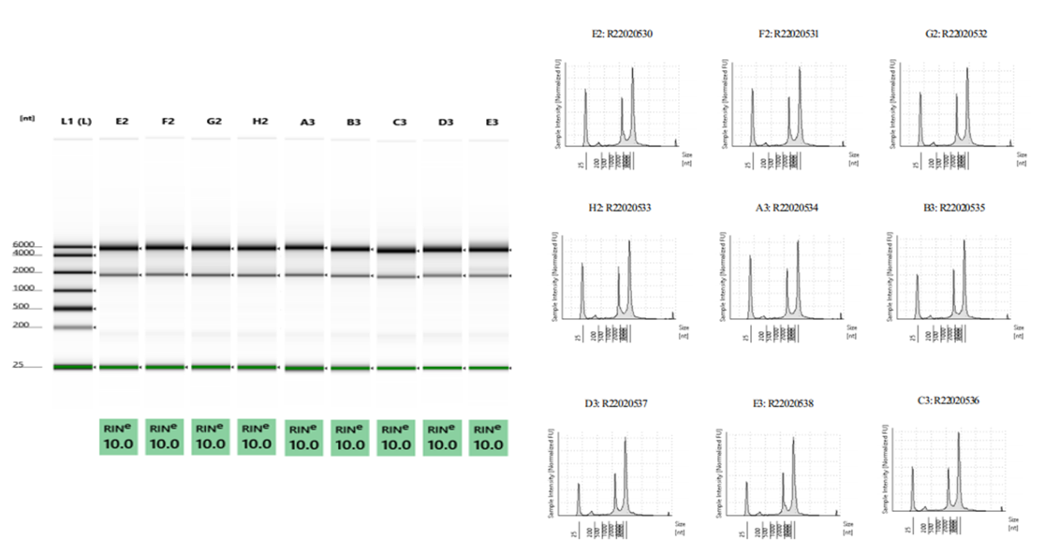
Supplementary Figure S1 RNA electrophoresis figure

Supplementary Tables S3 Data filtering statistics table
Sample | RawDatas | CleanData  (%) | Adapter  (%) | LowQuality  (%) | polyA  (%) | N  (%)
Control-1 | 46250326 | 45986960 (99.43%) | 16740 (0.04%) | 243886 (0.53%) | 0(0.00%) | 2740 (0.01%)
Control-2 | 55472590 | 55178334 (99.47%) | 20178 (0.04%) | 270884 (0.49%) | 0(0.00%) | 3194 (0.01%)
Control-3 | 61621318 | 61273728 (99.44%) | 21806 (0.04%) | 322116 (0.52%) | 0(0.00%) | 3668 (0.01%)
Model-1 | 55478900 | 55128206 (99.37%) | 24608 (0.04%) | 322952 (0.58%) | 0(0.00%) | 3134 (0.01%)
Model-2 | 50209436 | 49945154 (99.47%) | 17666 (0.04%) | 243664 (0.49%) | 0(0.00%) | 2952 (0.01%)
Model-3 | 57396918 | 57089544 (99.46%) | 21178 (0.04%) | 282786 (0.49%) | 0(0.00%) | 3410 (0.01%)
JTG-1 | 49204050 | 48931590 (99.45%) | 19746 (0.04%) | 249902 (0.51%) | 0(0.00%) | 2812 (0.01%)
JTG-2 | 54247914 | 53966492 (99.48%) | 18052 (0.03%) | 260188 (0.48%) | 0(0.00%) | 3182 (0.01%)
JTG-3 | 62177806 | 61853016 (99.48%) | 20904 (0.03%) | 300220 (0.48%) | 0(0.00%) | 3666 (0.01%)
Note: RawDatas is the number of original reads; CleanData(%) indicates the number and percentage of high quality reads; Adapter(%) is the number and percentage of reads that contain Adapter; LowQuality(%) refers to LowQuality reads, that is, the number and percentage of reads with more than 50% base quality value Q≤20 in single-ended read; PolyA (%) is the number and percentage of polyA reads; N(%) indicates the number and percentage of high filtering reads containing N ratio

Supplementary Tables S4 Statistical table of base information
Sample | RawData(bp) | BF_Q20(%) | BF_Q30(%) | BF_N(%) | BF_GC(%) | CleanData(bp) | AF_Q20(%) | AF_Q30(%) | AF_N(%) | AF_GC(%)
Control-1 | 6937548900 | 6761225812 (97.46%) | 6481070267 (93.42%) | 119747 (0.00%) | 3451592638 (49.75%) | 6871481355 | 6714021457 (97.71%) | 6440367607 (93.73%) | 29179 (0.00%) | 3414776988 (49.69%)
Control-2 | 8320888500 | 8117626530 (97.56%) | 7791093966 (93.63%) | 136802 (0.00%) | 4146950125 (49.84%) | 8240681472 | 8058730905 (97.79%) | 7739881512 (93.92%) | 34186 (0.00%) | 4102731930 (49.79%)
Control-3 | 9243197700 | 9006747582 (97.44%) | 8633203803 (93.40%) | 158269 (0.00%) | 4584868723 (49.60%) | 9156559820 | 8945113142 (97.69%) | 8580180586 (93.71%) | 38262 (0.00%) | 4536906606 (49.55%)
Model-1 | 8321835000 | 8089422516 (97.21%) | 7727421055 (92.86%) | 139454 (0.00%) | 4137609509 (49.72%) | 8232991819 | 8025611554 (97.48%) | 7672615778 (93.19%) | 34354 (0.00%) | 4088069105 (49.65%)
Model-2 | 7531415400 | 7342167103 (97.49%) | 7035910825 (93.42%) | 126580 (0.00%) | 3733007223 (49.57%) | 7463464590 | 7293454682 (97.72%) | 6993910683 (93.71%) | 31037 (0.00%) | 3695302054 (49.51%)
Model-3 | 8609537700 | 8392877790 (97.48%) | 8049204881 (93.49%) | 146086 (0.00%) | 4278920463 (49.70%) | 8532374466 | 8338253369 (97.72%) | 8002316306 (93.79%) | 35328 (0.00%) | 4236075771 (49.65%)
JTG-1 | 7380607500 | 7193344229 (97.46%) | 6891047677 (93.37%) | 123335 (0.00%) | 3660451996 (49.60%) | 7305476337 | 7137688039 (97.70%) | 6842718850 (93.67%) | 30409 (0.00%) | 3619013286 (49.54%)
JTG-2 | 8137187100 | 7943337099 (97.62%) | 7629546218 (93.76%) | 137192 (0.00%) | 4015108767 (49.34%) | 8067939441 | 7893990209 (97.84%) | 7587006154 (94.04%) | 33516 (0.00%) | 3976756936 (49.29%)
JTG-3 | 9326670900 | 9094890575 (97.51%) | 8720629072 (93.50%) | 159461 (0.00%) | 4632739772 (49.67%) | 9246693810 | 9038238845 (97.75%) | 8671883504 (93.78%) | 38437 (0.00%) | 4588321786 (49.62%)
Note: Before filter(BF), Sample base information before filtering; After filter(AF), Filtered sample base information; RawData, Total number of bases disembarked; CleanData, Total number of bases with high quality data after filtering; Q20(%), Base mass value > Q20 base number and percentage in RawData; Q30(%), Base mass value > Q30 base number and percentage in RawData; N(%), Number of N bases and percentage of RawData in single-ended READ; GC(%), Base GC ratio before and after filtration

Supplementary Tables S5 Sequencing sequence comparison results
Sample | Total | Unmapped  (%) | Unique_Mapped  (%) | Multiple_Mapped  (%) | Total_Mapped  (%)
Control-1 | 45943484 | 1779075 (3.87%) | 41499831 (90.33%) | 2664578(5.80%) | 44164409 (96.13%)
Control-2 | 55127354 | 2061901 (3.74%) | 49860350 (90.45%) | 3205103(5.81%) | 53065453 (96.26%)
Control-3 | 61218928 | 2364682 (3.86%) | 55253982 (90.26%) | 3600264(5.88%) | 58854246 (96.14%)
Model-1 | 55077064 | 2245222 (4.08%) | 49670328 (90.18%) | 3161514(5.74%) | 52831842 (95.92%)
Model-2 | 49895042 | 1945189 (3.90%) | 45093381 (90.38%) | 2856472(5.72%) | 47949853 (96.10%)
Model-3 | 57028432 | 2281588 (4.00%) | 51461556 (90.24%) | 3285288(5.76%) | 54746844 (96.00%)
JTG-1 | 48884666 | 1927655 (3.94%) | 43897316 (89.80%) | 3059695(6.26%) | 46957011 (96.06%)
JTG-2 | 53907214 | 2054981 (3.81%) | 48474353 (89.92%) | 3377880(6.27%) | 51852233 (96.19%)
JTG-3 | 61796328 | 2597239 (4.20%) | 55309331 (89.50%) | 3889758(6.29%) | 59199089 (95.80%)
Note: Total is a valid reads; Unmapped(%) is the proportion of Unmapped reads to effective reads; Unique_Mapped(%) is the ratio of the number of unique reads mapped to the number of effective reads; Multiple_Mapped(%) Ratio of the number of reads in multiple matches to the number of effective reads; Total_Mapped(%) Indicates the ratio of the number of reads in all locations to the number of effective reads

Supplementary Figure S2 Map of gene coverage
(A) Control-1, (B) Control-2, (C) Control-3, (D) Model-1, (E) Model-2, (F) Model-3, (G) JTG-1, (H) JTG-2, (I) JTG-3; Different colors represent the proportion of genes that have a certain coverage

Supplementary Figure S3 Sequencing saturation distribution
(A)Control-1, (B) Control-2, (C) Control-3, (D) Model-1, (E) Model-2, (F) Model-3, (G) JTG-1, (H) JTG-2, (I) JTG-3

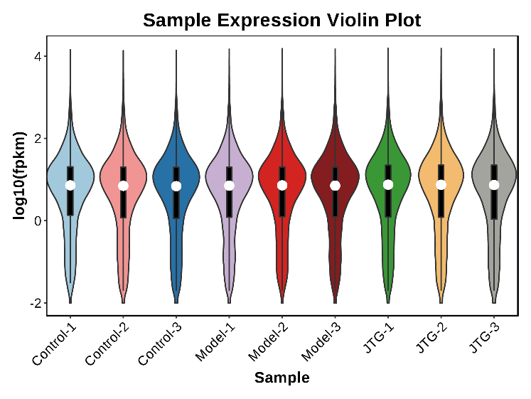
Supplementary Figure S4 Violin diagram of gene expression levels

Supplementary Tables S6 Control vs Model KEGG enrichment pathway table (top 60)
Pathway ID | Pathway | pvalue | qvalue
ko05205 | Proteoglycans in cancer | 3.71E-13 | 7.48E-11
ko04512 | ECM-receptor interaction | 4.82E-13 | 7.48E-11
ko04060 | Cytokine-cytokine receptor interaction | 7.35E-11 | 7.59E-09
ko04668 | TNF signaling pathway | 1.25E-10 | 9.67E-09
ko04510 | Focal adhesion | 2.45E-10 | 1.52E-08
ko05206 | MicroRNAs in cancer | 5.87E-09 | 3.03E-07
ko04657 | IL-17 signaling pathway | 1.98E-08 | 8.13E-07
ko04933 | AGE-RAGE signaling pathway in diabetic complications | 2.29E-08 | 8.13E-07
ko05410 | Hypertrophic cardiomyopathy (HCM) | 2.36E-08 | 8.13E-07
ko04974 | Protein digestion and absorption | 1.69E-07 | 5.25E-06
ko04350 | TGF-beta signaling pathway | 3.02E-07 | 8.51E-06
ko05200 | Pathways in cancer | 4.64E-07 | 1.2E-05
ko05418 | Fluid shear stress and atherosclerosis | 7.89E-07 | 1.88E-05
ko04010 | MAPK signaling pathway | 2.08E-06 | 4.61E-05
ko04061 | Viral protein interaction with cytokine and cytokine receptor | 4.6E-06 | 9.5E-05
ko04530 | Tight junction | 5.17E-06 | 0.0001
ko05412 | Arrhythmogenic right ventricular cardiomyopathy (ARVC) | 9.67E-06 | 0.000176
ko04151 | PI3K-Akt signaling pathway | 1.34E-05 | 0.000231
ko04390 | Hippo signaling pathway | 1.47E-05 | 0.000241
ko04810 | Regulation of actin cytoskeleton | 1.64E-05 | 0.000244
ko04210 | Apoptosis | 1.66E-05 | 0.000244
ko04625 | C-type lectin receptor signaling pathway | 2.14E-05 | 0.000301
ko04926 | Relaxin signaling pathway | 2.8E-05 | 0.000377
ko04928 | Parathyroid hormone synthesis, secretion and action | 7.79E-05 | 0.001006
ko05133 | Pertussis | 8.96E-05 | 0.001111
ko04978 | Mineral absorption | 0.000105 | 0.001254
ko05161 | Hepatitis B | 0.000114 | 0.001304
ko05146 | Amoebiasis | 0.00014 | 0.001553
ko05165 | Human papillomavirus infection | 0.000151 | 0.001614
ko04670 | Leukocyte transendothelial migration | 0.000278 | 0.00287
ko05226 | Gastric cancer | 0.000311 | 0.003109
ko05145 | Toxoplasmosis | 0.000337 | 0.003242
ko04218 | Cellular senescence | 0.000345 | 0.003242
ko04360 | Axon guidance | 0.000462 | 0.004163
ko05167 | Kaposi sarcoma-associated herpesvirus infection | 0.00047 | 0.004163
ko04216 | Ferroptosis | 0.00054 | 0.004651
ko05222 | Small cell lung cancer | 0.00059 | 0.00494
ko04380 | Osteoclast differentiation | 0.000756 | 0.006164
ko04611 | Platelet activation | 0.001334 | 0.010347
ko04371 | Apelin signaling pathway | 0.001335 | 0.010347
ko04520 | Adherens junction | 0.001647 | 0.012379
ko04270 | Vascular smooth muscle contraction | 0.001677 | 0.012379
ko05144 | Malaria | 0.001807 | 0.013027
ko05134 | Legionellosis | 0.001924 | 0.013554
ko04062 | Chemokine signaling pathway | 0.002026 | 0.013651
ko05225 | Hepatocellular carcinoma | 0.002026 | 0.013651
ko04550 | Signaling pathways regulating pluripotency of stem cells | 0.002589 | 0.017075
ko00970 | Aminoacyl-tRNA biosynthesis | 0.00275 | 0.017759
ko04022 | cGMP - PKG signaling pathway | 0.003099 | 0.019603
ko05212 | Pancreatic cancer | 0.0033 | 0.020458
ko05220 | Chronic myeloid leukemia | 0.003618 | 0.02199
ko05224 | Breast cancer | 0.004411 | 0.025973
ko04722 | Neurotrophin signaling pathway | 0.004441 | 0.025973
ko05142 | Chagas disease (American trypanosomiasis) | 0.004624 | 0.026546
ko04310 | Wnt signaling pathway | 0.004723 | 0.026621
ko05414 | Dilated cardiomyopathy (DCM) | 0.004884 | 0.027039
ko05020 | Prion diseases | 0.005345 | 0.029067
ko05163 | Human cytomegalovirus infection | 0.005697 | 0.030449
ko05100 | Bacterial invasion of epithelial cells | 0.005841 | 0.030693
ko04621 | NOD-like receptor signaling pathway | 0.007289 | 3.77E-02

Supplementary Tables S7 Model vs JTG KEGG enrichment pathway table (top 60)
Pathway ID | Pathway | Pvalue | Qvalue
ko04110 | Cell cycle | 4.04E-17 | 1.39E-14
ko03040 | Spliceosome | 9.85E-16 | 1.69E-13
ko03008 | Ribosome biogenesis in eukaryotes | 1.75E-14 | 2E-12
ko05200 | Pathways in cancer | 9.79E-14 | 8.39E-12
ko03013 | RNA transport | 3.53E-12 | 2.42E-10
ko03050 | Proteasome | 1.01E-11 | 5.41E-10
ko04218 | Cellular senescence | 1.1E-11 | 5.41E-10
ko05206 | MicroRNAs in cancer | 1.36E-11 | 5.81E-10
ko04668 | TNF signaling pathway | 5.58E-10 | 2.13E-08
ko04510 | Focal adhesion | 1.56E-09 | 5.34E-08
ko04115 | p53 signaling pathway | 2.2E-09 | 6.83E-08
ko04350 | TGF-beta signaling pathway | 2.39E-09 | 6.83E-08
ko03030 | DNA replication | 9.35E-09 | 2.47E-07
ko04141 | Protein processing in endoplasmic reticulum | 1.8E-08 | 4.41E-07
ko01100 | Metabolic pathways | 2E-08 | 4.57E-07
ko04114 | Oocyte meiosis | 2.5E-08 | 5.35E-07
ko04210 | Apoptosis | 2.65E-08 | 5.35E-07
ko05222 | Small cell lung cancer | 3.59E-08 | 6.84E-07
ko05132 | Salmonella infection | 1.15E-07 | 2.08E-06
ko05165 | Human papillomavirus infection | 1.27E-07 | 2.17E-06
ko04152 | AMPK signaling pathway | 1.75E-07 | 2.86E-06
ko04931 | Insulin resistance | 4.64E-07 | 7.24E-06
ko04068 | FoxO signaling pathway | 5.06E-07 | 7.54E-06
ko05205 | Proteoglycans in cancer | 5.56E-07 | 7.95E-06
ko04211 | Longevity regulating pathway - mammal | 5.91E-07 | 8.1E-06
ko04910 | Insulin signaling pathway | 7.22E-07 | 9.52E-06
ko03440 | Homologous recombination | 8.4E-07 | 1.07E-05
ko01521 | EGFR tyrosine kinase inhibitor resistance | 1.32E-06 | 1.61E-05
ko03430 | Mismatch repair | 4.46E-06 | 5.26E-05
ko05203 | Viral carcinogenesis | 4.6E-06 | 5.26E-05
ko04390 | Hippo signaling pathway | 5.31E-06 | 5.87E-05
ko05216 | Thyroid cancer | 8.02E-06 | 8.49E-05
ko05230 | Central carbon metabolism in cancer | 8.16E-06 | 8.49E-05
ko00230 | Purine metabolism | 1.3E-05 | 0.000131
ko05163 | Human cytomegalovirus infection | 1.66E-05 | 0.000162
ko04144 | Endocytosis | 1.75E-05 | 0.000167
ko05133 | Pertussis | 1.85E-05 | 0.000171
ko04371 | Apelin signaling pathway | 2.15E-05 | 0.000194
ko05215 | Prostate cancer | 2.22E-05 | 0.000196
ko05225 | Hepatocellular carcinoma | 2.61E-05 | 0.000215
ko05221 | Acute myeloid leukemia | 2.62E-05 | 0.000215
ko05220 | Chronic myeloid leukemia | 2.64E-05 | 0.000215
ko03410 | Base excision repair | 2.93E-05 | 0.000234
ko03015 | mRNA surveillance pathway | 3.41E-05 | 0.000262
ko01524 | Platinum drug resistance | 3.44E-05 | 0.000262
ko04710 | Circadian rhythm | 3.6E-05 | 0.000269
ko01212 | Fatty acid metabolism | 4.11E-05 | 0.0003
ko04933 | AGE-RAGE signaling pathway in diabetic complications | 4.41E-05 | 0.00031
ko05161 | Hepatitis B | 4.43E-05 | 0.00031
ko00240 | Pyrimidine metabolism | 4.58E-05 | 0.000314
ko05210 | Colorectal cancer | 4.91E-05 | 0.00033
ko04914 | Progesterone-mediated oocyte maturation | 6.38E-05 | 0.000421
ko05100 | Bacterial invasion of epithelial cells | 6.52E-05 | 0.000422
ko04360 | Axon guidance | 8.91E-05 | 0.000566
ko04934 | Cushing syndrome | 9.75E-05 | 0.000608
ko04137 | Mitophagy - animal | 0.000108 | 0.000663
ko04512 | ECM-receptor interaction | 0.000128 | 0.000773
ko00640 | Propanoate metabolism | 0.000147 | 0.000869
ko05167 | Kaposi sarcoma-associated herpesvirus infection | 0.000206 | 0.001198
ko04919 | Thyroid hormone signaling pathway | 0.000213 | 0.001217

