SUPPLEMENTAL INFORMATION

Distinct transcriptional profiles of HIV- and CMV-specific CD8 T cells in HIV progressors and long-term non-progressors

- Lisa van Pul^{1,2}, Melissa Stunnenberg^{1,2}, Brigitte D. M. Boeser-Nunnink^{1,2}, Agnes M. Harskamp^{1,2}, Teunis B. H. Geijtenbeek^{1,2}, Neeltje A. Kootstra^{1,2*}

¹ Amsterdam UMC location University of Amsterdam, Department of Experimental Immunology, Meibergdreef 9, Amsterdam, The Netherlands
² Amsterdam Institute for Infection and Immunity, Amsterdam, The Netherlands

* Correspondence:
N.A. Kootstra
n.a.kootstra@amsterdamumc.nl

CONTENT:

SUPPLEMENTARY FIGURES:

Supplementary Figure 1. Flow cytometry gating strategy for the (identification and) sorting of HIV and CMV-specific CD8 T cells.
Supplementary Figure 2. DEG network plot of the HIV-specific CD8 T cells of progressors and long-term non-progressors (LTNPs).
Supplementary Figure 3. DEG network plot of the CMV-specific CD8 T cells of progressors, long-term non-progressors (LTNPs) and MAVS-/-.

Supplementary Figure 1. Flow cytometry gating strategy for the (identification and) sorting of HIV and CMV-specific CD8 T cells.

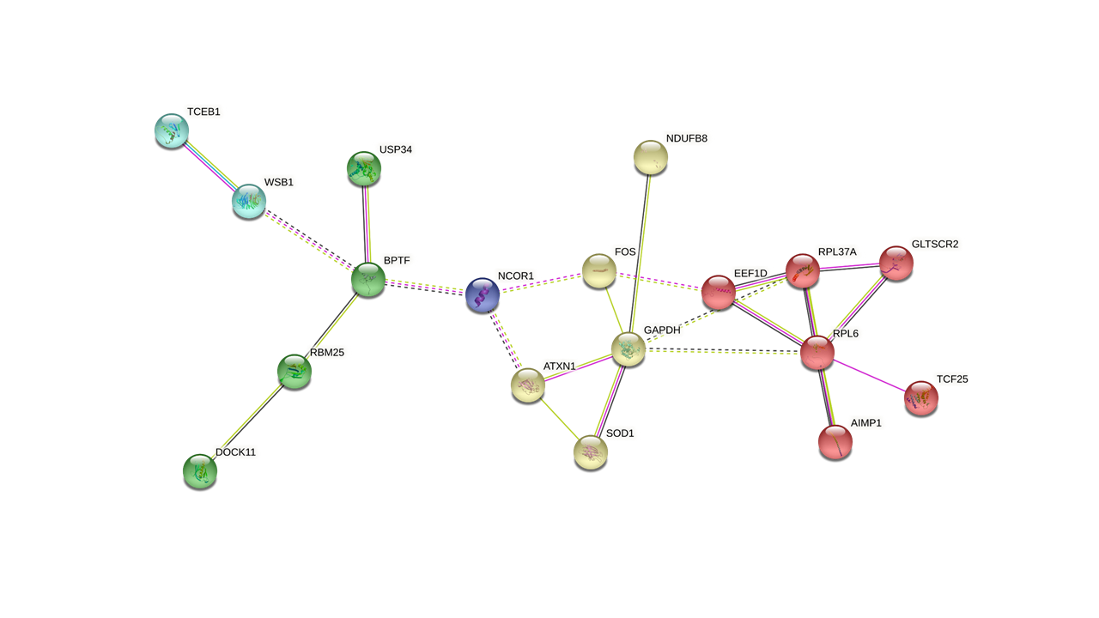 Supplementary Figure 2. DEG network plot of the HIV-specific CD8 T cells of progressors and long-term non-progressors (LTNPs). Network analysis of the DEGs in the HIV-specific CD8 T cells of progressors and LTNPs (B*57 & non-B*57) reveals 5 different clusters.

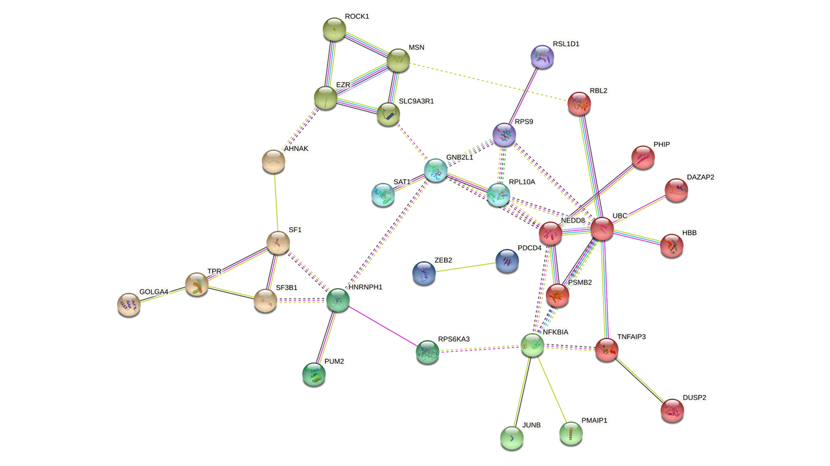
Supplementary Figure 3. DEG network plot of the CMV-specific CD8 T cells of progressors, long-term non-progressors (LTNPs) and MAVS-/-. Network analysis of the DEGs in the HIV-specific CD8 T cells of progressors, LTNPs (B*57 & non-B*57) and MAVS-/- reveals 8 different clusters.

