Table 1 Overview of the generated results on the cartilage samples.

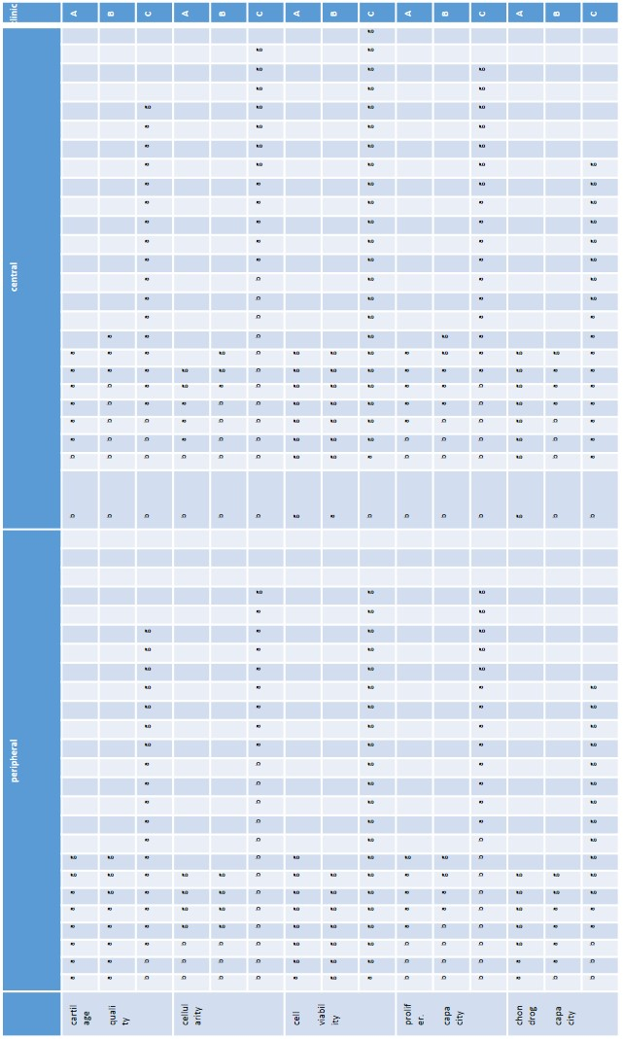
Samples were collected from the central part (central) or the surrounding region (peripheral) of cartilage lesions of patients in three different clinics (A-C) (see Material and Method section for more details). Each rectangle represents a sample. The rectangle with a diagonal line represents the sample that could be not analysed (see Material and Method section for more details). Values of the estimated parameters were classified in three arbitrary categories (b indicates bad, a indicates averaged, g indicates good) as follows: cartilage quality: <1, 1-2, >2 histological grades; cellularity: <1, 1-2, >2 millions of cell/gram of tissue; viability: <75%, 75-90%, >90% viable cells; proliferation capacity: <0.2, 0.2-0.3, >0.3 doublings/day; chondrogenic capacity: <3, 3-6, >3 Bern Score grading.

Table 2 Summary of the differences between peripheral (p) and central (c) chondrocytes derived from cartilage tissues of different qualities
 |  |  |  | Chondrocytes phenotype |  | Chondrocytes properties
 |  |  |  | Expression of differentiation markers | Expression of catabolic gens | Viability | Proliferation capacity | Chondrogenic capacity
 |  |  |  | Agg/Ver COL2/COL1 | MMP13 ADAMT5 | Viability | Proliferation capacity | Chondrogenic capacity
p vs c  p vs c |  | bad quality (0-1)  good quality (2-3) |  | = =  ↑* ↑* | = ↓*  ↓ ↓ | ↑  = | =  ↓ | ↑*  ↑

= no difference; ↑ increased, ↓ decreased, *p<0.05

