Supplementary Figure

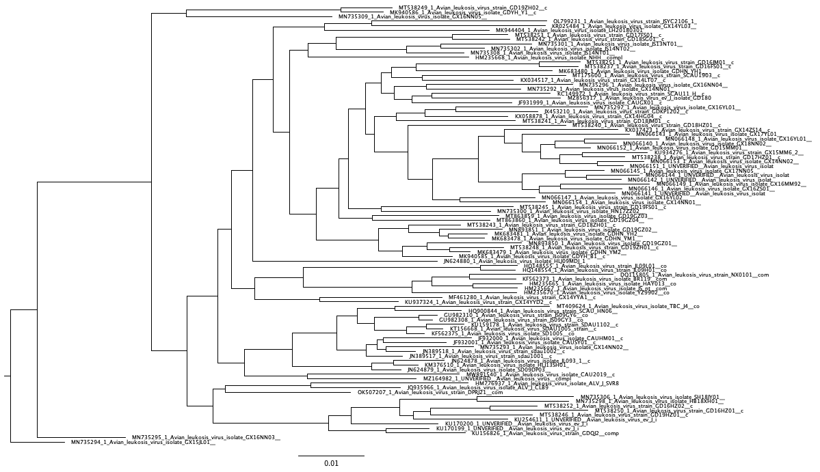
Figure S 1 Phylogenetic tree inferred from an alignment of real sequences (Avian Leukosis virus) that was used to simulate datasets with DNRs varying from 0 to 20. The alignment of Avian Leukosis virus had an average sequence identity (API) of ~90% and the branches of this tree were scaled to produce four other trees reflecting branch tip sequences with approximate pairwise identities of ~75%, ~80%, ~85% and ~95%.

Supplementary Table

Table S 1 Summary of the viral genome/genome component datasets used in the study.
Genome Type | Virus Family | Virus Genus | Virus Species | Dataset Name
ssDNA | Circoviridae | Circovirus | Beak and feather disease virus | BFDV
ssDNA | Circoviridae | Circovirus | Duck circovirus, Goose circovirus | DG_CV
ssDNA | Circoviridae | Circovirus | Columbine circovirus | PiCV
ssDNA | Circoviridae | Circovirus | Circovirus | CCCC
ssDNA | Circoviridae | Circovirus | Bat circovirus | BTC
ssDNA | Circoviridae | Circovirus | Porcine Circovirus 2 | POCV2
ssDNA | Circoviridae | Circovirus | Cyclovirus | CCV
ssDNA | Geminiviridae | Begomovirus | East Africa cassava mosaic virus, South African cassava mosaic virus | Begomo6
ssDNA | Geminiviridae | Begomovirus | Tomato yellow leaf curl virus | Begomo5
ssDNA | Geminiviridae | Begomovirus | Malvastrum yellow vein Yunnan virus, Cotton leaf curl Multan virus, Bhendi yellow vein India virus | Begomo9
ssDNA | Geminiviridae | Begomovirus | Tobacco yellow dwarf virus, Chickpea chlorosis virus, Chickpea yellows virus | Dicot_1
ssDNA | Geminiviridae | Mastrevirus | Chickpea chlorotic dwarf virus | Dicot_2
ssDNA | Geminiviridae | Mastrevirus | Maize streak virus | MSV
ssDNA | Geminiviridae | Mastrevirus | Panicum streak virus | PanSV
ssDNA | Geminiviridae | Mastrevirus | Wheat dwarf virus | WDV
ssDNA | Anelloviridae | Annellovirus | Torque teno virus 1 | TTV_1
ssDNA | Anelloviridae | Annellovirus | Torque teno sus virus | TTSV
ssDNA | Parvoviridae | Aneptorquevirus | minute virus of mice, MVM | MVM
ssDNA | Parvoviridae | Protoparvovirus | Human parvovirus | HPV
ssDNA | Parvoviridae | Protoparvovirus | Canine parvovirus | CPV
ssDNA | Parvoviridae | Protoparvovirus | porcine parvovirus | PPV
ssDNA | Parvoviridae | Amdoparvovirus | Carnivore amdoparvovirus | CAV_P
ssDNA | Nanoviridae | Babuvirus | Banana bunchy top virus | BBTV_M
 |  |  |  | BBTV_N
 |  |  |  | BBTV_R
 |  |  |  | BBTV_S
ssDNA | Nanoviridae | Nanovirus | Coconut foliar decay virus | CCDV
ssDNA | Nanoviridae | Nanovirus | Milk vetch dwarf virus full genome | MDV
ssDNA | Nanoviridae | Nanovirus | Pea necrotic yellow dwarf virus | PYDV
ssDNA | Nanoviridae | Nanovirus | Faba bean necrotic stunt virus | FBNS
ssDNA | Microviridae | Microviruses | Microvirus | BMV
ssDNA | Pleolipoviridae | Pleolipoviruses | Betapleolipovirus | BPV
ssDNA | Pleolipoviridae | Pleolipoviruses | Alphapleolipovirus | APV
ssRNA | Astroviridae | Astroviruses | Human astrovirus | HAV
ssRNA | Astroviridae | Astroviruses | Bovine astrovirus | BAV
ssRNA | Astroviridae | Astroviruses | Mamastrovirus | MMV
ssRNA | Astroviridae | Astroviruses | porcine astrovirus | PAV
ssRNA | Astroviridae | Astroviruses | chicken astrovirus | CKV
ssRNA | Astroviridae | Astroviruses | Goose astrovirus | GA
ssRNA | Astroviridae | Astroviruses | Canine astrovirus | CAV_A
ssRNA | Bromoviridae | Cucumovirus | Cucumber mosaic virus | CMV_RNA1
 |  |  |  | CMV_RNA2
 |  |  |  | CMV_RNA3
ssRNA | Bromoviridae | Alphamovirus | Alphalfa mosaic virus | AMS
ssRNA | Bromoviridae | Cucumovirus | Peanut stunt virus | PSV
ssRNA | Caliciviridae | Lagovirus | Lagovirus | LAV
ssRNA | Caliciviridae | coroviruses | Norovirus | NoV
ssRNA | Caliciviridae | Vesivirus | Vesivirus | VSV
ssRNA | Closteroviridae | Closterovirus | Citrus tristeza virus | CTV
ssRNA | Flaviviridae | Flavivirus | Dengue virus | DGV_T1
ssRNA | Flaviviridae | Flavivirus | Japanese encephalitis virus | JEV
ssRNA | Hepeviridae | Hepevirus | Hepatitis E virus | HPVE1
ssRNA | Hepeviridae | Hepevirus | Hepatitis E2 virus | HPVE2
ssRNA | Picornaviridae | Enterovirus | Human Rhinovirus A | HRV_A
ssRNA | Picornaviridae | Enterovirus | Enterovirus A | ENV_A
ssRNA | Picornaviridae | Teschovirus | Techovirus | TCV
ssRNA | Picornaviridae | Aichivirus | Aichivirus | AiV
ssRNA | Picornaviridae | Aphthovirus | Foot and mouth disease virus | FMDV
ssRNA | Picornaviridae | Aphthovirus | Avihepatovirus | AHP
ssRNA | Picornaviridae | Cardiovirus | Encephalomyo carditis virus | ECV
ssRNA | Picornaviridae | Cardiovirus | Cardiovirus | CDV
ssRNA | Fusariviridae | Fusarivirus | Fusariviruses | FRV
ssRNA | Retroviridae | Lentivirus | Human immuno-deficiency virus 1 | HIV1_setA
 |  |  |  | HIV1_M
 |  |  |  | HIV1_setC
 |  |  |  | HIV1_setD
 |  |  |  | HIV1_setE
 |  |  |  | HIV1_setF
ssRNA | Retroviridae | Lentivirus | Simian immuno-deficiency virus | SIV
ssRNA | Retroviridae | Lentivirus | Bovine immunodeficiency | BIV
ssRNA | Retroviridae | Lentivirus | Feline immunodeficiency | FIV
ssRNA | Retroviridae | Lentivirus | equine infectious anemia virus | EIV
ssRNA | Retroviridae | Lentivirus | caprine arthritis encephalitis virus | CAV
ssRNA | Orthomyxo-viridae | Influenzavirus | Influenza virus A | FluA_2
ssRNA | Orthomyxo-viridae | Influenzavirus | Influenza virus B | FluB_1
ssRNA | Filoviridae | Ebolavirus | Ebola virus | Ebola_2
ssRNA | Coronaviridae | Merbecovirus | Middle East respiratory syndrome | MERS-COV
ssRNA | Coronaviridae | Sarbecoviruses | Severe acute respiratory syndrome coronavirus | SARS-CoV
ssRNA | Coronaviridae | Sarbecoviruses | Severe acute respiratory syndrome coronavirus 2 | SARS-CoV_2
ssRNA | Coronaviridae | Sarbecoviruses | sarbecoviruses | SARB
dsDNA | Papillomaviridae | Alphapapillomavirus | Alphapapillomavirus 6 | APPV 6
dsDNA | Papillomaviridae | Alphapapillomavirus | Alphapapillomavirus 7 | HPV18_2
 |  |  |  | HPV45_2
dsDNA | Papillomaviridae | Alphapapillomavirus | Alphapapillomavirus 9 | HPV16_2
 |  |  |  | HPV31
dsDNA | Papillomaviridae | Alphapapillomavirus | Alphapapillomavirus 10 | HPV6_1
dsDNA | Papillomaviridae | Alphapapillomavirus | Bovine papillomavirus | BPV
dsDNA | Papillomaviridae | Alphapapillomavirus | Lambdaapapillomavirus | LPV
dsDNA | Papillomaviridae | Alphapapillomavirus | Deltapapillomavirus | DPV
dsDNA | Papillomaviridae | Alphapapillomavirus | Xipapillomavirus | XPV
dsDNA | Polyomaviridae | Polyomavirus | BK polyomavirus | BK_2
dsDNA | Polyomaviridae | Polyomavirus | JC polyomavirus | JC_2
dsDNA | Polyomaviridae | Polyomavirus | Bat polyomavirus | BPV
dsDNA | Polyomaviridae | Polyomavirus | Simian virus 40 | SMV_40
dsDNA | Caulimoviridae | Caulimovirus | cauliflower mosaic virus | CMV
dsDNA | Caulimoviridae | Caulimovirus | Cacao swollen shoot virus | CSSV
dsDNA | Caulimoviridae | Caulimovirus | Strawberry vein banding virus | SVBV
dsDNA | Caulimoviridae | Caulimovirus | Dioscorea bacilliform AL virus | DBAV
dsDNA | Caulimoviridae | Caulimovirus | Rice tungro bacilliform virus | RTBV
dsDNA | Caulimoviridae | Caulimovirus | badnavirus | BDV
dsDNA | Siphoviridae | Escherichia virus Lambda | coliphage lambda | CLV
dsDNA | Tectiviridae | Tectivirus | Tectivirus | TTIV
dsDNA | Adenoviridae | Aviadenovirus | Fowl aviadenovirus C | FAV_C
dsDNA | Adenoviridae | Aviadenovirus | Fowl aviadenovirus E | FAV_E
dsDNA | Adenoviridae | Aviadenovirus | Fowl aviadenovirus A | FAV_A
dsDNA | Adenoviridae | Aviadenovirus | Fowl aviadenovirus D | FAV_D
dsDNA |  | Mastadenovirus | Human mastadenovirus B | HMAV_B
dsDNA |  | Mastadenovirus | Human mastadenovirus D | HMAV_D
dsDNA |  | Mastadenovirus | Human mastadenovirus C | HMAV_C
dsDNA |  | Mastadenovirus | Human mastadenovirus E | HMAV_E
DsRNA | Birnaviridae | Avibirnavirus | Gumburo virus_setA | GBV_A
DsRNA | Birnaviridae | Avibirnavirus | Gumburo virus_setB | GBV_B
DsRNA | Birnaviridae | Aquabirnavirus | Infectious pancreatic necrosis virus | IPNV
DsRNA | Birnaviridae | Aquabirnavirus | Aquabirnavirus | AQBV
DsRNA | Reoviridae | Orbivirus | Bluetongue_virus_setA | BTV_A
DsRNA | Reoviridae | Orbivirus | Bluetongue_virus_setB | BTV_B
DsRNA | Reoviridae | Orbivirus | Bluetongue_virus_setC | BTV_C
DsRNA | Reoviridae | Orbivirus | Bluetongue_virus_setD | BTV_D
DsRNA | Reoviridae | Orbivirus | Bluetongue_virus_setF | BTV_F
DsRNA | Reoviridae | Orbivirus | Bluetongue_virus_setG | BTV_G
DsRNA | Reoviridae | Orbivirus | Bluetongue_virus_setH | BTV_H
DsRNA | Reoviridae | Orbivirus | Bluetongue_virus_setI | BTV_I
DsRNA | Reoviridae | Rotavirus | Bovine_rotavirus_A_setC | BRVA_C
DsRNA | Reoviridae | Rotavirus | Human_rotavirus_A_setA | HRVA_A
DsRNA | Reoviridae | Rotavirus | Human_rotavirus_A_setB | HRVA_B
DsRNA | Reoviridae | Rotavirus | Human_rotavirus_A_setC | HRVA_C
DsRNA | Reoviridae | Rotavirus | Human_rotavirus_A_setD2 | HRVA_D2
DsRNA | Reoviridae | Rotavirus | Human_rotavirus_A_setE | HRVA_E
DsRNA | Reoviridae | Rotavirus | Human_rotavirus_A_setF | BRVA_F
DsRNA | Reoviridae | Rotavirus | Human_rotavirus_A_setG | HRVA_G
DsRNA | Reoviridae | Rotavirus | Human_rotavirus_A_setH | HRVA_H
DsRNA | Reoviridae | Rotavirus | Porcine_rotavirus_A_setA | PRVA_A
DsRNA | Reoviridae | Rotavirus | Porcine_rotavirus_A_setB | PRVA_B
DsRNA | Reoviridae | Rotavirus | Human_rotavirus_C_setA | HRVC_A
DsRNA | Reoviridae | Orthoreovirus | Pteropine orthoreovirus | PTOV
DsRNA | Reoviridae | Fijivirus | Fijivirus_setB | FJV_B
DsRNA | Totiviridae | Totivirus | Totivirus | TTV
DsRNA | Totiviridae | Giardiavirus | Giardiavirus | GDV
DsRNA | Hypoviridae | Hypovirus | Hypovirus | HPV
DsRNA | Endornaviridae | Endornavirus | Endornavirus | EDV
DsRNA | Endornaviridae | Alphaendornavirus | Bell pepper alphaendornavirus | BPAV

