SUPPLEMENTARY MATERIAL
Telehealth-supported exercise/physical activity programs for knee osteoarthritis: A systematic review and meta-analysis
Xiao-Na Xiang^{1,2,3,†}, MD, Ze-Zhang Wang^{2, †}, BS, Jiang-yin Zhang^{1,2,3}, MS, Ke Li^{4,5}, PhD, Qi-Xu Chen^{4,5}, MS, Fa-Shu Xu^{6,7}, PhD, Yue-Wen Zhang^{4,5}, MS, Hong-Chen He^{1,2,3}, PhD, Cheng-Qi He^{1,2,3,}*, PhD, Si-Yi Zhu^{1,2,3,}*, PhD

- Department of Rehabilitation Medicine and Institute of Rehabilitation Medicine, West China Hospital, Sichuan University, Chengdu, 610041, P. R. China
- School of Rehabilitation Sciences, West China School of Medicine, Sichuan University, Chengdu, 610041, P. R. China
- Rehabilitation Medicine Key Laboratory of Sichuan Province, Chengdu, 610041, P. R. China
- Center of Statistical Research, School of Statistics, Southwestern University of Finance and Economics, Chengdu, China.
- Joint Lab of Data Science and Business Intelligence, School of Statistics, Southwestern University of Finance and Economics, Chengdu, China.
- West China Biomedical Big Data Center, West China Hospital, Sichuan University, Chengdu, 610041, P. R. China
- Med-X Center for Informatics, West China Hospital, Sichuan University, Chengdu, 610041, P. R. China
† These authors contributed equally to this manuscript

Corresponding Author:
Si-Yi Zhu, PhD, Department of Rehabilitation Medicine and Institute of Rehabilitation Medicine, West China Hospital, Sichuan University, #37 Guoxue Alley, Wuhou strict, Chengdu, Sichuan, PR China. Zip code: 610041; E-mail: hxkfzsy@scu.edu.cn

Co-corresponding Author:
Cheng-Qi He, PhD, full professor, Department of Rehabilitation Medicine and Institute of Rehabilitation Medicine, West China Hospital, Sichuan University, #37 Guoxue Alley, Wuhou strict, Chengdu, Sichuan, PR China. Zip code: 610041; E-mail: hxkfhcq2015@126.com

Contents
Supplementary Table 1: List of studies excluded at full-text screening stage | Page 3
Supplementary Figure 1: Cochrane risk of bias graphical summary and summary per study | Page 8
Supplementary Table 2: Physiotherapy Evidence Database (PEDro) Scale quality assessment | Page 9
Supplementary Table 3: GRADE summary of findings | Page 11
Supplementary Figure 2: Forest plots of secondary outcomes | Page 13
Supplementary Figure 3: Results of sensitivity analysis for primary outcomes | Page 14
Supplementary Table 4: Result of meta-regression test | Page 15
Supplementary Figure 4: Funnel plots of primary outcomes | Page 16
Supplementary Table 5: Search strategy | Page 17

Supplementary Table 1: List of studies excluded at full-text screening stage
Study title | Author | Year | Reason for exclusion
Effectiveness of a Mobile App for Individuals with or at Risk of Knee Osteoarthritis |  | 2019 | No accessible full text
MobilWise: Mobile Phone Remote Coaching After Worksite Joint ADventure Exposure |  | 2016 | No accessible full text
Wearable LITUS Device for Osteoarthritis of the Knee: a Randomized Double-Blind Placebo-Controlled Trial |  | 2014 | No accessible full text
SuPRA: Using Wearable Activity Trackers with a New Application to Improve Physical Activity in Knee Osteoarthritis |  | 2019 | No accessible full text
Exercise therapy, manual therapy, or both, for management of osteoarthritis of the hip or knee: 2-year follow-up of a randomized clinical trial | Abbott, J. H, et al. | 2014 | No telerehabilitation
Feasibility and efficacy of remotely supervised cranial electrical stimulation for pain in older adults with knee osteoarthritis: A randomized controlled pilot study | Ahn, H, et al. | 2020 | Use neuromuscular electrical stimulation
Is a periodized circuit training delivered by telerehabilitation effective for patients with knee osteoarthritis? a phase I randomized controlled trial | Aily, J, et al. | 2020 | No effectiveness outcome
Efficacy of high intensity laser therapy in knee osteoarthritis: a double-blind controlled randomized study | Akaltun, M. S, et al. | 2021 | No telerehabilitation
Effects of Preoperative Telerehabilitation on Muscle Strength, Range of Motion, and Functional Outcomes in Candidates for Total Knee Arthroplasty: A Single-Blind Randomized Controlled Trial | An, J, et al. | 2021 | Patients received total knee arthroplasty
Treatment of knee osteoarthritis with platelet-rich plasma in comparison with transcutaneous electrical nerve stimulation plus exercise: a randomized clinical trial | Angoorani, H, et al. | 2015 | No telerehabilitation
App-based rehabilitation program after total knee arthroplasty: a randomized controlled trial | Bäcker, H. C, et al. | 2021 | Patients received total knee arthroplasty
The effect of exercise therapy on inflammatory activity assessed by MRI in knee osteoarthritis: Secondary outcomes from a randomized controlled trial | Bandak, E, et al. | 2021 | Not RCT
Effects of App-based rehabilitation program after total knee arthroplasty: a randomized controlled trial -Enabled Physical Activity Counselling on Intra-Individual Variability and Other Measures of Cognitive Performance among Adults with Knee Osteoarthritis | Best, J. R, et al. | 2018 | Psychological treatment
Effectiveness of a web-based physical activity intervention in patients with knee and/or hip osteoarthritis: randomized controlled trial | Bossen, D, et al. | 2013 | Patients with other osteoarthritis
Measuring and Improving Evidence-Based Patient Care Using a Web-Based Gamified Approach in Primary Care (QualityIQ): Randomized Controlled Trial | Burgon, T, et al. | 2021 | Patients with other diseases
The Effectiveness of Virtual Reality Rehabilitation in Patients with Knee and Hip Osteoarthritis | Byra, J.Czernicki, K, et al. | 2020 | Patients with other osteoarthritis
Effectiveness of Dry Needling Therapy on Pain, Hip Muscle Strength, and Physical Function in Patients With Hip Osteoarthritis: A Randomized Controlled Trial | Ceballos-Laita, L, et al. | 2021 | No telerehabilitation
Improving Maximal Strength in the Initial Postoperative Phase After Anterior Cruciate Ligament Reconstruction Surgery: Randomized Controlled Trial of an App-Based Serious Gaming Approach | Clausen, J. D, et al. | 2020 | Patients received anterior cruciate ligament reconstruction surgery
Analgesic knee orthosis applying transcutaneous nerve electrical stimulation operated by bluetooth system in knee osteoarthritis. | Cobo-Sevilla, V. | 2018 | Neuromuscular electrical stimulation
Reductions of cardiovascular and metabolic risk factors after a 14-week periodized training model in patients with knee osteoarthritis: a randomized controlled trial | de Almeida, A. C. | 2021 | No telerehabilitation
Impact of telephone reinforcement and negotiated contracts on behavioral predictors of exercise maintenance in older adults with osteoarthritis | Desai, P. M, et al. | 2014 | Patients with other osteoarthritis
Feasibility and preliminary effects of a tele-prehabilitation program and an in-person prehablitation program compared to usual care for total hip or knee arthroplasty candidates: a pilot randomized controlled trial | Doiron-Cadrin, P, et al. | 2020 | Patients received total Knee Arthroplasty
No effects of a 12-week supervised exercise therapy program on gait in patients with mild to moderate osteoarthritis: a secondary analysis of a randomized trial | Eitzen, I, et al. | 2016 | Not RCT
Rehabilitation program in osteoarthritis patients during the covid-19 lockdown | Fugaru, O, et al. | 2021 | Patients with other osteoarthritis
Effects of high-velocity resistance training on muscle function, muscle properties, and physical performance in individuals with hip osteoarthritis: a randomized controlled trial | Fukumoto, Y, et al. | 2014 | No telerehabilitation
The clinical effects of mobilization with passive ankle dorsiflexion using a passive ankle dorsiflexion apparatus on older patients with knee osteoarthritis: A randomized trial | Fung, K. W. Y, et al. | 2021 | No telerehabilitation
Lower limb muscle strengthening does not change frontal plane moments in women with knee osteoarthritis: A randomized controlled trial | Foroughi, N, et al. | 2011 | No telerehabilitation
Combined intra-articular corticosteroid and exercise in patients with knee osteoarthritis: A randomised trial | Henriksen, M. | 2014 | No telerehabilitation
Initiating range of motion exercises within 24 hours following total knee arthroplasty affects the reduction of postoperative pain: A randomized controlled trial | Iwakiri, K, et al. | 2020 | No telerehabilitation
Investigation of clinical effects of high- and low-resistance training for patients with knee osteoarthritis: a randomized controlled trial | Jan, M. H, et al. | 2008 | No telerehabilitation
Evaluation of a Novel e-Learning Program for Physiotherapists to Manage Knee Osteoarthritis via Telehealth: Qualitative Study Nested in the PEAK (Physiotherapy Exercise and Physical Activity for Knee Osteoarthritis) Randomized Controlled Trial | Jones, S. E, et al. | 2021 | Physiotherapists were randomized but patients were not
Application of heat and a home exercise program for pain and function levels in patients with knee osteoarthritis: A randomized controlled trial | Karadağ, S, et al. | 2019 | No telerehabilitation
Effects of Pilates training VS. Suspension training on quality of life in women with knee osteoarthritis: A randomized controlled trial | Karimi, N, et al. | 2021 | No telerehabilitation
A comparison of two manual physical therapy approaches and electrotherapy modalities for patients with knee osteoarthritis: A randomized three arm clinical trial | Kaya Mutlu, E, et al. | 2018 | No telerehabilitation
Effectiveness of a Blended Physical Therapist Intervention in People With Hip Osteoarthritis, Knee Osteoarthritis, or Both: A Cluster-Randomized Controlled Trial | Kloek, Corelien J. J, et al. | 2018 | Patients with other osteoarthritis
Association Between Therapeutic Alliance and Outcomes Following Telephone-Delivered Exercise by a Physical Therapist for People With Knee Osteoarthritis: Secondary Analyses From a Randomized Controlled Trial | Lawford, B. J, et al. | 2021 | Not RCT
"I Was Really Pleasantly Surprised": Firsthand Experience and Shifts in Physical Therapist Perceptions of Telephone-Delivered Exercise Therapy for Knee Osteoarthritis-A Qualitative Study | Lawford, B. J, et al. | 2019 | Not RCT
Kinesiotape and quadriceps strengthening with elastic band in women with knee osteoarthritis and overweight or obesity. A randomized clinical trial | León-Ballesteros, S. | 2020 | No telerehabilitation
Wearable transcutaneous electrical nerve stimulation (actiTENS®) is effective and safe for the treatment of knee osteoarthritis pain: a randomized controlled trial versus weak opioids | Maheu, E, et al. | 2022 | Use neuromuscular electrical stimulation
Effect of Neuromuscular Electrical Stimulation During Walking on Pain Sensitivity in Women With Obesity With Knee Pain: A Randomized Controlled Trial | Matsuse, H, et al. | 2022 | No telerehabilitation
Telephone interventions for co-morbid insomnia and osteoarthritis pain: The OsteoArthritis and Therapy for Sleep (OATS) randomized trial design | McCurry, S. M, et al. | 2019 | Psychological treatment
The efficacy of exergaming in patients with knee osteoarthritis: A randomized controlled clinical trial | Mete, E, et al. | 2022 | No telerehabilitation
Effects of a 12-Week Digital Care Program for Chronic Knee Pain on Pain, Mobility, and Surgery Risk: Randomized Controlled Trial | Mecklenburg, G, et al. | 2018 | Patients without not osteoarthritis
Exploring Attitudes and Experiences of People With Knee Osteoarthritis Toward a Self-Directed eHealth Intervention to Support Exercise: Qualitative Study | Nelligan, R. K, et al. | 2020 | Not RCT
Telerehabilitation is non-inferior to usual care following total hip replacement - a randomized controlled non-inferiority trial | Nelson, M, et al. | 2020 | Patients without osteoarthritis
Long term efficacy of mobilisation with movement on pain and functional status in patients with knee osteoarthritis: a randomised clinical trial | Nigam, A. | 2021 | No telerehabilitation
Internet Cognitive-Behavioral Therapy for Depression in Older Adults With Knee Osteoarthritis: A Randomized Controlled Trial | O'Moore K, A, et al. | 2018 | Psychological treatment
Comparative effects of proprioceptive and isometric exercises on pain intensity and difficulty in patients with knee osteoarthritis: A randomised control study | Ojoawo, A. O. et al. | 2016 | No telerehabilitation
Promoting work ability with a wearable activity tracker in working age individuals with hip and/or knee osteoarthritis: a randomized controlled trial | Östlind, Elin et al. | 2022 | Patients with other osteoarthritis
Effects of knee taping during functional activities in older people with knee osteoarthritis: A randomized controlled clinical trial | Park, K. N, et al. | 2018 | No telerehabilitation
Effect of the dr. Bart application on healthcare use and clinical outcomes in people with osteoarthritis of the knee and/or hip in the Netherlands; a randomized controlled trial | Pelle, T, et al. | 2020 | Patients with other osteoarthritis
Does tension applied in kinesio taping affect pain or function in older women with knee osteoarthritis? A randomised controlled trial | Pinheiro, Y. T, et al. | 2020 | No telerehabilitation
Level of participation in physical therapy or an internet-based exercise training program: associations with outcomes for patients with knee osteoarthritis | Pignato, M, et al. | 2018 | Not RCT
Effectiveness of an interactive virtual telerehabilitation system in patients after total knee arthoplasty: a randomized controlled trial | Piqueras, M, et al. | 2013 | Patients received total knee arthroplasty
Relationship Between Attitudes and Beliefs and Physical Activity in Older Adults With Knee Pain: Secondary Analysis of a Randomized Controlled Trial | Quicke, J. G, et al. | 2017 | No telerehabilitation
Dextrose prolotherapy for knee osteoarthritis: results of a randomized controlled trial | Rabago, D. P, et al. | 2011 | No telerehabilitation
Evaluation of the Combined Application of Neuromuscular Electrical Stimulation and Volitional Contractions on Thigh Muscle Strength, Knee Pain, and Physical Performance in Women at Risk for Knee Osteoarthritis: A Randomized Controlled Trial | Rabe, K. G, et al. | 2018 | No telerehabilitation
Automated Internet-based pain coping skills training to manage osteoarthritis pain: a randomized controlled trial | Rini, Christine et al. | 2015 | Patients with other osteoarthritis
Internet-based outpatient telerehabilitation for patients following total knee arthroplasty: a randomized controlled trial | Russell, T. G, et al. | 2011 | Patients received total knee arthroplasty
Use of a self-guided mindfulness mobile application to improve pain outcomes in individuals with knee osteoarthritis | Sylvester, J, et al. | 2022 | Psychological treatment
Adding web-based behavioural support to exercise referral schemes for inactive adults with chronic health conditions: the e-coachER RCT | Taylor, A. H, et al. | 2020 | Patients without osteoarthritis
A Smartwatch Paired With A Mobile Application Provides Postoperative Self-Directed Rehabilitation Without Compromising Total Knee Arthroplasty Outcomes: A Randomized Controlled Trial | Tripuraneni, K. R.et al. | 2021 | Patients received total knee arthroplasty
Decision aids can decrease decisional conflict in patients with hip or knee osteoarthritis: Randomized controlled trial | van Dijk, L. A, et al. | 2021 | No telerehabilitation

Supplementary Figure 1: Cochrane risk of bias graphical summary and Cochrane risk of bias summary per study
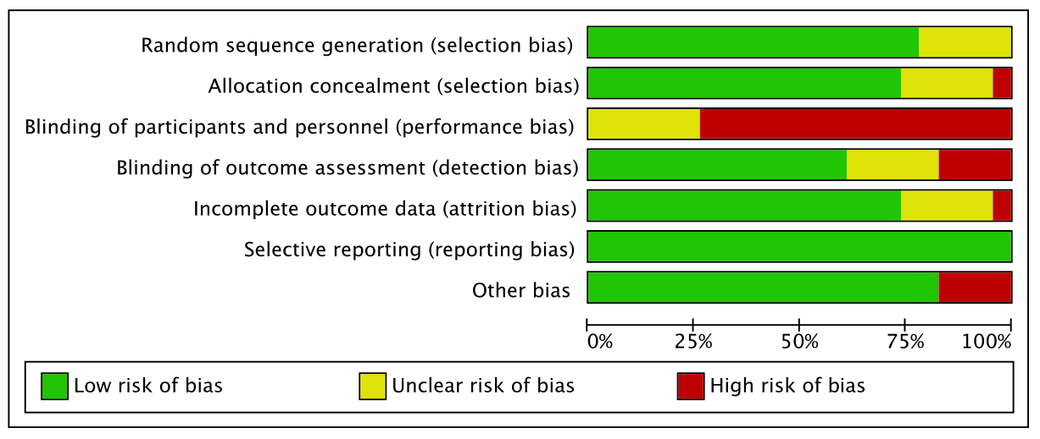
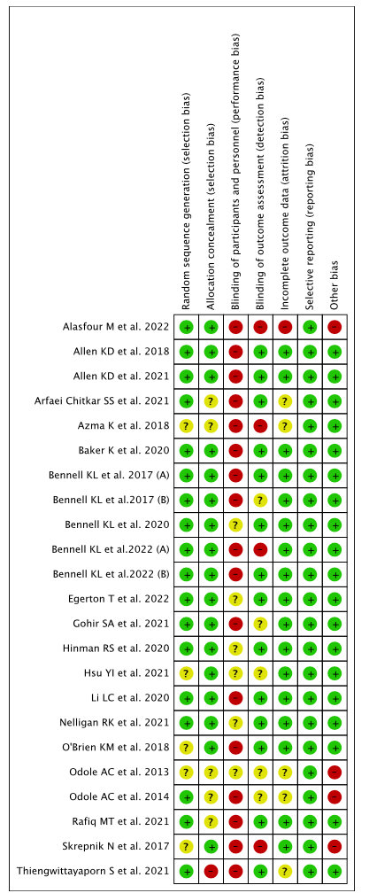

Supplementary Table 2: Physiotherapy Evidence Database (PEDro) Scale quality assessment
 | Eligibility criteria specified (0/1) | Random allocation (0/1) | Concealed allocation (0/1) | Comparable at baseline (0/1) | Blinded subjects (0/1) | Blinded therapists (0/1) | Blinded assessors (0/1) | Adequate follow-up (0/1) | Intention-to-treat analysis (0/1) | Between group comparisons (0/1) | Point estimates and variability (0/1) | Summary
Alasfour M et al. (2022) | 1 | 1 | 1 | 1 | 0 | 0 | 0 | 1 | 0 | 1 | 1 | 7
Allen KD et al. (2018) | 1 | 1 | 1 | 1 | 0 | 0 | 1 | 1 | 1 | 1 | 1 | 9
Allen KD et al. (2021) | 1 | 1 | 1 | 1 | 0 | 0 | 1 | 1 | 1 | 1 | 1 | 9
Arfaei Chitkar SS et al. (2021) | 1 | 0 | 1 | 1 | 0 | 0 | 1 | 1 | 1 | 1 | 1 | 8
Azma K et al. (2018) | 1 | 0 | 0 | 1 | 0 | 0 | 0 | 1 | 1 | 1 | 1 | 6
Baker K et al. (2020) | 1 | 1 | 1 | 1 | 0 | 0 | 1 | 1 | 1 | 1 | 1 | 9
Bennell KL et al. (2017) (A) | 1 | 1 | 1 | 1 | 1 | 0 | 1 | 1 | 1 | 1 | 1 | 10
Bennell KL et al. (2017) (B) | 1 | 1 | 1 | 1 | 0 | 0 | 1 | 1 | 1 | 1 | 1 | 9
Bennell KL et al. (2020) | 1 | 1 | 1 | 1 | 1 | 0 | 1 | 1 | 1 | 1 | 1 | 10
Bennell KL et al. (2022) (A) | 1 | 1 | 1 | 1 | 0 | 0 | 0 | 1 | 1 | 1 | 1 | 8
Bennell KL et al. (2022) (B) | 1 | 1 | 1 | 1 | 0 | 0 | 0 | 1 | 1 | 1 | 1 | 8
Egerton T et al. (2022) | 1 | 1 | 1 | 1 | 1 | 0 | 1 | 1 | 0 | 1 | 1 | 9
Gohir SA et al. (2021) | 1 | 1 | 1 | 1 | 0 | 0 | 0 | 1 | 1 | 1 | 1 | 8
Hinman RS et al. (2020) | 1 | 1 | 1 | 1 | 0 | 0 | 1 | 1 | 1 | 1 | 1 | 9
Hsu YI et al. (2021) | 1 | 0 | 1 | 1 | 1 | 0 | 0 | 1 | 1 | 1 | 1 | 8
Li LC et al. (2020) | 1 | 1 | 1 | 1 | 0 | 0 | 1 | 1 | 1 | 1 | 1 | 9
Nelligan RK et al. (2021) | 1 | 1 | 1 | 1 | 1 | 0 | 1 | 1 | 1 | 1 | 1 | 10
O'Brien KM et al. (2018) | 1 | 0 | 1 | 1 | 1 | 0 | 1 | 1 | 1 | 1 | 1 | 9
Odole AC et al. (2013) | 1 | 0 | 0 | 1 | 0 | 0 | 0 | 1 | 1 | 1 | 1 | 6
Odole AC et al. (2014) | 1 | 1 | 0 | 1 | 0 | 0 | 0 | 1 | 1 | 1 | 1 | 7
Rafiq MT et al. (2021) | 1 | 1 | 0 | 1 | 1 | 0 | 1 | 0 | 1 | 1 | 1 | 8
Skrepnik N et al. (2017) | 1 | 0 | 1 | 1 | 0 | 0 | 0 | 1 | 1 | 1 | 1 | 7
Thiengwittayaporn S et al. (2021) | 1 | 1 | 0 | 1 | 0 | 0 | 1 | 1 | 1 | 1 | 1 | 8

Supplementary Table 3: GRADE summary of findings
Telehealth-based exercise/physical activity programs for knee osteoarthritis
Patient or population: patients with knee osteoarthritis
Settings:
Intervention: Telerehabilitation
Outcomes | Illustrative comparative risks* (95% CI) |  | Relative effect  (95% CI) | No of Participants  (studies) | Quality of the evidence  (GRADE) | Comments
Outcomes | Assumed risk | Corresponding risk
 | Control | Telehealth-based exercise/physical activity programs
Pain  WOMAC-pain | The mean pain in the control group was between -37 and 1.4 from baseline | The mean pain in the intervention groups was 0.39 standard deviations lower (0.67 to 0.11 lower) |  | 2512  (19 studies) | ⊕⊕⊝⊝  low^{1,2} | The methods measuring outcome of trials were different
Physical activity  PASE | The mean physical activity in the control group was between -21.9 and 84.8 from baseline | The mean physical activity in the intervention groups was 0.13 standard deviations higher (0.03 to 0.23 higher) |  | 1570  (9 studies) | ⊕⊕⊝⊝  low^{1,3} | The methods measuring outcome of trials were different
Physical function  WOMAC-function | The mean physical function in the control group was between -13.14 and 1 from baseline | The mean physical function in the intervention groups was 0.51 standard deviations lower (0.98 to 0.05 lower) |  | 2373  (18 studies) | ⊕⊕⊝⊝  low^{1,4} | The methods measuring outcome of trials were different
Quality of life | The mean pain in the control group was between -0.6 and 6.5 from baseline | The mean quality of life in the intervention groups was 0.25 standard deviations higher (0.14 to 0.36 higher) |  | 1301  (9 studies) | ⊕⊕⊕⊝  moderate¹
ASES-pain | The mean pain in the control group was between -0.5 to 1.1 from baseline | The mean ASES-pain in the intervention groups was 0.72 standard deviations higher (0.53 to 0.91 higher) |  | 1337  (6 studies) | ⊕⊕⊕⊝  moderate¹
ASES-physical function | The mean pain in the control group was between 0.2 and 0.6 from baseline | The mean ASES-physical function in the intervention groups was 0.14 standard deviations higher (0.26 lower to 0.53 higher) |  | 578  (4 studies) | ⊕⊕⊝⊝  low^{1,5}
Global improvement | 636 per 1000 | 825 per 1000 (711 to 900) | OR 2.69  (1.41 to 5.15) | 1042  (4 studies) | ⊕⊕⊝⊝  low^{1,6}
*The basis for the assumed risk (e.g. the median control group risk across studies) is provided in footnotes. The corresponding risk (and its 95% confidence interval) is based on the assumed risk in the comparison group and the relative effect of the intervention (and its 95% CI).
CI: Confidence interval; OR: Odds ratio;
GRADE Working Group grades of evidence
High quality: Further research is very unlikely to change our confidence in the estimate of effect.
Moderate quality: Further research is likely to have an important impact on our confidence in the estimate of effect and may change the estimate.
Low quality: Further research is very likely to have an important impact on our confidence in the estimate of effect and is likely to change the estimate.
Very low quality: We are very uncertain about the estimate.
¹ Downgraded for risk of bias: Participants and personnel were unblinded
² Downgraded for inconsistency: Considerable heterogeneity (I²=83%)
³ Downgraded for imprecision: Small sample size (Li LC et al. 2020)
⁴ Downgraded for inconsistency: Considerable heterogeneity (I²=87%)
⁵ Downgraded for inconsistency: Considerable heterogeneity (I²=52%)
⁶ Downgraded for inconsistency: Considerable heterogeneity (I²=79%)

Supplementary Figure 2: Forest plots of secondary outcomes
Quality of living
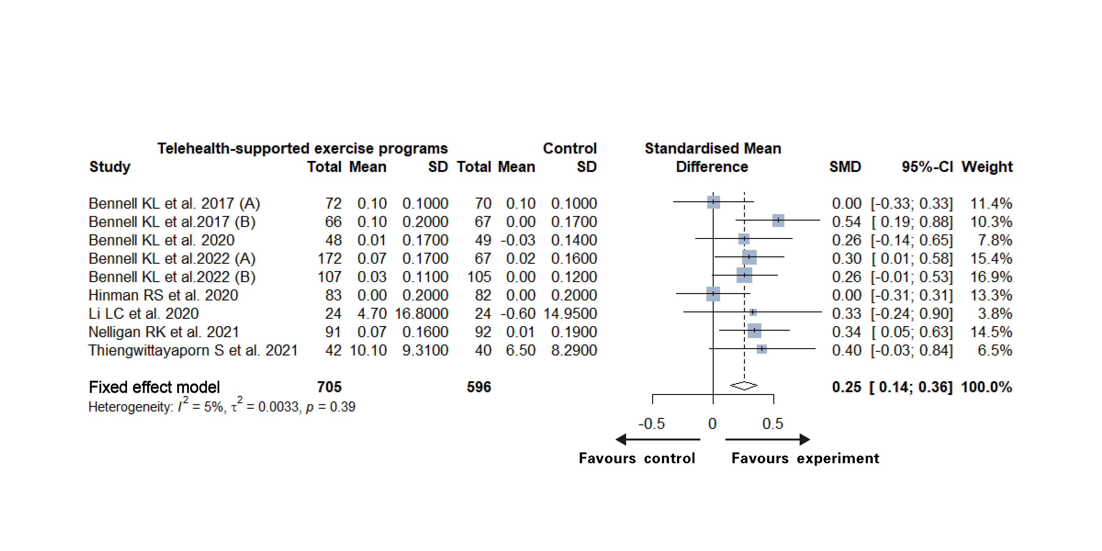
Favours intervention
Favours control
Self-efficacy for pain
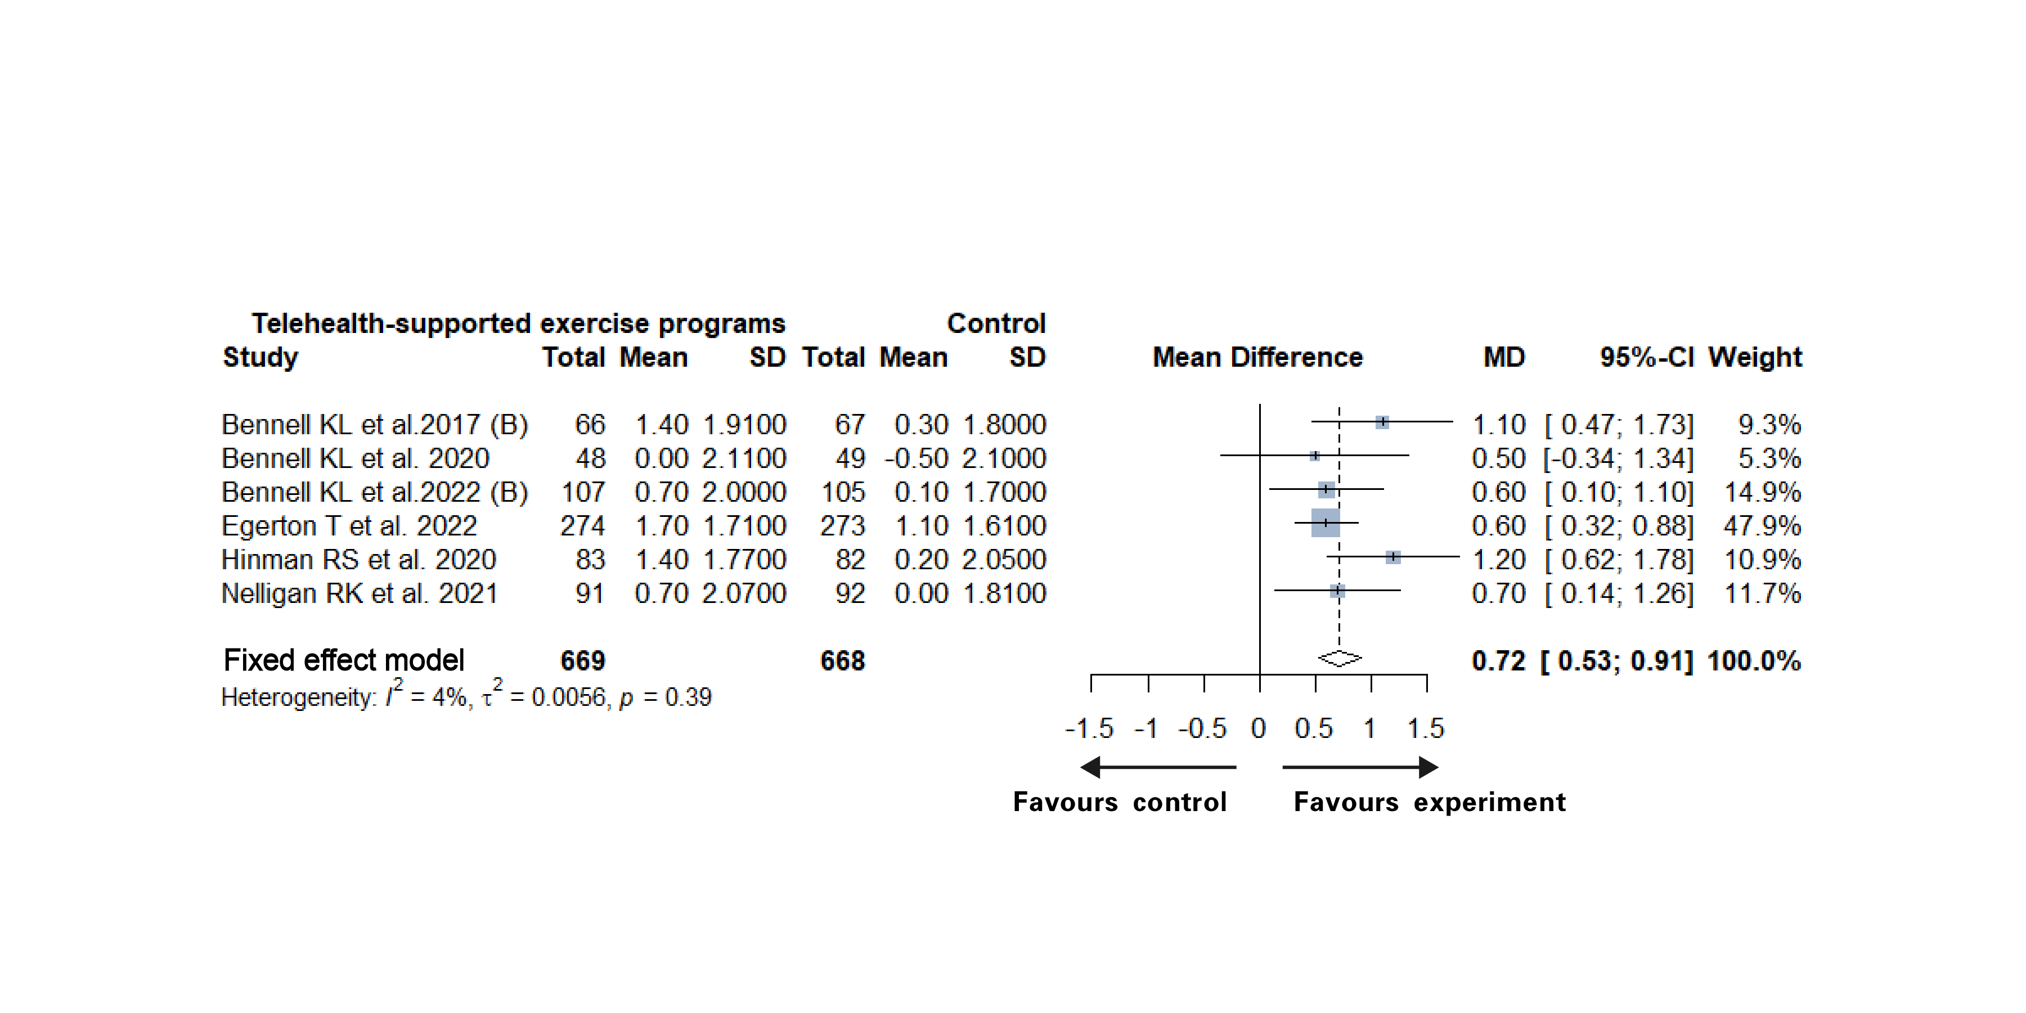
Favours intervention
Favours control
Global improvement
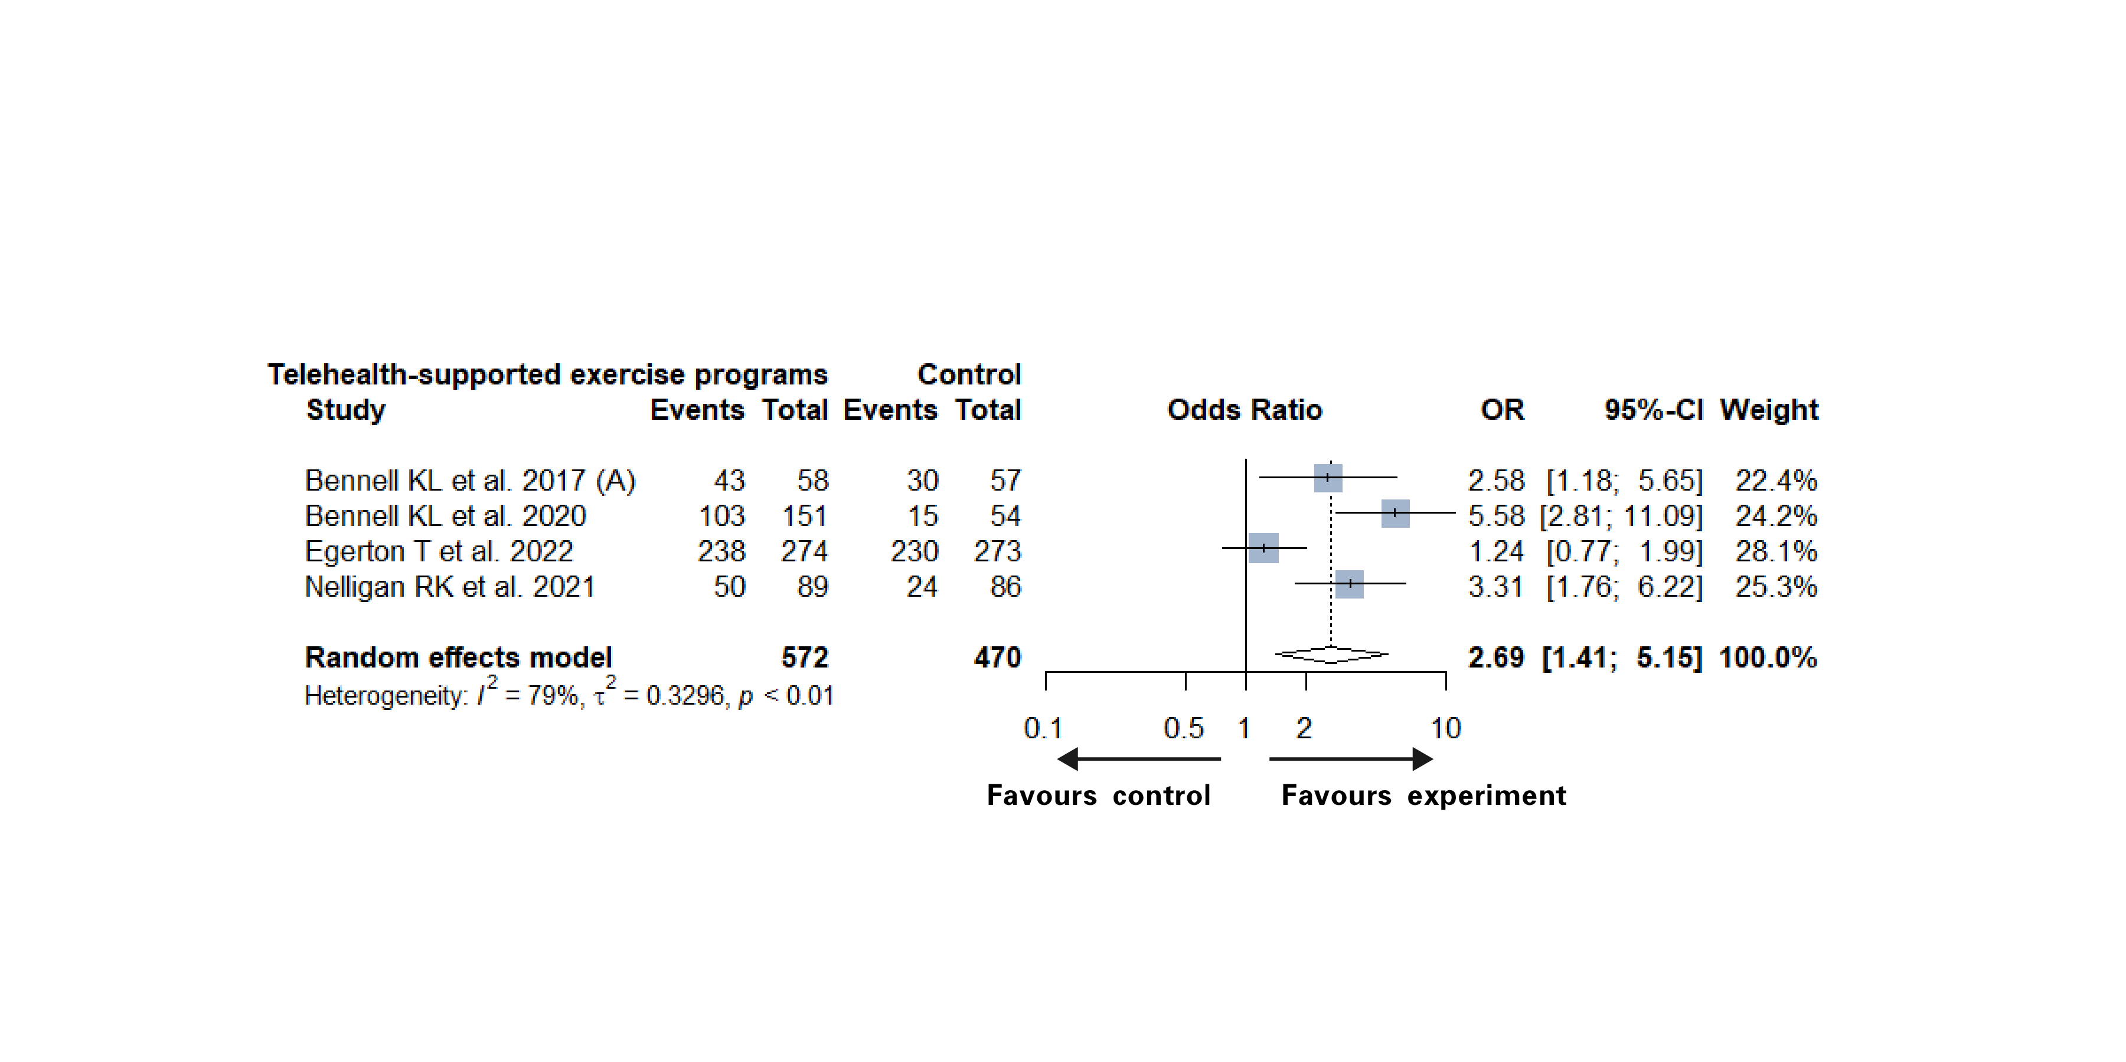
Favours intervention
Favours control
Self-efficacy for physical function
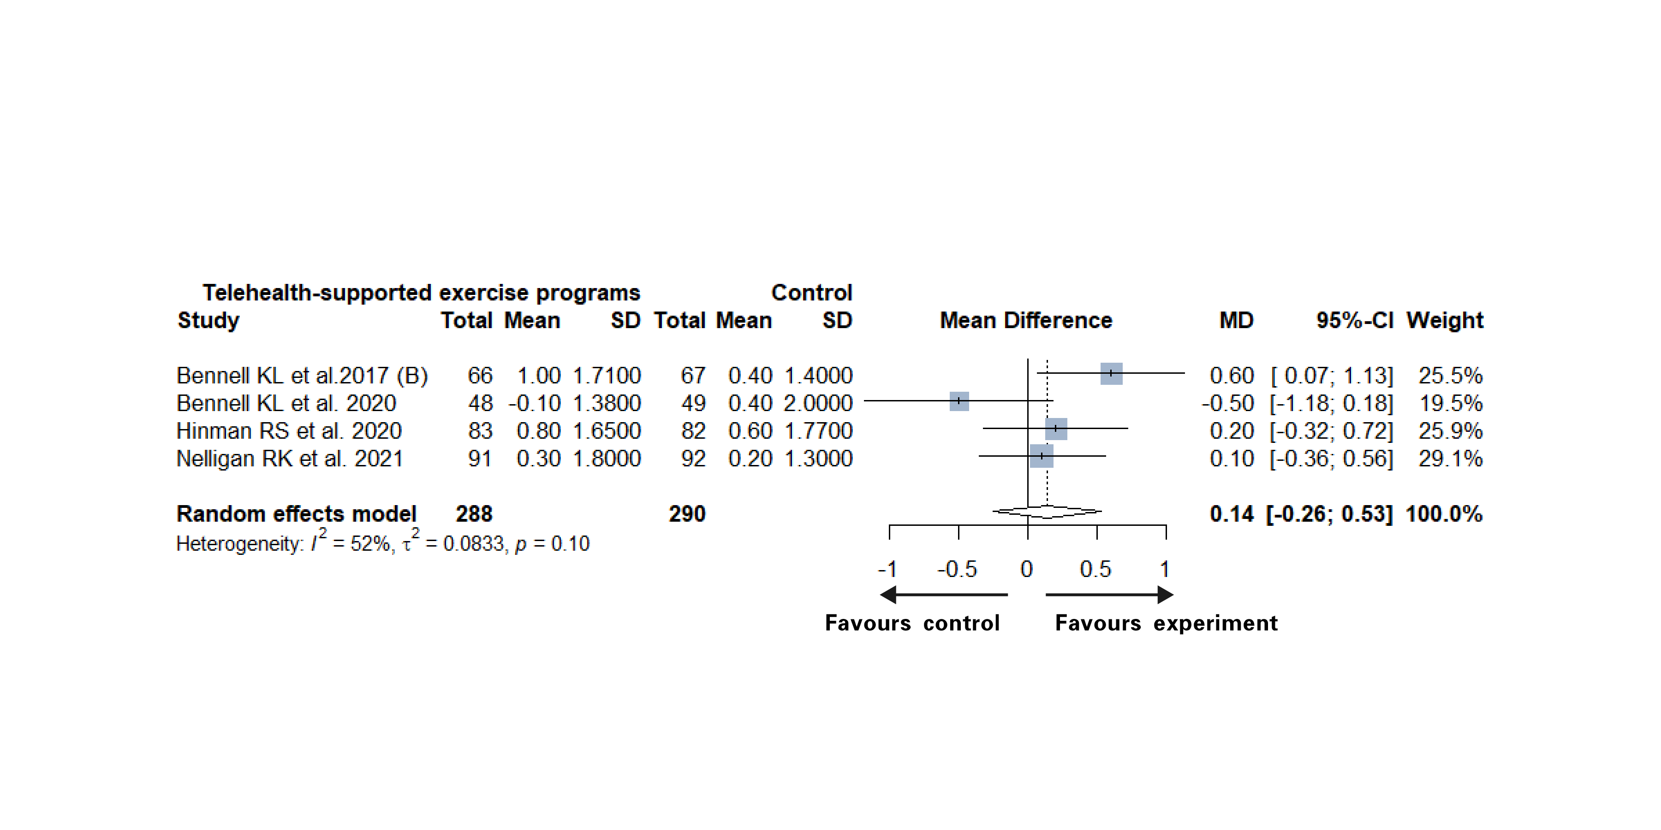
Favours intervention
Favours control

Supplementary Figure 3: Results of sensitivity analysis
Pain
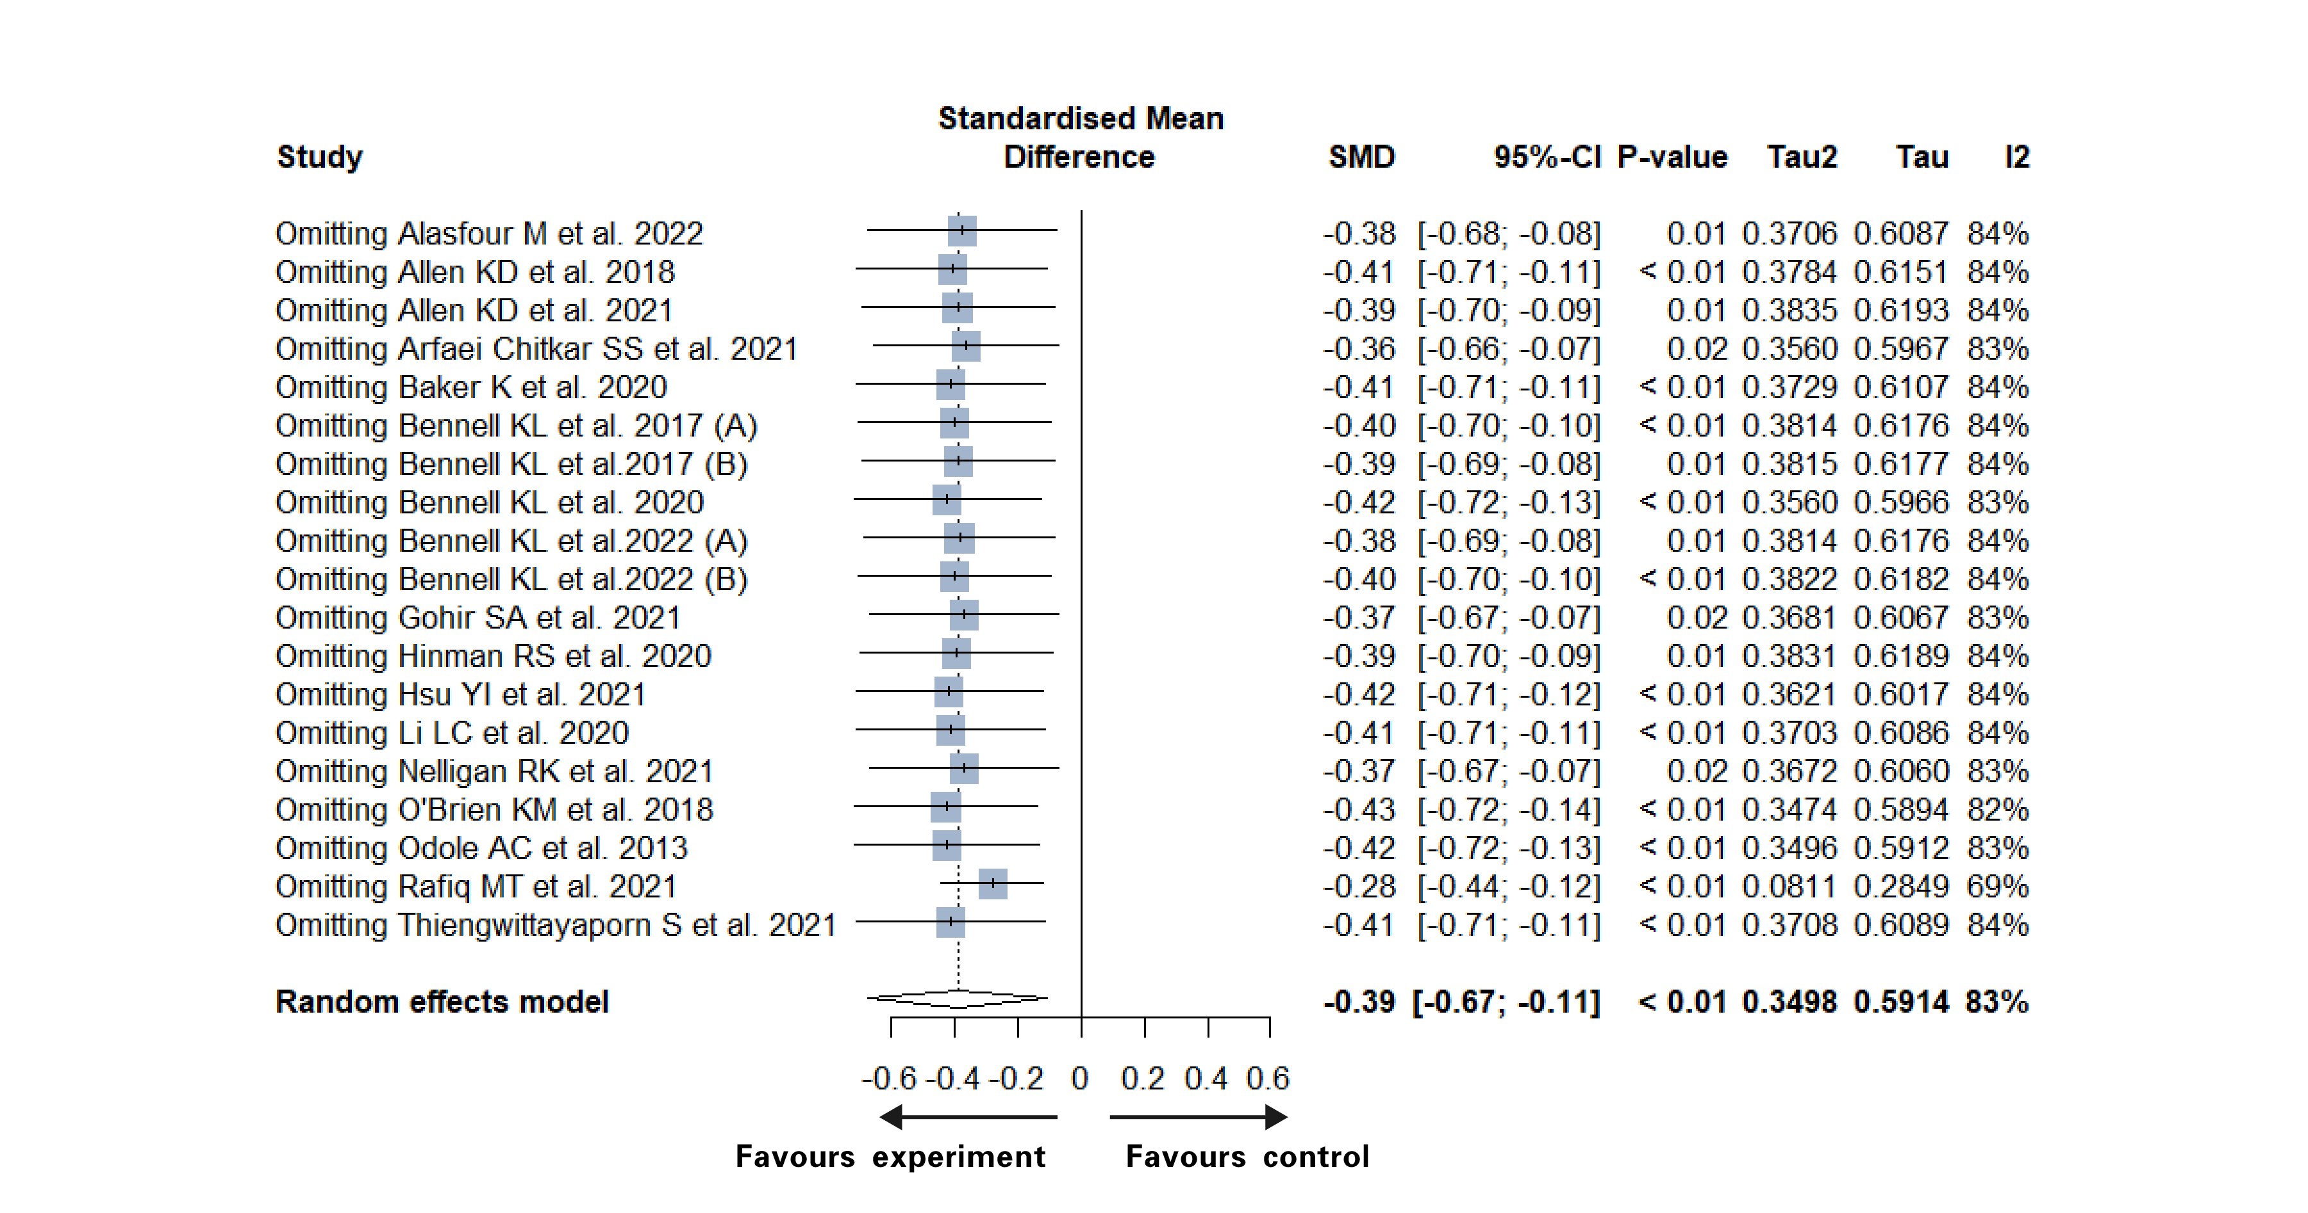
Favours control
Favours intervention
Physical function
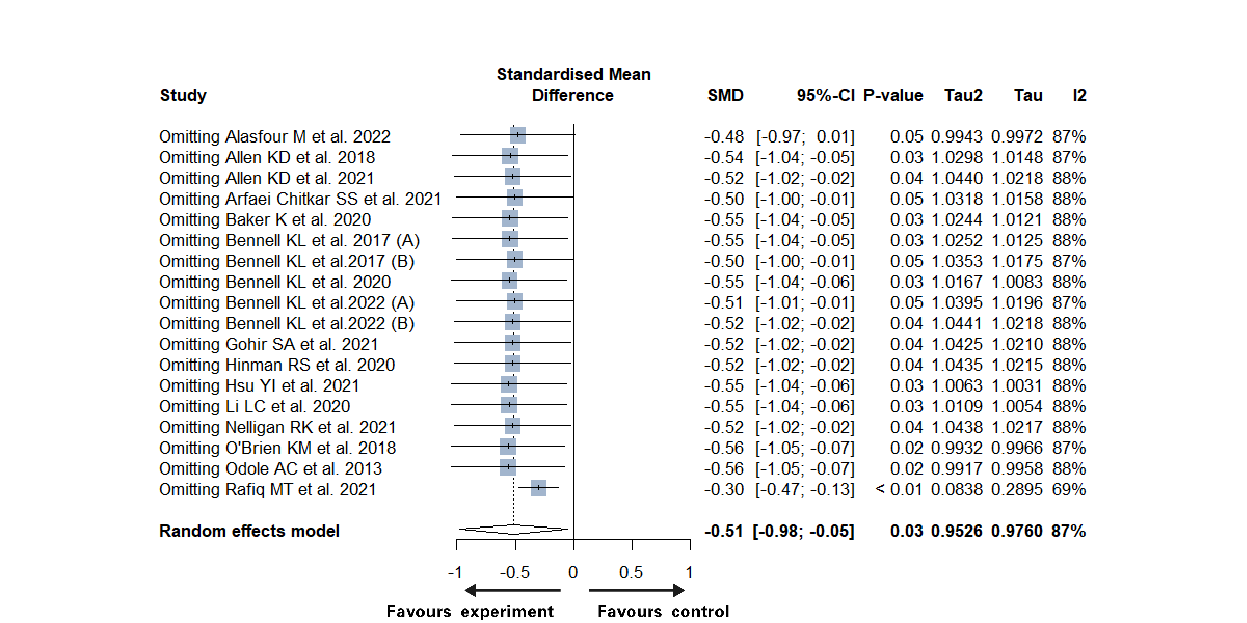
Favours control
Favours intervention

Supplementary Table 4: Result of meta-regression test
Relative factor | P-value of factor and pain | P-value of factor and physical function
The existing of coaching | 0.1196 | 0.156
The existing of monitoring | 0.2806 | 0.3102
The existing of reminder | 0.3208 | 0.4046
The content in experimental group | 0.9799 | 0.7398
The model of delivery | 0.589 | 0.0726
The type of tele-technology | 0.003 | 0.0115
Intervention duration | 0.5575 | 0.0665
The WHO classification | 0.0392 | 0.0399
Active/inactive control | 0.0214 | 0.0663
Sample size | 0.3215 | 0.4410
Quality of study | 0.4922 | 0.6948
Region | 0.2706 | 0.2060
WHO: World Health Organization

Supplementary Figure 4: Funnel plots of primary outcomes
Pain
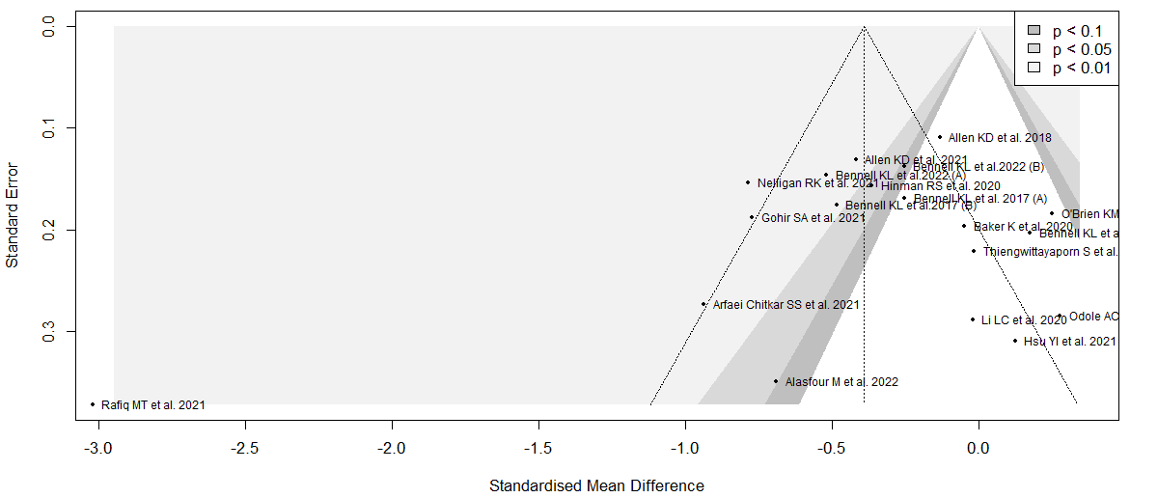
Physical activity
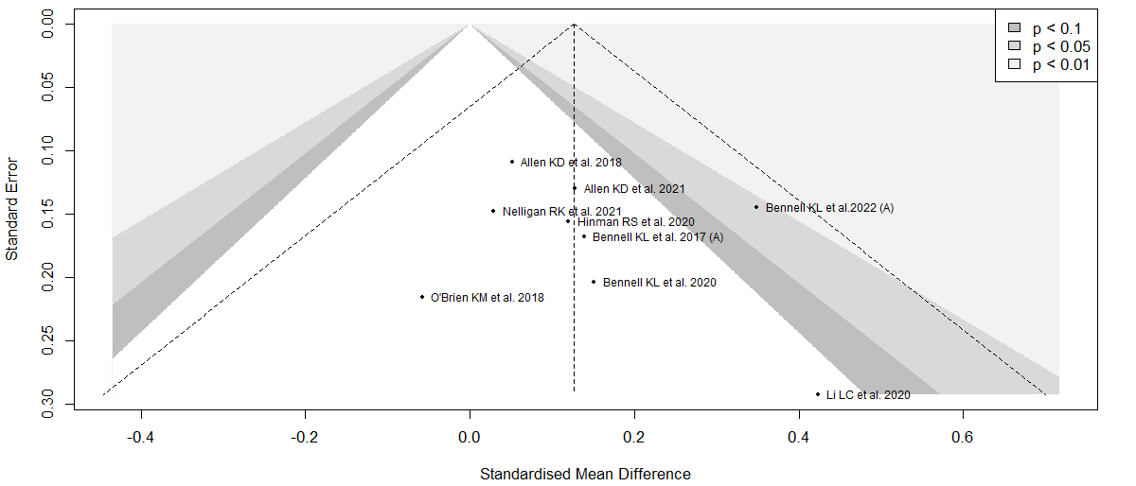
Physical function
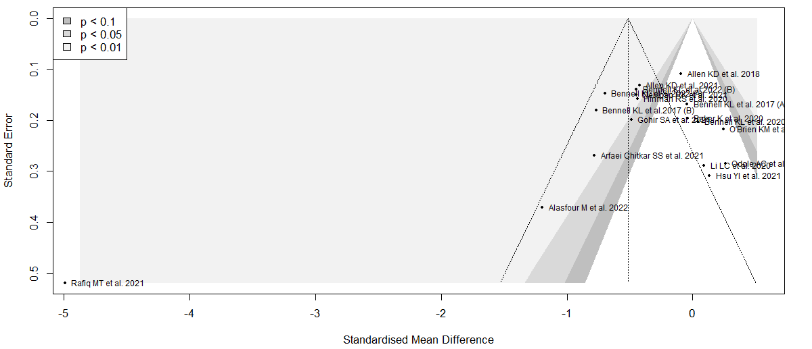

Supplementary Table 5: Search strategy
Medline (Ovid) search strategy (1946 to August Week 4, 2022)
exp telerehabilitation/
(Telecommunication or telemedicine or telehealth or telecoaching or E-health or E-medicine or Mobilehealth or Information technology or Information communication technology or Internet or Web-based or Videoconferencing or Remote consulting or Telemanagement or Teleconsulting or Telemonitoring or Mhealth or Online or SMS or Email or Wearable or Smartphone or Computer or Mobile or Remote). ab.
(Rehabilitation or Physical therapy or Exercise or physical activity).ab.
1 or 2 or 3
exp Osteoarthritis, Knee/
(Knee osteoarthritis or Osteoarthritis of knee or Osteoarthritis of knee or KOA).ab.
5 or 6
Randomized controlled trial.pt.
Controlled clinical trial.pt.
(randomized or placebo or randomly or groups or trial).ab.
random*.ti,ab.
or/8-11
4 and 7 and 12

EBM Reviews - Cochrane Central Register of Controlled Trials (Ovid) search strategy (to July 2022)
exp telerehabilitation/
(Telecommunication or telemedicine or telehealth or telecoaching or E-health or E-medicine or Mobilehealth or Information technology or Information communication technology or Internet or Web-based or Videoconferencing or Remote consulting or Telemanagement or Teleconsulting or Telemonitoring or Mhealth or Online or SMS or Email or Wearable or Smartphone or Computer or Mobile or Remote). ab.
(Rehabilitation or Physical therapy or Exercise or physical activity).ab.
1 or 2 or 3
exp Osteoarthritis, Knee/
(Knee osteoarthritis or Osteoarthritis of knee or Osteoarthritis of knee or KOA).ab.
5 or 6
Randomized controlled trial.pt.
Controlled clinical trial.pt.
(randomized or placebo or randomly or groups or trial).ab.
random*.ti,ab.
or/8-11
4 and 7 and 12

Embase search strategy (1974 to 6th September, 2022)
exp telerehabilitation/
(Telecommunication or telemedicine or telehealth or telecoaching or E-health or E-medicine or Mobilehealth or Information technology or Information communication technology or Internet or Web-based or Videoconferencing or Remote consulting or Telemanagement or Teleconsulting or Telemonitoring or Mhealth or Online or SMS or Email or Wearable or Smartphone or Computer or Mobile or Remote). ab.
(Rehabilitation or Physical therapy or Exercise or physical activity).ab.
1 or 2 or 3
exp Osteoarthritis, Knee/
(Knee osteoarthritis or Osteoarthritis of knee or Osteoarthritis of knee or KOA).ab.
5 or 6
Randomized controlled trial.pt.
Controlled clinical trial.pt.
(randomized or placebo or randomly or groups or trial).ab.
random*.ti,ab.
or/8-11
4 and 7 and 12

Scopus
TITLE-ABS-KEY ( telerehabilitation )
TITLE-ABS-KEY ( telecommunication* OR telemedicine OR telehealth OR telecoaching OR e-health OR e-medicine OR mobilehealth OR information AND technology OR information AND communication AND technology OR internet OR web-based OR videoconferencing OR remote AND consulting OR telemanagement OR teleconsulting OR telemonitoring OR mhealth OR online OR sms OR email OR wearable OR smartphone OR computer OR mobile OR remote )
Rehabilitation or Physical therapy or Exercise or physical activity
TITLE-ABS-KEY ( rehabilitation OR physical AND therapy OR exercise OR physical AND activity ) ) OR ( TITLE-ABS-KEY ( telecommunication* OR telemedicine OR telehealth OR telecoaching OR e-health OR e-medicine OR mobilehealth OR information AND technology OR information AND communication AND technology OR internet OR web-based OR videoconferencing OR remote AND consulting OR telemanagement OR teleconsulting OR telemonitoring OR mhealth OR online OR sms OR email OR wearable OR smartphone OR computer OR mobile OR remote ) ) OR ( TITLE-ABS-KEY ( telerehabilitation )
TITLE-ABS-KEY ( knee AND osteoarthritis OR osteoarthritis AND of AND knee OR osteoarthritis AND of AND knee OR koa )
TITLE-ABS-KEY ( knee AND osteoarthritis OR osteoarthritis AND of AND knee OR osteoarthritis AND of AND knee OR koa ) ) AND ( ( TITLE-ABS-KEY ( rehabilitation OR physical AND therapy OR exercise OR physical AND activity ) ) OR ( TITLE-ABS-KEY ( telecommunication* OR telemedicine OR telehealth OR telecoaching OR e-health OR e-medicine OR mobilehealth OR information AND technology OR information AND communication AND technology OR internet OR web-based OR videoconferencing OR remote AND consulting OR telemanagement OR teleconsulting OR telemonitoring OR mhealth OR online OR sms OR email OR wearable OR smartphone OR computer OR mobile OR remote ) ) OR ( TITLE-ABS-KEY ( telerehabilitation ) ) )

PubMed
telerehabilitation[MeSH Terms]
telecommunications*[Title/Abstract]
telemedicine[Title/Abstract]
telehealth[Title/Abstract]
telehealthcare[Title/Abstract]
telecoaching[Title/Abstract]
e-health[Title/Abstract]
e-medicine[Title/Abstract]
mobilehealth[Title/Abstract]
information technology[Title/Abstract]
internet[Title/Abstract]
web-based[Title/Abstract]
videoconferencing[Title/Abstract]
remote consultation[Title/Abstract]
telemanagement[Title/Abstract]
teleconsultation[Title/Abstract]
telemonitoring[Title/Abstract]
mhealth[Title/Abstract]
online[Title/Abstract]
SMS[Title/Abstract]
Email[Title/Abstract]
Wearable[Title/Abstract]
Smartphone[Title/Abstract]
Computer[Title/Abstract]
Mobile[Title/Abstract]
Remote[Title/Abstract]
Rehabilitation[Title/Abstract]
Physical therapy[Title/Abstract]
Exercise[Title/Abstract]
1 or 2 or 3 or 4 or 5 or 6 or 7 or 8 or 9 or 10 or 11 or 12 or 13 or 14 or 15 or 16 or 17 or 18 or 19 or 20 or 21 or 22 or 23 or 24 or 25 or 26 or 27 or 28 or 29
Osteoarthritis, knee[Title/Abstract]
Knee Osteoarthritis[Title/Abstract]
Knee Osteorathritides[Title/Abstract]
Osteoarthritis of knee[Title/Abstract]
Osteoarthritis of the knee[Title/Abstract]
31 or 32 or 33 or 334 or 35
Meta-analysis[Publication Type]
Review[Publication Type]
Randomized controlled trail[Publication Type]
Meta analysis[MeSH Terms]
Meta-analysis[Title/Abstract]
Search*[Title/Abstract]
Randomized[Title/Abstract]
placebo[Title/Abstract]
37 or 38 or 39 or 40 or 41 or 42 or 43 or 44
30 and 36 and 45

Web of science
TS=clinical trial*
TS=controlled trial*
TS=random*
#1 or #2 or #3
TS=Knee Osteoarthritis
TS=telerehabilitation
#4 AND #5 AND #6

Physiotherapy Evidence Database (PEDro)
https://www.pedro.org.au/: telerehabilitation and knee osteoarthritis.

Additional records identified through other sources
http://www.opengrey.eu/search/request?q=greynet: telerehabilitation and knee osteoarthritis.

https://www.medrxiv.org/: telerehabilitation and knee osteoarthritis.

