Table 1 Baseline demographic and clinical characteristics of the patients
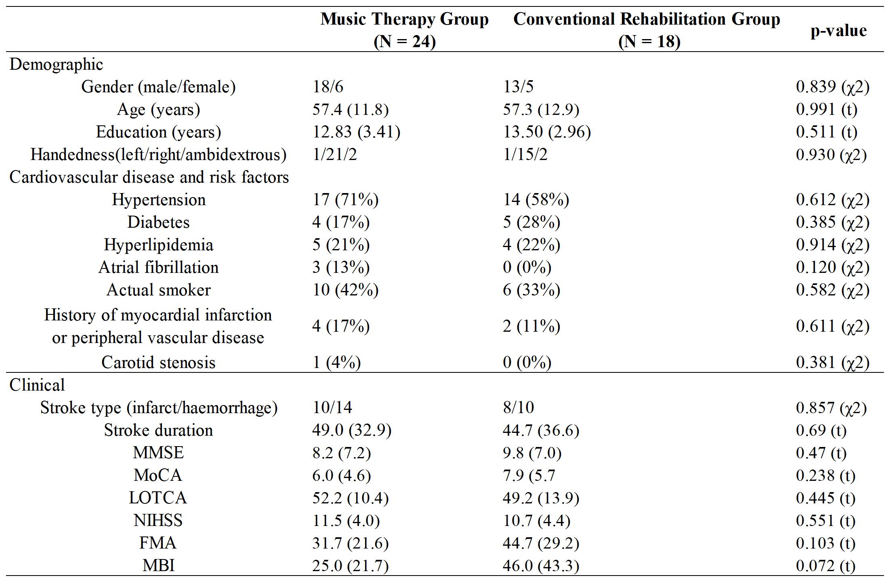Note: Data are mean (SD) unless otherwise stated. Significant group differences are shown in bold. t = independent samples t-test, χ 2 = chi_x0002_square test.
Abbreviations: MMSE, mini-mental state examination; MoCA, montreal cognitive assessment; LOTCA, loewenstein occupational therapy cognitive assessment; NIHSS, national institute of health stroke scale; FMA, fugl-meyer assessment scale; MBI, modified barthel index.

Table 2 Comparison of evaluation scores at different stages of the intervention
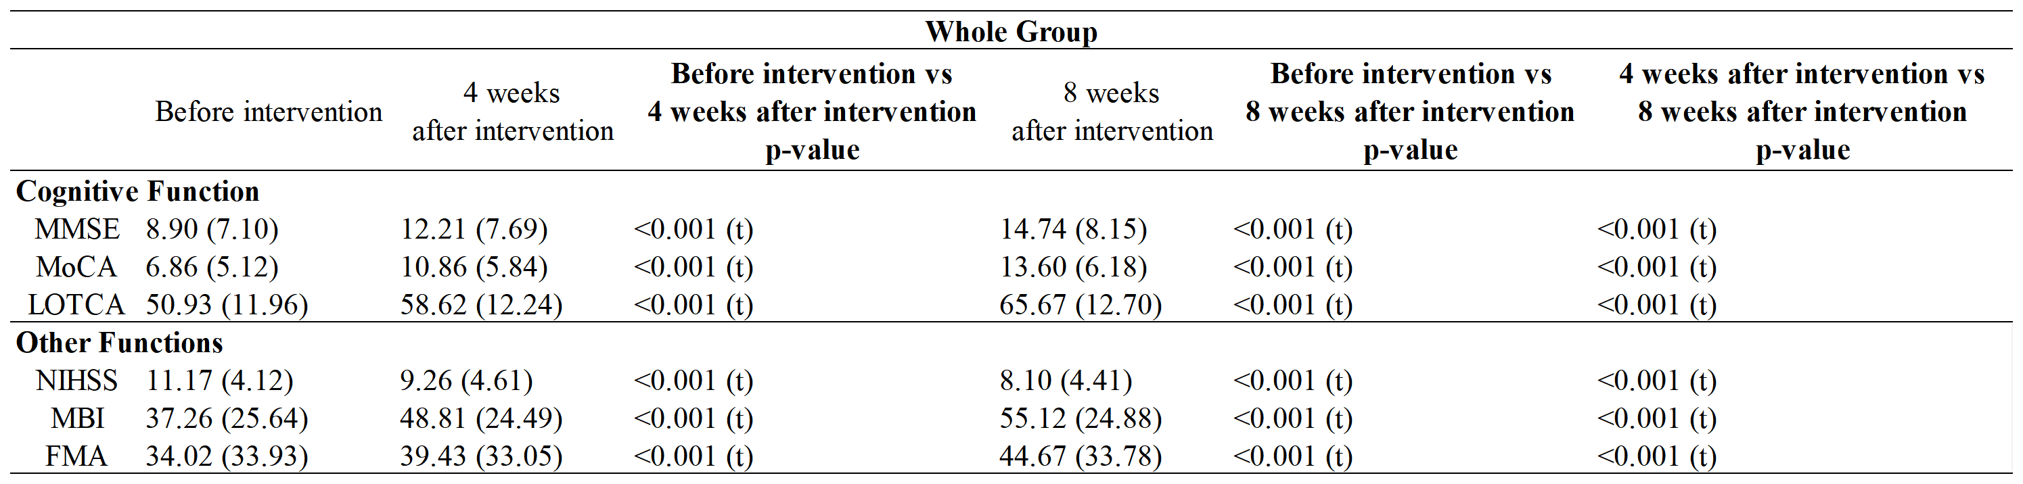
Note: Data are mean (SD) unless otherwise stated. t = paired t-test.
Abbreviations: MMSE, mini-mental state examination; MoCA, montreal cognitive assessment; LOTCA, loewenstein occupational therapy cognitive assessment; NIHSS, national institute of health stroke scale; FMA, fugl-meyer assessment scale; MBI, modified barthel index.

Table 3 Comparison of the improvement of evaluation scores after the intervention in the two groups
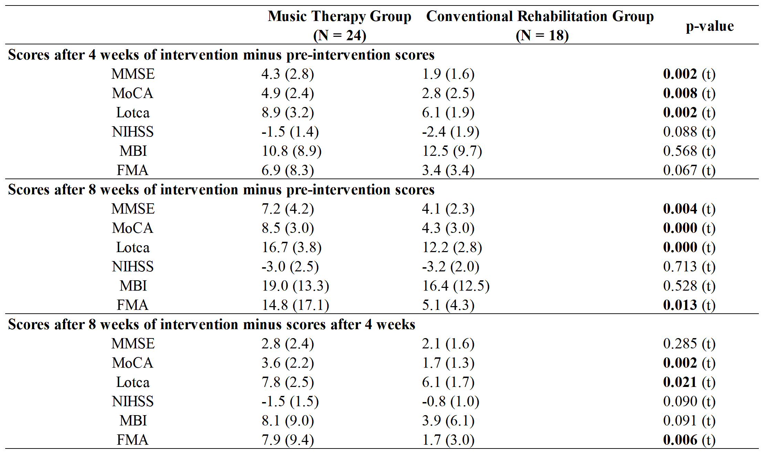
Note: Data are mean (SD) unless otherwise stated. Significant group differences are shown in bold. t = independent samples t-test.
Abbreviations: MMSE, mini-mental state examination; MoCA, montreal cognitive assessment; LOTCA, loewenstein occupational therapy cognitive assessment; NIHSS, national institute of health stroke scale; FMA, fugl-meyer assessment scale; MBI, modified barthel index.

Table 4 Comparison of domain-specific cognitive function scores at different stages of intervention
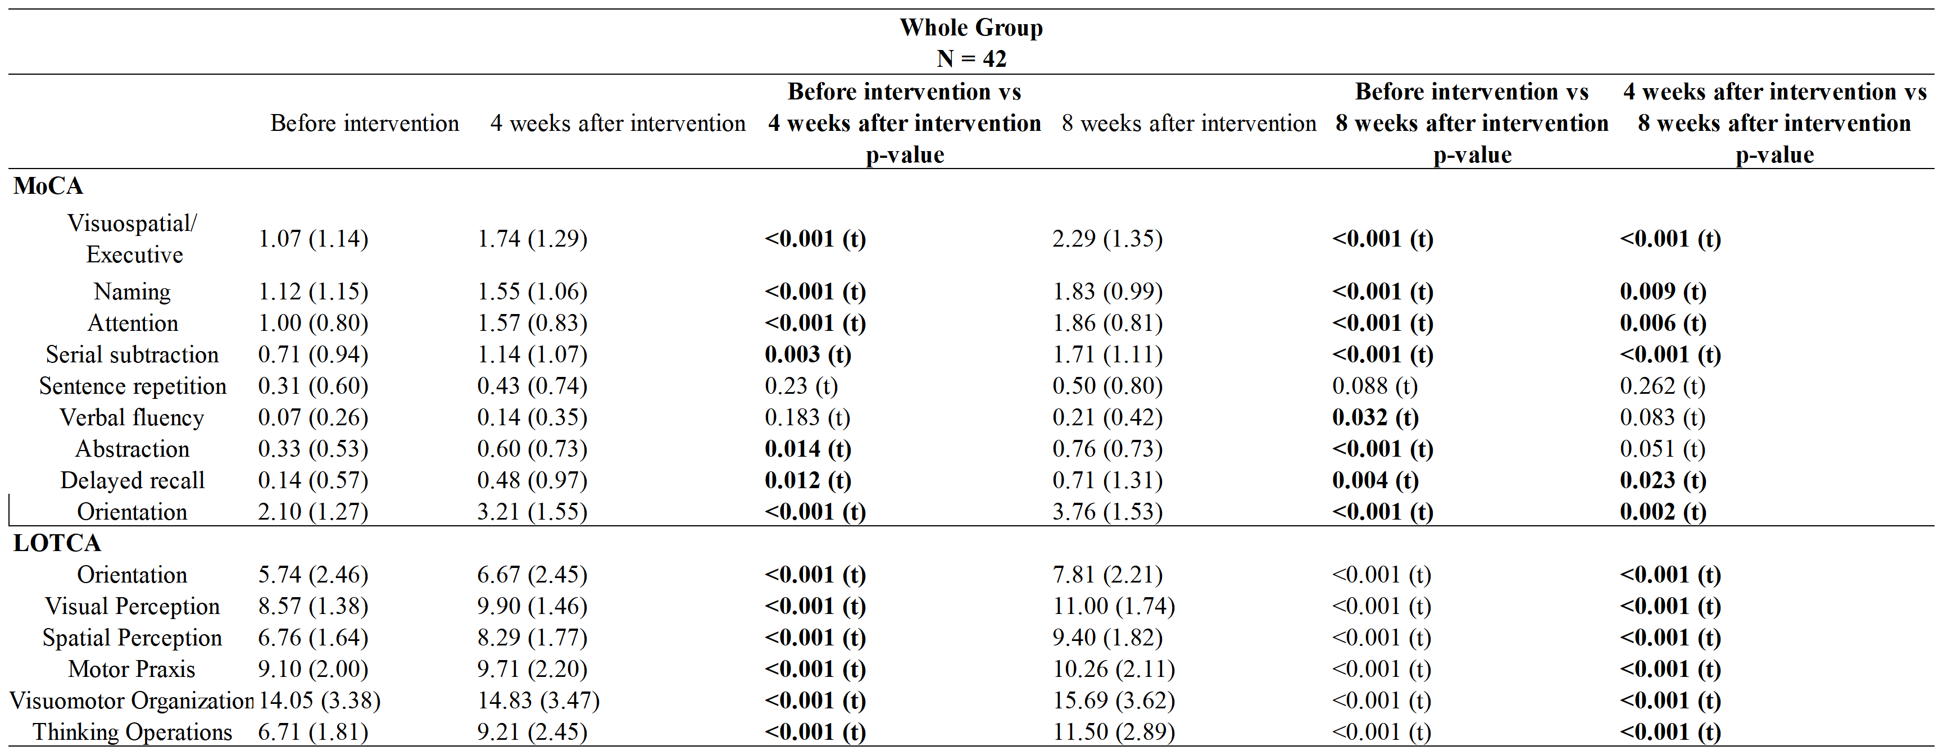
Note: Data are mean (SD) unless otherwise stated. Significant group differences are shown in bold. t = paired t-test.
Abbreviations: MoCA, montreal cognitive assessment; LOTCA, loewenstein occupational therapy cognitive assessment.
Table 5 Changes in domain-specific cognitive function
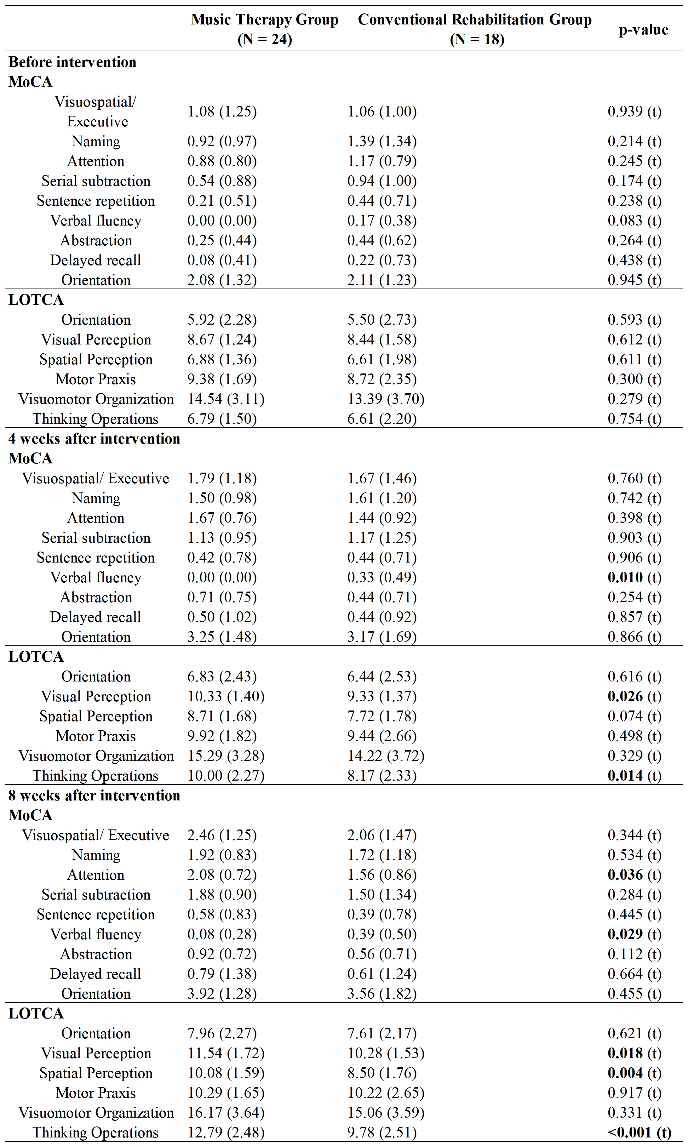
Note: Data are mean (SD) unless otherwise stated. Significant group differences are shown in bold. t = independent samples t-test.
Abbreviations: MoCA, montreal cognitive assessment; LOTCA, loewenstein occupational therapy cognitive assessment.

