SCIENTIFIC REPORTS

LONGITUDINAL PROFILING OF THE BURN PATIENT CUTANEOUS AND GASTROINTESTINAL MICROBIOTA

Kelly M. Lima, BS¹; Ryan R. Davis, BS¹; Stephenie Y. Liu, BA¹; David Greenhalgh, MD, FACS²; Nam K. Tran, PhD, HCLD (ABB), FAACC^{1*}

¹Dept. of Pathology and Laboratory Medicine, UC Davis
²Dept. of Surgery, UC Davis

SUPPLEMENTAL MATERIAL

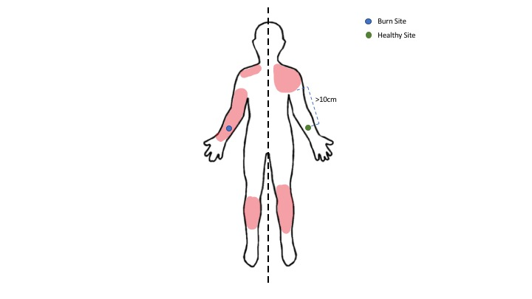
Figure S1. Sample Site Determination
This image depicts a hypothetical subject with approximately 10% TBSA anterior burns. For this subject there are several areas of burned tissue that could be selected. To maintain a spared site that is a minimum of 10cm away from injured skin, optimal sampling would be from the right forearm (Burn Site), and the corresponding location on the left forearm (Spared Site). The healthy site is distal enough to not be obstructed by peripheral line placement.
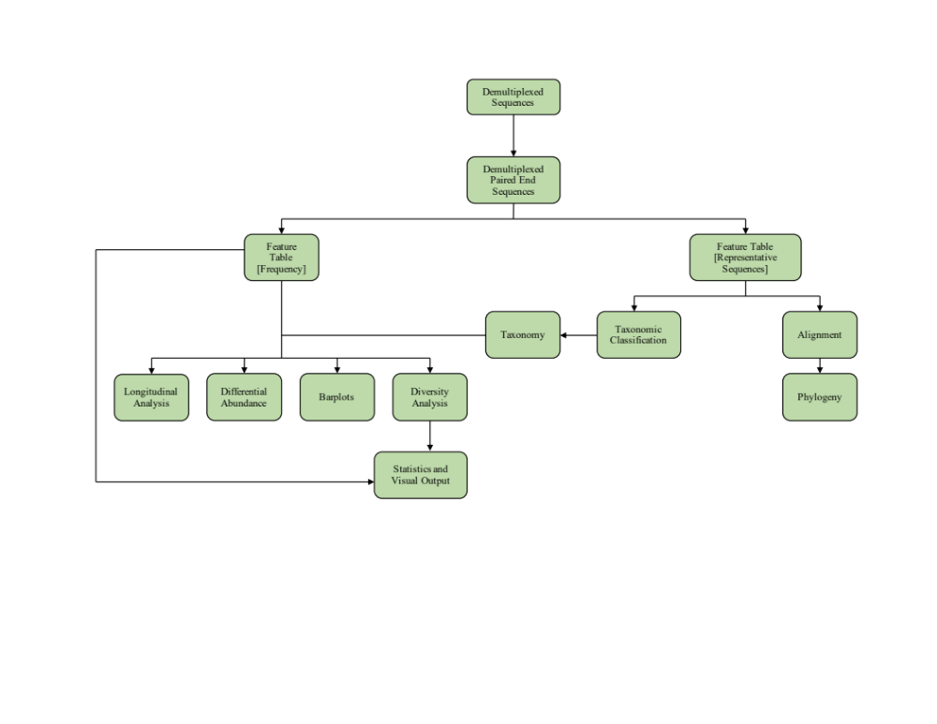
Figure S2. Bioinformatics Flow Chart

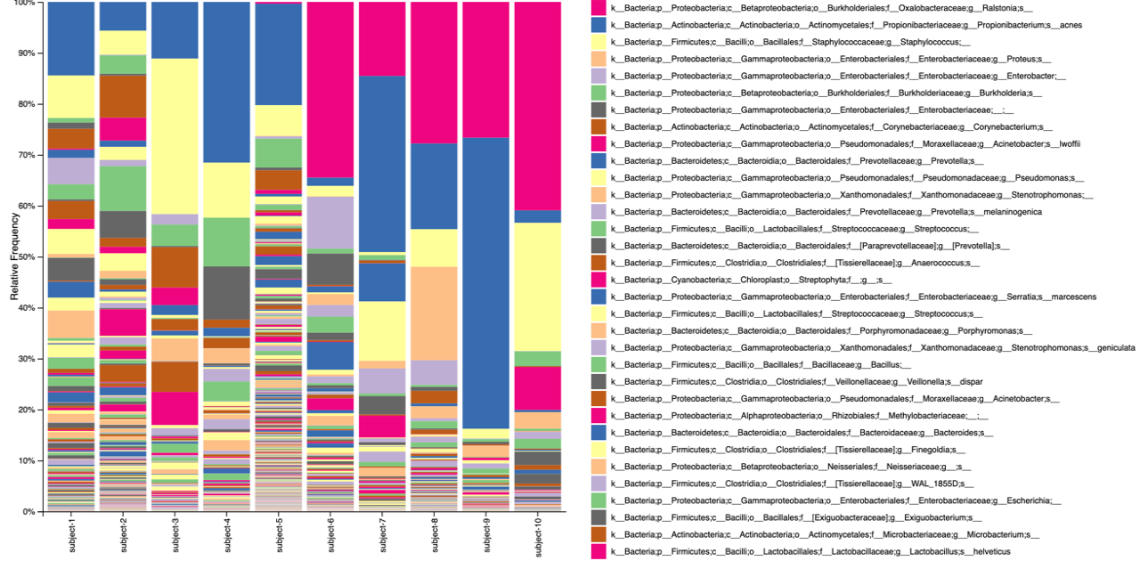
Figure S3. Taxonomy of Burn Patient Spared Skin.
Introduction of Ralstonia contaminant at Subject 6 (pink) following the start of a new extraction kit. Spared skin sample site has low microbial abundance and contaminants can predominate when comparing relative abundance.

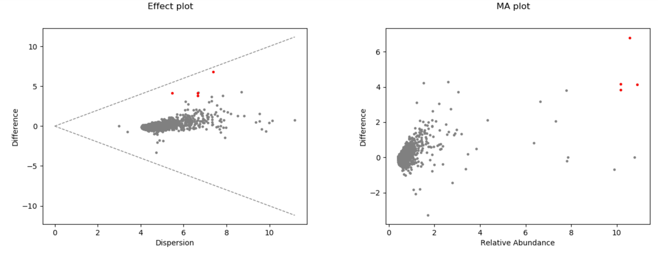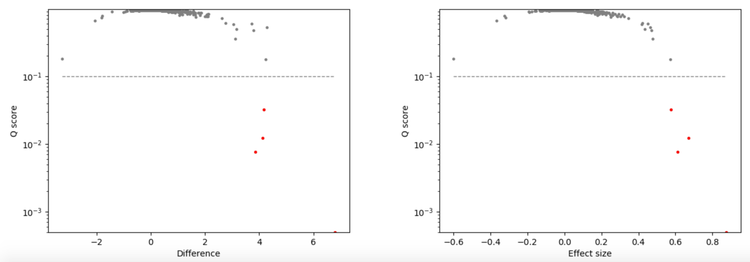
Figure S4. ALDEx2 Differential Abundance Between Burn Wound and Spared Skin
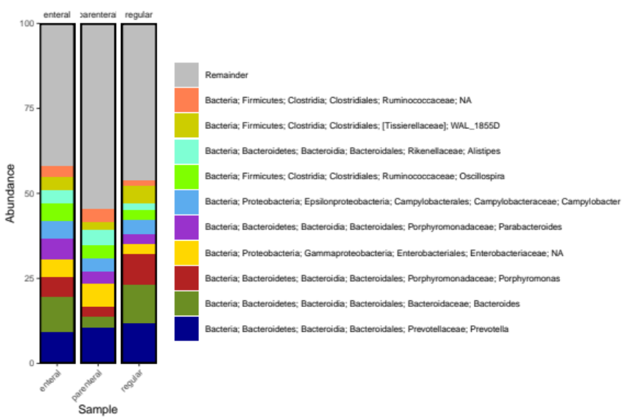
Figure S5. Taxonomic summary of the top 10 genera sequenced from the sum of perianal and rectal samples separated by diet type at the time of collection.

