Supplementary information:
Table 3-23
Fig. 4-23
Refs 31-62
Supplementary Text:
S1. Supplementary materials and methods
S2. Distribution shape
S3. Transition point, plots of full simulated and aerial distributions
S4. Detailed well site simulation results
S5. Pitfalls of extrapolating from a sub-region
S6. Basin v. campaign productivity profiles
S7. Well site visit basis effects
S8. Life-cycle assessment allocation
S9. Toward reconciliation with ground-based site-level measurements
S10. Campaign descriptions
S11. Significance of productivity stratification

Supplementary information for “Quantifying oil and natural gas system emissions using one million aerial site measurements”

Authors: Evan D. Sherwin^{1,*}, Jeffrey S. Rutherford¹, Zhan Zhang¹, Yuanlei Chen¹, Erin B. Wetherley², Petr V. Yakovlev², Elena S.F. Berman², Brian B. Jones², Daniel H. Cusworth³, Andrew K. Thorpe⁵, Alana K. Ayasse³, Riley M. Duren^{3,4,5}, Adam R. Brandt¹
Author Affiliations:

¹ Department of Energy Science and Engineering, Stanford University, 367 Panama St., Stanford, California 94305.
² Kairos Aerospace, 928 Benecia Ave, Sunnyvale, California 94085, United States.
³ Carbon Mapper, 12 S Raymond Ave, Pasadena, CA, 91105, United States
⁴ Arizona Institutes for Resilience, University of Arizona, Tucson, AZ, United States
⁵ Jet Propulsion Laboratory, California Institute of Technology, Pasadena, California 91109, United States.
* Correspondence: evands@stanford.edu

Supplementary materials and methods

Modeling error in aerially measured emissions

Because Kairos Aerospace produces wind-independent estimates of emissions, reported in kg per hour per meter per second of wind (kgh/mps), we use surface gust hourly wind speed estimates from the NOAA High Resolution Rapid Refresh (HRRR) wind reanalysis product to estimate total emissions for each plume in kg/hr. We then calibrate these emissions based on single-blind controlled releases from ²⁶ using the Monte Carlo-based method described in ¹³. After multiplying wind-normalized emission estimates by wind speed, we apply a power curve correction based on single-blind controlled release data, of the form 0.48x^{0.77}. In each of the 1000 Monte Carlo realizations, we then incorporate a percent error profile using a multiplier drawn randomly from a normal distribution with mean 0.7% and standard deviation 40%, as in Chen, Sherwin et al. 2022 ¹³.

Carbon Mapper also reports quantified emissions estimates based on NOAA HRRR wind data, averaging over the nine nearest instantaneous wind speed estimates from the hours before, during, and after the measurement, as described in ¹⁰. Because we do not have single-blind controlled methane release data similar to what exists for Kairos, we use Carbon Mapper’s reported quantification uncertainty, which takes the form of an error standard deviation. In each Monte Carlo realization, we incorporate a percent error profile into Carbon Mapper estimates by randomly drawing a percent error multiplier from a normal distribution with zero mean and the reported standard deviation.

Additional sources of uncertainty
The 95% confidence interval reported for emissions estimates and methane fractional loss rates incorporates several independent sources of uncertainty. One of these sources is quantification uncertainty, described above in the SI, Section S1.1.

Another source of uncertainty is rooted in the source-level simulation of aerially measured emissions. If an emission source is visited multiple times, only one of those measurements is used in a given Monte Carlo realization. If an emission source is visited three times, with two emissions detected at different magnitudes and no emission detected in the third measurement, each of the three will be drawn with equal probability in a given Monte Carlo realization. Thus, even with perfect quantification accuracy, this source may or may not be emitting in a given Monte Carlo realization, and if it is emitting, its magnitude will shift between the two quantified emission values.

Note that our method applies quantification uncertainty independently to each measurement at a given site. If emissions from a site are in fact relatively persistent at a constant value, accounting for quantification uncertainty independently at each measurement may overestimate overall uncertainty from this source. As a result, our uncertainty ranges may include a conservatively large contribution from quantification uncertainty.

An additional source of uncertainty is rooted in the well site-level emissions simulation tool. Simulated emission values are drawn at random, stratified according to the productivity of the covered sites (as described in the SI, Section S1.6). As a result, there is random variation in simulated emissions.

We do not have site-level estimates of simulated midstream emissions. We thus represent uncertainty in these emissions using reported low and high uncertainty values from the national GHGI, as discussed in Materials and methods, Step 5b.

Each Monte Carlo realization produced by this method is interpretable as the result of a hypothetical measurement campaign of all covered assets with a highly sensitive, perfectly accurate methane sensing technology. The 2.5th and 97.5th percentiles of these Monte Carlo realizations provide a 95% confidence interval bounding the results of such a campaign, measuring each covered asset precisely once.

The reported 95% confidence intervals in this analysis account for the fact that all campaigns measured the average covered asset more than once. We thus divide the error bars from the above Monte Carlo realization-level confidence interval by the square root of the average number of measurements per well sit in the campaign in question. This is analogous to converting a standard deviation to a standard error by dividing by the square root of the sample size. Note that this method implicitly assumes that all midstream assets were covered the same number of times on average as well sites. See the SI, Section S12.2.4 for further detail.

Attributing emissions to assets
Both Carbon Mapper and Kairos Aerospace attribute detected emissions to physical assets using a combination of automated and manual processes.

For well sites, in Kairos surveys we include only emissions labeled “Well site” in the New Mexico Permian (using designations from Chen, Sherwin et al. 2022), and using the label “upstream” in the Barnett.

The Kairos datasets include only emissions from oil and natural gas production and midstream activity. Any detected emissions from non-oil and gas sources are not included. Thus, we designate all emissions from sources other than well sites as midstream. This includes standalone tank facilities.

Carbon Mapper surveys sometimes attribute to equipment in more detail. For the 2016 and 2017 San Joaquin campaigns, we designate well site emissions using the following categories: “oil/gas tank”, “oil/gas drill rig”, “oil/gas pumpjack”, and “oil/gas possible plugged well”. We designate midstream emissions using the following categories: “gas storage facility”, “gas compressor”, “oil/gas unknown infrastructure”, “oil/gas gathering line”, “gas processing plant”, “oil/gas compressor”, and “oil/gas stack”.

For the remaining Carbon Mapper surveys, we designate well site plumes using the source category “Oil & Gas Production”, which includes sources labeled “well” and “tank”. For midstream, we include “compressor”, “pipeline”, “processing”, and “other oil and gas”. We exclude emissions from refineries, power plants, agricultural activity, waste management, and coal mining.

Well site emissions simulation
To estimate smaller-magnitude well site emissions, near the minimum detection limit of the aerial technology, we use a bottom-up emissions simulation model described in Rutherford et al. ⁵. The model, available at ⁴¹, is rewritten in the MATLAB programming language, but the underlying statistical analysis is identical to Rutherford et al. The analysis and data inputs are also very similar, with the exception that for this study we are simulating more recent data at a finer resolution (the basin level versus the national level).

This section describes the data inputs used in generating the below-detection emission distributions for the six studied basins. Key data inputs include (1) well and oil and gas production data and (2) equipment-level activity data.

Well and production data
Production data was downloaded from Enverus DrillingInfo web application between May 4 – May 6, 2022 ³⁸. The “Wells” data set was filtered for wells with “Monthly Production Date” between December 31, 2019 and December 31, 2020. Both “Well Headers” and “Well Monthly Production” are exported. Due to export limits, separate batches were prepared for Texas vertical wells, Texas directional and horizonal wells, New Mexico, California, Utah, Colorado/Wyoming/Nebraska, and Alabama/Kentucky/Ohio/Pennsylvania/Virginia/West Virginia/New York.

The “Surface Latitude” and “Surface Longitude” columns from the “Well Headers” dataset are joined with the “Well Monthly Production” datasets using well API14 identifiers. For each API14, monthly production totals are summed to generate well-level annual production totals for the year 2020.

Next, AAPG US sedimentary basin boundaries, shown in Figure 4, were downloaded as shapefiles ⁴² and imported into ArcMap along with the Enverus dataset. Production is then binned by oil and gas basin by performing a “Spatial Join” between the two datasets. The resulting statistics are tabulated below in Table 3.

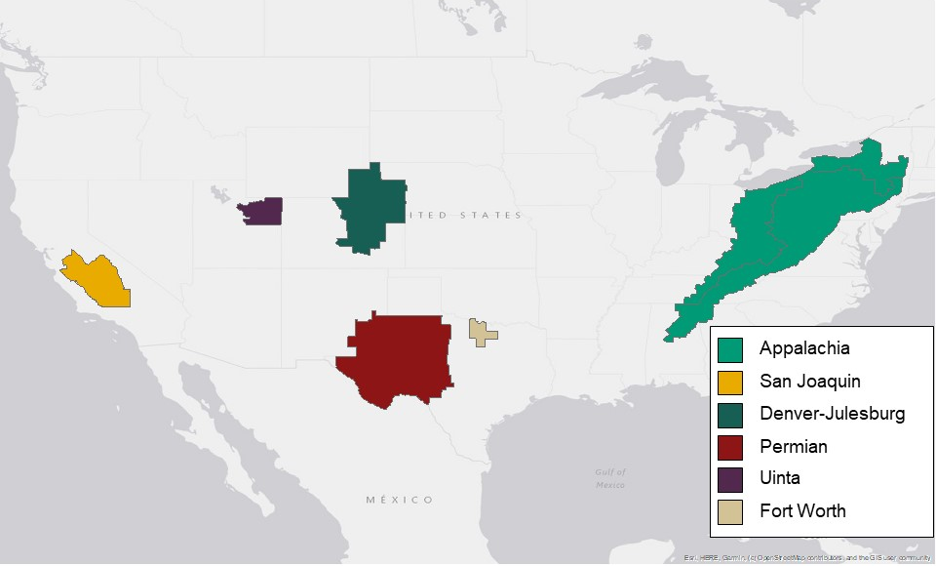
Figure 4: Location of basins analyzed in this study. Basin outlines are from AAPG ⁴³.
Production is then binned by oil and gas basin by performing a “Spatial Join” between the production and well headers datasets. The resulting statistics are tabulated below in Table 3.

Table 3: Well count and oil and gas production statistics for select US basins in 2020 (as reported in Enverus ³⁸).
Basin | AAPG code | Well count | Total oil [bbl year-1] | Total gas [mscf year-1] | Well productivity [bbl well-1 day-1] | Gas productivity [mscf well-1 day-1]
Appalachia | 160 | 208772 | 4.97E+07 | 1.23E+10 | 0.65 | 161.29
Denver-Julesburg | 540 | 21409 | 1.74E+08 | 1.12E+09 | 22.24 | 143.76
Fort Worth | 420 | 15150 | 3.06E+06 | 4.26E+08 | 0.55 | 76.98
Permian | 430 | 158714 | 1.64E+09 | 6.19E+09 | 28.25 | 106.88
San Joaquin | 745 | 39457 | 1.09E+08 | 1.34E+08 | 7.56 | 9.31
Uinta | 575 | 10824 | 2.61E+07 | 2.25E+08 | 6.61 | 57.02

Equipment-level activity data
Equipment-level activity data, or equipment counts, are required to parameterize the bottom-up model. However, comprehensive counts of all U.S. equipment are not available. Since the 2018 EPA Greenhouse Gas Inventory (GHGI) ⁴⁴, the EPA has calculated activity factors using Greenhouse Gas Reporting Program (GHGRP) data. This study follows the approach of the EPA GHGI ^{45,46}, also described in greater detail in Rutherford et al. ⁵. GHGRP data is reported by operators of facilities emitting greater than 25,000 tonnes per year in terms of CO₂eq. Activity factors are calculated as follows for equipment $i$ and basin $j$.

$$Activity factor{}_{i,j}=\frac{{\left(GHGRP Equipment count\right)}_{i,j}}{{\left(GHGRP Wellhead count\right)}_{j}}$$ | (4)

The GHGRP reporting tables used in generating the equipment count parameter for all emission sources are summarized in Table 3. Following EPA ^{45,46}, the wellhead count in the denominator is based on the “EQUIP_LEAKS_ONSHORE” table for most equipment (headers, heaters, separators, meters, compressors, and dehydrators). For recent years, wellhead and equipment counts reported to “EQUIP_LEAKS_ONSHORE” represent only a subset of equipment (equipment counts aren’t reported by facilities that fulfill reporting obligations using leak surveys). For equipment counts reported in different tables (pneumatic controllers, pneumatic pumps, storage tanks) the wellhead count in the denominator is based on the “FACILITY_OVERVIEW” table.

These tables were all downloaded from the Envirofacts website ⁴⁷ for reporting year 2020. Before summing equipment counts, the “Industry Segment” column was filtered for “Onshore petroleum and natural gas production”.

Low production well sites will have less on-site equipment compared to higher productivity sites. To account for this difference, we binned GHGRP equipment counts by production. This was accomplished by matching GHGRP facility IDs with Enverus API numbers (using the sheet “EF_W_ONSHORE_WELLS”) and then binning using a gas production cutoff of 10 mscf well⁻¹ day⁻¹. Activity factors for all basins are summarized in Table 4.

We also calculate important emission control parameters including (i) fraction of wells with plunger liquid unloadings, (ii) fraction of wells with non-plunger liquid unloadings, and (iii) fraction of crude throughput passing through tanks with emission controls. Fraction of tank throughput with emission controls was binned by well production but liquid unloading parameters were not. Emission control parameters are summarized in Table 6.

GHGRP uses the same basin schema as the AAPG ⁴³. Calculations were applied across all basins identified in Figure 4.

Table 4: Summary of Greenhouse Gas Reporting Program sheets used in generating activity factor data.
Emission type | GHGRP sheet | Additional columns filtered | Column summed
Tank venting (intentional and unintentional) | EF_W_ATM_STG_TANKS_CALC1OR2 |  | - ATMOSPHERIC_TANK_COUNT  - TANKS_WITH_VAPOR_RECOVERY  - TANKS_WITH_FLARING
Tank venting (intentional and unintentional) | EF_W_ATM_STG_TANKS_CALC3 |  | - ATMOSPHERIC_TANK_COUNT  - TANKS_WITH_FLARES
Equipment leaks | EF_W_EQUIP_LEAKS_ONSHORE | Filtered according to:  - EQUIPMENT_TYPE (Compressors, Dehydrators, Header, Heater-treater, In-line heaters, Meters/piping, Separators, Wellhead) | - EQUIPMENT_TYPE_COUNT
Pneumatic device venting | EF_W_NGPNEUMATIC_DEV_UNITS |  | - TOTAL_COUNT
Pneumatic pump venting | EF_W_NGPNEUMATIC_PMP_UNITS |  | - TOTAL_PNEUMATIC_PUMP_COUNT
Liquids unloadings | EF_W_LIQUIDS_UNLOAD_UNITS | Filtered according to:  - PLUNGER_LIFTS_USED | - NUMBER_OF_WELLS_VENTED
Flare stacks | FLARE_STACKS_UNITS

Table 5: Equipment activity scaling factors (counts of equipment per wellhead). Derived using reporting year 2020 data reported to the Greenhouse Gas Reporting Program (GHGRP). High productivity is defined as wells producing more than 10 mscf/well/day. Low productivity is defined as wells producing less than 10 mscf/well/day.
 |  | C1 fraction | Headers | Heaters | Separators | Meters | Tanks | Compressors | Dehydrators | Pneum. Pumps | Pneum. devices
Appalachia | High productivity | 0.82 | 0.00 | 0.07 | 0.38 | 0.90 | 0.09 | 0.00 | 0.00 | 0.02 | 0.50
 | Low productivity | 0.85 | 0.00 | 0.06 | 0.27 | 0.96 | 0.05 | 0.00 | 0.00 | 0.00 | 0.23
San Joaquin | High productivity | 0.15 | 0.07 | 0.00 | 0.01 | 0.00 | 0.00 | 0.00 | 0.00 | 0.00 | 0.00
 | Low productivity | 0.34 | 0.08 | 0.00 | 0.00 | 0.00 | 0.01 | 0.00 | 0.00 | 0.00 | 0.00
Denver-Julesburg | High productivity | 0.55 | 0.04 | 0.14 | 0.61 | 0.40 | 0.56 | 0.08 | 0.00 | 0.00 | 3.20
 | Low productivity | 0.55 | 0.03 | 0.07 | 0.49 | 0.46 | 0.41 | 0.06 | 0.00 | 0.00 | 2.37
Fort Worth | High productivity | 0.55 | 0.00 | 0.00 | 1.05 | 0.98 | 0.43 | 0.11 | 0.00 | 0.41 | 1.57
 | Low productivity | 0.55 | 0.01 | 0.00 | 1.02 | 0.93 | 0.51 | 0.15 | 0.00 | 0.37 | 1.60
Permian | High productivity | 0.61 | 0.12 | 0.21 | 0.57 | 0.15 | 0.35 | 0.02 | 0.00 | 0.11 | 1.85
 | Low productivity | 0.60 | 0.08 | 0.17 | 0.53 | 0.13 | 0.27 | 0.01 | 0.00 | 0.12 | 1.64
Uinta | High productivity | 0.49 | 0.11 | 0.66 | 0.85 | 0.88 | 0.87 | 0.00 | 0.00 | 0.49 | 3.32
 | Low productivity | 0.51 | 0.69 | 0.49 | 0.75 | 0.30 | 1.04 | 0.00 | 0.00 | 0.17 | 7.07

Table 6: Emission control parameters. Derived using reporting year 2020 data reported to the Greenhouse Gas Reporting Program (LU = liquids unloading). High productivity is defined as wells producing more than 10 mscf/well/day. Low productivity is defined as wells producing less than 10 mscf/well/day. Each basin name includes its AAPG identification number.
 |  | Fraction LU (plunger) | Fraction LU (no plunger) | Fraction throughput w. tank controls
Appalachia (997) | High productivity | 0.06 | 0.04 | 0.39
 | Low productivity |  |  | 0.01
San Joaquin (745) | High productivity | 0.00 | 0.00 | 0.65
 | Low productivity |  |  | 0.22
Denver-Julesburg (540) | High productivity | 0.03 | 0.31 | 0.93
 | Low productivity |  |  | 0.83
Fort Worth (420) | High productivity | 0.12 | 0.13 | 0.55
 | Low productivity |  |  | 0.31
Permian (430) | High productivity | 0.00 | 0.00 | 0.85
 | Low productivity |  |  | 0.79
Uinta (575) | High productivity | 0.01 | 0.43 | 0.38
 | Low productivity |  |  | 0.38

Estimating production for a surveyed area
Estimating fractional loss from well sites surveyed in a campaign requires two components: estimated methane emissions from surveyed assets and natural gas production from those assets. To estimate natural gas production volumes, we rely on monthly production microdata from Enverus.

Enverus reports monthly production data at the well level, rather than the well site level, in thousand standard cubic feet (mcf) per month of natural gas, with geolocation coordinates for each well. For each campaign, we begin with monthly production data for all assets in the relevant states in the year of the campaign. Except the Carbon Mapper Permian campaigns, all campaigns are restricted to a single state. Except the Kairos New Mexico Permian campaign, all are restricted to a single year.

We analyze only wells with an Active designation in Enverus at the time of download, including all months in all years in which a survey took place. For each region of interest, we merge data from the monthly production and well headers tables to produce a single table with one row per well, with columns for the 14-digit American Petroleum Institute identification number, surface longitude and latitude (using the WGS84 convention), and monthly oil and natural gas production for the year(s) of the survey in thousands of standard cubic feet of natural gas (mcf) or barrels of oil equivalent (boe). For the Permian basin, which spans Texas and New Mexico, we created a single basin-wide production dataset from Texas and New Mexico-specific datasets. These data were downloaded in June 2022.

We determine each well’s coverage during a campaign by conducting a spatial join between the flightline shapefile polygons and the geodatabase of wells from Enverus described above, including only wells within the region in question (either an AAPG field boundary or a state boundary). For the Kairos campaigns, this join is conducted internally by Kairos and anonymized results shared with co-authors to protect customer confidentiality. This produces a database of well visits by month for each well, joined with monthly oil and natural gas production values.

To estimate production covered in each campaign, we compute the weighted average of daily natural gas production for each visited well sites, weighting each month of production according to the number of visits during that month. If a well was visited twice in May and and once in July, we compute its average production as [2*Production(May)+1*Production(July)]/3. We then estimate total covered production as the sum of these well-level visit-weighted averages.

We do the same for oil production as well, although we do not use this number to compute fractional methane loss rates.

Because Enverus natural gas production quantities are in units of thousand standard cubic feet (mcf), we must assume a natural gas molar (volumetric) fraction to compute the methane production rate. We assume all natural gas quantities reported by Enverus have undergone stringent processing to allow direct injection into transmission pipelines. We thus assume this gas is 93.5% methane, based on ²⁶. This is likely a conservatively high assumption. If the true methane fraction is lower, this will reduce estimated methane production levels, thus increasing estimated fractional loss rates.

We use the same well-level dataset to estimate total oil and natural gas production in the region in question, as well as the distribution of well productivity in the surveyed area and the region as a whole.

Selecting simulated emissions based on productivity
In some cases, surveyed assets may be disproportionately more or less productive than assets in the basin as a whole. To ensure the productivity profile of simulated assets is similar to that of surveyed assets, we stratify random sampling of well sites from the basin-wide emissions simulation based on site productivity.

Well site productivity in the emissions simulation is based on Enverus data, with wells designated to sites via a spatial clustering algorithm introduced in ⁶. Thus, each well site has both simulated emissions and site-level production. We divide all simulated well sites into productivity quantiles, grouping wells by productivity decile up to the 5th decile, rising to 5-percentile increments through the 95th percentile, rising to 1-percentile increments through the 99th percentile, and moving to 0.1-percentile increments from the 99.5th to 100th percentile. This additional subdivision more accurately captures the heavy-tailed nature of well site productivity.

For the wells covered in the aerial survey, we convert well-level productivity to well site-level productivity using a rough heuristic, assuming all wells are located in well sites with the average number of wells per site, illustrated in Table 21. We thus multiply well-level productivity for all covered wells by the average number of wells per site.

We compute the number of covered well sites whose estimated productivity falls within the productivity quantiles from the emissions simulation. We then draw a corresponding number of simulated emissions from each of these productivity quantiles.

As a result, if a campaign oversamples high-productivity well sites, the emissions simulation correspondingly oversamples high-productivity well sites. This approach also corrects for any variation in the productivity profile of the surveyed region between 2020, the calibration year of the emissions simulation, and the year of the aerial campaign.

See the SI, Sections S6 and S13 for a discussion of the significance of including these productivity corrections.

For computational tractability, simulated emissions for each basin are drawn from a vector of 1 million randomly-selected simulated well sites from the original 100 Monte Carlo realizations of the emissions simulation model. These random samples are conducted with replacement, placing equal selection probability on all simulated well sites in each of the 1000 Monte Carlo realizations in this study.

Accounting for measured emissions in the partial detection range
The aerial methane emissions detection methods employed in this study were designed to detect the largest methane emissions, enabling rapid spatial coverage in exchange for lower sensitivity. Thus, such a system will have a range of emission sizes below which the probability of detection, γ, is below 100%, culminating in a minimum detection limit below which no emissions will be detected.

Characterizing partial detection capabilities allows us to leverage detected emissions in this range to estimate the magnitude of emissions in this range that were missed by the survey. To do this, we add a partial detection correction factor, (γ⁻¹ - 1), to each aerially measured emission from the Kairos campaigns the partial detection range. For example, if there is a 1/3 chance of detecting an emission of size X and one such emission is detected, then on average we would expect to have missed two emissions of similar magnitude. The partial detection correction adds 3 – 1 = 2 times X to the total, bringing the contribution of emissions of size X up to a total of 3X in the final cumulative emissions distribution.

The partial detection capabilities of the Kairos Aerospace instrument are characterized in Chen, Sherwin et al. 2022 and Sherwin, Chen et al. 2021, based on single-blind and internally blind testing, reproduced in Figure 5 ^{13,26}. These detection probabilities are wind-normalized, as the probability of detecting an emission is roughly inversely proportional to wind speed.

Figure 5: Detection probability in the partial detection range for Kairos Aerospace, reproduced from Chen, Sherwin et al. 2022 ¹³.
To correct for partial detection, we first compute the full cumulative distribution of aerially measured emissions. We then compute the partial detection correction for wind-normalized emissions provide by Kairos Aerospace, sorted from smallest to largest magnitude, applying a correction factor based on the height of the corresponding bin in the probability of detection curve in Figure 5. The probability of detection is given a floor value of 0.05 (5%) to prevent divergent corrections for quantified emissions below 4 kilograms per hour per meter per second (kgh/mps). The computed partial detection correction values are then applied to the corresponding simulated.

This partial detection correction is included only for emissions with magnitude higher than the transition point from simulated to measured emissions, since partial detection is not a concern for simulated emissions.

We do not attempt to correct for partial detection in Carbon Mapper campaigns. Although the partial detection regime for the instruments used by Carbon Mapper has been investigated in internally blind testing, field campaigns use a different data filtering process, making it difficult to translate between the two. The Carbon Mapper campaigns were also conducted at several flight altitudes, further altering the detection profile. This is a conservative approach to emissions estimates from Carbon Mapper campaigns because it does not correct for missed detections.

Determining the transition point from simulated to measured emissions
After correcting for partial detection, we determine a transition point, defined as an emission size at which the emissions distribution moves from simulated to aerially measured emissions. This transition occurs at the emission size beyond which the contribution of aerially measured emissions consistently exceeds simulated emissions. In cumulative emissions functions, this is the point at which the magnitude of the slope of the simulated emissions cumulative distribution function (CDF) exceeds the magnitude of the slope of the aerially measured emissions CDF (including all aerially measured emissions, after correcting for partial detection).

We estimate this slope by interpolating the empirical cumulative emissions curves at 1 kg/hr increments. We then compute empirical slope via 1 kg/hr lagged differencing, which we smooth using a 10 kg/hr lagged rolling average.

Using these smoothed empirical slopes, we then select the transition point as the emission size beyond which aerially visible emissions consistently have a steeper slope, contributing more to cumulative emissions per 1 kg incremental bin than the simulation does. Transition points vary substantially between campaigns, as shown in Table 7 and discussed in the SI, Section S3. Use of a transition point effectively removes airborne detections below the point, and simulated emissions above the point, from the final distribution. Note that in all cases, the vast majority of aerially measured emissions are above the transition point and are included directly into aerially measured emissions inventories.

Table 7: Transition points between simulated and aerially measured emissions distributions for each campaign, as well as the minimum aerially detected emission, the total plumes detected, and the plumes included above the transition point for well sites (excluding midstream emissions, which are not considered when computing the transition point for well site emissions).
Basin/Campaign | Transition point (kg/hr) | Min emission (kg/hr) | Total well site campaign plumes | Well site plumes above transition point
Kairos NM Permian | 19.2 | 7.1 | 1,083 | 1082
CM Permian/2019 | 60.1 | 15.0 | 1,749 | 1,644
CM Permian/2020 | 82.9 | 8.1 | 284 | 247
CM Permian/Summer 2021 | 77.9 | 23.3 | 334 | 275
CM Permian/Fall 2021 | 67.8 | 11.8 | 416 | 361
CM San Joaquin/2016 | 41.5 | 9.0 | 77 | 69
CM San Joaquin/2017 | 41.3 | 11.0 | 86 | 80
CM San Joaquin/Summer 2020 | 39.2 | 20.6 | 48 | 45
CM San Joaquin/Fall 2020 | 36.0 | 23.6 | 94 | 90
CM San Joaquin/Fall 2021 | 22.8 | 16.0 | 47 | 41
CM Denver-Julesburg /Summer 2021 | 74.8 | 11.1 | 34 | 27
CM Denver-Julesburg/Fall 2021 | 65.7 | 10.2 | 40 | 32
CM Pennsylvania/2021 | 104.1 | 92.2 | 64 | 62
CM Uinta/2020 | 52.5 | 8.4 | 56 | 41
Kairos Fort Worth | 54.7 | 10.9 | 80 | 80

Distribution shape

Many studies have noted the heavy-tailed character of the size distribution of methane emissions from oil and gas production sites ^{5,20,21}. Studies using ground-based site-level measurements sometimes model this heavy-tailed character using a lognormal distribution ⁴⁸. Studies based entirely on remote sensing measurements have proposed that the distribution follows a power law ^{18,49}.

We investigate the shape of the full distribution of site-level methane emissions from oil and natural gas production sites and compare this to a lognormal and a power law. Figure 6 shows combined aerial and simulated emissions distributions generated in this study, with site-level emissions displayed on a logarithmic x-axis and the cumulative fraction of sites emitting at least a given amount displayed on a logarithmic y-axis. Displayed this way, a power law should appear as a straight line, while a lognormal should appear as an upside-down parabola.
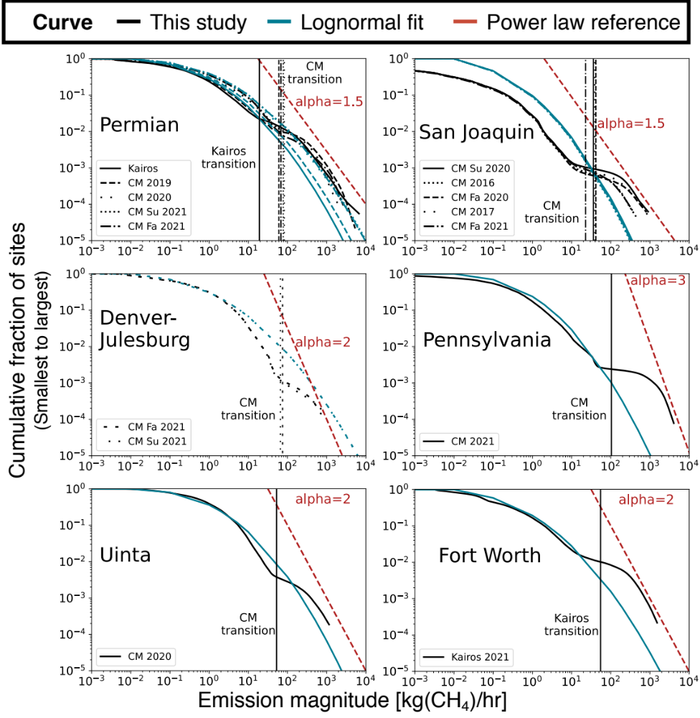
Figure 6: Log-log plot of site emission magnitude v. cumulative fraction of sites for combined aerial and simulated emissions distributions (black) for each campaign. Includes lognormal fits (brown) to each distribution, as well as illustrative power law lines (red) that roughly correspond to the tail of the distribution. Vertical lines denote the transition point between simulated and aerially measured emissions in each campaign.

Lognormal fits to the combined simulated and aerially measured distributions, displayed in brown in Figure 6 generally appear qualitatively similar to the simulated emissions below roughly 10 to 100 kg/hr. In some cases, as in Pennsylvania and the Fort Worth, the fit is quite close in this range. In most cases, the lognormal curve does not accurately describe the distribution of aerially measured emissions. These lognormal fits include only sites emitting at least 0.01 kg/hr, as including sites with smaller emissions artificially flattens the lognormal fit.

Figure 7 shows empirical probability density functions, which are derived from the cumulative distribution functions shown in Figure 6. These more clearly illustrate the bimodal character of the combined aerially measured and simulated emissions distributions. In most campaigns, there is a local minimum in incidence frequency for emissions near the low end of aerial detection capabilities, from roughly 10 kg/hr to 100 kg/hr. This is also visible in the cumulative emissions functions in Figure 3 in the form of a subtle flattening of the curve slope in this range. It is likely that this local minimum is at least in part an artifact of missed emissions below the full detection range of the aerial instruments. However, it is also possible that the emission size distribution is truly bimodal. In either case, it appears that the emissions distribution undergoes some form of regime transition from roughly lognormal to power law behavior between 10 kg/hr and several hundred kg/hr depending on the campaign.

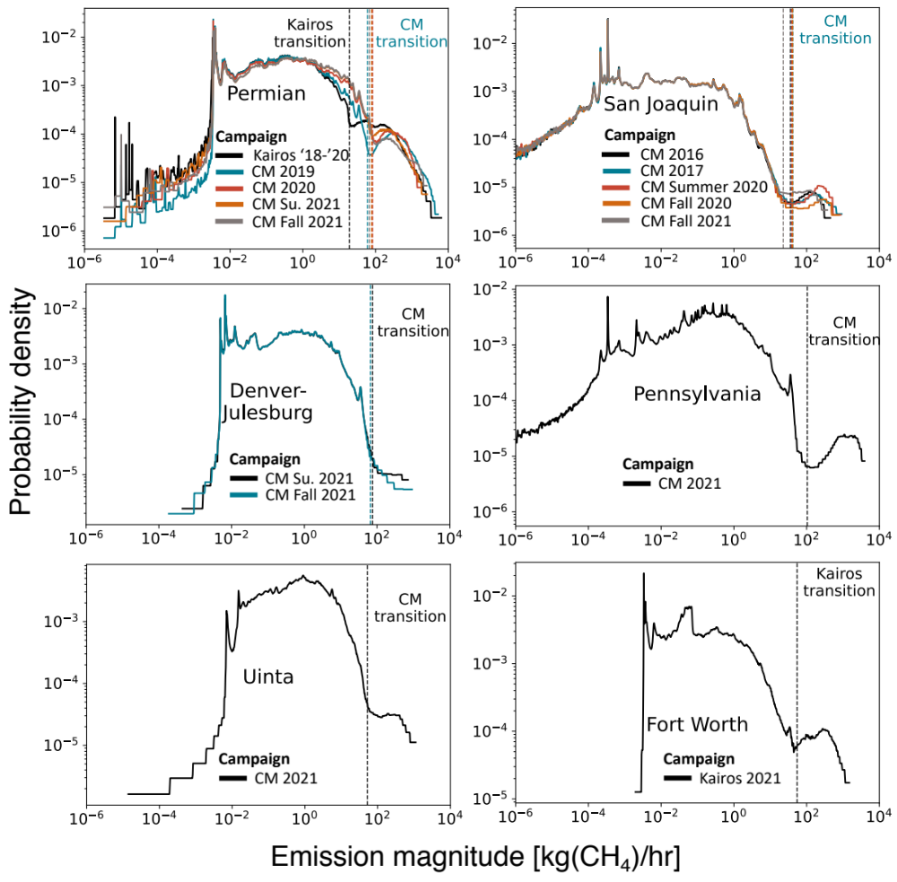
Figure 7: Empirical probability density functions for all campaigns. Derived by interpolation from the cumulative distribution functions in Figure 6. Displays both probability density and emission magnitude on a logarithmic scale. Note that in many cases, emission frequency has a second peak above 100 kg/hr, after a local minimum between roughly 10 and 100 kg/hr, where aerial surveys begin to detect point-source emissions. Vertical lines denote the transition point between simulated and aerially measured emissions for each distribution.
To illustrate the potential error introduced by a lognormal fit, we compute mean emissions for both the combined simulated and aerially measured distribution and a lognormal fit. For the lognormal, we simulate 10,000 samples from the fitted distribution and take the mean of these samples. Table 8 shows both means as well as the ratio of these means.

Table 8: Mean site-level emissions from the combined aerial and simulated distributions in this study and a lognormal fit to the same distributions (restricted to emissions greater than 0.01 kg/hr). The final column shows the ratio of these two means, which equates to the difference in total regional estimated emissions using these two distributions.
 | This study (kg/h) | Lognormal (kg/h) | Lognormal/This study
Kairos NM Permian | 10.42 | 2.84 | 27%
CM Permian/2019 | 12.00 | 3.80 | 32%
CM Permian/2020 | 14.27 | 5.32 | 37%
CM Permian/Summer 2021 | 12.13 | 7.65 | 63%
CM Permian/Fall 2021 | 12.48 | 7.48 | 60%
CM San Joaquin/2016 | 0.46 | 0.52 | 113%
CM San Joaquin/2017 | 0.68 | 0.54 | 79%
CM San Joaquin/Summer 2020 | 0.55 | 0.55 | 100%
CM San Joaquin/Fall 2020 | 0.67 | 0.52 | 78%
CM San Joaquin/Fall 2021 | 0.30 | 0.51 | 172%
CM Denver-Julesburg /Summer 2021 | 2.95 | 4.65 | 157%
CM Denver-Julesburg/Fall 2021 | 3.18 | 4.64 | 146%
CM Pennsylvania/2021 | 5.95 | 1.68 | 28%
CM Uinta/2020 | 3.74 | 3.58 | 96%
Kairos Fort Worth | 6.40 | 1.72 | 27%

This lognormal fit can underestimate emissions by as much as 73%, as in the New Mexico Permian. In the low-productivity, oil-heavy San Joaquin, half of sites have zero simulated methane emissions and many have very low emissions. The lognormal fit overestimates by up to 72% in the fall 2021 San Joaquin campaign and underestimates by up to 22% in the fall 2020 campaign. The lognormal fit underestimates by 68% in the more comprehensive Carbon Mapper 2019 surveys of the Permian, with underestimates of 37-63% in the 2020 and 2021 campaigns. Interestingly, for the Uinta 2020 campaign, the lognormal mean is within 4% of the combined aerial and simulated distribution mean, suggesting that in some areas, the distribution of emission sizes may be roughly lognormal.

Each subplot in Figure 6 includes a reference power law that roughly approximates the tail of the distribution. A power law takes the form P(x) = Bx^{-α}, where α becomes the slope of a line in the form log(P(x)) = -αlog(x) + log(B). In most cases, there is a roughly linear portion of the aerially measured distribution, which flattens on the low end as the fraction of emissions detected decreases and often steepens on the high end. In the Permian, this linear portion is close to a power law with α=1.5. In the San Joaquin basin, α=2 is a closer approximation, rising to roughly α=3 in the Uinta and Fort Worth. It is not clear whether any portion of the Denver-Julesberg distribution exhibits power law behavior. All power law lines shown are for reference only, and are not the outcome of a fit, which is difficult to conduct for curves that deviate from power law behavior (as even the aerially measured emission distributions do).

Were the roughly α=1.5 power law observed in the Permian to continue indefinitely, this would result in infinite total emissions, as power laws have a well-defined mean only for α>2. Thus, if the tail of the true distribution of emissions indeed exhibits power law behavior, this must necessarily soften to α>2 at larger emission sizes.

There is evidence that α increases at larger emission sizes. Lauvaux et al. 2022 find approximately power law behavior continues to emissions beyond 100,000 kg/hr in a global study of worldwide oil and natural gas produciton and midstream infrastructure ¹⁸. Figure 8 shows that even this power law appears to exhibit a steepening slope as emission magnitude rises, with emissions from ~10,000-30,000 kg/hr at roughly α=2.4, and larger emissions closer to α=4.5. This suggests that apparent power law behavior in the distribution of emission sizes from the oil and natural gas system may in fact soften as emission size increases, resulting in smaller total emissions than if this were not the case.

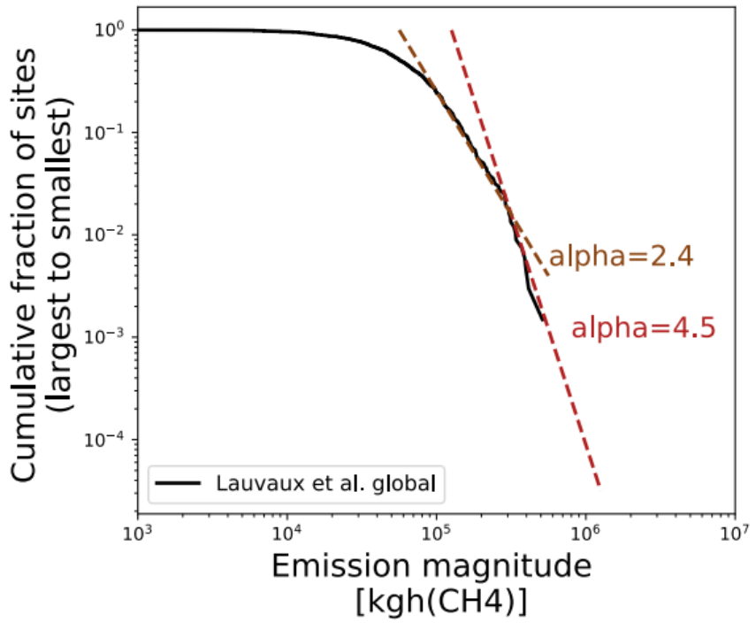
Figure 8: Cumulative emissions distribution for global oil and natural gas production and midstream infrastructure, as estimated by Lauvaux et al. 2022 ¹⁸. Uses data from the TROPOMI instrument, and excludes some sections of Earth’s landmass, as discussed in the paper. Dotted lines represent power laws that roughly correspond to the slope at different sections of the curve.

Transition point, plots of full simulated and aerial distributions
Figure 9 shows the individual distributions of simulated and aerially measured emissions, as well as the distribution of emissions added through the partial detection correction in the Kairos cases. These distributions are presented as a fraction of total estimated emissions from the combined simulated and aerially measured distributions shown in the main manuscript. Note that in most cases, total emissions from these component distributions sum to greater than 100% of total emissions from the combined distribution. This is because these distributions overlap and thus must be joined at a transition point, shown as vertical lines for each campaign, removing some emissions from at least one distribution from the total. Figure 10 shows an analogous figure for midstream infrastructure.

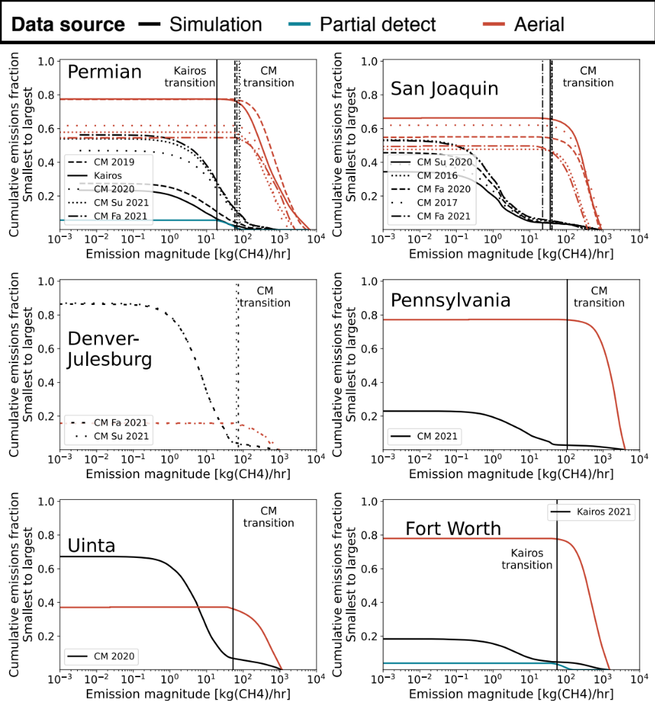
Figure 9: Full distributions of aerially measured and simulated emissions for well sites. Includes as the correction for emissions in the partial detection range for Kairos Aerospace, for each campaign. Vertical lines denote the transition point between simulated and aerially measured emissions in each campaign. These distributions are normalized by total estimated emissions from the combined distribution. As a result, the sum of the component distributions is often greater than 1, as the combined distribution generally discards some emissions from at least one component distribution.
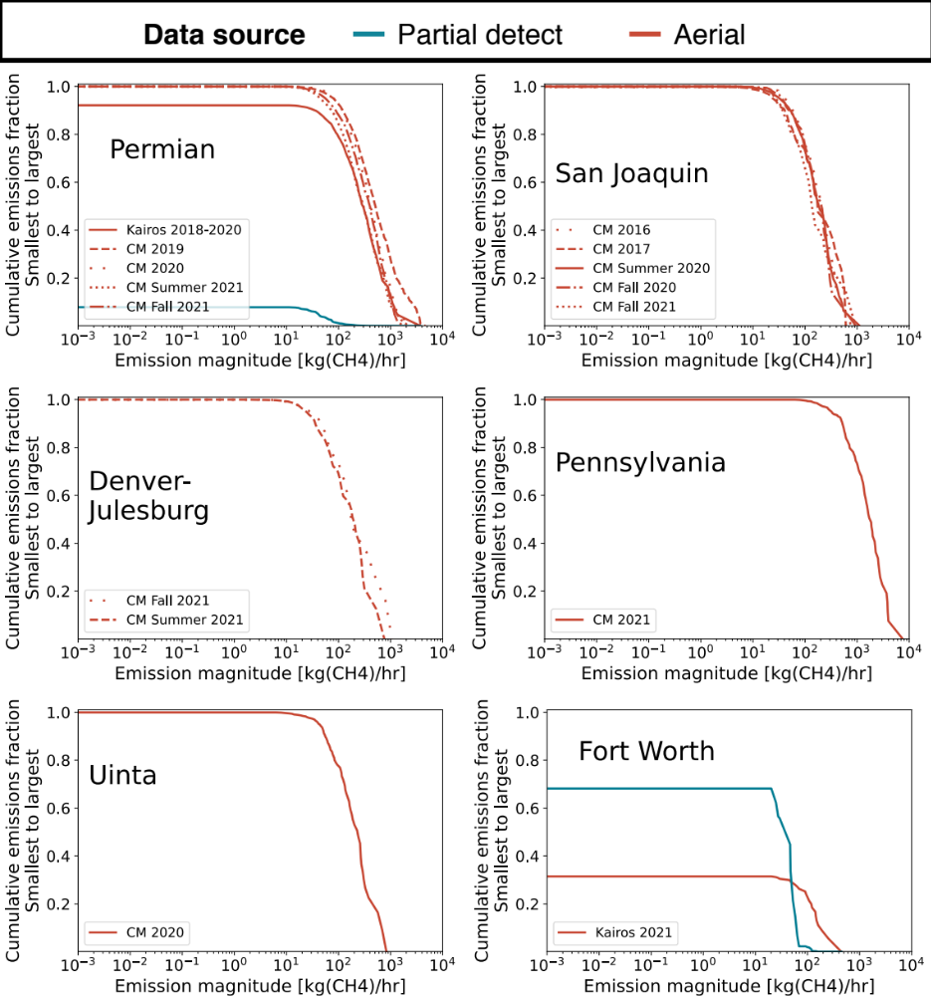
Figure 10: Full distributions of aerially measured emissions for midstream infrastructure. Includes as the correction for emissions in the partial detection range for Kairos Aerospace, for each campaign. These distributions are normalized by total aerially measured emissions, including a partial detection correction.

Detailed well site simulation results
This section shows the equipment-level breakdown of well site emissions for each basin in this study.

The workflow for generating methane emission totals and site-level distributions is the same as Rutherford et al. . Each emission event simulated in the Rutherford et al. model is on a per-well basis, and must be converted to a site-level basis for consistency with site-level aerial campaigns which measure aggregate emissions (a “site”, also often referred to as a well-pad, production-site, or production-facility, comprises all equipment necessary for oil production contained in close proximity, and which includes one or more wellheads and ancillary production equipment).

Using a method similar to Rutherford et al., we convert model results from the well-level to the site-level by estimating the wells-per-site for each basin as follows. For the Rutherford et al. modelling study, Rutherford et al. obtained the 2015 vintage Enverus dataset utilized in the Alvarez et al. ⁵¹ study, which had been “clustered” from the well-level to the site-level. For this study, we approximate the site size and configuration of each basin using the same Alvarez et al. dataset. First, the site-level well counts are binned into productivity tranches (the same 34 tranches used in Rutherford et al.). Next, iterating across wells in each basin, the well counts per site in the Alvarez et al. dataset are bootstrapped to define the site-level well counts. Like Rutherford et al., 100 Monte Carlo realizations of site-level distributions are generated. Table 21 shows the average (across the 100 Monte Carlo realizations) well count per site for each basin. Note that this Monte Carlo simulation is separate from the main analysis in this work, which uses 1,000 Monte Carlo realizations.

Table 9: Equipment level emissions [Tg year⁻¹], total production [Tg year⁻¹], and average loss rate across 100 Monte Carlo realizations (CIP = Chemical Injection Pumps, PC = Pneumatic Controllers, LU = Liquid Unloadings).
 | Appalachia | San Joaquin | Denver-Julesburg | FortWorth | Permian | Uinta
Wells | 0.133 | 0.008 | 0.015 | 0.014 | 0.089 | 0.010
Header | 0.000 | 0.001 | 0.001 | 0.000 | 0.023 | 0.003
Heater | 0.005 | 0.000 | 0.001 | 0.000 | 0.013 | 0.004
Separators | 0.049 | 0.000 | 0.010 | 0.017 | 0.057 | 0.010
Meter | 0.101 | 0.000 | 0.005 | 0.011 | 0.010 | 0.007
Tanks - leaks | 0.002 | 0.000 | 0.003 | 0.002 | 0.012 | 0.002
Tanks - vents | 0.019 | 0.000 | 0.026 | 0.016 | 0.090 | 0.025
Recip Compressor | 0.001 | 0.000 | 0.001 | 0.002 | 0.002 | 0.000
Dehydrators | 0.000 | 0.000 | 0.000 | 0.000 | 0.000 | 0.000
CIP | 0.002 | 0.000 | 0.000 | 0.010 | 0.028 | 0.010
PC | 0.053 | 0.000 | 0.052 | 0.020 | 0.209 | 0.034
LU | 0.095 | 0.000 | 0.003 | 0.002 | 0.000 | 0.005
Combustion | 0.002 | 0.000 | 0.004 | 0.005 | 0.006 | 0.000
Tank Venting | 0.026 | 0.005 | 0.010 | 0.001 | 0.213 | 0.011
Flare methane | 0.003 | 0.000 | 0.002 | 0.000 | 0.139 | 0.001
Total | 0.492 | 0.015 | 0.135 | 0.100 | 0.890 | 0.122
Production | 199.712 | 0.907 | 11.837 | 5.622 | 72.263 | 2.158
Loss rate | 0.25% | 1.61% | 1.14% | 1.78% | 1.23% | 5.64%

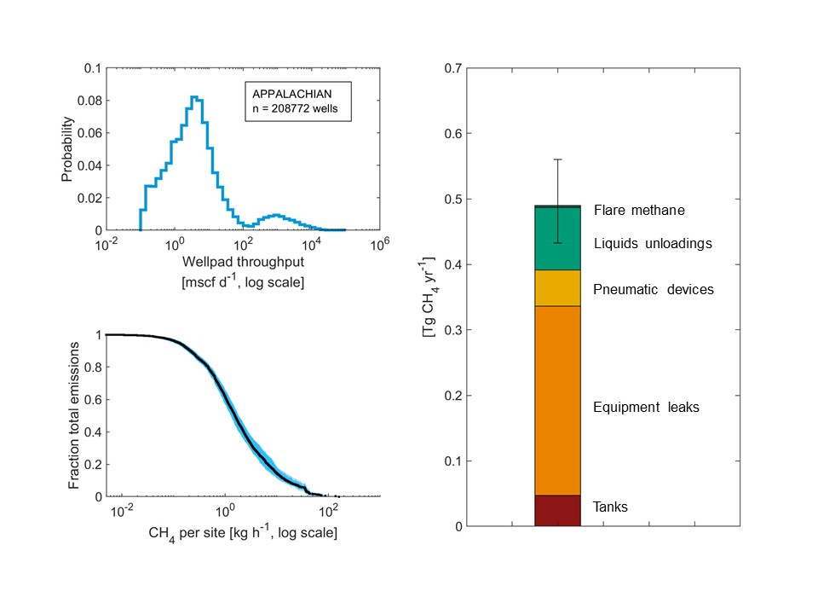
Figure 11: For the Appalachian basin, summary of (clockwise from top left): (i) 2020 well productivity distribution [mscf d⁻¹] based on Enverus data ³⁸, (ii) CH₄ emissions by emission source (mean across Monte Carlo realizations, and error bars represent 95% confidence interval based on the 2.5 and 97.5 percentile values extracted from the empirical distributions), and (iii) cumulative distribution plot describing the fraction of emissions contained above a given emission level (100 lines representing 100 Monte Carlo simulations are plotted).
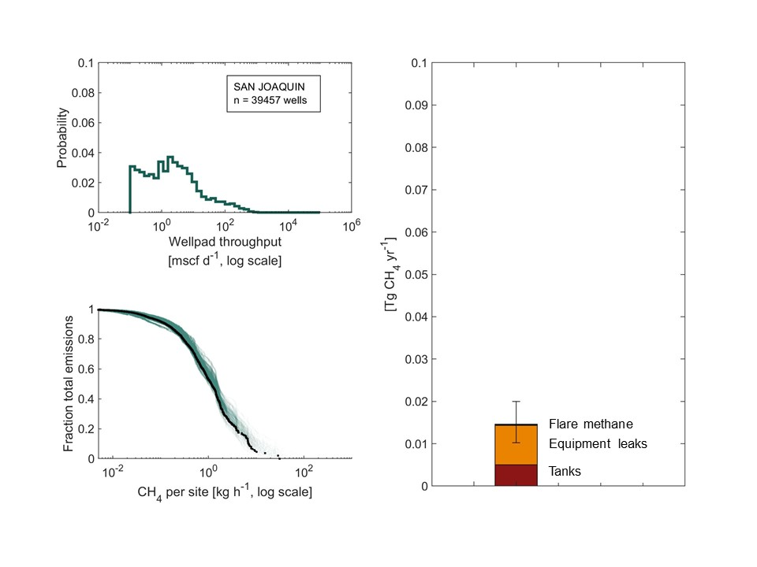
Figure 12: For the San Joaquin basin, summary of (clockwise from top left): (i) 2020 well productivity distribution [mscf d⁻¹] based on Enverus data , (ii) CH₄ emissions by emission source (mean across Monte Carlo realizations, and error bars represent 95% confidence interval based on the 2.5 and 97.5 percentile values extracted from the empirical distributions), and (iii) cumulative distribution plot describing the fraction of emissions contained above a given emission level (100 lines representing 100 Monte Carlo simulations are plotted).
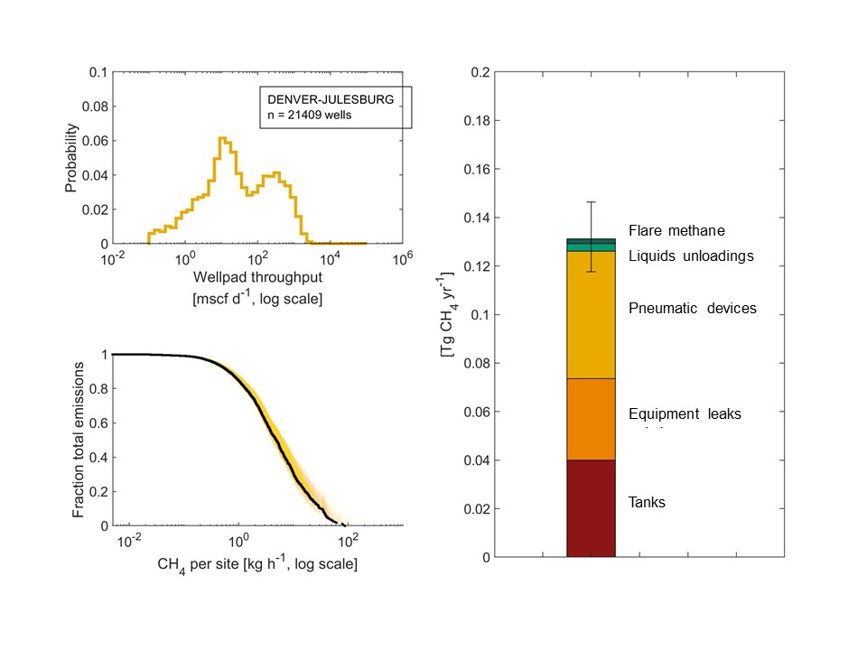
Figure 13: For the Denver-Julesburg basin, summary of (clockwise from top left): (i) 2020 well productivity distribution [mscf d⁻¹] based on Enverus data , (ii) CH₄ emissions by emission source (mean across Monte Carlo realizations, and error bars represent 95% confidence interval based on the 2.5 and 97.5 percentile values extracted from the empirical distributions), and (iii) cumulative distribution plot describing the fraction of emissions contained above a given emission level (100 lines representing 100 Monte Carlo simulations are plotted).

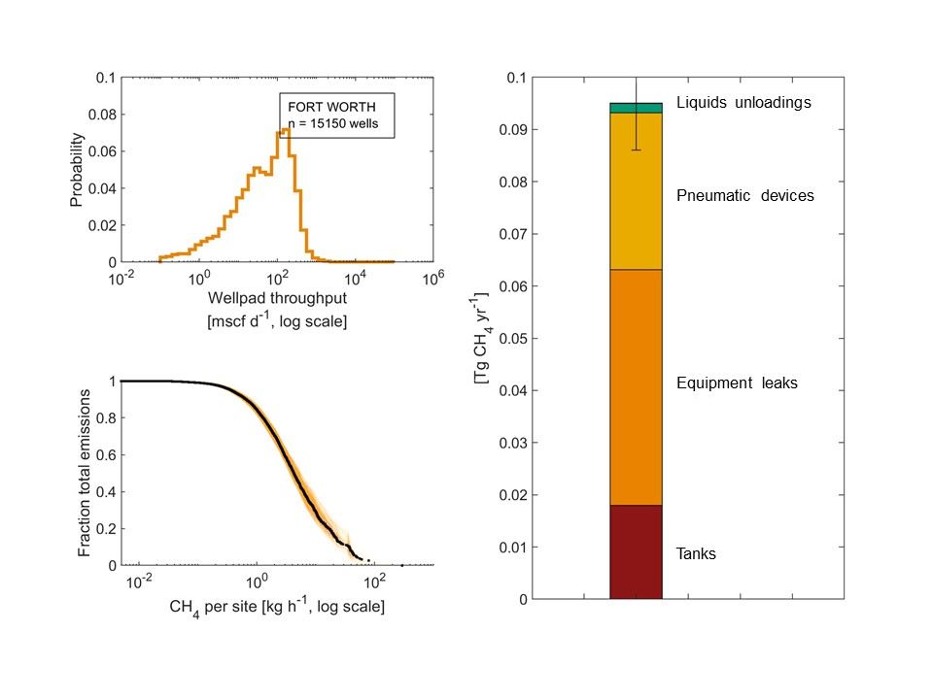
Figure 14: For the Fort Worth basin, summary of (clockwise from top left): (i) 2020 well productivity distribution [mscf d⁻¹] based on Enverus data , (ii) CH₄ emissions by emission source (mean across Monte Carlo realizations, and error bars represent 95% confidence interval based on the 2.5 and 97.5 percentile values extracted from the empirical distributions), and (iii) cumulative distribution plot describing the fraction of emissions contained above a given emission level (100 lines representing 100 Monte Carlo simulations are plotted).

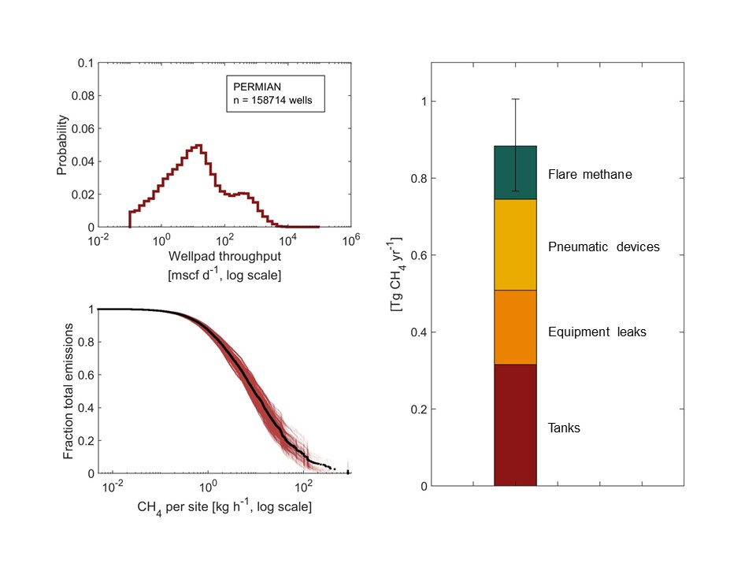
Figure 15: For the Permian basin, summary of (clockwise from top left): (i) 2020 well productivity distribution [mscf d⁻¹] based on Enverus data , (ii) CH₄ emissions by emission source (mean across Monte Carlo realizations, and error bars represent 95% confidence interval based on the 2.5 and 97.5 percentile values extracted from the empirical distributions), and (iii) cumulative distribution plot describing the fraction of emissions contained above a given emission level (100 lines representing 100 Monte Carlo simulations are plotted).

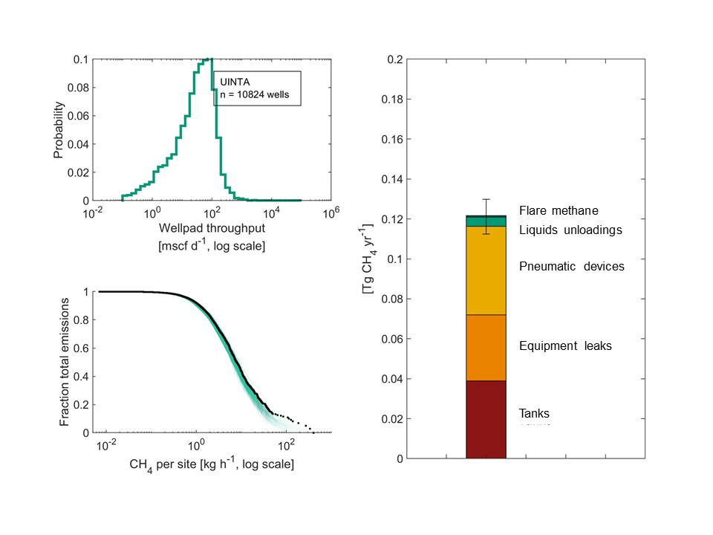
Figure 16: For the Uinta basin, summary of (clockwise from top left): (i) 2020 well productivity distribution [mscf d⁻¹] based on Enverus data , (ii) CH₄ emissions by emission source (mean across Monte Carlo realizations, and error bars represent 95% confidence interval based on the 2.5 and 97.5 percentile values extracted from the empirical distributions), and (iii) cumulative distribution plot describing the fraction of emissions contained above a given emission level (100 lines representing 100 Monte Carlo simulations are plotted).

Pitfalls of extrapolating from a sub-region

In many instances in statistics, it is common to rely on a sample of measurements to estimate the properties of a population. Such an approach often assumes that measurements are a representative sample of the full population, in this case a basin or region of oil and natural gas well sites.

We illustrate here that such extrapolation from measurements of a significant fraction of assets in a basin can result in substantial errors in estimated basin-wide emissions.

The 2019 Carbon Mapper Permian basin survey covered 63% of wells in the basin and 91% of natural gas production. The fall 2021 Carbon Mapper Permian basin survey covered only higher-productivity sections of the Delaware and Midland basins, accounting for 11% of wells and 43% of natural gas production. Figure 17 shows the coverage maps for both campaigns.

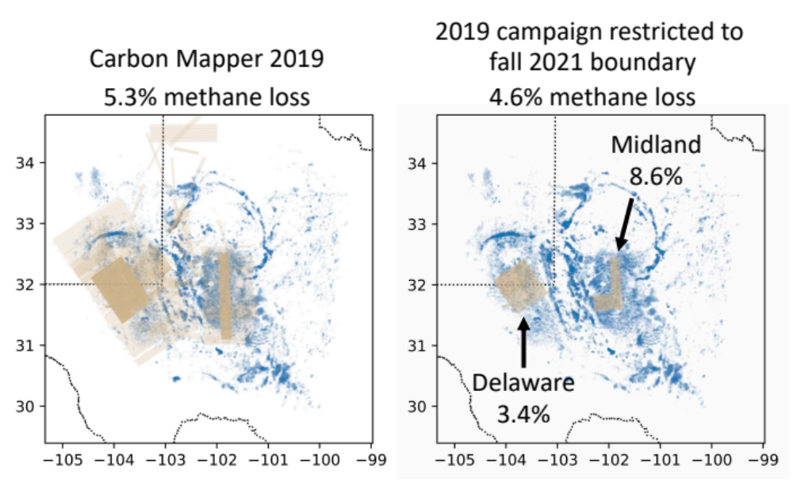
Figure 17: Methane fractional loss rates from the 2019 Carbon Mapper Permian campaign for different spatial extents. When data from the 2019 campaign are restricted to the boundaries of the fall 2021 campaign, the methane fractional loss rate from well sites and midstream infrastructure falls from 5.29% [5.07%, 5.51%] to 4.61% [4.37%, 4.88%]. When this is divided further into the Delaware and Midland sub-basins, the loss rates are 3.37% [3.16%, 3.59%] and 8.55% [7.87%, 9.38%], respectively. Tan indicates coverage area while blue indicates well site density. X and Y axes are longitude and latitude, respectively.
If we restrict the 2019 survey to the boundaries of the fall 2021 survey, the methane fractional loss rate from well sites and midstream infrastructure falls from 5.29% [5.07%, 5.51%] to 4.61% [4.37%, 4.88%]. However, computing the latter number separately for the Delaware and Midland regions, the loss rate becomes 3.37% [3.16%, 3.59%] and 8.55% [7.87%, 9.38%], respectively. Thus, although at first glance it may appear that the area within the fall 2021 survey is approximately representative of the more comprehensive 2019 survey area, this masks widely diverging loss rates in the Delaware and Midland sub-basins. Note that because the Delaware is significantly more productive than the Midland, its methane fractional loss rate contributes more to the average across both regions.

Basin v. campaign productivity profiles
Table 10, Table 12, and Table 14 show the average well productivity for all wells covered in each campaign, displayed for key percentiles. Average well productivity is computed over all visits to a given well.

Table 11, Table 13, and Table 15 show the same percentiles of monthly well productivity for all wells in the basin or region in question each campaign, including production for all twelve months of the year of the campaign. For the Kairos New Mexico Permian campaign, which covers three years, this is computed using monthly productivity values for all three years.

Note that the averaging across surveyed months in the campaign-specific year can artificially reduce the highest well-level productivity numbers, particularly for wells with a steep productivity decline between two or more aerial measurements.

The campaign-specific productivity profiles (in 0.1 percentile resolution) are used to compute the well site productivity corrections used to stratify emissions drawn from the emissions simulation tool, as described in the SI, Section S1.6. In this case, we convert well-level productivity into well-site-level productivity by assuming that all well sites in the basin in question have the average number of wells per site, based on the averages shown in Table 21.

Table 10: Percentiles of average well productivity for wells covered in each campaign in the Permian basin, in thousand standard cubic feet per day (mcf/d) of natural gas. The average is computed over all visits to a given well.
 | kairosNM | CMPermian2019 | CMPermian2020 | CMPermianS2021 | CMPermianF2021
10% | 0 | 0.0 | 0.0 | 0.0 | 0.0
20% | 0.04726 | 0.2 | 0.0 | 1.1 | 1.3
30% | 1.833 | 1.6 | 1.2 | 6.2 | 6.9
40% | 5.817 | 4.8 | 4.9 | 20.9 | 25.4
50% | 12.55 | 10.8 | 18.4 | 82.7 | 99.8
60% | 16.97 | 21.5 | 80.9 | 217.8 | 236.5
70% | 22.05 | 44.0 | 277.3 | 407.8 | 421.6
80% | 28.85 | 123.3 | 597.8 | 679.8 | 694.1
90% | 38.25 | 473.2 | 1196.5 | 1224.3 | 1217.4
95% | 53.43 | 922.0 | 1865.6 | 1865.7 | 1836.7
99% | 80.84 | 2572.4 | 3816.7 | 4114.5 | 4017.6
100% | 142.7 | 14294.5 | 14457.0 | 10435.2 | 11663.2

Table 11: Percentiles of monthly well productivity for all wells in the Permian basin for all twelve months of the year of each campaign, in thousand standard cubic feet per day (mcf/d) of natural gas.
 | kairosNM | CMPermian2019 | CMPermian2020 | CMPermianS2021 | CMPermianF2021
10% | N/A | 0.0 | 0.0 | 0.0 | 0.0
20% | N/A | 0.0 | 0.0 | 0.0 | 0.0
30% | N/A | 0.5 | 0.0 | 0.0 | 0.0
40% | N/A | 3.5 | 1.3 | 1.5 | 1.5
50% | N/A | 10.2 | 5.9 | 6.5 | 6.5
60% | N/A | 22.5 | 15.7 | 16.5 | 16.5
70% | N/A | 45.8 | 35.0 | 36.4 | 36.4
80% | N/A | 93.8 | 76.5 | 78.5 | 78.5
90% | N/A | 225.1 | 193.4 | 199.6 | 199.6
95% | N/A | 462.4 | 418.5 | 438.8 | 438.8
99% | N/A | 1701.2 | 1558.4 | 1601.8 | 1601.8
100% | N/A | 37965.1 | 37929.9 | 48585.8 | 48585.8

Table 12: Percentiles of average well productivity for wells covered in each campaign in the San Joaquin basin, in thousand standard cubic feet per day (mcf/d) of natural gas. The average is computed over all visits to a given well, weighting each equally.
 | CMCA2016 | CMCA2017 | CMCAS2020 | CMCAF2020 | CMCA2021
10% | 0.0 | 0.0 | 0.0 | 0.0 | 0.0
20% | 0.0 | 0.0 | 0.0 | 0.0 | 0.0
30% | 0.0 | 0.0 | 0.0 | 0.0 | 0.0
40% | 0.0 | 0.0 | 0.0 | 0.0 | 0.0
50% | 0.0 | 0.0 | 0.0 | 0.0 | 0.0
60% | 0.3 | 0.5 | 0.3 | 0.3 | 0.0
70% | 1.4 | 1.9 | 1.5 | 1.5 | 0.5
80% | 3.7 | 4.7 | 3.8 | 3.8 | 2.3
90% | 11.7 | 13.8 | 11.7 | 11.7 | 8.2
95% | 30.9 | 40.1 | 39.3 | 39.3 | 31.1
99% | 258.7 | 274.8 | 249.1 | 249.1 | 205.6
100% | 10227.6 | 8945.8 | 7253.5 | 7253.5 | 7096.4

Table 13: Percentiles of monthly well productivity for all wells in the San Joaquin basin for all twelve months of the year of each campaign, in thousand standard cubic feet per day (mcf/d) of natural gas.
 | CMCA2016 | CMCA2017 | CMCAS2020 | CMCAF2020 | CMCA2021
10% | 0.0 | 0.0 | 0.0 | 0.0 | 0.0
20% | 0.0 | 0.0 | 0.0 | 0.0 | 0.0
30% | 0.0 | 0.0 | 0.0 | 0.0 | 0.0
40% | 0.0 | 0.0 | 0.0 | 0.0 | 0.0
50% | 0.0 | 0.0 | 0.1 | 0.1 | 0.0
60% | 0.5 | 0.5 | 0.6 | 0.6 | 0.2
70% | 1.8 | 1.9 | 1.9 | 1.9 | 1.2
80% | 4.9 | 4.9 | 4.8 | 4.8 | 3.8
90% | 15.1 | 14.7 | 13.7 | 13.7 | 11.3
95% | 41.8 | 40.2 | 37.7 | 37.7 | 29.2
99% | 270.6 | 258.2 | 234.3 | 234.3 | 179.0
100% | 40671.7 | 44154.0 | 33436.4 | 33436.4 | 39666.9

Table 14: Percentiles of average well productivity for wells covered in each campaign in the Denver-Julesburg, Uinta, and Fort Worth basins as well as the Pennsylvania portion of the Appalachian basin, in thousand standard cubic feet per day (mcf/d) of natural gas. The average is computed over all visits to a given well.
 | CMDJS2021 | CMDJF2021 | CMPA2021 | CMUinta2020 | KairosFW2021
10% | 0.0 | 0.0 | 0.6 | 0.0 | 0.0
20% | 0.1 | 0.3 | 1.8 | 1.7 | 0.0
30% | 4.6 | 6.7 | 3.2 | 6.6 | 0.0
40% | 21.1 | 24.5 | 4.8 | 15.2 | 0.0
50% | 60.2 | 73.8 | 7.7 | 26.3 | 0.0
60% | 143.1 | 150.9 | 26.6 | 40.5 | 0.0
70% | 240.6 | 244.9 | 472.3 | 58.8 | 29.0
80% | 400.6 | 400.1 | 1078.3 | 84.5 | 96.6
90% | 659.9 | 643.8 | 2386.3 | 122.9 | 181.8
95% | 975.4 | 939.3 | 4029.7 | 165.2 | 259.8
99% | 2013.4 | 1890.6 | 12980.0 | 370.6 | 465.4
100% | 3929.5 | 3582.3 | 49008.1 | 4277.7 | 1243.6

Table 15: Percentiles of monthly well productivity for all wells in the Denver-Julesburg, Uinta, and Fort Worth basins as well as the Pennsylvania portion of the Appalachian basin for all twelve months of the year of each campaign, in thousand standard cubic feet per day (mcf/d) of natural gas.
 | CMDJS2021 | CMDJF2021 | CMPA2021 | CMUinta2020 | KairosFW2021
10% | 0.0 | 0.0 | 0.1 | 0.0 | 0.0
20% | 0.1 | 0.1 | 0.4 | 1.9 | 0.0
30% | 6.1 | 6.1 | 0.9 | 8.3 | 0.0
40% | 19.2 | 19.2 | 1.7 | 17.5 | 0.0
50% | 38.5 | 38.5 | 2.7 | 28.2 | 0.4
60% | 60.0 | 60.0 | 4.1 | 42.0 | 6.8
70% | 90.4 | 90.4 | 6.4 | 60.9 | 30.5
80% | 145.7 | 145.7 | 14.2 | 87.1 | 98.4
90% | 277.1 | 277.1 | 394.2 | 128.6 | 190.7
95% | 473.0 | 473.0 | 1372.4 | 177.1 | 279.8
99% | 1248.3 | 1248.3 | 5595.0 | 409.9 | 542.3
100% | 79806.9 | 79806.9 | 55915.5 | 6878.5 | 8599.0

Uncertainty remains in gas composition
This study follows Alvarez et al. in assuming natural gas from Enverus is 90% methane by volume ⁶. While this is a broadly accurate assumption for consumer-grade natural gas in the transmission system ⁵³, there is reason to believe natural gas production data from Enverus have a substantially lower methane fraction in some cases.

Enverus reports natural gas production at the well site ³⁸. Given that natural gas processing typically does not take place on well sites, but instead occurs in more centralized facilities, Enverus-reported natural gas production data, which are presented in units of standard cubic feet, most likely represent pre-processing gross natural gas volumes.

In oil-focused well sites in particular, produced natural gas is often heavily diluted with carbon dioxide, C₂₊ hydrocarbons, and other gases. For example, A 2009 report by the New Mexico Bureau of Geology and Mineral Resources Methane fractions reported a methane fraction of 60-75% in natural gas produced in the region at that time. If this methane fraction holds for current natural gas production in New Mexico, it would imply a methane loss rate 20%-50% higher than our baseline rate computed assuming a 90% methane fraction.

Note that in the case of New Mexico, this lower methane fraction is associated with natural gas from an oil-focused region, which this study finds tend to have higher methane loss rates. If this relationship holds more generally, this would introduce bias into any analysis that attempts to compute a multi-region methane loss rate assuming a uniform, relatively high methane fraction in produced natural gas.

Further research is needed to characterize regional variation in natural gas composition in detail. Such analysis should characterize methane, CO₂, and higher hydrocarbon fractions to facilitate careful life-cycle assessment.

Well site visit basis effects
The main analysis treats each well site visited in the campaign as an independent unit of analysis. For the purposes of estimating fractional loss, our method essentially averages over all visits to the same well site (as discussed in Materials and methods).

If we instead treat each visit to a well site during the campaign as an independent measurement, the results can change substantially. With this approach, a well site visited five times counts five times as much toward total emissions as a comparable well site visited only once.

In the Carbon Mapper Permian 2019 campaign, the overall well site and midstream methane fractional loss rate is 5.29% [5.07%, 5.51%] in the main analysis, simulating each site independently. When repeated site visits are treated as independent measurements, the methane fractional loss rate falls to 2.97% [2.87%, 3.07%], a decline of 44%. This is largely because the Carbon Mapper 2019 campaign disproportionately oversamples high-productivity, relatively low-loss assets in the Delaware sub-basin compared with the lower-productivity Midland sub-basin, as discussed in the SI, Section S5.

This illustrates that accurate estimation of true methane emissions and the true fractional loss rate from a region requires analysis on an asset-level basis, rather than on an asset visit-level basis to avoid introducing errors potentially approaching a factor of two.

See the SI, Section S12 for further illustration of variation in the number of visits across regions within most campaigns.

Life-cycle assessment allocation
Where oil and natural gas are co-produced, some fraction of methane emitted on site should be attributed to the produced oil, with the rest attributed to natural gas. The ratio of oil to natural gas production varies widely across basins, as shown in the SI, Section S12. The Appalachian basin, which contains all covered well sites in Pennsylvania, produces very little oil and thus produces 61 times more natural gas per unit of oil produced than the Permian basin.

Thus, if methane emissions are allocated to produced oil and natural gas on an energy-weighted basis, almost all of the methane emitted on site in the Appalachian basin would count toward natural gas emissions, while roughly 2/3 of the methane emitted in the Permian basin would be allocated toward oil ¹³. These post-allocation numbers, rather than the raw methane fractional loss rate, should then be used in any life-cycle assessment, e.g. comparing greenhouse gas emissions from electricity generated using natural gas and coal. Similarly, for oil-related life cycle assessment, the oil-allocated methane emissions in a basin like the Permian could significantly affect decisions about alternative vehicle fuels. Failure to apply such an emission allocation method across both produced natural gas and oil can result in considerable double-counting in life-cycle assessment efforts.

We do not generate life cycle assessment figures here, as that would require emissions estimates for other aspects of the supply chain, such as gas transmission, processing, and distribution. We leave these calculations to users of the data, but we do include the breakdown by energy of oil and natural gas production in each surveyed region, which can be used to allocate the methane fractional loss rates in this paper on an energy basis.

Table 16: Total covered daily oil and natural gas production on an energy basis for each campaign. Assumes 1.037 MMBtu per mcf of natural gas and 5.691 MMBtu per barrel of oil ^{54,55}.
Basin/Campaign | Natural gas [PJ/day] | Oil [PJ/day] | % NG | % Oil
Kairos NM Permian | 3.0 | 4.4 | 38.9% | 61.1%
CM Permian/2019 | 16.0 | 25.0 | 40.2% | 59.8%
CM Permian/2020 | 7.2 | 8.7 | 45.4% | 54.6%
CM Permian/Summer 2021 | 9.0 | 11.8 | 43.4% | 56.6%
CM Permian/Fall 2021 | 9.4 | 12.5 | 43% | 57%
CM San Joaquin/2016 | 0.4 | 2.2 | 15.6% | 84.4%
CM San Joaquin/2017 | 0.4 | 2.0 | 17.5% | 82.5%
CM San Joaquin/Summer 2020 | 0.4 | 1.5 | 19.1% | 80.9%
CM San Joaquin/Fall 2020 | 0.4 | 1.5 | 19.5% | 80.5%
CM San Joaquin/Fall 2021 | 0.3 | 1.5 | 16.8% | 83.2%
CM Denver-Julesburg/Summer 2021 | 3.0 | 2.0 | 60.7% | 39.3%
CM Denver-Julesburg /Fall 2021 | 3.0 | 2.0 | 59.5% | 40.5%
CM Pennsylvania/2021 | 15.5 | 0.0 | 99.7% | 0.3%
CM Uinta/2020 | 0.5 | 0.4 | 55.3% | 44.7%
Kairos Fort Worth/2021 | 1.0 | 0.0 | 99.2% | 0.8%

Calculating the cost of surveyed emissions
We use two metrics to compute the cost of methane emissions in the surveyed regions.

In both cases, we use emissions estimates from the survey covering the most well sites a given region. This is the CM Permian/2019, CM San Joaquin/2016, CM Denver-Julesburg/Fall 2021, CM Pennsylvania/2021, CM Uinta/2020, and Kairos Fort Worth/2021 surveys. In total, this amounts to 717 [676, 760] t(CH₄)/hr. Note that this emission rate combines surveys from different years and thus is an aggregate statistic, not representative of a particular year.

Given 8,760 hours in a year, this amounts to 6.3 [5.9, 6.7] million t(CH₄)/yr, including only emissions from surveyed regions. Using a 20-year global warming potential of 81, this amounts to 509 [479, 539] million metric tonnes of carbon dioxide equivalent per year, larger than all greenhouse gas emissions in France in 2015 ^{3,56}. Using the 90% methane fraction assumed throughout this work, this translates to 362 [342, 384] billion standard cubic feet of natural gas.

The U.S. natural gas benchmark Henry Hub price averaged $3.36 per thousand standard cubic feet of natural gas (mcf) from January 2010 to November 2022 (the latest date for which data are reported at the time of this writing) ⁵⁷. On this basis, we conservatively value emitted natural gas at a price of $3/mcf (roughly 1¢/kWh) when assessing the economic opportunities available to operators able to capture this gas. Note that this pricing assumption only holds if sufficient natural gas pipeline capacity exists to bring produced gas to market, which is not currently the case in all producing regions.

We then value that emitted natural gas from the surveyed regions at $3/mcf * 362 [342, 384] million mcf = $1.1 [$1.0, $1.2] billion per year.

To estimate the social cost of this emitted methane due to climate impacts, we use a social cost of methane of $1,500/t(CH₄), derived from the United States Inflation Reduction Act methane fee, which will rise to $1,500/t(CH₄) by 2026 ²⁷.

This places the social cost of emitted methane from the regions surveyed in this study at 6.3 [5.9, 6.7] million t(CH₄)/yr * $1,500/t(CH₄) = $9.4 [$8.9, $10.0] billion.

Toward reconciliation with ground-based site-level measurements
The substantial divergence between the results of this study and many previous estimates raises significant questions. If both approaches are measuring the same assets, why are the results so different in some instances?

Much of the past methane emissions literature has relied on ground-based methane measurements. For example, Alvarez et al. 2018 leverages 1009 site-level methane emissions measurements and a modeling method introduced in Omara et al. 2018 to estimate emissions from oil and gas production at 870 t/h [680, 1,080], translating to a production-only natural gas loss rate of 1.5% in both cases for the year 2015 ^{6,20}. The Environmental Protection Agency Greenhouse Gas Inventory (GHGI) leverages component-level emissions measurements in concert with estimates of component counts per piece of equipment, emission incidence rates, equipment counts per well site, and well site counts across the country ⁴, estimating natural gas fractional loss of 0.64% of production for the same period ²⁰. Rutherford et al. applies the same basic method as the GHGI, but with updated input data, finding a well site-only loss rate of 1.3% [1.2%, 1.4%], largely reproducing results from the site-level studies.

However, all of these estimates are substantially lower than the emission rate estimated in this study for all regions except the Denver-Julesburg and Pennsylvania. For the Denver-Julesburg campaigns, simulated emissions constitute over 87% of the estimated total for well sites and over 80% of the total including midstream. In these cases, emissions estimates using ground-based component-level simulations and aerial measurements are essentially reconciled. Because our simulation matches a comprehensive synthesis of site-level measurements on a national scale, this likely translates to approximate reconciliation between the aerial and ground-based measurements in the Denver-Julesburg.

For the Permian, San Joaquin, Fort Worth, and Pennsylvania campaigns, aerially measured emissions represent 50-81% of the estimated total, diverging sharply both from simulated estimates and the site-level measurement-based literature.

We explore two possible explanations for this apparent discrepancy between the ground measurement-based and aerial methane emissions literatures. A first hypothesis is that emissions visible to hyperspectral aircraft are rare, leaving a significant possibility that even 1,000 measurements -- like those reported in Omara et al. 2018 – would have a high likelihood of undersampling this heavy tail. A second hypothesis is that common site-level measurement techniques may have a low bias for large emissions visible to hyperspectral aircraft.

To assess the first hypothesis, we refer readers to Chen, Sherwin et al. 2022, in which we simulate emissions from a random sample of site-level measurements of the assets covered in the New Mexico Permian survey ¹³. We find that ground-based survey of 1,000 sites with the same minimum detection capabilities as the Kairos system would have only a 20% chance of underestimating total emissions by 50% or more. A survey of 100 sites would have roughly a 50% chance of underestimating by 50% or more, and a 34% chance of finding no emissions. This suggests that, while important, small sample size effects are likely not the sole explanation of the discrepancy between the emissions simulation and aerial measurements in Pennsylvania and the Permian, San Joaquin basins.

We then assess the hypothesis that ground-based methane measurement campaigns may have systematically underestimated large emissions. The most common methods for ground-based site-level measurements of methane emissions are the Environmental Protection Agency’s Other Test Method 33A (OTM 33A), downwind mobile measurements followed by Gaussian modeling (MM-Gaussian), and tracer flux methods ²⁰. OTM 33A has been evaluated in single-blind testing, but only up to 20 kg/hr ⁵⁸.

Furthermore, the formula used by OTM 33A and MM-Gaussian to convert methane concentration measurements into methane flux estimates relies on the assumption that the measured methane plume has no significant initial upward velocity ^{59–62}. This is acknowledged in the literature, with Edie et al. noting that “OTM 33A struggles to quantify plumes with a particularly high vertical velocity or buoyancy (such as manual unloadings, lit or unlit flares, or very hot emissions)” ²⁸. Due to assumptions of Gaussian emission dispersion, a plume with an upward initial velocity will appear artificially small to an OTM 33A or MM-Gaussian measurement, as its concentrations at the ground-level measurement station will be lower than they would if the plume were lofting more slowly. High release points, such as flares or the top of tanks, also introduce similar complications for methods assuming Gaussian emission dispersion, even without a substantial upward velocity, as it is difficult for these methods to distinguish a large, high emission from a smaller ground-level emission without a priori knowledge of the source location.

However, larger methane emissions at oil and gas facilities may often come from sources likely to have a significant upward velocity, such as unlit flares, and pressure release valves at the top of tanks ⁵. In many cases, larger emissions come from relatively small orfices, often from sources well above atmospheric pressure. Thus, it is possible or perhaps likely that many emissions large enough to see via hyperspectral airplane sensing have a significant upward velocity. This tendency for OTM 33A to underestimate large emissions has been observed for measurements of two liquids unloading events, estimated at 100-200 kg/hr through process-based emissions simulation and in one case estimated accurately via a tracer flux method. OTM 33A estimated emissions to be roughly one order of magnitude lower in both cases ⁶³. Tracer flux methods appear to be more effective at quantifying larger emissions, but this method represents only 6.7% of measurements in the Omara et al. 2018 synthesis dataset ²⁰.

Almost all aerially measured emissions in this study are substantially greater than 20 kg/hr. Thus, if OTM 33A and MM-Gaussian methods are systematically underestimating large methane emissions, e.g. due to substantial upward velocity, that likely explains the discrepancy between aerial surveys and the ground based site-level literature not attributable to small sample sizes.

Campaign descriptions

This study leverages comprehensive aerial surveys of six basins, with each survey covering at least 10% of all wells in the basin (using American Association of Petroleum Geologists geographic boundaries and well location data from Enverus ^{38,64}).

In each campaign, the survey team, either Kairos Aerospace or Carbon Mapper, identified methane emissions and attributed them to a facility or pipeline. Detections from Kairos datasets were anonymized by Kairos prior to analysis.

Table 17: Percentage of unique wells visited as well as total unique wells visited for each campaign by basin. Note that these wells have not yet been converted to well sites, as described in the SI, Section S1.6. Indicates which instrument(s) were used for a campaign, including the Airborne Visible-Infrared Imaging Spectrometer - Next Generation (AVIRIS-NG) and Global Airborne Observatory (GAO) instruments used by Carbon Mapper. Includes only active wells, as classified by Enverus. Because we assume each well is on a site with the basin-average number of wells, the % wells covered column also represents the percentage of well sites covered in each campaign. Totals count only the largest campaign in each region to avoid double-counting.
Basin/Campaign | Instrument | Dates | % wells covered | # Wells covered
Kairos NM Permian | Kairos | Oct. 2018-Jan. 2020 | 91.2% | 21,637
CM Permian/2019 | AVIRIS-NG; GAO | Sep. 22-Nov. 3, 2019 | 62.7% | 84,570
CM Permian/2020 | GAO | Jul. 13-24, 2020 | 10.8% | 17,120
CM Permian/Summer 2021 | GAO | Jul. 26-Aug. 10, 2021 | 12.6% | 19,670
CM Permian/Fall 2021 | GAO | Oct. 3-17, 2021 | 12.2% | 19,040
CM San Joaquin/2016 | AVIRIS-NG | Sep. 2016-Oct. 2016 | 94.7% | 41,547
CM San Joaquin/2017 | AVIRIS-NG | Jun. 2017-Oct. 2017 | 95.3% | 40,365
CM San Joaquin/Summer 2020 | AVIRIS-NG | Jul. 8-Sep. 1, 2020 | 85.0% | 33,090
CM San Joaquin/Fall 2020 | GAO | Nov. 9-23, 2020 | 81.9% | 31,919
CM San Joaquin/Fall 2021 | GAO | Nov. 5-13, 2021 | 85.1% | 33,418
CM Denver-Julesburg /Summer 2021 | GAO | Jul. 15-23, 2021 | 59.8% | 11,671
CM Denver-Julesburg/Fall 2021 | GAO | Sep. 19-29, 2021 | 59.7% | 11,688
CM Pennsylvania/2021 | GAO | May 12-26, 2021 | 17.7% | 16,105
CM Uinta/2020 | GAO | Jul. 26-Aug. 7, 2020 | 85.0% | 9,185
Kairos Fort Worth/2021 | Kairos | Jul.-Nov., 2021 | 51.2% | 7,474
Total | Various | Oct. 2018-Oct 2021 | - | 170,569

Table 18: Flight altitude and pixel width. Note that Carbon Mapper (CM) campaign altitude is given with respect to mean sea level, while Kairos altitude is given above ground level. As a result, the Denver and Uinta surveys, which were conducted in areas with roughly 1,500 meters of elevation, were closer to 3,800 meters above ground level.
Basin/Campaign | Instrument | Altitude [m] | Pixel width [m]
Kairos NM Permian | Kairos | 900 | 3
CM Permian/2019 | AVIRIS-NG; GAO | 8,500; 5,300 | 8; 3
CM Permian/2020 | GAO | 5,300 | 3
CM Permian/Summer 2021 | GAO | 5,300 | 3
CM Permian/Fall 2021 | GAO | 5,300 | 3
CM San Joaquin/2016 | AVIRIS-NG | 3,000 | 3
CM San Joaquin/2017 | AVIRIS-NG | 3,000 | 3
CM San Joaquin/Summer 2020 | AVIRIS-NG | 3,000 | 3
CM San Joaquin/Fall 2020 | GAO | 3,000 | 3
CM San Joaquin/Fall 2021 | GAO | 3,000 | 3
CM Denver-Julesburg /Summer 2021 | GAO | 5,300 | 4.5
CM Denver-Julesburg/Fall 2021 | GAO | 5,300 | 4.5
CM Pennsylvania/2021 | GAO | 5,300 | 4.5
CM Uinta/2020 | GAO | 5,300 | 4.5
Kairos Fort Worth/2021 | Kairos | 900 | 3

Table 19: Gross oil and gas daily production covered by campaign, also expressed as a fraction of the total in the basin or region year of the campaign. The latter is computed as the weighted average of production in each month proportional to the number of well visits in that month during the campaign. Total covered row sums production from the campaign in each region that covers the most well sites, CM Permian/2019, CM San Joaquin/2016, CM Denver-Julesburg/Fall 2021, CM Pennsylvania/2021, CM Uinta/2020, and Kairos Fort Worth/2021, showing them as a fraction of 2021 U.S. onshore production from Enverus (downloaded November 11, 2022) ³⁸.
Basin/Campaign | Gas prod. covered (mcf/d) | Oil prod. covered (boe/d) | % of basin gas covered | % of basin oil covered
Kairos NM Permian | 2,703,944 | 732,226 | 95% | 97%
CM Permian/2019 | 14,581,588 | 4,166,402 | 91% | 91%
CM Permian/2020 | 6,602,522 | 1,446,172 | 39% | 33%
CM Permian/Summer 2021 | 8,626,713 | 2,080,908 | 45% | 42%
CM Permian/Fall 2021 | 8,242,447 | 1,957,728 | 43% | 41%
CM San Joaquin/2016 | 367,038 | 363,066 | 87% | 95%
CM San Joaquin/2017 | 394,315 | 339,581 | 98% | 95%
CM San Joaquin/Summer 2020 | 339,694 | 255,427 | 91% | 87%
CM San Joaquin/Fall 2020 | 320,561 | 247,126 | 89% | 83%
CM San Joaquin/Fall 2021 | 274,292 | 248,085 | 95% | 88%
CM Denver-Julesburg /Summer 2021 | 2,766,761 | 326,977 | 91% | 76%
CM Denver-Julesburg/Fall 2021 | 2,732,591 | 339,089 | 90% | 77%
CM Pennsylvania/2021 | 14,187,732 | 8,085 | 44% | 8%
CM Uinta/2020 | 485,839 | 71,453 | 80% | 98%
Kairos Fort Worth/2021 | 881,902 | 1,294 | 82% | 17%
Total covered | 33,236,689 | 4,949,389 | 29% | 52%
Total USA/2021 | 113,702,140 | 9,524,749 | - | -

At 5.488 mcf per barrel of oil equivalent (boe) ^{54,55}, that total covered oil and gas production is 36.4% of 2021 US oil and gas production.

Table 20: Average well natural gas productivity by basin and campaign. Includes covered well productivity averaged over all well visits, and average well productivity including all repeated visits as independent measurements. Includes results for the subregions of the Carbon Mapper 2019 based on the fall 2021 campaign region, as discussed in S5. The Kairos NM Permian “Basin gas productivity” number is for the New Mexico Permian basin only.
Basin/Campaign | Basin gas productivity/well (mcf/d) | Campaign gas productivity/well (mcf/d) | Campaign gas productivity/well counting repeats (mcf/d)
Kairos NM Permian | 128.0 | 125.0 | 154.3
CM Permian/2019 | 118.6 | 171.8 | 331.5
CM Permian/2020 | 107.0 | 384.5 | 499.2
CM Permian/Summer 2021 | 122.6 | 437.3 | 460.5
CM Permian/Fall 2021 | 121.0 | 431.7 | 370.1
CM San Joaquin/2016 | 9.4 | 8.7 | 7.9
CM San Joaquin/2017 | 9.4 | 9.7 | 13.9
CM San Joaquin/Summer 2020 | 9.5 | 10.1 | 11.8
CM San Joaquin/Fall 2020 | 9.1 | 9.9 | 12.1
CM San Joaquin/Fall 2021 | 7.3 | 8.1 | 8.3
CM Denver-Julesburg /Summer 2021 | 154.0 | 233.6 | 234.3
CM Denver-Julesburg/Fall 2021 | 156.5 | 236.8 | 226.0
CM Pennsylvania/2021 | 225.3 | 881.0 | 1090.2
CM Uinta/2020 | 55.8 | 52.8 | 56.5
Kairos Fort Worth/2021 | 73.5 | 118.0 | 124.0
CM Permian F2021 boundary/2019 | 48.7 | 382.7 | 500.3
CM Permian F2021 Delaware/2019 | 36.9 | 626.4 | 669.6
CM Permian F2021 Midland/2019 | 11.7 | 171.6 | 169.6

The simulation and aerial survey each report emissions at the well site level, rather than at the well level. Thus, we then compute well site visits by dividing well visits by wells per site in each basin, shown in Table 21.

Table 21: Wells per site by basin, derived from the emissions simulation model based on Enverus data unless otherwise specified. Based on the clustering algorithm from ⁶, using all Enverus wells within the AAPG boundaries of each basin, in all cases except the New Mexico Permian.
Basin | Wells per site
New Mexico Permian | 1.2 ⁶⁵
Permian | 1.83
San Joaquin 2016-2017 | 1.75
San Joaquin 2020-2021 | 2.00
Denver-Julesburg | 1.61
Appalachian (Pennsylvania) | 1.26
Uinta | 1.71
Fort Worth | 1.62

For each campaign, lists total unique well sites covered, total unique emissions detected, unique emission sources detected, average visits per sites, and average number and fraction sources emitting in a given Monte Carlo realization. Totals count only the largest campaign in each region to avoid double-counting, except average visits per site, which averages over all campaigns.

Table 22: Site and emission summary statistics for well sites. Total estimated sites covered is computed based on wells covered (Table 17) and average wells per site by basin (Table 21). Also includes total unique emission and emission sources detected, average visites per well site (identical to average visits per well in this analysis), average instantaneous sources and average fraction of sites emitting in a given Monte Carlo realization of the full analysis.
Basin/Campaign | Well sites covered | # emissions detected | # sources  detected | Avg. visits/site | Avg. instantaneous # sources | Avg. % sites emitting
Kairos NM Permian | 18,030 | 1,083 | 537 | 3.8 | 258.8 | 1.44%
CM Permian/2019 | 46,337 | 1,749 | 1,054 | 3.9 | 483.4 | 1.04%
CM Permian/2020 | 9,380 | 284 | 239 | 2.9 | 101.2 | 1.08%
CM Permian/Summer 2021 | 10,777 | 334 | 232 | 4.8 | 92.8 | 0.86%
CM Permian/Fall 2021 | 10,432 | 416 | 296 | 4.8 | 124.7 | 1.20%
CM San Joaquin/2016 | 23,779 | 77 | 40 | 2.0 | 15.1 | 0.06%
CM San Joaquin/2017 | 23,103 | 86 | 54 | 4.8 | 15.9 | 0.07%
CM San Joaquin/Summer 2020 | 16,579 | 48 | 27 | 7.2 | 8.1 | 0.05%
CM San Joaquin/Fall 2020 | 15,992 | 94 | 39 | 7.5 | 13.4 | 0.08%
CM San Joaquin/Fall 2021 | 16,743 | 47 | 35 | 3.6 | 15.7 | 0.09%
CM Denver-Julesburg /Summer 2021 | 7,254 | 34 | 27 | 5.1 | 8.5 | 0.12%
CM Denver-Julesburg/Fall 2021 | 7,265 | 40 | 33 | 5.8 | 8.5 | 0.12%
CM Pennsylvania/2021 | 12,801 | 64 | 43 | 1.7 | 29.5 | 0.23%
CM Uinta/2020 | 5,371 | 57 | 239 | 3.5 | 25.2 | 0.47%
Kairos Fort Worth/2021 | 4,606 | 80 | 49 | 1.7 | 40.0 | 0.87%
Total | 100,159 | - | - | - | 1240.5 | 0.52%

Table 23. Estimated overall methane emissions, methane production, and methane loss rate as a fraction of production for each campaign. Methane production numbers are derived from Enverus using the same natural gas composition assumptions as the rest of the paper. Emissions include simulated and measured emissions, accounting for partial detection, for well sites and midstream infrastructure. Includes a national EPA Greenhouse Gas Inventory estimate. Also includes a Total estimate for all surveyed regions, using the campaign covering the largest number of wells in each case (CM Permian/2019, CM San Joaquin/2016, CM Denver-Julesburg/Fall 2021, CM Pennsylvania/2021, CM Uinta/2020, and Kairos Fort Worth/2021) and using national onshore natural gas production from 2021 to compute the combined methane loss rate.
Scenario | Methane emissions [t/hr] | Methane production [t/hr] | Methane loss rate [%]
Kairos NM Permian | 188 [176, 202] | 1,952 | 9.63 [9.03%, 10.37%]
CM Permian/2019* | 557 [534, 580] | 10,527 | 5.29% [5.07%, 5.51%]
CM Permian/2020 | 134 [123, 145] | 4,767 | 2.81% [2.59%, 3.05%]
CM Permian/Summer 2021 | 131 [121, 141] | 6,228 | 2.10% [1.94%, 2.27%]
CM Permian/Fall 2021 | 131 [121, 140] | 5,950 | 2.19% [2.04%, 2.35%]
CM San Joaquin/2016* | 11 [9, 13] | 265 | 4.13% [3.53%, 4.88%]
CM San Joaquin/2017 | 16 [14, 18] | 285 | 5.56% [4.97%, 6.23%]
CM San Joaquin/Summer 2020 | 9 [8, 11] | 245 | 3.75% [3.24%, 4.44%]
CM San Joaquin/Fall 2020 | 11 [10, 12] | 231 | 4.64% [4.14%, 5.22%]
CM San Joaquin/Fall 2021 | 5 [4, 6] | 198 | 2.52% [2.20%, 2.87%]
CM Denver-Julesburg /Summer 2021 | 21 [20, 24] | 1,997 | 1.08% [0.98%, 1.18%]
CM Denver-Julesburg/Fall 2021* | 23 [21, 26] | 1,973 | 1.17% [1.06%, 1.33%]
CM Pennsylvania/2021* | 76 [67, 87] | 10,242 | 0.75% [0.65%, 0.85%]
CM Uinta/2020* | 20 [19, 22] | 351 | 5.73% [5.30%, 6.20%]
Kairos Fort Worth/2021* | 30 [26, 33] | 637 | 4.64% [4.15%, 5.13%]
CM Permian F2021 boundary/2019 | 219 [208, 232] | 4,756 | 4.61% [4.37%, 4.88%]
CM Permian F2021 Delaware/2019 | 122 [114, 130] | 3,613 | 3.37% [3.16%, 3.59%]
CM Permian F2021 Midland/2019 | 98 [90, 107] | 1,143 | 8.55% [7.87%, 9.38%]
GHGI 2022 (for 2020) | 810 [646, 980] | 80,224 | 1.01% [0.81%, 1.22%]
Total | 717 [676, 760] | 23,994 | 2.99% [2.82%, 3.17%]
*Denotes campaign covering the largest number of wells in a given region. These are used to compute Total values.

Campaign maps
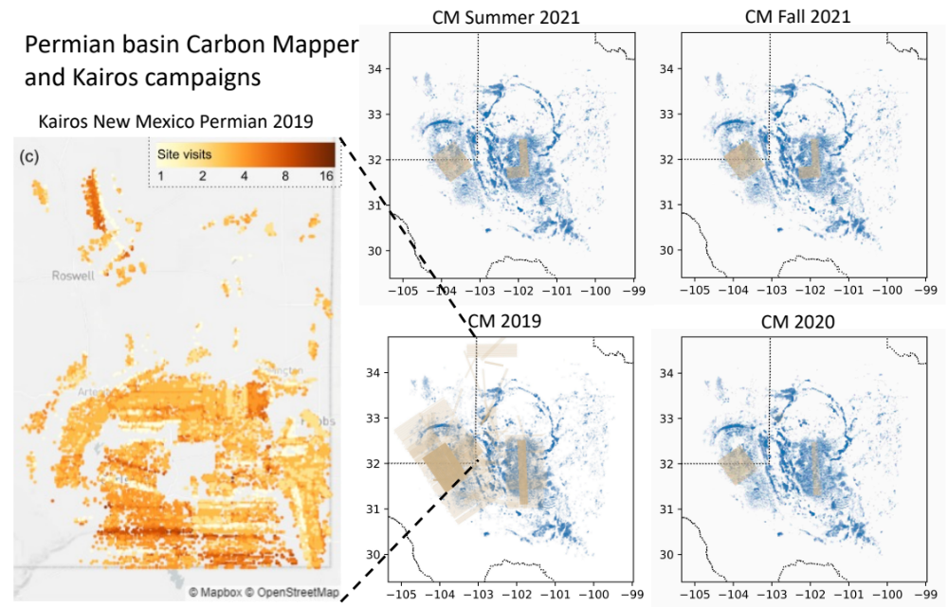
Figure 18: Coverage maps of all campaigns in the Permian basin. Carbon Mapper campaigns show flightlines overlaid upon all wells in the basin, with shading increasing with each visit. The Kairos New Mexico campaign image, reproduced from Chen, Sherwin et al. 2022, shows all wells in the campaign colored by number of site visits ¹³. State shapefiles from US Census Bureau.
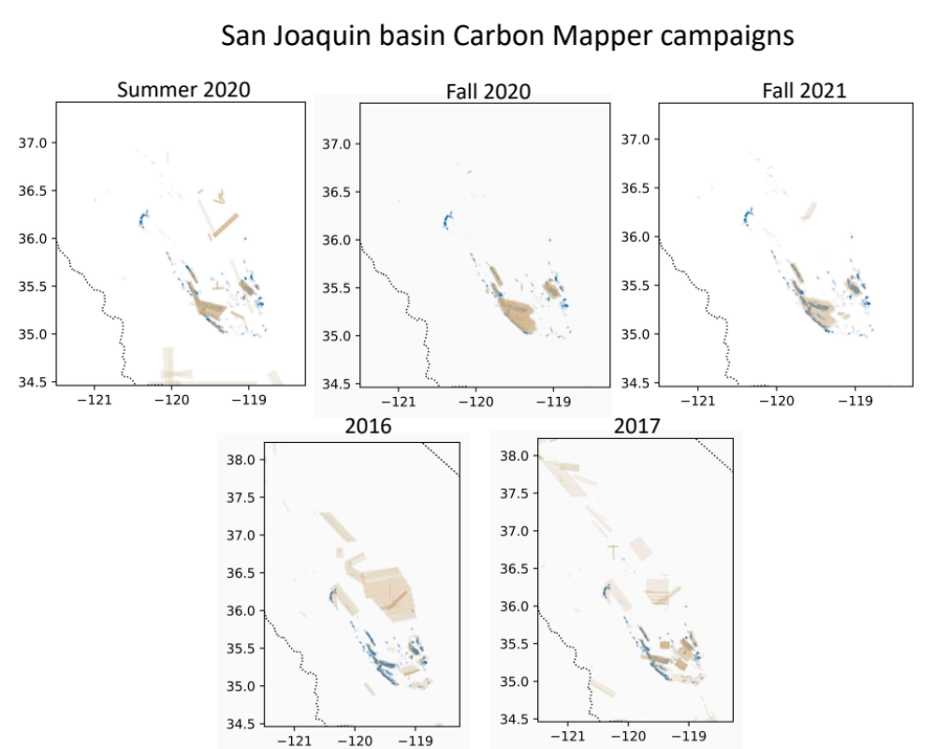
Figure 19: Coverage maps of all campaigns in the San Joaquin basin. Carbon Mapper campaigns show flightlines overlaid upon all wells in the basin, with shading increasing with each visit. State shapefiles from US Census Bureau.
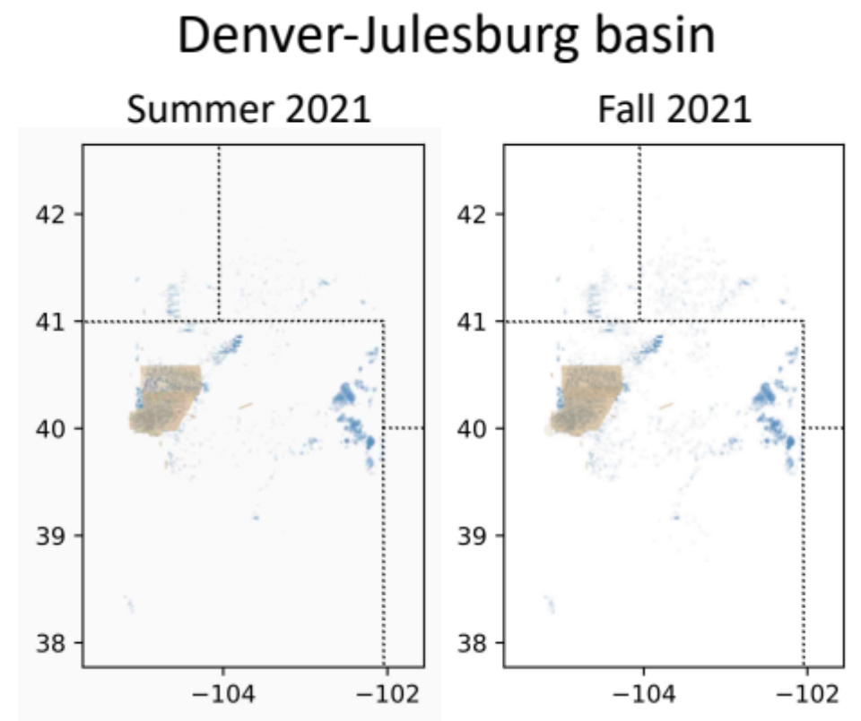
Figure 20: Coverage maps of all campaigns in the Denver-Julesburg basin. Carbon Mapper campaigns show flightlines overlaid upon all wells in the basin, with shading increasing with each visit. State shapefiles from US Census Bureau.
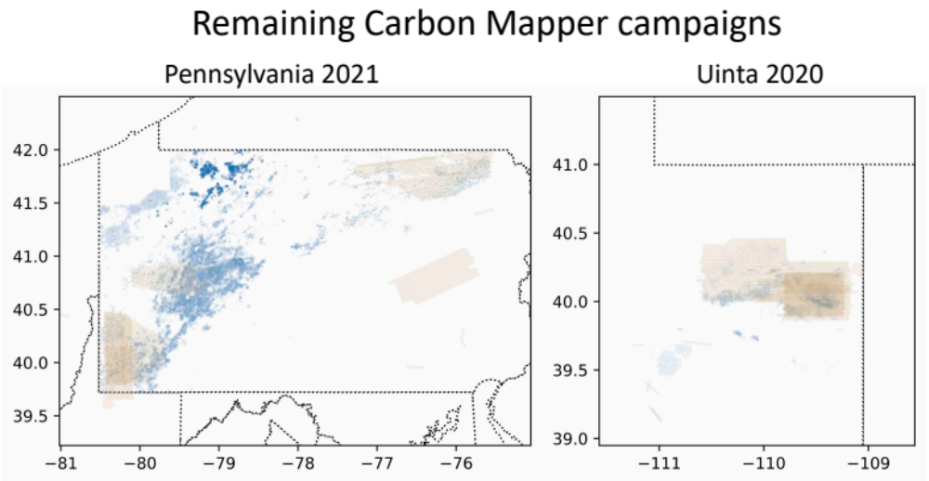
Figure 21: Coverage maps of all campaigns in Pennsylvania (within the Appalachian basin) and the Uinta basin. Carbon Mapper campaigns show flightlines overlaid upon all wells in the basin, with shading increasing with each visit. State shapefiles from US Census Bureau.

The flightlines for the Fort Worth campaign cannot be shared due to anonymization concerns. See Table 17 and Table 19 for quantitative coverage summaries.

Statistical validity

Constructing unbiased estimates using aerial snapshot measurements of intermittent sources
The aerially measured portion of campaign-wide emissions is the average of measured emissions in the surveyed area at a given instant in time. This approach leverages nearly instantaneous “snapshot” measurements taken over a period of weeks to years over thousands to tens of thousands of assets. Many of the underlying emission sources are intermittent, as evidenced by the number of locations at which the aircraft detected emissions during some measurements and did not during others.

Chen, Sherwin et al. 2022, SI, Section S3, provide a detailed mathematical demonstration of why the method employed in this study will produce an unbiased estimate of total methane emissions from the surveyed region ¹³. The key assumptions behind this justification are:

1. “The decision to collect more samples or discontinue data collection at any given site is not dependent on whether emissions were previously detected or not detected at that site
2. The assets surveyed are representative of the assets in the full survey area.
3. The distribution of emissions is stationary over time of day and season.”

Condition 1 holds for all campaigns in this study. The presence or absence of previously detected emissions was not a factor in survery design for any of these campaigns.

The question of representativeness raised in Condition 2 is discussed below, in the SI, Section S12.2.2.

There is evidence of modest seasonal variation in methane emissions in some basins. Carbon Mapper flew two campaigns in the San Joaquin in 2020 and two in the Permian and Denver-Julesburg in 2021. This suggests that for longer campaigns, such as the Carbon Mapper and Kairos Permian campaigns in and around 2019, these results are most representative of the main months in which the surveys were conducted, generally in summer and fall.

There is also evidence of intra-day variation in methane emissions profiles from oil and natural gas systems. Chen, Sherwin et al. 2022 found that the emission incidence rate at 8:00 am was more than twice that of the emission incidence rate at 2:00 pm ¹³. This suggests that emissions estimates in this paper are most representative of the most common times of day for measurement, generally between 9:00 am and 2:00 pm. Both Kairos and Carbon Mapper rely on reflected sunlight to detect methane emissions, meaning that neither can operate at night. Thus, our methane emission rates must be considered daytime estimates. It is possible that emission rates may change at night, but we cannot determine the magnitude or direction of the effect based on the information available in this study.

The regional emission rate estimates in this paper are best estimates of total emissions from the surveyed assets at the time(s) of measurement. This is not precisely identical to estimating average emissions of the surveyed assets over all time, even if the underlying time-varying distribution of emissions were stationary over seasons. In both cases, the average value is the same, but uncertainty is greater in the latter due to sampling issues. Chen, Sherwin et al. demonstrate that a random sample of 10,000 well site measurements from their estimated distribution of measurements for the New Mexico Permian basin, even assuming perfect quantification accuracy, would have a 95% confidence interval of roughly ±25% ¹³. With ~100,000 well site measurements, this falls to roughly ±10%. In other regions, the magnitude of these confidence intervals depends on the shape of the distribution of methane emissions, with larger uncertainty for more heavy-tailed distributions.

The smallest survey in this study is 8,001 well site visits in the Kairos Fort Worth survey, meaning that our numbers for this survey should accurately represent true average emissions from the surveyed assets to within about ±25% based on the above analysis using the distribution of emissions from the New Mexico Permian basin. Because the distribution of emissions from the Fort Worth basin is not as heavy-tailed as in the Kairos New Mexico Permian survey, the true uncertainty range due to these sampling issues is likely smaller. The remaining surveys range between 20,000 and 180,000 well site visits. We do not include these uncertainties in our error bars because our results are estimating emissions inventories based on the aerial measurements conducted in each survey. As a result, our reported uncertainty bounds are interpretable as the best estimate of total emissions from the surveyed assets at the time(s) of survey. This is not identical to an estimate of average emissions over time of the surveyed assets, which is a quantity with the same average estimate but larger error bars to incorporate the above sampling uncertainty.

Estimating the contribution of intermittent sources with a single snapshot measurment

Although the above logic and the longer exposition in Chen, Sherwin et al. 2022 demonstrate mathematically why our method produces a statistically unbiased estimate of regional methane emissions, the treatment of intermittency may at first appear counterintuitive ¹³. If an intermittently emitting asset is visited only once and an emission is detected, our method repeatedly draws from that single measurement in all Monte Carlo realizations. As a result, that source is treated as persistent in the analysis.

This overestimates average emissions from this particular source. However, this overestimate is counterbalanced by underestimation of emissions from intermittent sources covered only once at which no emissions were detected. Our method repeatedly draws from that single measurement in all Monte Carlo realizations, treating such an intermittent emission source as never emitting.

As an illustration, suppose an aerial survey of two sites, i and j, is conducted in hour t, as shown in Figure 22. Suppose all three sites have a 50% probability of emitting amount Q at a given time. If this survey, Survey(t), finds an emission at site j but not at site i, then the method employed in this study will correctly estimate overall average emissions from these two assets as Q. In doing so, it will overestimate average emissions from site j as Q instead of the true value of Q/2, while it will underestimate emissions at sites i as 0 instead of the true value of Q/2.

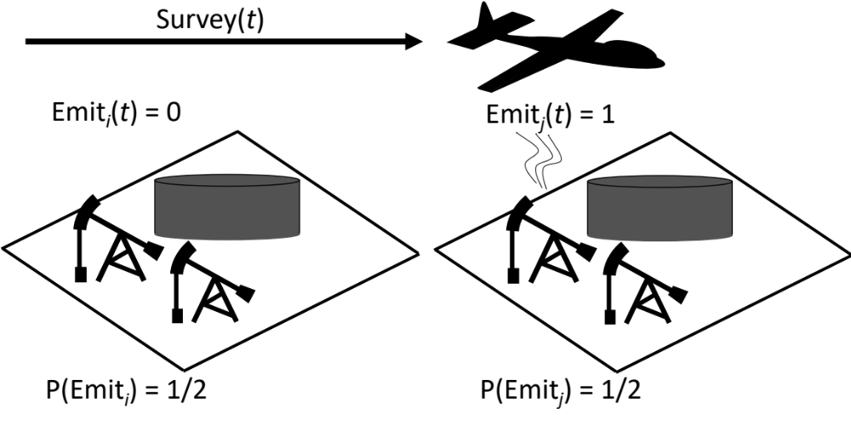
Figure 22: Illustration of a hypothetical single-measurement aerial survey at time t of two assets, which both have 50% probability of emitting at rate Q.
It is also possible that Survey(t) will detect emissions at both sites, thus overestimating average emissions, with probability 25% (one of four possible combinations). Survey(t) may also detect no emissions, with probability 25%, thus underestimating average emissions.

Thus, although Survey(t) may not always accurately estimate true average emissions of the surveyed assets, Q, it provides an unbiased estimate of total emissions from this population of assets, with some probability of overestimating or underestimating total emissions. The same basic logic holds for surveys with repeated visits to each asset and for assets with a variety of emissions profiles.

In the field, each asset has both a probability of emitting, P(Emit_{i}), and a probability distribution of possible emission rates during periods in which it is emitting. The above logic generalizes to such cases. Indeed, a single snapshot measurement will produce an unbiased estimate of a single intermittent source with a randomly-varying, heavy-tailed emission profile. A sufficiently large number of measurements of this asset, e.g. 1 million, will produce an unbiased estimate of the asset’s average emissions. This means that a single measurement will do so as well, albeit with large variance.

Note that this method does not produce an accurate representation of emission persistence.

Is the surveyed area representative of the basin?
Our results are only representative of the surveyed basins if the surveyed assets are measured in a manner that produces statistically representative results. Kairos and Carbon Mapper campaigns cover wide areas, visiting over 10% of all oil and gas well sites within the region in question in all cases. Flight lines are set in advance and assets at which emissions are detected are not selected for additional visits beyond the originally planned survey design. The flights used here do not target particular operators. As a result, we believe that these surveys produce a statistically representative picture of the assets covered in the study. See section S3 of the supplementary information of Chen, Sherwin et al. 2022 for further detail.

The Kairos New Mexico Permian, Carbon Mapper Permian 2019, San Joaquin, Denver-Julesburg, and Uinta campaigns all include over 50% of well sites and 80% of natural gas production in the surveyed region, as shown in Table 21. Because aerial campaigns tend to focus on higher-productivity assets, which tend to be more concentrated in higher-productivity sections of a basin, the unmeasured assets are less productive on average, as shown in Table 20. Lower-productivity well sites tend to have higher methane loss rates, as illustrated in ^{20,66}. This also holds for the low-productivity Midland basin in 2019, in which the estimated midstream methane fractional loss rate is more than twice that of the more productive Delaware basin during the same time period, illustrated in the SI, Section S5. This provides anecdotal evidence that midstream emissions tend to rise in lower-productivity fields.

Thus, for surveys which cover assets with higher average well-site productivity than the basin-wide average, estimated methane emission rates in this study are likely conservative.

Even fairly comprehensive surveys often cover wells with higher average productivity than the basin as a whole, as shown in Table 20. Note that in the Carbon Mapper Permian 2019 campaign, average covered well productivity for natural gas is 45% higher than the Permian-wide average despite 91% production coverage, rising to 178% higher if repeated well site visits are counted as independent measurements. In Pennsylvania, covered wells are roughly four times more productive than the Pennsylvania-wide average. In other basins, such as the Uinta, average productivity is relatively constant across all three metrics.

Monte Carlo sample size
We conduct 1,000 Monte Carlo realization of the surveyed assets in each campaign. Note that each Monte Carlo realization represents a full simulation of all surveyed assets, meaning that 1,000 Monte Carlo realizations represents a minimum of 4,607,000 simulated well site measurements plus associated midstream infrastructure in the Kairos Fort Worth campaign, and a maximum of 46,744,000 for the 2019 Carbon Mapper Permian survey. Because of this size, exceeding this 1,000 Monte Carlo realizations becomes computationally difficult for the 2019 Carbon Mapper Permian survey.

The standard deviation of total well site and midstream emissions across Monte Carlo realizations ranges from 3% in the 2019 Carbon Mapper Permian survey to 20% in the 2020 Carbon Mapper San Joaquin survey. For a Monte Carlo simulation, the standard error of mean quantities estimated from this simulation is equal to the standard deviation of Monte Carlo realizations multiplied by $1/\sqrt{B}$, where B is the number of Monte Carlo realizations, in this case 1000. Thus, the Monte Carlo results accurately estimate the sample mean with a standard error ranging from $3\%/\sqrt{1,000}=0.1\%$ to $20\%/\sqrt{1,000}=0.6\%$. Table 24 shows the standard deviation of estimated mean total well site and midstream emissions for each campaign.

Table 24: Standard deviation of Monte Carlo estimates of total methane emissions from well sites and midstream infrastructure for each campaign across 1,000 realizations. The standard error of the sample mean of these values is the standard deviation multiplied by $1/\sqrt{1,000}$ = 0.07. This characterizes expected variability in mean estimated emissions introduced by the Monte Carlo simulation into each simulated campaign, independent of other sources of uncertainty.
Basin/Campaign | % standard deviation of Monte Carlo realizations | % standard error on the sample mean
Kairos NM Permian | 6% | 0.2%
CM Permian/2019 | 3% | 0.1%
CM Permian/2020 | 5% | 0.2%
CM Permian/Summer 2021 | 6% | 0.2%
CM Permian/Fall 2021 | 5% | 0.1%
CM San Joaquin/2016 | 10% | 0.3%
CM San Joaquin/2017 | 12% | 0.4%
CM San Joaquin/Summer 2020 | 20% | 0.6%
CM San Joaquin/Fall 2020 | 15% | 0.5%
CM San Joaquin/Fall 2021 | 11% | 0.4%
CM Denver-Julesburg /Summer 2021 | 5% | 0.1%
CM Denver-Julesburg/Fall 2021 | 9% | 0.3%
CM Pennsylvania/2021 | 6% | 0.2%
CM Uinta/2020 | 7% | 0.2%
Kairos Fort Worth/2021 | 7% | 0.2%

This estimated error on the sample mean is different than the full uncertainty in our estimate of mean total well site and midstream emissions in the surveyed area in each campaign. Each campaign conducted between 1.7 and 5.8 measurements per well site. This means that the 95% confidence interval is derived by multiplying the 2.5th and 97.5th percentile error bars by $1/\sqrt{N}$, where N is the average number of measurements per well site in the campaign, shown in Table 22. This multiplier could be refined further by using some form of Monte Carlo-specific clustered standard error statistic, which could account for differences in measurement counts across surveyed sites ⁶⁷. However, development of such a statistical method is outside the scope of this study.

For computational reasons, all results from this Monte Carlo simulation are computed in 10 batches of 100 Monte Carlo realizations. Because all key results are averages, we simply average over the average value from each of these 10 batches to produce the average across the full 1,000 Monte Carlo realizations.

Significance of productivity stratification
The productivity of assets covered in a survey may not be representative of the region as a whole. To ensure simulated emissions have a similar productivity profile to the surveyed assets, we stratify our random sampling from the emissions simulation tool. To do this, we divide all wells in the simulated basin into productivity quantiles, grouping wells by productivity decile up to the 50th decile, rising to 5-percentile increments through the 95th percentile, rising to 1-percentile increments through the 99th percentile, and moving to 0.1-percentile increments from the 99.5th to 100th percentile. See the SI, Section S1.6 for further detail.

For each covered well site, we then match its productivity to the basin-wide productivity quantiles computed above and simulate its emissions by drawing only from simulated sites in the same productivity quantile.

Note that the emissions simulation tool divides wells into sites using a clustering algorithm, while the aerial survey analysis simply assumes that all wells are on sites with the basin-wide average number of wells per site. This simplifying assumption thus tends to underestimate production from the highest-producing sites and overestimates from the lowest-producing sites.

Figure 23 shows the simulated emissions profile for the Carbon Mapper Permian campaigns in 2019, covering 62.7% of well sites, and fall 2021, covering 12.2% of well sites. Note that high-productivity assets are a larger percentage of the total in the fall 2021 campaign even though both are drawing from the same simulated site-level emissions.
Figure 23: Simulated emissions for the Permian 2019 (left) and fall 2021 (right) Carbon Mapper campaigns. Note that because the fall 2021 campaign disproportionately surveyed high-productivity assets, the proportion of high-emitting sites is larger than in the 2019 campaign.
Excluding this productivity stratification can introduce significant errors. In the fall 2021 Permian Carbon Mapper campaign, removing production stratification and assuming covered well sites are representative of the full basin reduces simulated well site emissions from 0.47% to 0.16% methane fractional loss, a factor of three difference.

Source data for maps
In addition to the emission and well data presented in this study, maps use the following sources for shapefiles representing boundaries of relevant geographic features.

State and US national boundaries: US State Boundaries. U.S. Census Bureau. 2018. Downloaded on September 18, 2022 from https://www.census.gov/geographies/mapping-files/time-series/geo/carto-boundary-file.html

National boundaries for Canada and Mexico: 10m Countries Cultural Map. Natural Earth Data. Downloaded on November 11, 2022 from http://www.naturalearthdata.com/downloads/

Lakes and rivers: USGS. North American Atlas – Hydrography. U.S. Geological Survey, National Atlas of the United States. Downloaded on November 10, 2022 from https://www.sciencebase.gov/catalog/item/4fb55df0e4b04cb937751e02

Oceans: Flanders Marine Institute (2021). Global Oceans and Seas, version 1. Available online at https://www.marineregions.org/. https://doi.org/10.14284/542. Downloaded on November 10, 2022.

Supplementary references
41. Rutherford, J. S. Closing the gap: Explaining persistent underestimation of US oil and natural gas production-segment methane inventories, O-G_Methane_Supporting_Code. Preprint at https://doi.org/10.5281/zenodo.4667781 (2021).
42. (USGS) United States Geological Survey. National Geologic Map Database, Geolex — AAPG Geologic Provinces. https://ngmdb.usgs.gov/Geolex/stratres/provinces (2022).
43. (EPA) Environmental Protection Agency. Electronic Greenhouse Gas Reporting Tool, Sub-basin selection. https://ccdsupport.com/confluence/display/help/Sub-Basin+Selection.
44. (EPA) Environmental Protection Agency. Inventory of U.S. Greenhouse Gas Emissions and Sinks 1990-2016: Revisions to Create Year-Specific Emissions and Activity Factors. https://www.epa.gov/sites/production/files/2018-04/documents/ghgemissions_year_specific_2018.pdf (2018).
45. (EPA) Environmental Protection Agency. Revisions to Natural Gas and Petroleum Production Emissions. (2016).
46. (EPA) Environmental Protection Agency. Additional Revisions Considered for 2018 and Future GHGIs. (2018).
47. (EPA) Environmental Protection Agency. Greenhouse gas customized search. https://www.epa.gov/enviro/greenhouse-gas-customized-search.
48. Zhang, Y. et al. Quantifying methane emissions from the largest oil-producing basin in the United States from space. Sci. Adv. 6, eaaz5120 (2020).
49. Ehret, T. et al. Global Tracking and Quantification of Oil and Gas Methane Emissions from Recurrent Sentinel-2 Imagery. arXiv:2110.11832 [physics] (2021).
50. Rutherford, J. S. et al. Closing the methane gap in US oil and natural gas production emissions inventories. Nature Communications 12, (2021).
51. Alvarez, R. A. et al. Assessment of methane emissions from the US oil and gas supply chain. Science eaar7204 (2018).
52. Enervus. Enervus Exploration and Production. https://www.enverus.com/industry/exploration-and-production/.
53. PG&E. California Gas Transmission | Pipe Ranger | Operating Data | Gas Quality. https://www.pge.com/pipeline/operations/gas_quality/index.page (2019).
54. EIA. Units and calculators explained: Energy conversion calculators. https://www.eia.gov/energyexplained/units-and-calculators/energy-conversion-calculators.php (2022).
55. EIA. What are Ccf, Mcf, Btu, and therms? How do I convert natural gas prices in dollars per Ccf or Mcf to dollars per Btu or therm? (2017).
56. Crippa, M. et al. Fossil CO2 and GHG emissions of all world countries: 2019 report. (Publications Office of the European Union, 2019).
57. EIA. Henry Hub Natural Gas Spot Price (Monthly). https://www.eia.gov/dnav/ng/hist/rngwhhdM.htm (2022).
58. Foster-Wittig, T. A., Thoma, E. D. & Albertson, J. D. Estimation of point source fugitive emission rates from a single sensor time series: A conditionally-sampled Gaussian plume reconstruction. Atmospheric Environment 115, 101–109 (2015).
59. Other Test Method (OTM) 33 and 33A Geospatial Measurement of Air Pollution-remote Emissions Quantification-direct Assessment. https://www3.epa.gov/ttnemc01/prelim/otm33.pdf (2014).
60. Lan, X., Talbot, R., Laine, P. & Torres, A. Characterizing Fugitive Methane Emissions in the Barnett Shale Area Using a Mobile Laboratory. Environ. Sci. Technol. 49, 8139–8146 (2015).
61. Yacovitch, T. I. et al. Mobile Laboratory Observations of Methane Emissions in the Barnett Shale Region. Environ. Sci. Technol. 49, 7889–7895 (2015).
62. Rella, C. W., Tsai, T. R., Botkin, C. G., Crosson, E. R. & Steele, D. Measuring Emissions from Oil and Natural Gas Well Pads Using the Mobile Flux Plane Technique. Environ. Sci. Technol. 49, 4742–4748 (2015).
63. Bell, C. S. et al. Comparison of methane emission estimates from multiple measurement techniques at natural gas production pads. Elementa: Science of the Anthropocene 5, 79 (2017).
64. USGS. National Geologic Map Database, Geolex — AAPG Geologic Provinces. https://ngmdb.usgs.gov/Geolex/stratres/provinces (2022).
65. Robertson, A. M. et al. New Mexico Permian Basin Measured Well Pad Methane Emissions Are a Factor of 5–9 Times Higher Than U.S. EPA Estimates. Environ. Sci. Technol. 54, 13926–13934 (2020).
66. Omara, M. et al. Methane emissions from US low production oil and natural gas well sites. Nat Commun 13, 2085 (2022).
67. Abadie, A., Athey, S., Imbens, G. W. & Wooldridge, J. When Should You Adjust Standard Errors for Clustering? 30.

