Supplementary information
Fig. S1 Maximum likelihood (A) and maximum parsimony (B) trees showing the phylogenetic relationships between strains G2-23^{T} and J2-29^{T} and closely related taxa, based on 16S rRNA gene sequences. Numbers at the branches indicate the percentages of 1,000 bootstrap replicates; only values >70% are shown. Parvibaculum lavamentivorans DS-1^{T} (AY387398) was used as the outgroup. The scale bars of panels A and B indicate nucleotide changes per nucleotide position and over the whole sequence, respectively.
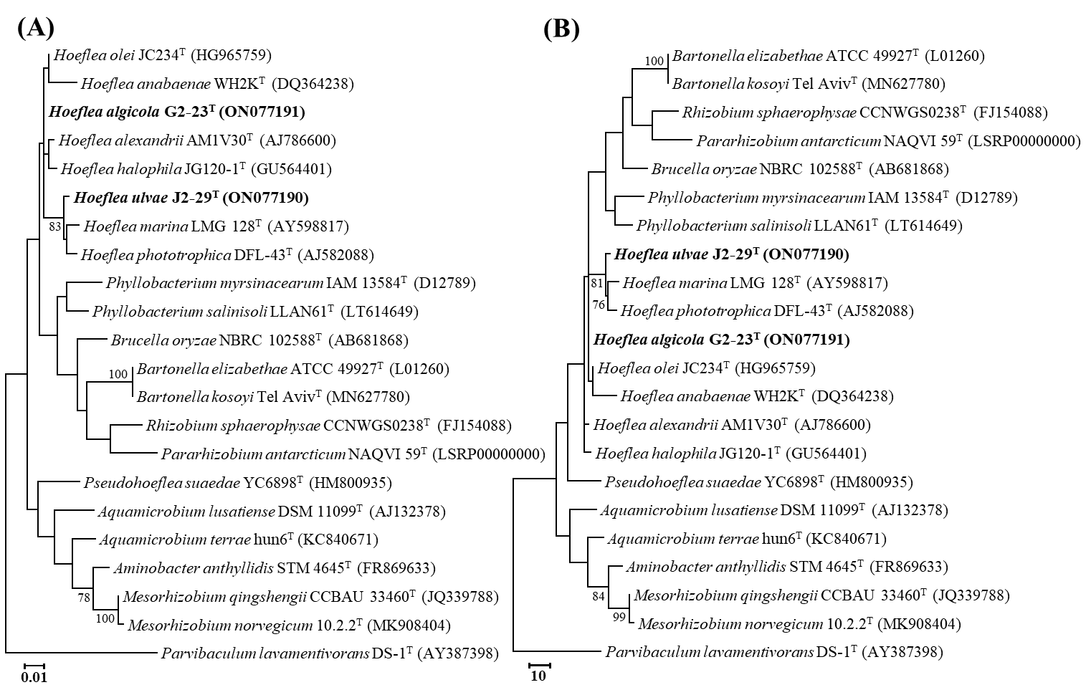
Fig. S2 Transmission electron micrographs of negatively stained cells showing the general morphologies of strains G2-23^{T} (A) and J2-29^{T} (B) grown on marine agar for 3 days.
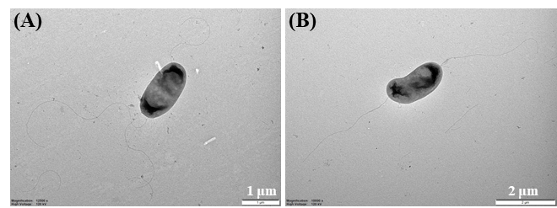

Fig. S3 Two-dimensional thin-layer chromatograms (TLC) showing the polar lipid profiles of strains G2-23^{T} and J2-29^{T}. Solvent systems: (I) chloroform-methanol-water (65:25:4, v/v/v); (II) chloroform-acetic acid methanol-water (80:15:12:4, v/v/v/v). The TLC plates were sprayed with 10% ethanolic molybdatophosphoric acid, ninhydrin, Dittmer-Lester, α-naphthol, and Dragendorff’s reagents for the detection of total polar lipids (A), aminolipids (B), phospholipids (C), glycolipids (D), and phosphatidylcholine (E), respectively. Abbreviations: PG, phosphatidylglycerol; PE, phosphatidylethanolamine; DPG, diphosphatidylglycerol; PME, phosphatidyl-N-monomethylethanolamine; SQDG, sulfoquinovosyl diacylglycerol; PL, unidentified phospholipid; L1–L3, unidentified lipids.
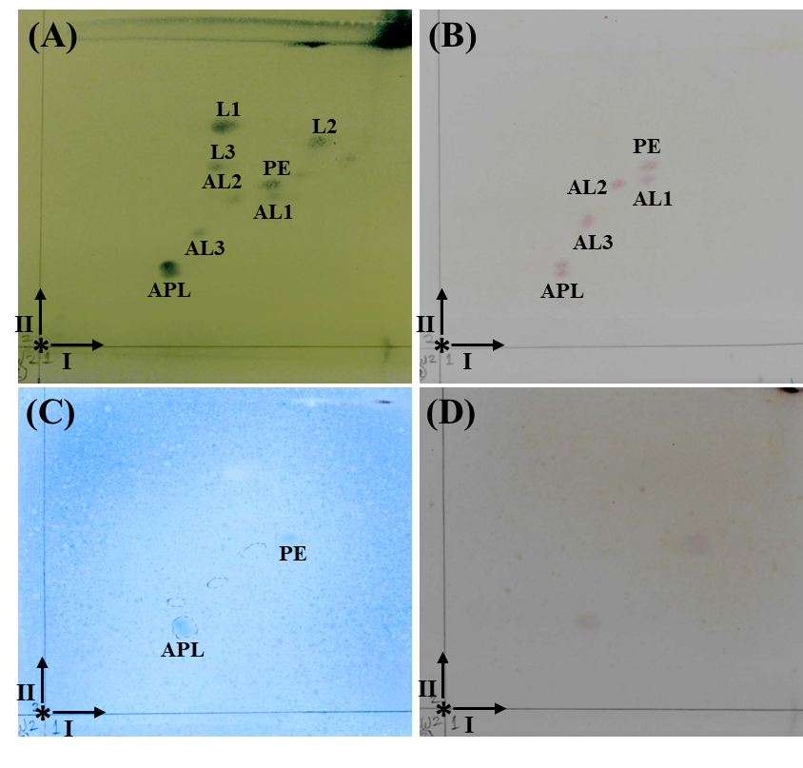
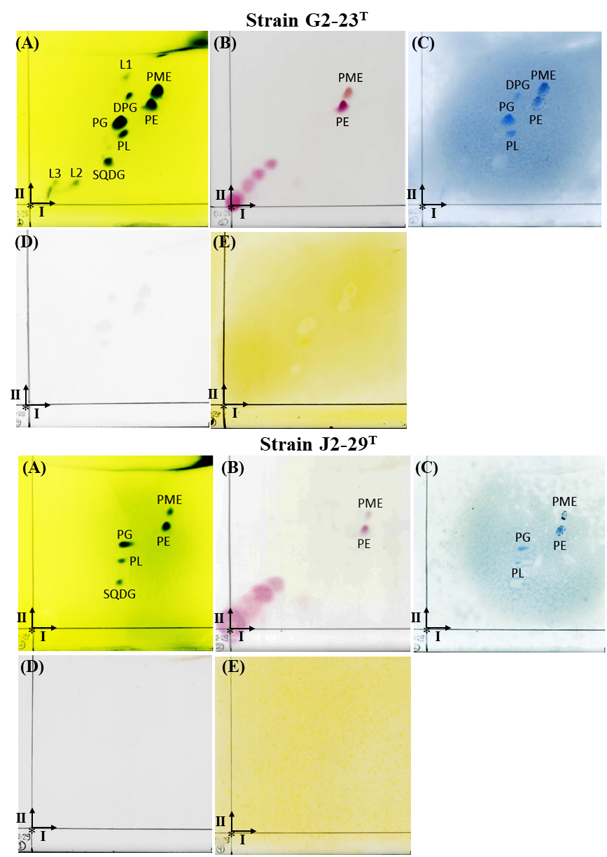
Strain MSW2

