Electronic Supplementary Information

Resculpting Carbon dots via electrochemical etching
Qingsong Yang^{1,2}, Spyridon Gavalas², Aleksander Ejsmont^{2,3}, Marta J. Krysmann⁴, Jiangtao Guo¹, Li Li¹, Xuhong Guo^{1,5}*, Antonios Kelarakis²*

¹State-Key Laboratory of Chemical Engineering, East China University of Science and Technology, Shanghai, China,
²UCLan Research Centre for Smart Materials, School of Natural Sciences, University of Central Lancashire, Preston PR12HE, UK
³Adam Mickiewicz University in Poznań, Faculty of Chemistry, Department of Chemical Technology, Uniwersytetu Poznańskiego 8, 61-614 Poznań, Poland
⁴UCLan Research Centre for Smart Materials, School of Dentistry, University of Central Lancashire, Preston PR12HE, UK
⁵Engineering Research Centre of Materials Chemical Engineering of Xinjiang Bingtuan, Shihezi, University, Shihezi, China

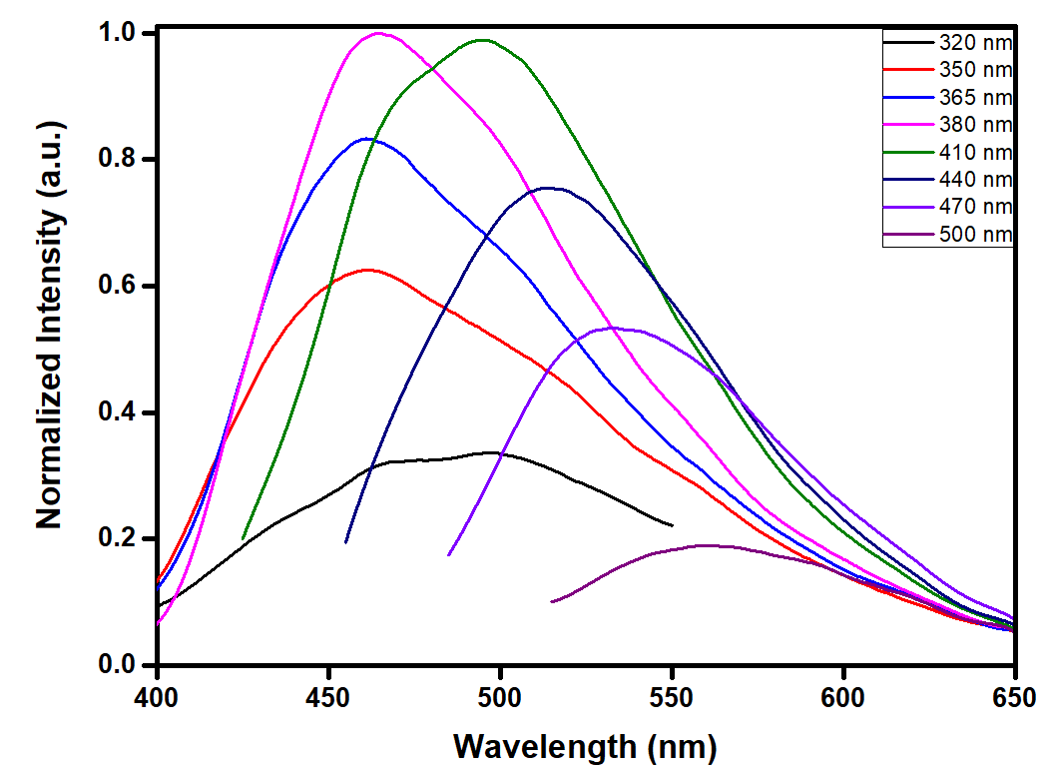

SI Figure 1. Normalized (with respect to the I_{max} at λ_{ex}=380 nm) PL spectra of 0.01 mg mL^{–1} aqueous dispersions of C-dots. The excitation wavelength (λ_{ex}) was varied from 320 to 500 nm as indicated.

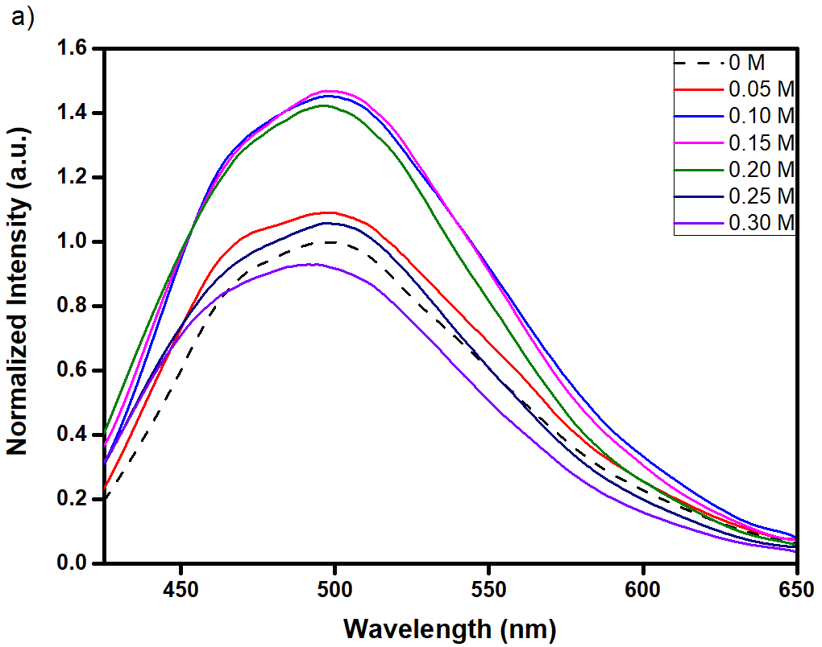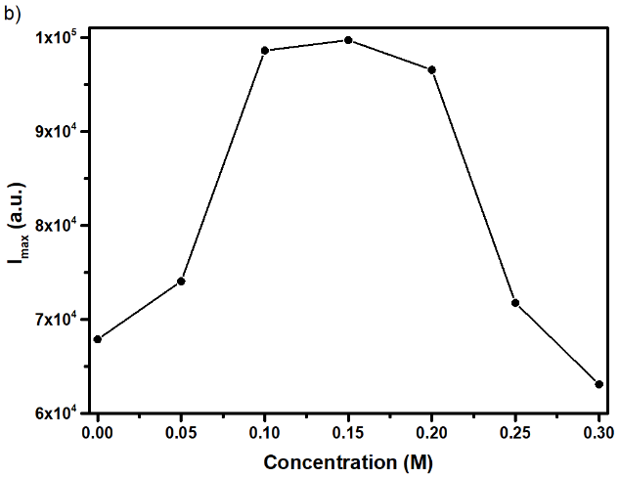

SI Figure 2. 0.02 mg ml^{–1} C-dots dispersions that have been subjected to chronoamperometry treatments for 60 s at 2.0 V in the presence of 0.05, 0.10, 0.15, 0.20, 0.25, 0.30 M KCl. (a) PL spectra (λ_{ex} = 410 nm) and (b) the corresponding maximum PL intensity (I_{max}) as a function of KCl concentration.

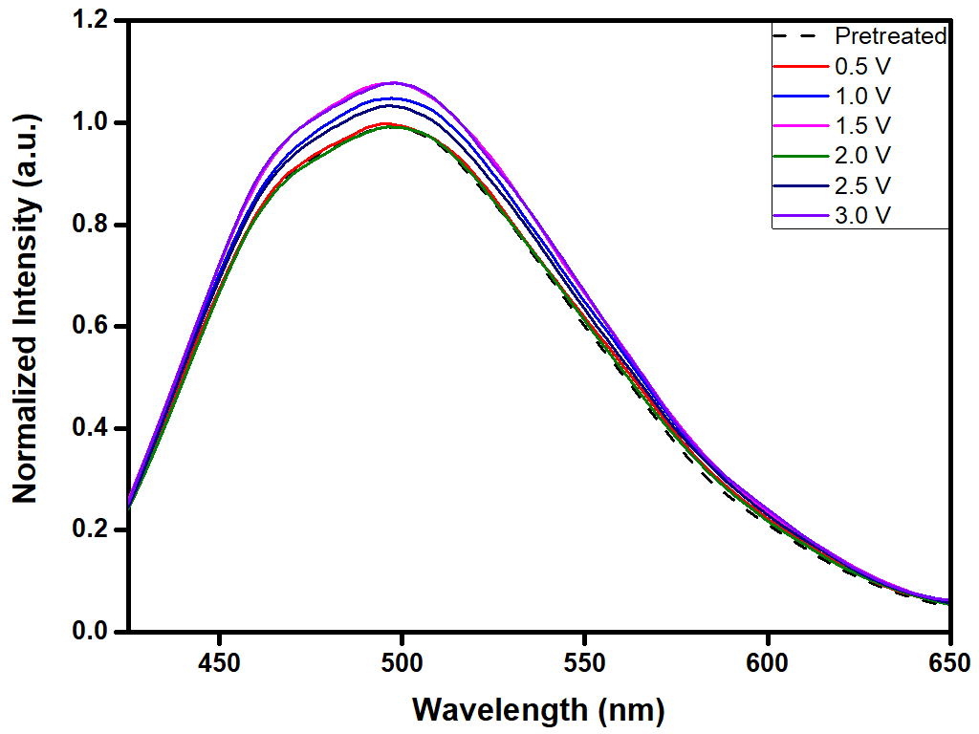

SI Figure 3. PL spectra (λ_{ex} = 410 nm) of 0.02 mg ml^{–1} C-dots pretreated with 1mM NaClO solution for 48 h and then subjected to chronoamperometry treatments for 60s at the voltages indicated.
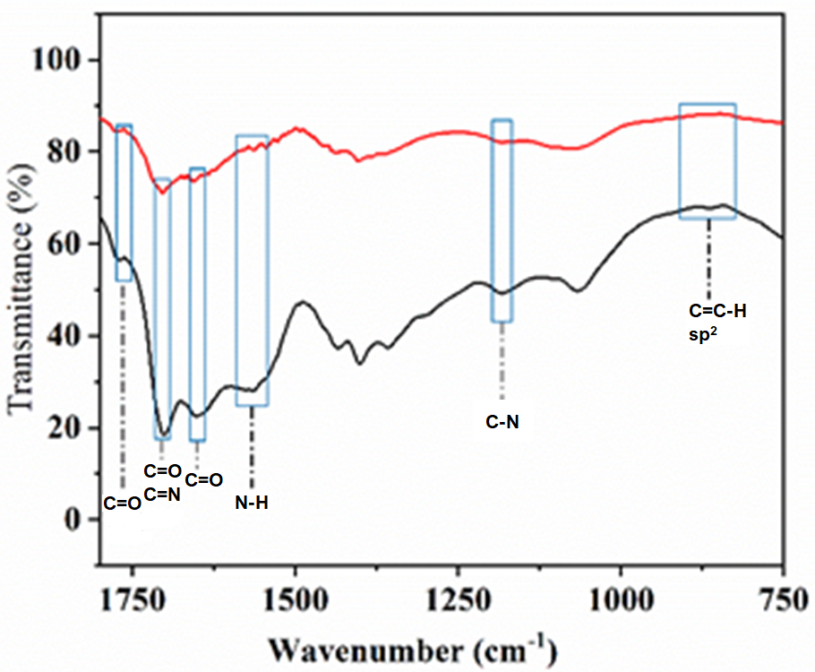

SI Figure 4. FTIR spectra of C-dots prior (lower black line) and after (upper red line) the chronoamperometry treatment at 2.0 V for 60 s.

S.I. Table 1. Analysis of the C1s XPS spectrum of untreated C-dots.
Chemical Bind | Combined energy peak position (eV) | Half peak width (eV) | Peak area %
sp² | 284.19 | 1.63 | 19.1
sp³ | 284.8 | 2.26 | 60.6
C–O | 286.05 | 0.50 | 2.4
C=O | 287.96 | 1.65 | 17.8
π–π* | 291.05 | 0.50 | 0.1

S.I. Table 2. Analysis of the C1s XPS spectrum of C-dots that have been subjected to chronoamperometry treatment a 2.0 V for 60 s.
Chemical Bind | Combined energy peak position (eV) | Half peak width (eV) | Peak area %
sp2 | 284.2 | 0.96 | 4.9
sp3 | 284.81 | 1.7 | 42.4
C–O | 285.94 | 2.29 | 39.6
C=O | 287.97 | 1.17 | 13.1

