Supplementary Material 1

This supplementary material for the article “Who is adapting and how? Identifying actors and roles in climate change adaptation” contains the following information:
1 Screening flowchart
2 Coding framework
3 Actor-roles analysis
4 Actor-roles analysis per region
5 High depth adaptation patterns

22 December 2022
Contact: Jan Petzold (Ludwig-Maximilians-University Munich), jan.petzold@lmu.de

- Screening flowchart

Figure SM1.1 illustrates the screening process, building on the GAMI database, and applying our specific inclusion criteria relating to sufficiency in information about actors involved in climate-related responses and their roles. Climate-related responses need to be documented/observed and published in peer-reviewed literature.

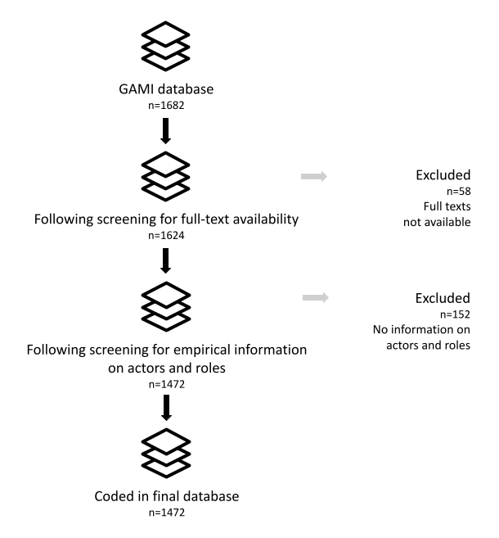
Figure SM1.1: Selection of articles to be reviewed/coded on actors and roles in climate change adaptation.

- Coding framework

Figure SM1.2 illustrates the adaptation cycle and the set of actors involved in its various stages. Table SM1.1 explains the specific variables, labels and definitions used for the additional coding building on the GAMI dataset.

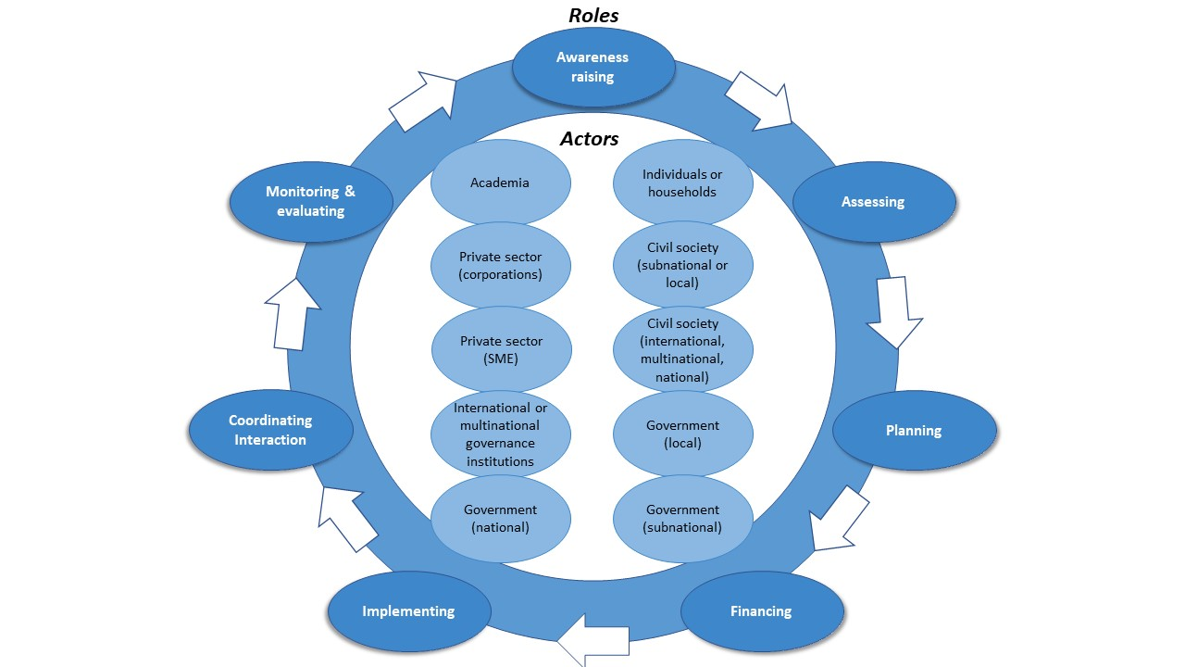

Figure SM1.2: Actors and roles in the process of climate change adaptation. The roles occur in an iterative and timely overlapping way. Actors can be involved in one or more of the various adaptation roles.

Table SM1.1: Coding framework
Variable | Label | Definition/example
Settlement type | Urban | Unambiguously urban centres with much of the economically active population deriving their living from manufacturing or services. In virtually all nations, settlements with 20,000+ inhabitants are considered as urban.
Settlement type | Rural | Unambiguously rural settlements with most of the inhabitants deriving a living from farming and/or forestry or fishing. Populations of rural settlements range from farmsteads to a few hundred inhabitants.
Settlement type | Ambiguous | ‘Large villages’, ‘small towns’ and ‘small urban centres’. The proportion of the population in rural and urban areas is influenced by each nation’s definition of ‘urban areas’. Populations range from a few hundred to 20,000 inhabitants.
Actor type | Individuals or households | Including informal community networks
Actor type | Civil society (sub-national or local) | Formal community associations
Actor type | Civil society (international/multinational/national) | Voluntary civil society organizations. Includes charities, non-profits, faith-based organizations, professional organizations (e.g. labour unions, associations, federations), cultural groups, religious groups, sporting associations, advocacy groups (e.g. NGOs).
Actor type | Government (local) | Terms include municipality, local government, community, urban, urban regions, rural, etc.
Actor type | Government (sub-national) | Domestic, sub-national governing unit. Terms include state, province, territory, department, canton, Bundesländer, etc.
Actor type | Government (national) | Countries officially recognized by the UN
Actor type | International or multinational governance institutions | Global or regional treaty body or agency (e.g. UN institutions/organizations, EU instittutions, Organization of American States, African Union)
Actor type | Private sector (SME) | Small- and medium-enterprises
Actor type | Private sector (corporations) | Large national or international companies
Actor type | Academia | Academic institutions such as private or public research institutes, think tanks, or universities
Actor type | Other | Any other actor type
Adaptation role | Awareness raising | Convincing politicians of the need to do adaptation planning and /or to integrate adaptation in other policy areas. Or general raising of awareness about climate change adaptation measures, local effects of climate change etc. Awareness raising focuses more explicitly on the communication of climate change: informing actors and of its importance while "assessing" focuses more on assessment of the potential effects of climate change for the purpose of developing suitable adaptation measures.
Adaptation role | Assessing | Assessing impacts, vulnerability, risks, and resilience: This first step consists of initial and periodically updated assessments, grounded in systematic observations and the best available science, of how climate change is impacting, and is expected to impact, natural and human systems. It also includes an assessment of the capacity of these systems to adapt to climate change impacts.
Adaptation role | Planning | Planning for adaptation: Subsequently, it is necessary to identify potential adaptation measures, and evaluate these measures – using, for example, a cost effectiveness analysis – to prioritize and choose among the options available. Adaptation planning should seek to avoid duplication, prevent maladaptation, and contribute to sustainable development outcomes. This step, along with the following implementation step, is undertaken while acknowledging that, in some cases, not all impacts will be addressed by planned adaptation, and there will be a role for contingency arrangements and loss acceptance.
Adaptation role | Financing of measures | Bearing the cost of adaptation measures, compensating the damages inflicted by climate impacts or adaptation measures
Adaptation role | Implementing | Implementing adaptation measures: Once a plan is in place, the next step is to implement adaptation initiatives at various levels – including local, national, and regional – and through a variety of means, including projects, programmes, policies, or strategies. Increasingly, adaptation is pursued through mainstreaming initiatives into budgets, sectoral policies, and sustainable development plans, though efforts can nonetheless be undertaken as stand-alone processes.
Adaptation role | Monitoring and evaluating | Monitoring and evaluating (M&E) adaptation: Finally, a continuous process of monitoring and evaluating adaptation is undertaken. This helps ensure that efforts are successful and that the knowledge and information generated from planning and implementation are fed back into the process to bolster the success of future efforts. Monitoring seeks to keep a record of progress made throughout the implementation phase, while evaluation seeks to determine the effectiveness of the initiative.
Adaptation role | Coordinating interaction | Bringing actors together; strengthening networks; facilitating actor exchange etc.
Adaptation role | Other | Any other roles

- Actor-roles analysis

Table SM1.2 includes the results of the analysis of relationships between actors and specific roles. We performed a chi-squared test of independence. The table shows expected versus observed frequencies of actor/role combinations.

Table SM1.2. Actors and their roles in adapting to climate change.
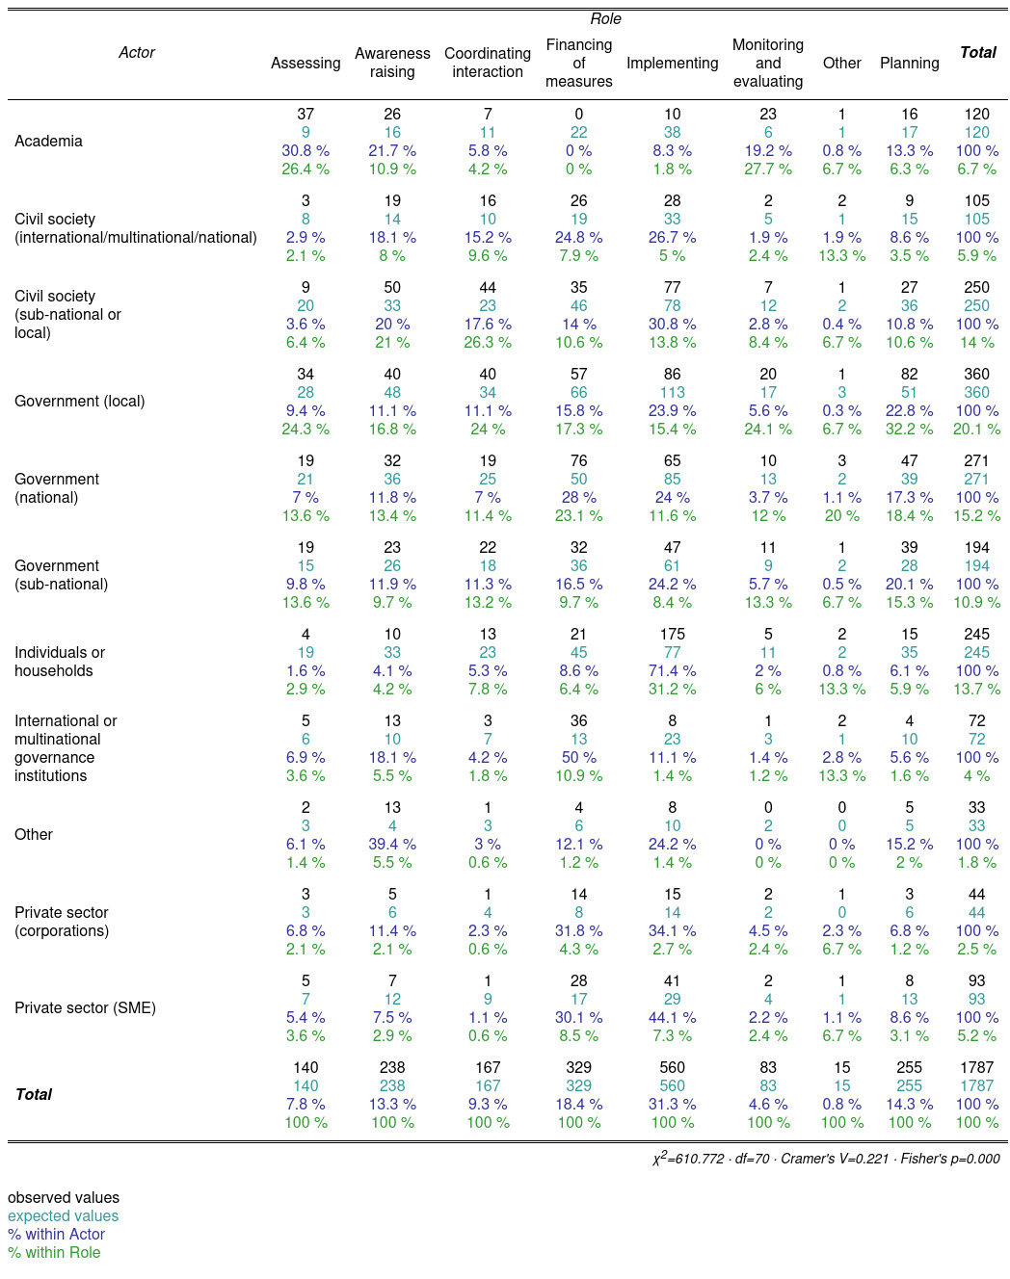

- Actor-roles analysis per region

Table SM1.3 includes an overview of the frequencies of observations of actor-role combinations per region.

Table SM1.3: Number of observed actor-role combinations per region.
Region | Actor | Awareness raising | Assessing | Planning | Financing | Implementing | Coordinating interaction | Monitoring and evaluating | Other
Africa | Individuals or households | 14 | 14 | 37 | 56 | 320 | 27 | 5 | 5
Africa | Civil society (sub-national or local) | 21 | 6 | 11 | 11 | 30 | 19 | 3 | 0
Africa | Civil society (international/multinational/national) | 9 | 1 | 4 | 14 | 16 | 7 | 1 | 0
Africa | Government (local) | 15 | 9 | 24 | 13 | 23 | 9 | 3 | 2
Africa | Government (sub-national) | 4 | 1 | 2 | 5 | 7 | 1 | 0 | 1
Africa | Government (national) | 30 | 13 | 27 | 43 | 42 | 12 | 7 | 1
Africa | International or multinational governance institutions | 2 | 3 | 8 | 23 | 9 | 2 | 5 | 0
Africa | Private sector (SME) | 3 | 0 | 5 | 18 | 29 | 2 | 1 | 1
Africa | Private sector (corporations) | 1 | 0 | 2 | 6 | 8 | 0 | 0 | 0
Africa | Academia | 8 | 12 | 2 | 0 | 5 | 3 | 9 | 0
Africa | Other | 6 | 1 | 2 | 2 | 2 | 0 | 0 | 0
Asia | Individuals or households | 20 | 13 | 44 | 65 | 320 | 22 | 3 | 4
Asia | Civil society (sub-national or local) | 22 | 4 | 9 | 19 | 35 | 30 | 5 | 1
Asia | Civil society (international/multinational/national) | 11 | 1 | 1 | 11 | 11 | 6 | 0 | 0
Asia | Government (local) | 23 | 12 | 27 | 37 | 43 | 18 | 8 | 0
Asia | Government (sub-national) | 11 | 4 | 13 | 18 | 13 | 5 | 3 | 0
Asia | Government (national) | 29 | 16 | 53 | 52 | 52 | 20 | 5 | 2
Asia | International or multinational governance institutions | 9 | 3 | 2 | 22 | 6 | 6 | 0 | 0
Asia | Private sector (SME) | 0 | 1 | 2 | 21 | 33 | 2 | 1 | 0
Asia | Private sector (corporations) | 4 | 0 | 1 | 11 | 7 | 1 | 1 | 0
Asia | Academia | 7 | 8 | 4 | 0 | 7 | 3 | 8 | 0
Asia | Other | 5 | 0 | 0 | 1 | 2 | 0 | 0 | 0
Australasia | Individuals or households | 4 | 4 | 7 | 5 | 28 | 2 | 3 | 0
Australasia | Civil society (sub-national or local) | 3 | 1 | 1 | 1 | 6 | 5 | 0 | 0
Australasia | Civil society (international/multinational/national) | 1 | 0 | 0 | 0 | 1 | 0 | 0 | 0
Australasia | Government (local) | 4 | 6 | 9 | 4 | 6 | 7 | 0 | 0
Australasia | Government (sub-national) | 2 | 3 | 5 | 1 | 2 | 2 | 0 | 0
Australasia | Government (national) | 3 | 3 | 6 | 7 | 5 | 1 | 1 | 0
Australasia | International or multinational governance institutions | 1 | 0 | 0 | 2 | 1 | 0 | 0 | 0
Australasia | Private sector (SME) | 1 | 1 | 2 | 7 | 9 | 1 | 0 | 1
Australasia | Private sector (corporations) | 1 | 0 | 1 | 4 | 4 | 0 | 1 | 0
Australasia | Academia | 1 | 3 | 1 | 0 | 0 | 0 | 1 | 0
Australasia | Other | 0 | 1 | 0 | 2 | 1 | 0 | 0 | 0
Central and South America | Individuals or households | 5 | 1 | 7 | 5 | 36 | 3 | 0 | 0
Central and South America | Civil society (sub-national or local) | 8 | 2 | 6 | 6 | 9 | 11 | 2 | 0
Central and South America | Civil society (international/multinational/national) | 0 | 0 | 1 | 1 | 0 | 1 | 1 | 0
Central and South America | Government (local) | 3 | 2 | 5 | 3 | 4 | 4 | 1 | 0
Central and South America | Government (sub-national) | 2 | 0 | 3 | 2 | 3 | 2 | 0 | 0
Central and South America | Government (national) | 5 | 3 | 7 | 9 | 9 | 5 | 0 | 0
Central and South America | International or multinational governance institutions | 2 | 0 | 1 | 6 | 2 | 1 | 1 | 0
Central and South America | Private sector (SME) | 1 | 0 | 0 | 2 | 3 | 0 | 1 | 0
Central and South America | Private sector (corporations) | 0 | 0 | 0 | 1 | 0 | 0 | 0 | 0
Central and South America | Academia | 3 | 3 | 2 | 0 | 0 | 1 | 1 | 1
Central and South America | Other | 1 | 1 | 2 | 1 | 2 | 1 | 0 | 0
Europe | Individuals or households | 4 | 1 | 8 | 12 | 43 | 1 | 0 | 0
Europe | Civil society (sub-national or local) | 3 | 0 | 3 | 1 | 4 | 3 | 0 | 0
Europe | Civil society (international/multinational/national) | 1 | 0 | 0 | 0 | 1 | 1 | 0 | 0
Europe | Government (local) | 2 | 7 | 27 | 14 | 26 | 6 | 3 | 0
Europe | Government (sub-national) | 4 | 4 | 13 | 3 | 7 | 4 | 1 | 0
Europe | Government (national) | 8 | 11 | 23 | 16 | 18 | 7 | 2 | 0
Europe | International or multinational governance institutions | 2 | 0 | 1 | 3 | 1 | 1 | 0 | 1
Europe | Private sector (SME) | 5 | 2 | 6 | 9 | 16 | 1 | 3 | 0
Europe | Private sector (corporations) | 2 | 1 | 3 | 5 | 5 | 1 | 1 | 0
Europe | Academia | 4 | 8 | 1 | 0 | 2 | 1 | 2 | 0
Europe | Other | 1 | 0 | 0 | 0 | 0 | 0 | 0 | 0
North America | Individuals or households | 1 | 5 | 9 | 7 | 56 | 4 | 2 | 0
North America | Civil society (sub-national or local) | 7 | 1 | 2 | 4 | 12 | 7 | 3 | 1
North America | Civil society (international/multinational/national) | 1 | 0 | 0 | 1 | 1 | 1 | 0 | 0
North America | Government (local) | 7 | 15 | 27 | 10 | 25 | 5 | 8 | 0
North America | Government (sub-national) | 7 | 9 | 17 | 9 | 21 | 8 | 6 | 1
North America | Government (national) | 8 | 11 | 11 | 19 | 16 | 6 | 5 | 1
North America | International or multinational governance institutions | 0 | 1 | 1 | 1 | 1 | 1 | 1 | 0
North America | Private sector (SME) | 2 | 2 | 7 | 7 | 18 | 2 | 2 | 0
North America | Private sector (corporations) | 1 | 0 | 0 | 3 | 4 | 1 | 1 | 0
North America | Academia | 7 | 12 | 3 | 0 | 2 | 3 | 3 | 0
North America | Other | 5 | 2 | 2 | 0 | 3 | 4 | 1 | 0
Small Islands | Individuals or households | 4 | 0 | 1 | 2 | 15 | 1 | 0 | 2
Small Islands | Civil society (sub-national or local) | 3 | 0 | 2 | 2 | 4 | 1 | 0 | 0
Small Islands | Civil society (international/multinational/national) | 2 | 0 | 1 | 4 | 0 | 2 | 0 | 1
Small Islands | Government (local) | 0 | 0 | 0 | 1 | 0 | 0 | 0 | 0
Small Islands | Government (sub-national) | 0 | 1 | 1 | 0 | 2 | 1 | 0 | 0
Small Islands | Government (national) | 3 | 2 | 7 | 5 | 7 | 3 | 0 | 1
Small Islands | International or multinational governance institutions | 2 | 0 | 2 | 5 | 0 | 1 | 0 | 1
Small Islands | Private sector (SME) | 0 | 0 | 0 | 0 | 0 | 0 | 0 | 0
Small Islands | Private sector (corporations) | 0 | 1 | 0 | 1 | 2 | 0 | 0 | 0
Small Islands | Academia | 0 | 1 | 0 | 0 | 0 | 0 | 1 | 0
Small Islands | Other | 1 | 0 | 0 | 0 | 0 | 0 | 0 | 0

- High-depth adaptation patterns

Table SM1.4 shows the full results of the ordered logistic regression analysis of low versus medium depth or medium versus high depth when there is a given variable.

Table SM1.4: Characteristics of medium-to-high-depth responses. Results of the ordered logistic regression predict depth levels. The coefficients (ORs) are the odds ratios of low versus medium depth or medium versus high depth when there is a given variable. Studies that mention Small Island States, for instance, have a 1.3 times higher likelihood to be associated with higher depth levels than studies that do not mention Small Island States.
 | Value | Std. Error | t value | p value
Africa | -0.113 | 0.199 | -0.568 | 0.570
Asia | 0.061 | 0.188 | 0.327 | 0.743
Australasia | -0.021 | 0.311 | -0.068 | 0.946
Central and South America | 0.202 | 0.267 | 0.756 | 0.450
Europe | -0.387 | 0.269 | -1.437 | 0.151
North America | 0.430 | 0.230 | 1.867 | 0.062
Small Island States | 1.308 | 0.401 | 3.266 | 0.001
Behavioural/cultural | -0.651 | 0.180 | -3.622 | 0.000
Ecosystem-based | 0.055 | 0.156 | 0.349 | 0.727
Institutional | 0.553 | 0.161 | 3.424 | 0.001
Technological/infrastructural | 0.243 | 0.162 | 1.501 | 0.133
settlement_ambiguous | 0.372 | 0.710 | 0.524 | 0.600
settlement_rural | 0.972 | 0.664 | 1.464 | 0.143
settlement_unclear | 0.408 | 0.685 | 0.595 | 0.552
settlement_urban | 0.482 | 0.674 | 0.714 | 0.475
Academia | 0.526 | 0.286 | 1.838 | 0.066
Civil society (international/multinational/national) | 0.214 | 0.297 | 0.723 | 0.470
Civil society (sub-national or local) | -0.072 | 0.197 | -0.362 | 0.717
Government (local) | 0.353 | 0.198 | 1.788 | 0.074
Government (national) | 0.118 | 0.176 | 0.669 | 0.504
Government (sub-national) | 0.352 | 0.233 | 1.512 | 0.131
Individuals or households | -0.201 | 0.213 | -0.943 | 0.346
International or multinational governance institutions | 0.569 | 0.269 | 2.116 | 0.034
Other | 0.276 | 0.406 | 0.680 | 0.496
Private sector (corporations) | 0.466 | 0.335 | 1.393 | 0.163
Private sector (SME) | -0.071 | 0.245 | -0.292 | 0.770
Assessing | -0.079 | 0.197 | -0.399 | 0.690
Awareness raising | 0.079 | 0.173 | 0.456 | 0.649
Coordinating interaction | 0.392 | 0.185 | 2.124 | 0.034
Financing of measures | -0.111 | 0.169 | -0.656 | 0.512
Implementing | -0.285 | 0.350 | -0.812 | 0.417
Monitoring and evaluating | -0.736 | 0.260 | -2.834 | 0.005
Other | 0.436 | 0.441 | 0.989 | 0.323
Planning | 0.217 | 0.167 | 1.300 | 0.193
low|medium | 1.787 | 0.785 | 2.276 | 0.023
medium|high | 4.991 | 0.820 | 6.085 | 0.000

