Appendix:
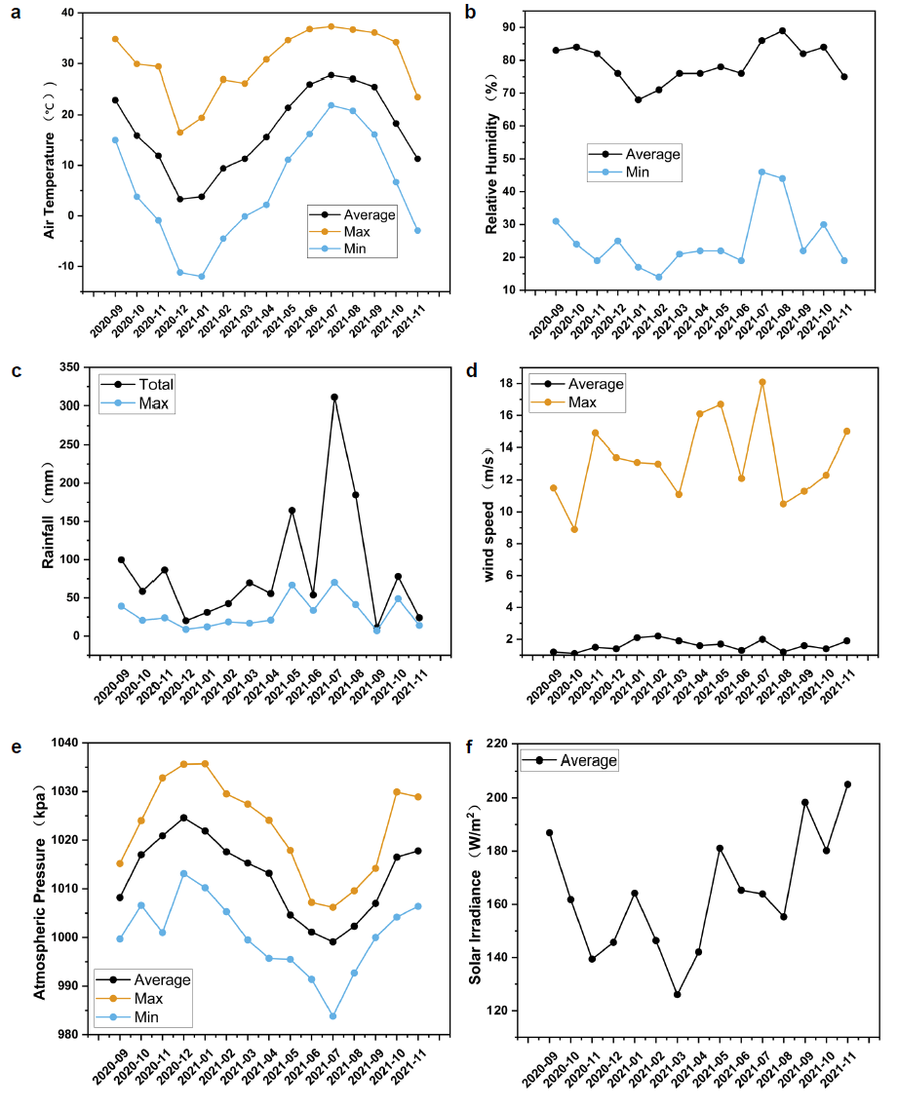
Fig. A1. Meteorological data for the study area: a Air Temperature; b Relative Humidity; c Rainfall; d Wind Speed; e Atmospheric Pressure; f Solar Irradiance

Fig. A2. Heat map showing the change in root factors. The coefficient of variation (CV) indicated the sensitivity of root factors.
Fig. A3. Root Structures in Cunninghamia lanceolata plantations: a Measured root structures;b Relationship between Measured root structures and root decomposition rate; c Modeled root structures; d Relationship between Modeled root structures and root decomposition rate; e Connectivity of root; f Relationship between connectivity of root and root decomposition rate; (Note: upper case letters indicate significant differences between different soil layers (p <= 0.05))

Fig. A4. Root Structures in Pinus taedaL plantations: a Measured root structures; b Relationship between Measured root structures and root decomposition rate; c Modeled root structures; d Relationship between Modeled root structures and root decomposition rate; e Connectivity of root; f Relationship between connectivity of root and root decomposition rate; (Note: upper case letters indicate significant differences between different soil layers (p <= 0.05))

