Supplementary material
Supplemental material for:
Understanding heterogeneity and building capacity for research in long-term care and geriatric settings: a systematic qualitative review and conceptual mapping framework using mixed methods

Contents
Supplementary methods 3
Search databases 3
Search queries 4
Medline [OVID] 4
Embase [OVID] 5
EBM Reviews [OVID] 6
PsycInfo [OVID] 6
CINAHL COMPLETE [EBSCO] 8
PubMed 11
Google Scholar 12
Worldcat 13
Networked Digital Library of Theses and Dissertation (NDLT) 14
Health Systems Evidence 14
National institute for Health and Care Excellence (NICE) 14
University of York (CRD) | Centre for Reviews and Dissemination 15
Prospero 15
Organisation for Economic Co-operation and Development (OECD) 15
World Health organization (WHO) 15
Current Gerontology and Geriatrics Research retrieved from Directory of Open Access Journals (DOAJ) 15
Google 16
Supplementary Tables 17
Supplementary Figures 28

Supplementary methods

Search databases
The following electronic databases were searched:
- MEDLINE (Ovid)
- EMBASE (Ovid)
- CINAHL (EBSCOhost)
- PsycINFO (Ovid)
- EBM Reviews - Cochrane Database of Systematic Reviews 2005 to September 29, 2021, Database Field Guide
- ACP Journal Club 1991 to August 2021
- Database of Abstracts of Reviews of Effects 1st Quarter 2016
- Cochrane Clinical Answers September 2021
- Cochrane Central Register of Controlled Trials August 2021
- Cochrane Methodology Register 3rd Quarter 2012
- Health Technology Assessment 4th Quarter 2016
- NHS Economic Evaluation Database 1st Quarter 2016. Pubmed was searched from September 20, 2021, to September 27, 2021
- Theses on WorldCat (https://www.worldcat.org/) and Networked Digital Library of Theses and Dissertation (http://search.ndltd.org/)
- Health Systems Evidence (http://www.healthsystemsevidence.org)
- National Institute for Health and Care Excellence (http://www.evidence.nhs.uk/)
- Centre for Reviews and Dissemination (https://www.crd.york.ac.uk/CRDWeb/)
- Prospero (https://www.crd.york.ac.uk/prospero/)
- Organisation for Economic Co-operation and Development (https://data.oecd.org/)
- World Health Organization (https://www.who.int/home/search)
- Directory of Open Access Journals (https://www.doaj.org/), specifically Current Gerontology and Geriatrics Research (https://www.hindawi.com/journals/cggr/)
- Google Scholar with the first 20 results screened.
The Medline strategy was peer reviewed by another senior information specialist prior to execution using the PRESS Checklist (3). Duplicates were removed in EndNote using the method reported by W. Bramer (4).

Search queries

Medline [OVID]
Ovid MEDLINE(R) and Epub Ahead of Print, In-Process, In-Data-Review & Other Non-Indexed Citations, Daily and Versions(R)

# | Searches | Results
1 | exp Geriatrics/ | 30706
2 | exp Geriatric nursing/ | 13756
3 | exp Health Services for the Aged/ | 18071
4 | exp Long-Term Care/ | 27020
5 | exp Nursing Homes/ | 41738
6 | residential facilities/ or homes for the aged/ | 19916
7 | exp Skilled Nursing Facilities/ | 4785
8 | ((long term care or chronic care or residential or nursing or old or older or aged or elder* or senior* or assisted living) adj2 (facilit* or home* or residence* or center* or centre* or hospital*)).tw,kf. | 72852
9 | ((health service* or department* or unit* or ward*) adj2 (elder* or old or older or aged or senior* or long term care or chronic care)).tw,kf. | 3471
10 | (centre* hospitalier* de soin* de longue duree or CHSLD or heberg*).tw,kf. | 38
11 | (Aged/ or frail elderly/) and (Hospitals/ or hospitalization/) | 57440
12 | ((acute or short) adj2 care adj2 (elder* or old or older or aged or senior*)).tw,kf. | 331
13 | (((unite or soins) adj2 courte duree) and (geriatri* or aine*)).tw,kf. | 2
14 | (geriatric* or gerontolo*).tw,kf. | 75652
15 | or/1-14 | 256537
16 | research*.ti,kf. | 363827
17 | 15 and 16 | 5527
18 | (barrier* or obstacle* or challenge* or issue* or difficult* or problem* or constraint* or hindrance* or negative* or drawback* or liabilit* or inconvenience* or block* or prevent* or hinder* or limit*).tw,kf. | 7577302
19 | ((patient* or subject* or volunteer* or geriatric* or old or older or elder* or senior* or aged) adj2 (recruit* or select* or attrition or dropout or drop out or participat*)).tw,kf. | 238670
20 | 18 or 19 | 7728294
21 | 17 and 20 | 2348
22 | (Facilitat* or enabl* or favor* or simplif* or encourag* or stimulat* or promot* or "giv* rise to" or "gav* rise to" or "result* in" or initiat* or "bring forth*" or "brought forth" or benefit* or boost* or increase* or spur* or inspir* or propel* or increas* or augment* or fuel* or incit* or motivat* *).tw,kf. | 10488845
23 | 17 and 22 | 2229
24 | (Solution* or strateg* or answer* or resolv* or solv* or fix* or correct* or address* or remediat*).tw,kf. | 4013798
25 | 17 and 24 | 1150
26 | 21 or 23 or 25 | 3414
27 | (exp child/ or exp infant/ or adolescent/) not exp adult/ | 1978939
28 | (newborn* or new-born* or neonat* or neo-nat* or infan* or child* or adolesc* or paediatr* or pediatr* or baby* or babies* or toddler* or kid or kids or boy* or girl* or juvenile* or teen* or youth* or pubescen* or preadolesc* or prepubesc* or preteen or tween).ti. | 1598847
29 | (pediatr* or paediatr*).jw. | 600247
30 | 27 or 28 or 29 | 2594195
31 | 26 not 30 | 3336

Embase [OVID]
# | Searches | Results
1 | Geriatrics/ or geriatric ward/ | 31656
2 | Geriatric nursing/ | 12284
3 | elderly care/ | 41284
4 | home for the aged/ | 11255
5 | long term care/ | 134820
6 | nursing home/ | 55651
7 | Residential home/ | 7400
8 | ((long term care or chronic care or residential or nursing or old or older or aged or elder* or senior* or assisted living) adj2 (facilit* or home* or residence* or center* or centre* or hospital* or institution*)).tw,kw. | 99372
9 | ((health service* or department* or unit* or ward*) adj2 (elder* or old or older or aged or senior* or long term care or chronic care)).tw,kw. | 5422
10 | (centre* hospitalier* de soin* de longue duree or CHSLD or heberg*).tw,kw. | 16
11 | (Aged/ or frail elderly/) and (Hospitals/ or hospitalization/) | 119476
12 | ((acute or short) adj2 care adj2 (elder* or old or older or aged or senior*)).tw,kw. | 521
13 | (((unite or soins) adj2 courte duree) and (geriatri* or aine*)).tw,kw. | 0
14 | (geriatric* or gerontolo*).tw,kw. | 97080
15 | or/1-14 | 483913
16 | research*.ti,kw. | 309675
17 | 15 and 16 | 5029
18 | (barrier* or obstacle* or challenge* or issue* or difficult* or problem* or constraint* or hindrance* or negative* or drawback* or liabilit* or inconvenience* or block* or prevent* or hinder* or limit*).tw,kw. | 9635419
19 | ((patient* or subject* or volunteer* or geriatric* or old or older or elder* or senior* or aged) adj2 (recruit* or select* or attrition or dropout or drop out or participat*)).tw,kw. | 381942
20 | 18 or 19 | 9868760
21 | 17 and 20 | 2262
22 | (Facilitat* or enabl* or favor* or simplif* or encourag* or stimulat* or promot* or "giv* rise to" or "gav* rise to" or "result* in" or initiat* or "bring forth*" or "brought forth" or benefit* or boost* or increase* or spur* or inspir* or propel* or increas* or augment* or fuel* or incit* or motivat* *).tw,kw. | 13239713
23 | 17 and 22 | 2071
24 | (Solution* or strateg* or answer* or resolv* or solv* or fix* or correct* or address* or remediat*).tw,kw. | 4944811
25 | 17 and 24 | 1152
26 | 21 or 23 or 25 | 3253
27 | (exp child/ or exp adolescent/) not exp adult/ | 2270766
28 | (newborn* or new-born* or neonat* or neo-nat* or infan* or child* or adolesc* or paediatr* or pediatr* or baby* or babies* or toddler* or kid or kids or boy* or girl* or juvenile* or teen* or youth* or pubescen* or preadolesc* or prepubesc* or preteen or tween).ti. | 1847999
29 | (pediatr* or paediatr*).jx. | 714974
30 | 27 or 28 or 29 | 2998060
31 | 26 not 30 | 3146
32 | limit 31 to embase | 1711

EBM Reviews [OVID]
All EBM Reviews - Cochrane DSR, ACP Journal Club, DARE, CCA, CCTR, CMR, HTA, and NHSEED

# | Searches | Results
1 | (Geriatric* or Gerontolo* or Home for the aged or Long term care or Nursing home* or Health Services for the Aged or Institutionalization).ti,hw. | 17404
2 | ((chronic care or old or older or aged or elder* or senior* or nursing or residential or assisted living or skilled nursing) adj2 (facilit* or home* or residence* or center* or centre* or hospital* or institution*)).ti,hw. | 7483
3 | ((health service* or department* or unit* or ward*) adj2 (elder* or old or older or aged or geriatric* or senior* or long term care or chronic care)).ti,hw. | 1177
4 | (centre* hospitalier* de soin* de longue duree or CHSLD or heberg*).ti,hw. | 0
5 | ((acute or short) adj2 care adj2 (elder* or old or older or aged or geriatric* or senior*)).ti,hw. | 84
6 | or/1-5 | 21011
7 | research*.ti,hw. | 52934
8 | 6 and 7 | 1514
9 | (barrier* or obstacle* or challenge* or issue* or difficult* or problem* or constraint* or hindrance* or negative* or drawback* or liabilit* or inconvenience* or block* or prevent* or hinder* or limit*).ti,hw. | 194450
10 | ((patient* or subject* or volunteer* or geriatric* or old or older or elder* or senior* or aged) adj2 (recruit* or select* or attrition or dropout or drop out or participat*)).ti,hw. | 12187
11 | 9 or 10 | 204822
12 | 8 and 11 | 342
13 | (Facilitat* or enabl* or favor* or simplif* or encourag* or stimulat* or promot* or "giv* rise to" or "gav* rise to" or "result* in" or initiat* or "bring forth*" or "brought forth" or benefit* or boost* or increase* or spur* or inspir* or propel* or increas* or augment* or fuel* or incit* or motivat* *).ti,hw. | 227997
14 | 8 and 13 | 319
15 | (Solution* or strateg* or answer* or resolv* or solv* or fix* or correct* or address* or remediat*).ti,hw. | 56533
16 | 8 and 15 | 55
17 | 12 or 14 or 16 | 590
18 | remove duplicates from 17 | 586

PsycInfo [OVID]
# | Searches | Results
1 | exp Geriatrics/ | 14375
2 | exp Geriatric Patients/ | 13785
3 | exp gerontology/ | 9857
4 | exp Elder Care/ | 5263
5 | exp long term care/ | 5658
6 | exp nursing homes/ | 9362
7 | exp nursing home residents/ | 2649
8 | exp institutionalization/ or exp Residential Care Institutions/ | 76715
9 | ((long term care or chronic care or residential or nursing or old or older or aged or elder* or senior* or assisted living) adj2 (facilit* or home* or residence* or center* or centre* or hospital*)).tw,hw. | 30584
10 | ((health service* or department* or unit* or ward*) adj2 (elder* or old or older or aged or senior* or long term care or chronic care)).tw,hw. | 1397
11 | (centre* hospitalier* de soin* de longue duree or CHSLD or heberg*).tw,hw. | 19
12 | (Hospitals/ or Hospitalized Patients/ or Hospitalization/) and (Aging/ or Older Adulthood/) | 615
13 | ((acute or short) adj2 care adj2 (elder* or old or older or aged or senior*)).tw,hw. | 117
14 | (((unite or soins) adj2 courte duree) and (geriatri* or aine*)).tw,hw. | 1
15 | (geriatric* or gerontolo*).tw,hw. | 46492
16 | or/1-15 | 137149
17 | research*.ti,hw. | 117443
18 | 16 and 17 | 2549
19 | (barrier* or obstacle* or challenge* or issue* or difficult* or problem* or constraint* or hindrance* or negative* or drawback* or liabilit* or inconvenience* or block* or prevent* or hinder* or limit*).tw,hw. | 2020686
20 | ((patient* or subject* or volunteer* or geriatric* or old or older or elder* or senior* or aged) adj2 (recruit* or select* or attrition or dropout or drop out or participat*)).tw,hw. | 33810
21 | 19 or 20 | 2039529
22 | 18 and 21 | 1514
23 | (Facilitat* or enabl* or favor* or simplif* or encourag* or stimulat* or promot* or "giv* rise to" or "gav* rise to" or "result* in" or initiat* or "bring forth*" or "brought forth" or benefit* or boost* or increase* or spur* or inspir* or propel* or increas* or augment* or fuel* or incit* or motivat* *).tw,hw. | 1808846
24 | 18 and 23 | 1083
25 | (Solution* or strateg* or answer* or resolv* or solv* or fix* or correct* or address* or remediat*).tw,hw. | 1049542
26 | 18 and 25 | 770
27 | 22 or 24 or 26 | 2027
28 | (newborn* or new-born* or neonat* or neo-nat* or infan* or child* or adolesc* or paediatr* or pediatr* or baby* or babies* or toddler* or kid or kids or boy* or girl* or juvenile* or teen* or youth* or pubescen* or preadolesc* or prepubesc* or preteen or tween).ti. | 594442
29 | (pediatr* or paediatr*).jn. | 4118
30 | 28 or 29 | 595595
31 | 27 not 30 | 1886

CINAHL COMPLETE [EBSCO]
Question | Opérateurs de restriction/Opérateurs d'expansion | Opérateurs de restriction/Opérateurs d'expansion | Dernière exécution par | Résultats
S1 | (MH "Long Term Care") | Opérateurs d'expansion - Appliquer des sujets équivalents  Modes de recherche - Booléen/Phrase | Interface - EBSCOhost Research Databases  Ecran de recherche - Recherche avancée  Base de données - CINAHL | 26,785
S2 | (MH "Nursing Homes") | Opérateurs d'expansion - Appliquer des sujets équivalents  Modes de recherche - Booléen/Phrase | Interface - EBSCOhost Research Databases  Ecran de recherche - Recherche avancée  Base de données - CINAHL | 24,472
S3 | (MH "Gerontologic Care") | Opérateurs d'expansion - Appliquer des sujets équivalents  Modes de recherche - Booléen/Phrase | Interface - EBSCOhost Research Databases  Ecran de recherche - Recherche avancée  Base de données - CINAHL | 24,401
S4 | (MH "Skilled Nursing Facilities") | Opérateurs d'expansion - Appliquer des sujets équivalents  Modes de recherche - Booléen/Phrase | Interface - EBSCOhost Research Databases  Ecran de recherche - Recherche avancée  Base de données - CINAHL | 4,493
S5 | (MH "Nursing Home Patients") | Opérateurs d'expansion - Appliquer des sujets équivalents  Modes de recherche - Booléen/Phrase | Interface - EBSCOhost Research Databases  Ecran de recherche - Recherche avancée  Base de données - CINAHL | 14,505
S6 | (MH "Health Services for the Aged") | Opérateurs d'expansion - Appliquer des sujets équivalents  Modes de recherche - Booléen/Phrase | Interface - EBSCOhost Research Databases  Ecran de recherche - Recherche avancée  Base de données - CINAHL | 6,830
S7 | (MH "Gerontologic Nursing") | Opérateurs d'expansion - Appliquer des sujets équivalents  Modes de recherche - Booléen/Phrase | Interface - EBSCOhost Research Databases  Ecran de recherche - Recherche avancée  Base de données - CINAHL | 13,384
S8 | (MH "Geriatrics") | Opérateurs d'expansion - Appliquer des sujets équivalents  Modes de recherche - Booléen/Phrase | Interface - EBSCOhost Research Databases  Ecran de recherche - Recherche avancée  Base de données - CINAHL | 5,696
S9 | TI ( ((long term care or chronic care or residential or nursing or old or older or aged or elder* or senior* or assisted living) N2 (facilit* or home* or residence* or center* or centre* or hospital*)) ) OR AB ( ((long term care or chronic care or residential or nursing or old or older or aged or elder* or senior* or assisted living) N2 (facilit* or home* or residence* or center* or centre* or hospital* or institution*)) ) | Opérateurs d'expansion - Appliquer des sujets équivalents  Modes de recherche - Booléen/Phrase | Interface - EBSCOhost Research Databases  Ecran de recherche - Recherche avancée  Base de données - CINAHL | 63,134
S10 | TI ( ((health service* or department* or unit* or ward*) N2 (elder* or old or older or aged or senior* or long term care or chronic care)) ) OR AB ( ((health service* or department* or unit* or ward*) N2 (elder* or old or older or aged or senior* or long term care or chronic care)) ) | Opérateurs d'expansion - Appliquer des sujets équivalents  Modes de recherche - Booléen/Phrase | Interface - EBSCOhost Research Databases  Ecran de recherche - Recherche avancée  Base de données - CINAHL | 4,287
S11 | TI ( (centre* hospitalier* de soin* de longue duree or CHSLD or heberg*) ) OR AB ( (centre* hospitalier* de soin* de longue duree or CHSLD or heberg*) ) | Opérateurs d'expansion - Appliquer des sujets équivalents  Modes de recherche - Booléen/Phrase | Interface - EBSCOhost Research Databases  Ecran de recherche - Recherche avancée  Base de données - CINAHL | 54
S12 | (MH "Aged, Hospitalized") | Opérateurs d'expansion - Appliquer des sujets équivalents  Modes de recherche - Booléen/Phrase | Interface - EBSCOhost Research Databases  Ecran de recherche - Recherche avancée  Base de données - CINAHL | 3,900
S13 | TI ( ((acute or short) N2 care N2 (elder* or old or older or aged or senior*)) ) OR AB ( ((acute or short) N2 care N2(elder* or old or older or aged or senior*)) ) | Opérateurs d'expansion - Appliquer des sujets équivalents  Modes de recherche - Booléen/Phrase | Interface - EBSCOhost Research Databases  Ecran de recherche - Recherche avancée  Base de données - CINAHL | 656
S14 | TI ( (((unite or soins) N2 courte duree) and (geriatri* or aine*)) ) OR AB ( (((unite or soins) N2 courte duree) and (geriatri* or aine*)) ) | Opérateurs d'expansion - Appliquer des sujets équivalents  Modes de recherche - Booléen/Phrase | Interface - EBSCOhost Research Databases  Ecran de recherche - Recherche avancée  Base de données - CINAHL | 1
S15 | TI ( (geriatric* or gerontolo*) ) OR AB ( (geriatric* or gerontolo*) ) | Opérateurs d'expansion - Appliquer des sujets équivalents  Modes de recherche - Booléen/Phrase | Interface - EBSCOhost Research Databases  Ecran de recherche - Recherche avancée  Base de données - CINAHL | 31,125
S16 | TI research* | Opérateurs d'expansion - Appliquer des sujets équivalents  Modes de recherche - Booléen/Phrase | Interface - EBSCOhost Research Databases  Ecran de recherche - Recherche avancée  Base de données - CINAHL | 138,384
S17 | TI ( (barrier* or obstacle* or challenge* or issue* or difficult* or problem* or constraint* or hindrance* or negative* or drawback* or liabilit* or inconvenience* or block* or prevent* or hinder* or limit*) ) OR AB ( (barrier* or obstacle* or challenge* or issue* or difficult* or problem* or constraint* or hindrance* or negative* or drawback* or liabilit* or inconvenience* or block* or prevent* or hinder* or limit*) ) | Opérateurs d'expansion - Appliquer des sujets équivalents  Modes de recherche - Booléen/Phrase | Interface - EBSCOhost Research Databases  Ecran de recherche - Recherche avancée  Base de données - CINAHL | 1,690,366
S18 | TI ( ((patient* or subject* or volunteer* or geriatric* or old or older or elder* or senior* or aged) N2 (recruit* or select* or attrition or dropout or drop out or participat*)) ) OR AB ( ((patient* or subject* or volunteer* or geriatric* or old or older or elder* or senior* or aged) N2 (recruit* or select* or attrition or dropout or drop out or participat*)) ) | Opérateurs d'expansion - Appliquer des sujets équivalents  Modes de recherche - Booléen/Phrase | Interface - EBSCOhost Research Databases  Ecran de recherche - Recherche avancée  Base de données - CINAHL | 85,398
S19 | S17 OR S18 | Opérateurs d'expansion - Appliquer des sujets équivalents  Modes de recherche - Booléen/Phrase | Interface - EBSCOhost Research Databases  Ecran de recherche - Recherche avancée  Base de données - CINAHL | 1,741,559
S20 | TI ( (Facilitat* or enabl* or favor* or simplif* or encourag* or stimulat* or promot* or "giv* rise to" or "gav* rise to" or "result* in" or initiat* or "bring forth*" or "brought forth" or benefit* or boost* or increase* or spur* or inspir* or propel* or increas* or augment* or fuel* or incit* or motivat* *) ) OR AB ( (Facilitat* or enabl* or favor* or simplif* or encourag* or stimulat* or promot* or "giv* rise to" or "gav* rise to" or "result* in" or initiat* or "bring forth*" or "brought forth" or benefit* or boost* or increase* or spur* or inspir* or propel* or increas* or augment* or fuel* or incit* or motivat* *) ) | Opérateurs d'expansion - Appliquer des sujets équivalents  Modes de recherche - Booléen/Phrase | Interface - EBSCOhost Research Databases  Ecran de recherche - Recherche avancée  Base de données - CINAHL | 2,569,285
S21 | TI ( (Solution* or strateg* or answer* or resolv* or solv* or fix* or correct* or address* or remediat*) ) OR AB ( (Solution* or strateg* or answer* or resolv* or solv* or fix* or correct* or address* or remediat*) ) | Opérateurs d'expansion - Appliquer des sujets équivalents  Modes de recherche - Booléen/Phrase | Interface - EBSCOhost Research Databases  Ecran de recherche - Recherche avancée  Base de données - CINAHL | 816,819
S22 | S1 OR S2 OR S3 OR S4 OR S5 OR S6 OR S7 OR S8 OR S9 OR S10 OR S11 OR S12 OR S13 OR S14 OR S15 | Opérateurs d'expansion - Appliquer des sujets équivalents  Modes de recherche - Booléen/Phrase | Interface - EBSCOhost Research Databases  Ecran de recherche - Recherche avancée  Base de données - CINAHL | 152,716
S23 | S16 AND S22 | Opérateurs d'expansion - Appliquer des sujets équivalents  Modes de recherche - Booléen/Phrase | Interface - EBSCOhost Research Databases  Ecran de recherche - Recherche avancée  Base de données - CINAHL | 3,117
S24 | S19 AND S23 | Opérateurs d'expansion - Appliquer des sujets équivalents  Modes de recherche - Booléen/Phrase | Interface - EBSCOhost Research Databases  Ecran de recherche - Recherche avancée  Base de données - CINAHL | 1,157
S25 | S20 AND S23 | Opérateurs d'expansion - Appliquer des sujets équivalents  Modes de recherche - Booléen/Phrase | Interface - EBSCOhost Research Databases  Ecran de recherche - Recherche avancée  Base de données - CINAHL | 1,203
S26 | S21 AND S23 | Opérateurs d'expansion - Appliquer des sujets équivalents  Modes de recherche - Booléen/Phrase | Interface - EBSCOhost Research Databases  Ecran de recherche - Recherche avancée  Base de données - CINAHL | 591
S27 | (S24 OR S25 OR S26) | Opérateurs d'expansion - Appliquer des sujets équivalents  Modes de recherche - Booléen/Phrase | Interface - EBSCOhost Research Databases  Ecran de recherche - Recherche avancée  Base de données - CINAHL | 1,752

PubMed
Search
((((((((Geriatric*[ti] OR Geriatric*[mh]) OR (Gerontolo*[ti] OR Gerontolo*[mh]) OR ("Home for the aged"[ti] OR "Home for the aged"[mh]) OR ("Long term care"[ti] OR "Long term care"[mh]) OR (Nursing home*[ti] OR Nursing home*[mh]) OR ("Health Services for the Aged"[ti] OR "Health Services for the Aged"[mh]) OR ("Institutionalization"[ti] OR "Institutionalization"[mh]))) OR ((((health service*[ti] OR health service*[mh]) OR (department*[ti] OR department*[mh]) OR (unit*[ti] OR unit*[mh]) OR (ward*[ti] OR ward*[mh])) AND ((elder*[ti] OR elder*[mh]) OR ("old"[ti] OR "old"[mh]) OR ("older"[ti] OR "older"[mh]) OR ("aged"[ti] OR "aged"[mh]) OR (geriatric*[ti] OR geriatric*[mh]) OR (senior*[ti] OR senior*[mh]) OR ("long term care"[ti] OR "long term care"[mh]) OR ("chronic care"[ti] OR "chronic care"[mh]))))) OR (((centre* hospitalier* de soin* de longue duree[ti] OR centre* hospitalier* de soin* de longue duree[mh]) OR ("CHSLD"[ti] OR "CHSLD"[mh]) OR (heberg*[ti] OR heberg*[mh])))) OR (((("acute"[ti] OR "acute"[mh]) OR ("short"[ti] OR "short"[mh])) AND ("care"[ti] OR "care"[mh]) AND ((elder*[ti] OR elder*[mh]) OR ("old"[ti] OR "old"[mh]) OR ("older"[ti] OR "older"[mh]) OR ("aged"[ti] OR "aged"[mh]) OR (geriatric*[ti] OR geriatric*[mh]) OR (senior*[ti] OR senior*[mh]))))) OR (((("chronic care"[ti] OR "chronic care"[mh]) OR ("old"[ti] OR "old"[mh]) OR ("older"[ti] OR "older"[mh]) OR ("aged"[ti] OR "aged"[mh]) OR (elder*[ti] OR elder*[mh]) OR (senior*[ti] OR senior*[mh]) OR ("nursing"[ti] OR "nursing"[mh]) OR ("residential"[ti] OR "residential"[mh]) OR ("assisted living"[ti] OR "assisted living"[mh]) OR ("skilled nursing"[ti] OR "skilled nursing"[mh])) AND ((facilit*[ti] OR facilit*[mh]) OR (home*[ti] OR home*[mh]) OR (residence*[ti] OR residence*[mh]) OR (center*[ti] OR center*[mh]) OR (centre*[ti] OR centre*[mh]) OR (hospital*[ti] OR hospital*[mh]) OR (institution*[ti] OR institution*[mh]))))) AND ((research*[ti] OR research*[mh]))) AND ((Facilitat*[ti] OR enabl*[ti] OR favor*[ti] OR simplif*[ti] OR encourag*[ti] OR stimulat*[ti] OR promot*[ti] OR giv* rise to[ti] OR gav* rise to[ti] OR result* in[ti] OR initiat*[ti] OR bring forth*[ti] OR "brought forth"[ti] OR benefit*[ti] OR boost*[ti] OR increase*[ti] OR spur*[ti] OR inspir*[ti] OR propel*[ti] OR increas*[ti] OR augment*[ti] OR fuel*[ti] OR incit*[ti] OR motivat* *[ti])) AND (2021/09/20:3000/12/31[Date - Create]) OR | 0
((((((((Geriatric*[ti] OR Geriatric*[mh]) OR (Gerontolo*[ti] OR Gerontolo*[mh]) OR ("Home for the aged"[ti] OR "Home for the aged"[mh]) OR ("Long term care"[ti] OR "Long term care"[mh]) OR (Nursing home*[ti] OR Nursing home*[mh]) OR ("Health Services for the Aged"[ti] OR "Health Services for the Aged"[mh]) OR ("Institutionalization"[ti] OR "Institutionalization"[mh]))) OR ((((health service*[ti] OR health service*[mh]) OR (department*[ti] OR department*[mh]) OR (unit*[ti] OR unit*[mh]) OR (ward*[ti] OR ward*[mh])) AND ((elder*[ti] OR elder*[mh]) OR ("old"[ti] OR "old"[mh]) OR ("older"[ti] OR "older"[mh]) OR ("aged"[ti] OR "aged"[mh]) OR (geriatric*[ti] OR geriatric*[mh]) OR (senior*[ti] OR senior*[mh]) OR ("long term care"[ti] OR "long term care"[mh]) OR ("chronic care"[ti] OR "chronic care"[mh]))))) OR (((centre* hospitalier* de soin* de longue duree[ti] OR centre* hospitalier* de soin* de longue duree[mh]) OR ("CHSLD"[ti] OR "CHSLD"[mh]) OR (heberg*[ti] OR heberg*[mh])))) OR (((("acute"[ti] OR "acute"[mh]) OR ("short"[ti] OR "short"[mh])) AND ("care"[ti] OR "care"[mh]) AND ((elder*[ti] OR elder*[mh]) OR ("old"[ti] OR "old"[mh]) OR ("older"[ti] OR "older"[mh]) OR ("aged"[ti] OR "aged"[mh]) OR (geriatric*[ti] OR geriatric*[mh]) OR (senior*[ti] OR senior*[mh]))))) OR (((("chronic care"[ti] OR "chronic care"[mh]) OR ("old"[ti] OR "old"[mh]) OR ("older"[ti] OR "older"[mh]) OR ("aged"[ti] OR "aged"[mh]) OR (elder*[ti] OR elder*[mh]) OR (senior*[ti] OR senior*[mh]) OR ("nursing"[ti] OR "nursing"[mh]) OR ("residential"[ti] OR "residential"[mh]) OR ("assisted living"[ti] OR "assisted living"[mh]) OR ("skilled nursing"[ti] OR "skilled nursing"[mh])) AND ((facilit*[ti] OR facilit*[mh]) OR (home*[ti] OR home*[mh]) OR (residence*[ti] OR residence*[mh]) OR (center*[ti] OR center*[mh]) OR (centre*[ti] OR centre*[mh]) OR (hospital*[ti] OR hospital*[mh]) OR (institution*[ti] OR institution*[mh]))))) AND ((research*[ti] OR research*[mh]))) AND (((barrier*[ti] OR obstacle*[ti] OR challenge*[ti] OR issue*[ti] OR difficult*[ti] OR problem*[ti] OR constraint*[ti] OR hindrance*[ti] OR negative*[ti] OR drawback*[ti] OR liabilit*[ti] OR inconvenience*[ti] OR block*[ti] OR prevent*[ti] OR hinder*[ti] OR limit*[ti])) OR (((patient*[ti] OR subject*[ti] OR volunteer*[ti] OR geriatric*[ti] OR "old"[ti] OR "older"[ti] OR elder*[ti] OR senior*[ti] OR "aged"[ti]) AND (recruit*[ti] OR select*[ti] OR "attrition"[ti] OR "dropout"[ti] OR "drop out"[ti] OR participat*[ti])))) AND (2021/09/20:3000/12/31[Date - Create]) OR | 1
((((((((Geriatric*[ti] OR Geriatric*[mh]) OR (Gerontolo*[ti] OR Gerontolo*[mh]) OR ("Home for the aged"[ti] OR "Home for the aged"[mh]) OR ("Long term care"[ti] OR "Long term care"[mh]) OR (Nursing home*[ti] OR Nursing home*[mh]) OR ("Health Services for the Aged"[ti] OR "Health Services for the Aged"[mh]) OR ("Institutionalization"[ti] OR "Institutionalization"[mh]))) OR ((((health service*[ti] OR health service*[mh]) OR (department*[ti] OR department*[mh]) OR (unit*[ti] OR unit*[mh]) OR (ward*[ti] OR ward*[mh])) AND ((elder*[ti] OR elder*[mh]) OR ("old"[ti] OR "old"[mh]) OR ("older"[ti] OR "older"[mh]) OR ("aged"[ti] OR "aged"[mh]) OR (geriatric*[ti] OR geriatric*[mh]) OR (senior*[ti] OR senior*[mh]) OR ("long term care"[ti] OR "long term care"[mh]) OR ("chronic care"[ti] OR "chronic care"[mh]))))) OR (((centre* hospitalier* de soin* de longue duree[ti] OR centre* hospitalier* de soin* de longue duree[mh]) OR ("CHSLD"[ti] OR "CHSLD"[mh]) OR (heberg*[ti] OR heberg*[mh])))) OR (((("acute"[ti] OR "acute"[mh]) OR ("short"[ti] OR "short"[mh])) AND ("care"[ti] OR "care"[mh]) AND ((elder*[ti] OR elder*[mh]) OR ("old"[ti] OR "old"[mh]) OR ("older"[ti] OR "older"[mh]) OR ("aged"[ti] OR "aged"[mh]) OR (geriatric*[ti] OR geriatric*[mh]) OR (senior*[ti] OR senior*[mh]))))) OR (((("chronic care"[ti] OR "chronic care"[mh]) OR ("old"[ti] OR "old"[mh]) OR ("older"[ti] OR "older"[mh]) OR ("aged"[ti] OR "aged"[mh]) OR (elder*[ti] OR elder*[mh]) OR (senior*[ti] OR senior*[mh]) OR ("nursing"[ti] OR "nursing"[mh]) OR ("residential"[ti] OR "residential"[mh]) OR ("assisted living"[ti] OR "assisted living"[mh]) OR ("skilled nursing"[ti] OR "skilled nursing"[mh])) AND ((facilit*[ti] OR facilit*[mh]) OR (home*[ti] OR home*[mh]) OR (residence*[ti] OR residence*[mh]) OR (center*[ti] OR center*[mh]) OR (centre*[ti] OR centre*[mh]) OR (hospital*[ti] OR hospital*[mh]) OR (institution*[ti] OR institution*[mh]))))) AND ((research*[ti] OR research*[mh]))) AND ((Solution*[ti] OR strateg*[ti] OR answer*[ti] OR resolv*[ti] OR solv*[ti] OR fix*[ti] OR correct*[ti] OR address*[ti] OR remediat*[ti])) AND (2021/09/20:3000/12/31[Date - Create]) | 1

Google Scholar
Search | Results
Geriatric* OR Gerontolo* OR Home for the aged OR Long term care OR Nursing home*) AND research | 0 selected articles within the first 20 results
(centre* hospitalier* de soin* de longue duree or CHSLD or heberg*) AND Recherche | 0 selected articles within the first 20 results
(((acute or short) AROUND 2 care AROUND 2 (elder* or old or older or aged or geriatric* or senior*))) AND research | 0 selected articles within the first 20 results
(UCDG OR (unité de courte durée gériatrique)) AND recherche | 0 selected articles within the first 20 results

Worldcat
Search | Results
Kw: (Geriatric* OR Gerontolo* OR Home for the aged OR Long term care or Nursing home*) AND research*  Ti: (Geriatric* OR Gerontolo* OR Home for the aged OR Long term care or Nursing home*) AND research  Format: Article (117) | 1 selected article within 117 results

Networked Digital Library of Theses and Dissertation (NDLT)
http://search.ndltd.org/

Search | Results
(geriatric* OR gerontology* ) AND research  Tagged with:  - Gerontology  - Health  - Studies  - Older  - Aging  - Sciences  - Research  - English or French | 1 selected article within 518 results
CHSLD AND Recherche  Tagged with:  - French | 0 selected article within 29 results
centre hospitalier de soins de longue durée AND recherche  Tagged with:  - Sciences  - Santé  - Health  - French | 0 selected article within 347 results
UCDG AND Recherche  Tagged with:  - French | 0 selected articles out of 1 result
unité de courte durée gériatrique AND recherche  Tagged with:  - French | 0 selected articles within 45 results
“Long term care” AND research | 0 selected article of 186 results

Health Systems Evidence
http://www.healthsystemsevidence.org

Search | Results
(Geriatric OR geronto*) AND research | 0 selected articles within 237
Nursing home* and research | 0 selected articles within first 100 results
Long term care AND research | 0 selected articles within first 100 results

National institute for Health and Care Excellence (NICE)
http://www.evidence.nhs.uk/

Search | Results
Nursing home* research | 0 selected articles within first 100 results
Long term care research | 2 selected articles within first 100 results
Gerontology research | 0 selected articles within first 100 results
Geriatric Research | 2 selected articles within first 100 results

University of York (CRD) | Centre for Reviews and Dissemination
http://www.crd.york.ac.uk/crdweb/SearchPage.asp

Search | Results
Gerontology AND research (any field) | 0 selected articles within 27 results
(geriatric):TI AND (research):TI | 0 results
(nursing home):TI AND (research) | 0 selected articles within 28 results
(long term care):TI AND (research):TI | 0 selected results out of 1 result

Prospero
https://www.crd.york.ac.uk/prospero/

Search | Results
geriatric AND research | 0 selected articles within first 100 results
Gerontology AND research | 0 selected articles within 270 results
Nursing home* AND research | 0 selected articles within first 100 results
Long term care AND research | 0 selected articles within first 100 results

Organisation for Economic Co-operation and Development (OECD)
https://data.oecd.org/

Search | Results
geriatric | 0 results
gerontology | 0 results
Nursing homes | 0 selected articles within first 100 results
Long term care | 0 selected articles within first 100 results

World Health organization (WHO)
https://www.who.int/home/search

Search | Results
Geriatric AND research | 0 results
Gerontology AND research | 0 results
Gerontology AND research | 0 results
long term care AND research | 0 results

Current Gerontology and Geriatrics Research retrieved from Directory of Open Access Journals (DOAJ)
Search | Results
Geriatric AND research | 1 selected article within first 100 results
KW: Gerontology AND research | Same article selected within 203 results
TI: long term care AND research | 0 selected articles within 21 results
TI: nursing home AND research | 0 selected articles within 2 results

Google
Search | Results
geriatric* research | 0 selected articles within first 20 results
gerontology research | 0 selected articles within first 20 results
Nursing home* research | 1 selected articles within first 20 results
Long term care and research | 0 selected articles within first 20 results

Supplementary Tables

Supplementary Table 1. Initial stakeholders and research stages
Initial stakeholders
Researchers based in LTC and GAC
Researchers in general
Research staff
Residents and patients
Caregivers
Staff (professionals)
Staff (others)
Ethics review committees
Managers
Management and regional authorities (e.g., central offices)
Research networks and groups
Funding agencies and institutes
Foundations
Trainees
Initial research stages
Training
Study planning and protocol
Study design and methods
Funding
Ethics approval
Facility or center recruitment
Individual recruitment
Consent
Intervention
Data collection
Outcomes
Analyses
Knowledge transfer
Sustainability

Supplementary Table 2. Articles included in systematic qualitative review and conceptual mapping framework
Author | Year | Title | Jurisdiction | Methodology | Main objective
Ahouah et al. | 2019 | End-users and caregivers’ involvement in health interventional research carried out in geriatric facilities: a systematic review | France | Review | To provide a critical overview of the involvement of caregivers and end-users in interventions in these facilities, based on Rifkin’s analytical framework
Baier et al. | 2021 | Nursing home leaders’ perceptions of a research partnership | USA | Qualitative | To understand nursing home leader’s motivations for participating in a research study and perceptions of the process and value.
Berkman et al. | 2001 | Methodologic issues in conducting research on hospitalized older people | USA | Quantitative | To describe challenges in conducting research with hospitalized geriatric patients.
Davies et al. | 2014 | Enabling research in care homes: an evaluation of a national network of research ready care homes | UK | Mixed | To evaluate the feasibility and early impact of an initiative to increase care home participation in research.
Hickman et al. | 2008 | Administrators' perspectives on ethical issues in long-term care research | USA | Qualitative | To describe the perspectives of LTC administrators regarding the value of research and the ethics of human subject’s protections
Backhouse et al. | 2016 | Older care-home residents as collaborators or advisors in research: a systematic review | UK | Review | To determine how older care-home residents have been involved as PPI members in care-home research.
Black et al. | 2008 | Predictors of providing informed consent or assent for research participation in assisted living residents | USA | Quantitative | To identify factors associated with providing either informed consent or assent for research in individuals at high risk for cognitive impairment.
Bowling et al. | 2019 | The 5Ts: Preliminary development of a framework to support inclusion of older adults in research | USA | Qualitative | To elicit challenges to inclusion of older adults in clinical research and to develop a preliminary framework for communicating these challenges to non-geriatrics-trained researchers.
Brandt et al. | 2006 | Challenges in the design and conduct of a randomized study of two interventions for liquid aspiration | USA | Qualitative | To examine the key issues in the design and implementation of the first multisite, randomized behavioral trial in dysphagia in an aging population.
Bravo et al. | 2010 | Research with decisionally incapacitated older adults: practices of Canadian research ethics boards | Canada | Qualitative | To report the results of a study exploring the practices and perceptions of Canadian REBs regarding such protocols.
Chen et al. | 2018 | Applications of Minimum Data Set in long-term care research | Taiwan | Review | To introduce the development of MDS and related research using MDS, especially the Longitudinal Older Veterans (LOVE) study in Taiwan
Clark et al. | 2011 | A randomized trial of the impact of survey design characteristics on response rates among nursing home providers | USA | Quantitative | To assess ways to maximize the likelihood of obtaining completed questionnaires from both the DoN and the ADMIN using a nationally representative sample of U.S. nursing homes.
Collingridge Moore et al. | 2019 | Research, recruitment and observational data collection in care homes: lessons from the PACE study | Europe | Methods | To describe the challenges encountered in conducting the study in England to inform the design and conduct of future international research in care homes.
Cowdell et al. | 2008 | Engaging older people with dementia in research: myth or possibility | UK | Review | To explore a range of strategies that were used to enable older people with dementia to become actively engaged in research ‘with’ rather than ‘on’ them.
Cusack et al. | 2013 | Challenges and implications for biomedical research and intervention studies in older populations: insights from the ELDERMET Study | Ireland | Review | To outline the challenges and practical difficulties experienced and overcome by the ELDERMET project
Dewing et al. | 2007 | Participatory research a method for process consent with persons who have dementia | UK | Methods | To describe a method for consent that focuses on persons with dementia, traditionally excluded from consent and thus from research.
Ellwood et al. | 2018 | Recruiting care homes to a randomised controlled trial | UK | Quantitative | To describe two methods of recruiting care homes to the trial and draws out learning to inform future studies
Ersek et al. | 2012 | Addressing methodological challenges in implementing the nursing home pain management algorithm randomized controlled trial | USA | Methods | To describe several issues that arose in the design and conduct of a study that compared the effectiveness of pain management algorithms coupled with a comprehensive adoption program versus the effectiveness of education alone in improving evidence-based pain assessment and management practices, decreasing pain and depressive symptoms, and enhancing mobility among NH residents.
Faes et al. | 2007 | Methodological issues in geriatric research | Netherlands | Methods | To discuss issues important for successful recruitment and selection of subjects, the informed consent procedure and selection of appropriate research designs and research instruments in geriatric research.
Frank et al. | 2021 | Participation of persons with dementia and their caregivers in research | USA | Review | To address research participation by persons living with dementia (PLWD) and their care partners in two different ways: as research participants with input on outcomes studied and as engaged research partners
Froggatt et al. | 2021 | Public involvement in research within care homes: benefits and challenges in the APPROACH study | UK | Qualitative | To present one way in which PIR has been integrated into the design and delivery of a multisite research study based in care homes.
Fudge et al. | 2007 | Involving older people in health research | UK | Review | To establish the scope and extent of the involvement of older people in health research over the past 10 years, to identify reported barriers to the involvement of older people in research and to determine the impact of the involvement of older people on research and on participants.
Goodman et al. | 2011 | Culture, consent, costs and care homes: Enabling older people with dementia to participate in research | UK | Qualitative | To describe factors that support and inhibit recruitment and participation of people with dementia living in care homes.
Gustavson et al. | 2019 | Conducting clinical research in post-acute and long-term nursing home care settings: regulatory challenges | USA | Review | To expand upon previous literature that describes challenges to research in NHs1–6 and provide lessons learned when navigating the regulatory aspects of NH research.
Hall et al. | 2009 | Challenges to conducting research with older people living in nursing homes | UK | Qualitative | To highlight some of the methodological challenges we experienced whilst conducting a study of the perceptions of dignity of older people living in nursing homes with a view to describing the lessons learned, responses and strategies developed and recommendations for future research study design and delivery.
Hanson et al. | 2010 | Successful clinical trial research in nursing homes: the Improving Decision-Making Study | USA | Qualitative | To (1) describe the methods used in this randomized trial for effective nursing home and nursing home resident recruitment and retention; and (2) describe research ethics approaches to minimize harms and maximize benefits for this population.
Henwood et al. | 2015 | Achieving ethics approval in residential aged care research: A protective process or barrier | Australia | Review | To discuss ethics approval in residential aged care research: A protective process or barrier
Holden et al. | 2018 | A procedural framework to facilitate hospital-based informed consent for dementia research | USA | Methods | To develop a procedural framework for obtaining informed consent from hospitalized ADRD patients and caregivers to participate in a minimal risk care intervention
Hsu et al. | 2005 | Challenges of doing intervention research with the elderly Taiwanese population: example of a Tai Chi/Movement therapy | Taiwan | Review | To address the challenges of doing intervention research with an elderly population using tai chi as an intervention and to describe the strategies used to manage those challenges.
Hubbard et al. | 2003 | Including older people with dementia in research: challenges and strategies | UK | Review | To examine key challenges and strategies for including older people with dementia in an ethnographic study of quality of life in institutional care settings.
Huybretchts et al. | 2014 | Instrumental variable applications using nursing home prescribing preferences in comparative effectiveness research† | USA | Quantitative | To evaluate the validity of instrumental variable (IV) methods based on nursing home prescribing preference to mitigate such confounding, using psychotropic medications to manage behavioral problems in dementia as a case study.
Ilgili et al. | 2014 | Ethics in geriatric medicine research | Turkey | Review | To evaluate the research process in geriatrics from the ethical point of view.
Jenkins et al. | 2016 | Overcoming challenges of conducting research in nursing homes | UK | Review | To explore the process of carrying out research in nursing homes, identifying barriers and enabling factors, and making recommendations for researchers.
Kapp et al. | 2004 | Protecting human participants in long-term care research: The role of state law and policy | USA | Qualitative | To analyze and interweave recommendations regarding the role of state of law and public policy in protecting older persons who are or may become participants in LTC research projects
Kemper et al. | 2003 | Long-term care research and policy | USA | Qualitative | To provide a framework for understanding how LTC research contributes to policy and identify barriers to funding such investments
Kolanowski et al. | 2013 | The triple challenge of recruiting older adults with dementia and high medical acuity in skilled nursing facilities | USA | Quantitative | To describe strategies, culled from experience, for responding to several recruitment challenges in an ongoing RCT of delirium in persons with dementia.
Kovach et al. | 2015 | Academic research partnerships for long-term care | USA | Review | To offer some perspectives on academic research partnerships for LTC
Lam et al. | 2018 | Challenges of conducting research in long-term care facilities: a systematic review | Canada | Review | To identify relevant studies that report on challenges derived from first-hand experience of empirical research studies
Lingler et al. | 2009 | Informed consent to research in long-term care settings | USA | Review | To describe the practical implications of nurse investigators obligation to ensure informed consent among participants in LTC research.
Maas et al. | 2002 | Issues in conducting research in nursing homes | USA | Review | To discuss issues and challenges of ethically acceptable and rigorous research in nursing homes that are related to dependency and institutionalization of older persons and to setting, staff, and residents characteristics. Strategies for easing the challenges of nursing research in nursing homes are offered.
McMurdo et al. | 2011 | Improving recruitment of older people to research through good practice | UK | Review | To examine best practice on how to effectively recruit older people to clinical research, including planning, recruitment in specific settings, involving hard to target groups and engaging older people in research.
Mentes et al. | 2002 | Barriers and facilitators in nursing home intervention research | USA | Qualitative | To better understand the barriers and facilitators to the research process in NH.
Mitchell et al. | 2006 | Advanced dementia research in the nursing home: The CASCADE study | USA | Methods | To present the methodology established in the CASCADE study and to describe how the challenges specific to this research were met
Mody et al. | 2008 | Recruitment and Retention of Older Adults in Aging Research | USA | Review | To provide study recruitment and retention techniques and strategies to address concerns and overcome barriers to older adult participation in clinical research.
Mold et al. | 2008 | Methodological challenges of researching in the care home sector | UK | Qualitative | To address the challenges encountered while undertaking a feasibility study in care home
Morse et al. | 2005 | Ethical issues in institutional research | USA | Review | To comment on ethical issues with health care institutions with regard to research
Pachana et al. | 2015 | Can we do better? Researchers' experiences with ethical review boards on projects with later life as a focus | Australia and USA | Mixed | To describe researchers’ experiences in submitting ethical proposals focused on older adult populations, including studies with persons with dementia, to ethical review boards.
Peri et al. | 2008 | Promoting independence in residential care: Successful recruitment for a randomized controlled trial | New Zealand | Quantitative | To describe the recruitment strategy and association between facility and staff characteristics and success of resident recruitment for the PIRC trial
Rantz et al. | 2006 | Entrepreneurial program of research and service to improve nursing home care | USA | Methods | To demonstrate the integration of multiple goals, multiple projects with diverse foci, and multiple fundings sources to develop an entrepreneurial program of research and service to directly affect and improve the quality of care of older adults, particularly nursing home residents.
Robinson et al. | 2020 | Contamination in complex healthcare trials: the falls in care homes (FinCH) study experience | UK | Qualitative | To explore the potential risks of contamination bias (when members of the ‘control’ group inadvertently receive the treatment or are exposed to the intervention) in rehabilitation studies
Shepherd et al. | 2015 | Setting up a clinical trial in care homes: challenges encountered and recommendations for future research practice | UK | Qualitative | To draw on the experience of setting up a randomised controlled trial in care homes
Shepherd et al. | 2020 | How nurses can support the inclusion in research of older people who lack capacity to consent | UK | Review | To discuss some of the challenges associated with the inclusion in research of older people who lack capacity to consent, including the involvement of relatives and friends in decision-making; describes the findings of recent research and shares resources with the aim of supporting nurses to ensure that older people in their care who lack capacity can participate in research
Smith et al. | 2019 | Encouraging managers of care homes for older adults to participate in research | UK | Review | To note the challenges faced by the care home sector, this article considers ways in which research studies can encourage care home managers and their homes to participate in research.
Snyder et al. | 2001 | Challenges of implementing intervention research in persons with dementia: Example of a glider swing intervention | USA | Mixed | To address challenges of implementing intervention studies in persons with dementia.
Stocker et al. | 2021 | Patient and public involvement in care home research: Reflections on the how and why of involving patient and public involvement partners in qualitative data analysis and interpretation | UK | Qualitative | To provide a critical account of the ‘how’ of PPI (patient and public involvement those with a relative residing in a care home, or involved in working with or in care homes in a voluntary or professional capacity) in our collaborative qualitative data analysis.
Suhonen et al. | 2013 | Older people in long-term care settings as research informants: Ethical challenges | Finland | Mixed | To analyse the research ethics of the empirical studies that focus on older people in long-term care settings as research participants.
Tilden et al. | 2013 | Sampling challenges in nursing home research | USA | Quantitative | To compare characteristics of nursing homes that dropped from study to those that completed the study. The focus of the study was the relationship of staff communication, teamwork, and palliative/end-of-life care practices to symptom distress and other care outcomes as perceived by family members
Tory et al. | 2020 | The process of obtaining informed consent to research in long term care facilities (LTCFs) | USA | Quantitative | To evaluate the LTCF personnel’s assessment of resident ability to provide to clinical research, and studied potential limitations to resident autonomy.
Tsouvara et al. | 2015 | Lessons learned from recruiting nursing homes to a quantitative cross-sectional pilot study | UK | Mixed | To describe the barriers and challenges faced in recruiting to a recent pilot study, consider previously implemented and proposed recruitment strategies, and propose a new multi-method approach to maximising recruitment of care homes.
Van Ness et al. | 2012 | Efficacy and effectiveness as aspects of cluster randomized trials with nursing home residents: Methodological insights from a pneumonia prevention trial | USA | Mixed | To discuss how efficacy and effectiveness considerations have played a role in the design and conduct of the pride trial, an ongoing cluster randomized trial of an enhanced oral hygiene intervention to prevent pneumonia in nursing home residents. We also discuss methodological responses to the challenges of conducting clinical research in nursing home settings.
Verbeek et al. | 2020 | The living lab in ageing and long-term care: a sustainable model for translational research improving quality of life, quality of care and quality of work | Netherlands | Methods | To describe the aim of the living lab and explain the key working mechanisms of the interdisciplinary collaboration, highlighting the scientific and societal impact. We will provide a blueprint for the model, describe its business model, and discuss challenges in getting the model operational and sustainable.
Watson et al. | 2020 | Influencing factors that support and build aged care research capacity: Staff perspectives | Australia | Qualitative | To explore aged care staff attitudes towards research particularly the influencing factors that promote and sustain care staff participation in research in the residential aged care facility (RACF) setting.
White et al. | 2000 | Alzheimer's disease research in the nursing home setting | USA | Review | To provide an overview of these issues (ethical concerns to informed consent and regarding the benefits and pitfalls of research in an institutional setting) to assist medical directors and nursing home administrative staff in the appraisal of proposed Alzheimer's disease research in their institutions
Williams et al. | 2001 | Obtaining family consent for participation in Alzheimer's research in a Cuban-American population: Strategies to overcome the barriers | USA | Qualitative | To describe the concerns expressed by these families in regard to providing consent to participate in research for an elder with dementia and the strategies that were successful in allaying their concerns.
Wilson et al. | 2011 | The value of reflexivity in resolving ethical dilemmas research in care homes | UK | Qualitative | To highlight ethical dilemmas experienced by researchers when undertaking qualitative inquiry with vulnerable older people in care homes.
Witham et al. | 2017 | Conducting and reporting trials for older people | UK | Qualitative | To provide practical advice on how to report randomised controlled trials that are targeted at older people.
Wood et al. | 2013 | Consent, including advanced consent, of older adults to research in care homes: a qualitative study of stakeholders’ views in South Wales | UK | Qualitative | To explore take holders’ views about the ethical and practical challenges associated with recruiting care home residents into research studies.
Zermansky et al. | 2007 | Striving to recruit: the difficulties of conducting clinical research on elderly care home residents | UK | Mixed | To highlight the issues and pitfalls of large randomized controlled trial on care home residents

Supplementary Table 3. Characteristics of articles included in systematic mapping review
Year (n = 68)
2000-2004 | 9 (13%)
2005-2009 | 17 (25%)
2010-2014 | 16 (24%)
2015-2019 | 17 (25%)
2020-2021 | 9 (13%)
Jurisdiction
United States of America | 30 (45%)
United Kingdom | 23 (34%)
Europe | 6 (9.0%)
Australia and New Zealand | 4 (6.0%)
Asia | 3 (4.5%)
Canada | 2 (3.0%)
Methodology
Review | 23 (34%)
Qualitative | 21 (32%)
Quantitative | 9 (14%)
Mixed | 7 (11%)
Methods | 8 (12%)
Population
Long-term care | 51 (75%)
Geriatric acute care or mixed | 27 (25%)

Supplementary Figures

Supplementary Figure 1. Initial conceptual framework and interaction map
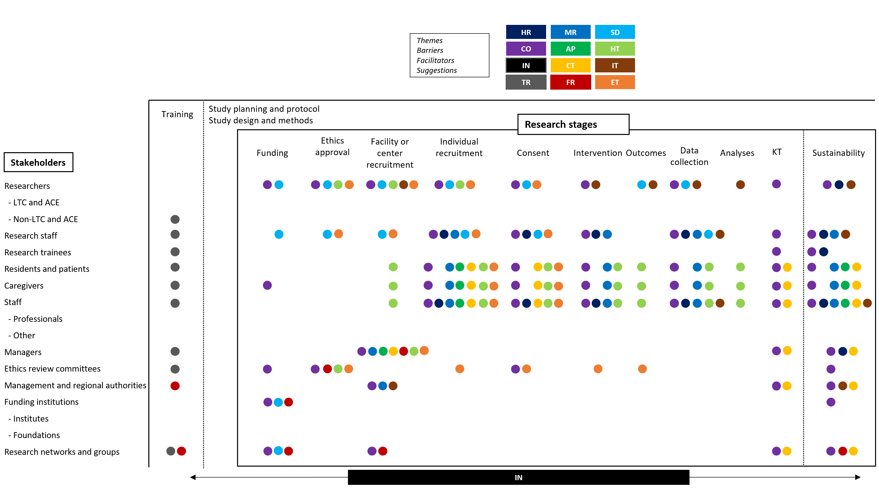

Supplementary Figure 2. PRISMA flow chart for the selection of articles
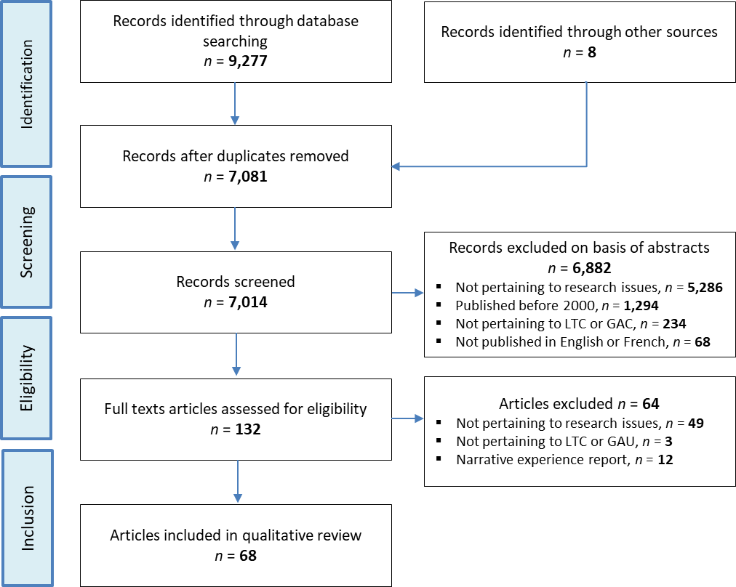

Supplementary Figure 3. Perception of stakeholders, research stages, and themes as facilitator or barriers
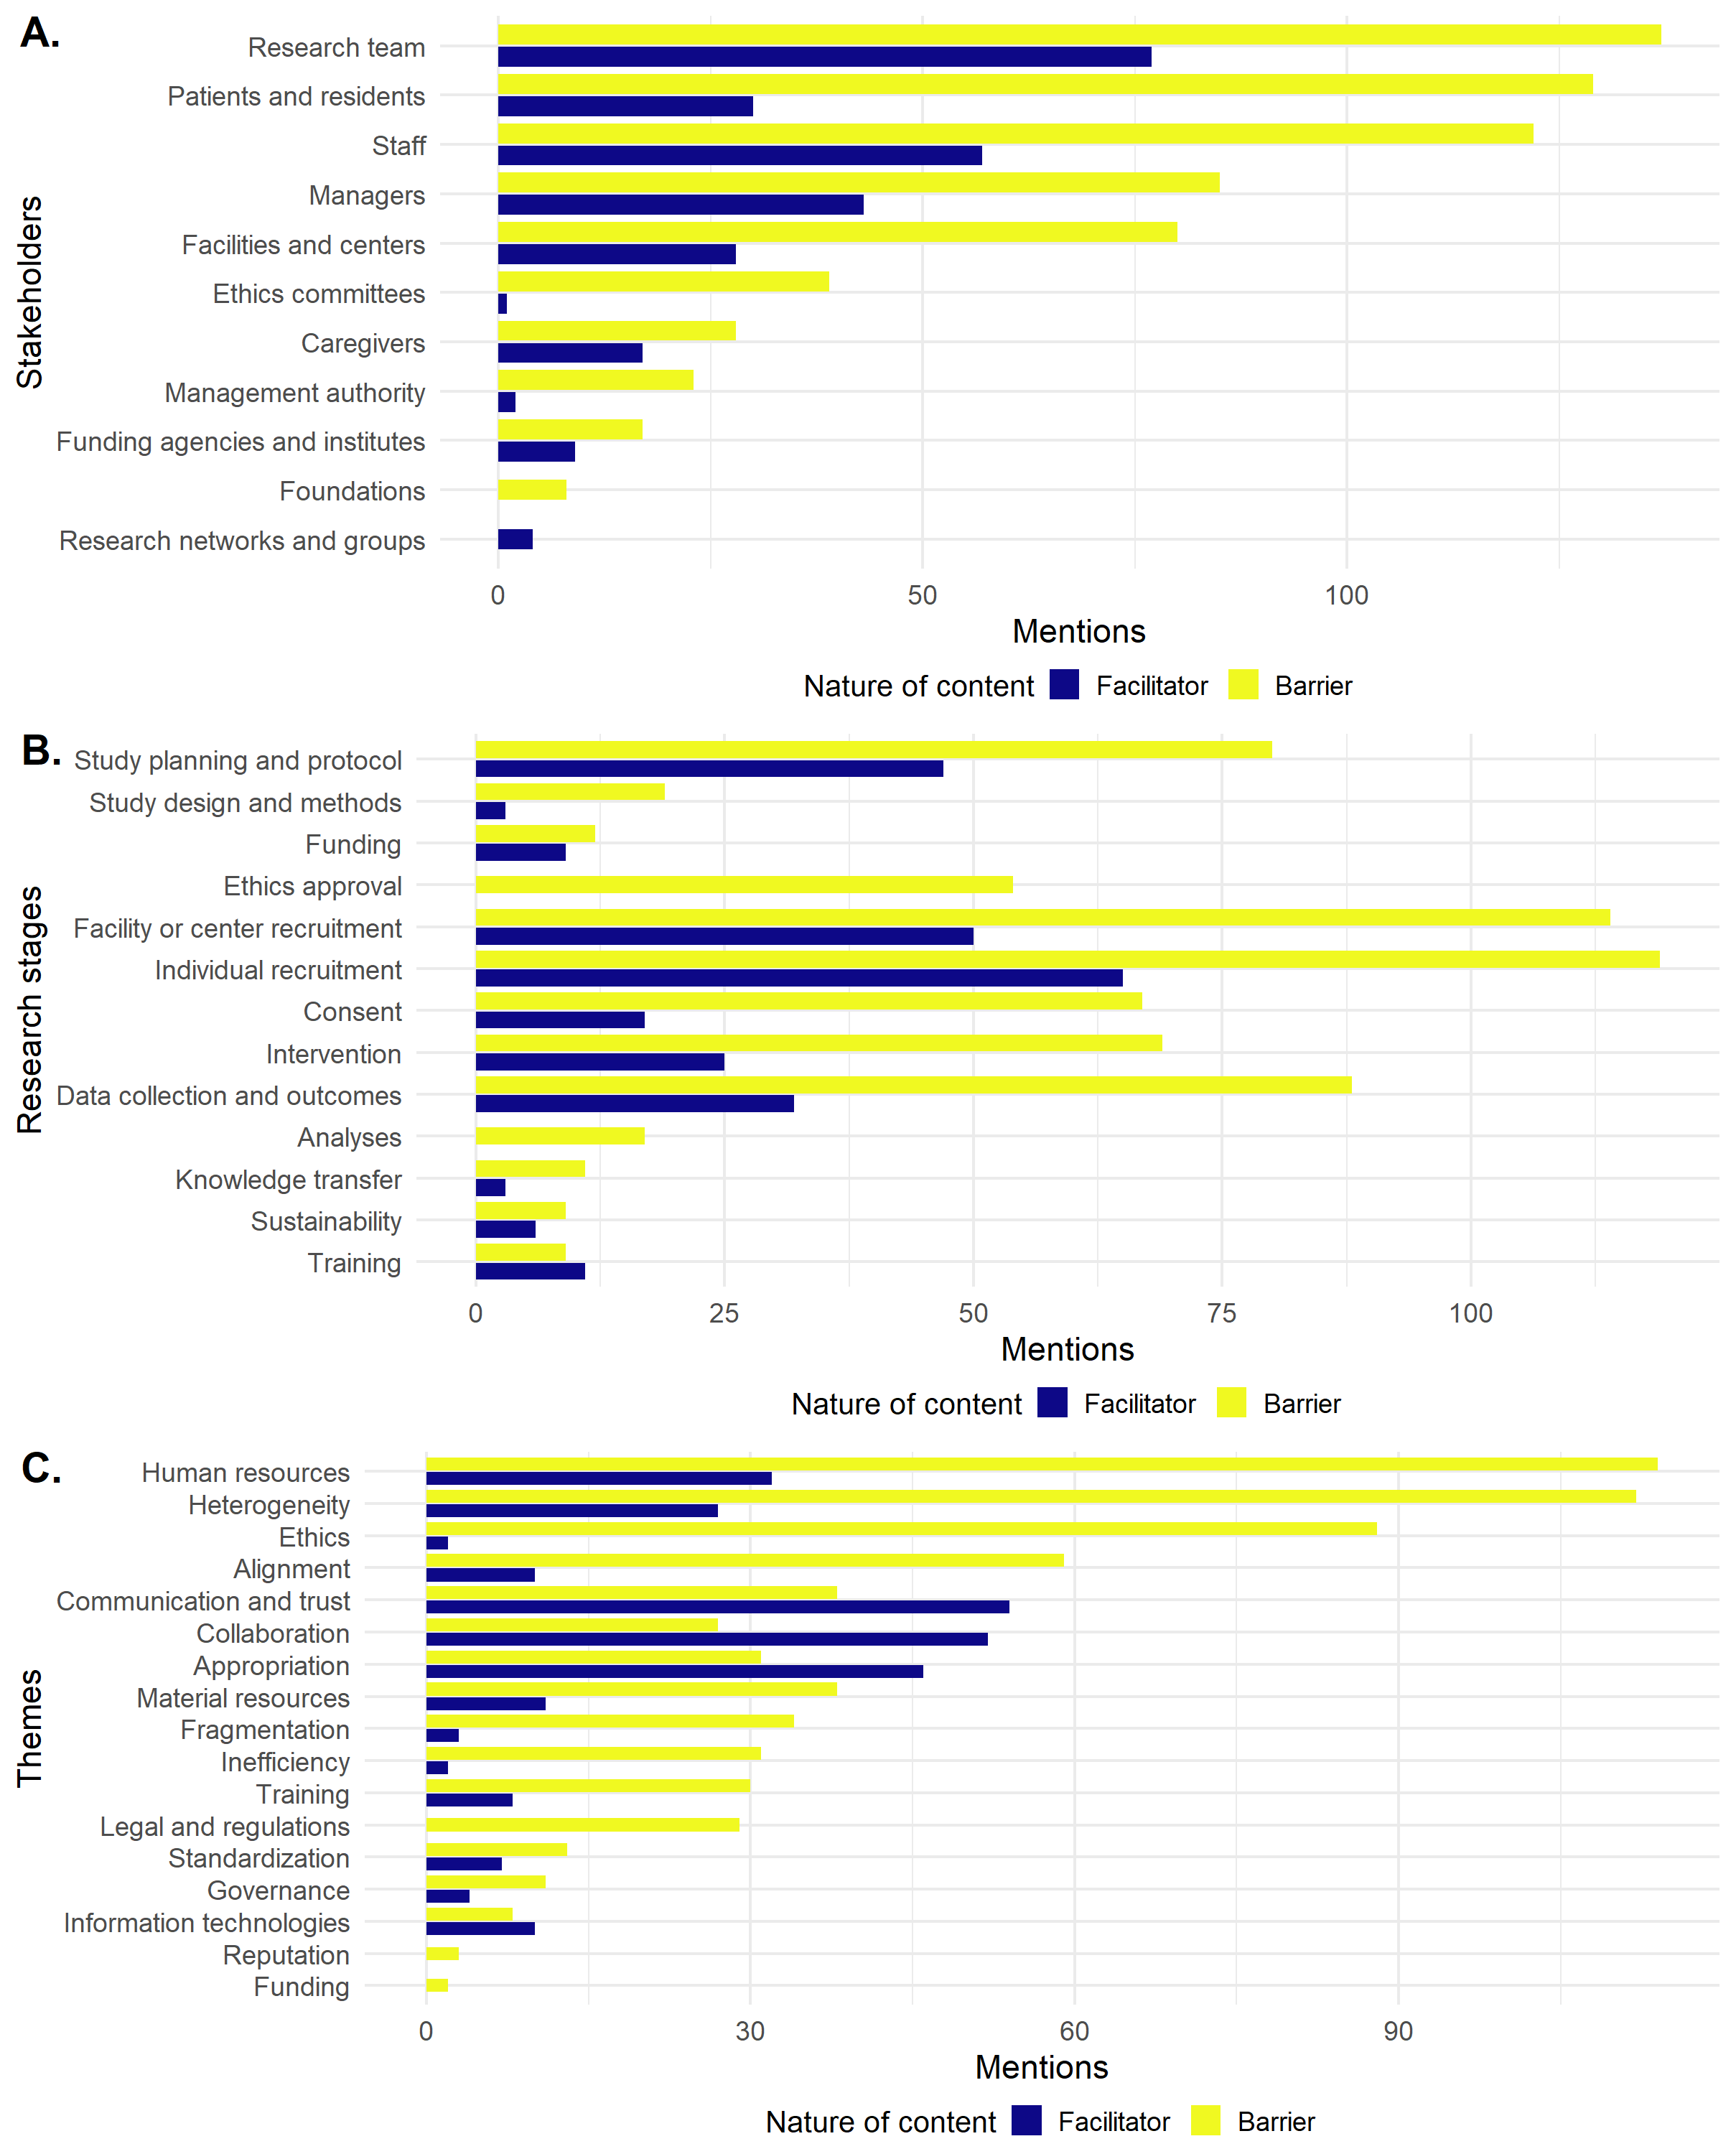
Legend. There were 668 instances of barriers and 268 of facilitators related to stakeholders, research stages, and themes. A. Stakeholders, B. Research stages, C. Themes.

