Table S1. Location and volumetric capacity of the 150 analyzed reservoirs.
Hydrographic Region (Area / Volume) |  | Reservoir |  | # | Municipality |  | Capacity (hm³) |  |  | Location
Acaraú - AC  (14,423 km² /1,737.46 hm³) |  | Acaraú Mirim |  | 1 | Massapê |  | 36.71 |  |  | 9612378 N / 357860 E
 |  | Araras |  | 2 | Varjota |  | 859.53 |  |  | 9534504 N / 338912 E
 |  | Arrebita |  | 3 | Forquilha |  | 18.53 |  |  | 9574670 N / 358835 E
 |  | Ayres de Sousa |  | 4 | Sobral |  | 96.80 |  |  | 9582035 N / 333521 E
 |  | Bonito |  | 5 | Ipu |  | 6.00 |  |  | 9520383 N / 319109 E
 |  | Carão |  | 6 | Tamboril |  | 26.23 |  |  | 9467438 N / 349014 E
 |  | Carmina |  | 7 | Catunda |  | 13.19 |  |  | 9484139 N / 366710 E
 |  | Diamantino II |  | 8 | Marco |  | 18.04 |  |  | 9651266 N / 348461 E
 |  | Edson Queiroz |  | 9 | Santa Quitéria |  | 254.00 |  |  | 9533892 N / 381715 E
 |  | Farias de Sousa |  | 10 | Nova Russas |  | 12.23 |  |  | 9472792 N / 324368 E
 |  | Forquilha |  | 11 | Forquilha |  | 50.13 |  |  | 9580216 N / 360780 E
 |  | Jatobá II |  | 12 | Ipueiras |  | 6.24 |  |  | 9492271 N / 306478 E
 |  | Jenipapo |  | 13 | Meruoca |  | 4.94 |  |  | 9606126 N / 339795 E
 |  | São Vicente |  | 14 | Santana do Acaraú |  | 9.84 |  |  | 9624535 N / 359595 E
 |  | Sobral |  | 15 | Sobral |  | 4.27 |  |  | 9595680 N / 348243 E
 |  | Taquara |  | 16 | Cariré |  | 320.78 |  |  | 9568979 N / 321160 E
Alto Jaguaribe - AJ  (24,636 km² /2,765.18 hm³) |  | Arneiroz II |  | 17 | Arneiroz |  | 178.13 |  |  | 9306986 N / 364915 E
 |  | Benguê |  | 18 | Aiuaba |  | 18.00 |  |  | 9270799 N / 373918 E
 |  | Broco |  | 19 | Tauá |  | 11.88 |  |  | 9335952 N / 353325 E
 |  | Caldeirões |  | 20 | Saboeiro |  | 1.13 |  |  | 9277977 N / 398364 E
 |  | Canoas |  | 21 | Assaré |  | 69.25 |  |  | 9232037 N / 396097 E
 |  | Do Coronel |  | 22 | Antonina do Norte |  | 1.66 |  |  | 9258861 N / 394779 E
 |  | Facundo |  | 23 | Parambu |  | 1.75 |  |  | 9302856 N / 314504 E
 |  | Faé |  | 24 | Quixelô |  | 12.79 |  |  | 9319045 N / 475628 E
 |  | Favelas |  | 25 | Tauá |  | 30.10 |  |  | 9338612 N / 375799 E
 |  | João Luís |  | 26 | Araripe |  | 6.58 |  |  | 9217192 N / 369886 E
 |  | Mamoeiro |  | 27 | Antonina do Norte |  | 20.49 |  |  | 9249373 N / 382137 E
 |  | Monte Belo |  | 28 | Araripe |  | 3.96 |  |  | 9209263 N / 376570 E
 |  | Muquém |  | 29 | Cariús |  | 46.55 |  |  | 9269155 N / 446733 E
 |  | Orós |  | 30 | Orós |  | 1,940.00 |  |  | 9310529 N / 508099 E
 |  | Parambu |  | 31 | Parambu |  | 9.04 |  |  | 9314188 N / 310530 E
 |  | Pau Preto |  | 32 | Potengi |  | 1.90 |  |  | 9217107 N / 380135 E
 |  | Poço da Pedra |  | 33 | Campos Sales |  | 52.00 |  |  | 9227731 N / 350171 E
 |  | Quincoé |  | 34 | Acopiara |  | 4.30 |  |  | 9327438 N / 449651 E
 |  | Rivaldo de Carvalho |  | 35 | Catarina |  | 20.10 |  |  | 9306514 N / 396793 E
 |  | Trici |  | 36 | Tauá |  | 13.00 |  |  | 9346024 N / 343305 E
 |  | Trussu |  | 37 | Iguatu |  | 268.80 |  |  | 9302785 N / 451897 E
 |  | Valério |  | 38 | Altaneira |  | 1.86 |  |  | 9229711 N / 419554 E
 |  | Várzea do Boi |  | 39 | Tauá |  | 51.91 |  |  | 9346884 N / 360972 E
Baixo Jaguaribe - BJ  (5,452km² /24.00 hm³) |  | Santo Antônio de Russas |  | 40 | Russas |  | 24.00 |  |  | 9463453 N / 592405 E
Banabuíu - BN  (19,316 km²/ 2,755.32 hm³) |  | Banabuiú |  | 41 | Banabuiú |  | 1,601.00 |  |  | 9410829 N / 508385 E
 |  | Capitão Mor |  | 42 | Pedra Branca |  | 6.00 |  |  | 9378122 N / 389251 E
 |  | Cedro |  | 43 | Quixadá |  | 126.00 |  |  | 9449899 N / 492939 E
 |  | Cipoada |  | 44 | Morada Nova |  | 86.09 |  |  | 9418278 N / 539052 E
 |  | Curral Velho |  | 45 | Morada Nova |  | 12.17 |  |  | 9437992 N / 576882 E
 |  | Fogareiro |  | 46 | Quixeramobim |  | 118.00 |  |  | 9429088 N / 445613 E
 |  | Jatobá |  | 47 | Milhã |  | 1.07 |  |  | 9380290 N / 473728 E
 |  | Mons. Tabosa |  | 48 | Monsenhor Tabosa |  | 11.70 |  |  | 9468480 N / 387762 E
 |  | Patu |  | 49 | Senador Pompeu |  | 65.10 |  |  | 9383106 N / 455289 E
 |  | Pedras Brancas |  | 50 | Quixadá |  | 456.00 |  |  | 9430868 N / 513425 E
 |  | Pirabibu |  | 51 | Quixeramobim |  | 74.00 |  |  | 9449235 N / 460629 E
 |  | Poço do Barro |  | 52 | Morada Nova |  | 52.00 |  |  | 9404969 N / 559612 E
 |  | Quixeramobim |  | 53 | Quixeramobim |  | 7.88 |  |  | 9425394 N / 465184 E
 |  | São José I |  | 54 | Boa Viagem |  | 7.67 |  |  | 9425645 N / 433286 E
 |  | São José II |  | 55 | Piquet Carneiro |  | 21.00 |  |  | 9354722 N / 447139 E
 |  | Serafim Dias |  | 56 | Mombaça |  | 40.94 |  |  | 9366889 N / 428197 E
 |  | Trapiá II |  | 57 | Pedra Branca |  | 18.00 |  |  | 9391775 N / 418130 E
 |  | Umari |  | 58 | Madalena |  | 30.00 |  |  | 9468532 N / 438796 E
 |  | Vieirão |  | 59 | Boa Viagem |  | 20.70 |  |  | 9429901 N / 420108 E
Coreaú - CO  (10,657 km²/283.64 hm³) |  | Angicos |  | 60 | Coreaú |  | 56.05 |  |  | 9597857 N / 297639 E
 |  | Diamante |  | 61 | Coreaú |  | 13.20 |  |  | 9602093 N / 292867 E
 |  | Gangorra |  | 62 | Granja |  | 54.40 |  |  | 9649455 N / 292965 E
 |  | Itaúna |  | 63 | Granja |  | 72.58 |  |  | 9651203 N / 259095 E
 |  | Martinópole |  | 64 | Martinópole |  | 24.83 |  |  | 9642082 N / 320710 E
 |  | Premuoca |  | 65 | Uruoca |  | 5.20 |  |  | 9632779 N / 327322 E
 |  | Trapiá III |  | 66 | Coreaú |  | 5.51 |  |  | 9587465 N / 313237 E
 |  | Tucunduba |  | 67 | Senador Sá |  | 39.37 |  |  | 9648274 N / 338959 E
 |  | Várzea da Volta |  | 68 | Moraújo |  | 12.50 |  |  | 9612662 N / 320651 E
Curu - CR  (8,528 km²/1,028.80 hm³) |  | Caxitoré |  | 69 | Umirim |  | 202.00 |  |  | 9586246 N / 460391 E
 |  | Desterro |  | 70 | Caridade |  | 5.60 |  |  | 9551266 N / 487281 E
 |  | Escuridão |  | 71 | Canindé |  | 2.72 |  |  | 9499356 N / 457997 E
 |  | Frios |  | 72 | Umirim |  | 33.02 |  |  | 9592131 N / 466950 E
 |  | General Sampaio |  | 73 | General Sampaio |  | 322.20 |  |  | 9550799 N / 449530 E
 |  | Itapajé |  | 74 | Itapajé |  | 4.24 |  |  | 9594043 N / 436205 E
 |  | Jerimum |  | 75 | Irauçuba |  | 20.50 |  |  | 9575807 N / 423204 E
 |  | Pentecoste |  | 76 | Pentecoste |  | 360.00 |  |  | 9579735 N / 471097 E
 |  | Salão |  | 77 | Canindé |  | 6.04 |  |  | 9512806 N / 465387 E
 |  | São Domingos |  | 78 | Caridade |  | 3.20 |  |  | 9533459 N / 468496 E
 |  | São Mateus |  | 79 | Canindé |  | 10.33 |  |  | 9516791 N / 464889 E
 |  | Sousa |  | 80 | Canindé |  | 30.84 |  |  | 9514327 N / 468585 E
 |  | Tejuçuoca |  | 81 | Tejuçuoca |  | 28.11 |  |  | 9560422 N / 443648 E
Hydrographic Region (Area / Volume) | Reservoir |  | # |  |  | Municipality |  | Capacity (hm³) | Location
Litoral - LT  (8,619km² /214.90 hm³) | Gameleira |  | 82 |  |  | Itapipoca |  | 52.64 | 9627162 N / 445462 E
Litoral - LT  (8,619km² /214.90 hm³) | Gerardo Atimbone |  | 83 |  |  | Sobral |  | 4.00 | 9576083 N / 390360 E
Litoral - LT  (8,619km² /214.90 hm³) | Missi |  | 84 |  |  | Miraíma |  | 65.30 | 9616069 N / 404613 E
Litoral - LT  (8,619km² /214.90 hm³) | Mundaú |  | 85 |  |  | Uruburetama |  | 21.30 | 9598257 N / 442629 E
Litoral - LT  (8,619km² /214.90 hm³) | Patos |  | 86 |  |  | Sobral |  | 7.55 | 9584120 N / 385010 E
Litoral - LT  (8,619km² /214.90 hm³) | Poço Verde |  | 87 |  |  | Itapipoca |  | 12.43 | 9619758 N / 429913 E
Litoral - LT  (8,619km² /214.90 hm³) | Quandú |  | 88 |  |  | Itapipoca |  | 3.37 | 9604941 N / 430029 E
Litoral - LT  (8,619km² /214.90 hm³) | S. Pedro Timbaúba |  | 89 |  |  | Miraíma |  | 15.77 | 9605053 N / 391837 E
Litoral - LT  (8,619km² /214.90 hm³) | Sta Mª de Aracatiaçu |  | 90 |  |  | Sobral |  | 8.20 | 9553031 N / 390472 E
Litoral - LT  (8,619km² /214.90 hm³) | Sto Ant. de Aracatiaçu |  | 91 |  |  | Sobral |  | 24.34 | 9570752 N / 387605 E
Médio Jaguaribe - MJ  (10,376 km²/7,364.80 hm³) | Adauto Bezerra |  | 92 |  |  | Pereiro |  | 4.79 | 9332605 N / 561062 E
Médio Jaguaribe - MJ  (10,376 km²/7,364.80 hm³) | Canafístula |  | 93 |  |  | Iracema |  | 13.11 | 9351171 N / 575271 E
Médio Jaguaribe - MJ  (10,376 km²/7,364.80 hm³) | Ema |  | 94 |  |  | Iracema |  | 10.39 | 9361194 N / 572216 E
Médio Jaguaribe - MJ  (10,376 km²/7,364.80 hm³) | Castanhão |  | 95 |  |  | Alto Santo |  | 6,700.00 | 9393082 N / 560672 E
Médio Jaguaribe - MJ  (10,376 km²/7,364.80 hm³) | Figueiredo |  | 96 |  |  | Alto Santo |  | 497.00 | 9378117 N / 581223 E
Médio Jaguaribe - MJ  (10,376 km²/7,364.80 hm³) | Jenipapeiro |  | 97 |  |  | Dep. Irapuan Pinheiro |  | 14.59 | 9357591 N / 472607 E
Médio Jaguaribe - MJ  (10,376 km²/7,364.80 hm³) | Joaquim Távora |  | 98 |  |  | Jaguaribe |  | 26.77 | 9342313 N / 518608 E
Médio Jaguaribe - MJ  (10,376 km²/7,364.80 hm³) | Nova Floresta |  | 99 |  |  | Jaguaribe |  | 5.19 | 9342442 N / 510137 E
Médio Jaguaribe - MJ  (10,376 km²/7,364.80 hm³) | Riacho da Serra |  | 100 |  |  | Alto Santo |  | 23.47 | 9384852 N / 574789 E
Médio Jaguaribe - MJ  (10,376 km²/7,364.80 hm³) | Riacho do Sangue |  | 101 |  |  | Solonópole |  | 58.43 | 9370733 N / 505277 E
Médio Jaguaribe - MJ  (10,376 km²/7,364.80 hm³) | Santa Maria |  | 102 |  |  | Ererê |  | 6.72 | 9340497 N / 580195 E
Médio Jaguaribe - MJ  (10,376 km²/7,364.80 hm³) | Santo Antônio |  | 103 |  |  | Iracema |  | 0.83 | 9348889 N / 564993 E
Médio Jaguaribe - MJ  (10,376 km²/7,364.80 hm³) | Tigre |  | 104 |  |  | Solonópole |  | 3.51 | 9348963 N / 483020 E
Metropolitana - MT  (15,085 km²/1,350.45 hm³) | Sítios Novos |  | 105 |  |  | Caucaia |  | 126.00 | 9583193 N / 504174 E
Metropolitana - MT  (15,085 km²/1,350.45 hm³) | Acarape do Meio |  | 106 |  |  | Redenção |  | 29.60 | 9536464 N / 522155 E
Metropolitana - MT  (15,085 km²/1,350.45 hm³) | Amanary |  | 107 |  |  | Maranguape |  | 11.01 | 9556446 N / 512931 E
Metropolitana - MT  (15,085 km²/1,350.45 hm³) | Aracoiaba |  | 108 |  |  | Aracoiaba |  | 162.00 | 9513372 N / 533518 E
Metropolitana - MT  (15,085 km²/1,350.45 hm³) | Batente |  | 109 |  |  | Ocara |  | 37.00 | 9485970 N / 556497 E
Metropolitana - MT  (15,085 km²/1,350.45 hm³) | Castro |  | 110 |  |  | Itapiúna |  | 62.31 | 9495272 N / 507537 E
Metropolitana - MT  (15,085 km²/1,350.45 hm³) | Catucinzenta |  | 111 |  |  | Aquiraz |  | 24.90 | 9555401 N / 562295 E
Metropolitana - MT  (15,085 km²/1,350.45 hm³) | Cauhipe |  | 112 |  |  | Caucaia |  | 12.00 | 9586522 N / 514922 E
Metropolitana - MT  (15,085 km²/1,350.45 hm³) | Cocó |  | 113 |  |  | Fortaleza |  | 5.10 | 9575046 N / 551468 E
Metropolitana - MT  (15,085 km²/1,350.45 hm³) | Germinal |  | 114 |  |  | Palmácia |  | 2.11 | 9537730 N / 514876 E
Metropolitana - MT  (15,085 km²/1,350.45 hm³) | Itapebussu |  | 115 |  |  | Maranguape |  | 6.00 | 9551406 N / 510927 E
Metropolitana - MT  (15,085 km²/1,350.45 hm³) | Macacos |  | 116 |  |  | Ibaretama |  | 10.32 | 9469342 N / 532329 E
Metropolitana - MT  (15,085 km²/1,350.45 hm³) | Malcozinhado |  | 117 |  |  | Cascavel |  | 38.09 | 9545946 N / 578636 E
Metropolitana - MT  (15,085 km²/1,350.45 hm³) | Maranguapinho |  | 118 |  |  | Maranguape |  | 9.35 | 9571284 N / 538682 E
Metropolitana - MT  (15,085 km²/1,350.45 hm³) | Pacajus |  | 119 |  |  | Pacajus |  | 232.00 | 9533151 N / 568153 E
Metropolitana - MT  (15,085 km²/1,350.45 hm³) | Pacoti |  | 120 |  |  | Horizonte |  | 380.00 | 9553622 N / 551947 E
Metropolitana - MT  (15,085 km²/1,350.45 hm³) | Penedo |  | 121 |  |  | Maranguape |  | 2.23 | 9561314 N / 528357 E
Metropolitana - MT  (15,085 km²/1,350.45 hm³) | Pesqueiro |  | 122 |  |  | Capistrano |  | 9.03 | 9508743 N / 504185 E
Metropolitana - MT  (15,085 km²/1,350.45 hm³) | Pompeu Sobrinho |  | 123 |  |  | Choró |  | 143.00 | 9465146 N / 484236 E
Metropolitana - MT  (15,085 km²/1,350.45 hm³) | Riachão |  | 124 |  |  | Itaitinga |  | 47.92 | 9557818 N / 552737 E
Metropolitana - MT  (15,085 km²/1,350.45 hm³) | Tijuquinha |  | 125 |  |  | Baturité |  | 0.48 | 9522847 N / 511734 E
Sertões de Crateús - SC  (10,821 km² /436.04 hm³) | Barra Velha |  | 126 |  |  | Independência |  | 99.56 | 9411763 N / 353196 E
Sertões de Crateús - SC  (10,821 km² /436.04 hm³) | Barragem do Batalhão |  | 127 |  |  | Crateús |  | 1.64 | 9425478 N / 316366 E
Sertões de Crateús - SC  (10,821 km² /436.04 hm³) | Carnaubal |  | 128 |  |  | Crateús |  | 73.20 | 9415923 N / 314969 E
Sertões de Crateús - SC  (10,821 km² /436.04 hm³) | Colina |  | 129 |  |  | Quiterianópolis |  | 4.29 | 9354244 N / 310092 E
Sertões de Crateús - SC  (10,821 km² /436.04 hm³) | Cupim |  | 130 |  |  | Independência |  | 4.60 | 9403792 N / 355955 E
Sertões de Crateús - SC  (10,821 km² /436.04 hm³) | Flor do Campo |  | 131 |  |  | Novo Oriente |  | 105.00 | 9383821 N / 314656 E
Sertões de Crateús - SC  (10,821 km² /436.04 hm³) | Jaburu II |  | 132 |  |  | Independência |  | 101.64 | 9401151 N / 336199 E
Sertões de Crateús - SC  (10,821 km² /436.04 hm³) | Realejo |  | 133 |  |  | Crateús |  | 31.55 | 9418184 N / 299673 E
Sertões de Crateús - SC  (10,821 km² /436.04 hm³) | São José III |  | 134 |  |  | Ipaporanga |  | 7.96 | 9458399 N / 303630 E
Sertões de Crateús - SC  (10,821 km² /436.04 hm³) | Sucesso |  | 135 |  |  | Tamboril |  | 6.60 | 9452150 N / 331063 E
Serra da Ibiapaba - SI  (5,988km²/140.00 hm³) | Jaburu I |  | 136 |  |  | Ubajara |  | 140.33 | 9572594 N / 265377 E
Salgado - SL  (12,865 km² /449.92 hm³) | Atalho |  | 137 |  |  | Brejo Santo |  | 72.55 | 9155172 N / 511686 E
Salgado - SL  (12,865 km² /449.92 hm³) | Cachoeira |  | 138 |  |  | Aurora |  | 34.33 | 9227177 N / 497955 E
Salgado - SL  (12,865 km² /449.92 hm³) | Jenipapeiro II |  | 139 |  |  | Baixio |  | 41.40 | 9262330 N / 527313 E
Salgado - SL  (12,865 km² /449.92 hm³) | Junco |  | 140 |  |  | Granjeiro |  | 2.03 | 9238167 N / 476071 E
Salgado - SL  (12,865 km² /449.92 hm³) | Lima Campos |  | 141 |  |  | Icó |  | 66.38 | 9292399 N / 504679 E
Salgado - SL  (12,865 km² /449.92 hm³) | Manoel Balbino |  | 142 |  |  | Juazeiro do Norte |  | 37.18 | 9214559 N / 463631 E
Salgado - SL  (12,865 km² /449.92 hm³) | Olho d'Água |  | 143 |  |  | Várzea Alegre |  | 19.00 | 9249442 N / 458508 E
Salgado - SL  (12,865 km² /449.92 hm³) | Prazeres |  | 144 |  |  | Barro |  | 32.50 | 9214089 N / 534964 E
Salgado - SL  (12,865 km² /449.92 hm³) | Quixabinha |  | 145 |  |  | Mauriti |  | 31.78 | 9170685 N / 527971 E
Salgado - SL  (12,865 km² /449.92 hm³) | Rosário |  | 146 |  |  | Lavras da Mangabeira |  | 47.22 | 9238468 N / 491171 E
Salgado - SL  (12,865 km² /449.92 hm³) | São Domingos II |  | 147 |  |  | Caririaçu |  | 2.25 | 9223049 N / 468649 E
Salgado - SL  (12,865 km² /449.92 hm³) | Tatajuba |  | 148 |  |  | Icó |  | 2.72 | 9290888 N / 490791 E
Salgado - SL  (12,865 km² /449.92 hm³) | Thomás Osterne |  | 149 |  |  | Crato |  | 28.78 | 9216094 N / 446291 E
Salgado - SL  (12,865 km² /449.92 hm³) | Ubaldinho |  | 150 |  |  | Cedro |  | 31.80 | 9272123 N / 473526 E

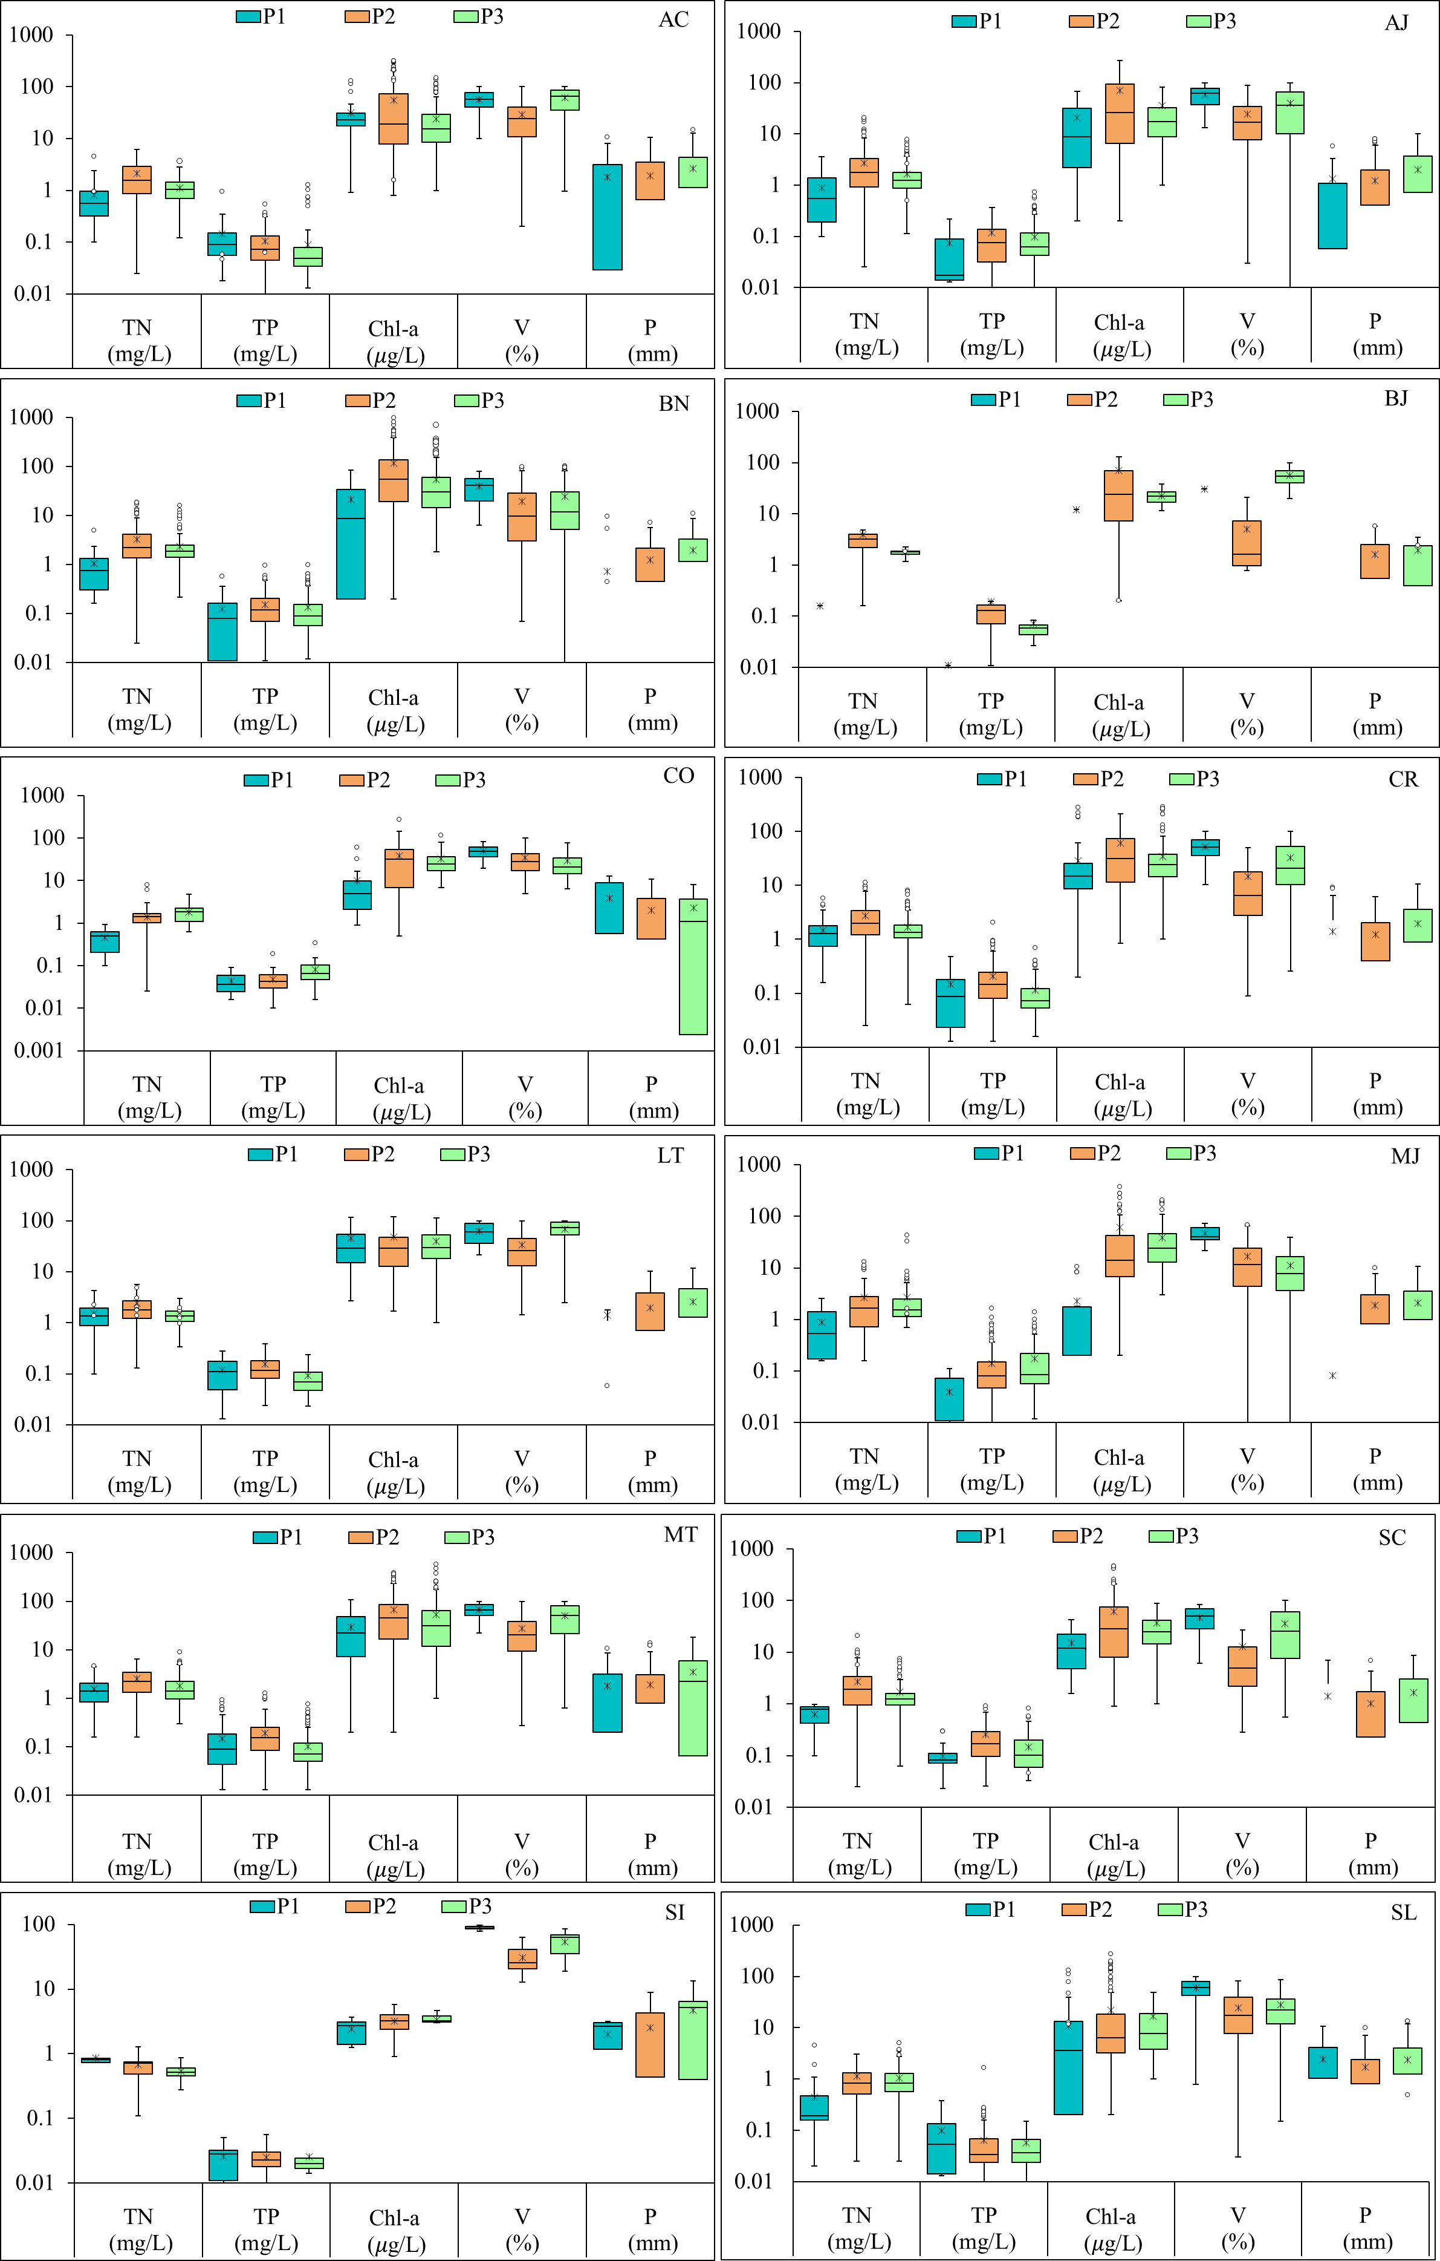
Figure S1. Total Nitrogen (TN), Total Phosphorus (TP), Chlorophyll-a (Chl-a), Volume (%) and Precipitation (P) variation in the analyzed watersheds during periods P1 (2008-2012), P2 (2013-2017) and P3 (2018-2021). The horizontal lines and stars within the graphs indicate the median and mean, respectively. The circles indicate outliers.

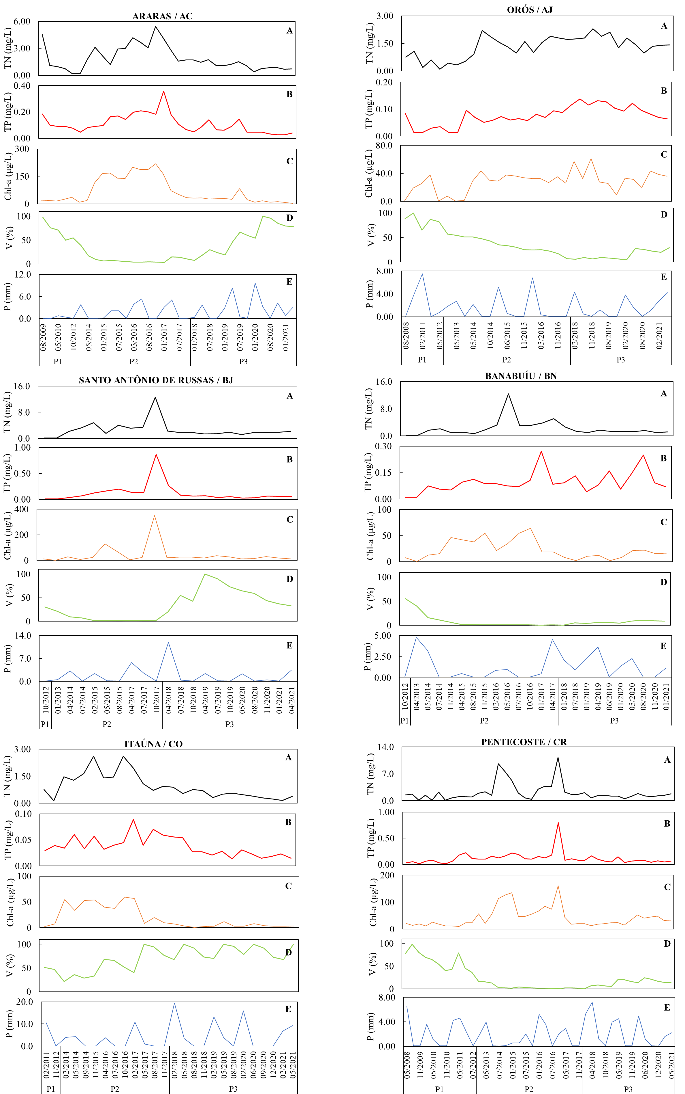
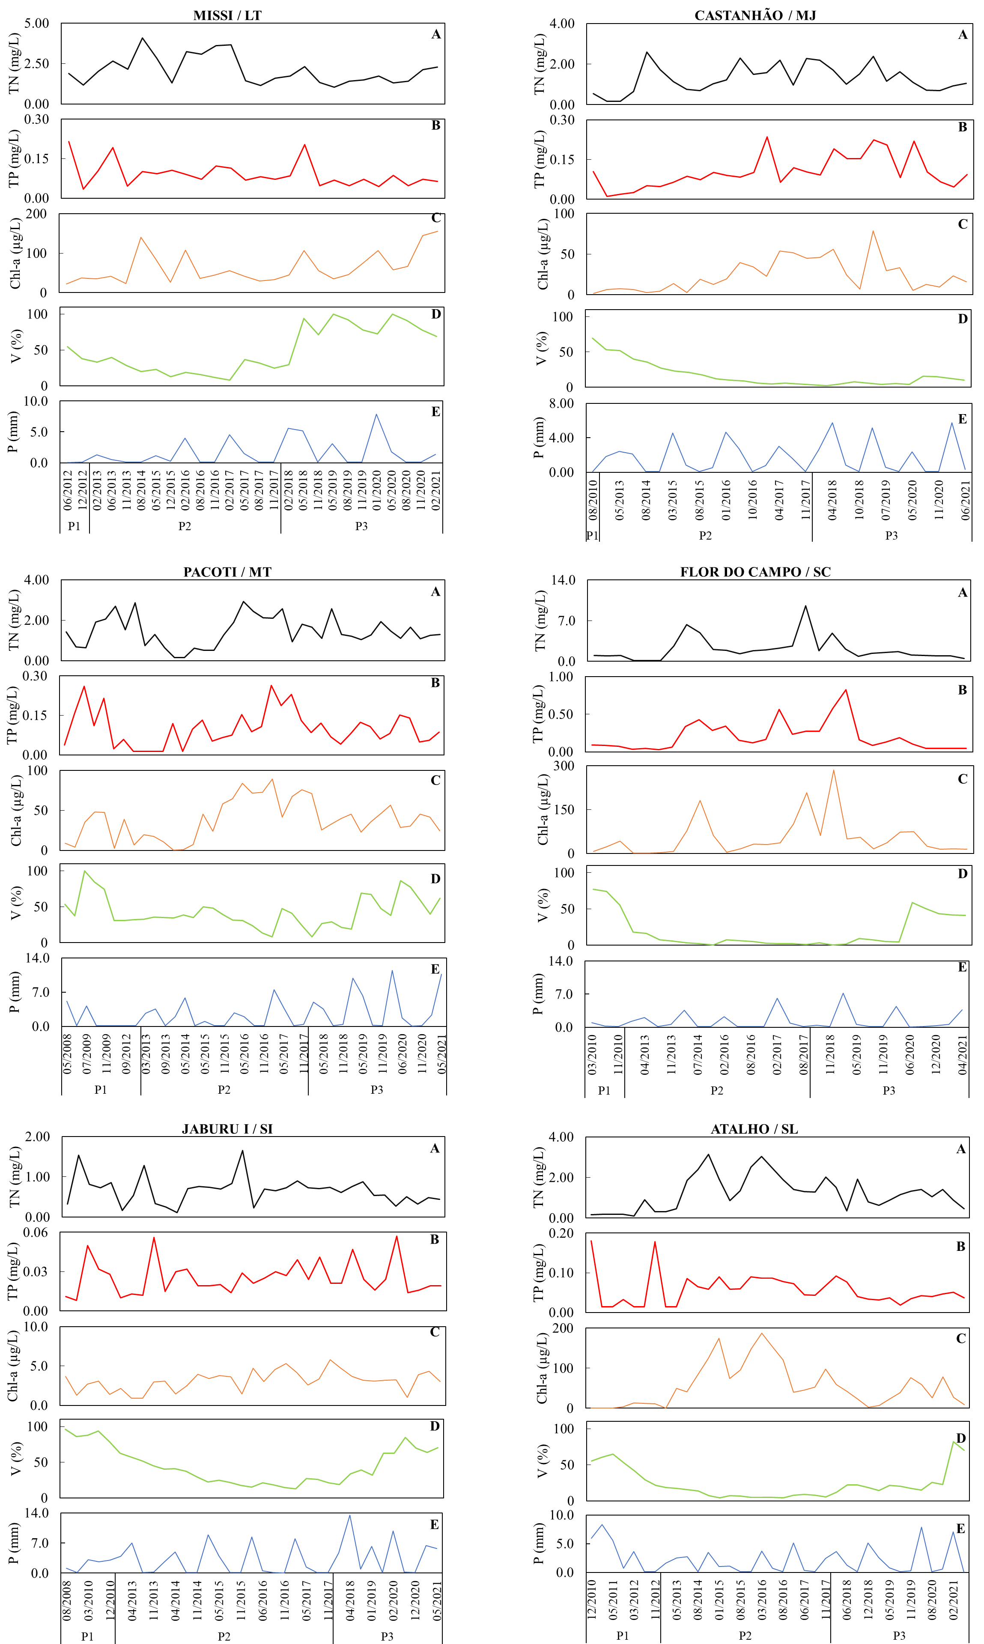
Figura S2. Time series plot of TN (A), TP (B), Chl-a (C), V (D) and P (E) for the highest capacity reservoirs in each analyzed watershed.
Table S2. Developed empirical equations and observed performance metrics.
 | Reservoir | N | R² [Cla(f)] |  |  |  | Cla =n(NTª PT^{b}V^{c}[1+P/Pmax])^{d})
 | Reservoir | N | TN | TP | V | P | R² | MAE | RMSE | Performance¹ | n | a | b | c | d
AC | ACARAÚ MIRIM | 23 | 0.31 | 0.00 | 0.00 | 0.00 | 0.52 | 4.45 | 5.18 | SATISFACTORY | 2.02 | 2.13 | -0.07 | 0.44 | -1.17
AC | ARARAS | 34 | 0.56 | 0.55 | 0.46 | 0.00 | 0.86 | 18.64 | 25.99 | VERY GOOD | 871.38 | -0.05 | 0.24 | -0.75 | -0.37
AC | ARREBITA | 26 | 0.52 | 0.26 | 0.19 | 0.01 | 0.57 | 11.59 | 15.29 | SATISFACTORY | 192.08 | 0.45 | 0.50 | -0.18 | 0.01
AC | AYRES DE SOUSA | 29 | 0.09 | 0.21 | 0.20 | 0.04 | 0.43 | 6.76 | 8.64 | SATISFACTORY | 0.28 | -0.06 | -0.91 | 0.30 | 1.31
AC | BONITO | 15 | 0.39 | 0.30 | 0.20 | 0.02 | 0.75 | 3.73 | 4.61 | VERY GOOD | 65.19 | -0.60 | 1.19 | 0.34 | 0.48
AC | CARÃO | 12 | 0.50 | 0.05 | 0.42 | 0.04 | 0.68 | 21.86 | 27.63 | GOOD | 329.66 | 0.06 | -0.16 | -0.65 | -0.45
AC | CARMINA | 21 | 0.33 | 0.24 | 0.08 | 0.00 | 0.46 | 55.00 | 71.60 | SATISFACTORY | 99.45 | 0.48 | 0.72 | 0.17 | 1.50
AC | DIAMANTINO II | 22 | 0.01 | 0.00 | 0.01 | 0.04 | 0.30 | 4.36 | 5.58 | SATISFACTORY | 6,165.43 | -3.40 | 0.58 | -1.00 | -1.90
AC | EDSON QUEIROZ | 32 | 0.50 | 0.38 | 0.56 | 0.00 | 0.74 | 26.59 | 32.91 | VERY GOOD | 1,770.00 | 0.08 | 0.21 | -0.73 | -0.47
AC | FARIAS DE SOUSA | 19 | 0.01 | 0.19 | 0.14 | 0.04 | 0.66 | 8.39 | 10.02 | GOOD | 296.10 | -0.41 | 0.51 | -0.48 | 0.52
AC | FORQUILHA | 30 | 0.76 | 0.05 | 0.32 | 0.02 | 0.87 | 21.83 | 30.35 | VERY GOOD | 1,724.21 | 0.11 | 0.44 | -0.86 | -0.77
AC | JATOBÁ II | 19 | 0.40 | 0.35 | 0.05 | 0.03 | 0.85 | 5.68 | 7.56 | VERY GOOD | 160.14 | 2.74 | 1.02 | 0.20 | 1.32
AC | JENIPAPO | 28 | 0.02 | 0.08 | 0.25 | 0.03 | 0.43 | 1.82 | 2.28 | SATISFACTORY | 2,174.84 | -0.06 | 0.56 | -0.87 | 0.06
AC | SÃO VICENTE | 27 | 0.46 | 0.59 | 0.10 | 0.05 | 0.62 | 14.14 | 16.18 | GOOD | 491.05 | 0.26 | 0.71 | -0.16 | 0.33
AC | SOBRAL | 30 | 0.16 | 0.00 | 0.01 | 0.06 | 0.51 | 12.49 | 14.74 | SATISFACTORY | 1.29 | 0.96 | 0.10 | 0.80 | -1.21
AC | TAQUARA | 29 | 0.31 | 0.01 | 0.58 | 0.04 | 0.76 | 2.70 | 3.22 | VERY GOOD | 0.39 | 0.70 | -0.28 | 0.73 | -0.30
AJ | ARNEIROZ II | 35 | 0.73 | 0.54 | 0.26 | 0.00 | 0.83 | 23.21 | 30.06 | VERY GOOD | 112.89 | 1.00 | 0.48 | -0.05 | -0.25
AJ | BENGUÊ | 34 | 0.86 | 0.77 | 0.35 | 0.07 | 0.91 | 23.89 | 30.67 | VERY GOOD | 135.90 | 1.12 | 0.57 | -0.06 | -0.24
AJ | BROCO | 22 | 0.81 | 0.36 | 0.28 | 0.03 | 0.85 | 14.67 | 18.70 | VERY GOOD | 70.59 | 0.42 | 0.31 | -0.27 | 0.08
AJ | CALDEIRÕES | 24 | 0.52 | 0.68 | 0.70 | 0.01 | 0.76 | 28.71 | 37.92 | VERY GOOD | 1,269.68 | 0.48 | 1.42 | 0.00 | -0.70
AJ | CANOAS | 29 | 0.84 | 0.72 | 0.24 | 0.01 | 0.96 | 9.86 | 13.68 | VERY GOOD | 10.50 | 1.39 | 0.31 | 0.35 | 0.76
AJ | DO CORONEL | 28 | 0.29 | 0.08 | 0.10 | 0.30 | 0.74 | 7.34 | 8.89 | VERY GOOD | 8.69 | 0.61 | -0.34 | -0.19 | 1.72
AJ | FACUNDO | 19 | 0.01 | 0.01 | 0.41 | 0.01 | 0.40 | 2.44 | 2.97 | SATISFACTORY | 42.38 | -0.18 | -0.11 | -0.56 | -0.06
AJ | FAÉ | 12 | 0.38 | 0.15 | 0.00 | 0.17 | 0.72 | 2.90 | 3.99 | VERY GOOD | 414.84 | 0.77 | 0.29 | -0.55 | -1.27
AJ | FAVELAS | 12 | 0.73 | 0.19 | 0.53 | 0.01 | 0.93 | 50.64 | 57.88 | VERY GOOD | 2,991.95 | -0.15 | 0.31 | -0.67 | 0.02
AJ | JOÃO LUÍS | 22 | 0.01 | 0.45 | 0.03 | 0.02 | 0.47 | 4.28 | 5.21 | SATISFACTORY | 204.97 | 0.19 | 0.92 | 0.03 | -0.05
AJ | MAMOEIRO | 25 | 0.11 | 0.52 | 0.00 | 0.01 | 0.66 | 1.85 | 2.40 | GOOD | 206.03 | -0.35 | 1.22 | 0.11 | -0.73
AJ | MONTE BELO | 14 | 0.93 | 0.40 | 0.40 | 0.08 | 0.95 | 36.34 | 46.21 | VERY GOOD | 90.85 | 0.84 | 0.74 | 0.34 | -0.45
AJ | MUQUÉM | 25 | 0.00 | 0.59 | 0.13 | 0.00 | 0.65 | 1.20 | 1.39 | GOOD | 271.80 | -0.17 | 1.23 | -0.08 | -0.23
AJ | ORÓS | 32 | 0.43 | 0.06 | 0.25 | 0.01 | 0.51 | 8.50 | 10.32 | SATISFACTORY | 14.85 | 0.79 | -0.19 | -0.04 | 0.48
AJ | PARAMBU | 21 | 0.78 | 0.09 | 0.17 | 0.00 | 0.93 | 13.63 | 17.14 | VERY GOOD | 21.82 | 1.64 | 0.14 | -0.16 | -0.18
AJ | PAU PRETO | 24 | 0.77 | 0.61 | 0.40 | 0.01 | 0.88 | 5.31 | 7.32 | VERY GOOD | 14.05 | 1.57 | 0.55 | 0.24 | 0.68
AJ | POÇO DA PEDRA | 31 | 0.61 | 0.45 | 0.10 | 0.00 | 0.75 | 28.94 | 35.48 | VERY GOOD | 23.87 | 0.52 | -0.32 | -0.29 | 0.16
AJ | QUINCOÉ | 23 | 0.41 | 0.31 | 0.12 | 0.05 | 0.73 | 11.86 | 16.48 | VERY GOOD | 36.22 | 1.44 | 0.56 | -0.04 | -1.71
AJ | RIVALDO DE CARVALHO | 30 | 0.20 | 0.28 | 0.10 | 0.01 | 0.84 | 32.82 | 45.35 | VERY GOOD | 237.16 | 0.57 | 1.27 | 0.44 | -1.10
AJ | TRICI | 28 | 0.00 | 0.00 | 0.12 | 0.01 | 0.55 | 10.41 | 14.23 | SATISFACTORY | 1,623.10 | -0.82 | 0.27 | -1.08 | -1.11
AJ | TRUSSU | 36 | 0.83 | 0.80 | 0.27 | 0.00 | 0.95 | 7.90 | 10.28 | VERY GOOD | 134.45 | 0.58 | 0.47 | -0.24 | 0.17
AJ | VALÉRIO | 37 | 0.33 | 0.13 | 0.52 | 0.02 | 0.72 | 1.62 | 2.00 | VERY GOOD | 28.39 | 0.44 | -0.18 | -0.64 | 0.17
AJ | VÁRZEA DO BOI | 14 | 0.55 | 0.07 | 0.13 | 0.00 | 0.80 | 12.31 | 17.66 | VERY GOOD | 4.39 | 1.94 | -0.10 | -0.45 | 2.52
BJ | SNT ANT. DE RUSSAS | 21 | 0.73 | 0.86 | 0.09 | 0.04 | 0.98 | 7.20 | 9.91 | VERY GOOD | 3,949.97 | -0.86 | 1.69 | 0.05 | -3.48
BN | BANABUIÚ | 24 | 0.06 | 0.00 | 0.17 | 0.21 | 0.71 | 8.37 | 9.86 | VERY GOOD | 16.72 | 0.04 | -0.45 | -0.45 | -3.51
BN | CAPITÃO MOR | 29 | 0.54 | 0.53 | 0.38 | 0.01 | 0.61 | 73.11 | 88.19 | GOOD | 236.67 | 0.33 | 0.61 | 0.07 | -0.80
BN | CEDRO | 22 | 0.73 | 0.13 | 0.25 | 0.03 | 0.88 | 23.29 | 28.23 | VERY GOOD | 29.63 | 0.83 | -0.23 | -0.40 | -0.49
BN | CIPOADA | 26 | 0.66 | 0.64 | 0.40 | 0.07 | 0.73 | 26.13 | 31.05 | VERY GOOD | 680.60 | 0.56 | 1.24 | 0.26 | -2.40
BN | CURRAL VELHO | 29 | 0.51 | 0.31 | 0.13 | 0.00 | 0.61 | 15.77 | 19.34 | GOOD | 92.35 | 0.78 | 0.35 | -0.03 | 0.05
BN | FOGAREIRO | 20 | 0.44 | 0.22 | 0.02 | 0.08 | 0.78 | 20.90 | 25.17 | VERY GOOD | 14.35 | 1.30 | 0.29 | 0.14 | 1.50
BN | JATOBÁ | 11 | 0.22 | 0.49 | 0.01 | 0.02 | 0.84 | 10.85 | 13.50 | VERY GOOD | 225.19 | -0.45 | 1.18 | 0.18 | 0.52
BN | MONS. TABOSA | 21 | 0.82 | 0.47 | 0.34 | 0.11 | 0.87 | 70.25 | 90.56 | VERY GOOD | 134.71 | 0.78 | 0.52 | 0.03 | 0.91
BN | PATU | 28 | 0.75 | 0.48 | 0.40 | 0.00 | 0.93 | 18.12 | 23.85 | VERY GOOD | 20.18 | 1.57 | -0.31 | -0.38 | -0.15
BN | PEDRAS BRANCAS | 28 | 0.65 | 0.76 | 0.15 | 0.07 | 0.93 | 5.82 | 8.29 | VERY GOOD | 124.10 | 2.02 | 0.93 | -0.19 | -0.14
BN | PIRABIBU | 11 | 0.64 | 0.31 | 0.15 | 0.01 | 0.99 | 13.31 | 21.53 | VERY GOOD | 0.51 | 3.49 | -0.60 | -1.03 | 0.69
BN | POÇO DO BARRO | 28 | 0.02 | 0.05 | 0.38 | 0.09 | 0.59 | 4.92 | 5.89 | SATISFACTORY | 4.85 | 0.37 | 0.24 | 0.61 | 0.95
BN | QUIXERAMOBIM | 20 | 0.75 | 0.12 | 0.09 | 0.02 | 0.96 | 17.04 | 24.25 | VERY GOOD | 0.28 | 2.72 | -0.63 | 0.68 | -2.19
BN | SÃO JOSÉ I | 20 | 0.09 | 0.12 | 0.10 | 0.02 | 0.83 | 6.81 | 7.89 | VERY GOOD | 167.48 | -0.60 | 1.02 | 0.04 | -1.20
BN | SÃO JOSÉ II | 16 | 0.79 | 0.00 | 0.21 | 0.02 | 0.85 | 10.85 | 13.91 | VERY GOOD | 35.81 | 0.85 | 0.11 | -0.15 | 0.35
BN | SERAFIM DIAS | 11 | 0.89 | 0.19 | 0.16 | 0.03 | 0.96 | 14.85 | 17.93 | VERY GOOD | 64.88 | 1.17 | 0.35 | -0.17 | 0.09
BN | TRAPIÁ II | 23 | 0.10 | 0.25 | 0.03 | 0.12 | 0.60 | 21.35 | 29.62 | SATISFACTORY | 8,222.01 | -0.21 | 2.00 | 0.37 | -1.95
BN | UMARI | 20 | 0.81 | 0.30 | 0.09 | 0.10 | 0.89 | 24.07 | 28.33 | VERY GOOD | 29.23 | 1.29 | 0.34 | 0.21 | 0.58
BN | VIEIRÃO | 14 | 0.63 | 0.18 | 0.21 | 0.00 | 1.00 | 14.25 | 19.20 | VERY GOOD | 0.81 | 4.18 | -0.47 | -0.25 | -7.87
CO | ANGICOS | 32 | 0.70 | 0.55 | 0.04 | 0.00 | 0.83 | 14.95 | 18.52 | VERY GOOD | 67.73 | 1.70 | 0.41 | 0.12 | -0.98
CO | DIAMANTE | 26 | 0.04 | 0.00 | 0.11 | 0.07 | 0.31 | 1.41 | 1.76 | SATISFACTORY | 4.97 | -0.10 | -0.24 | -0.31 | 0.82
CO | GANGORRA | 26 | 0.60 | 0.16 | 0.03 | 0.12 | 0.77 | 10.59 | 12.77 | VERY GOOD | 81.93 | 0.86 | 0.49 | 0.09 | 0.53
CO | ITAÚNA | 26 | 0.81 | 0.25 | 0.51 | 0.03 | 0.87 | 6.17 | 7.55 | VERY GOOD | 66.61 | 1.25 | -0.21 | -0.50 | 0.52
CO | MARTINÓPOLE | 27 | 0.69 | 0.43 | 0.32 | 0.51 | 0.90 | 14.66 | 21.52 | VERY GOOD | 369.15 | 0.24 | -0.13 | -0.88 | 1.26
CO | PREMUOCA | 20 | 0.02 | 0.53 | 0.16 | 0.09 | 0.85 | 5.35 | 6.94 | VERY GOOD | 425.67 | 0.05 | 1.69 | 0.49 | 1.28
CO | TRAPIÁ III | 30 | 0.76 | 0.38 | 0.52 | 0.00 | 0.86 | 14.90 | 19.80 | VERY GOOD | 777.75 | 0.43 | 0.32 | -0.66 | -0.03
CO | TUCUNDUBA | 25 | 0.25 | 0.00 | 0.12 | 0.01 | 0.35 | 2.31 | 3.00 | SATISFACTORY | 27.18 | 0.68 | -0.15 | -0.43 | 0.26
CO | VÁRZEA DA VOLTA | 19 | 0.43 | 0.66 | 0.38 | 0.02 | 0.67 | 6.82 | 8.13 | GOOD | 1900.93 | -0.20 | 1.36 | -0.17 | 0.07
CR | CAXITORÉ | 34 | 0.26 | 0.02 | 0.26 | 0.00 | 0.54 | 9.47 | 10.85 | SATISFACTORY | 93.54 | 0.19 | 0.14 | -0.30 | 0.14
CR | DESTERRO | 18 | 0.00 | 0.28 | 0.07 | 0.01 | 0.55 | 7.07 | 8.54 | SATISFACTORY | 38.82 | -0.14 | -0.77 | -0.68 | 0.34
CR | ESCURIDÃO | 16 | 0.47 | 0.40 | 0.07 | 0.12 | 0.74 | 11.10 | 13.97 | VERY GOOD | 30,843.51 | -0.20 | 1.64 | -0.80 | -1.24
CR | FRIOS | 34 | 0.70 | 0.43 | 0.42 | 0.04 | 0.92 | 16.81 | 22.32 | VERY GOOD | 159.84 | 0.68 | 0.84 | -0.05 | 0.24
CR | GENERAL SAMPAIO | 37 | 0.29 | 0.01 | 0.17 | 0.07 | 0.48 | 9.73 | 11.76 | SATISFACTORY | 27.29 | 1.19 | 0.19 | -0.13 | 0.91
CR | ITAPAJÉ | 23 | 0.28 | 0.01 | 0.01 | 0.07 | 0.72 | 5.29 | 6.47 | VERY GOOD | 7.28 | 1.61 | -0.51 | -0.21 | 1.42
 | JERIMUM | 22 | 0.53 | 0.71 | 0.10 | 0.01 | 0.95 | 26.44 | 29.68 | VERY GOOD | 29,787.39 | -0.27 | 2.23 | -1.13 | 2.89
 | PENTECOSTE | 41 | 0.76 | 0.43 | 0.23 | 0.03 | 0.79 | 13.26 | 16.21 | VERY GOOD | 49.99 | 0.53 | 0.13 | -0.05 | -0.59
 | SALÃO | 11 | 0.43 | 0.23 | 0.22 | 0.01 | 0.92 | 20.59 | 25.20 | VERY GOOD | 20.68 | 1.43 | 2.26 | 0.93 | 0.44

BH | RESERVOIRS | R² [Cla(f)] |  |  |  |  | Cla =n(NTª PT^{b}V^{c}[1+P/Pmax])^{d})
BH | RESERVOIRS | N | TN | TP | V | P | R² | MAE | RMSE | Performance¹ | n | a | b | c | d
CR | SÃO DOMINGOS | 22 | 0.57 | 0.39 | 0.30 | 0.04 | 0.95 | 9.41 | 12.15 | VERY GOOD | 910.43 | -0.03 | -0.09 | -1.35 | -6.62
CR | SÃO MATEUS | 26 | 0.82 | 0.35 | 0.06 | 0.02 | 0.95 | 5.69 | 6.92 | VERY GOOD | 30.50 | 1.84 | 0.34 | -0.02 | 0.12
CR | SOUSA | 19 | 0.12 | 0.13 | 0.00 | 0.14 | 0.65 | 4.81 | 5.83 | GOOD | 5.16 | 0.27 | -0.53 | -0.20 | 0.69
CR | TEJUÇUOCA | 25 | 0.77 | 0.37 | 0.18 | 0.00 | 0.94 | 9.50 | 11.79 | VERY GOOD | 0.80 | 3.49 | -0.61 | -0.04 | -0.64
LT | GAMELEIRA | 25 | 0.05 | 0.00 | 0.09 | 0.00 | 0.50 | 13.11 | 16.73 | SATISFACTORY | 0.22 | 1.26 | 0.31 | 1.26 | -0.20
LT | GERARDO ATIMBONE | 27 | 0.55 | 0.50 | 0.01 | 0.03 | 0.91 | 12.77 | 17.41 | VERY GOOD | 14.41 | 1.51 | 0.85 | 0.43 | 1.64
LT | MISSI | 26 | 0.14 | 0.00 | 0.06 | 0.06 | 0.81 | 14.68 | 17.14 | VERY GOOD | 0.07 | 2.38 | -0.58 | 0.95 | 0.32
LT | MUNDAÚ | 36 | 0.38 | 0.05 | 0.20 | 0.08 | 0.67 | 8.49 | 10.64 | GOOD | 326.37 | 0.42 | 0.25 | -0.40 | -1.28
LT | PATOS | 27 | 0.39 | 0.21 | 0.01 | 0.08 | 0.75 | 21.69 | 31.33 | VERY GOOD | 0.09 | 3.08 | -0.46 | 0.58 | 2.76
LT | POÇO VERDE | 34 | 0.45 | 0.00 | 0.06 | 0.00 | 0.90 | 11.85 | 15.63 | VERY GOOD | 0.06 | 3.24 | -1.04 | 0.53 | -0.26
LT | QUANDÚ | 34 | 0.56 | 0.14 | 0.37 | 0.01 | 0.74 | 19.60 | 22.86 | VERY GOOD | 271.00 | 0.58 | 0.02 | -0.45 | 0.28
LT | S. PEDRO TIMBAÚBA | 32 | 0.15 | 0.15 | 0.01 | 0.03 | 0.35 | 10.04 | 12.85 | SATISFACTORY | 4.78 | 0.82 | -0.39 | 0.07 | 0.38
LT | SNT Ma DE ARACATIAÇU | 24 | 0.20 | 0.04 | 0.05 | 0.26 | 0.51 | 7.55 | 9.04 | SATISFACTORY | 36.13 | 0.20 | -0.02 | -0.05 | -0.86
LT | SNT ANT DE ARACATIAÇU | 30 | 0.39 | 0.19 | 0.12 | 0.00 | 0.66 | 34.27 | 44.98 | GOOD | 0.25 | 1.87 | -0.94 | 0.22 | 2.01
MJ | ADAUTO BEZERRA | 9 | 0.06 | 0.12 | 0.04 | 0.10 | 0.39 | 10.52 | 14.38 | SATISFACTORY | 5.84 | -0.26 | -0.97 | -0.65 | -0.72
MJ | CANAFÍSTULA | 20 | 0.17 | 0.10 | 0.21 | 0.04 | 0.54 | 16.37 | 19.86 | SATISFACTORY | 70.81 | 0.71 | 0.89 | 0.46 | -1.13
MJ | CASTANHÃO | 29 | 0.34 | 0.16 | 0.38 | 0.20 | 0.79 | 7.00 | 8.94 | VERY GOOD | 66.38 | 0.34 | 0.05 | -0.58 | 0.97
MJ | EMA | 19 | 0.81 | 0.43 | 0.50 | 0.08 | 0.96 | 13.38 | 17.87 | VERY GOOD | 67.06 | 0.98 | 0.23 | -0.25 | -0.49
MJ | FIGUEIREDO | 19 | 0.01 | 0.01 | 0.13 | 0.00 | 0.84 | 5.19 | 6.23 | VERY GOOD | 3.68 | -0.18 | -0.36 | -0.42 | 1.08
MJ | JENIPAPEIRO | 22 | 0.78 | 0.48 | 0.51 | 0.09 | 0.92 | 12.59 | 14.73 | VERY GOOD | 31.46 | 0.64 | -0.01 | -0.13 | 0.06
MJ | JOAQUIM TÁVORA | 26 | 0.81 | 0.69 | 0.26 | 0.03 | 0.96 | 8.56 | 10.95 | VERY GOOD | 175.03 | 0.16 | 0.45 | -0.60 | -0.19
MJ | NOVA FLORESTA | 15 | 0.52 | 0.87 | 0.13 | 0.01 | 0.99 | 3.48 | 5.00 | VERY GOOD | 155.98 | -0.09 | 1.43 | -0.09 | 1.77
MJ | RIACHO DA SERRA | 25 | 0.29 | 0.44 | 0.06 | 0.09 | 0.64 | 7.40 | 9.48 | GOOD | 59.58 | 0.16 | 0.65 | 0.17 | 0.38
MJ | RIACHO DO SANGUE | 27 | 0.86 | 0.62 | 0.27 | 0.01 | 0.96 | 46.16 | 66.17 | VERY GOOD | 9.13 | 1.88 | 0.34 | -0.02 | -1.30
MJ | SANTA MARIA | 25 | 0.16 | 0.12 | 0.10 | 0.00 | 0.33 | 9.29 | 11.53 | SATISFACTORY | 62.77 | -0.01 | 0.17 | -0.21 | -0.35
MJ | SANTO ANTÔNIO | 18 | 0.29 | 0.25 | 0.29 | 0.00 | 0.67 | 10.35 | 11.81 | GOOD | 64.01 | 0.52 | 0.23 | -0.33 | -0.61
MJ | TIGRE | 23 | 0.19 | 0.14 | 0.30 | 0.01 | 0.49 | 3.68 | 4.43 | SATISFACTORY | 27.98 | 0.27 | 0.41 | -0.12 | 1.30
MT | ACARAPE DO MEIO | 40 | 0.28 | 0.38 | 0.33 | 0.00 | 0.68 | 9.16 | 11.45 | GOOD | 20.91 | 0.16 | 0.49 | 0.40 | 0.83
MT | AMANARY | 24 | 0.24 | 0.01 | 0.07 | 0.00 | 0.70 | 9.41 | 11.71 | GOOD | 3.68 | 1.48 | -0.23 | 0.30 | -0.20
MT | ARACOIABA | 36 | 0.07 | 0.05 | 0.35 | 0.02 | 0.39 | 9.39 | 11.72 | SATISFACTORY | 78.12 | 0.20 | -0.06 | -0.28 | -0.08
MT | BATENTE | 22 | 0.22 | 0.02 | 0.03 | 0.03 | 0.33 | 13.54 | 16.75 | SATISFACTORY | 21.55 | 0.56 | 0.01 | 0.10 | -0.71
MT | CASTRO | 26 | 0.74 | 0.31 | 0.16 | 0.01 | 0.88 | 27.67 | 34.16 | VERY GOOD | 15.93 | 2.03 | 0.26 | -0.17 | -0.40
MT | CATUCINZENTA | 30 | 0.16 | 0.06 | 0.08 | 0.06 | 0.43 | 30.50 | 37.14 | SATISFACTORY | 72.01 | 0.53 | 0.05 | -0.14 | 1.19
MT | CAUHIPE | 26 | 0.28 | 0.00 | 0.06 | 0.08 | 0.79 | 19.06 | 22.36 | VERY GOOD | 110.33 | 1.27 | 0.22 | -0.20 | -3.88
MT | COCÓ | 11 | 0.27 | 0.52 | 0.15 | 0.57 | 0.76 | 27.51 | 33.42 | VERY GOOD | 318.51 | -0.42 | 0.53 | 0.18 | -1.78
MT | GERMINAL | 14 | 0.41 | 0.07 | 0.08 | 0.59 | 0.84 | 2.68 | 3.15 | VERY GOOD | 3.83 | 0.77 | -0.35 | -0.24 | 3.42
MT | ITAPEBUSSU | 27 | 0.03 | 0.00 | 0.28 | 0.04 | 0.34 | 8.41 | 11.20 | SATISFACTORY | 0.09 | 0.05 | 0.14 | 1.32 | -0.82
MT | MACACOS | 28 | 0.34 | 0.10 | 0.29 | 0.02 | 0.65 | 19.64 | 23.87 | GOOD | 149.17 | 0.14 | -0.14 | -0.46 | -0.01
MT | MALCOZINHADO | 36 | 0.75 | 0.46 | 0.40 | 0.00 | 0.95 | 22.72 | 29.60 | VERY GOOD | 155.59 | 1.16 | 0.51 | -0.25 | -1.31
MT | MARANGUAPINHO | 24 | 0.72 | 0.09 | 0.58 | 0.01 | 0.82 | 27.04 | 31.68 | VERY GOOD | 146.60 | 1.11 | -0.11 | -0.31 | -0.09
MT | PACAJUS | 40 | 0.01 | 0.03 | 0.04 | 0.01 | 0.31 | 2.43 | 3.00 | SATISFACTORY | 8.33 | 0.13 | -0.46 | -0.35 | 0.43
MT | PACOTI | 39 | 0.19 | 0.19 | 0.06 | 0.00 | 0.61 | 12.50 | 15.05 | GOOD | 278.14 | 0.43 | 0.39 | -0.31 | -0.30
MT | PENEDO | 23 | 0.21 | 0.00 | 0.28 | 0.00 | 0.79 | 5.09 | 6.50 | VERY GOOD | 10.85 | 0.67 | -0.87 | -0.61 | 0.25
MT | PESQUEIRO | 31 | 0.70 | 0.40 | 0.53 | 0.00 | 0.86 | 27.43 | 32.86 | VERY GOOD | 468.81 | 0.53 | 0.36 | -0.33 | -0.63
MT | POMPEU SOBRINHO | 35 | 0.43 | 0.30 | 0.21 | 0.00 | 0.85 | 18.69 | 27.14 | VERY GOOD | 4209.16 | -0.11 | 0.15 | -2.01 | -0.86
MT | RIACHÃO | 36 | 0.67 | 0.32 | 0.08 | 0.00 | 0.71 | 9.41 | 11.40 | VERY GOOD | 35.96 | 0.69 | 0.12 | 0.07 | -0.10
MT | SÍTIOS NOVOS | 39 | 0.43 | 0.46 | 0.11 | 0.00 | 0.61 | 18.05 | 22.66 | GOOD | 74.63 | 0.41 | 0.46 | -0.03 | 0.53
MT | TIJUQUINHA | 27 | 0.12 | 0.13 | 0.23 | 0.02 | 0.32 | 3.86 | 5.16 | SATISFACTORY | 36.04 | -0.31 | -0.18 | -0.48 | 0.36
SC | BARRA VELHA | 17 | 0.15 | 0.63 | 0.10 | 0.03 | 0.64 | 7.92 | 9.93 | GOOD | 178.54 | -0.03 | 1.25 | -0.07 | 0.00
SC | BAR. DO BATALHÃO | 15 | 0.18 | 0.12 | 0.13 | 0.02 | 0.41 | 7.70 | 9.96 | SATISFACTORY | 14.02 | 0.42 | 0.34 | 0.32 | -0.26
SC | CARNAUBAL | 20 | 0.06 | 0.41 | 0.04 | 0.14 | 0.41 | 4.54 | 5.60 | SATISFACTORY | 22.01 | 0.00 | 0.54 | 0.09 | 0.68
SC | COLINA | 23 | 0.27 | 0.06 | 0.05 | 0.05 | 0.33 | 13.34 | 14.87 | SATISFACTORY | 26.92 | 0.46 | -0.04 | 0.01 | 0.56
SC | CUPIM | 18 | 0.06 | 0.09 | 0.14 | 0.02 | 0.50 | 7.33 | 9.21 | SATISFACTORY | 7.89 | 0.47 | 0.21 | 0.47 | -1.27
SC | FLOR DO CAMPO | 29 | 0.59 | 0.28 | 0.10 | 0.02 | 0.89 | 15.45 | 21.95 | VERY GOOD | 162.51 | 0.59 | 0.85 | -0.03 | -2.13
SC | JABURU II | 28 | 0.65 | 0.70 | 0.19 | 0.04 | 0.97 | 17.87 | 25.38 | VERY GOOD | 92.36 | 0.25 | 0.51 | -1.34 | -1.26
SC | REALEJO | 29 | 0.35 | 0.53 | 0.24 | 0.00 | 0.58 | 39.32 | 52.57 | SATISFACTORY | 212.55 | 0.26 | 0.42 | -0.21 | -0.58
SC | SÃO JOSÉ III | 27 | 0.44 | 0.11 | 0.29 | 0.07 | 0.58 | 16.19 | 21.76 | SATISFACTORY | 34.67 | 0.42 | -0.34 | -0.21 | -0.45
SC | SUCESSO | 20 | 0.25 | 0.37 | 0.30 | 0.07 | 0.79 | 6.63 | 8.33 | VERY GOOD | 314.49 | -0.12 | 0.70 | -0.27 | -0.93
SI | JABURU I | 35 | 0.06 | 0.02 | 0.21 | 0.01 | 0.32 | 0.80 | 1.01 | SATISFACTORY | 14.28 | -0.11 | 0.07 | -0.37 | -0.04
SL | ATALHO | 36 | 0.70 | 0.08 | 0.38 | 0.05 | 0.88 | 14.60 | 17.95 | VERY GOOD | 355.92 | 0.66 | 0.18 | -0.63 | -0.12
SL | CACHOEIRA | 30 | 0.08 | 0.00 | 0.02 | 0.26 | 0.50 | 2.15 | 2.65 | SATISFACTORY | 3.56 | 0.51 | 0.14 | 0.19 | 2.18
SL | JENIPAPEIRO II | 20 | 0.02 | 0.33 | 0.01 | 0.10 | 0.49 | 4.97 | 6.20 | SATISFACTORY | 43.49 | 0.00 | 0.61 | -0.03 | 0.90
SL | JUNCO | 31 | 0.62 | 0.05 | 0.29 | 0.11 | 0.76 | 6.73 | 8.63 | VERY GOOD | 77.37 | 0.92 | 0.68 | 0.00 | 0.43
SL | LIMA CAMPOS | 35 | 0.72 | 0.22 | 0.31 | 0.00 | 0.91 | 17.54 | 21.83 | VERY GOOD | 218.57 | 0.93 | 0.90 | -0.03 | 0.33
SL | MANOEL BALBINO | 35 | 0.25 | 0.01 | 0.38 | 0.00 | 0.51 | 2.14 | 2.64 | SATISFACTORY | 63.54 | -0.26 | 0.15 | -0.96 | 0.00
SL | OLHO D'ÁGUA | 33 | 0.01 | 0.01 | 0.31 | 0.03 | 0.37 | 1.92 | 2.19 | SATISFACTORY | 60.14 | 0.07 | 0.14 | -0.53 | 0.38
SL | PRAZERES | 29 | 0.03 | 0.18 | 0.01 | 0.01 | 0.41 | 3.75 | 4.52 | SATISFACTORY | 0.00 | -0.73 | -0.72 | 2.91 | -17.27
SL | QUIXABINHA | 32 | 0.42 | 0.32 | 0.33 | 0.05 | 0.60 | 7.98 | 10.01 | GOOD | 50.22 | 0.10 | 0.08 | -0.45 | 0.42
SL | ROSÁRIO | 27 | 0.01 | 0.05 | 0.03 | 0.16 | 0.33 | 1.54 | 1.81 | SATISFACTORY | 9.68 | 0.16 | 0.17 | -0.12 | 1.02
SL | SÃO DOMINGOS II | 29 | 0.03 | 0.11 | 0.36 | 0.02 | 0.37 | 1.42 | 1.63 | SATISFACTORY | 3.35 | 0.36 | -0.17 | -0.26 | 0.57
SL | TATAJUBA | 33 | 0.17 | 0.03 | 0.08 | 0.13 | 0.66 | 1.56 | 1.87 | GOOD | 0.00 | 0.87 | -0.25 | 1.48 | 3.20
SL | THOMÁS OSTERNE | 32 | 0.45 | 0.00 | 0.17 | 0.08 | 0.55 | 2.02 | 2.32 | SATISFACTORY | 22.99 | 0.59 | 0.04 | -0.29 | -0.50
SL | UBALDINHO | 32 | 0.02 | 0.15 | 0.46 | 0.10 | 0.68 | 5.29 | 5.89 | GOOD | 4335.71 | -0.17 | 0.12 | -1.57 | 0.09
¹ Moriasi et al. (2015)

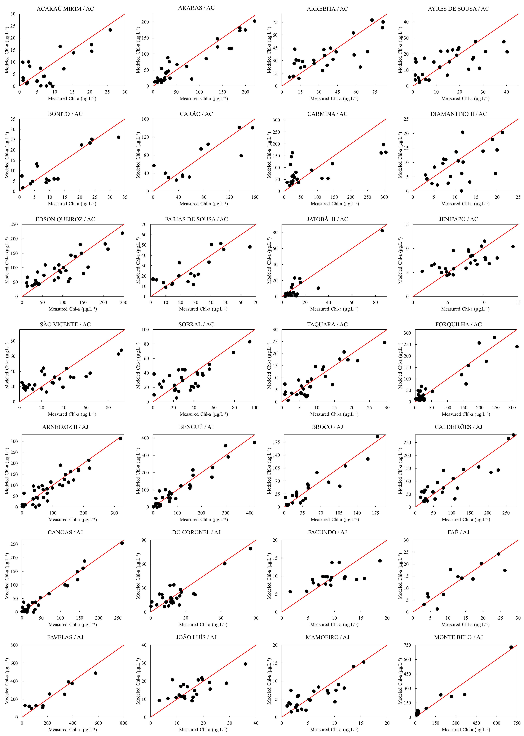

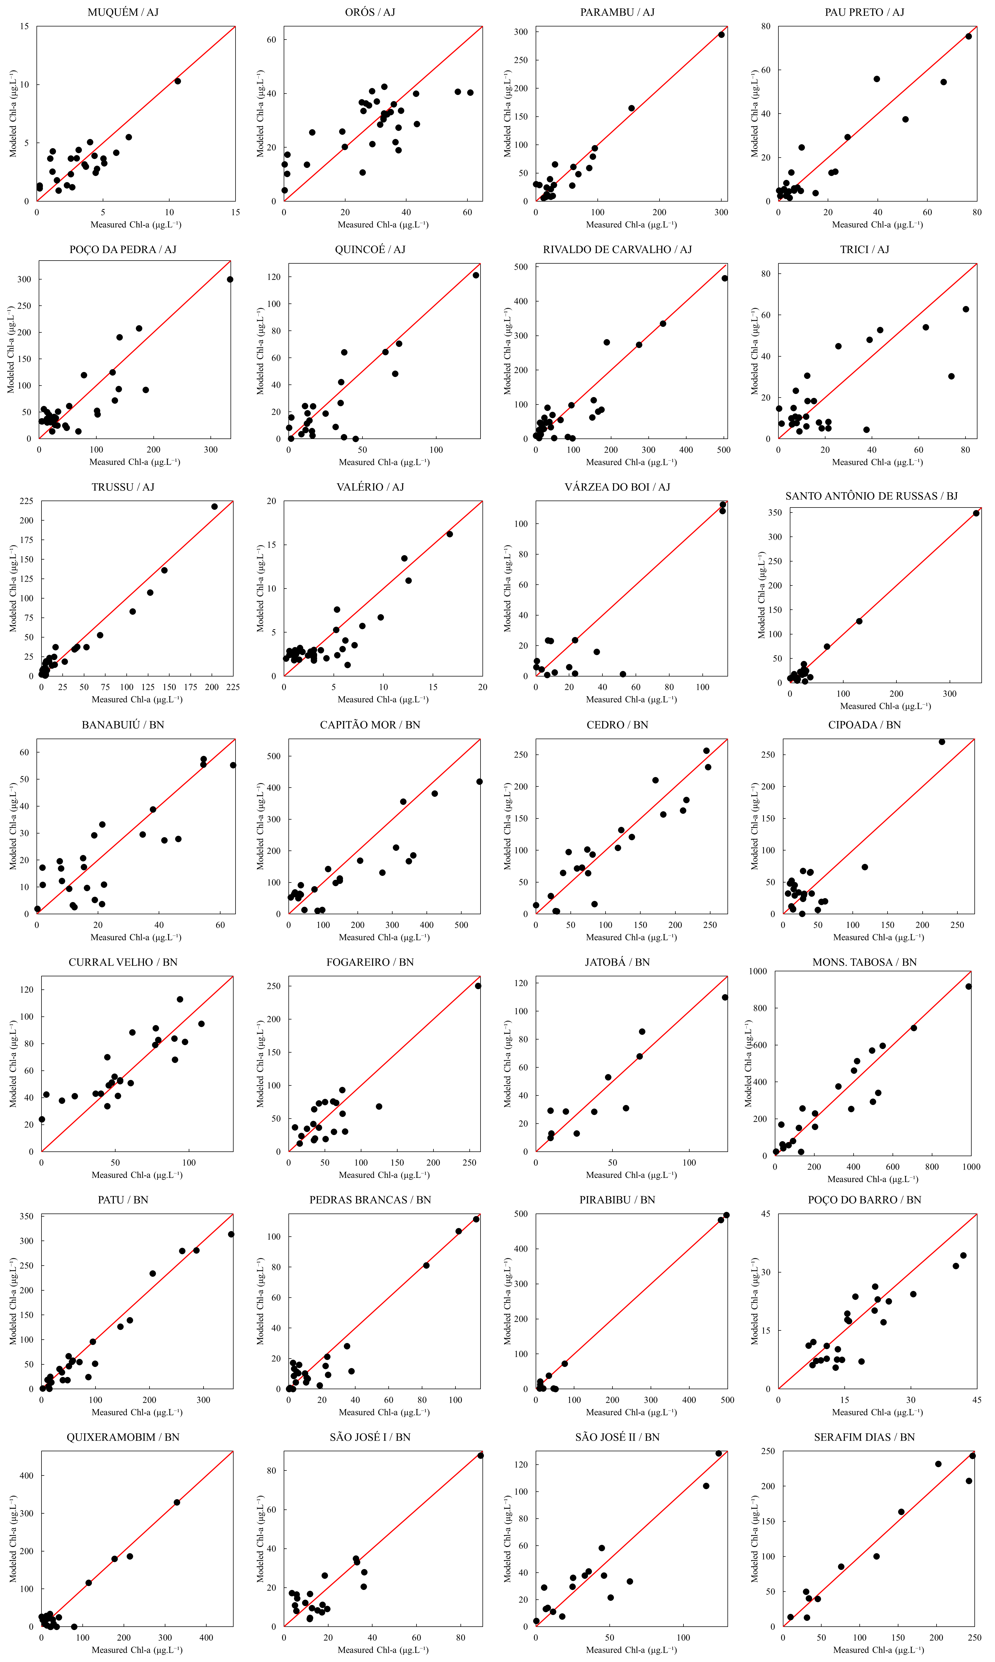

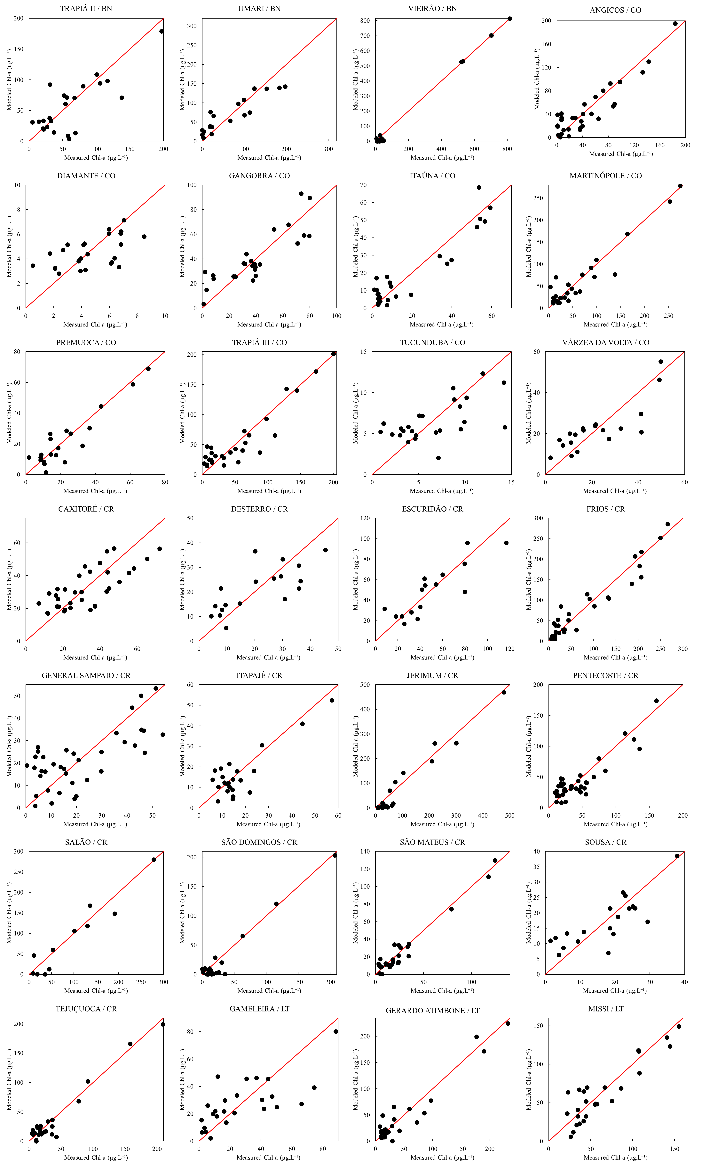
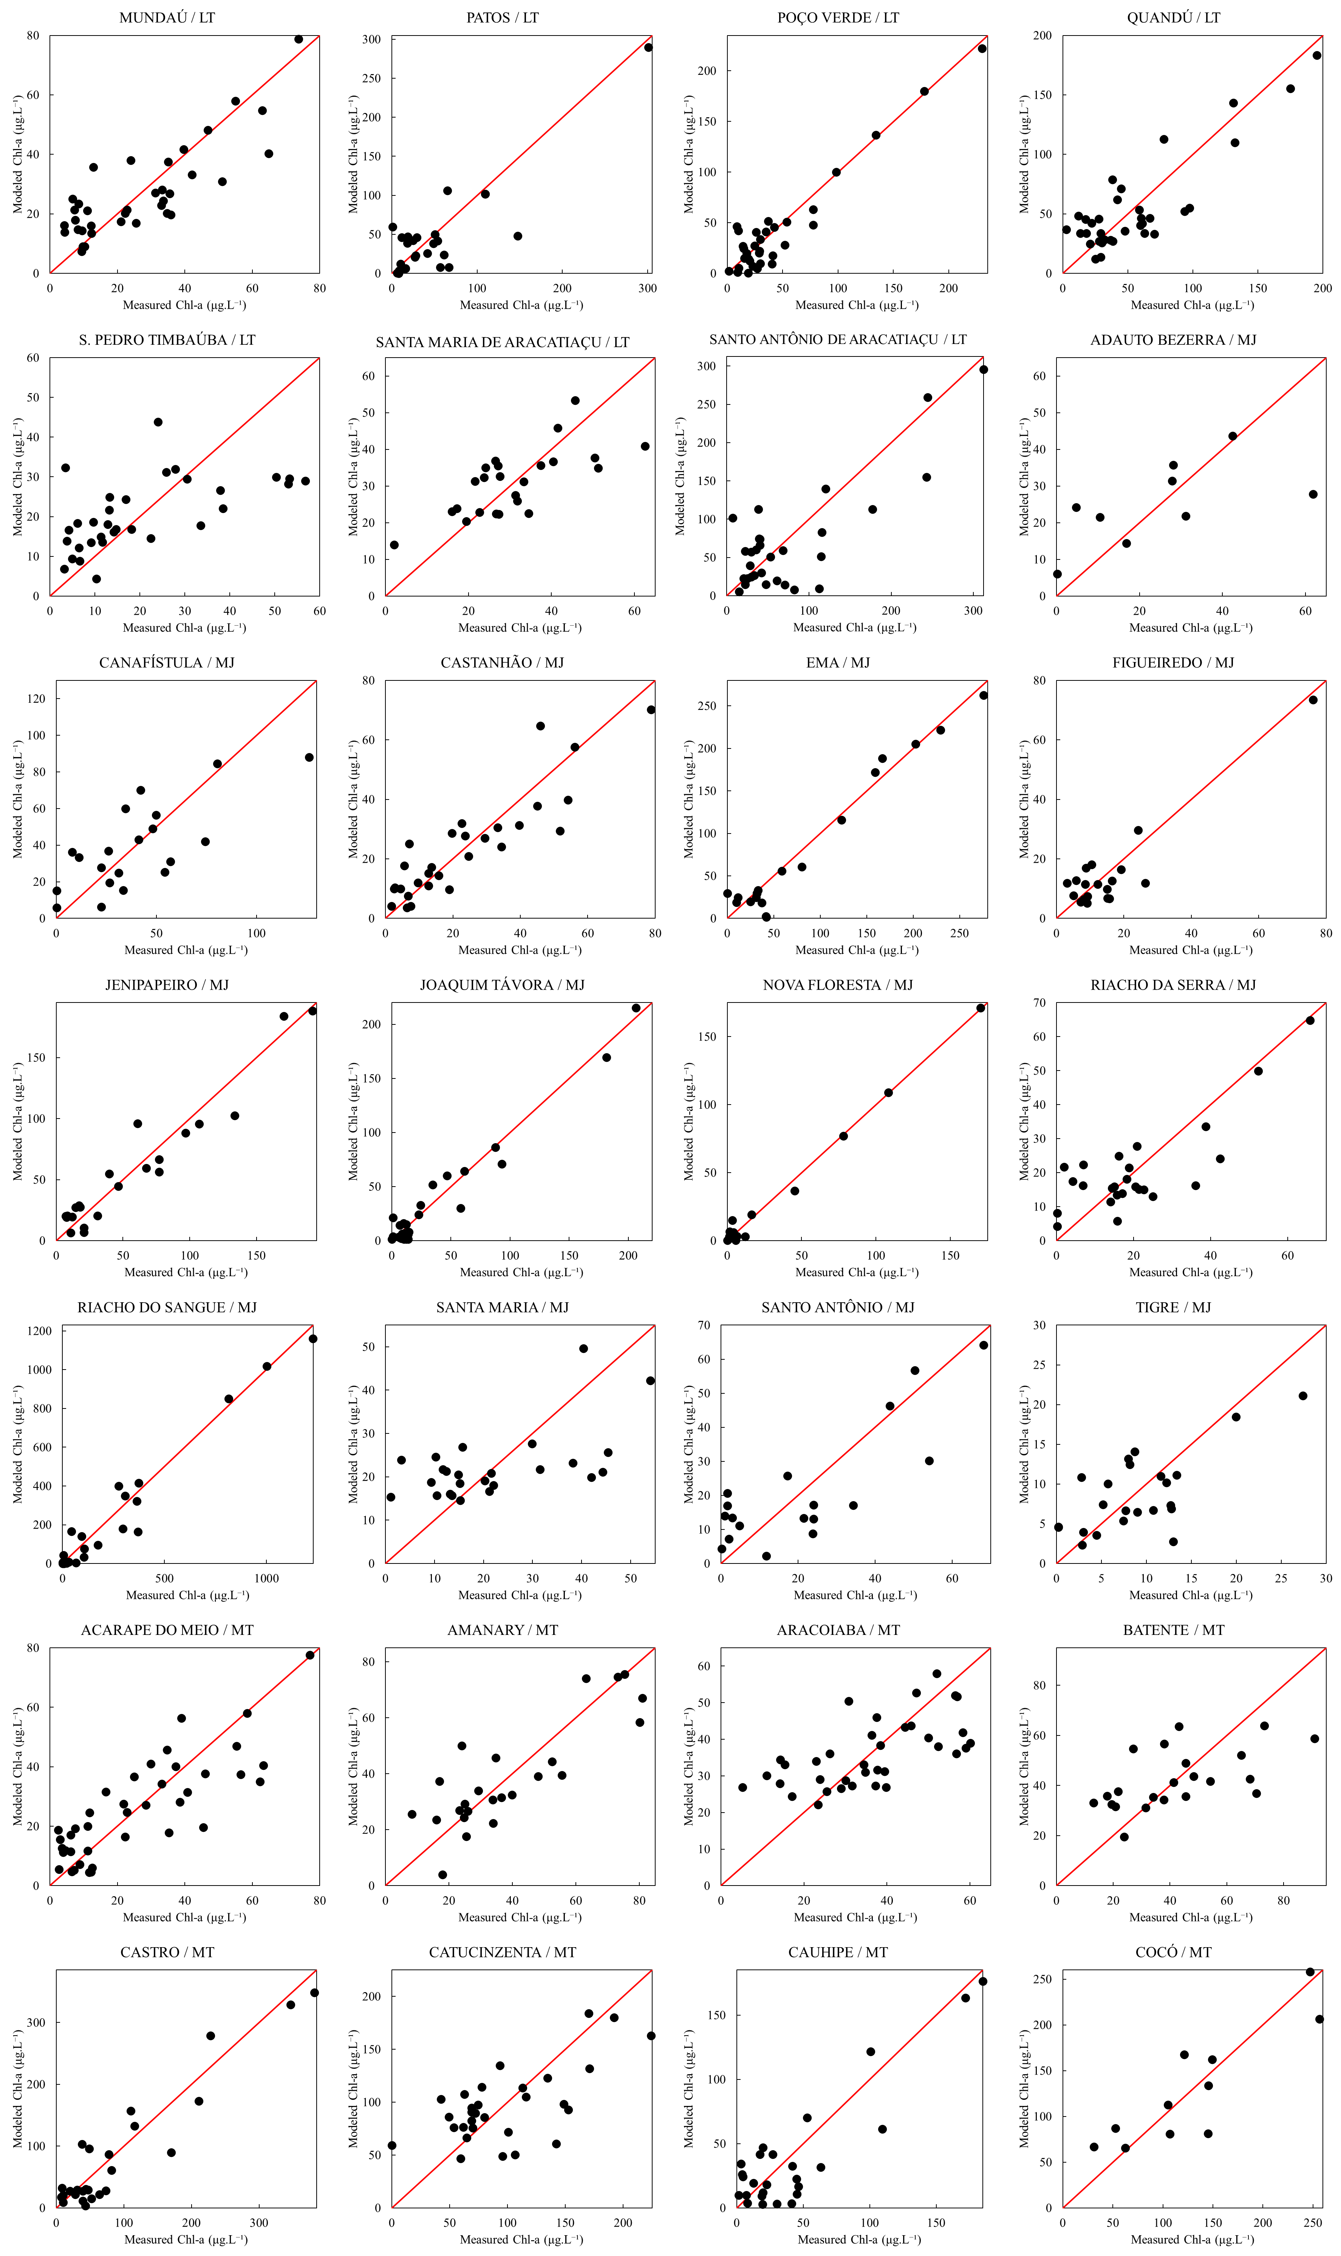

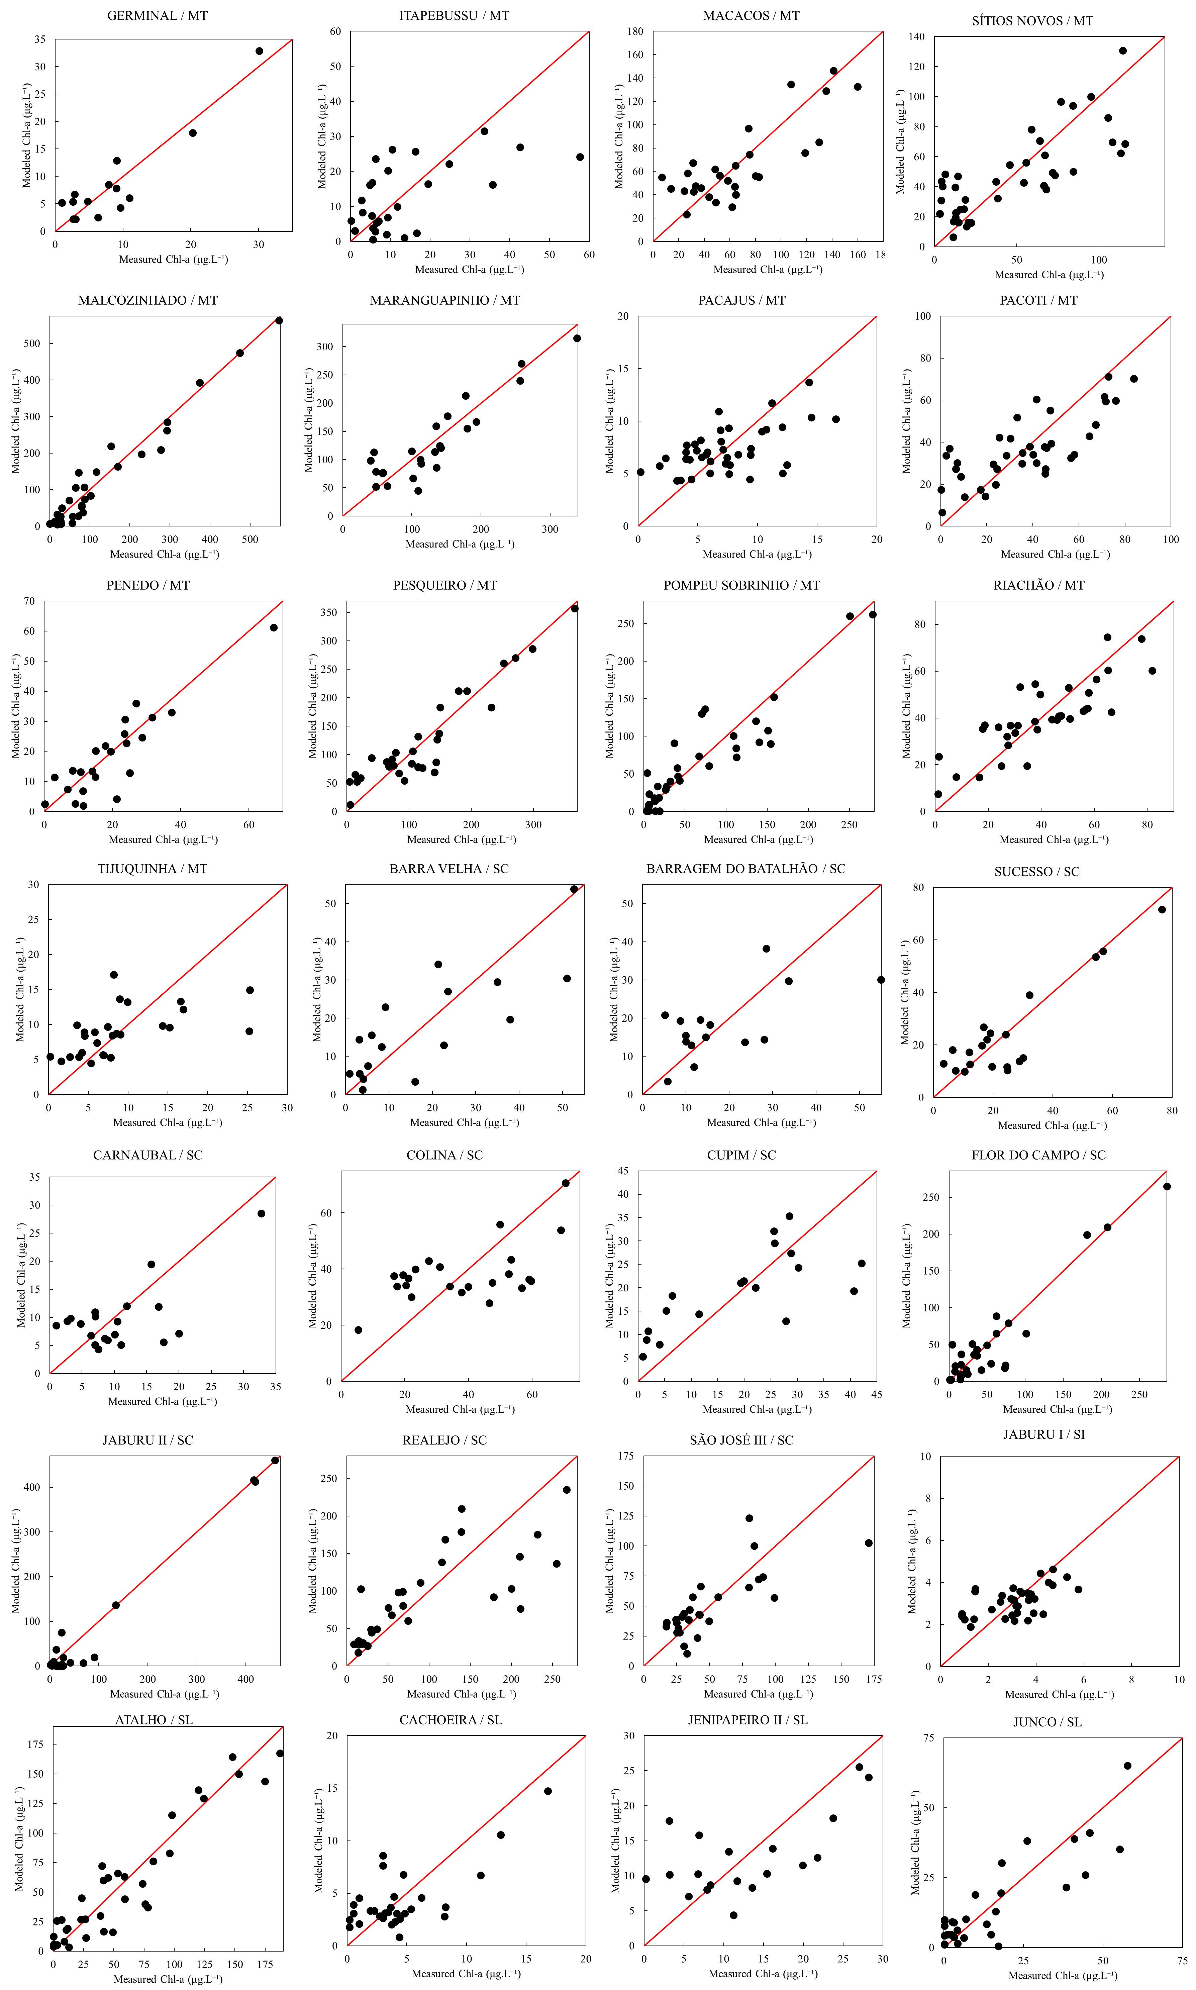

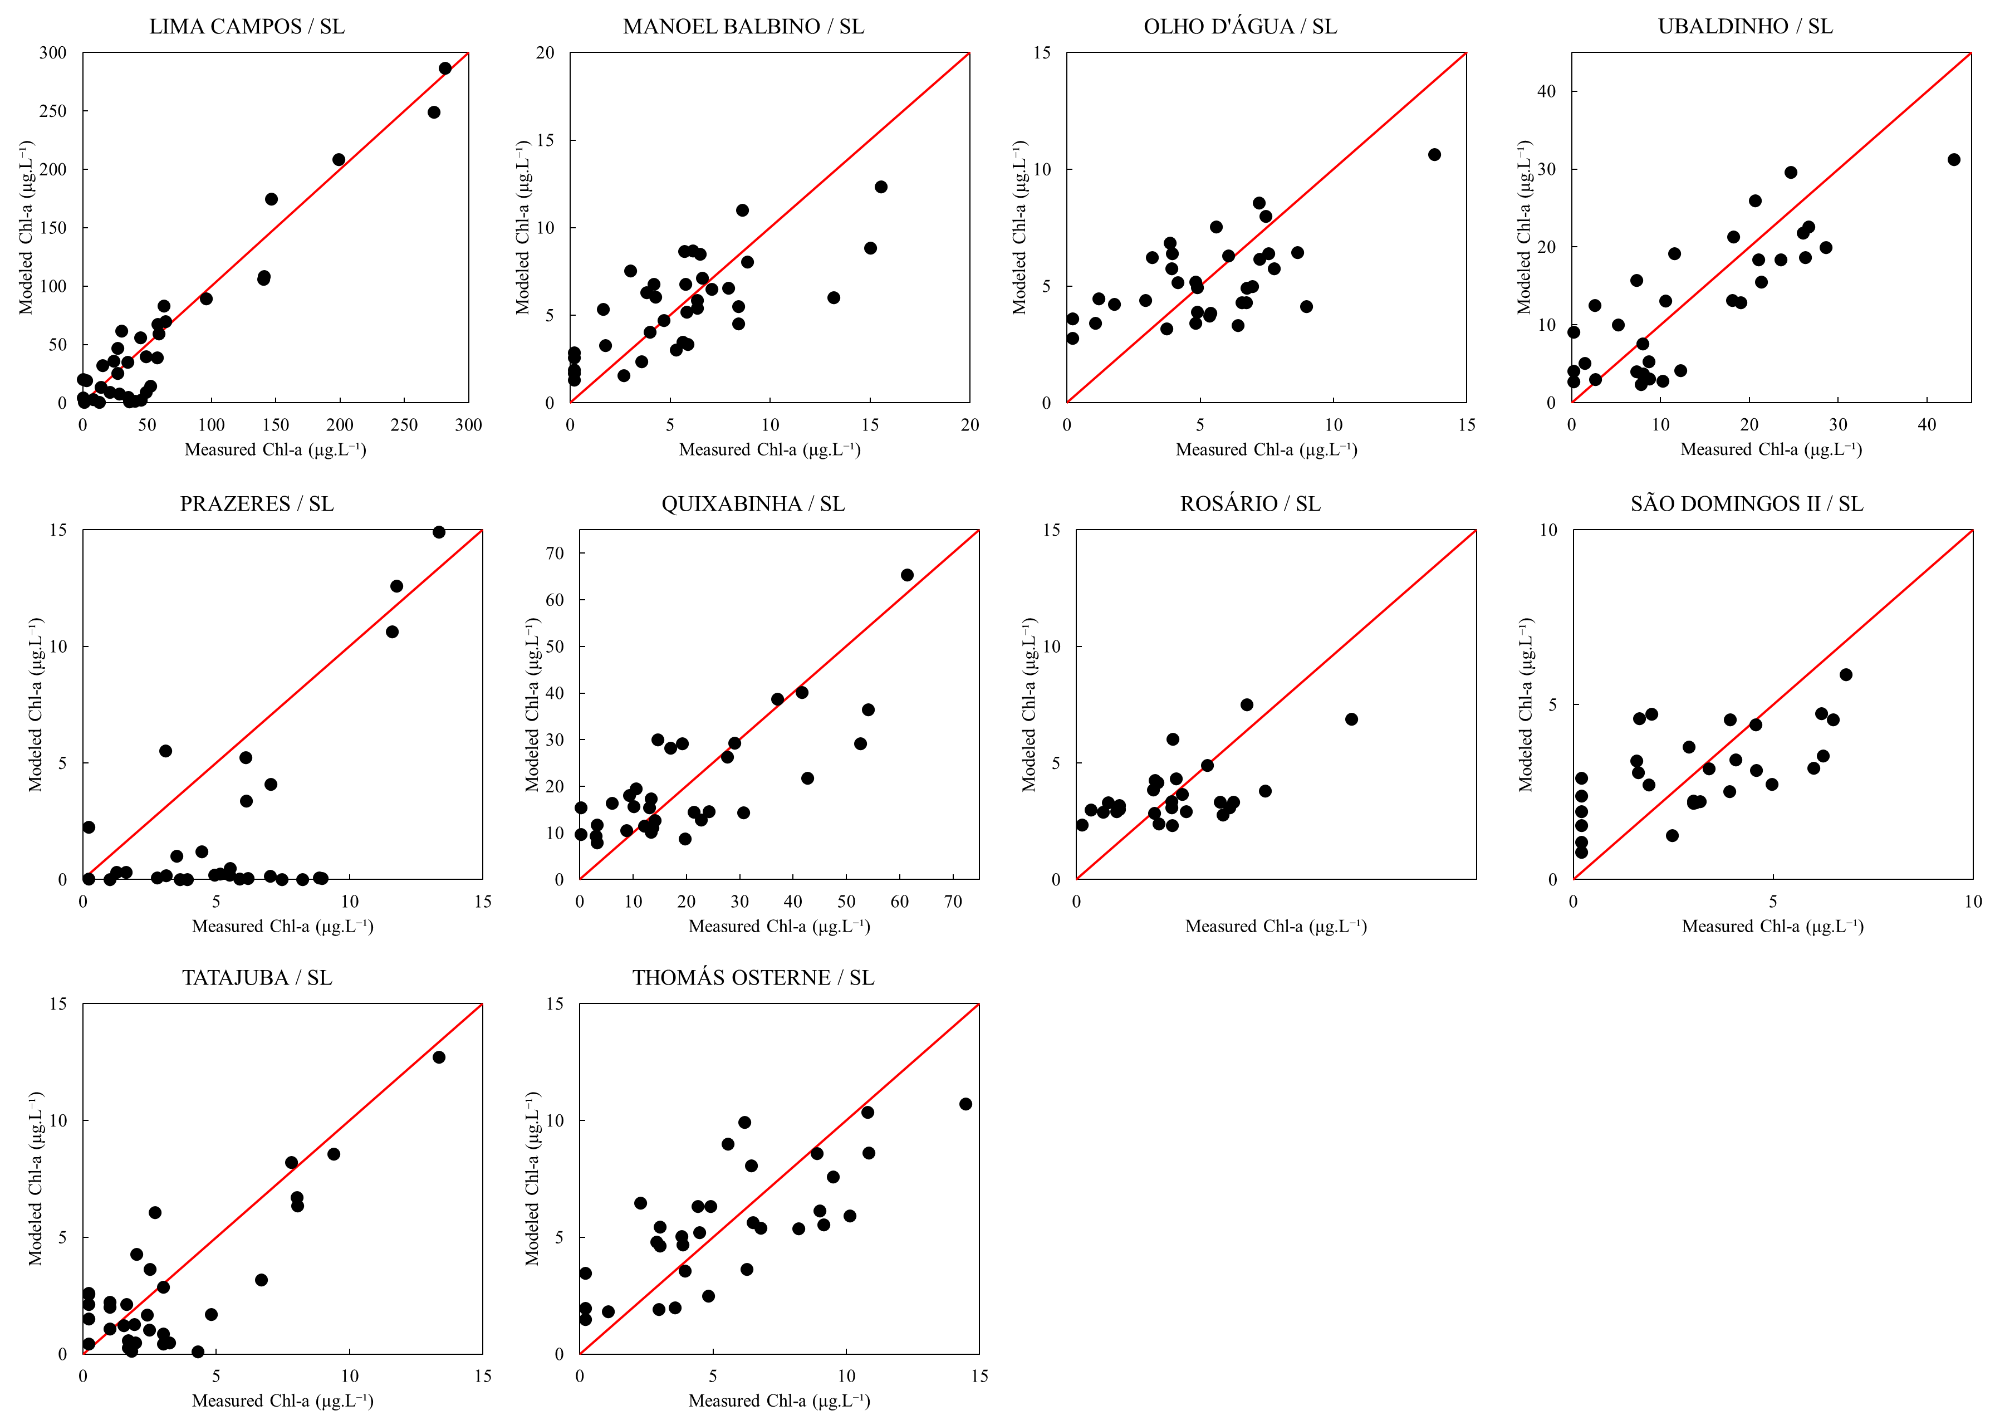

Figura S3. Relationship between measured and modelled chlorophyll-a in the 150 analyzed reservoirs.

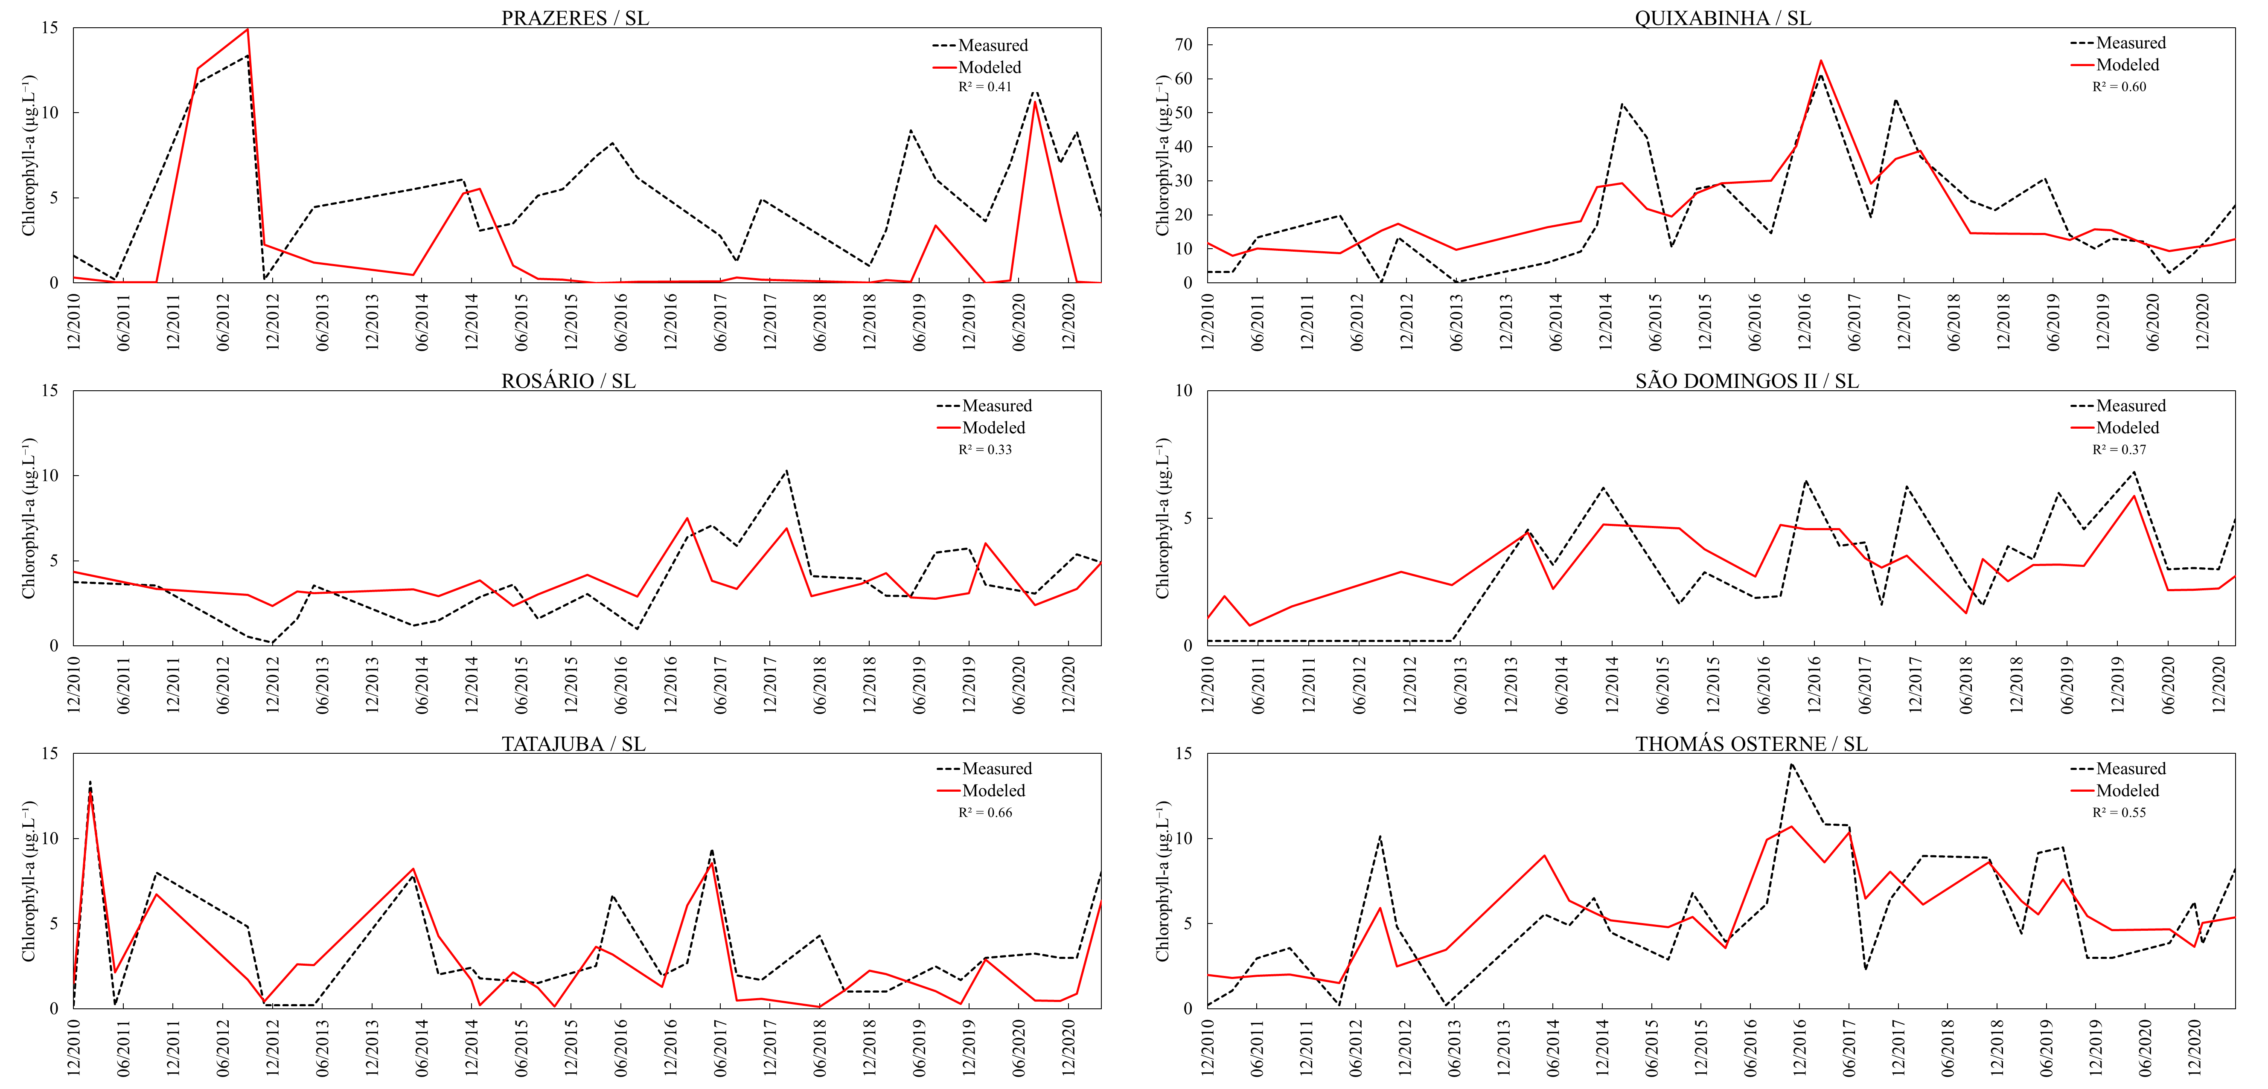
Figure S4. Time series plot comparison between modeled (red line) and measured (dashed black line) chlorophyl-a concentrations for the 150 studied reservoirs.

Figure S5. Simulation of all plausible combinations among Classes 4,3, 2 and 1 for each input variable using the empirical equations of the reservoirs (A) Castanhão/MJ and (B) Orós/AJ.

Table S3. Most unfavorable (Scenario A) and favorable (Scenario B) results regarding the concentration of Chlorophyll-a estimated through the empirical equations for the strategic reservoirs Castanhão/MJ and Orós/AJ.

 |  | CASTANHÃO/MJ |  |  |  |  | ORÓS/AJ
 |  | TN | TP | V | P | Chl-a | TN | TP | V | P | Chl-a
SCNEARIO A | 1 | C4 | C4 | C4 | C4 | C3 | C4 | C1 | C4 | C4 | C4
SCNEARIO A | 2 | C4 | C3 | C4 | C4 | C3 | C4 | C1 | C3 | C4 | C4
SCNEARIO A | 3 | C4 | C2 | C4 | C4 | C3 | C4 | C1 | C2 | C4 | C4
SCNEARIO B | 1 | C1 | C1 | C1 | C1 | C1 | C1 | C4 | C1 | C1 | C2
SCNEARIO B | 2 | C1 | C2 | C1 | C1 | C1 | C1 | C4 | C2 | C1 | C2
SCNEARIO B | 3 | C1 | C3 | C1 | C1 | C1 | C1 | C4 | C3 | C1 | C2

