Supplementary Material

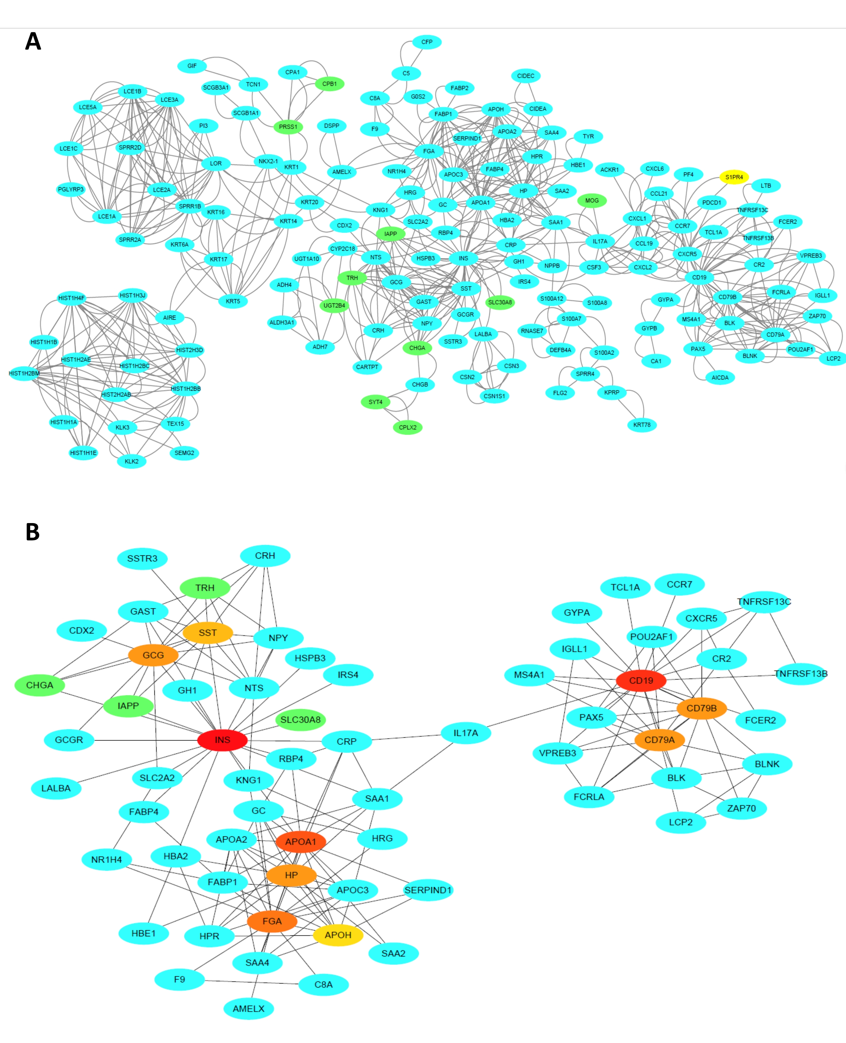

Supplementary Figure 1. Protein–protein interaction network of RAB2A-related DEGs and top 10 hub genes. (A) Protein–protein interaction network of RAB2A-related DEGs. Purple ovals and green diamonds represent upregulated and downregulated DEGs, respectively. (B) Top 10 hub genes in RAB2A expression-associated DEGs. Red to yellow, higher to lower order. DEGs, differentially expressed genes.

