Supplementary Material
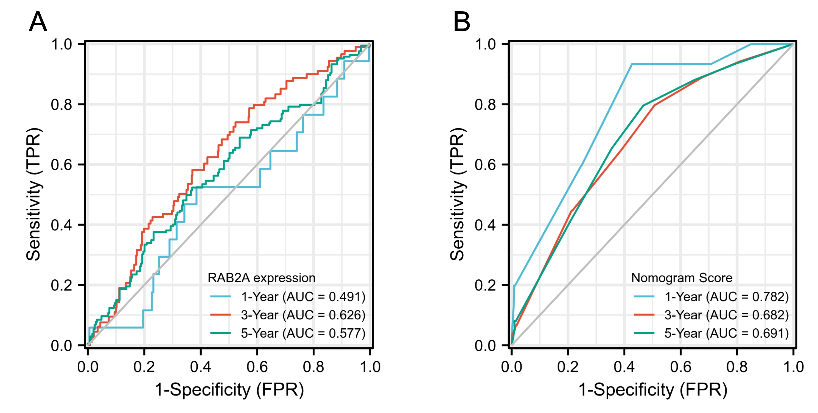
Supplementary figure 3. Time-dependent ROC curves at different time points.
Time-dependent ROC curves based on (A) RAB2A expression and (B) nomogram score for one-, three-, and five-year OS probability. ROC, receiver-operating characteristic; AUC, area under the ROC curve; OS, overall survival.

