SUPPLEMENTARY MATERIALS

Inactivation of TRPM7 kinase targets AKT signaling and cyclooxygenase-2 expression in human CML cells
Birgit Hoeger#, Wiebke Nadolni#, Sarah Hampe, Kilian Hölting, Marco Fraticelli, Nadja Zaborsky, Anna Madlmayr, Viktoria Sperrer, Laura Fraticelli, Lynda Addington, Dirk Steinritz, Vladimir Chubanov, Roland Geisberger, Richard Greil, Andreas Breit, Ingrid Boekhoff, Thomas Gudermann and Susanna Zierler*

#contributed equally to this work
*to whom correspondence should be addressed: susanna.zierler@jku.at

SUPPLEMENTARY TABLE

Table T1
Table T1. Information on CML patients. CD34⁺ cells were sorted out of freshly isolated PBMCs.
Patient code | Year of birth | Month of diagnosis | Dates of sampling | BCR-ABL status | Therapy
P1 | 1964 | 12/2016 | 12/2016 | positive | Hydroxycarbamide in 12/2016, Imatinib since
P2 | 1985 | 07/2017 | 07/2017, 08/2017, 08/2018, | positive | Hydroxycarbamide after diagnosis, Imatinib since 08/2017, switch to Dasatinib since 08/2018
P3 | 1942 | 10/2017 | 08/2018 | positive | Hydroxycarbamide after diagnosis, switch to Azacitidine in 06/2018
P4 | 1957 | 11/2017 | 11/2017, 09/2018, | positive | Imatinib since 12/2017
P5 | 1957 | 06/2018 | 06/2018, 08/2018, | positive | Imatinib since 06/2018 and adjuvant Nivolumab
P6 | 1941 | 06/2018 | 06/2018, 08/2018, 08/2019, | negative | Hydroxycarbamide since diagnosis

SUPPLEMENTARY FIGURES AND FIGURE LEGENDS

Figure S1
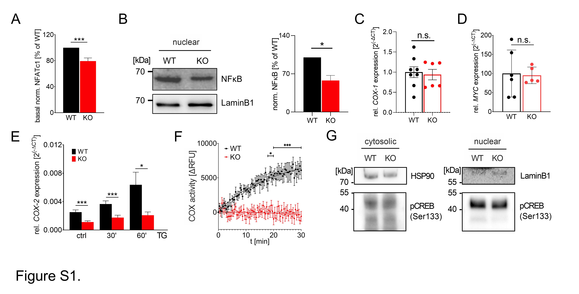
Figure S1. Additional data corresponding to Figure 1. (A) Quantification of basal nuclear NFATc1 levels, as in Fig. 1F, normalized to Lamin B1 (mean ± s.e.m., n=13). (B) Representative Western blot image (left panel) and semi-quantification (right panel) of nuclear NF-κB (p65, n=5) in indicated HAP1 clones, at basal state. (C-D) Relative COX-1 and MYC mRNA expression levels in WT (black) and TRPM7 KO (red) HAP1 cells, assessed by qRT-PCR. Data were related to respective housekeeping controls and depicted as 2^{-ΔCT} (mean ± s.e.m, n=4-8). (E) Relative COX-2 expression in WT and KO cells, upon stimulation with thapsigargin (n=7-13). (F) COX activity assay on TRPM7 WT (black) and KO (red) HAP1 cell lysates. (G) Representative Western blots of cytosolic (left) and nuclear (right) pCREB (Ser133) levels in resting HAP1 clones, as indicated. Lamin B1 served as housekeeping control. Data are shown as mean ± s.e.m, Statistics: unpaired student’s t-test, * p<0.05, ** p< 0.005, **** p<0.00005, n.s. – not significant.

Figure S2
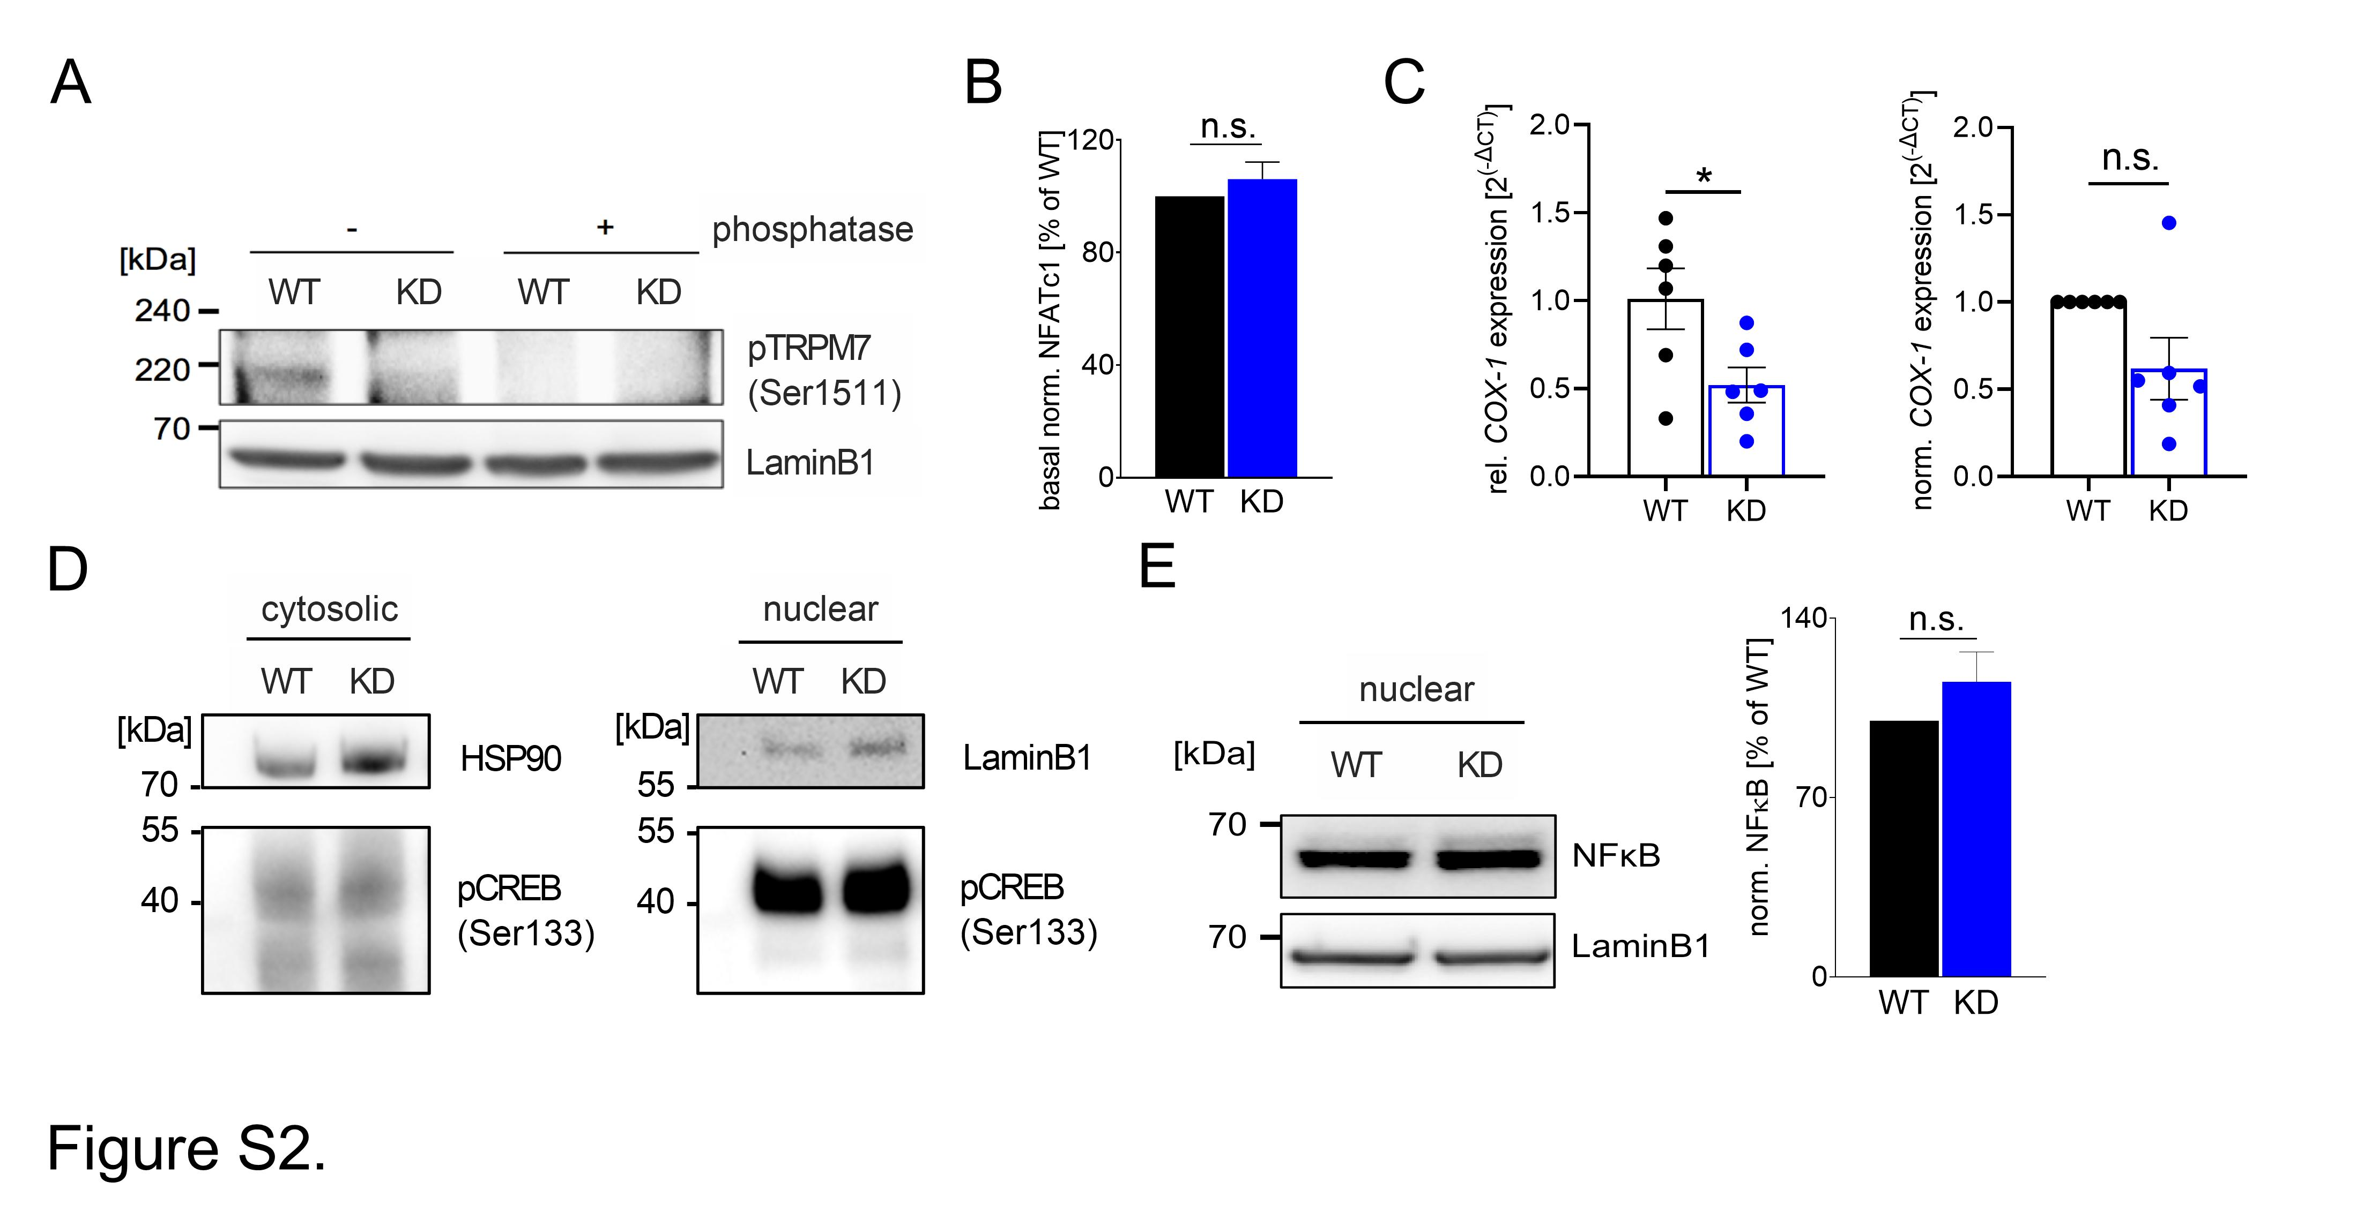
Figure S2. Additional data corresponding to Figure 2. (A) Validation of TRPM7 kinase inactivation in TRPM7 KD HAP1 cells, compared to WT. A representative Western blot is shown against a phospho-specific antibody of´ TRPM7 targeting its autophosphorylation site Ser1511. Note the absence of a specific band in KD cells and well as in phosphatase-treated WT lysates, confirming successful depletion of phosphotransferase activity in the TRPM7 KD mutant. (B) Quantification of basal nuclear NFATc1 levels, as in Fig. 2F, normalized to Lamin B1 (mean ± s.e.m., n=10). (C) Relative (left panel) and normalized (right panel) COX-1 mRNA expression levels in WT (black) and TRPM7 KD (blue) HAP1 cells, assessed by qRT-PCR. Data were related to respective housekeeping controls and depicted as 2^{-ΔCT} (mean ± s.e.m, n=6-8). (D) Representative Western blots of cytosolic (left) and nuclear (right) pCREB (Ser133) levels in resting HAP1 clones, as indicated. Lamin B1 served as housekeeping control. (E) Representative Western blot image (left panel) and semi-quantification (right panel) of basal nuclear NF-κB (p65, n=5) in indicated HAP1 clones. Data are shown as mean ± s.e.m, Statistics: unpaired student’s t-test, * p<0.05, **** p<0.00005, n.s. – not significant.

Figure S3
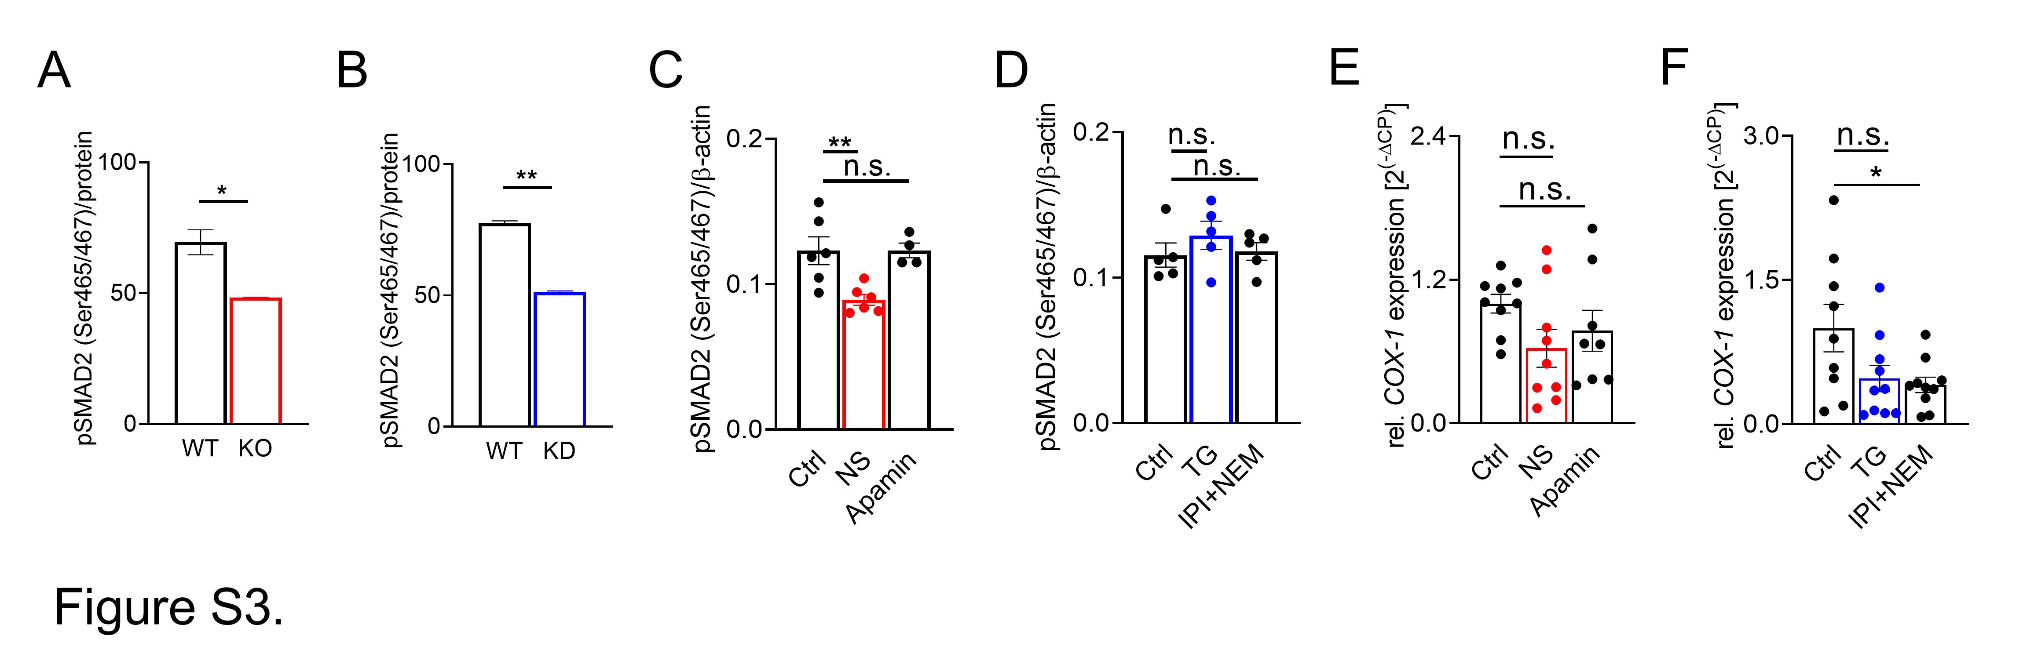
Figure S3. Additional plots corresponding to Figure 3. (A) Bio-Plex Assay of HAP1 cell lysates from TRPM7 WT (black) and KO (red) cells, indicating basal pSMAD2 (Ser465/467) levels. Data were normalized to protein content. (B) Bio-Plex Assay of HAP1 cell lysates from TRPM7 WT (black) and KD (blue) cells, indicating basal pSMAD2 (Ser465/467) levels. Data were normalized to protein content. (C-D) Bio-Plex Assay of cell lysates from HAP1 WT cells treated with indicated inhibitors or control, indicating basal phosphorylation levels of SMAD2 (Ser465/467). Normalized to ß-actin. (E) qRT-PCR data on relative COX-1 mRNA levels in HAP1 WT cells, treated with indicated inhibitors or DMSO control, corresponding to Figure 3D. (F) relative COX-1 mRNA levels in HAP1 WT cells, treated with indicated inhibitors or control, corresponding to Figure 3F. All plots show mean ± s.e.m. Inhibitors as in Figure 3. Statistics: ratio-paired t-test or two-way ANOVA, * p<0.05, ** p<0.005, n.s. – not significant.

Figure S4
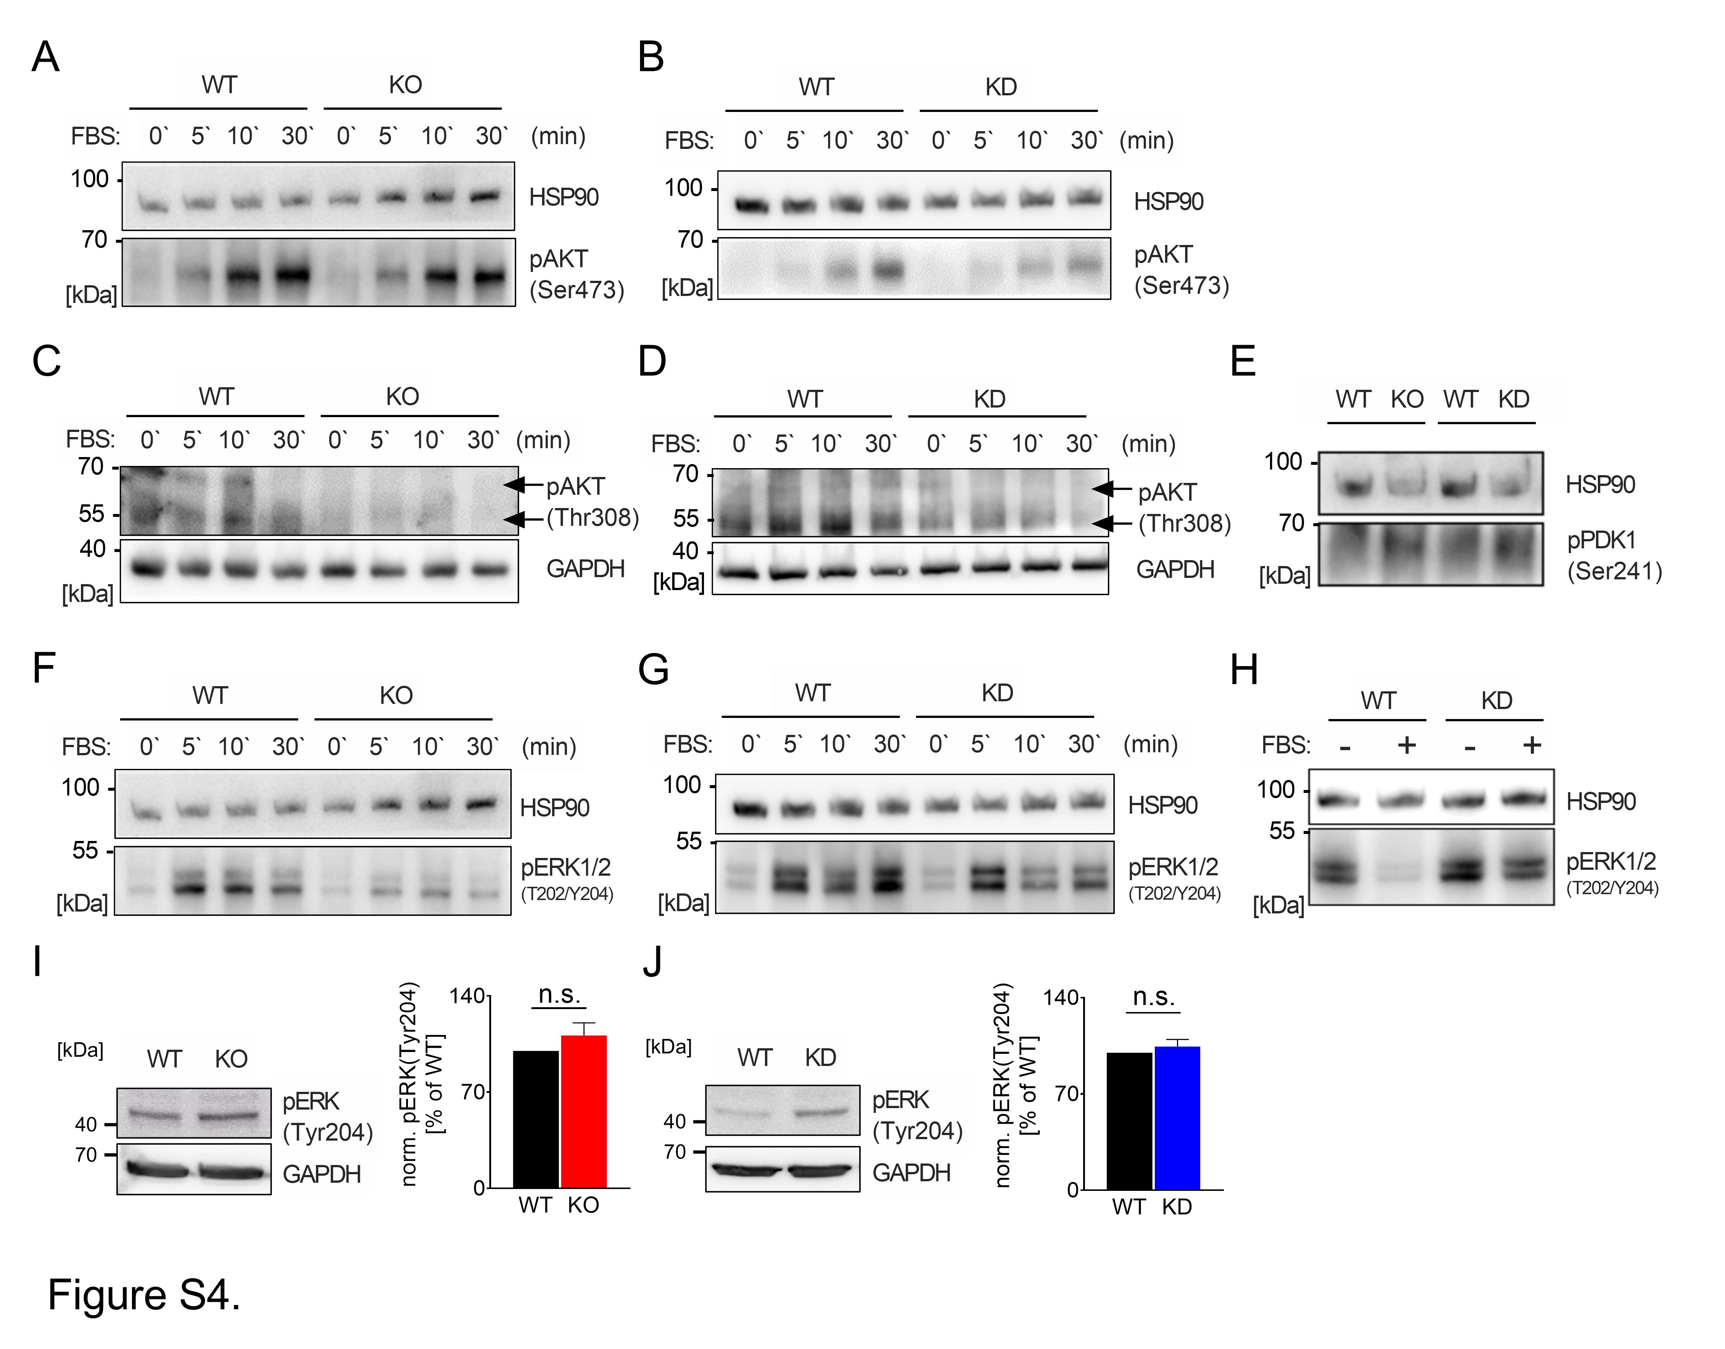
Figure S4. Additional Western blots corresponding to Figure 3. (A) Western blot of pAKT (Ser473) in TRPM7 WT and KO HAP1 lysates. Before lysis, cells were starved from serum for 1 h and re-stimulated with FBS for the indicated times. (B) Western blot of pAKT (Ser473) in TRPM7 WT and KD HAP1 lysates. Cell were stimulated as in A. (C) Western blot of pAKT (Thr308) in TRPM7 WT and KO HAP1 lysates, stimulated as in A. Note the two visible bands indicated by arrows, and the serum-unresponsiveness of pAKT (Thr308). (D) Western blot of pAKT (Thr308) in TRPM7 WT and KD HAP1 lysates, stimulated as in A. (E) Western blot of basal pPDK1 at its autophosphorylation site Ser241, in lysates of indicated HAP1 clones. (F) Western blot of pERK1/2 (Thr202/Tyr204) in TRPM7 WT and KO HAP1 lysates. Cells were starved from serum for 1 h and re-stimulated with FBS for the indicated times. (G) Western blot of pERK1/2 (Thr202/Tyr204) in TRPM7 WT and KD HAP1 lysates. Stimulation as in F. (H) Western blot of pERK1/2 (Thr202/Tyr204) in TRPM7 WT and KD HAP1 lysates. Cells were starved from serum for 21 h (-FBS) and re-stimulated for 1 h (+ FBS). Note the cyclic behavior of ERK1/2 phosphorylation depending on starvation length, compared to G. (I) Western blot (left panel) of basal pERK (Tyr204) levels in TRPM7 WT and KO HAP1 lysates. Semi-quantification is shown to the right. (J) Western blot (left panel) of basal pERK (Tyr204) levels in TRPM7 WT and KD HAP1 lysates. Semi-quantification is shown to the right. Representative Western blot images out of one to six replicates. HSP90 or GAPDH were used as housekeeping controls. Plots show mean ± s.e.m, Statistics: ratio-paired t-test, n.s. – not significant.

Figure S5
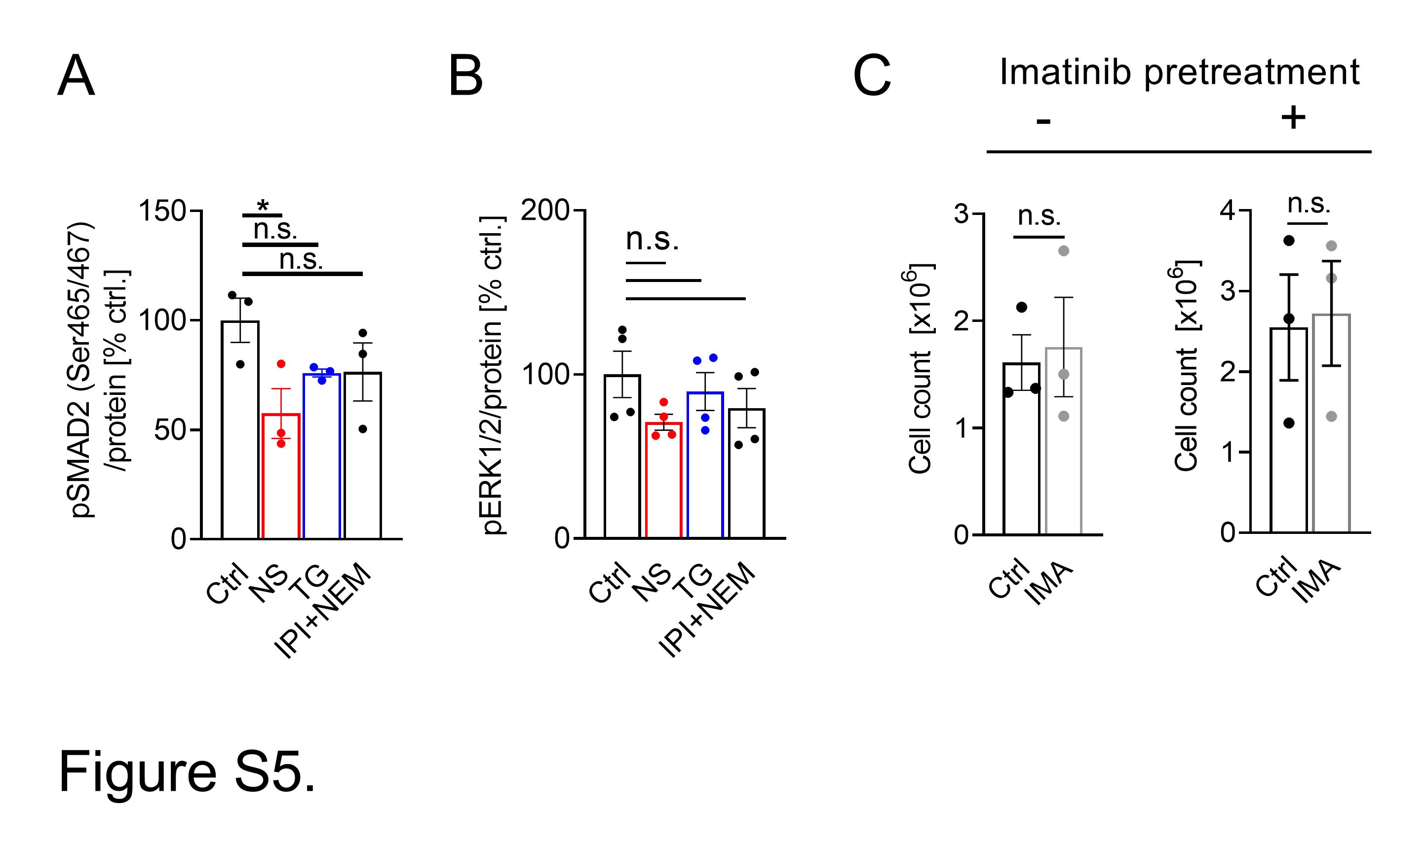
Figure S5. Additional data corresponding to Figure 4. (A) Bio-Plex Assay on basal pSMAD2 (Ser165/467) levels in CML patient-derived PBMC lysates, treated with the TRPM7 channel inhibitor NS8593 (NS, red), the TRPM7 kinase inhibitor TG100-115 (blue, TG), the PI3K inhibitors IPI-549 (IPI) + Nemiralisib (NEM) or DMSO control, as described in the Methods section. (B) Bio-Plex Assay on basal pERK1/2 levels in CML patient-derived PBMC lysates, treated with inhibitors as in A. (C) HAP1 WT cells showing a growth resistance to Imatinib (gray, IMA) after Imatinib pretreatment (+), compared to non-pretreated cells (–) and DMSO controls, respectively. Plots show mean ± s.e.m, Statistics: ratio-paired t-test or two-way ANOVA, * p<0.05, n.s. – not significant.

