Supplementary materials 4: Elicitation exercise
Objective
Due to the paucity of data pertaining to health states 3, 4, 5, and 6 in the C-Path data (Figure 1), an elicitation exercise was used to inform transitions into States 3, 4, and 5/6 in the natural history model.
Figure 1: Structure of the natural history model
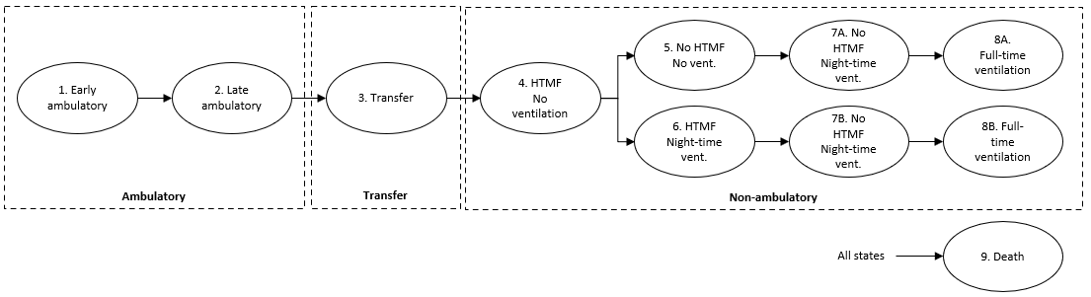
Abbreviations: HTMF, hand to mouth function.
Methods
Data were elicited from individuals with experience of the trajectory of Duchenne muscular dystrophy (DMD), i.e. clinicians, patients, parents, and carers.
Respondents were asked the questions presented in Table 1 to obtain estimates for the age at which transitions from state 2 to 3, 3 to 4 and 4 to 5/6 were typically made. Respondents were also asked to estimate the proportions of patients that moved to state 5 from state 4, and to state 6 from state 4.
Table 1: Questions used in the elicitation exercise
Expert status | Medically Qualified  Nurse  Other Health Care Professional  Parent  Caregiver  Patient  Other (please specify)
Question 1 | On average, at what age would you expect someone with DMD to stop being able to walk 10m (but still be able to stand, i.e., weight bearing)? [State 2 to State 3]  Can you specify a plausible range for this average?
Question 2 | Given what you have said about the average in Question 1, how long would you expect it to be before they lose the ability to stand? (or say, on average, at what age you think this would happen, if that is easier) [State 3 to State 4]  Can you specify a plausible range for this average?
Question 3 | Given what you have said in Questions 1 and 2, if someone has lost the ability to stand, but still has HTMF and does NOT require any ventilation:  On average, how long do you think it would be before they lost either HTMF or required night-time ventilation? (or say, on average, at what age you think this would happen, if that is easier) [State 4 to State 5 or 6]  Can you specify a plausible range for this average?  What proportion (%) of patients do you think would lose HTMF first? [State 4 to State 5]
Abbreviations: DMD, Duchenne muscular dystrophy; HTMF, hand to mouth function.
Note: what we mean by a plausible range – lower value is such that 1 in 4 (25%) patients would be below it, and upper value is such that 1 in 4 (25%) patients would be above it.
The elicitation exercise was conducted in two phases: a pilot study and an anonymised online survey. The pilot was conducted at a Project HERCULES steering group meeting on 25/10/2019. Eight stakeholders completed at least one of the questions on the questionnaire.
The subsequent anonymised online survey was circulated by Duchenne UK and received 20 responses. Respondents were all from the UK and included:
- Two “medically qualified”
- Twelve “parent”
- Two “parent and carer”
- One “parent and nurse”
- Three “patient”.
For both the pilot study and subsequent online survey, fifty hypothetical patients were generated in state 3 with starting ages simulated from a normal distribution, with the mean equal to the mean age of answers to Question 1, and standard deviation selected such that 50% of the normal distribution covered the mean age range of answers in Question 1. Their transition times to state 4 were simulated by taking their age in state 3 and adding a random value from a normal distribution with the mean equal to the mean difference between Question 1 and Question 2, and a standard deviation selected in the same way as for state 3. This value was left-truncated at 0.1 years and right-truncated at 15 years. This was repeated for transitions from state 4 to states 5/6 with these transitions apportioned to state 5 and state 6 based on responses to the final part of Q3.
Results
The results of the online elicitation exercise (Figure 2) were broadly similar to the pilot elicitation of eight stakeholders. The mean age at each transition, and mean age range, are shown next to each individual response.
Figure 2: Elicitation data from 20 respondents on DMD progression (online survey)
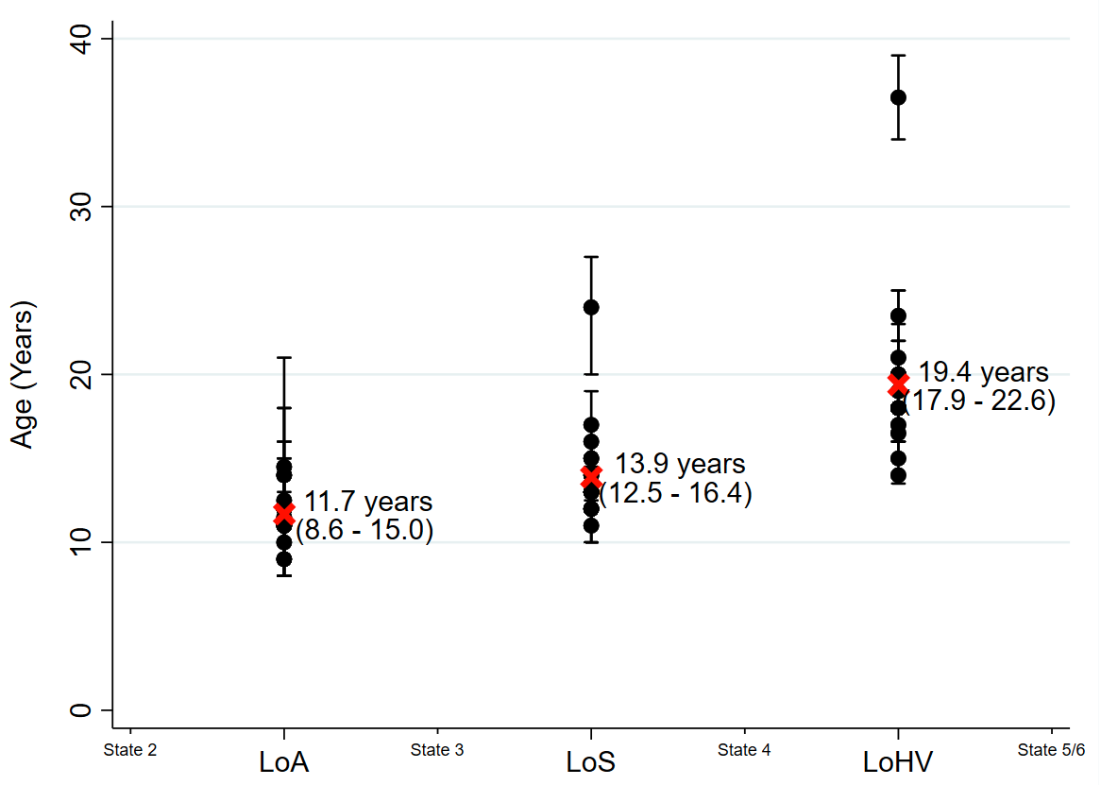
Abbreviations: DMD, Duchenne muscular dystrophy; LoA, loss of ambulation (10 m); LoHV, loss of hand to mouth function/requires night ventilation; LoS, loss of standing (weight-bearing).
The loss of ambulation (state 2 to 3) was estimated by both groups to occur at around 12 years, and the loss of hand to mouth function or requirement of night-time ventilation (state 4 to state 5/6) was estimated to occur around 6 years after losing the ability to stand. The results from the online survey predicted a slightly shorter stay in state 3, estimating that patients lose the ability to stand at around 14 years. The ages at loss of ambulation were simulated from a normal (11.7, 5) distribution, at loss of standing from a normal (age_{LOA}+2.2, 2) and at loss of hand to mouth function/requiring night ventilation from a normal (age_{LOS}+5.5, 3) to reflect the mean ages and age ranges.
On average, respondents estimated that 52.1% of patients move from state 4 to state 5, with a minimum of 20% and a maximum of 80%. As such, 50% of patients were assigned to state 5 from state 4 and 50% to state 6 from state 4 in the simulated dataset.
Congruence of age distributions with those from the D-RSC data set
A comparison of age distributions for the base case simulated dataset from the online elicitation exercise and the C-Path dataset are shown in Figure 3.
Figure 3: Comparison of age distributions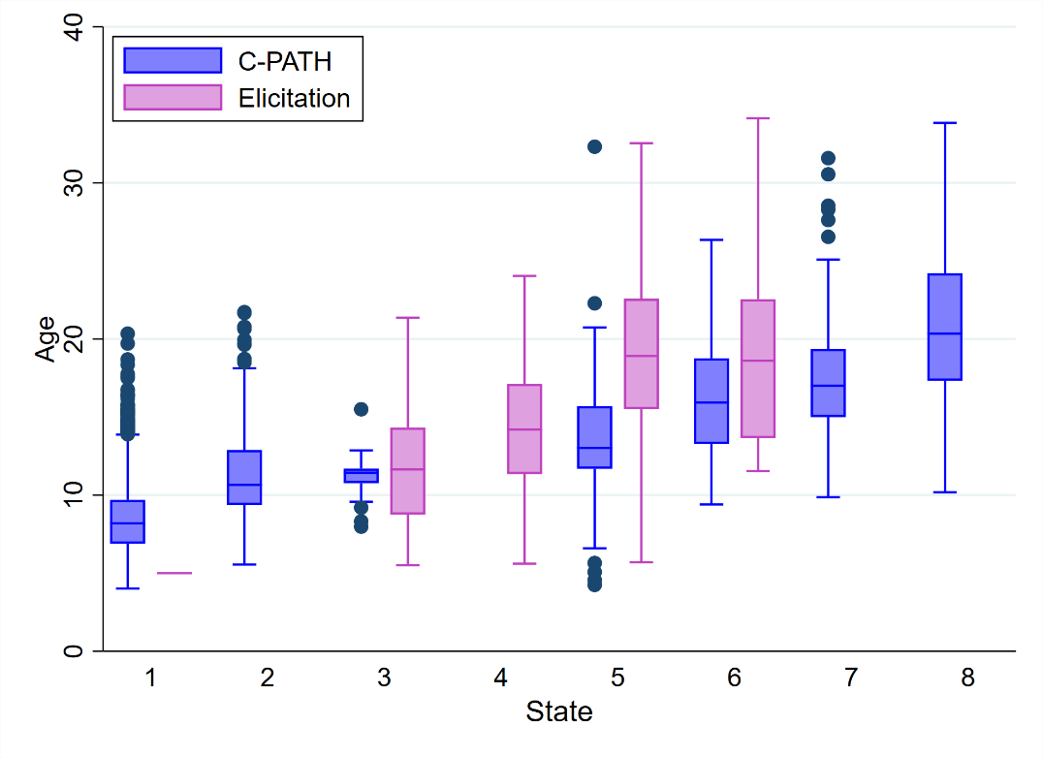
The mean (and SD of) ages in states 3, 4, 5, and 6 respectively of patients from the simulated dataset are 11.8 (4.2), 14.3 (4.5), 19.5 (5.6), and 19.3 (6.4), respectively. There is some small difference in the age distributions in state 5 between the two datasets. This is largely due to the small numbers in the simulated dataset, since only 30 simulated patients were assigned to state 5. Otherwise, overall there is largely agreement between the age distributions.
Sensitivity analyses
A number of sensitivity analyses were conducted. These included the exclusion of an outlying survey response, and varying the methods used to generate the age distribution in each state.
There was one outlying response in the online survey. Excluding this response from the analysis showed that the outlying response did little to change the overall results (Figure 4).
Figure 4: Sensitivity analysis removing the one outlying response in the online survey (n=19)
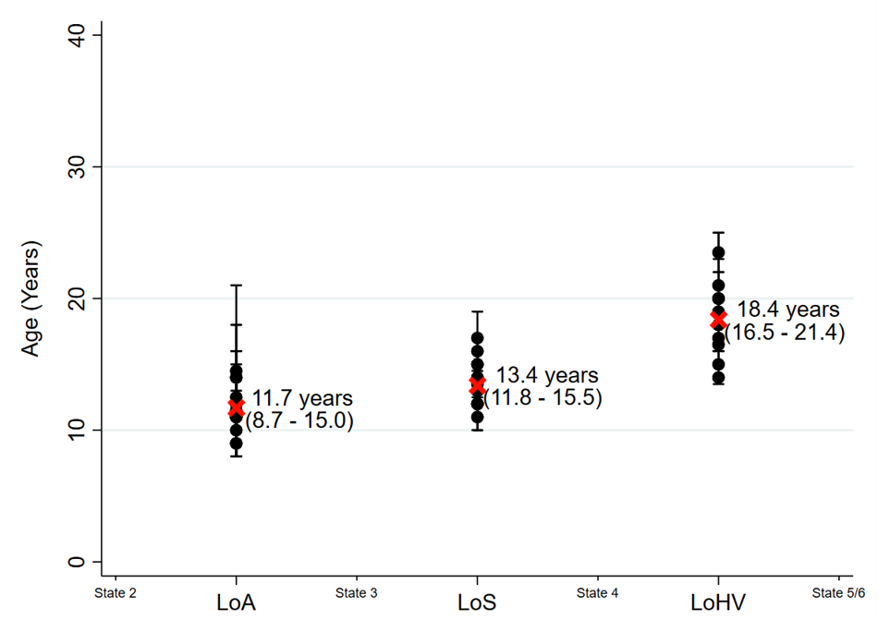
Abbreviations: LoA, loss of ambulation (10 m); LoHV, loss of hand to mouth function/requires night ventilation; LoS, loss of standing (weight-bearing).
The dataset was re-simulated multiple times with different parameter values for the age distributions chosen to assess the sensitivity of the model to the elicitation exercise. These are detailed below in Table 2.
Table 2: Different scenarios considered in the sensitivity analysis
Scenario | Sample Size | Values for Normal Distributions | Proportion
Base case | 50 | N(11.7, 5), N(age_{LOA}+2.2, 2), N(age_{LOS}+5.5, 3) | 50%
Other values | 20 | N(11.7, 2), N(age_{LOA}+2.2, 1), N(age_{LOS}+5.5, 1) | 25%
Other values | 100 | N(10.7, 5), N(age_{LOA}+2.2, 2), N(age_{LOS}+5.5, 3) | 75%
Abbreviations: LoA, loss of ambulation (10 m); LoS, loss of standing (weight-bearing).
The sample size was varied to assess the impact of the weight that the simulated dataset was providing. The values for the normal distributions of ages in each state and the proportion moving from state 4 to state 5 were varied to quantify the uncertainty around the elicitation responses. Each time a different dataset was simulated, the model was re-estimated and gave very similar results in terms of transition intensities and probabilities. The other simulated datasets from the sensitivity analysis also showed similar agreement with the age distributions in the C-Path dataset.
Conclusions
In the absence of clinical/real-world data, the elicitation exercise is considered to represent an appropriate alternative (1).
References
- S. Dias, N. Welton, A. Sutton, and A. Ades, 2011. Nice DSU Technical Support Document 5: Evidence synthesis in the baseline natural history model.

